Supporting Information

Molecular Engineering of Melanin for Enhanced Biological γ-ray Protection

Ruotong Deng, Wei Chen, Hanjie Zhu, Yuxi Li, Yining Ou, Jian Wang, Qing Ruan, Xuanying Zhang, Junbo Zhang, Yongxian Zhang, Yantao Niu, Zhubin Hu, Chunlei Zhang, Huaping Xu,* and Wei Cao*

This PDF file includes:
Reagents and materials
Apparatus and characterization
Methods
Additional discussion
Supporting Figure S1 to S42
Supporting Tables S1 to S3
SI References

Reagents and materials
L-3,4-dihydroxyphenylalanine (L-DOPA) was purchased from Leyan (Shanghai, China). Dopamine hydrochloride (DA·HCl) was purchased form Jiangsu Aikon. L-Selenocystine, tris(2-carboxyethyl) phosphine hydrochloride (TCEP·HCl) and 2-(2-Methoxy-4-nitrophenyl)-3-(4-nitrophenyl)-5-(2,4-disulfophenyl)-2H-tetrazolium sodium salt (WST-8) were purchased from Aladdin. Selenocystamine dihydrochloride was purchased from Hwrk Chem. Potassium permanganate (KMnO₄) was purchased from Beijing TongGuang Fine Chemicals Company. Ammonium hydroxide (NH₃·H₂O), 2′,7′-dichlorodihydrofluorescein diacetate (DCFH-DA, solid) and 2,2-diphenyl-1-(2,4,6-trinitrophenyl) hydrazyl (DPPH) were purchased from Macklin. Ethanol absolute (99.5%), Xanthine (X) and sodium nitroferricyanide dihydrate were purchased from Innochem. Xanthine Oxidase (XO) was purchased from Sigma-Aldrich. Griess reagent was purchased from Yuanye. CellTiter-Blue® Reagent was purchased from Promega. DAPI was purchased from Solarbio. Hoechst 33342 was purchased from Beijing LABLEAD Inc. Cell cycle and apoptosis analysis kit, and reactive oxygen species assay kit (DCF-DA, for cell) were purchased from Beyotime. Wheat Germ Agglutinin (WGA) conjugated to Alexa Fluor 488 was purchased from Kaixin Tech. Lipid peroxidation probe BODIPY (581/599)-C11 was purchased from Dojindo. All reagents and materials were used as received unless otherwise stated.

Apparatus and characterization
Transmission electron microscopic (TEM) images were recorded using a FEI Tecnai Spirit 120kV TEM at Tsinghua University. The zeta potential and dynamic light scattering (DLS) size of the nanoparticles in water was obtained on a Zetasizer Lab (Malvern Panalytical). Energy dispersive X-ray spectroscopy (EDS) mapping images were captured with a FEI Talos F200S. UV-Vis absorbance measurement was carried out on a Cary 60 UV-Vis Spectrophotometer (Agilent Technologies). Fluorescence spectra were collected on a Cary Eclipse Fluorescence Spectrophotometer (Agilent Technologies). X-ray photoelectron spectroscopy (XPS) spectra were analyzed by a Thermo Scientific K-Alpha. Electron paramagnetic resonance (EPR) spectra were measured on a Bruker EMXplus-6/1. Fourier transform infrared spectroscopy (FTIR) spectra were carried out on a Thermo Scientific Nicolet iS20 FTIR spectrophotometer. ¹³C solid-state nuclear magnetic resonance (ssNMR) spectra were measured on a JNM-ECA600 JEOL. Inductively coupled plasma optical emission spectrometry (ICP-OES) was performed on an Agilent 5110 ICP-OES and a Thermo iCAP 7400 ICP-OES at Tsinghua University. Computed tomography (CT) images and Hounsfield Unit values were detected by a Philips IQon Spectral CT in Beijing Tongren Hospital. Confocal laser scanning microscopy (CLSM) images were acquired using a Nikon A1R microscopy system at Beijing Normal University and a Multi-SIM AXR multimodal super-resolution confocal microscope at Tsinghua University. Flow cytometry data was recorded via a BD AccuriTM C6 Plus Flow cytometer. The fluorescence intensity of 96-well plates was monitored with the fluorescence microplate reader Tecan Infinite M200 PRO. Cells were irradiated by ⁶⁰Co gamma irradiator (GM-11-03-A, Beijing Gamma high-tech Co., Ltd) in Beijing Normal University. Na^{99m}TcO₄ was obtained from a ⁹⁹Mo/^{99m}Tc generator provided by Beijing Senke Pharmaceutical Co., Ltd. TriFoil Triumph II mciroSPECT/CT equipment (Trifoil) was used for imaging studies. Radioactivity was determined on a PerkinElmer system (WIZARD² 2480 Automatic γ-Counter).

Methods
Preparations of eumelanin nanoparticles
L-DOPA NPs^{1, 2}: L-DOPA solution was mixed with 0.2 M KMnO₄ overnight. The product was purified by centrifugation and washed in HCl solution to exchange the Mn²⁺ ions, and three more cycles of washing and centrifugation with ultrapure water.
DA NPs³: 99.5% ethanol absolute, ultrapure water and 28-30% NH₃·H₂O solution were added to the flask and stirred vigorously. DA·HCl solution was added to the mixture overnight. The product was collected by centrifugation and washed with ultrapure water three times.

Computational methods
The density functional theory (DFT) calculations were carried out to study the configurational stability and rotation barrier. All geometry optimizations were performed using B3LYP⁴ functional with DFT-D3(BJ)⁵⁻⁶ dispersion correction and 6-31G(d)⁷⁻⁹ basis set by Gaussian 16 program¹⁰. The vibrational frequencies were computed at the same level of theory as for the geometry optimizations, and to evaluate the thermal corrections at 298.15 K with a zero-point-energy scale factor of 0.9813¹¹ by Shermo code¹². The high-level single-point energies were computed based on the optimized structures using the PWPB95¹³ double-hybrid functional with DFT-D4¹⁴ dispersion correction and def2-QZVPP¹⁵ basis set with the RIJCOSX¹⁶⁻¹⁷ approximation by ORCA 5.0.4 program¹⁸. The Gibbs free energies were obtained by summing the high-level single-point energies and thermal free energy corrections. The rotation barrier was defined as the difference of Gibbs free energies between the equilibrium structure and transition-state structure.

O₂^{• −} scavenging assay
WST-8, a highly water-soluble tetrazolium salts, was applied to this assay. The superoxide anion generated by X/XO reduced WST-8 to water-soluble formazans which exhibited absorbance maxima at 460 nm. Therefore, the lower absorption at 460 nm means the better O₂^{• −} scavenging ability of the material. Briefly, into 0.5 mL of a 10 mM PBS buffer (pH 7.0-8.0), 20 μL of 3 mM X solution, 20 μL of 3 mM EDTA, 20 μL of 1mM WST-8, and 100 μL of 0.5 mg mL⁻¹ melanin or 100 μL of water were added. The reaction was initiated by adding 6 μL of 0.83 mU mL⁻¹ XO solution. The absorbance change at 460 nm (WST-8) after 1 h was monitored with the Cary 50/60 UV-Vis Spectrophotometer maintained at 25 °C. O₂^{• −} radical scavenging activity was calculated as
I=[1-(A_{i}-A_{j})/A_{c}] * 100%
where A_{c} is the absorbance of WST-8 solution without melanin, A_{i} is the absorbance of melanin mixed with the WST-8 solution, and A_{j} is the absorbance of melanin without WST-8 solution. Experiments were run in ≥ three times.

H₂O₂ scavenging assay
DCFH solution was prepared by mixing 0.5 mL of 1 mM DCFH-DA in ethanol with 2 mL of 0.01 M NaOH.¹⁹⁻²⁰ 100 μL of 0.04 mg mL⁻¹ melanin suspension in ultrapure water or 100 μL ultrapure water was added to 1.8 mL of freshly prepared 10 mM H₂O₂ and 20 μL of freshly prepared DCFH solution. The H₂O₂ scavenging activity was evaluated by monitoring the fluorescence intensity decrease at 522 nm over 90 min. Excitation wavelength: 505 nm. Detection Wavelength: 510-660 nm. Slit: 2.5 nm. H₂O₂ radical scavenging activity was calculated as
I= [1-(I_{i} −I_{j})/I_{c}] * 100%
where I_{c} is the fluorescence intensity of H₂O₂ solution mixed with DCFH solution without melanin, I_{i} is the fluorescence intensity of melanin mixed with the H₂O₂ and DCFH solution, I_{j} is the fluorescence intensity of H₂O₂ solution mixed with melanin without DCFH solution. Experiments were run in ≥ three times.

·OH scavenging assay
DCFH solution was prepared by mixing 0.5 mL of 1 mM DCFH-DA in ethanol with 2 mL of 0.01 M NaOH.¹⁹⁻²⁰ 100 μL of 0.04 mg mL⁻¹ melanin suspension in ultrapure water or 100 μL ultrapure water was added to 1.8 mL of freshly prepared 10 mM H₂O₂ and 20 μL of freshly prepared DCFH solution. Next, the mixture was irradiated 5 Gy γ-ray at the dose rate of 5 Gy·min⁻¹. The ·OH scavenging activity was evaluated by monitoring the fluorescence intensity decrease at 527 nm. Excitation wavelength: 505 nm. Detection Wavelength: 510-660 nm. Slit: 2.5 nm. ·OH radical scavenging activity was calculated as
I= [1-(I_{i} −I_{j})/I_{c}] * 100%
where I_{c} is the fluorescence intensity of H₂O₂ solution without melanin, I_{i} is the fluorescence intensity of melanin mixed with the H₂O₂ solution, I_{j} is the fluorescence intensity of H₂O₂ solution mixed with melanin without DCFH solution. Experiments were run in ≥ three times.

NO· scavenging assay²¹
100 μL of 0.5 mg mL⁻¹ melanin suspension in ultrapure water or 100 μL ultrapure water was added to 150 μL of a freshly prepared 10 mM solution of sodium nitroferricyanide dihydrate in 0.2 M PBS buffer (pH 7.4) and the mixture was taken under vigorous stirring at room temperature. After 2 h, 500 μL of Griess reagent (0.5% sulfanilamide and 0.05% naphthylethylenediamine dihydrochloride in 2.5% phosphoric acid) was added to the above mixture and the absorbance at 540 nm was measured. NO· radical scavenging activity was calculated as
I= [1-(A_{i}-A_{j})/A_{c}] * 100%
where A_{c} is the absorbance of NO· solution without melanin, A_{i} is the absorbance of melanin mixed with the NO· solution, and A_{j} is the absorbance of melanin without NO· solution. Experiments were run in ≥ three times.

DPPH scavenging assay^{1, 22-23}
Briefly, 100 μL of 0.5 mg mL⁻¹ melanin suspension in ultrapure water or 100 μL ultrapure water was mixed with 1.8 mL of a 0.2 mM DPPH solution in 95% ethanol. The scavenging activity was evaluated by monitoring the absorbance decrease at 516 nm over 20 min. DPPH radical scavenging activity was calculated as
I= [1-(A_{i}-A_{j})/A_{c}] * 100%
where A_{c} is the absorbance of DPPH solution without melanin, A_{i} is the absorbance of melanin mixed with the DPPH solution, and A_{j} is the absorbance of melanin without DPPH. Experiments were run in ≥ three times.

Cell culture
Human keratinocyte (HaCaT) cells were purchased from Wuhan Sunncell Biotechnology Co., Ltd, and cultured in Dulbecco's Modified Eagle Medium (DMEM) (VivaCell) containing 10% (v/v) FBS and 1% antibiotics (penicillin-streptomycin) with high glucose, and maintained at 37 °C in 5% CO₂ with a relative humidity of 95%.

Biocompatibility of synthesized SeMNPs and eumelanin NPs
Briefly, HaCaT cells were seeded in 96-well plates at a density of 10,000 cells per well for 24 h. The cells were then treated with SeMNPs and eumelanin NPs at different concentrations for another 24 h. After the incubation period, the cells were washed 3 times with PBS, and then CellTiter-Blue® at 10% (v/v) in complete media was added to each well and incubated for 2 h at 37 °C to allow the live cells to convert resazurin to fluorescent resorufin. The fluorescent signal was then analyzed with excitation wavelength at 560 nm and emission wavelength at 600 nm by a plate reader. Untreated cells in complete medium were used as a blank control. Viability is reported as a percentage of untreated cells, averaged over three biological repeats.

Cellular distribution of SeMNPs in HaCaT cells
HaCaT cells were plated in glass bottom dishes at 20,000 cells per well and seeded for 24 h before treatment with 0.004 mg mL⁻¹ SeMNPs for another 24 h. The cells were washed twice with PBS and stained with 5 μg mL⁻¹ of WGA conjugated to Alexa Fluor 488 in PBS for 10 minutes at room temperature, washed twice with PBS, and returned to complete growth medium. Before imaging by CLSM, 1 drop of Hoechst 33342 dye was added to stain the nuclei. WGA 488 scan excitation wavelength: 486 nm. Detection wavelength: 510-550 nm. Hoechst 33342 scan excitation wavelength: 405 nm. Detection wavelength: 420-480 nm.

ROS scavenging experiments on HaCaT cells
Confocal laser scanning microscopy: HaCaT cells were plated at 50,000 cells per well in glass bottom dishes and seeded for 24 h before treatment with 0.004 mg mL⁻¹ SeMNPs for another 24 h. The cells were washed 2 times with PBS and then treated with 10 μM of the ROS probe DCF-DA, incubated at 37 °C for 20 min. Next, the loading buffer was removed, and cells were returned to the growth medium. Then, the cells were treated with 6 Gy γ-ray irradiation. A drop of Hoechst 33342 dye was added to 0.5 mL media for the nucleus staining before imaging by CLSM. Live-cell imaging was performed on a multi-SIM AXR multimodal super-resolution confocal microscope. ROS probe scan excitation wavelength: 486 nm. Detection wavelength: 510-550 nm. Hoechst 33342 scan excitation wavelength: 405 nm. Detection wavelength: 420-480 nm. The quantitative analysis of fluorescence intensity was performed by ImageJ software.
Plate reader: HaCaT cells were plated at a density of 10,000 cells per well in 96-well plates and cultured for 24 h. Then 0.004 mg mL⁻¹ SeMNPs were added to each well for 24 h. The cells were washed 2 times with PBS and then treated with 10 μM of the ROS probe DCF-DA, incubated at 37 °C for 20 min. Next, the cells were treated with 4 Gy and 6 Gy γ-ray irradiation, and 50 μM H₂O₂ for 90 min, respectively. The fluorescence intensity of cells was monitored by a plate reader with excitation wavelength at 488 nm and emission wavelength at 525 nm.
Flow cytometry: HaCaT cells were seeded in 12-well plates at a density of 50,000 cells per well for 24 h, and then treated with 0.004 mg mL⁻¹ SeMNPs for another 24 h. After the incubation period, the cells were washed 3 times with PBS and then treated with 10 μM of the ROS probe DCF-DA, incubated at 37 °C for 20 min. Then, the cells were treated with 6 Gy γ-ray irradiation. Next, the cells were harvested for flow cytometry.

Lipid peroxidation scavenging experiments on HaCaT cells
Confocal laser scanning microscopy: HaCaT cells were plated at 50,000 cells per well in glass bottom dishes and seeded for 24 h before treatment with 0.004 mg mL⁻¹ SeMNPs for another 24 h. The cells were washed 2 times with PBS and then treated with the lipid peroxidation probe BODIPY (581/599)-C11 at 0.1% (v/v) in media according to the technical manual, incubated at 37 °C for 30 min. Next, the loading buffer was removed, and cells were returned to the growth medium. Then, the cells were treated with 6 Gy γ-ray irradiation. A drop of Hoechst 33342 dye was added to 0.5 mL media for the nucleus staining before imaging by CLSM. Live-cell imaging was performed on a multi-SIM AXR multimodal super-resolution confocal microscope. Lipid peroxidation probe scan excitation wavelength: 488 nm. Detection wavelength: 510-550 nm. Hoechst 33342 scan excitation wavelength: 405 nm. Detection wavelength: 420-480 nm. The quantitative analysis of fluorescence intensity was performed by ImageJ software.
Flow cytometry: HaCaT cells were seeded in 12-well plates at a density of 50,000 cells per well for 24 h, and then treated with 0.004 mg mL⁻¹ SeMNPs for another 24 h. After the incubation period, the cells were washed 2 times with PBS and then treated with the lipid peroxidation probe BODIPY (581/599)-C11 at 0.1% (v/v) in media according to the technical manual, incubated at 37 °C for 30 min. Then, the cells were treated with 6 Gy γ-ray irradiation. Next, the cells were harvested for flow cytometry.

Cell viability after SeMNPs and 10 Gy irradiation treatment
HaCaT cells were plated at a density of 10,000 cells per well in 96-well plates and cultured for 24 h. Then 0.004 mg mL⁻¹ SeMNPs were added to each well for 24 h. The cells were treated with 10 Gy irradiation incubated for the desired times (24 h, 48 h), and then CellTiter-Blue® at 10% (v/v) in complete media was added to each well and incubated for 2 h to allow the live cells to convert resazurin to fluorescent resorufin. The fluorescent signal was then analyzed with excitation wavelength at 560 nm and emission wavelength at 600 nm by a plate reader.

RNA‑sequencing processing
HaCaT cells were plated at a density of 50,000 cells per well in 12-well plates and cultured for 24 h, and then divided into different groups with different treatment. The control groups (Control) were neither irradiated nor pretreated with any melanin. The irradiated groups (γ-ray) were treated with 10 Gy γ-ray irradiation incubated for 24 h and not pretreated with any melanin nanoparticles. The irradiated cells pretreated with SeMNPs-1, -2 and -4 were named as γ-ray+SeMNPs-1, γ-ray+SeMNPs-2 and γ-ray+SeMNPs-4, respectively. The cells were collected, washed 2 times with PBS and snap-frozen in liquid nitrogen for RNA‑sequencing.
RNA sequencing and sequence quality control of the HaCaT cells were performed using the BGISEQ platform. The human genome reference was established from GCF_000001405.40_GRCh38.p14 of NCBI version. Data analysis was all completed using the Beijing Genomics Institute (BGI) Dr. Tom system. Gene-enrichment and functional annotation analysis for significant gene list was performed using Gene Ontology (GO) and pathway analysis was done based on the Kyoto Encyclopedia of Genes (KEGG).

Animal studies
Animal studies were performed in compliance with the guidelines of the Ethics Committee of Beijing Normal University and regulations on laboratory animals of Beijing Laboratory Animal Management Office. 7-9 weeks BALB/c mice were used for animal studies.

Additional discussion
As shown in Figure 6F, in the Control and γ-ray groups, there was a clear pattern of gene expression, with several key cell cycle-related genes showing upregulation following γ-ray exposure. However, in the SeMNPs-treated groups, particularly the γ-ray+SeMNPs-4 group, a significant shift in the expression profile was observed. The up-regulation of CDKN1A in the γ-ray group suggested a response to DNA damage, promoting cell cycle arrest. Interestingly, in the γ-ray+SeMNPs-4 group, there was a down-regulation of CDKN1A expression, indicating a potential restoration of normal cell cycle progression disrupted by γ-ray exposure. This down-regulation aligns with our previous observation that SeMNPs mitigated G2/M arrest induced by γ-ray exposure. Additionally, genes such as CCND1 and CDK1 showed a trend towards normalized expression in the γ-ray+SeMNPs-4 group compared to the γ-ray group.
The spleen, lung, kidney, testis, and liver were stained with H&E staining at 4 days after irradiation to observe the damage of multiple organs (Figure 7D). For the spleen, the white pulp (WP) and red pulp (RP) of the normal spleen were well demarcated (as shown by the white circle and text in Figure 7D), but the WP and RP boundaries of the damaged spleen were blurred, with a significant reduction in the number and volume of WP and a disorganized medulla. Regarding the lungs, comparing with the normal group, it can be visualized very well that the alveolar structure of the damaged lungs was destroyed, with irregular thickening of alveolar septa and capillary congestion. As for the damaged kidneys, the hemorrhagic glomeruli (blank arrows in Figure 7D) were filled with a large number of erythrocytes, the renal tubules are dilated (green arrows in Figure 7D) and protein cast formation (blue arrows in Figure 7D). As one of the most sensitive organs to irradiation, the irradiation-damaged testis showed very obvious deformations: the diameter of the seminiferous tubules was reduced, the structure was loosely disorganized, and a large number of bubble-like cavities were formed (γ-ray group); there was a large reduction of testicular interstitial stromal cells (γ-ray+low-AMF group); and a large number of germ cells in the lumen of the testicular seminiferous tubules were detached (γ-ray+high-AMF group). Occasional foci of necrosis were seen in damaged livers compared to normal livers (black arrow in Figure 7D).
Supporting Figures

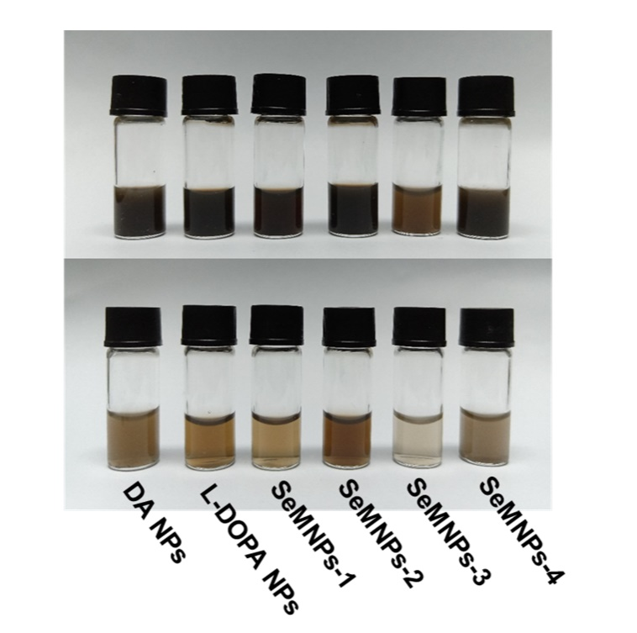
Figure S1. Images of SeMNPs and eumelanin NPs suspensions. 0.5 mg mL⁻¹ (top) and 0.1 mg mL⁻¹ (bottom).

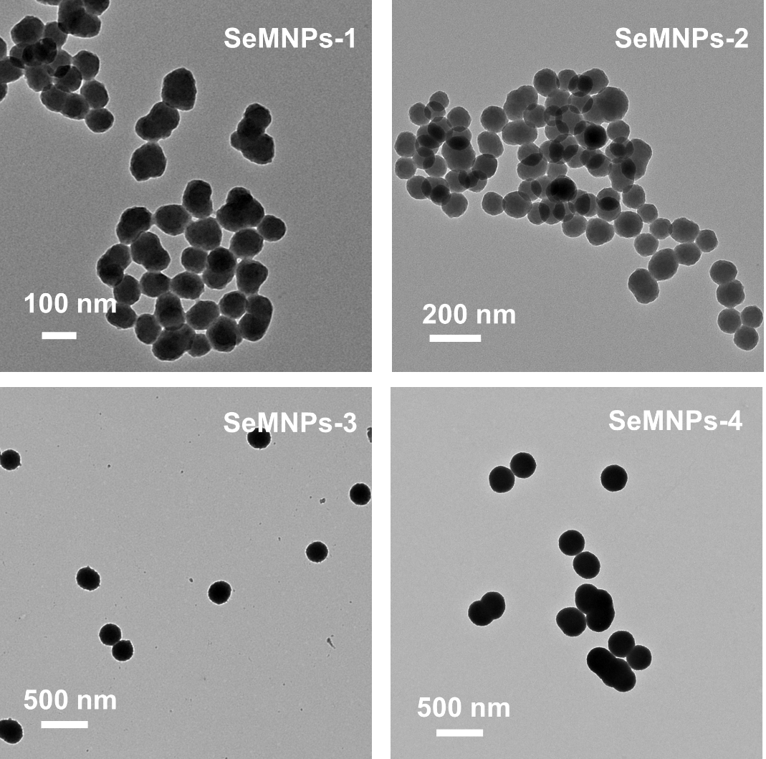
Figure S2. Representative TEM image of SeMNPs.

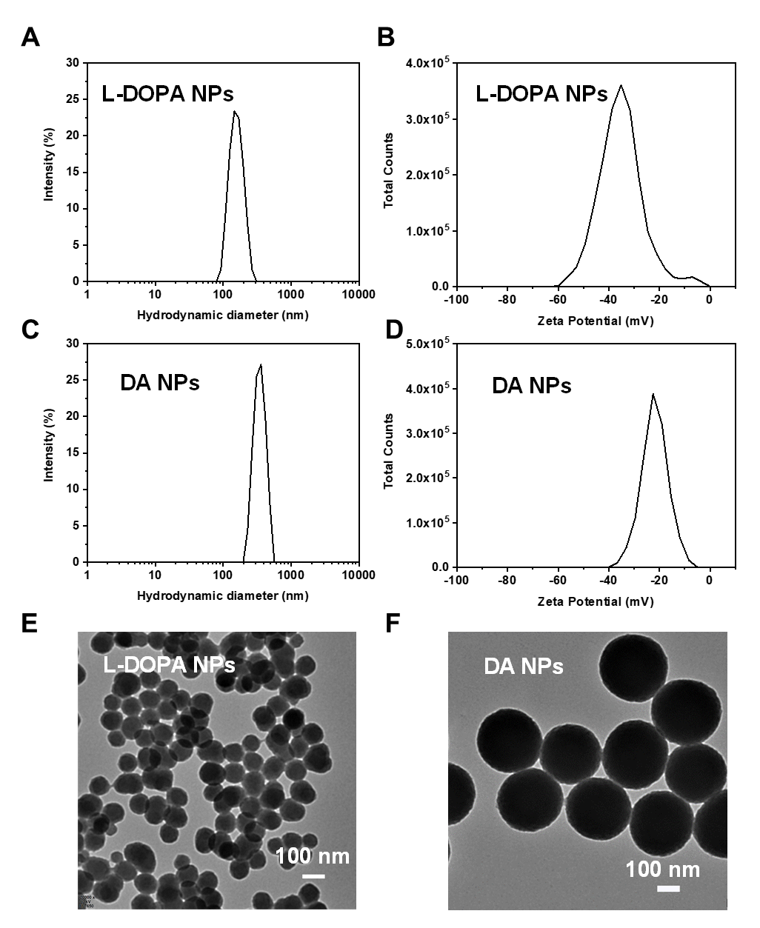
Figure S3. Characterization of synthetic eumelanin materials. DLS intensity plots of (A) L-DOPA NPs and (C) DA NPs. Zeta potential of (B) L-DOPA NPs and (D) DA NPs. TEM images of (E) L-DOPA NPs and (F) DA NPs.
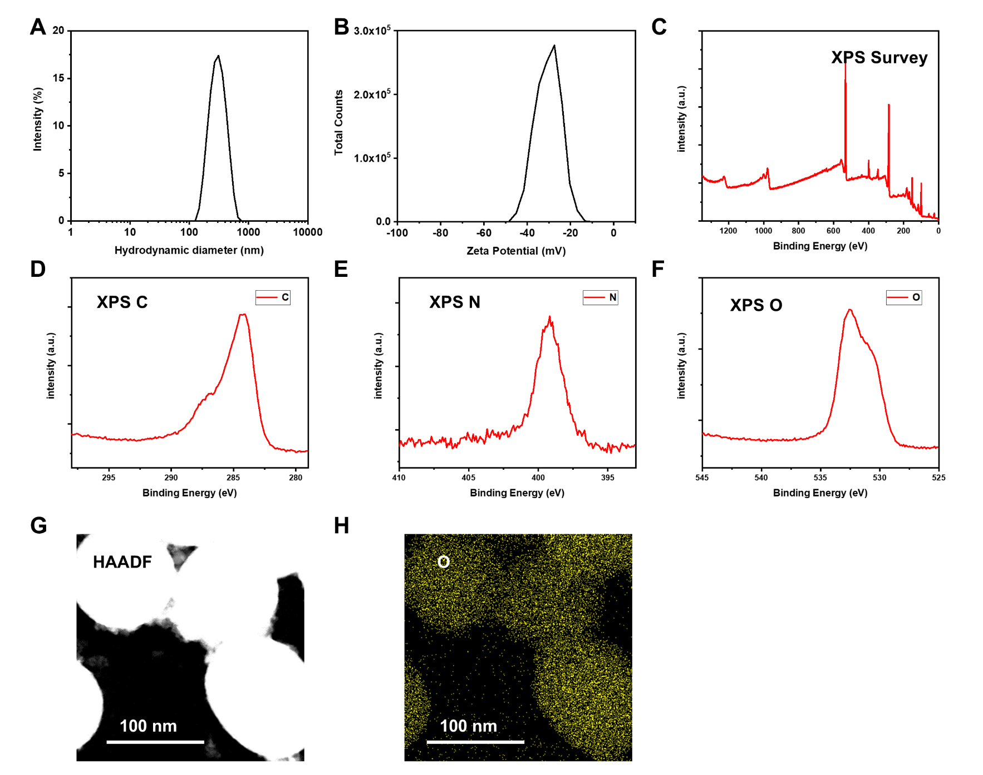
Figure S4. Characterization of SeMNPs-1. (A) DLS intensity plot. (B) Zeta potential. (C) XPS wide-scan survey spectrum. (D) C 1s spectrum. (E) N 1s spectrum. (F) O 1s spectrum. (G) High-angle annular dark-field imaging (HAADF) image. (H) Elemental mappings of O signals.

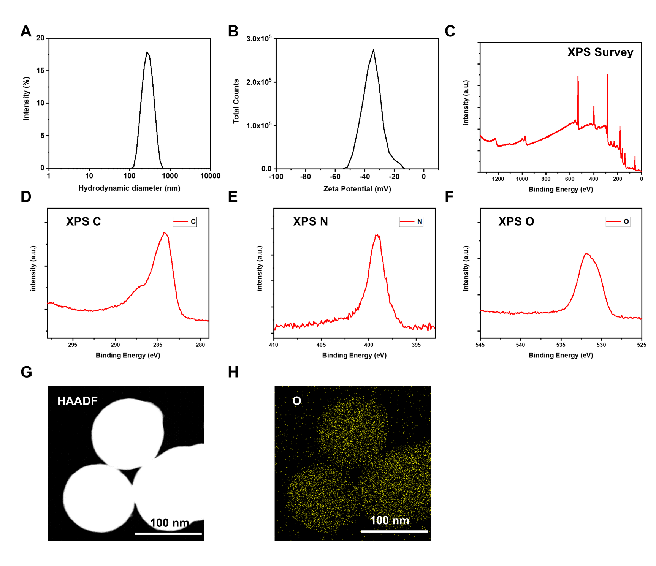
Figure S5. Characterization of SeMNPs-2. (A) DLS intensity plot. (B) Zeta potential. (C) XPS wide-scan survey spectrum. (D) C 1s spectrum. (E) N 1s spectrum. (F) O 1s spectrum. (G) HAADF image. (H) Elemental mappings of O signals.

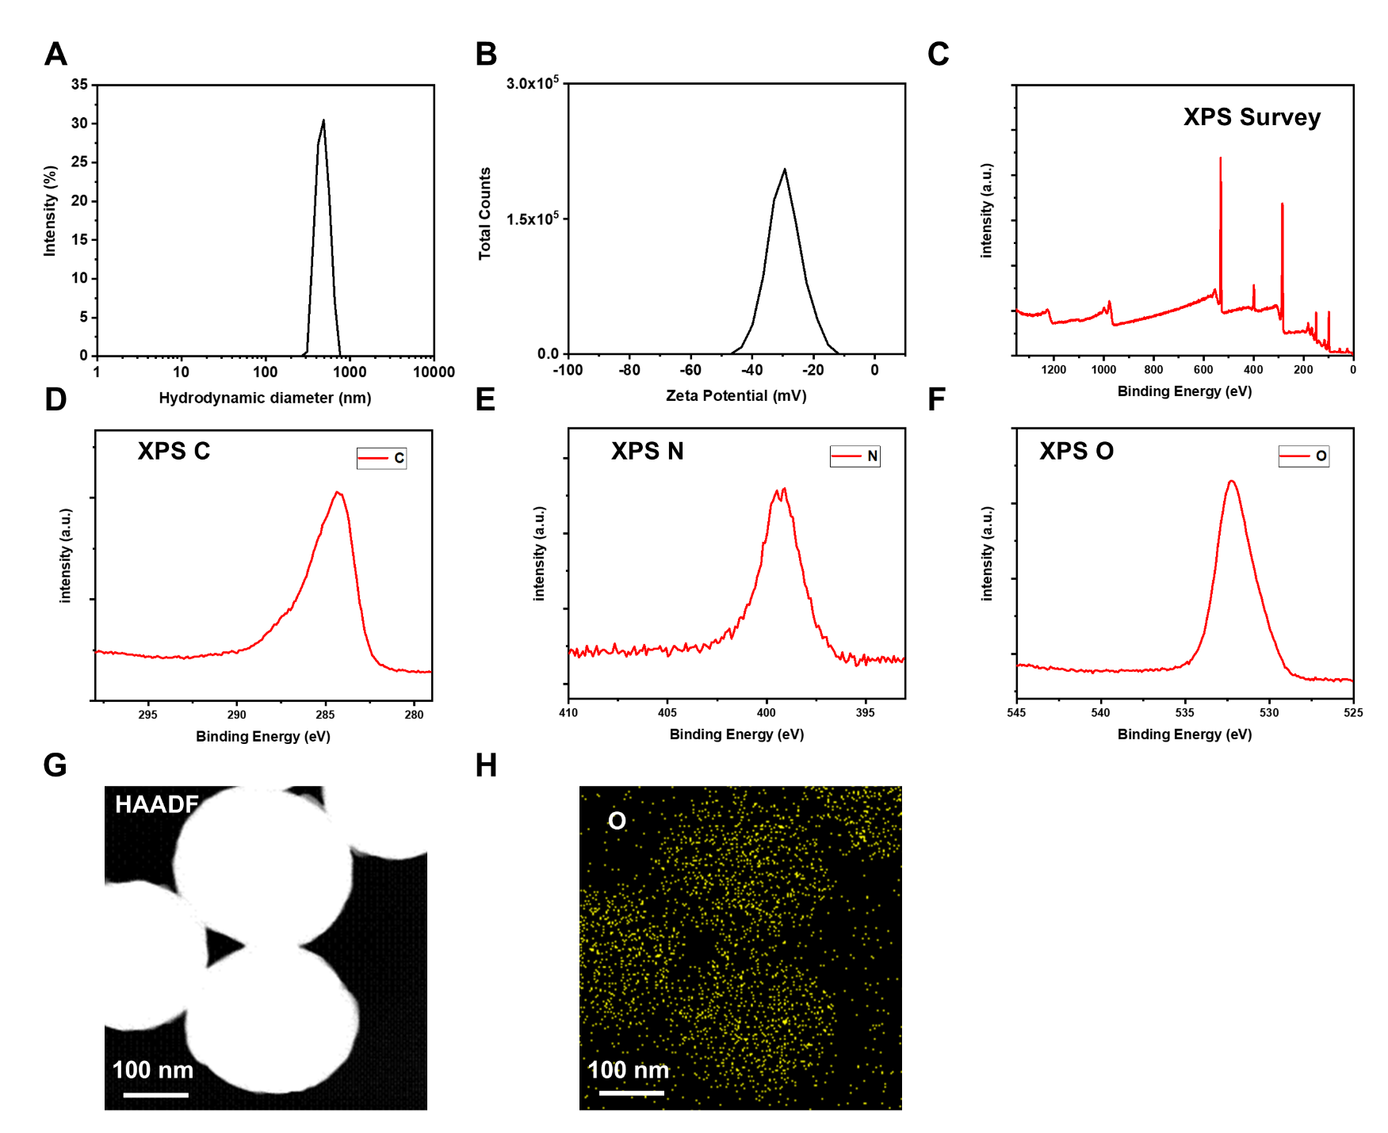
Figure S6. Characterization of SeMNPs-3. (A) DLS intensity plot. (B) Zeta potential. (C) XPS wide-scan survey spectrum. (D) C 1s spectrum. (E) N 1s spectrum. (F) O 1s spectrum. (G) HAADF image. (H) Elemental mappings of O signals.

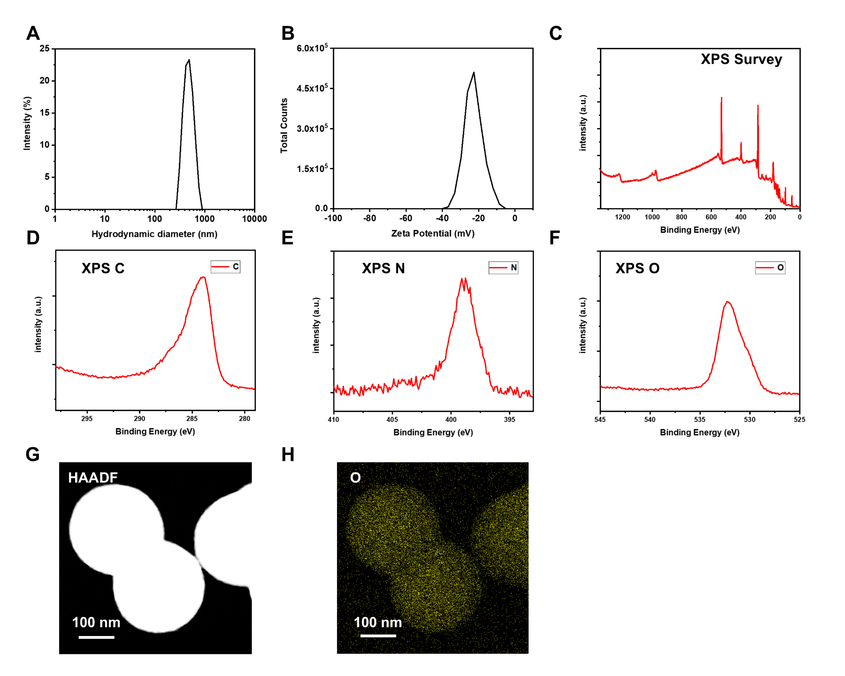
Figure S7. Characterization of SeMNPs-4. (A) DLS intensity plot. (B) Zeta potential. (C) XPS wide-scan survey spectrum. (D) C 1s spectrum. (E) N 1s spectrum. (F) O 1s spectrum. (G) HAADF image. (H) Elemental mappings of O signals.

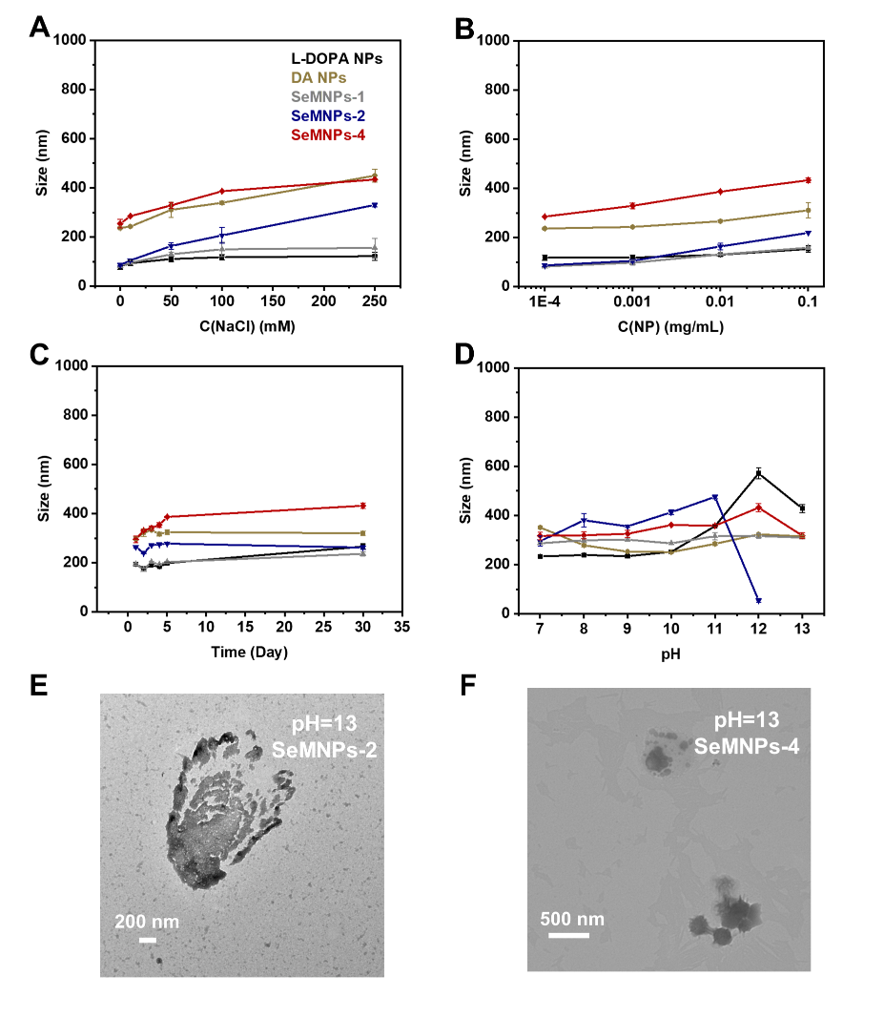
Figure S8. Stability of MNPs under various conditions was obtained by measuring the hydrodynamic diameter. (A) Changing ionic concentration (NaCl solution). (B) nanoparticles (NPs) dilution. (C) 30 days under ambient conditions. (D) Increasing pH. Samples were measured in triplicate, and error bars indicate standard deviation. (E-F) TEM images of SeMNPs-3 and -4 in pH=13 buffer, respectively. Interestingly, irregular aggregates were observed instead of spherical particles, suggesting that SeMNPs-2 and -4 were dissolved under alkaline conditions. A similar phenomenon was also observed for SeMNPs-1 and natural pheomelanin.^{1, 24}

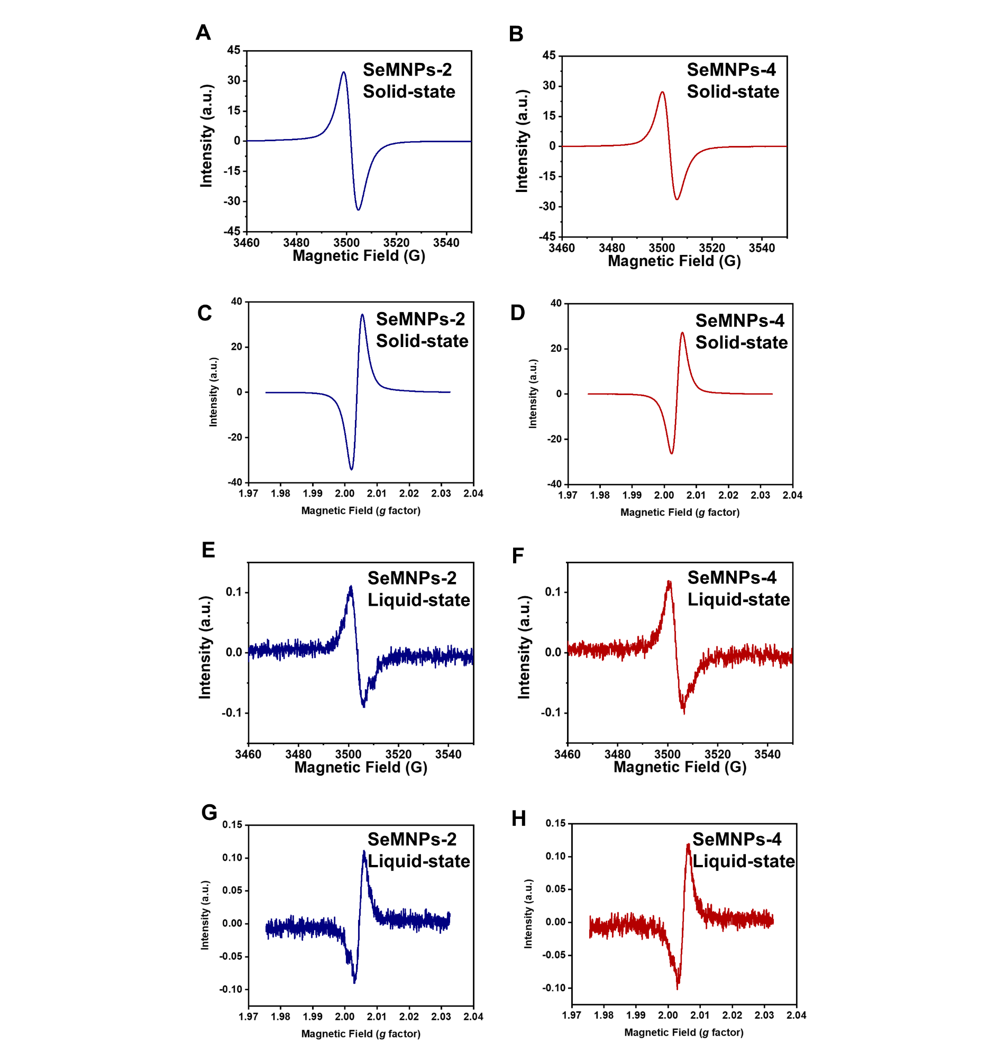
Figure S9. EPR spectra of SeMNPs. (A) and (C) EPR spectra in solid-state of SeMNPs-2. (B) and (D) EPR spectra in solid-state of SeMNPs-4. (E) and (G) EPR spectra in liquid-state of SeMNPs-2. (F) and (H) EPR spectra in liquid-state of SeMNPs-4.

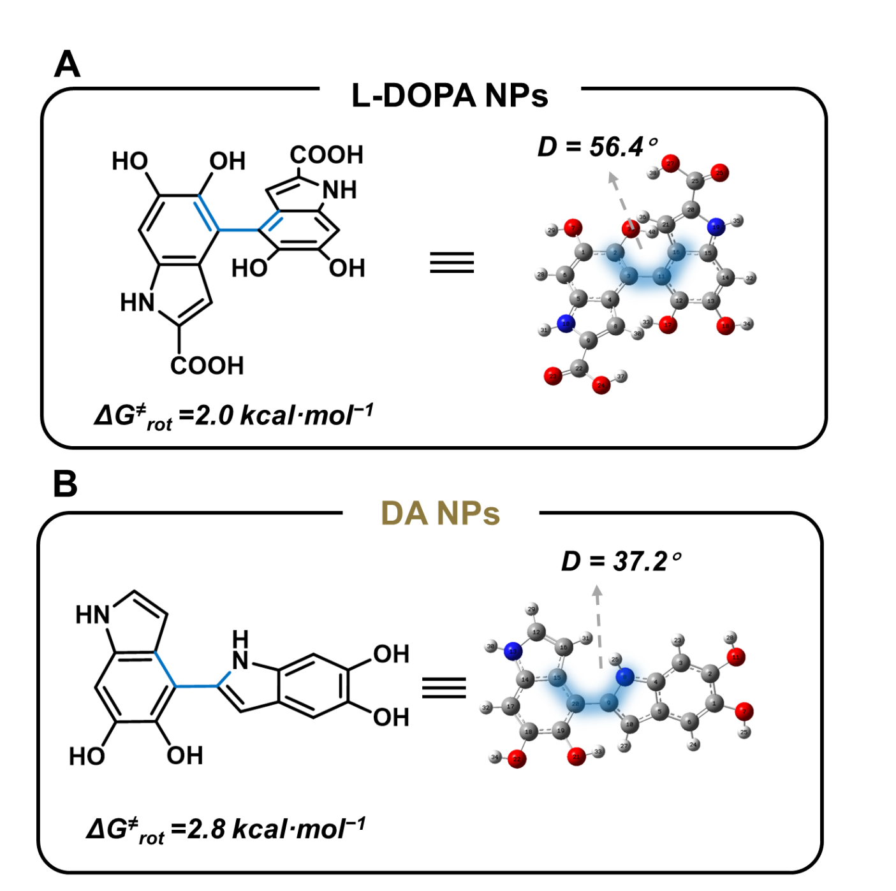
Figure S10. DFT calculations of rotational barrier (ΔG≠_{rot}) and dihedral angle (D) of eumelanin dimers.

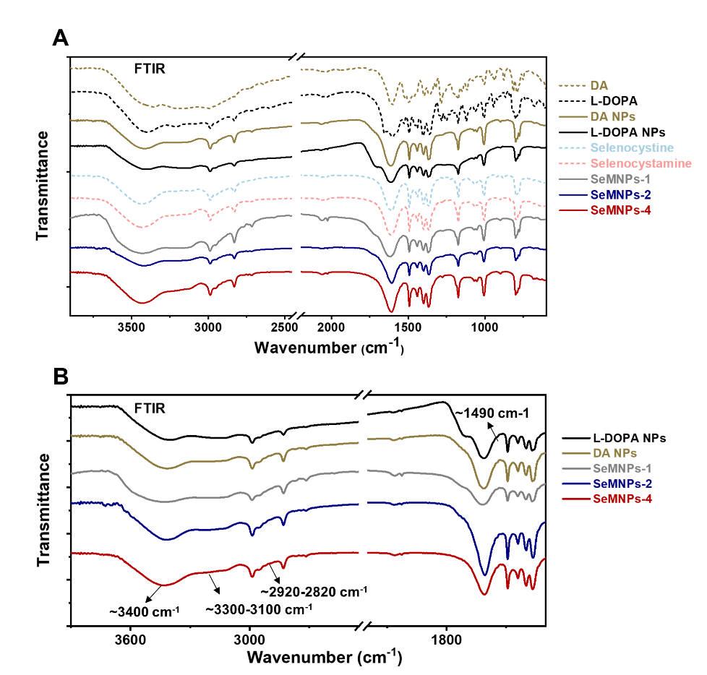
Figure S11. FTIR spectra of monomers, synthetic SeMNPs and eumelanin NPs. (A) Full spectra. (B) Zoomed spectra of synthetic SeMNPs and eumelanin NPs.

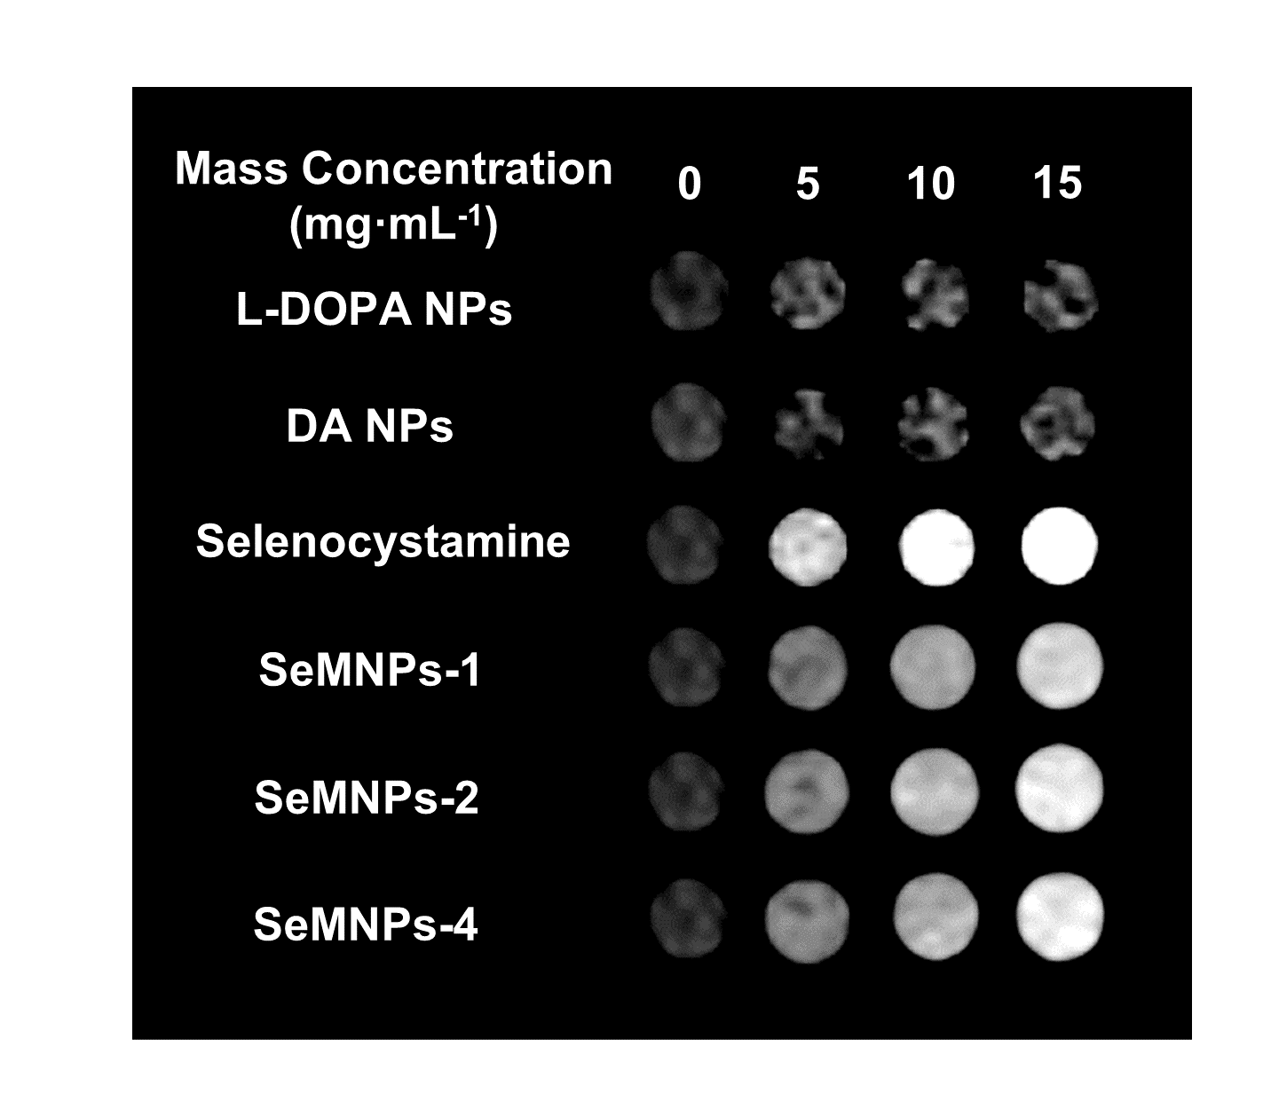
Figure S12. CT images of SeMNPs, eumelanin NPs and selenium-containing monomer with different mass concentrations at 80 kVp.

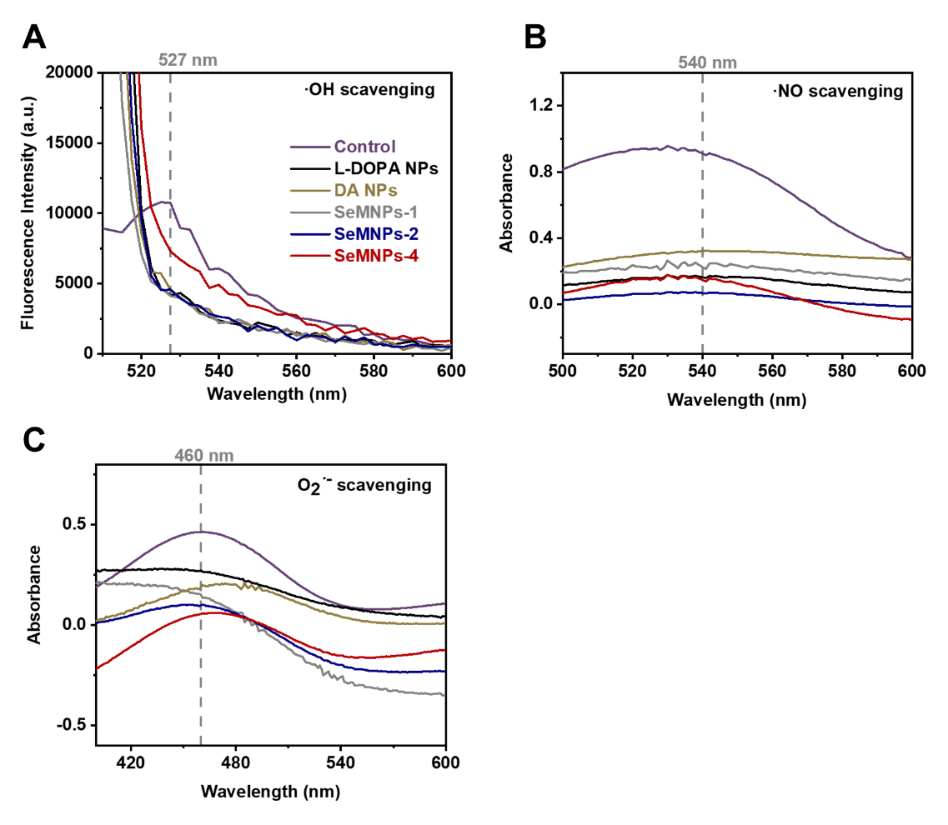
Figure S13. Fluorescence spectra or UV-Vis spectra of SeMNPs and eumelanin NPs reacted with (A) ·OH, (B) NO· and (C) O₂^{·-}, respectively.

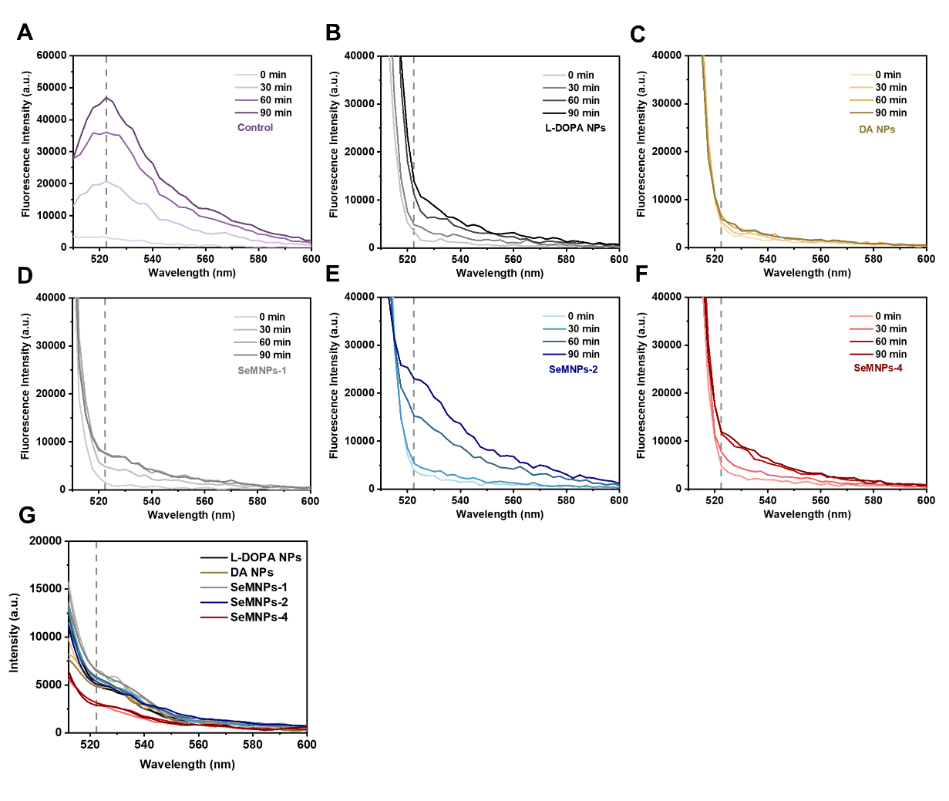
Figure S14. H₂O₂ scavenging performance of SeMNPs and eumelanin NPs. Fluorescence spectra at different times (0−90 min) of (A) Non-NP-treated control group, (B) L-DOPA NPs, (C) DA NPs, (D) SeMNPs-1, (E) SeMNPs-2 and (F) SeMNPs-4 reacted with H₂O₂, respectively. (G) Fluorescence spectra at different times (30−90 min) of H₂O₂ solution mixed with melanin without DCFH solution.

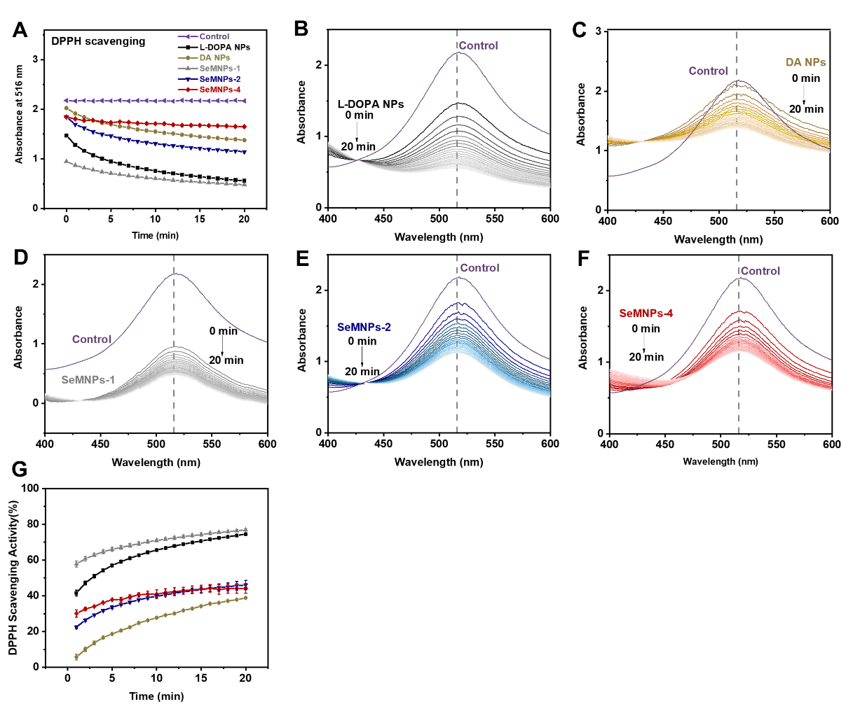
Figure S15. DPPH radical scavenging performance of SeMNPs and eumelanin NPs. (A) UV-Vis absorbance at 516 nm of SeMNPs and eumelanin NPs from 0 to 20 min. UV-Vis spectra at different times (0−20 min) of (B) L-DOPA NPs, (C) DA NPs, (D) SeMNPs-1, (E) SeMNPs-2 and (F)SeMNPs-4 reacted with DPPH, respectively. (G) DPPH scavenging activity of SeMNPs and eumelanin NPs from 0 to 20 min.

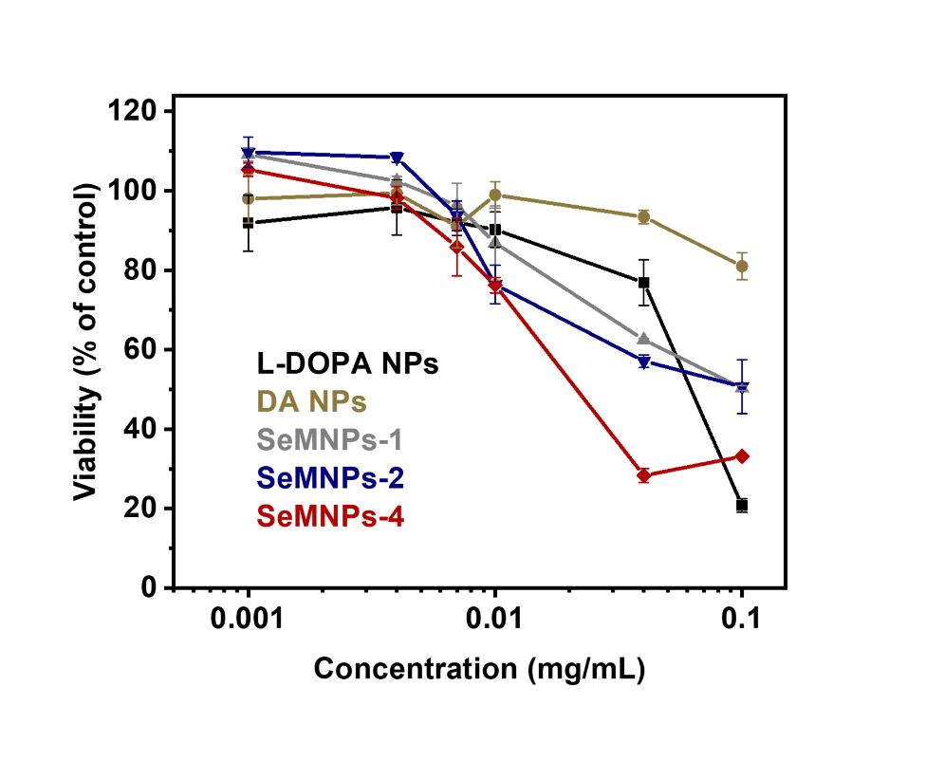
Figure S16. Cell viability of HaCaT cells after incubation with different concentrations of SeMNPs and eumelanin NPs for 24 h. Viability was determined using the CellTiter-Blue® assay. The fluorescent signal was then analyzed with excitation wavelength at 560 nm and emission wavelength at 600 nm by a plate reader. Error bars represent standard deviation from at less three experiments.

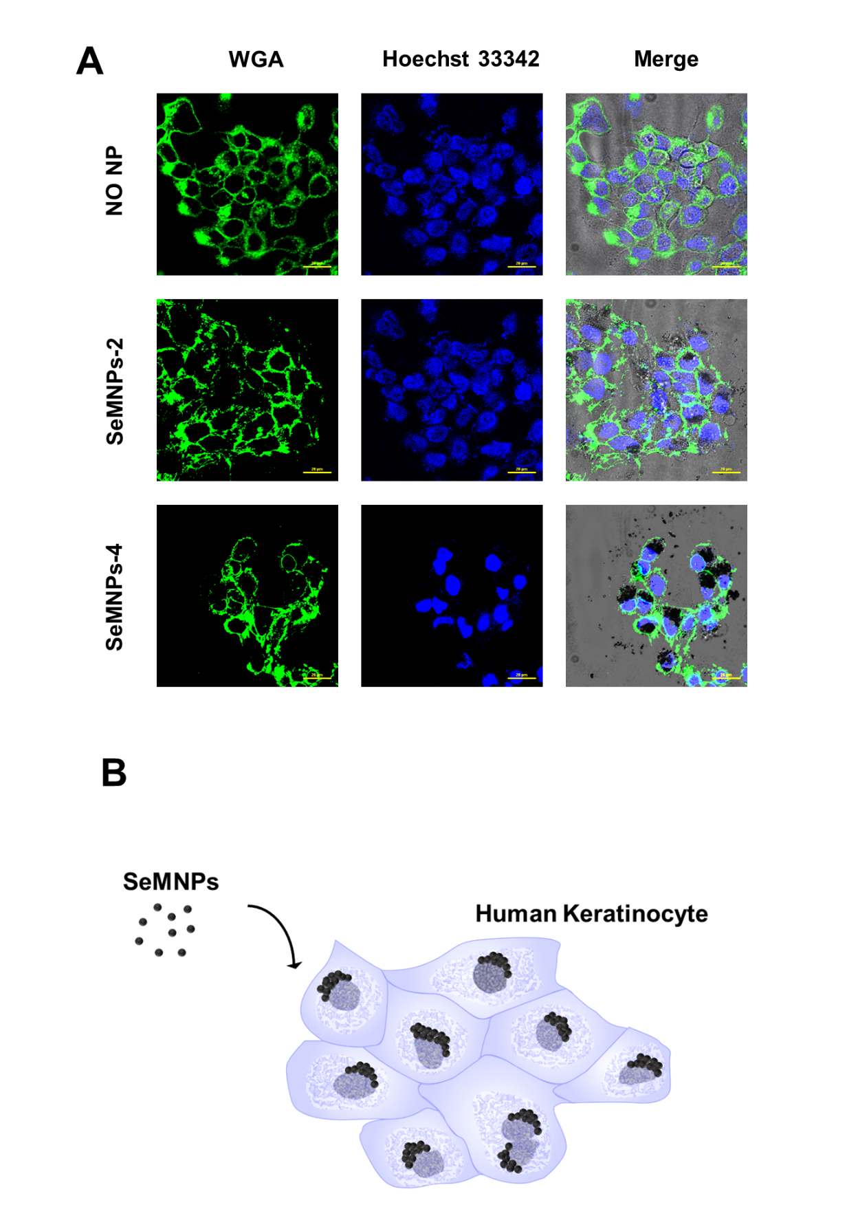
Figure S17. Intracellular distribution of SeMNPs in HaCaT cells. (A) CLSM images of HaCaT cells after 0.004 mg mL⁻¹ SeMNPs-2 and -4 treatment, or no-NP-treated control. Cell membrane stained with WGA conjugated to Alexa Fluor 488 (green) and cell nuclei stained with Hoechst 33342 (blue). Scale bar: 20 μm. (B) Schematic showing SeMNPs artificial perinuclear caps formation in HaCaT cells. Cell icon by DBCLS https://togotv.dbcls.jp/en/pics.html is licensed under CC-BY 4.0 Unported https://creativecommons.org/licenses/by/4.0/.
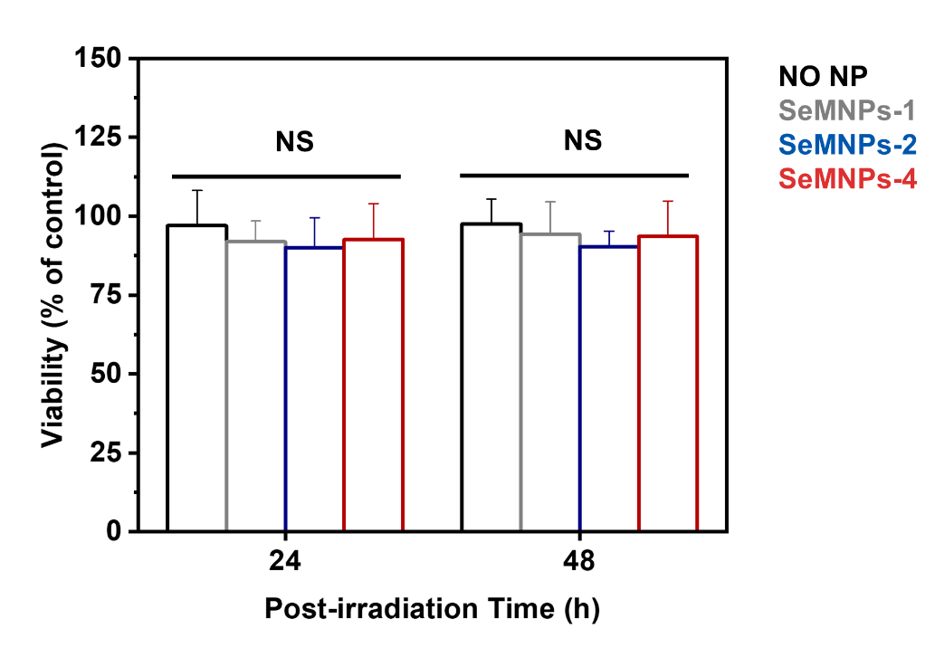
Figure S18. Survival fraction of HaCaT cells after γ-ray irradiation and SeMNPs treatment. NS means no statistical difference (P > 0.05), with reference to no-NP-treated at the same incubation time, determined by Student's two-tailed t test.

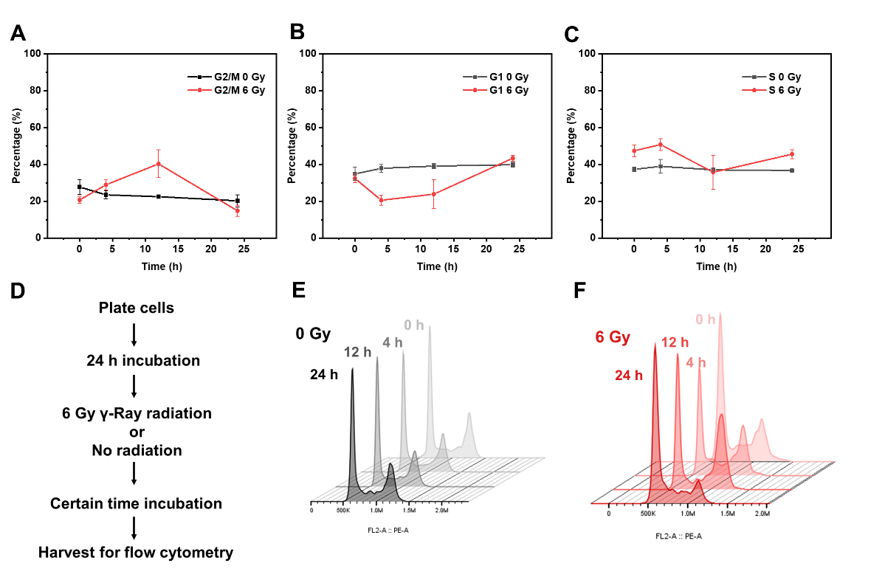
Figure S19. Cell cycle changes of HaCaT cells after 6 Gy γ-ray irradiation. The cell population percentage in different cell cycle phases, (A) G2/M, (B) G1, and (C) S were plotted against post-irradiation time. (D) Experimental timeline for this initial study. (E) Cell cycle distribution plots of 0 Gy irradiation. (F) Cell cycle distribution plots of 6 Gy irradiation.

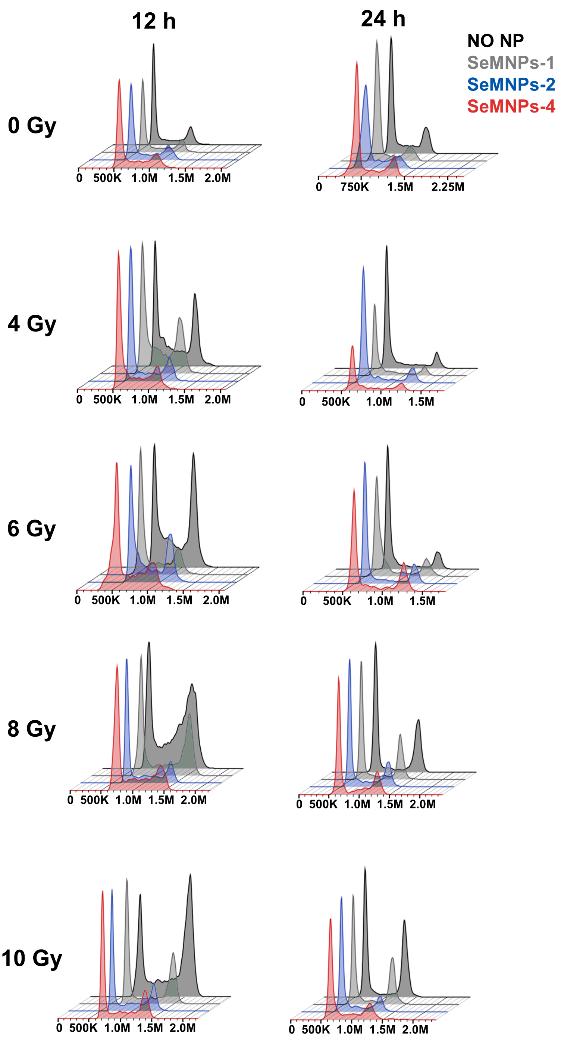
Figure S20. Cell cycle distribution plots at different doses (0 to 10 Gy) and different post-irradiation incubation time (12 h and 24 h). Histograms are stagger offset for better clarify and are representative of ≥ three experiments.
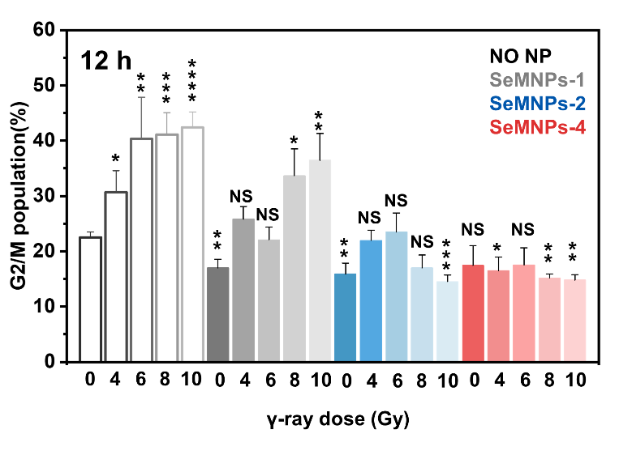
Figure S21. SeMNPs protect cells against cell cycle changes induced by γ-ray after 12 h post-irradiation incubation. Error bars represent standard deviation from ≥ three experiments. NS means no statistical difference (P > 0.05), *P < 0.05, **P < 10⁻², ***P < 10⁻³, ****P < 10⁻⁴, with reference to no-NP-treated and non-irradiated control, determined by Student's two-tailed t test.
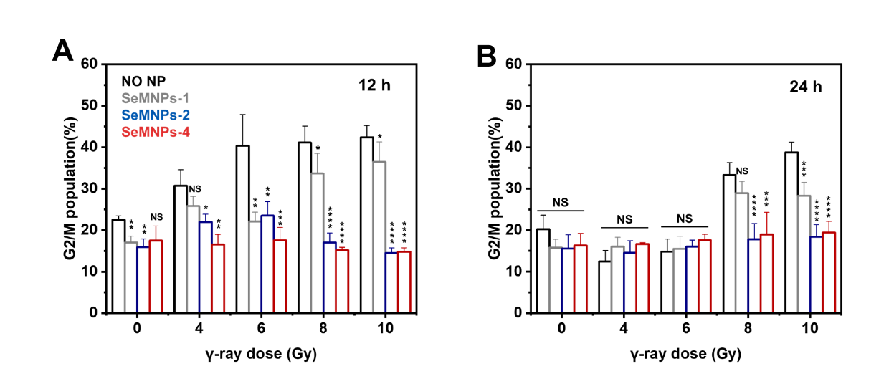
Figure S22. SeMNPs protect cells against cell cycle changes induced by γ-ray after (A) 12 h and (B) 24 h post-irradiation. Error bars represent standard deviation from ≥ three experiments. NS means no statistical difference (P > 0.05), *P < 0.05, **P < 10⁻², ***P < 10⁻³, ****P < 10⁻⁴, with reference to no-NP-treated at same γ-ray dose, determined by Student's two-tailed t test.

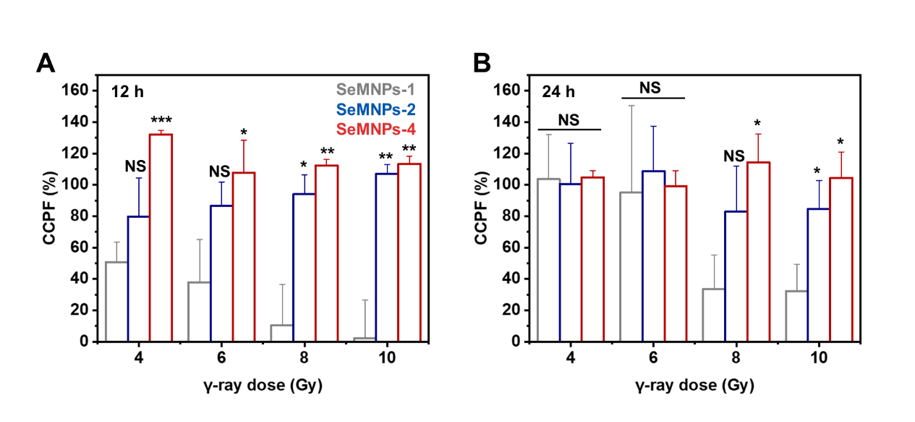
Figure S23. Cell cycle protection factor (CCPF) of (A) 12 h post-irradiation and (B) 24 h post-irradiation. Cell cycle protection factor was calculated as
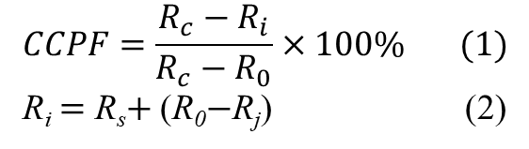
In equation (1), R_{c} is the G2/M phase population treated with γ-ray without SeMNPs, R_{i} is the G2/M phase population treated with γ-ray and SeMNPs after correction, R₀ is the G2/M phase population without γ-ray and SeMNPs treatment.
To compensate the fluorescence quenching caused by SeMNPs, Equation (2) is utilized to rectify the experimental R_{s} value, correcting the decrement attributed to the presence of SeMNPs in non-irradiated control groups. R_{s} is the G2/M phase population treated with γ-ray and SeMNPs, R_{j} is the G2/M phase population treated with SeMNPs without γ-ray.
Error bars represent standard deviation from ≥ three experiments. NS means no statistical difference (P > 0.05), *P < 0.05, **P < 10⁻², ***P < 10⁻³, with reference to SeMNPs-1 group at same γ-ray dose, determined by Student's two-tailed t test.

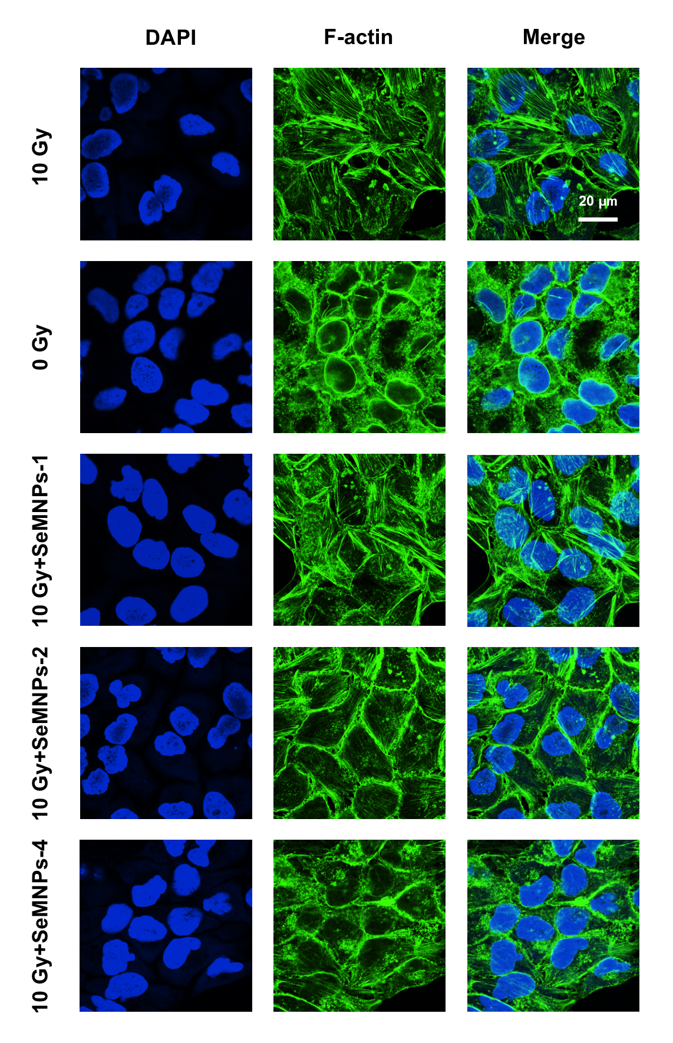
Figure S24. CLSM images of live cells treated with 10 Gy irradiation and 0.004 mg mL⁻¹ SeMNPs, showing Actin-Tracker Red-594 F-actin-positive signal (pseudo-color: green). Cell nuclei were stained with DAPI (blue). F-actin probe scan excitation wavelength: 561 nm. Detection wavelength: 570-625 nm. DAPI scan excitation wavelength: 405 nm. Detection wavelength: 420 --480 nm.

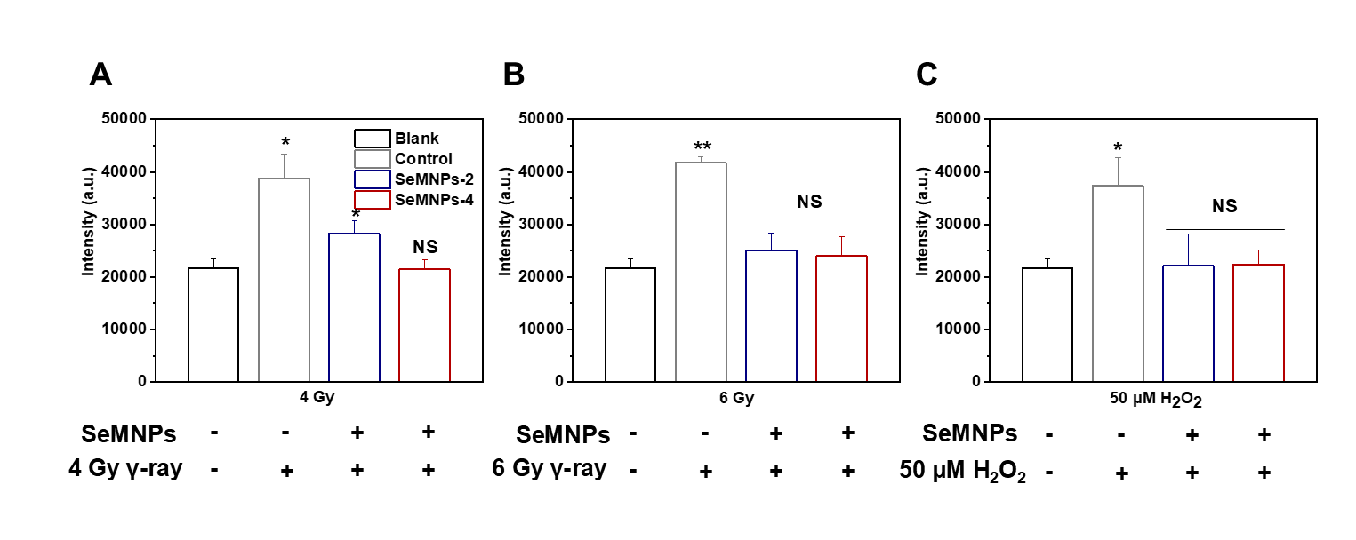
Figure S25. ROS scavenging activity of SeMNPs under different conditions. (A) 4 Gy γ-ray irradiation, (B) 6 Gy γ-ray irradiation, (C)50 μM H₂O₂. The fluorescence intensity of cells was monitored by a plate reader with excitation wavelength at 488 nm and emission wavelength at 525 nm. Error bars represent standard deviation from ≥ three experiments. NS means no statistical difference (P > 0.05), *P < 0.05, **P < 10⁻², with reference to no-NP-treated and non-irradiated control, determined by Student's two-tailed t test.

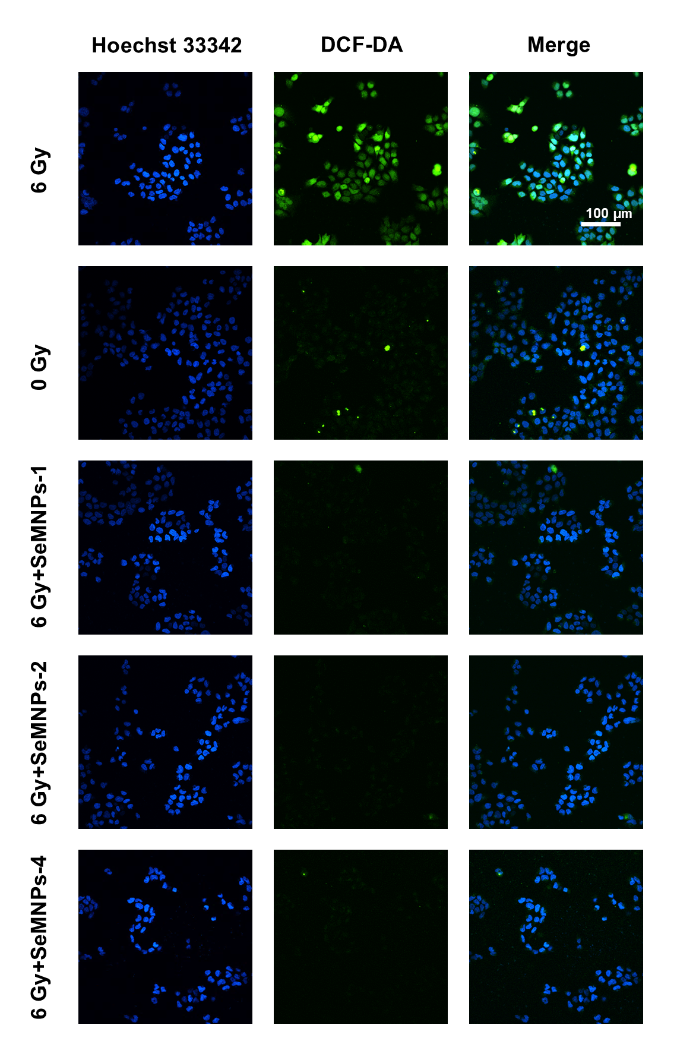
Figure S26. CLSM images of live cells treated with 6 Gy irradiation and 0.004 mg mL⁻¹ SeMNPs. DCF-DA ROS-positive signal (green). Cell nuclei were stained with Hoechst 33342 (blue). ROS probe scan excitation wavelength: 486 nm. Detection Wavelength: 510-550 nm. Hoechst 33342 scan excitation wavelength: 405 nm. Detection Wavelength: 420-480 nm.

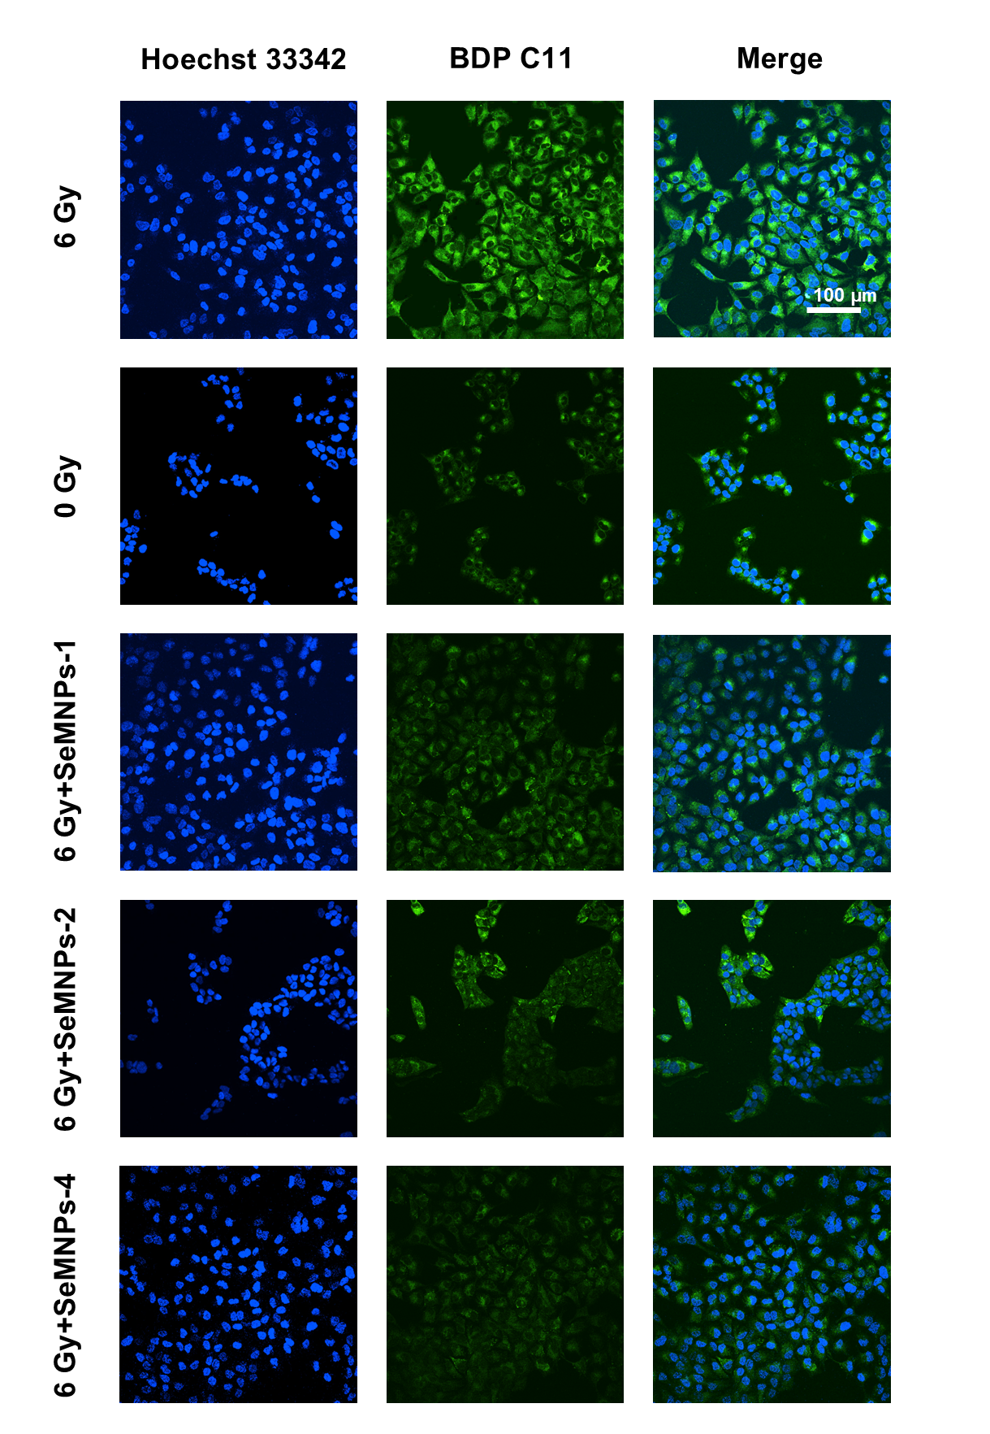
Figure S27. CLSM images of live cells treated with 6 Gy irradiation and 0.004 mg mL⁻¹ SeMNPs. BDP C11 lipid peroxidation-positive signal (green). Cell nuclei were stained with Hoechst 33342 (blue). Lipid peroxidation probe scan excitation wavelength: 488 nm. Detection Wavelength: 510-550 nm. Hoechst 33342 scan excitation wavelength: 405 nm. Detection Wavelength: 420-480 nm.

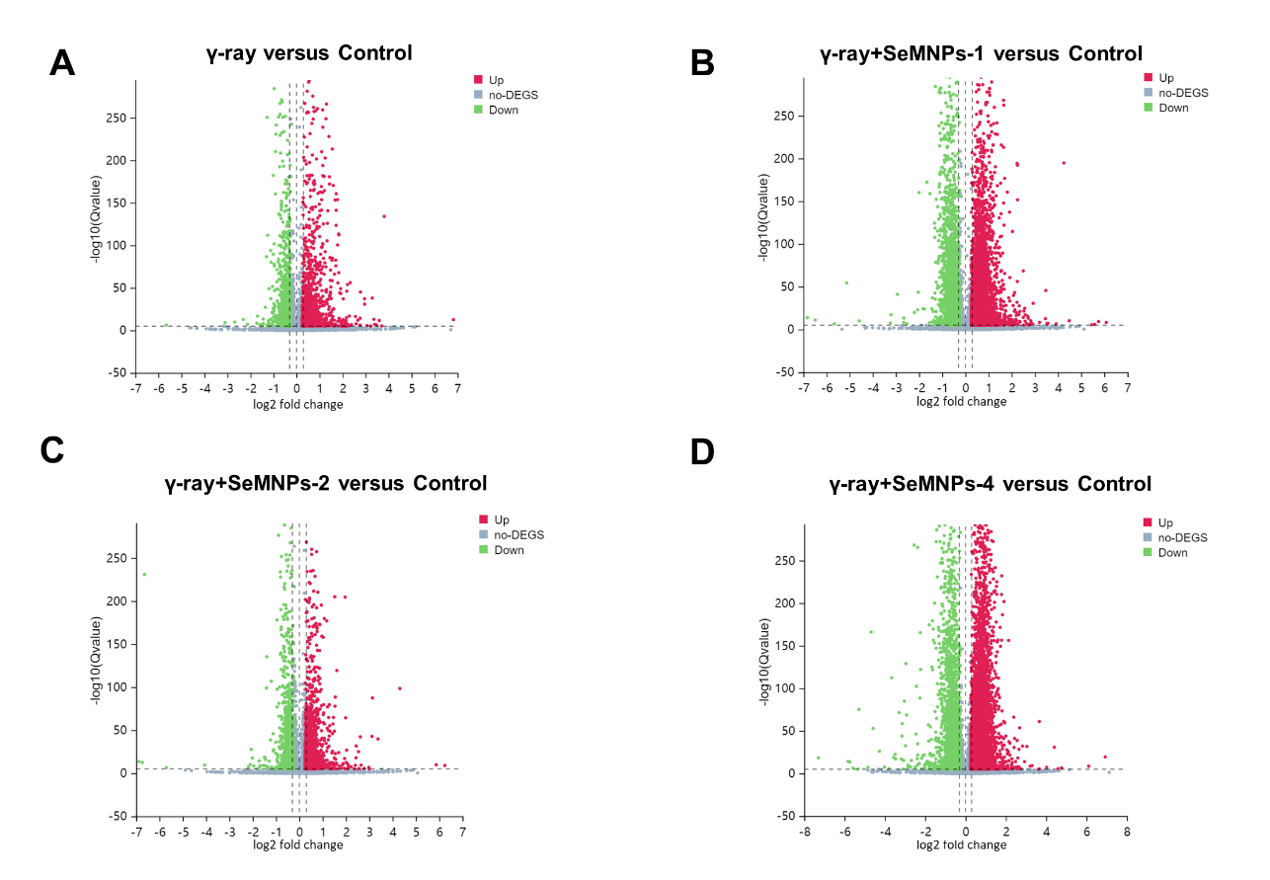
Figure S28. Volcano plots of differentially expressed genes (DEGs). Volcano plots of DEG for (A) γ-ray versus Control, (B) γ-ray+SeMNPs-1 versus Control, (C) γ-ray+SeMNPs-2 versus Control and (D) γ-ray+SeMNPs-4 versus Control. Differentially expressed genes are defined with |log2FC| ≥ 0.25 and Q value ≤ 10⁻⁴. Data are from three independent experiments.

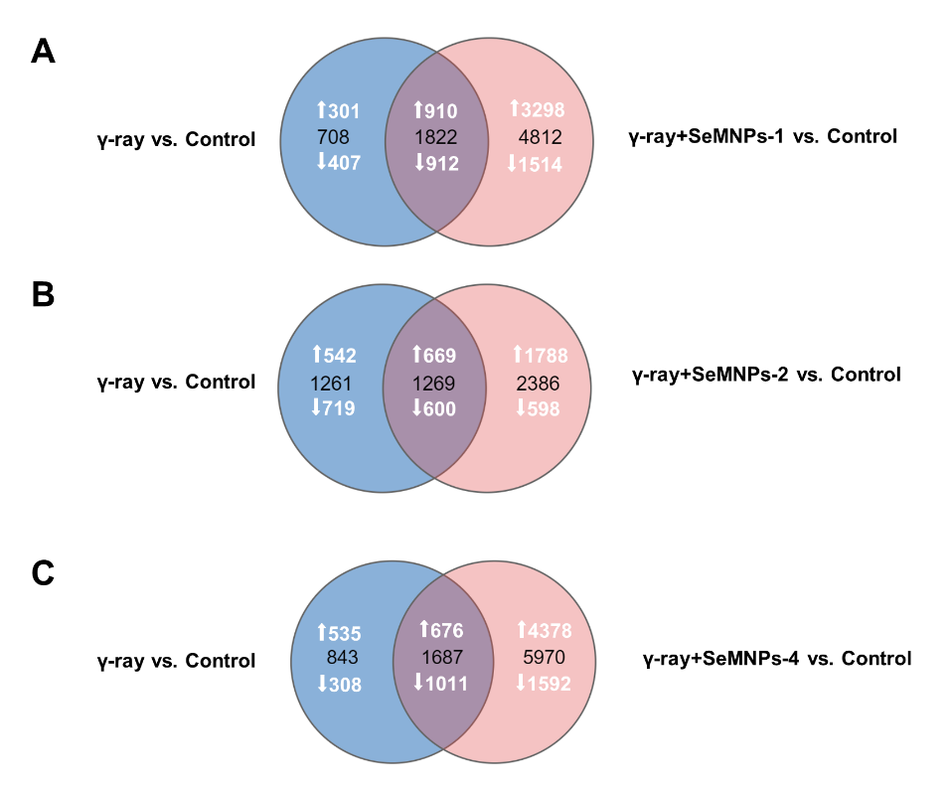
Figure S29. Venn diagrams created from mRNA sequencing data. (A) γ-ray versus Control∩γ-ray+SeMNPs-1 versus Control. (B) γ-ray versus Control∩γ-ray+SeMNPs-2 versus Control versus Ctrl. (C) γ-ray versus Control∩γ-ray+SeMNPs-4 versus Control. Differentially expressed genes are satisfying with |log2FC| ≥ 0.25 and Q value ≤ 10⁻⁴. Data are from three independent experiments.

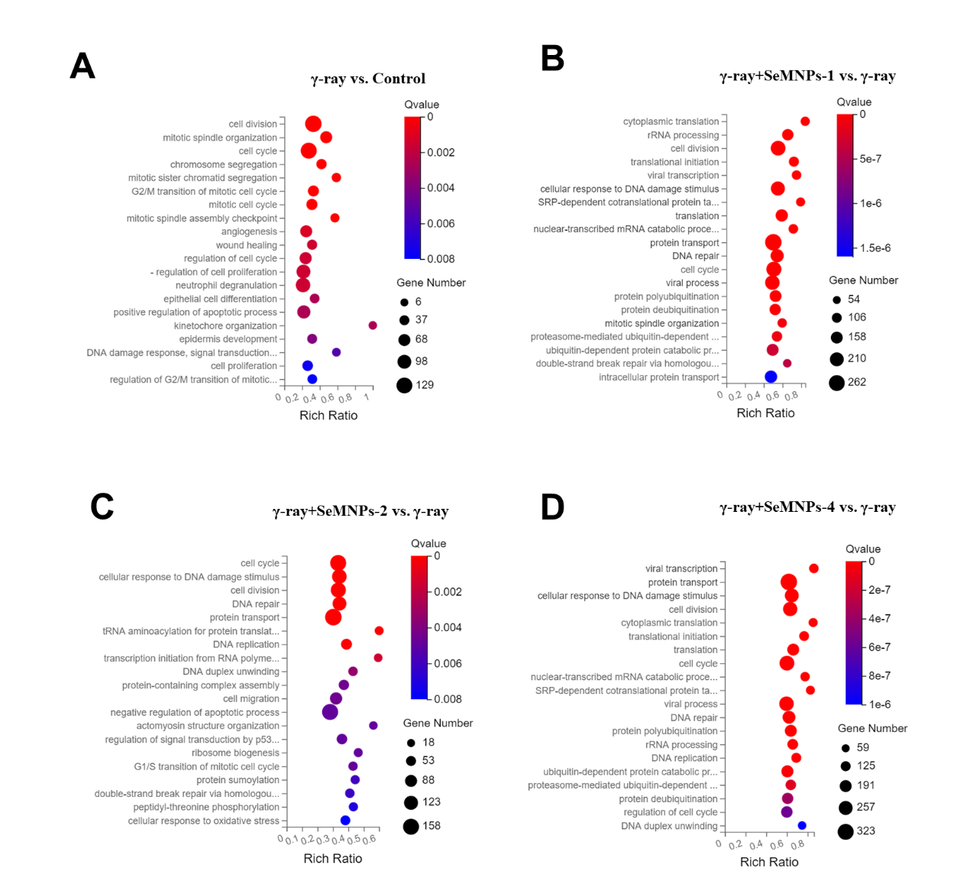
Figure S30. Go biological process (BP) enrichment bubble charts of DEGs. (A) γ-ray vs. Control. (B) γ-ray+SeMNPs-1 vs. γ-ray. (C) γ-ray+SeMNPs-2 vs. γ-ray. (D) γ-ray+SeMNPs-4 vs. γ-ray. Enrichment analyses were performed using the phyper function in the R software based on the GO BP annotation classification, calculating P value, and then applying a false discovery rate (FDR) correction to P value to obtain Q value, which is usually considered to be significantly enriched as a function of Q value ≤ 0.05.

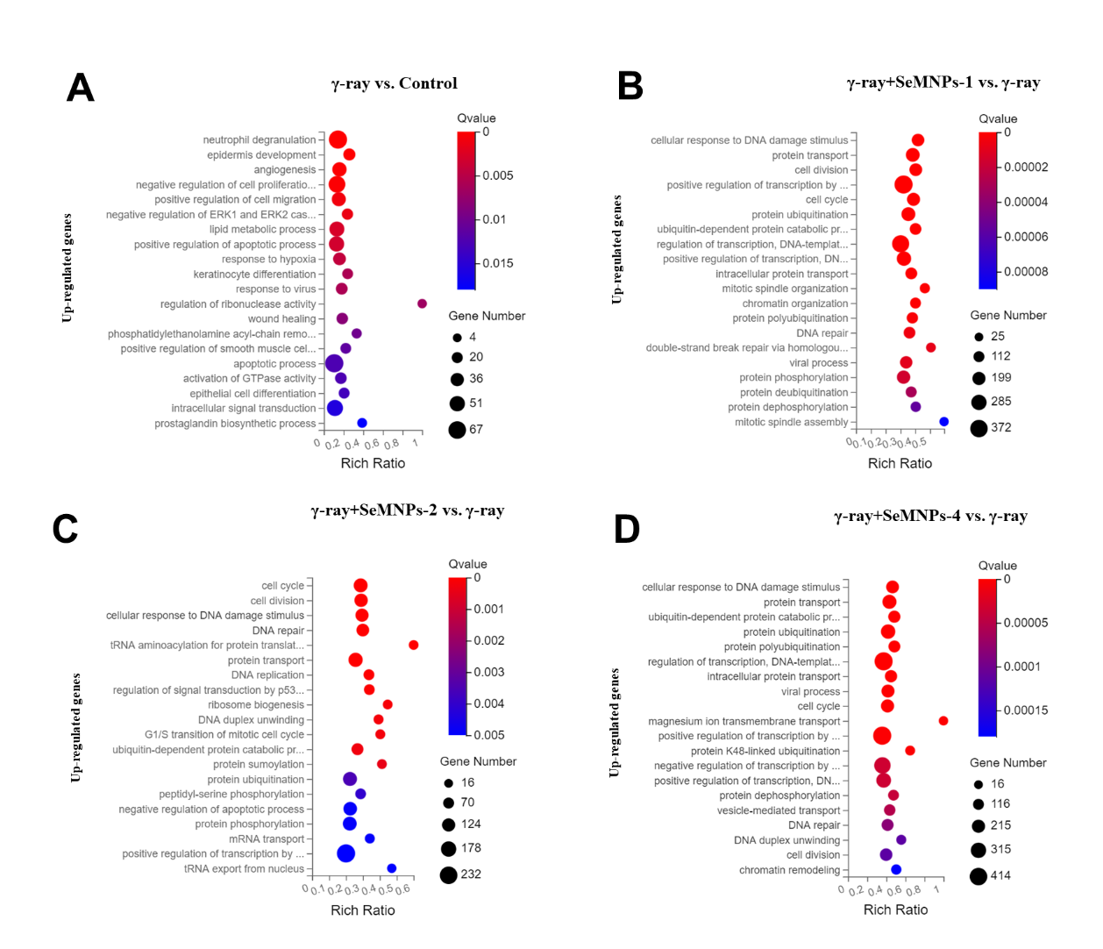
Figure S31. Go biological process (BP) enrichment bubble charts of up-regulated genes. (A) γ-ray vs. Control. (B) γ-ray+SeMNPs-1 vs. γ-ray. (C) γ-ray+SeMNPs-2 vs. γ-ray. (D) γ-ray+SeMNPs-4 vs. γ-ray. Enrichment analyses were performed using the phyper function in the R software based on the GO BP annotation classification, calculating P value, and then applying a false discovery rate (FDR) correction to P value to obtain Q value, which is usually considered to be significantly enriched as a function of Q value ≤ 0.05.

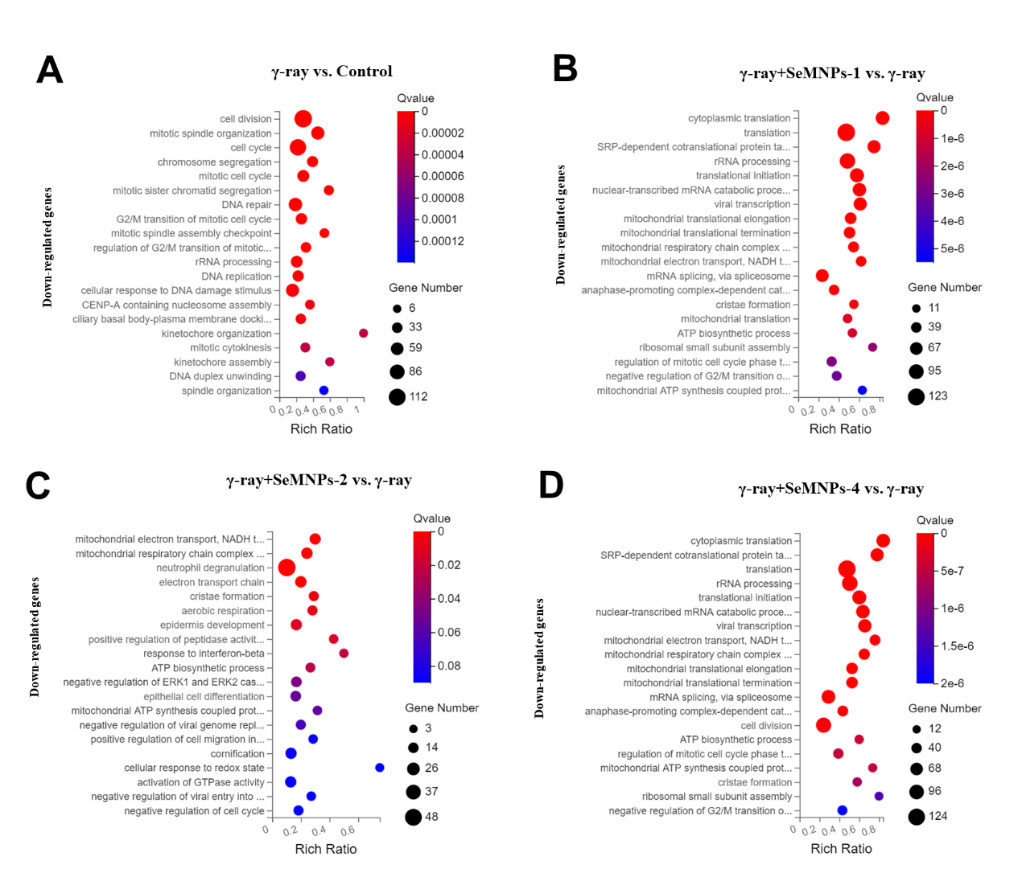
Figure S32. Go biological process (BP) enrichment bubble charts of down-regulated genes. (A) γ-ray vs. Control. (B) γ-ray+SeMNPs-1 vs. γ-ray. (C) γ-ray+SeMNPs-2 vs. γ-ray. (D) γ-ray+SeMNPs-4 vs. γ-ray. Enrichment analyses were performed using the phyper function in the R software based on the GO BP annotation classification, calculating P value, and then applying a false discovery rate (FDR) correction to P value to obtain Q value, which is usually considered to be significantly enriched as a function of Q value ≤ 0.05.

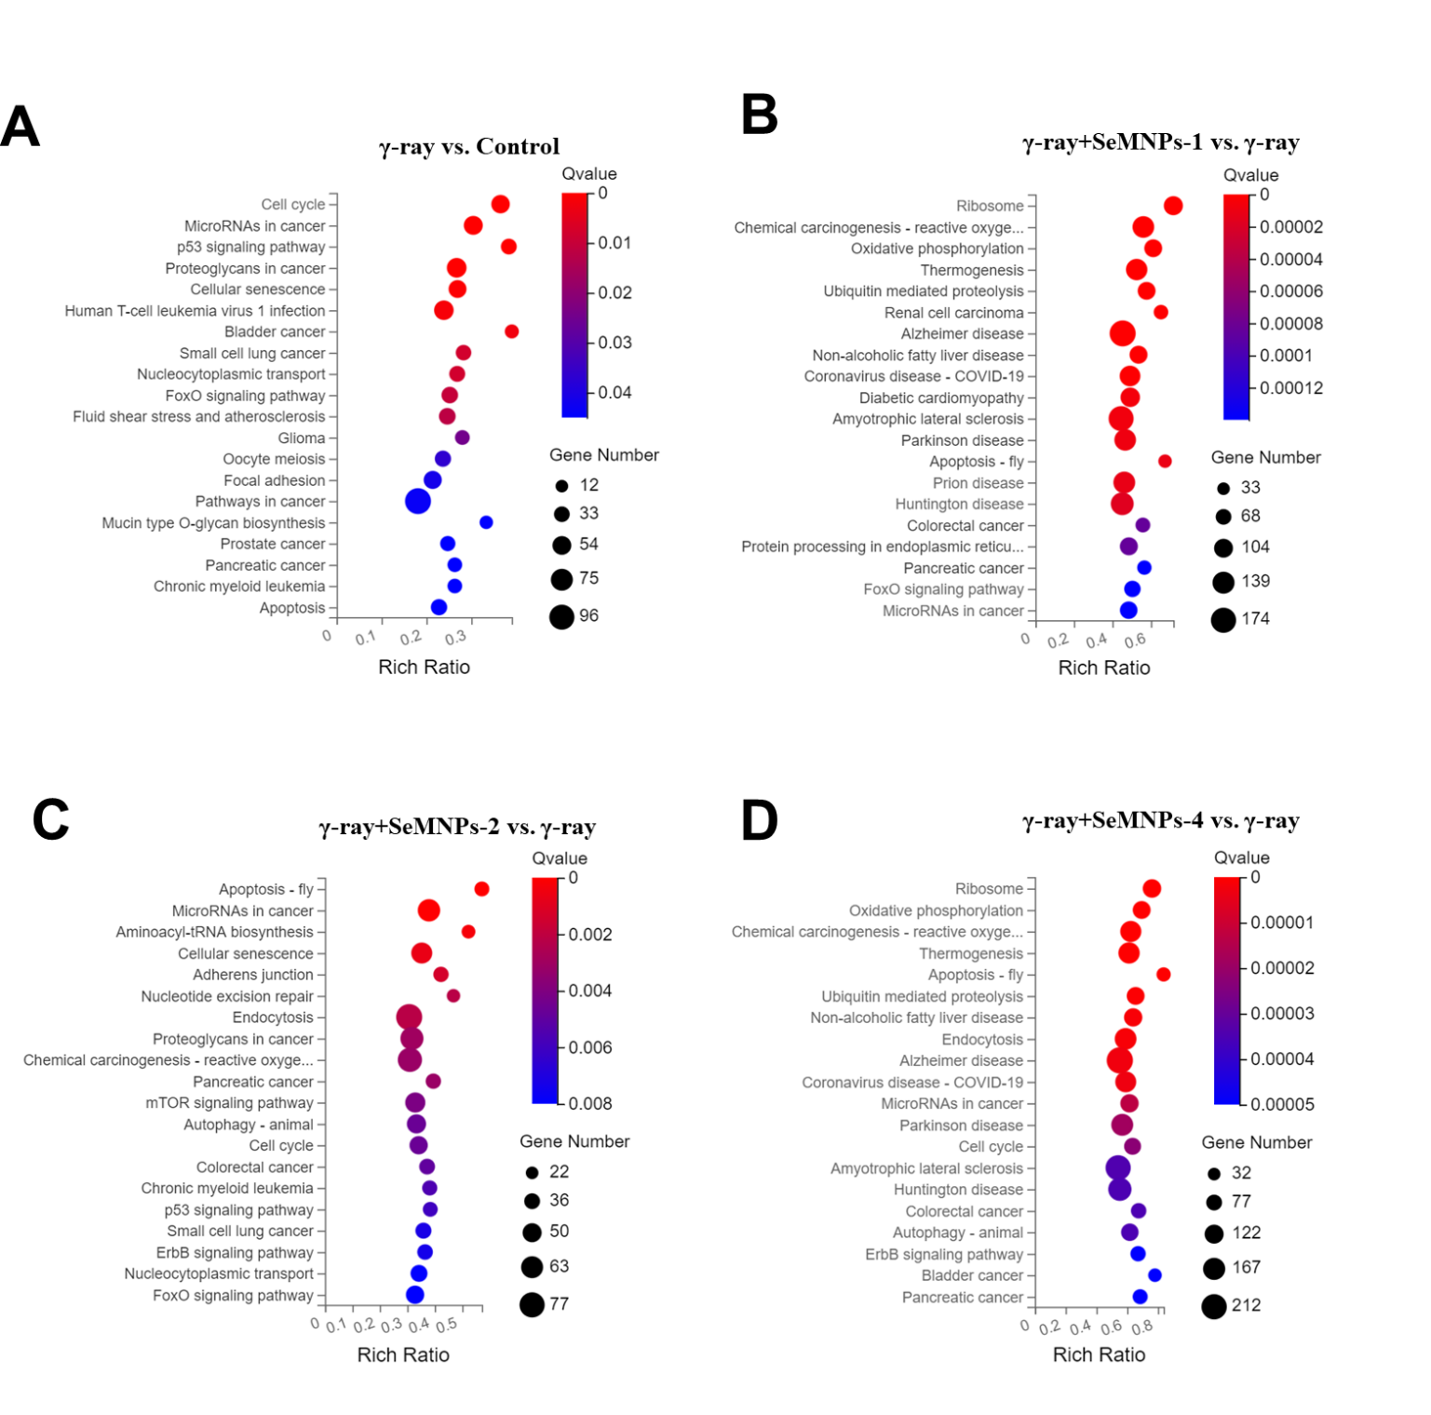
Figure S33. KEGG pathway enrichment bubble charts of DEGs. (A) γ-ray vs. Control. (B) γ-ray+SeMNPs-1 vs. γ-ray. (C) γ-ray+SeMNPs-2 vs. γ-ray. (D) γ-ray+SeMNPs-4 vs. γ-ray. Functional classification of differential genes was performed according to KEGG Pathway annotation classification, calculating P value, and then applying an FDR correction to P value to obtain Q value, which is usually considered to be significantly enriched as a function of Q value ≤ 0.05.

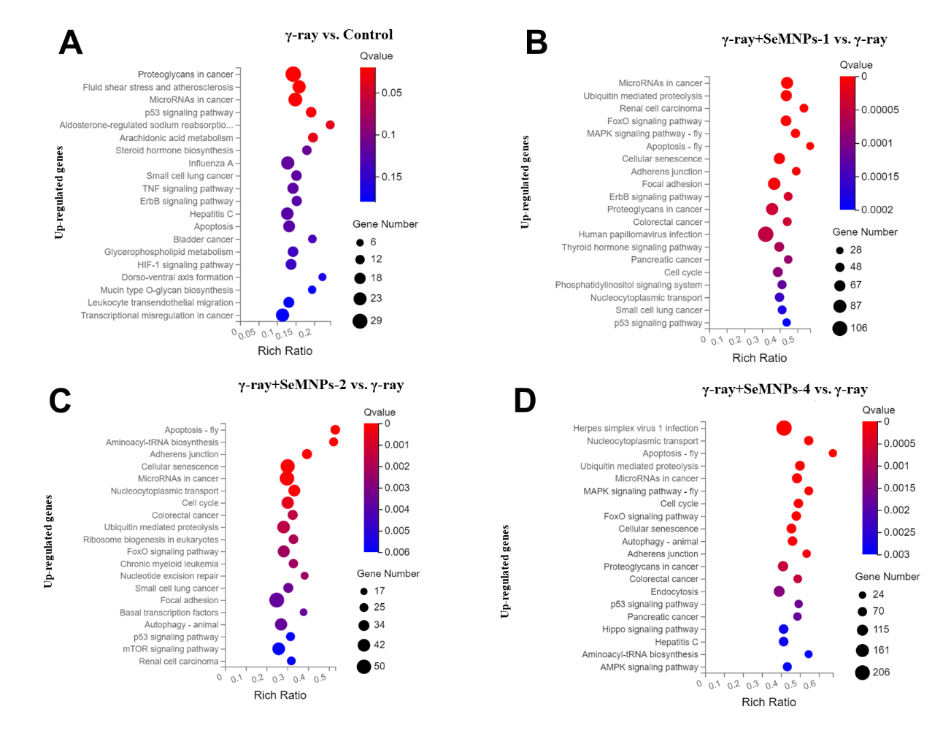
Figure S34. KEGG pathway enrichment bubble charts of up-regulated genes. (A) γ-ray vs. Control. (B) γ-ray+SeMNPs-1 vs. γ-ray. (C) γ-ray+SeMNPs-2 vs. γ-ray. (D) γ-ray+SeMNPs-4 versus γ-ray. Functional classification of differential genes was performed according to KEGG Pathway annotation classification, calculating P value, and then applying an FDR correction to P value to obtain Q value, which is usually considered to be significantly enriched as a function of Q value ≤ 0.05.

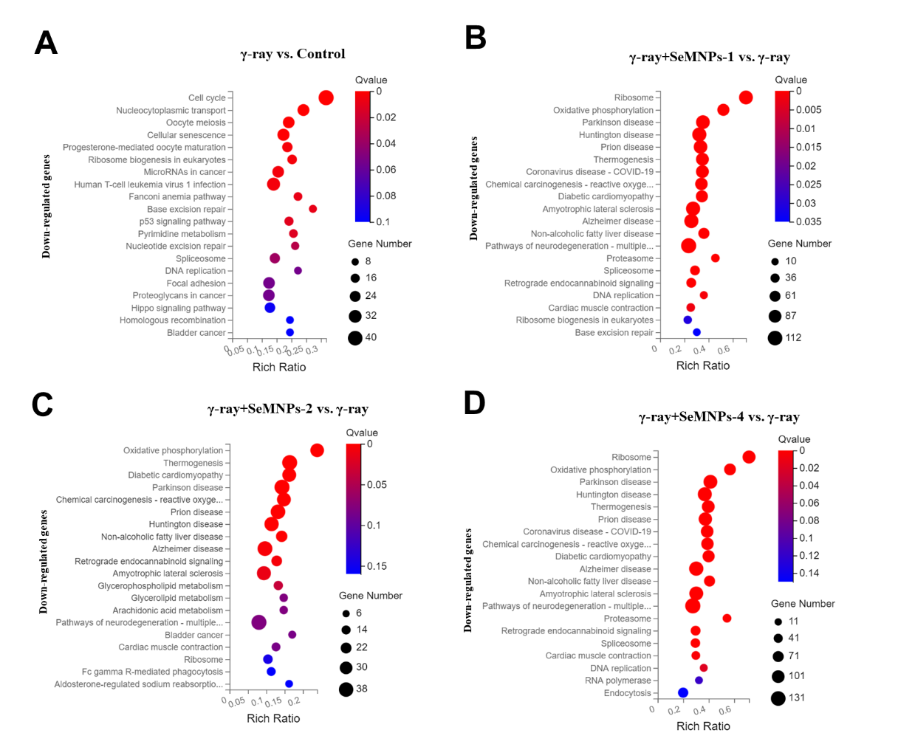
Figure S35. KEGG pathway enrichment bubble charts of down-regulated genes. (A) γ-ray vs. Control. (B) γ-ray+SeMNPs-1 vs. γ-ray. (C) γ-ray+SeMNPs-2 vs. γ-ray. (D) γ-ray+SeMNPs-4 vs. γ-ray. Functional classification of differential genes was performed according to KEGG Pathway annotation classification, calculating P value, and then applying an FDR correction to P value to obtain Q value, which is usually considered to be significantly enriched as a function of Q value ≤ 0.05.

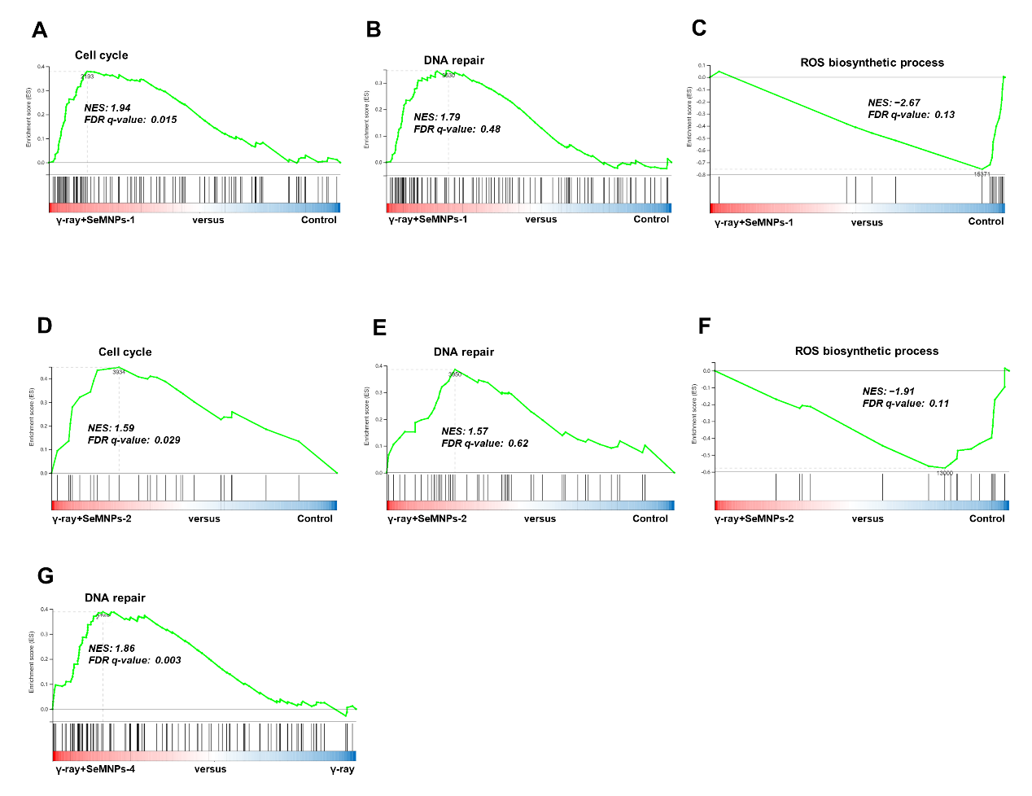
Figure S36. GSEA analyses of gene sets. (A) GSEA analyses of gene sets of cell cycle pathway in the γ-ray and γ-ray+SeMNPs-1 groups. (B) GSEA analyses of gene sets of DNA repair pathway in the γ-ray and γ-ray+SeMNPs-1 groups. (C) GSEA analyses of gene sets of ROS biosynthetic process pathway in the γ-ray and γ-ray+SeMNPs-1 groups. (D) GSEA analyses of gene sets of cell cycle pathway in the γ-ray and γ-ray+SeMNPs-2 groups. (E) GSEA analyses of gene sets of DNA repair pathway in the γ-ray and γ-ray+SeMNPs-2 groups. (F) GSEA analyses of gene sets of ROS biosynthetic process pathway in the γ-ray and γ-ray+SeMNPs-2 groups. (G) GSEA analyses of gene sets of DNA repair pathway in the γ-ray and γ-ray+SeMNPs-4 groups. NES, normalized enrichment score. FDR, false discovery rate. NES values > 0 indicate that the core gene set is located to the left of the peak and is highly expressed in the left group compared to the right group, and this pathway is activated in the left group. NES values < 0 indicate that the core gene set is located to the right of the peak and is highly expressed in the right group compared to the left group, and this pathway is activated in the right group. Pathways with |NES| > 1 and FDR < 0.25 are significantly enriched.

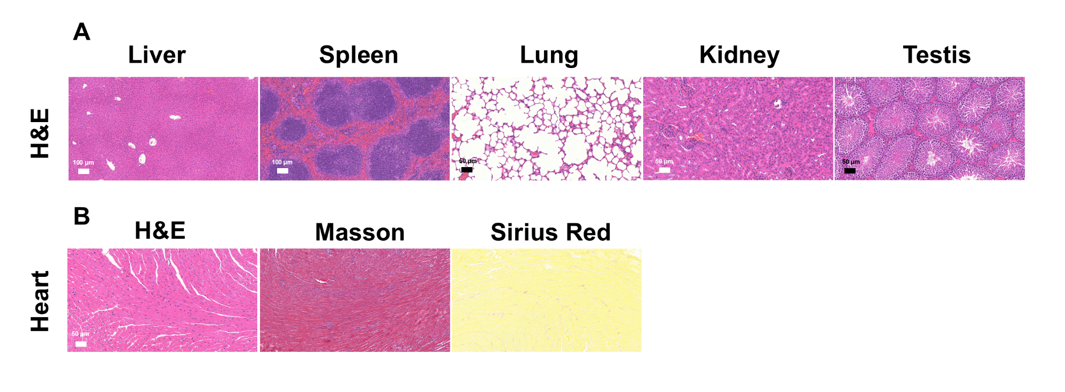
Figure S37. The SeMNPs-4 material displayed a good biosafety profile. (A) H&E staining of spleen, lungs, kidneys, testes and liver 4 days after SeMNPs-4 injection. (B) Morphological detection of heart 4 days after SeMNPs-4 injection, including H&E staining, Masson staining and Sirius red staining. Scale bar: 50 μm.

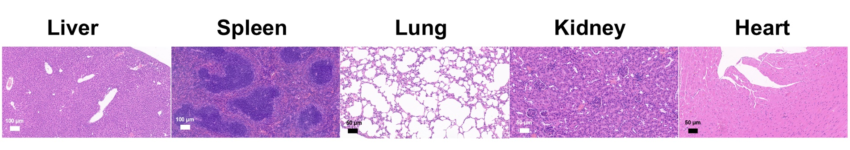
Figure S38. H&E staining of liver, spleen, lungs, kidneys and heart 4 days after 6 Gy irradiation for multi-organ damage observation. There was no significant damage to any of the organs under 6 Gy irradiation.

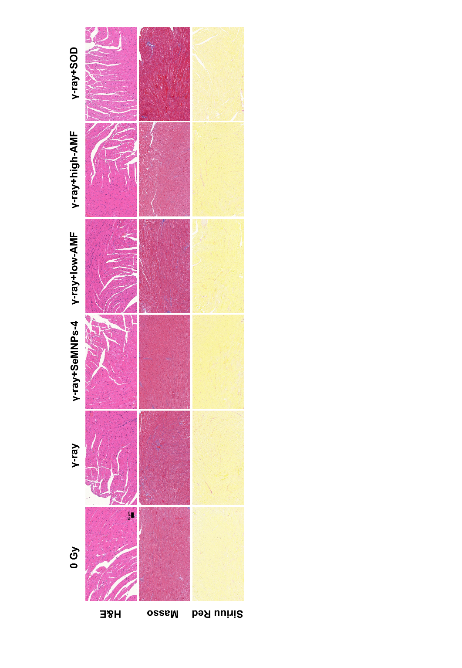
Figure S39. Morphological detection of heart 4 days after 8 Gy irradiation, including H&E staining, Masson staining and Sirius red staining. Scale bar: 50 μm. The cardiac morphology among all groups did not differ significantly. Grouping details: The 0 Gy group comprised normal mice (neither irradiation nor injection). The γ-ray group was irradiated with 8 Gy without injection. The γ-ray+SeMNPs-4 group was both irradiated with 8 Gy and intraperitoneally injected 7.5 mg kg⁻¹ body weight SeMNPs-4. The γ-ray+low-AMF group was both irradiated with 8 Gy and intraperitoneally injected 30 mg kg⁻¹ body weight AMF. The γ-ray+high-AMF group was both irradiated with 8 Gy and intraperitoneally injected 100 mg kg⁻¹ body weight AMF. The γ-ray+SOD group was both irradiated with 8 Gy and intraperitoneally injected 30 mg kg⁻¹ body weight SOD

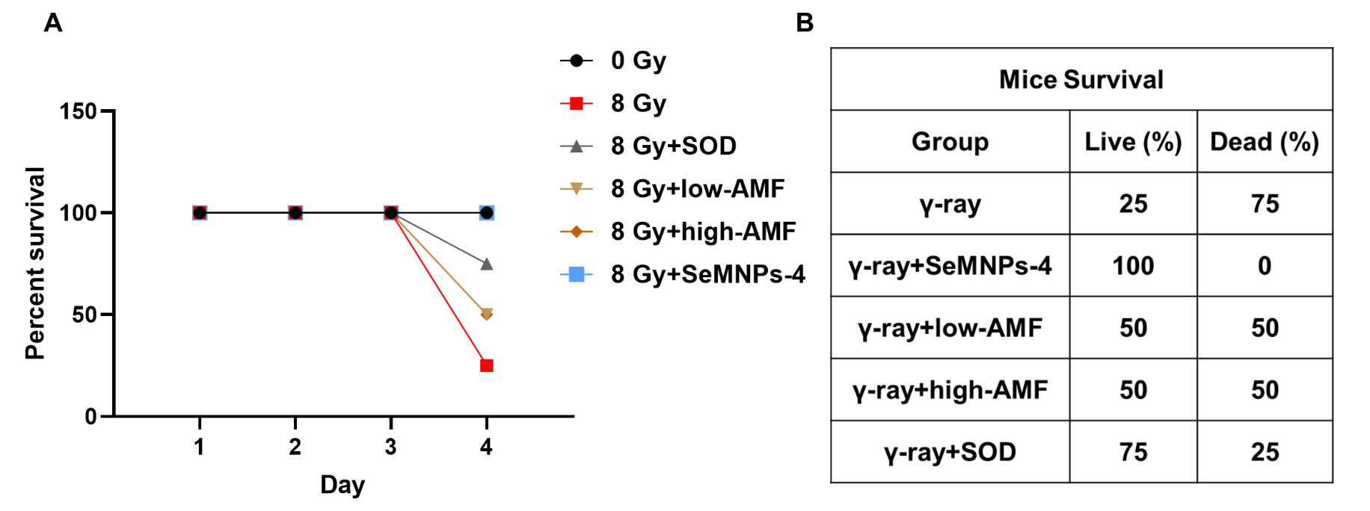
Figure S40. Mice survival of each group 4 days after 8 Gy irradiation. (A) Survival rate curve. (B) Comparison of survival of mice in each group at day 4 post-irradiation. Grouping details: The 0 Gy group comprised normal mice (neither irradiation nor injection). The γ-ray group was irradiated with 8 Gy without injection. The γ-ray+SeMNPs-4 group was both irradiated with 8 Gy and intraperitoneally injected 7.5 mg kg⁻¹ body weight SeMNPs-4. The γ-ray+low-AMF group was both irradiated with 8 Gy and intraperitoneally injected 30 mg kg⁻¹ body weight AMF. The γ-ray+high-AMF group was both irradiated with 8 Gy and intraperitoneally injected 100 mg kg⁻¹ body weight AMF. The γ-ray+SOD group was both irradiated with 8 Gy and intraperitoneally injected 30 mg kg⁻¹ body weight SOD

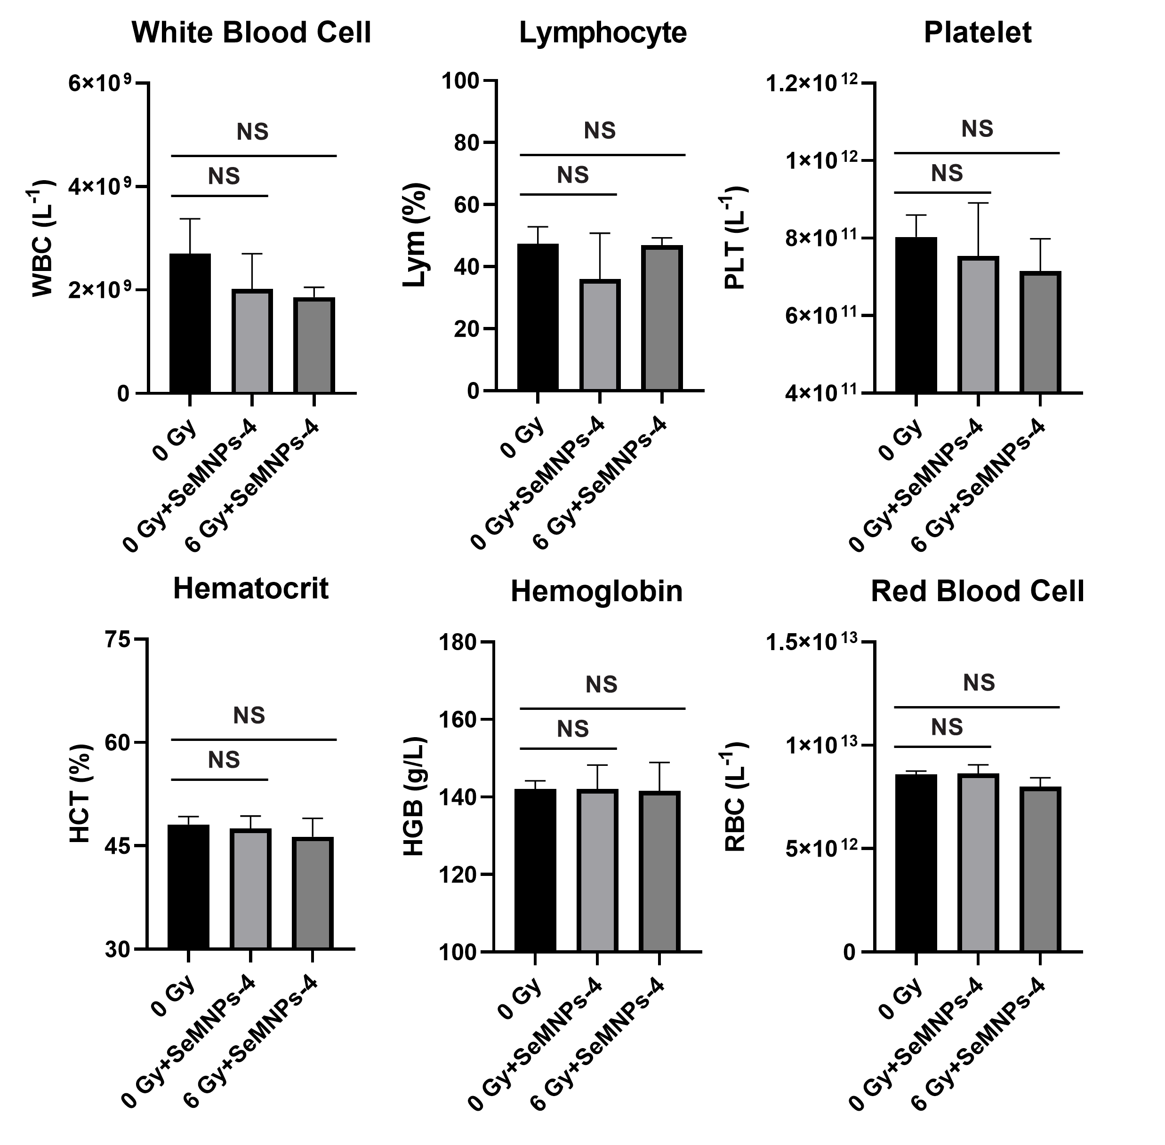
Figure S41. Blood routine indices at day 30 after irradiation for long-term radioprotective evaluation. Grouping details: The 0 Gy group comprises normal mice (neither irradiation nor injection). The γ-ray group was only irradiated with 6 Gy γ-ray without injection. The γ-ray+SeMNPs-4 group was both irradiated with 6 Gy and intraperitoneally injected 7.5 mg kg⁻¹ body weight SeMNPs-4. The 0 Gy+SeMNPs-4 group was intraperitoneally injected 7.5 mg kg⁻¹ body weight SeMNPs-4 without irradiation. Error bars represent standard deviation from ≥ three experiments. NS means no statistical difference (P > 0.05).

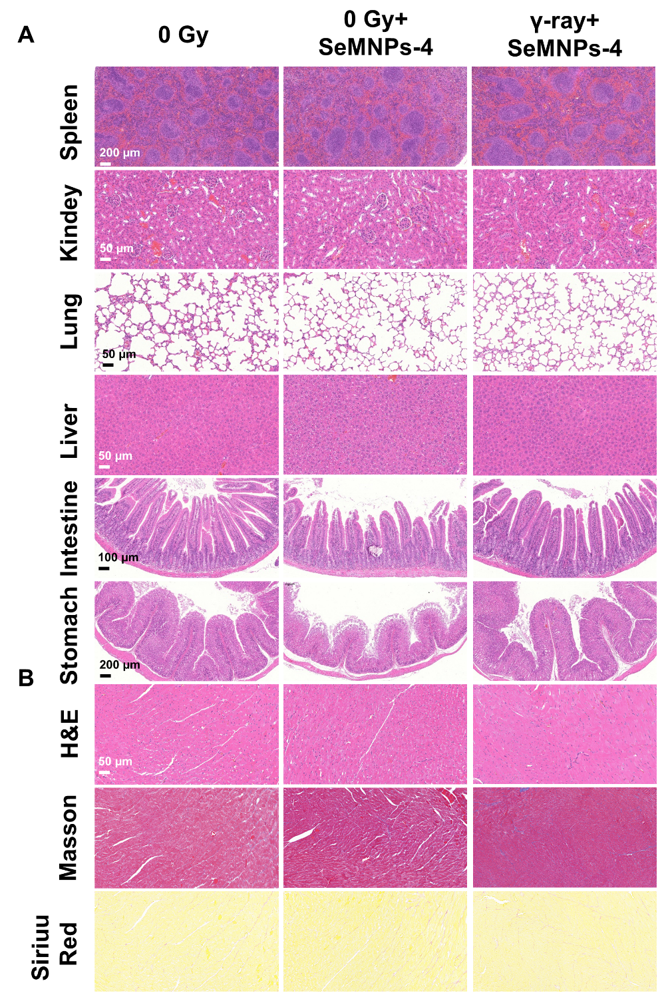
Figure S42. Long-term organ protection after 6 Gy irradiation. (A) H&E staining of spleen, lungs, kidneys, liver, intestines and stomach 30 days after irradiation for multi-organ observation. (B) Morphological detection of heart 4 days after irradiation, including H&E staining, Masson staining and Sirius red staining. Scale bar: 50 μm. Grouping details: The 0 Gy group comprises normal mice (neither irradiation nor injection). The γ-ray group was only irradiated with 6 Gy γ-ray without injection. The γ-ray+SeMNPs-4 group was both irradiated with 6 Gy and intraperitoneally injected 7.5 mg kg⁻¹ body weight SeMNPs-4. The 0 Gy+SeMNPs-4 group was intraperitoneally injected 7.5 mg kg⁻¹ body weight SeMNPs-4 without irradiation.

Supporting Tables

Table S1. Estimation of decarboxylation ratio of SeMNPs-1 and SeMNPs-2.
The theoretical C content was calculated from the elemental ratios of Se and N in XPS spectra, and the decarboxylation ratio was estimated by comparing that with the actual C content in XPS spectra. For example, for SeMNPs-1, the monomers are L-DOPA (C₉H₁₁NO₄) and selenocysteine (Sec, C₃H7NO₂Se). Experimental Se atomic content was At_{actual}(Se)=1.0 at%, which is from the monomer selenocysteine. Thus, N content from selenocysteine was At_{Sec}(N)=At_{actual}(Se)=1.0 at%, so theoretical C content from selenocysteine was At_{Sec}(C)=3*At_{Sec}(N)=3*1.0 at%=3.0 at%. Experimental N content was At_{actual}(N)=8.4 at%, so N content from L-DOPA was At_{L-DOPA}(N)=At_{actual}(N)- At_{Sec}(N)=8.4 at%-1.0 at%=7.4 at%, and theoretical C content from selenocysteine was At_{L-DOPA} (C)=9*At_{L-DOPA}(N)=9*7.4 at%=66.6 at%. Thus, total theoretical C content was At_{theoretical} (C)= At_{Sec}(C)+ At_{L-DOPA}(C)=3.0 at%+66.6 at%=69.6 at%. As actual C content was At_{actual}(C)=61.6 at%, which was less than At_{theoretical}(C) because of decarboxylation, decarboxylation ratio was estimated by R=[At_{theoretical}(C)- At_{actual}(C)]/At_{theoretical}(C)*100%= (69.6 at%-61.6 at%)/69.6 at%*100%=11.5%

Sample | Actual  Se Content | Actual  N Content | Actual  C Content | Theoretical  C Content | Decarboxylation  ratio
SeMNPs-1 | 1.0 at% | 8.4 at% | 61.6 at% | 69.0 at% | 11.5%
SeMNPs-2 | 5.1 at% | 11.4 at% | 64.9 at% | 66.9 at% | 3.0%

Table S2. Calculated g factors for the EPR spectra of the selenomelanin samples. g values in liquid-state are both higher than in solid-state, with the liquid-state g corresponding to semiquinone radical and the solid-state g to semi-localized ring-based carbon radicals.

Sample | g factors
liquid-state SeMNPs-2 | 2.00454
liquid-state SeMNPs-4 | 2.00466
solid-state SeMNPs-2 | 2.00377
solid-state SeMNPs-4 | 2.00398

Table S3. DFT calculations of E, G, ΔE and ΔG of forming pyrrole ring. E, energies of reactants and products. G, Gibbs free energies of reactants and products. ΔE, energy difference of the reaction (E of products minus E of reactants). ΔG, Gibbs free energies difference of the reaction (G of products minus G of reactants). Negative values of ∆E and ∆G indicated that the closed-loop product energy is lower.
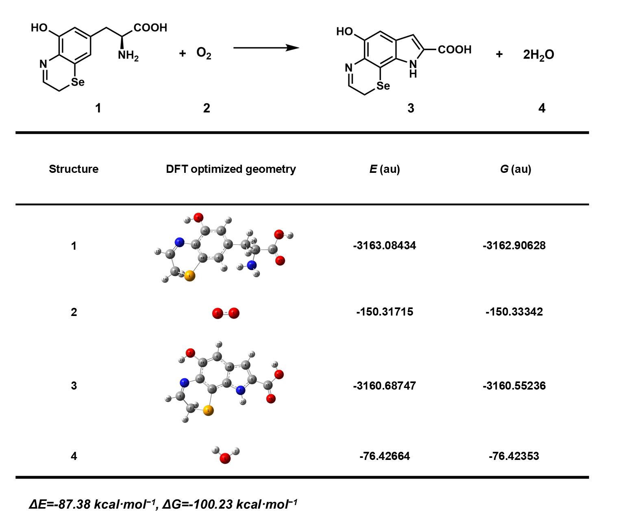

References
1. Cao, W.; McCallum, N. C.; Ni, Q. Z.; Li, W.; Boyce, H.; Mao, H.; Zhou, X.; Sun, H.; Thompson, M. P.; Battistella, C.; Wasielewski, M. R.; Dhinojwala, A.; Shawkey, M. D.; Burkart, M. D.; Wang, Z.; Gianneschi, N. C., Selenomelanin: An Abiotic Selenium Analogue of Pheomelanin. J. Am. Chem. Soc. 2020, 142 (29), 12802-12810.
2. Pyo, J.; Ju, K.-Y.; Lee, J.-K., Artificial pheomelanin nanoparticles and their photo-sensitization properties. J. Photoch. Photobiol. B 2016, 160, 330-335.
3. Huang, Y.; Li, Y.; Hu, Z.; Yue, X.; Proetto, M. T.; Jones, Y.; Gianneschi, N. C., Mimicking Melanosomes: Polydopamine Nanoparticles as Artificial Microparasols. ACS Cent. Sci. 2017, 3 (6), 564-569.
4. Stephens, P. J.; Devlin, F. J.; Chabalowski, C. F.; Frisch, M. J., Ab Initio Calculation of Vibrational Absorption and Circular Dichroism Spectra Using Density Functional Force Fields. J. Phys. Chem. 1994, 98 (45), 11623-11627.
5. Grimme, S.; Antony, J.; Ehrlich, S.; Krieg, H., A consistent and accurate ab initio parametrization of density functional dispersion correction (DFT-D) for the 94 elements H-Pu. J. Chem. Phys. 2010, 132 (15), 154104.
6. Grimme, S.; Ehrlich, S.; Goerigk, L., Effect of the damping function in dispersion corrected density functional theory. J. Comput. Chem. 2011, 32 (7), 1456-1465.
7. Hariharan, P. C.; Pople, J. A., The influence of polarization functions on molecular orbital hydrogenation energies. Theor. Chim. Acta 1973, 28 (3), 213-222.
8. Hehre, W. J.; Ditchfield, R.; Pople, J. A., Self-Consistent Molecular Orbital Methods. XII. Further Extensions of Gaussian—Type Basis Sets for Use in Molecular Orbital Studies of Organic Molecules. J. Chem. Phys. 1972, 56 (5), 2257-2261.
9. Ditchfield, R.; Hehre, W. J.; Pople, J. A., Self‐Consistent Molecular‐Orbital Methods. IX. An Extended Gaussian‐Type Basis for Molecular‐Orbital Studies of Organic Molecules. J. Chem. Phys. 1971, 54 (2), 724-728.
10. Frisch, M. J.; Trucks, G. W.; Schlegel, H. B.; Scuseria, G. E.; Robb, M. A.; Cheeseman, J. R.; Scalmani, G.; Barone, V.; Petersson, G. A.; Nakatsuji, H.; Li, X.; Caricato, M.; Marenich, A. V.; Bloino, J.; Janesko, B. G.; Gomperts, R.; Mennucci, B.; Hratchian, H. P.; Ortiz, J. V.; Izmaylov, A. F.; Sonnenberg, J. L.; Williams; Ding, F.; Lipparini, F.; Egidi, F.; Goings, J.; Peng, B.; Petrone, A.; Henderson, T.; Ranasinghe, D.; Zakrzewski, V. G.; Gao, J.; Rega, N.; Zheng, G.; Liang, W.; Hada, M.; Ehara, M.; Toyota, K.; Fukuda, R.; Hasegawa, J.; Ishida, M.; Nakajima, T.; Honda, Y.; Kitao, O.; Nakai, H.; Vreven, T.; Throssell, K.; Montgomery Jr., J. A.; Peralta, J. E.; Ogliaro, F.; Bearpark, M. J.; Heyd, J. J.; Brothers, E. N.; Kudin, K. N.; Staroverov, V. N.; Keith, T. A.; Kobayashi, R.; Normand, J.; Raghavachari, K.; Rendell, A. P.; Burant, J. C.; Iyengar, S. S.; Tomasi, J.; Cossi, M.; Millam, J. M.; Klene, M.; Adamo, C.; Cammi, R.; Ochterski, J. W.; Martin, R. L.; Morokuma, K.; Farkas, O.; Foresman, J. B.; Fox, D. J. Gaussian 16 Rev. B.01, Wallingford, CT, 2016.
11. Merrick, J. P.; Moran, D.; Radom, L., An Evaluation of Harmonic Vibrational Frequency Scale Factors. J. Phys. Chem. A 2007, 111 (45), 11683-11700.
12. Lu, T.; Chen, Q., Shermo: A general code for calculating molecular thermochemistry properties. Comput. Theor. Chem. 2021, 1200, 113249.
13. Goerigk, L.; Grimme, S., Efficient and Accurate Double-Hybrid-Meta-GGA Density Functionals—Evaluation with the Extended GMTKN30 Database for General Main Group Thermochemistry, Kinetics, and Noncovalent Interactions. J. Chem. Theory Comput. 2011, 7 (2), 291-309.
14. Caldeweyher, E.; Ehlert, S.; Hansen, A.; Neugebauer, H.; Spicher, S.; Bannwarth, C.; Grimme, S., A generally applicable atomic-charge dependent London dispersion correction. J. Chem. Phys. 2019, 150 (15), 154122.
15. Weigend, F.; Ahlrichs, R., Balanced basis sets of split valence, triple zeta valence and quadruple zeta valence quality for H to Rn: Design and assessment of accuracy. Phys. Chem. Chem. Phys. 2005, 7 (18), 3297-3305.
16. Neese, F., An improvement of the resolution of the identity approximation for the formation of the Coulomb matrix. 2003, 24 (14), 1740-1747.
17. Neese, F.; Wennmohs, F.; Hansen, A.; Becker, U., Efficient, approximate and parallel Hartree–Fock and hybrid DFT calculations. A ‘chain-of-spheres’ algorithm for the Hartree–Fock exchange. Chem. Phys. 2009, 356 (1), 98-109.
18. Neese, F., The ORCA program system. WIREs Comput. Mol. Sci. 2012, 2 (1), 73-78.
19. LeBel, C. P.; Ischiropoulos, H.; Bondy, S. C., Evaluation of the probe 2',7'-dichlorofluorescin as an indicator of reactive oxygen species formation and oxidative stress. Chem. Res. Toxicol. 1992, 5 (2), 227-231.
20. Cathcart, R.; Schwiers, E.; Ames, B. N., Detection of picomole levels of hydroperoxides using a fluorescent dichlorofluorescein assay. Anal. Biochem. 1983, 134 (1), 111-116.
21. Panzella, L.; Gentile, G.; D'Errico, G.; Della Vecchia, N. F.; Errico, M. E.; Napolitano, A.; Carfagna, C.; d'Ischia, M., Atypical Structural and π-Electron Features of a Melanin Polymer That Lead to Superior Free-Radical-Scavenging Properties. Angew. Chem. Int. Ed. 2013, 52 (48), 12684-12687.
22. Ju, K.-Y.; Lee, Y.; Lee, S.; Park, S. B.; Lee, J.-K., Bioinspired Polymerization of Dopamine to Generate Melanin-Like Nanoparticles Having an Excellent Free-Radical-Scavenging Property. Biomacromolecules 2011, 12 (3), 625-632.
23. Zhou, X.; McCallum, N. C.; Hu, Z.; Cao, W.; Gnanasekaran, K.; Feng, Y.; Stoddart, J. F.; Wang, Z.; Gianneschi, N. C., Artificial Allomelanin Nanoparticles. ACS Nano 2019, 13 (10), 10980-10990.
24. Ito, S.; Novellino, E.; Chioccara, F.; Misuraca, G.; Prota, G., Co-polymerization of dopa and cysteinyldopa in melanogenesis in vitro. Experientia 1980, 36 (7), 822-823.

