Supplementary Information
for
Asymmetric effects of Indian Ocean dipole on surface chlorophyll variability in the Indian Ocean

Thivin Abeywickrama¹, Gayan Pathirana^{1*}, Kyung-Min Noh², Kushlani Dissanayake¹, Dongxiao Wang³, and Dong-Geon Lee^{4,5}
¹Department of Oceanography and Marine Geology, Faculty of Fisheries and Marine Sciences & Technology, University of Ruhuna, Matara, Sri Lanka.
²Princeton University/Atmospheric and Oceanic Sciences Program, Princeton, New Jersey.
³School of Marine Sciences, Sun Yat-sen University, Guangzhou, China.
⁴Division of Environmental Science and Engineering, Pohang University of Science and Technology (POSTECH), Pohang, South Korea.
⁵School of Earth and Environmental Sciences, Seoul National University, Seoul, South Korea.

*Corresponding author. Email: upgpathirana@fish.ruh.ac.lk

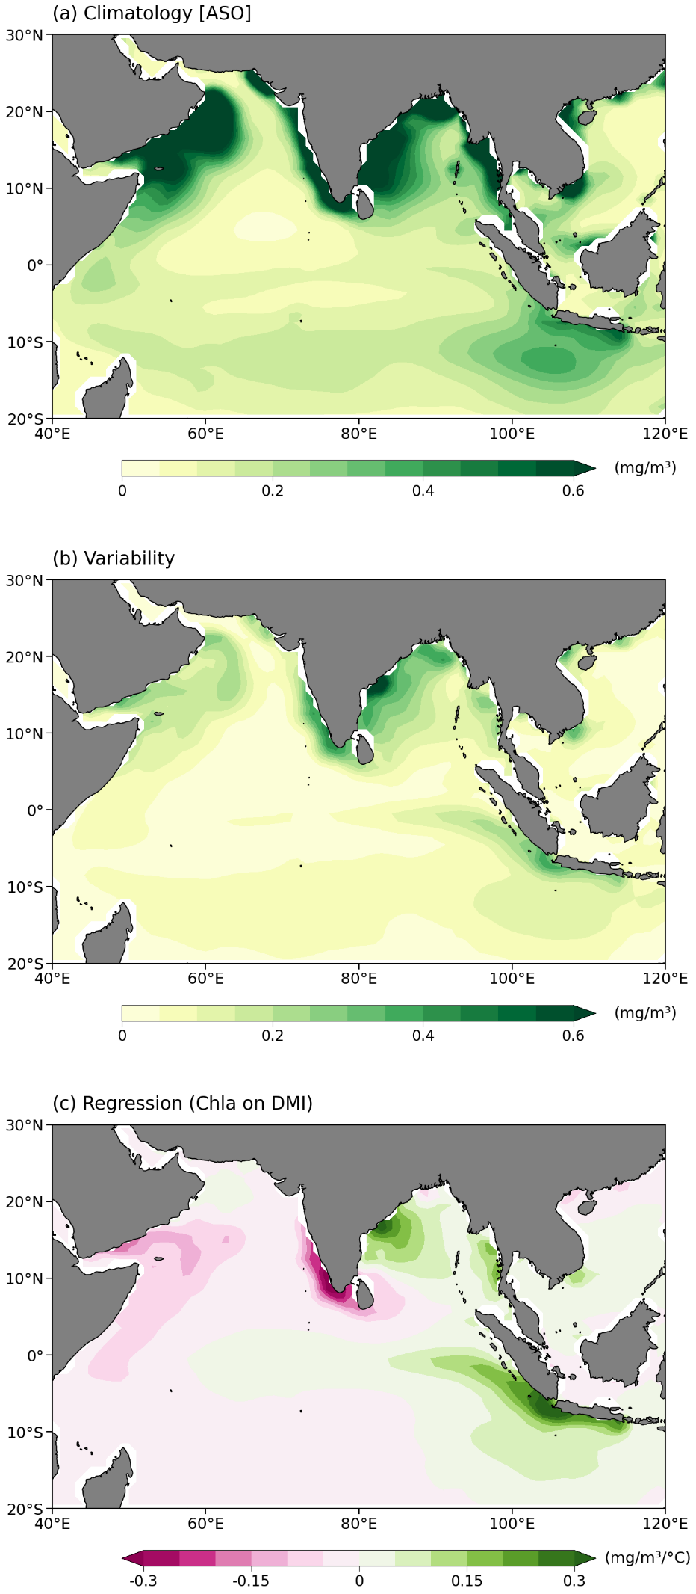
Fig. S1 Surface chlorophyll (a) mean state, (b) interannual variability, and (c) regression on DMI for historical simulations from 1850-2014. The chosen time period is August to October.
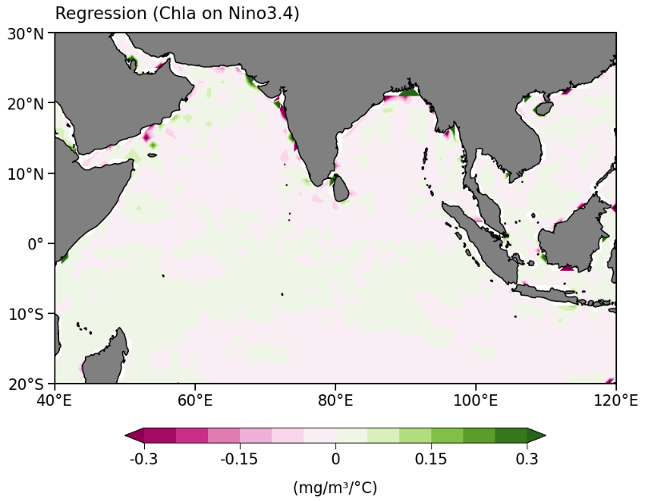
Fig. S2 Same as Fig. 1c but for Niño3.4.

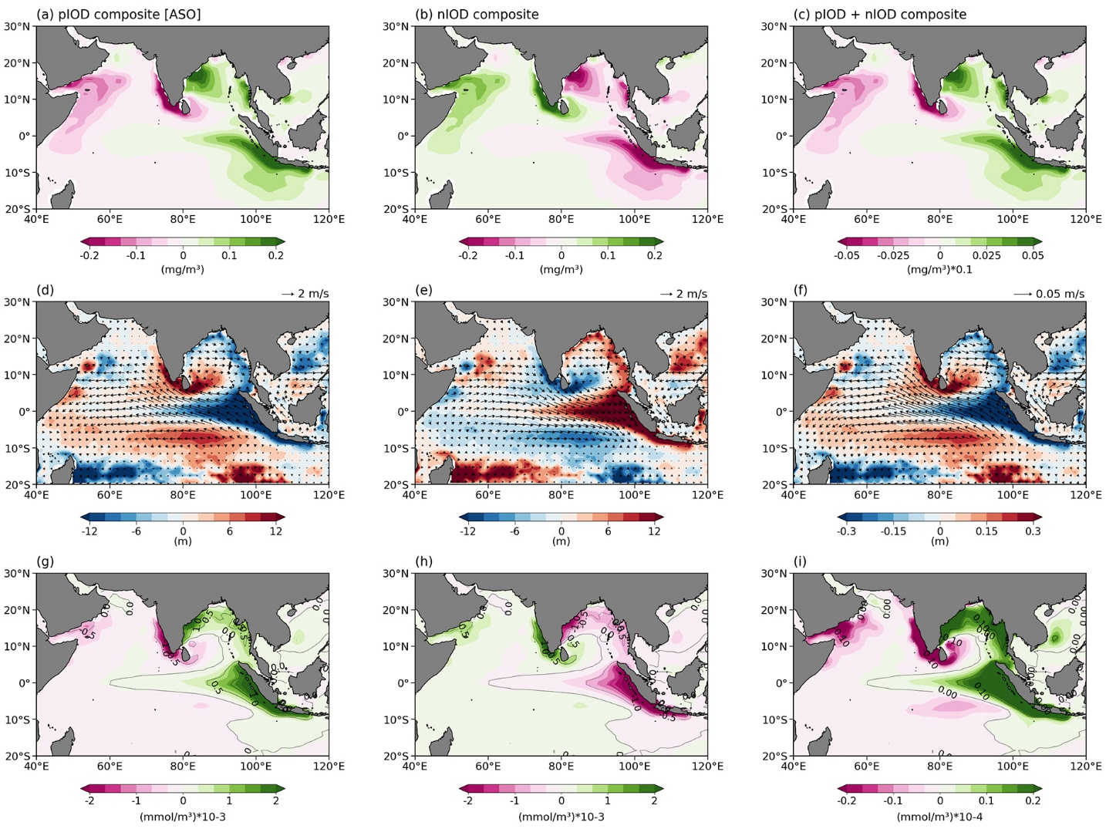
Fig. S3 Composites of chlorophyll, thermocline and 10m winds, and nutrients nitrate and phosphate, as Fig. 2, 4, and 5 respectively, for historical simulations from 1850-2014. The chosen time period is August to October.

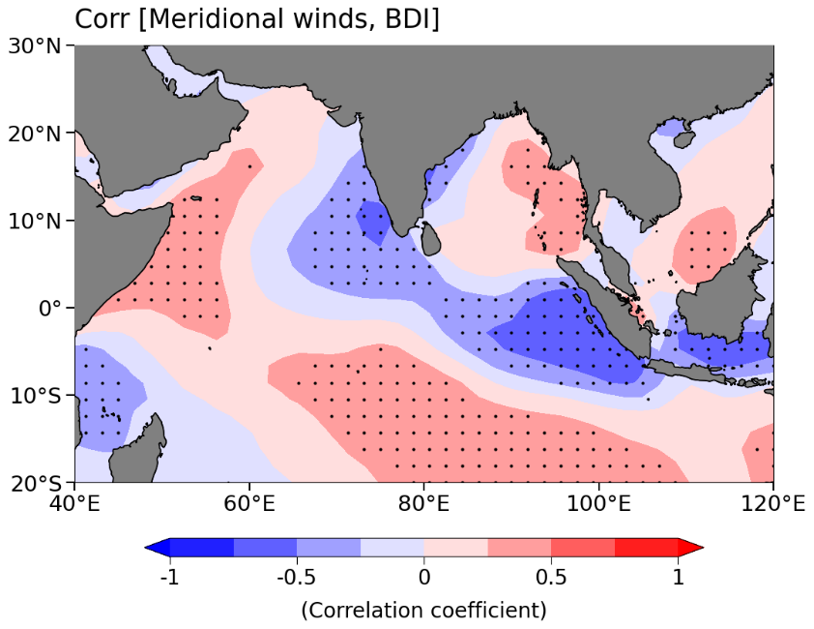
Fig. S4 Spatial correlation plot between anomalous meridional winds and the Biological Dipole Index (BDI). Northward winds are defined as positive values. The chosen time period is August to October. The black dots indicate statistically significant regions with a 99% confidence level.

Table S1 CMIP6 model information.
Model | Group
ACCESS-ESM1-5 | Commonwealth Scientific and Industrial Research Organization, Australia
CanESM5 | Canadian Centre for Climate Modelling and Analysis, Canada
CESM2 | NSF, Department of Energy and NCAR, USA
CESM2-WACCM | NSF, Department of Energy and NCAR, USA
CNRM-ESM2-1 | Centre National de Recherches Météorologiques–Centre Européen de Recherche et de Formation Avancée en Calcul Scientifique, France
GFDL-ESM4 | Geophysical Fluid Dynamics Laboratory, USA
IPSL-CM6A-LR | Institute Pierre Simon Laplace, France
MIROC-ES2L | Japan Agency for Marine–Earth Science and Technology, Atmosphere and Ocean Research Institute, The University of Tokyo, National Institute for Environmental Studies, and RIKEN Center for Computational Science, Japan
MPI-ESM1-2-HR | Max Planck Institute for Meteorology, Germany
MPI-ESM1-2-LR | Max Planck Institute for Meteorology, Germany
NorESM2-LM | Norwegian Climate Centre, Norway
NorESM2-MM | Norwegian Climate Centre, Norway
UKESM1-0-LL | Met Office Hadley Centre/UK

