Figure S1. Chromosomal location distribution of FAR genes in four Gossypium species. (A) G. arboreum, (B) G. raimondii, (C) G. hirsutum, (D) G.barbadense.
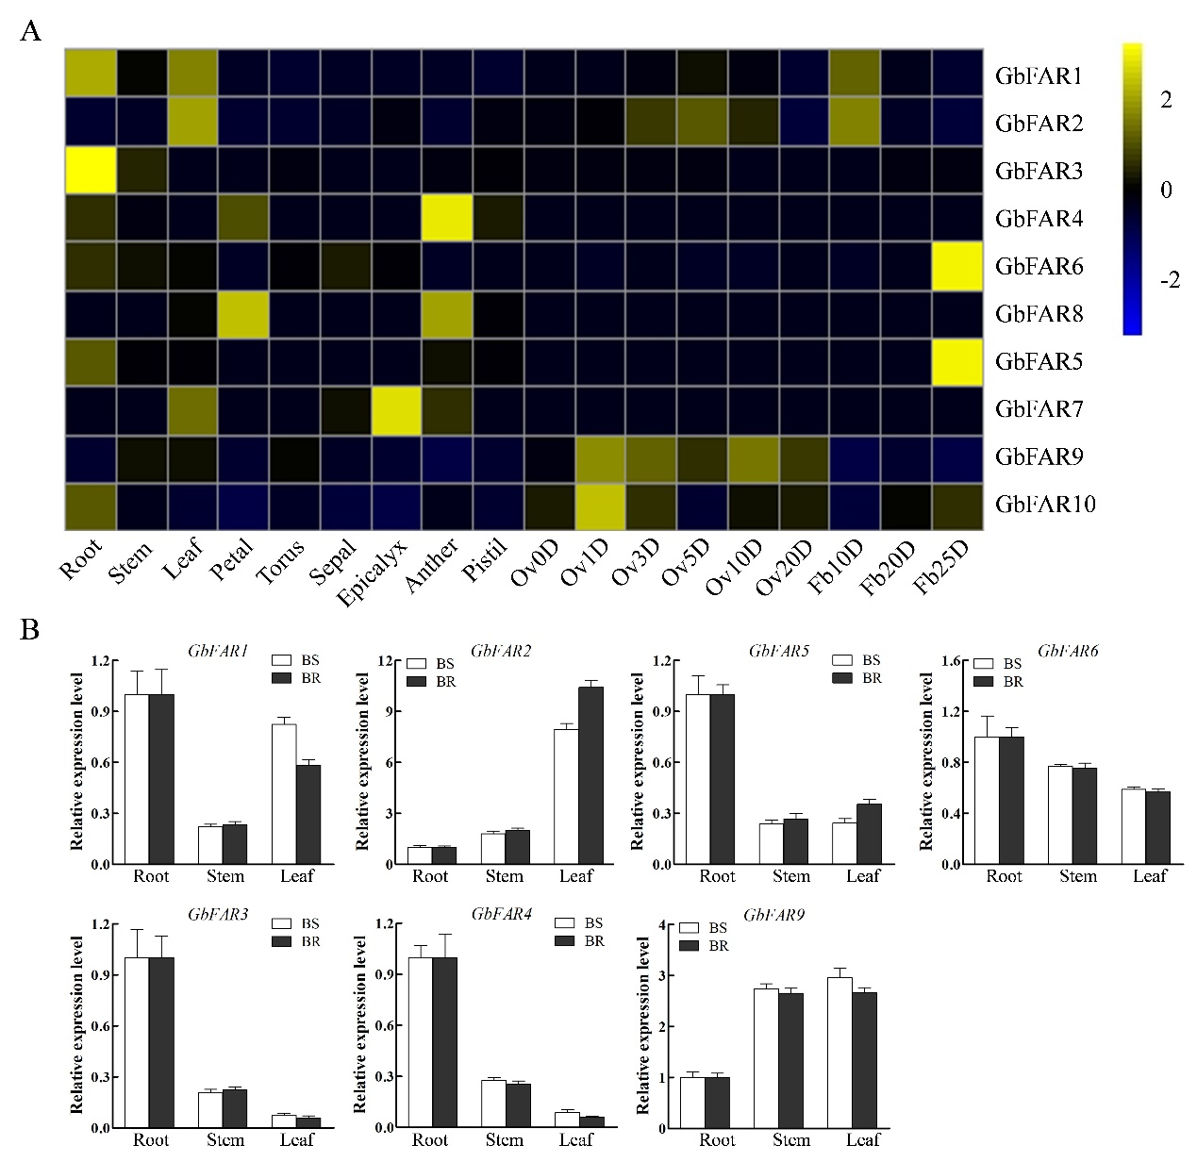

Figure S2. Expression analysis of FAR genes in different tissues of Gossypium barbadense. (A) Transcriptomic data for GbFAR genes in various tissues. (B) qRT-PCR validation of GbFAR genes in roots, stems, and leaves. Data are shown as mean ± SD of three biological replicates (** P < 0.01; t-test).

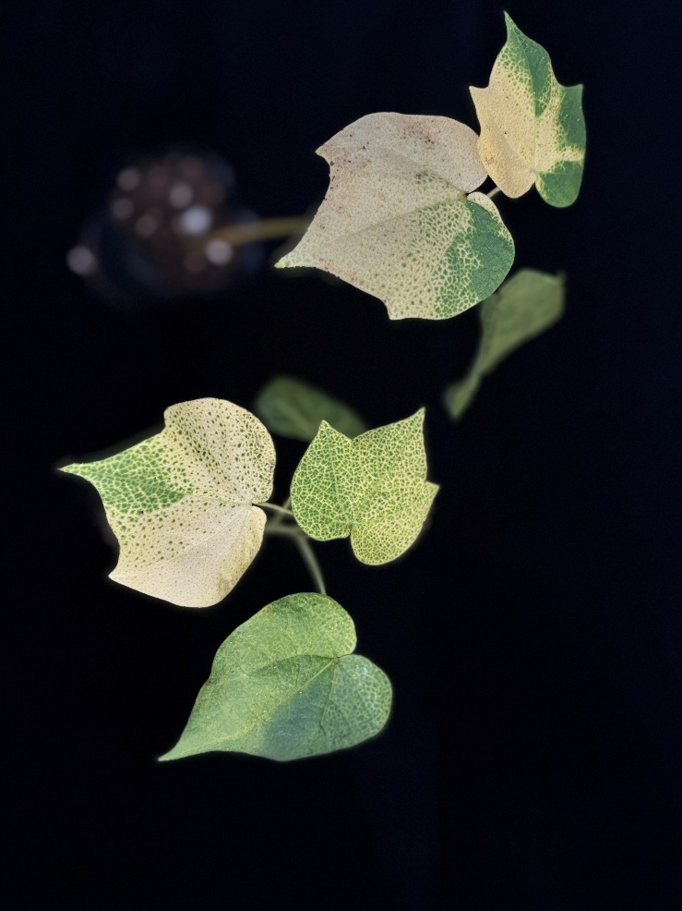
Figure S3. The albino phenotype of TRV: GhCHLI.

