Supplementary Information

Chiral-Selective Biocatalysis of (S)-1-BOC-3-Hydroxypiperidine: Developing analytical method for Quantifying (R)-Isomer Impurities
Sanjay Kumar Sharma^{a1*} and Sayeeda Sultana^{a1}
Author Affiliation
ªDepartment of Chemistry, St. Peter’s Institute of Higher Education and Research, Avadi, Chennai, 60054, Tamilnadu, India.
1Both the authors contributed equally
*Corresponding Author
Email: sanjay11sharma@yahoo.com, Phone: +917000553543,

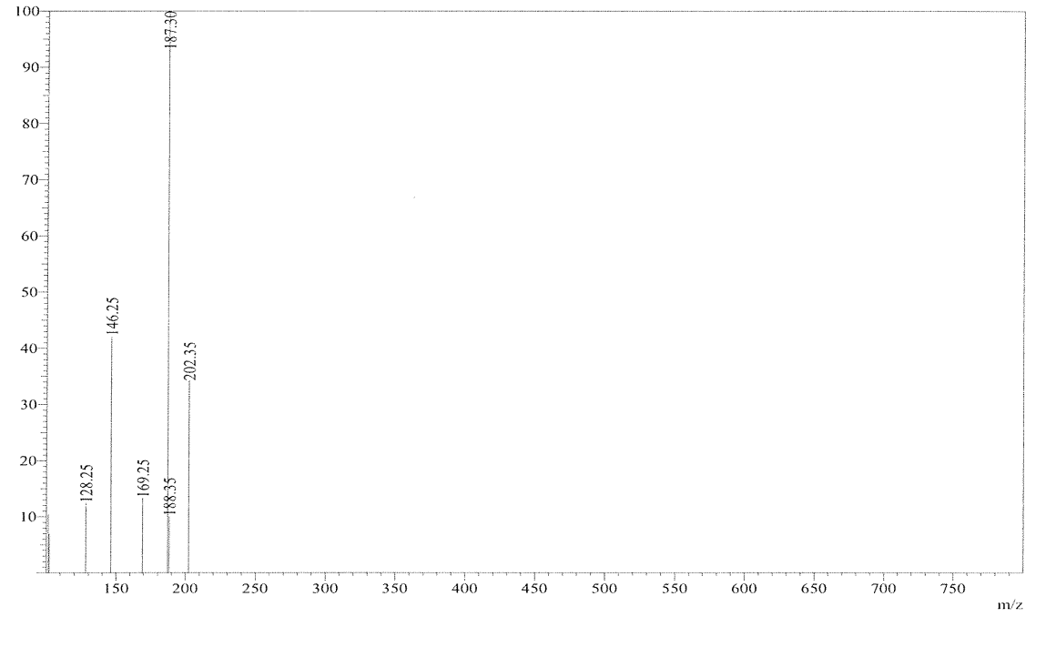

Figure S1. Mass spectrometery analysis of (S)-1-BOC-3-Hydroxypiperidine. The mass spectrum of 202 [M+H]⁺ indicates the molecular ion of the (S)-1-BOC-3-Hydroxypiperidine

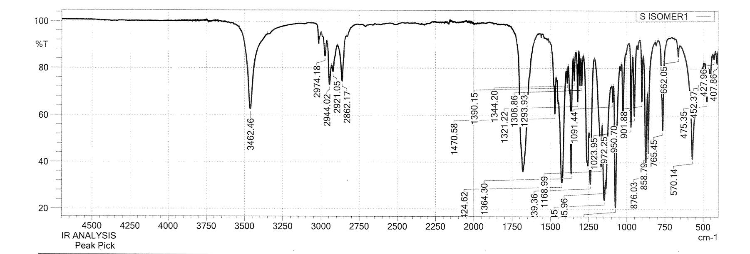

Figure S2. FT-IR spectra of (S)-1-BOC-3-Hydroxypiperidine.

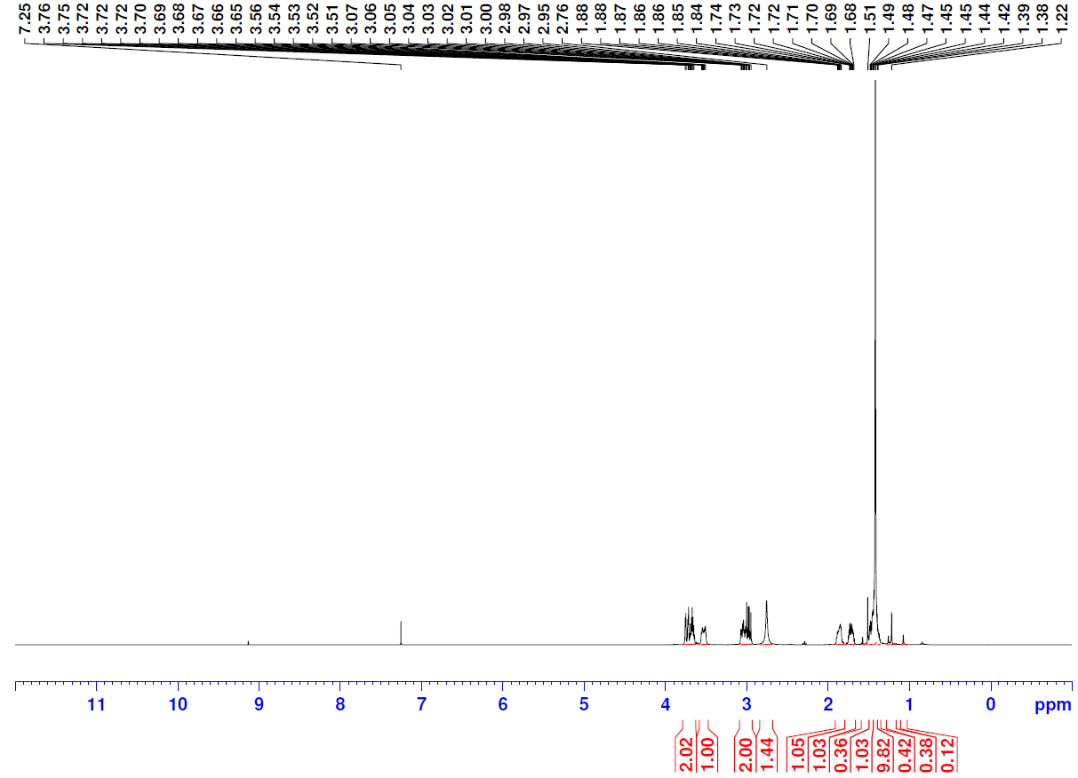
Figure S3. (A) H¹NMR spectra of (S)-1-BOC-3-Hydroxypiperidine
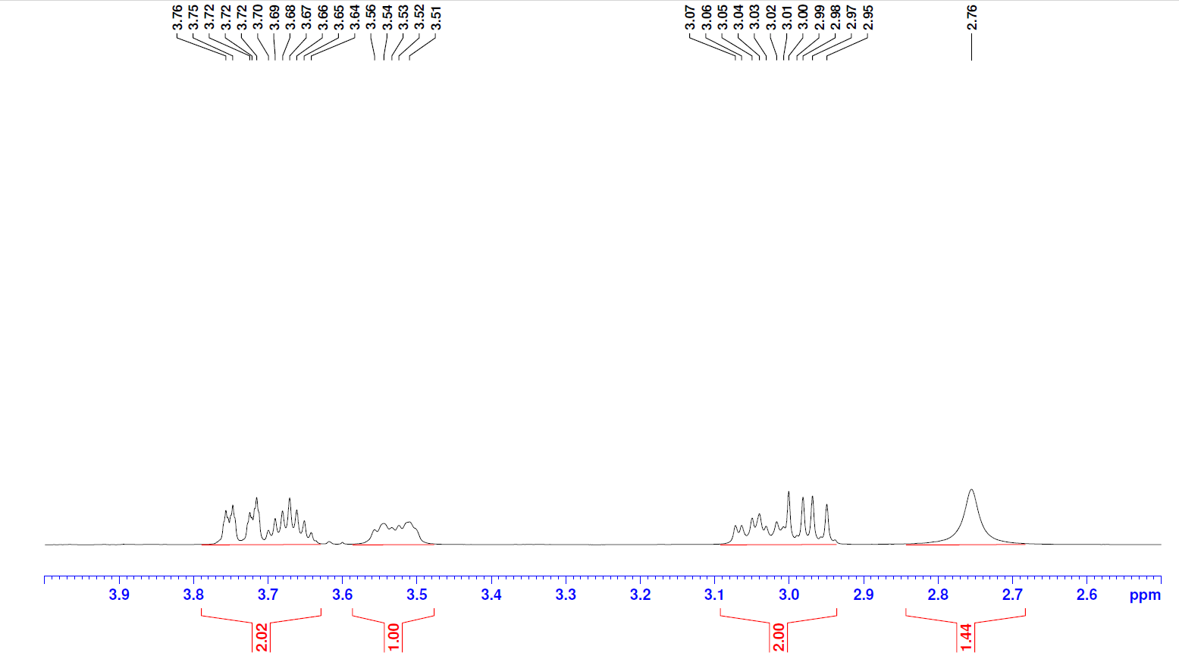

Figure S3. (B) Zoom-in view of H¹ NMR spectra between 2.6 and 3.9 ppm of (S)-1-BOC-3-Hydroxypiperidine

Table S1. The specific optical rotation (SOR) of (S)-1-BOC-3-hydroxypiperidine was found to be (-) 11.74, as shown in table S1.

