eAppendix
Supplement table 1 Risk factors for perioperative respiratory adverse events.
Presence of ≥1 risk factor below is considered to be at risk of respiratory adverse events.
- Respiratory tract infection within the past 2 weeks
- Wheezing 3 or more times in past 12 months
- Wheezing during exercise
- Previous asthma (if wheeze-negative)
- Nocturnal dry cough
- Current or past eczema
- Family history of asthma, eczema, or hay fever (≥2 family members including parents or siblings)
- Exposure to passive smoking (parent or caregiver)

Supplement table 2 The modified Yale Preoperative Anxiety Scale (m-YPAS) score.
Item | Scoring Criteria
Activity | 1 = Looking around, curious, playing with toys, reading (or other age-appropriate behavior); moves around holding area/treatment room to get toys or go to parent; may move toward OR equipment.  2 = Not exploring or playing, may look down, may fidget with hands or suck thumb (blanket); may sit close to parent while waiting, or play has a definite manic quality.  3 = Moving from toy to parent in unfocused manner, nonactivity-derived movements; frenetic/frenzied movement or play; squirming, moving on table, may push mask away, or clinging to parent.  4 = Actively trying to get away, pushes with feet and arms, may move whole body; in waiting room, running around unfocused, not looking at toys or will not separate from parent, desperate clinging.
Vocalizations | 1 = Reading (nonvocalizing appropriate to activity), asking questions, making comments, babbling, laughing, readily answers questions but may be generally quiet; child too young to talk in social situations or too engrossed in play to respond.  2 = Responding to adults but whispers, “baby talk,” only head nodding.  3 = Quiet, no sounds or responses to adults.  4 = Whimpering, moaning, groaning, silently crying.  5 = Crying or may be screaming “no.”  6 = Crying, screaming loudly, sustained (audible through mask).
Emotional Exoressivity | 1 = Manifestly happy, smiling, or concentrating on play.  2 = Neutral, no visible expression on face.  3 = Worried (sad) to frightened, sad, worried, or tearful eyes.  4 = Distressed, crying, extremely upset, may have wide eyes.
State of apparent arousal | 1 = Alert, looks around occasionally, notices or watches what anesthesiologist does with him/her (could be relaxed).  2 = Withdrawn, child sitting still and quiet, may be sucking on thumb or face turned into adult.  3 = Vigilant, looking quickly all around, may startle to sounds, eyes wide, body tensed.  4 = Panicked whimpering, may be crying or pushing others away, turns away.
Use of parents | 1 = Busy playing, sitting idle, or engaged in age-appropriate behavior and does not need parent; may interact with parent if parent initiates the interaction.  2 = Reaches out to parent (approaches parent and speaks to otherwise silent parent), seeks and accepts comfort, may lean against parent.  3 = Looks to parents quietly, apparently watches actions, does not seek contact or comfort, accepts it if offered or clings to parent.  4 = Keeps parent at distance or may actively withdraw from parent, may push parent away or desperately clinging to parent and will not let parent go.
Divide each item rating by the highest possible rating (i.e., 6 for the “vocalizations” item and 4 for all other items), then caculated as follows:
m-YPAS score=(Activity/4+Vocalizations/6+Emotional expressivity/4+State apparent arousal/4+Use of parents/4)*100/5
Patient, who has a m-YPAS score ≥30 points, is defined as anxiety state.

Supplement table 3 The COLDS score.
 | 1 | 2 | 5
- Current signs/  symptoms | None | Mild  (Parent confirms URI  AND/OR congestion, rhinorrhea, sore throat, sneezing, low fever, dry cough) | Moderate/Severe  (Purulence, wet cough, abnormal lung sounds, lethargy, ‘toxic’ appearance, or high fever)
- Onset of symptoms | >4 weeks ago | 2-4 weeks ago | <2 weeks ago
- Presence of lung disease | None | Mild  (Hx of RSV, mild intermittent asthma, CLD if >1 year old, loud snoring, or passive smoker) | Moderate/Severe  (Moderate persistent asthma,infant with CLD, OSA, or pulmonary HTN)
- Airway device | None or facemask | Laryngeal mask airway or supraglottic airway | Tracheal tube
- Surgery | Other (including ear tubes) | Minor airway  (T/A, NLD probe, flexible bronchoscopy, and dental extractions) | Major airway  (Cleft palate, rigid bronchoscopy and maxillofacial surgery)
URI, upper respiratory tract infection; Hx, history; RSV, respiratory syncytial virus; CLD, chronic lung disease, also known as bronchopulmonary dysplasia; OSA, obstructive sleep apnea; HTN, hypertension; T/A, tonsillectomy and/or adenoidectomy; NLD, nasolacrimal duct.

Supplement table 4 The Paediatric Anaesthesia Behavior (PAB) score.
Score | Description of behavior
1 | Happy | Calm and controlled. Compliant with induction
2 | Sad | Tearful and/or withdrawn but compliant withinduction
3 | Mad | Loud vocal resistance (screaming or shouting) AND/OR Physical resistance to induction requiring physicarestraint by staff and/or parents
A score of 2 or 3 is defined as anxiety state.

Supplement table 5 The Wong-Baker Pain Scale.[https://wongbakerfaces.org/]
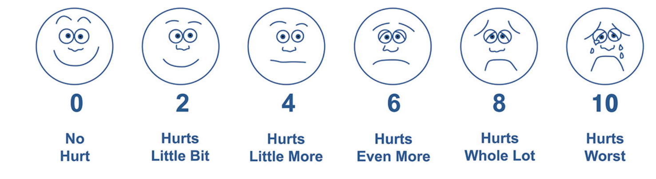
Supplement table 6 Aono’s Four Point Scale.
Score | Patient characteristic | Emergence agitation
1 | Calm (conversation). | No
2 | Not calm, but can be easily calmed by verbal instructions and able to tolerate ordinary fixation straps for both arms and legs. | No
3 | Not calm despite frequent verbal instructions, moderately agitated or restless, and requires physical restraint. | Yes
4 | Combative, excited, disoriented, and strongly requires physical restraint. | Yes

Supplement table 7 The physiological criteria-based discharge scoring system.
Discharge Criteria |  | Score
Conscious level & activity | Awake & orientated, appropriate movements | 2
 | Rousable with minimal stimulation, weak movements | 1
 | Responsive only to tactile stimulation, no movement | 0
Respiratory stability | Able to cough, deep breathe or cry | 2
 | Hoarseness with crying or coughing | 1
 | Stridor, dyspnea or wheeze | 0
Oxygen saturation | Maintains ＞ 95% on room air | 2
 | 90%-95% on room air | 1
 | Requires O₂ to maintain [90% | 0
Hemodynamic stability | HR & systolic BP within 15% of baseline value | 2
 | HR &/or systolic BP within 15-30% of baseline | 1
 | HR &/or systolic BP outside 30% of baseline, mottled | 0
Post-op pain | None, or mild discomfort | 2
 | Moderate to severe, controlled with intravenous analgesia | 1
 | Persistent severe pain | 0
Post-op nausea or vomiting | None, or mild nausea with no vomiting | 2
 | Transient vomiting or retching | 1
 | Persistent moderate to severe nausea & vomiting | 0
Surgical site | No blood or fluid loss | 2
 | Minimal loss, no intervention required | 1
 | Ongoing losses, dressing changes required | 0
HR, heart rate; BP, blood pressure.
Discharge standards are satisfied if the score is ≥ 12.

Supplement table 8 The airway hyperreactivity score.
Parameter | 0 | 1 | 2 | 3 | 4
Cough/bucking retraction | None | Occasional | Frequent | Continuous | Laryngospasm  (partial/complete)
Breath holding | None | ＜15 sec | 15-30sec | ＞30sec | Positive pressure ventilation
Oxygen desaturation | None SpO₂ ≥98% | SpO₂ 94-97% | SpO₂ 90-94% ＞10 sec | SpO₂ ＜90% ＞10 sec | SpO₂ ＜85% ＞10 sec
Severity of airway hyperreactivity: mild score 3, moderate score 4–8, and severe score 9. SpO₂ = oxygen saturation as measured by pulse oximetry.

