Extended Data

Dysregulation of macrophage PEPD in obesity determines adipose tissue fibro-inflammation and insulin resistance

V Pellegrinelliet.al

Correspondence:vp332@medschl.cam.ac.uk(V.P);ajv22@medschl.cam.ac.uk(A.V.-P.).

Extended Data includes 9 Figures and 1 Table

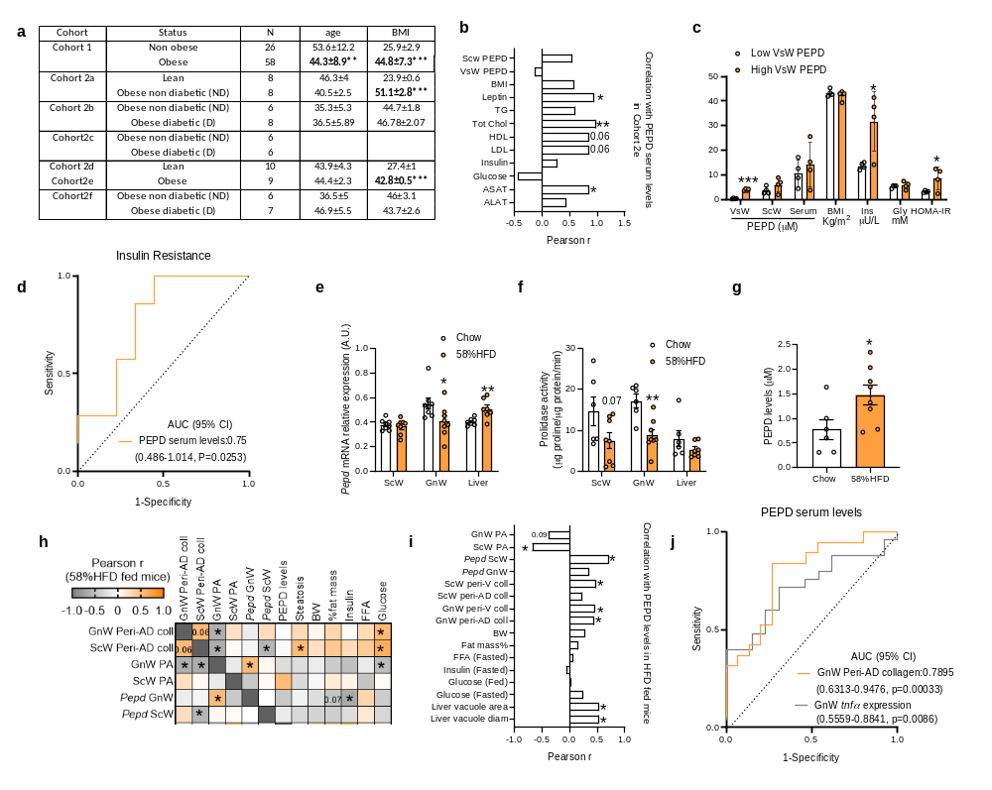

Extended Data Figure 1| Obesity reduces AT PEPD activity and promotes PEPD release in association with AT fibrosis and insulin resistance. a, Age, BMI and glycemic status in the different human cohorts. b, Pearson correlation matrix between ScW and VsW ECM remodelling markers and metabolic parameters in obese subjects from cohort 2b (n=14). c, PEPD serum/ScW levels, BMI and metabolic parameters in obese subjects from cohort cohort 2e (n=9) with low vs. high VsW PEPD levels). d, Area under the receiver operating curve (AUC) values (95% CI) for PEPD serum levels from Hyungwon Choi etal. cohort¹¹ to discriminate subjects with insulin resistance. e, f, Pepd mRNA relative expression (e), and PEPD prolidase activity (f) in ScW, GnW and liver from C57Bl/6 mice in chow (n=6) and 58% HFD (n=8, 20 weeks) conditions.* compared to chow diet. g, ELISA analysis of PEPD protein in serum from C57/Bl6 mice fed chow (n=6) or 20 weeks 58% HFD (n=8). h, i, Pearson correlations between ScW and GnW ECM remodelling markers (h), PEPD serum levels (i) and metabolic parameters in chow and HFD conditions (n=22). j, Area under the receiver operating curve (AUC) values (95% CI) for PEPD serum levels to predict high degree of fibro-inflammation in GnW from mice fed chow and 58%HFD (n=34) . *p<0.05 compared to lean/non obese (a), low VsW PEPD level (c), chow (e-g) using t-test.

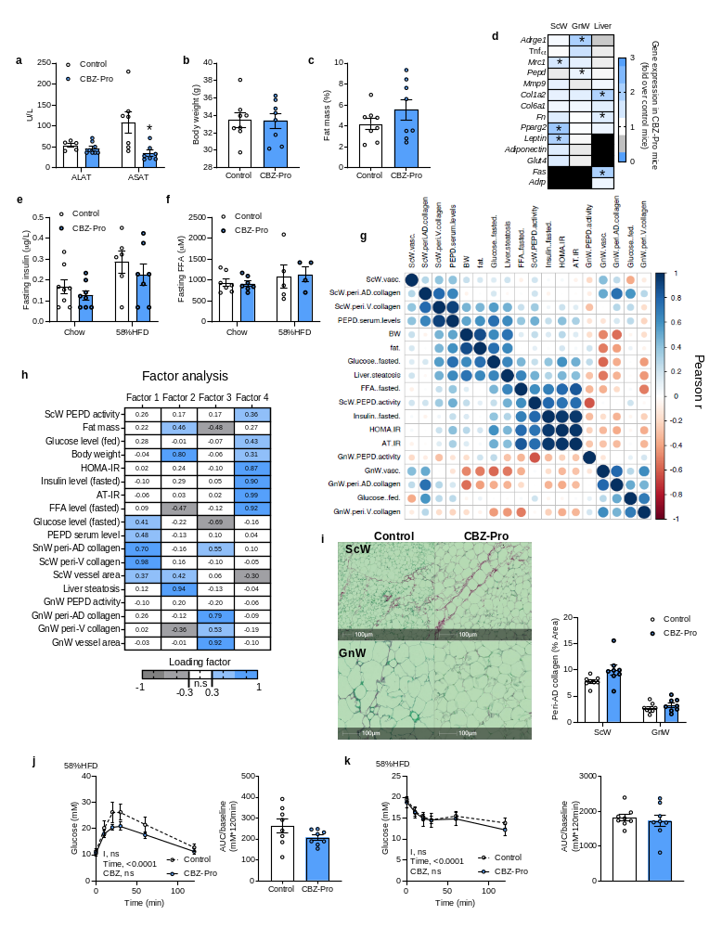

Extended data Figure 2: PEPD pharmacological inhibition promotes AT fibro-inflammation independently from obesity
a-c. ALAT and ASAT serum levels (a), body weight (b), and fat mass % (c), in mice treated 10 weeks or not (control, n=8) with CBZ-Pro (n=8). d. Heat map representation of the fold variation of gene expression in ScW, GnW and liver from CBZ-Pro-treated mice (n=8) compared to control mice (n=8). e, f. Fasting insulin and FFA blood levels from CBZ-Pro-treated mice (n=8) compared to control mice (n=8) fed chow and HFD 58% for 16 weeks. g. Pearson correlations between ScW and GnW ECM remodelling markers, PEPD serum levels and metabolic parameters in control and CBZ-Pro-treated mice (n=16). h. Heat map representing the four factors extracted through exploratory factor analysis. The columns report the factors loadings of the observed variables. i. Representative images of red Sirius staining in ScW and GnW of control (n=8) and CBZ-Pro treated mice (n=8) fed HFD 58%, and corresponding quantification of peri-adipocyte collagen content (peri-AD) represented in % Area (excluding perivascular staining). j, k. Blood glucose levels up to 120 min. after an intraperitoneal injection of glucose (2g/kg) in a glucose tolerance test (j) or insulin (0.75 IU/kg) in an insulin tolerance test (k) in control (n=8) and CBZ-Pro treated mice (n=8) fed HFD 58%. Respective AUC are represented. *p<0.05 compared to control using t-test (a-d, i-k); 2way ANOVA with Turkey’s post-hoc multiple comparisons test (e, f, j, k).

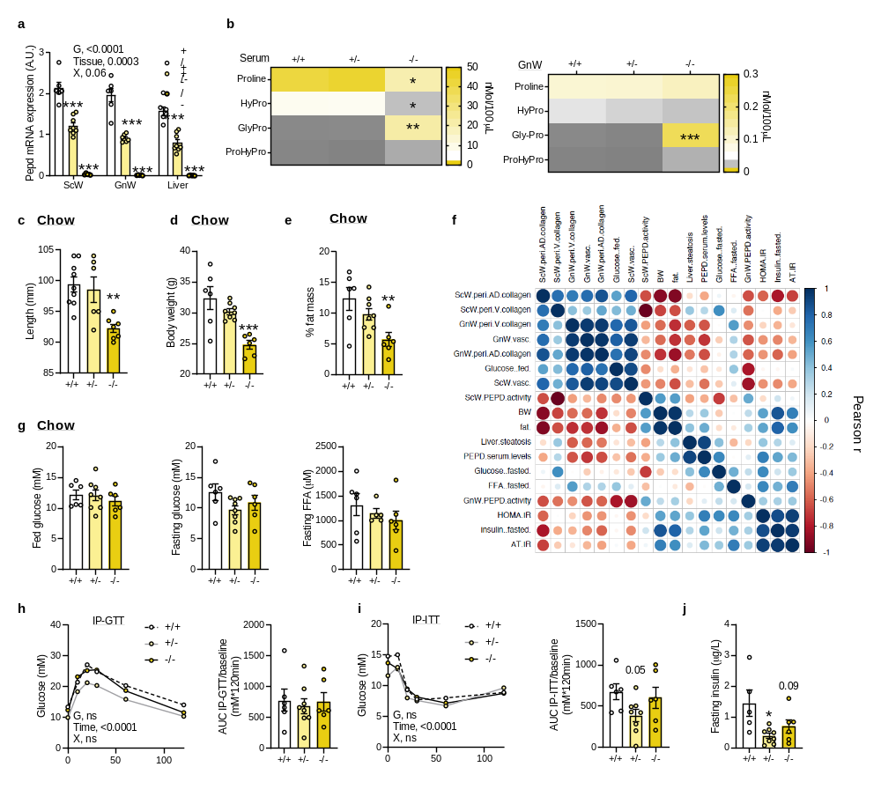

Extended data Figure 3: Pepd silencing promotes AT fibrosis but does not affect metabolic parameters in chow fed mice. a. Pepd RNA relative expression in ScW, GnW and liver from pepd WT (n=6), HET (n=8) and KO mice (n=5). b. Level of amino acids related to proline metabolism in the serum or GnW explant medium from pepd WT (n=6), HET (n=8) and KO mice (n=5). c-e, g, j. Body length (c), body weight (d), fat mass % (e), fed glucose , fasting glucose and FFA (g) blood levels, and fasting insulin (j) in pepd WT (n=6), HET (n=8) and KO (n=5)mice fed chow diet. f. Pearson correlations between ScW and GnW ECM remodelling markers, PEPD serum levels and metabolic parameters in pepd mice fed chow (n=19). h, i. Blood glucose levels up to 120 minutes after an intraperitoneal injection of glucose (2g/kg) in a glucose tolerance test (h, IP-GTT) or insulin (0.75 IU/kg) in an insulin tolerance test (i, IP-ITT), and respective AUC adjusted to basal, in pepd WT (n=6), HET (n=8) and KO (n=5)mice fed chow diet. 2way ANOVA with Turkey’s post-hoc multiple comparisons test; G, genotype; X, interaction (a, h, i). *p<0.05 compared to +/+ using One way ANOVA with Dunnett’s (b-g, j) or Sidak’s (h, i) post-hoc multiple comparisons test.

Extended data Figure 4: Pepd silencing exacerbates metabolic disturbances in HFD 58%-fed mice. a. Body weight curves and fat mass % curves of pepd WT, HET and KO mice after 20 weeks HFD 45% (n=8, 11, 9, respectively) and HFD 58% (n=8, 11, 8, respectively). B, c. Blood glucose levels up to 120 min. after an intraperitoneal injection of glucose in a glucose tolerance test (b) or insulin (0.75 IU/kg) in an insulin tolerance test (c) with the representative AUC in pepd WT (n=9), HET (n-11) and KO (n=9) mice fed HFD 45%. d. Fasting glucose, insulin and FFA blood levels in pepd WT (n=8), HET (n=11) and KO (n=8) mice fed HFD 45%. e. Representative images of red Sirius staining in ScW and GnW from C57Bl/6 mice fed chow (n=6), 45%HFD (n=8) and HFD 58% (n=8, 20 weeks) conditions and quantification of peri-adipocyte collagen content (peri-AD) represented in % Area (excluding perivascular staining).f. Heat map of gene expression in GnW from C57Bl/6 mice fed 20 weeks with chow (n=6), 45%HFD (n=8) and HFD 58% (n=8). Results are expressed as fold change over chow diet. g. AT-IR index in pepd WT, HET and KO mice in chow (n=6, 8, 6, respectively), 45%HFD (n=9, 11, 9, respectively) and HFD 58% conditions (n= 8,11,9 respectively). h. Representative images of H&E staining in liver from pepd WT, HET and KO mice fed chow (n=4, 6, 4, respectively), HFD 45% (n=7, 10, 6, respectively) and HFD 58% conditions (n= 9, 11, 6, respectively) and quantification of liver steatosis. 2way ANOVA with Turkey’s post-hoc multiple comparisons test; G, genotype; X, interaction (a-c, g, h). *p<0.05 compared to +/+ using One way ANOVA with Sidak’s (b, c, e) or Dunnett’s (d) post-hoc multiple comparisons test. *p<0.05 using t-test (f).

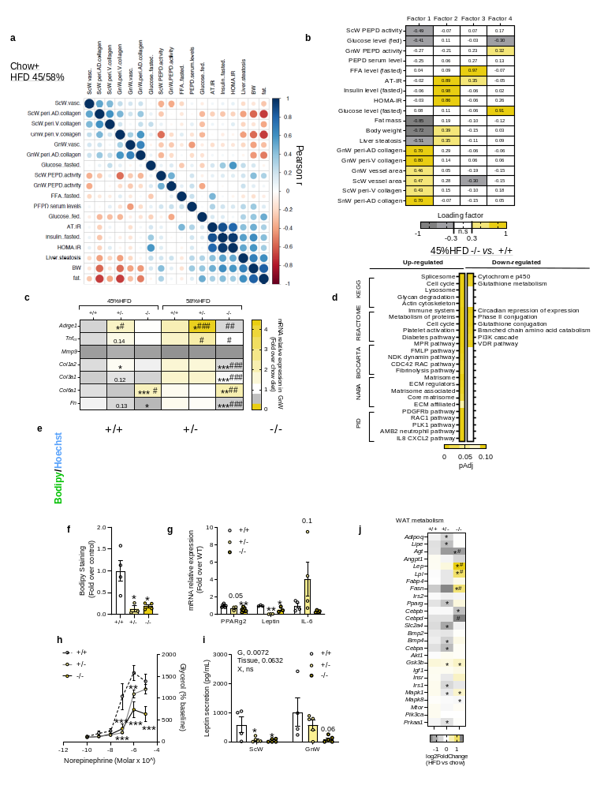

Extended data Figure 5: Pepd silencing promotes AT dysfunctions and exacerbates fAT fibro-inflamamtion in HFD 58%-fed mice
a. Pearson correlations between ScW and GnW ECM remodelling markers, PEPD serum levels and metabolic parameters in pepd WT, HET and KO fed chow, HFD 45% and 58% (n=76). b. Heat map representing the four factors extracted through exploratory factor analysis. The columns report the factors loadings of the observed variables. c. Heat map of gene expression in GnW from pepd WT, HET and KO fed HFD 45% (n=6, 10, 9, respectively) and HFD 58% (n=8, 9, 9, respectively) expressed as fold change variation over chow diet; *p<0.05 compared to chow, #p<0.05 compared to WT. d. Pathway enrichment analysis of the DEGs in GnW from pepd KO mice (n=9) compared to WT mice (n=8) fed HFD 45%, using different data bases (KEGG, Reactome, Biocarta, NABA and PID). The heat maps indicate the level of significant changes (false discovery rate-adjusted p-value). e, f. Representative image of confocal analysis (Bodipy staining in green, e) and quantification of lipid accumulation (f) in primary differentiated adipocytes isolated from GnW of pepd WT, HET and KO mice (n=4). g. Gene expression in primary differentiated adipocytes isolated from GnW of pepd WT, HET and KO mice (n=4). h. Lipolytic dose-response curves for mature adipocytes isolated from GnW of from pepd WT (n=5), HET (n=7) and KO mice (n=6) in chow condition in response to 2h treatment with Norepinephrine; *p<0.05 compared to WT. i. ELISA analysis of leptin secretion from ScW and GnW explants from pepd WT (n=4), HET (n=5) and KO (n=5) mice in chow condition. j. Heat map of AT-related DEGs in GnW of pepd WT, HET and KO mice in HFD 45% (8, 10, 9, respectively) expressed as Log2 fold change (Log2FC) variation over chow diet (n=4, 8, 5, respectively); *p-Adj<0.1, significant DEG compared to chow diet. #q<0.05 compared to pepd W. 2way ANOVA with Turkey’s post-hoc multiple comparisons test (c, h). *p<0.05 compared to WT using One way ANOVA with Dunnett’s post-hoc multiple comparisons test (f, g, i).

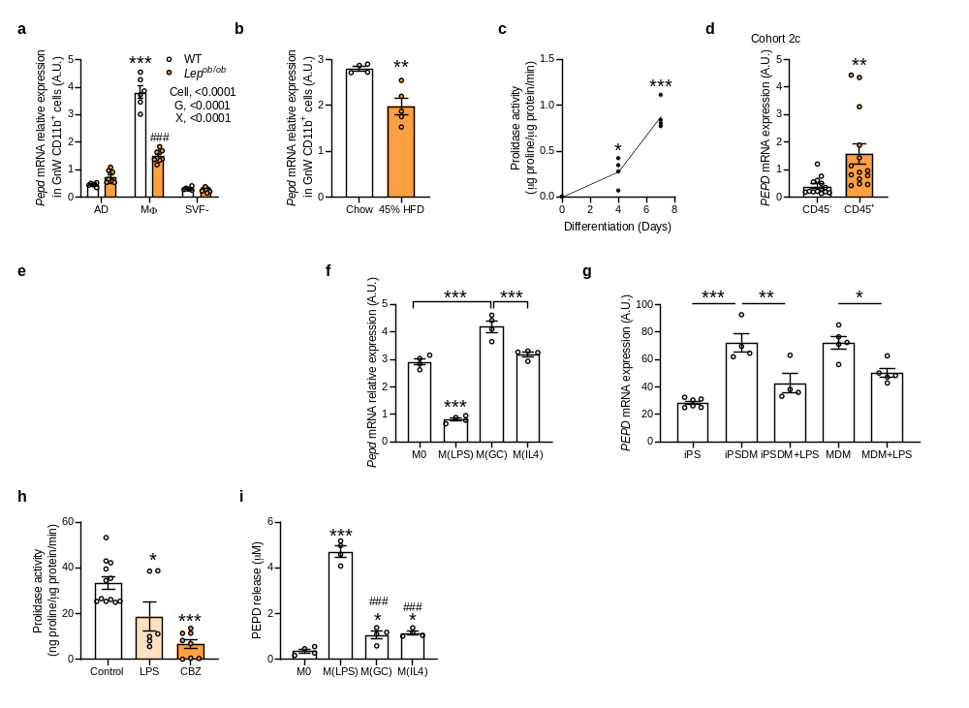

Extended data Figure 6: PEPD regulation in macrophages in response to obesity and polarising agents. a. Pepd mRNA relative expression in adipocytes (AD), Mɸ (CD11b positive cells) and negative stroma-vascular fraction (SVF⁻) isolated from GnW of WT (n=6) and Lep^{Ob/Ob} mice (n=9). *compared to AD WT, # compared to Mφ WT. b. Pepd mRNA relative expression in CD11b positive fraction (MΦ) of the GnW from C57Bl/6 mice fed chow (n=4) and HFD 45% (n=5) (20 weeks). c. Prolidase activity in BMDMs during differentiation (n=4). d. Pepd mRNA relative expression in CD45⁺ and CD45⁻ cells isolated from VsW of obese subjects from cohort 2c (n=14). e. Abundance of PEPD measured by mass spectrometry in unstimulated human iPS-derived Mɸ differentiated from FPS10C iPS line. Relative abundance of PEPD in comparison of other detected protein in the same sample is plotted in the graph- where actin and cyclin are representing examples of high and low abundant proteins respectively. f. Pepd mRNA relative expression in BMDMs treated or not (M0) 6h with LPS, dexamethasone (GC) or IL4 (n=4). g. Global transcriptome of iPS cells (n=6), iPS-derived Mɸ (iPSDM, n=4), and monocyte-derived Mɸ MDM (n=5) were compared by RNAseq; and transcript per million (TPM) value of PEPD mRNA for each condition is plotted as bar diagram. iPSDM and MDM were treated with either 2.5 ng LPS for 6h or left untreated. h. Prolidase activity in BMDMs treated or not (control, n=12) 24h with LPS (n=6) or CBZ-Pro (n=8). i. PEPD ELISA in culture media from BMDMs after 24h treatment with LPS, glucocorticoids (GC, dexamethasone) and IL4 (n=4). *p<0.05 compared to +/+ using One way ANOVA with Tuckey’s (f, g, i) or Dunnett’s (c, h) post-hoc multiple comparisons test. 2-way ANOVA with Tukey's post-hoc multiple comparisons test (a) ; G, genotype; T, treatment. *p<0.05 using t-test (b, d).
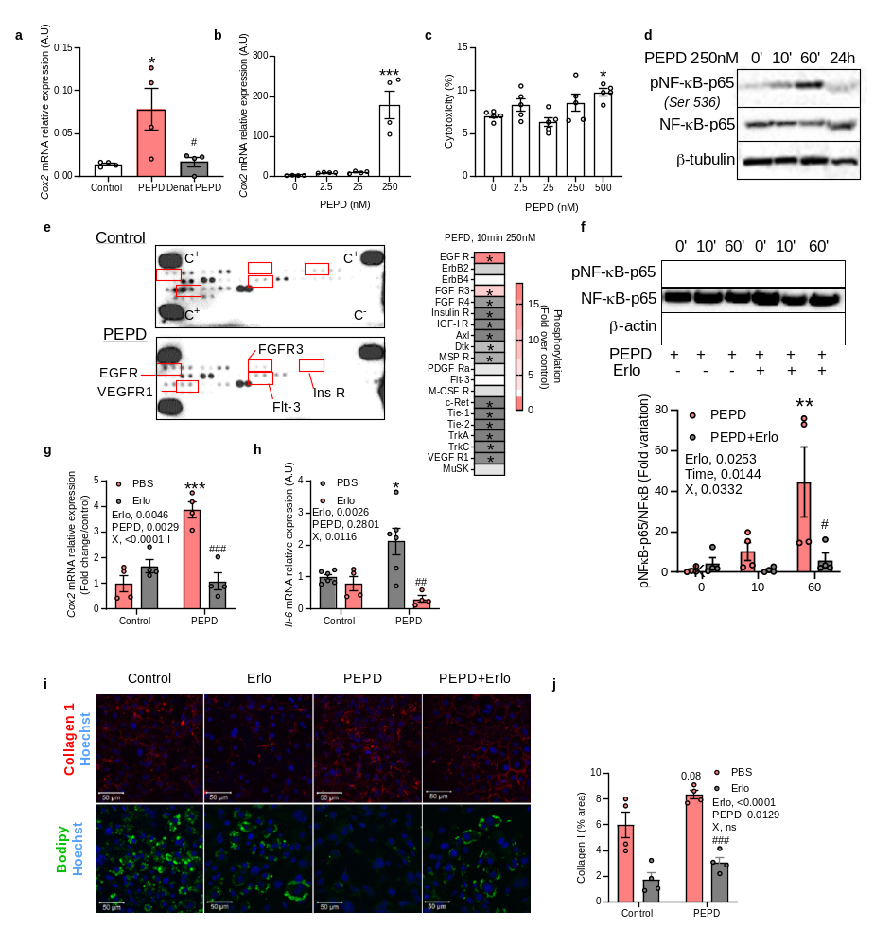
Extended data Figure 7: Purified PEPD protein promotes fibro-inflammation in macrophages and preadipocytes through EGFR signalling. a. Cox2 mRNA relative expression in BMDMs treated or not (control) 4h with purified PEPD protein active or denaturated (denat PEPD) (n=3).b. Dose response effect of 4h treatment with purified PEPD protein on cox2 mRNA relative expression in BMDMs (n=4-). c. % of cytotoxicity in BMDMs after 4h treatment with purified PEPD protein (n=4). d.Representative images of blots of total and phosphorylated (Ser 536) NF-kB protein and beta-tubulin in BMDMs (n=4) treated with purified PEPD protein (0, 10, 60min or 24h, 250nM). e. Tyrosine-kinase receptor phospho-Array of multiple analytes and quantification of phosphorylation levels in cell extract from BMDMs treated without (control) or with purified PEPD protein (10 min, 250nM). Data from one experiment of a pool of 4 independent macrophage preparations. f. Representative images of blots and quantification of total and phosphorylated (Ser 536) NF-kB protein and beta-Actin in BMDMs (n=4) pre-treated or not with Erlotinib (Erlo, 5µM) prior treatment with purified PEPD protein (0, 10 and 60min, 250nM), and quantification. *compared to PEPD 0min, # compared to PEPD 60min. X, interaction. g. Cox2 mRNA relative expression in BMDMs (n=4) pre-treated (Erlo) or not (PBS) with Erlotinib 5µM, prior 24h treatment with (PEPD) or without (control) purified PEPD protein. * compared to control PBS, # compared to PEPD PBS. h. Il-6 gene expression in 3T3-L1 adipocytes pre-treated (Erlo, n=4) or not (PBS, n=6) with Erlotinib (5µM) prior treatment with (PEPD, n=6) or without (control, n=6) purified PEPD protein (250nM) during the first 5 days of adipogenic differentiation. * compared to control PBS, # compared to PEPD PBS. I, j. Representative images of confocal analysis of anti-Collagen type I (in red,) and Bodipy staining (lipid accumulation in green) (i) and corresponding quantifications of collagen I staining (j) in 3T3-L1 adipocytes (n=4) pre-treated (Erlo) or not (PBS) with Erlotinib (5µM) prior treatment with (PEPD) or without (control) purified PEPD protein (250nM) during the first 5 days of adipogenic differentiation. * compared to control PBS, # compared to PEPD PBS. X, interaction. *p<0.05, compared to control (a) or PEPD 0mM (b, c) using a 1way ANOVA with Dunnett’s (b, c ) or Tuckey’s (a) post-hoc multiple comparisons test. 2-way ANOVA with Tukey's post-hoc multiple comparisons test (f-h, j).

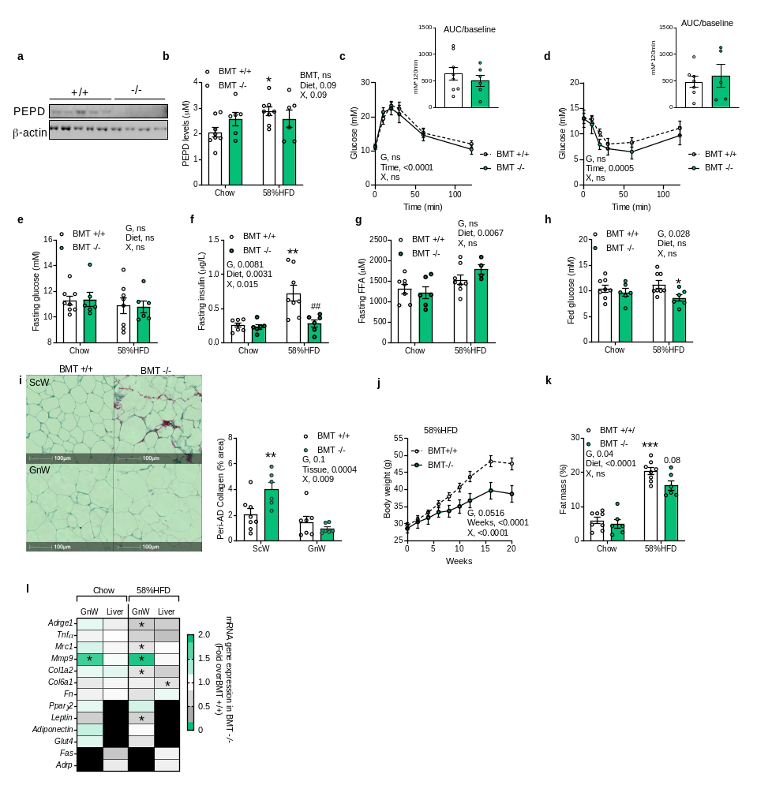

Extended data Figure 8: Pepd silencing in hematopoietic cells prevent obesity and associated metabolic disturbances. a. Representative image of western blot analysis of PEPD and Actin protein expression in BMDMs from pepd WT (n=5) and KO mice (n=4). b. ELISA analysis of PEPD levels in the serum of BMT WT (n=8) and KO (n=6) mice fed chow and HFD 58%. c, d. Blood glucose levels up to 120 min. after an intraperitoneal injection of glucose (2g/kg) in a glucose tolerance test (c) or insulin (0.75 IU/kg) in an insulin tolerance test (d) in BMT WT (n=8) and KO mice (n=6) fed chow. Respective AUC are represented. e-h. Fasting glucose (e), fasting insulin (f), fasting FFA (g) and fed glucose (h) blood levels in BMT-WT (n=8) mice compared to BMTKO mice (n=6) fed chow and HFD 58% (20 weeks). i. Representative images of red Sirius staining ScW and GnW from BMT-WT (n=8) mice compared to BMTKO mice (n=6) fed HFD 58% and quantification of peri-AD collagen represented as %. j. Body weight curve in BMT-WT (n=8) mice compared to BMTKO mice (n=6) mice between 0 and 20 weeks HFD 58%. k. Fat mass % in BMT +/+ (n=8) and -/- (n=6) mice fed chow and HFD 58% for 20 weeks. l. Heat map of gene expression in GnW and liver from BMTKO mice (n=6) fed chow and HFD 58% (20 weeks) expressed as fold change variation over BMT WT mice (n=8). 2way ANOVA with Turkey’s post-hoc multiple comparisons test; G, genotype; X, interaction (b-k).*p<0.05 compared to BMT WT mice using t-test (c, d).

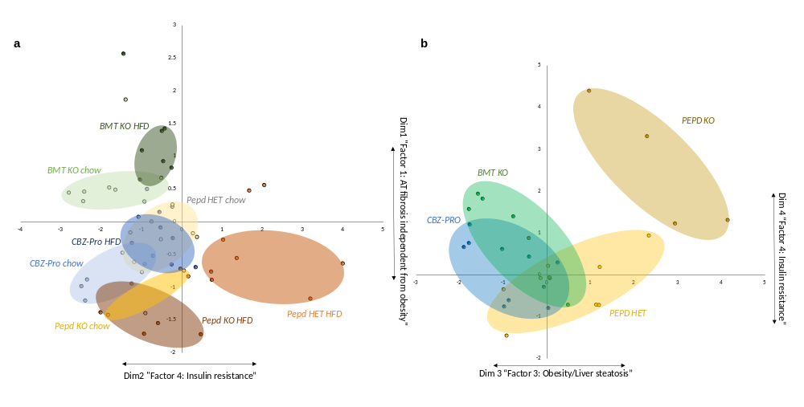

Extended data Figure 9: Insulin resistance-related variables are driving differences between the animal models of PEPD downregulation. Plot of mice from the three animal models (i.e. CBZ-Pro, PEPD and BMT) according to factor 1 and 4 (a) or factor 3 and 4 (b) extracted through the EFA presented in Figure 4c and 4a respectively. Each colour corresponds to a group of animal.

Extended data Table 1 | Clinical parameters and bivariate correlations between PEPD gene expression and metabolic parameters in cohort 1 and 3
 | Cohort 1 |  |  |  | Cohort 3
 | VsW (n=84) |  | ScW (n=70) |  | VsW(n=46) |  | ScW (n=36)
 | r | p | r | p | r | p | r | p
Age (years) | 0.36 | 0.001 | 0.05 | 0.6 | 0.21 | 0.1 | -0.07 | 0.6
BMI (kg/m2) | -0.34 | 0.002 | 0.25 | 0.04 | -0.35 | 0.01 | 0.13 | 0.4
Fasting glucose (mg/dl) | 0.31 | 0.005 | 0.21 | 0.08 | 0.13 | 0.4 | -0.14 | 0.4
Fasting triglycerides (mg/dl) | 0.16 | 0.1 | 0.07 | 0.5
PLIN (R.U.) | 0.37 | 0.01 | 0.36 | 0.02 | 0.61 | <0.0001 | 0.22 | 0.2
CIDEC (R.U.) | 0.32 | 0.03 | 0.24 | 0.1 | 0.63 | <0.0001 | 0.17 | 0.3
ADRP (R.U.) | 0.37 | 0.01 | 0.08 | 0.6 | 0.13 | 0.4 | -0.23 | 0.1
TIP47 (R.U.) | 0.4 | 0.006 | 0.21 | 0.1 | 0.69 | <0.0001 | 0.22 | 0.1
PPARG (R.U.) | 0.51 | <0.0001 | 0.09 | 0.5 | 0.28 | 0.07 | 0.07 | 0.7
FASN (R.U.) | 0.16 | 0.1 | -0.09 | 0.5 | 0.05 | 0.7 | 0.24 | 0.1
TNFα (R.U.) | 0.1 | 0.4 | -0.04 | 0.7 | 0.21 | 0.2 | 0.27 | 0.1
COL6A3 (R.U.) | 0.1 | 0.4 | 0.03 | 0.8
COL6A6 (R.U.) | -0.19 | 0.1 | 0.1 | 0.6
CD68 (R.U.) | 0.23 | 0.05 | 0.1 | 0.4
EGFR (R.U.) | 0.22 | 0.05 | -0.18 | 0.2 | 0.37 | 0.02 | -0.02 | 0.9
COL4A1 (R.U.) |  |  |  |  | 0.36 | 0.02 | 0.02 | 0.9
GLUT4 (R.U.) |  |  |  |  | 0.55 | <0.0001 | 0.16 | 0.3
(R.U.) |  |  |  |  | -0.08 | 0.6 | -0.07 | 0.7
ADIPOQ (R.U.) |  |  |  |  | 0.33 | 0.03 | -0.02 | 0.8

