upplementary information:
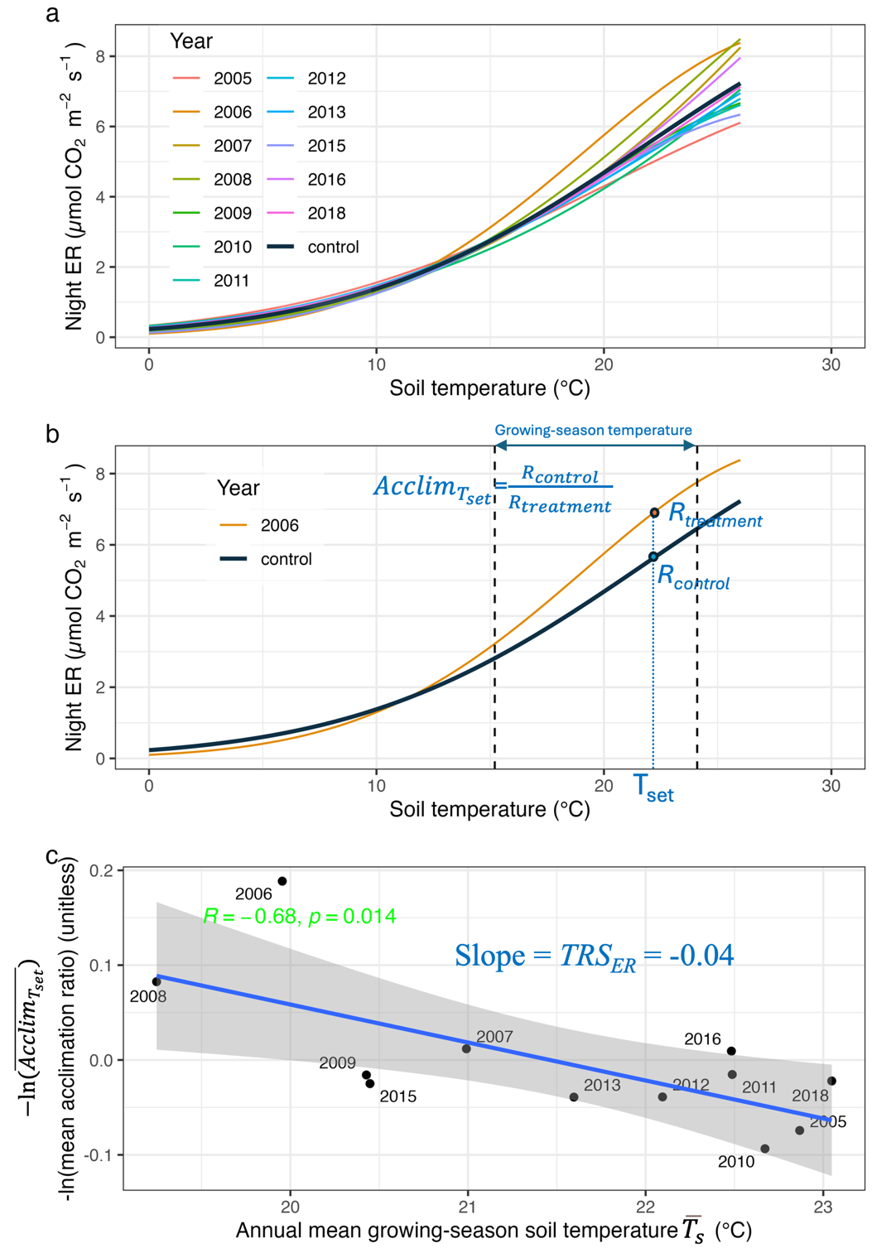
Figure S1. Illustration of the three steps for estimating thermal response strength of ecosystem respiration (TRS_{ER}) using the site US-IB2 as an example: (a) fit a curve between topsoil temperature ($T_{s}$) and nighttime ecosystem respiration (ER) (i.e., $T_{s}\sim ER$ curve) for each year (i.e., treatment conditions) and all the years (i.e., the control condition), (b) calculate average acclimation ratios over the growing-season temperature range for each year ($\overline{{Acclim}_{T_{set}}}$), and (c) conduct a linear regression between the annual mean growing-season topsoil temperature ($\overline{T_{s}}$) and $-ln⁡(\overline{{Acclim}_{T_{set}}}$), with the regression slope representing ${TRS}_{ER}$.
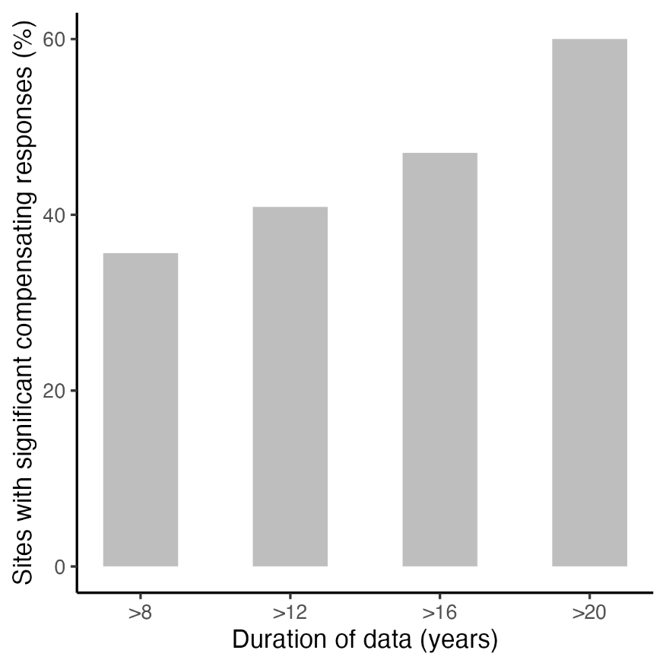
Figure S2. The fraction of sites with significant compensating thermal responses increases with the duration of CO₂ flux data.
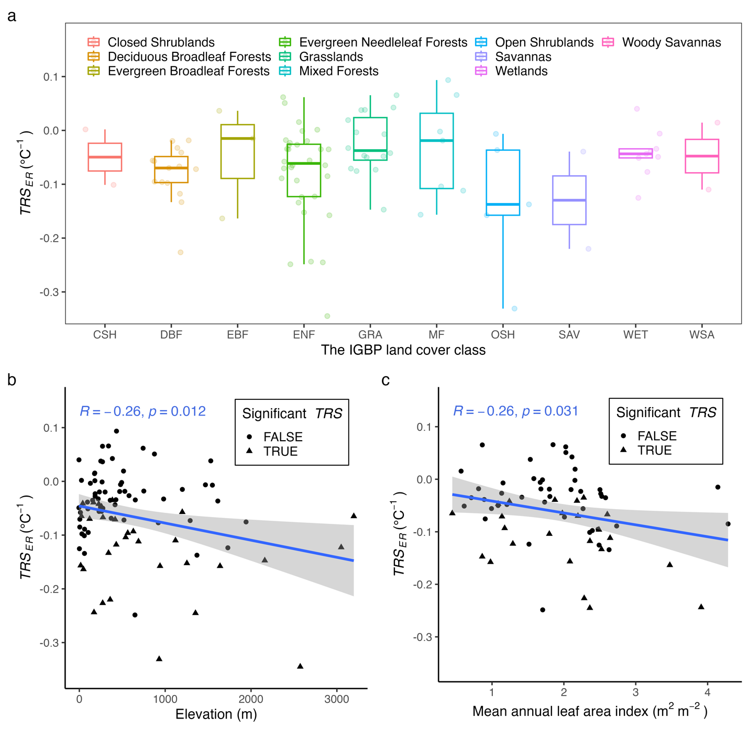
Figure S3. Variations in thermal response strength of ecosystem respiration (${TRS}_{ER}$) with IGBP land cover class, elevation, and mean annual leaf area index, revealed by univariate analysis. (a) No significant difference in ${TRS}_{ER}$ is observed among the various IGBP land cover classes (n = 93, p = 0.19 by analysis of variance). (b) The magnitude of compensating ${TRS}_{ER}$ increases with elevation (more negative) across all study sites (n = 93). (c) For sites in humid climates (i.e., humid tropical, subtropical, and continental climates; n = 69), the magnitude of compensating ${TRS}_{ER}$ increases with mean annual leaf area index (more negative). The trends shown in (b) and (c) from the linear univariate analysis are consistent with the partial dependence plots from the random forest model (Fig. 3c-d), except that the random forest model can capture highly nonlinear relationships.
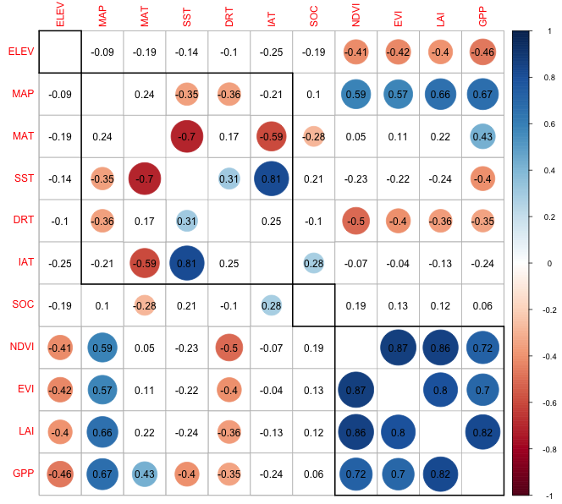
Figure S4. Pearson correlation matrix between any two variables potentially affecting ${TRS}_{ER}$ (See Table S3 for the definitions of these variables). The numbers represent the correlation coefficients. Circles indicate correlations above the 0.01 significance level, with red circles representing negative correlations and blue circles indicating positive correlations. Variables within a bold square belong to one category.
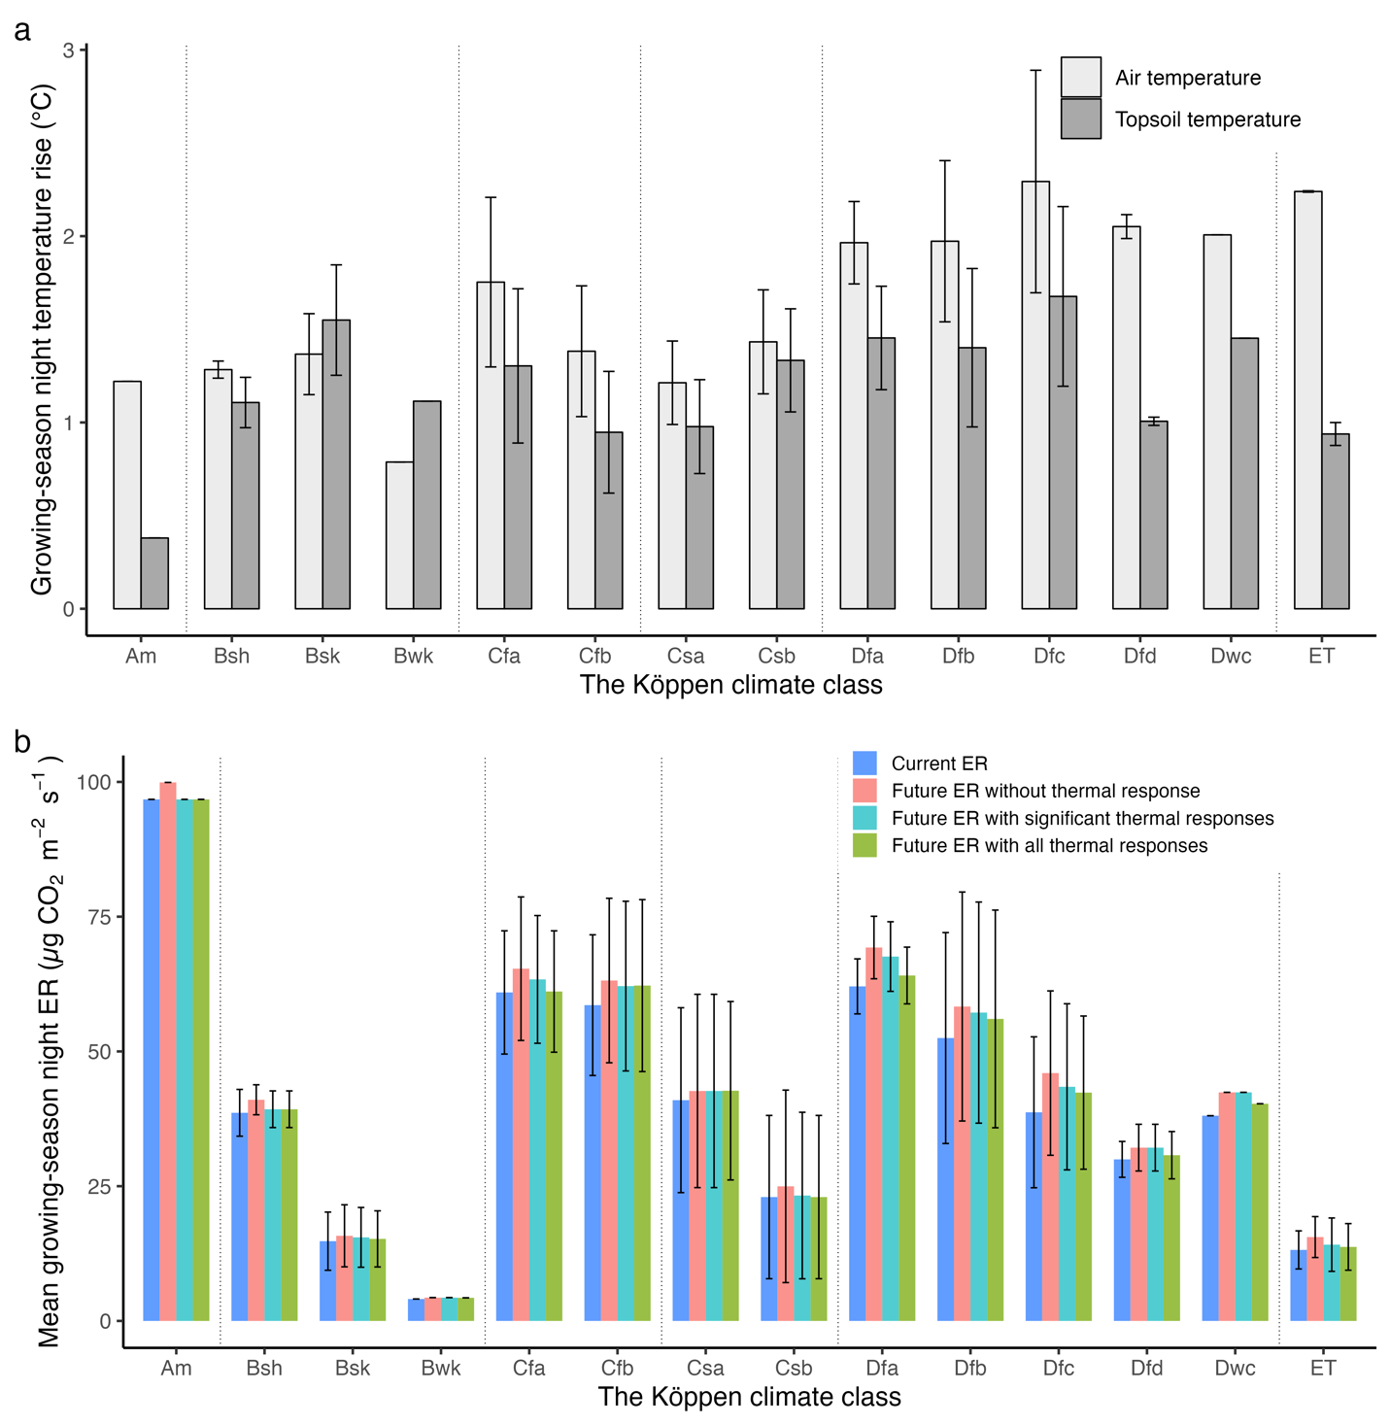
Figure S5. Growing-season nighttime air and topsoil (depth < 0.1 m) temperature rise from 2000-2020 to 2041-2060 at the study sites grouped by the Köppen climate classes (a) and the responses of future nighttime ecosystem respiration (ER) with and without considering thermal responses (b) under the medium warming scenario (SSP245). Error bars denote standard deviation of temperature and ER for sites in the same climate class. In (b), future ER with all thermal responses was calculated using estimated ${TRS}_{ER}$ for all sites, while future ER with significant thermal responses was calculated assuming no thermal response for sites with non-significant ${TRS}_{ER}$ (p > 0.1).
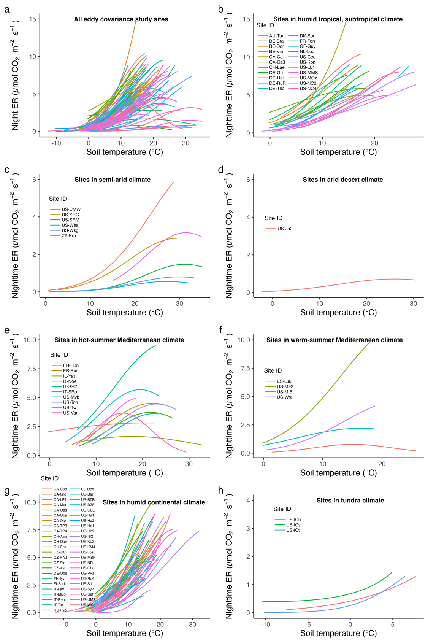
Figure S6. Relationships between topsoil temperature and nighttime ecosystem respiration (ER) for all the study sites (a), for sites in humid tropical, subtropical climate (b), in semi-arid climate (c), in arid desert climate (d), in hot-summer (e) and warm-summer (f) Mediterranean climate, in humid continental climate (g), and in tundra climate (h). Note: two sites in (e), US-Tw1 and US-Myb, which do not display clear hump-shaped temperature~ER relationships are wetlands.
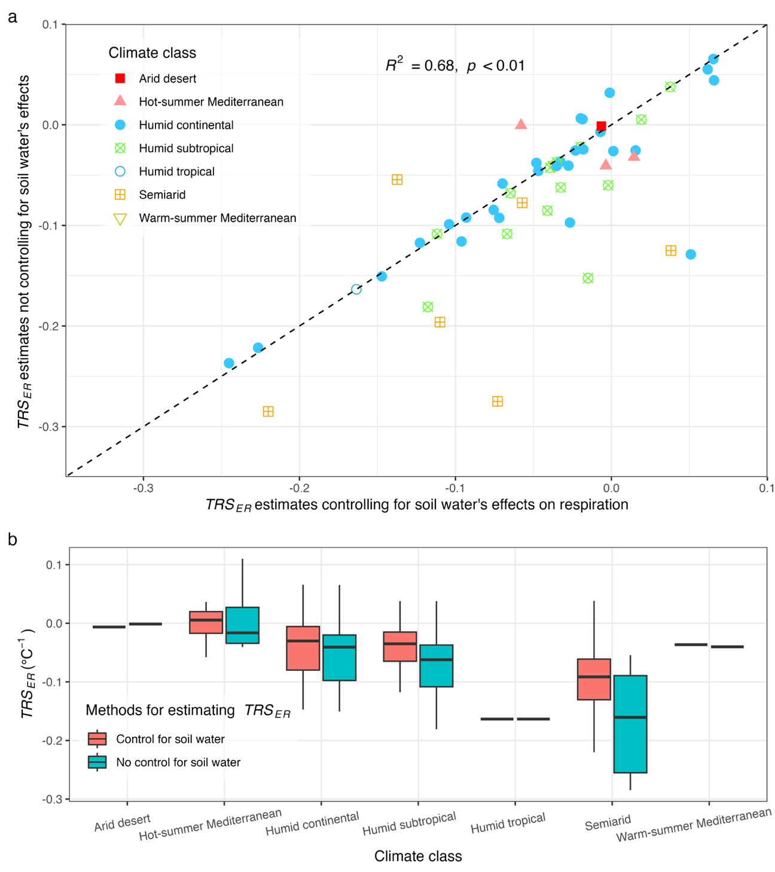
Figure S7. Comparison of ${TRS}_{ER}$ estimates using respiration models with and without controlling for the effects of soil water content. This figure compares ${TRS}_{ER}$ estimates derived from respiration models that either control for the direct effects of soil water content (Eq. (3)) or exclude these effects (i.e., removing the soil water term from Eq. (3)) for 54 flux sites with sufficient soil water measurements. (a) Overall comparison of ${TRS}_{ER}$ estimates from the two methods at the 54 sites. The black dashed line represents the 1:1 line. (b) Comparison of ${TRS}_{ER}$ estimates from the two methods by climate class. In semi-arid sites, controlling for soil water’s effects generally reduced the magnitude of estimated ${TRS}_{ER}$ (less negative) except for one site (US-Whs). For sites in other climates (e.g., arid, Mediterranean, and humid), the two methods generally provided similar estimates.

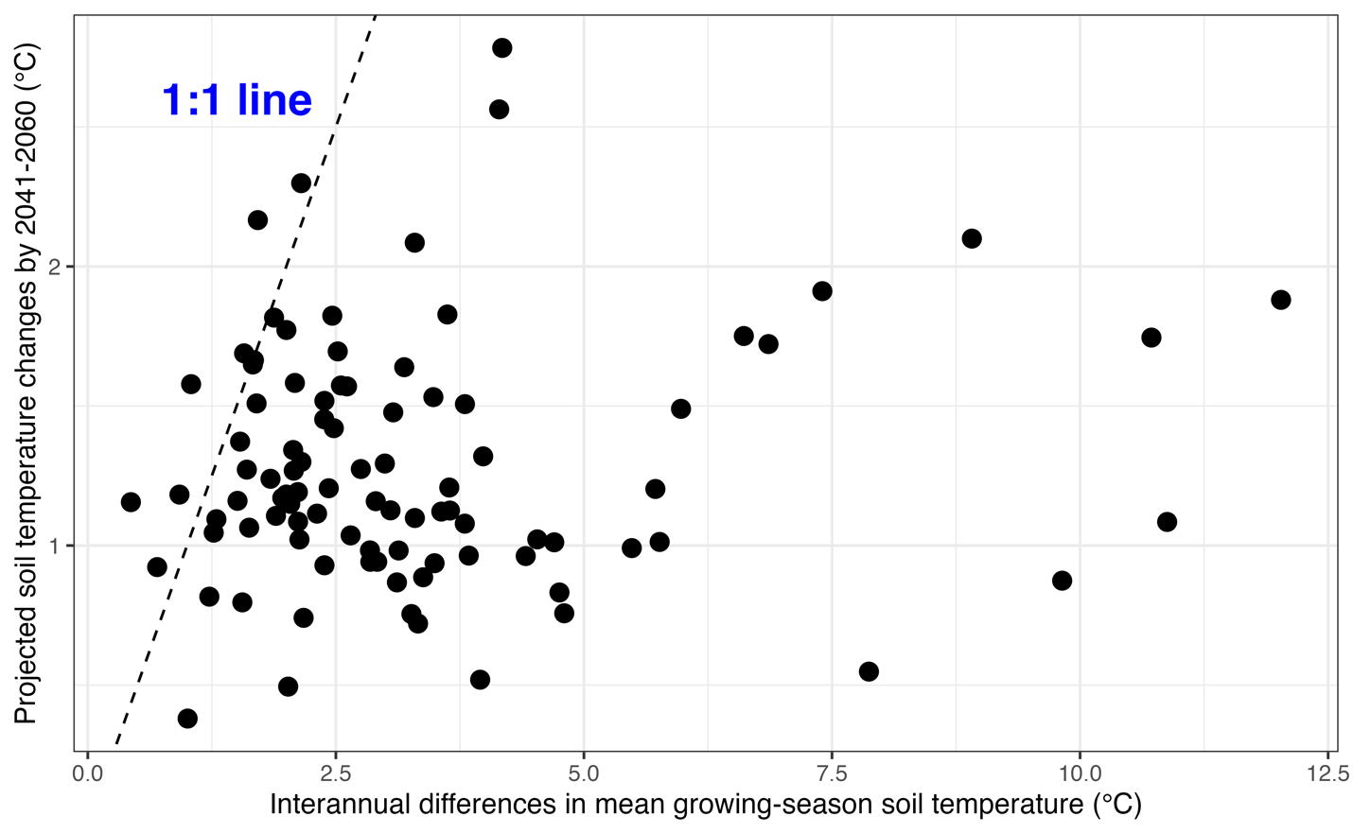
Figure S8. Comparison of interannual differences in mean growing-season topsoil temperature and projected topsoil temperature changes (2041-2060 under medium greenhouse gas emissions scenario: SSP245) for each study site. This figure shows that, for most sites (86 out of 93), interannual differences in mean growing-season topsoil temperature exceed projected topsoil temperature changes (below the 1:1 line). This suggests that using ${TRS}_{ER}$ derived from long-term observations over the past one to three decades to project the effects of thermal acclimation on future ecosystem respiration in 2041-2060 is unlikely to suffer from extrapolation errors or biased estimates for most sites.
Table S1. Climate, vegetation, and ecosystem characteristics of the 93 eddy covariance flux sites, along with the estimated thermal response strength of ecosystem respiration (${TRS}_{ER}$).
Köppen climate class | Study sites | Vegetation class | Soil water used or not | Number of years | Mean annual air temperature ($℃$) | Mean annual precipitation (mm) | Mean annual net ecosystem productivity  (g C m⁻²) | $${TRS}_{ER}$$  ($℃^{-1}$)
Am | GF-Guy | EBF | YES | 13 | 25.66 | 3041 | 242.09 | -0.164**
Bsh | US-CMW | DBF | YES | 17 | 17.01 | 288 | 369.04 | -0.057**
Bsh | ZA-Kru | SAV | YES | 10 | 21.86 | 547 | 44.58 | -0.220**
Bsk | US-Wkg | GRA | YES | 17 | 17.47 | 407 | 34.95 | 0.038
Bsk | US-SRM | WSA | YES | 17 | 19.19 | 380 | 2.05 | -0.110**
Bsk | US-Whs | OSH | YES | 15 | 17.12 | 320 | -15.04 | -0.137
Bsk | US-SRG | GRA | YES | 16 | 18.94 | 420 | 41.94 | -0.073
Bwk | US-Jo2 | OSH | YES | 10 | 17.64 | 282.3 | 174.96 | -0.006
Cfa | US-MMS | DBF | YES | 23 | 12.46 | 1032 | 357.65 | -0.067**
Cfa | US-Kon | GRA | NO | 11 | 13.15 | 867 | 163.00 | -0.071**
Cfa | US-MOz | DBF | YES | 14 | 13.53 | 986 | 364.68 | -0.033
Cfa | US-NC2 | ENF | NO | 11 | 15.99 | 1320 | 531.90 | -0.085
Cfa | US-LL1 | SAV | YES | 12 | 19.42 | 1310 | 203.97 | -0.039*
Cfa | US-NC4 | WET | NO | 10 | 17.04 | 1311 | -38.72 | -0.125
Cfa | US-Ced | CSH | NO | 9 | 12.03 | 1138 | 80.63 | -0.101
Cfb | CA-Ca3 | ENF | NO | 13 | 12.11 | 1676 | 401.96 | -0.244**
Cfb | CA-Ca1 | ENF | YES | 12 | 8.07 | 1369 | 373.76 | -0.020
Cfb | AU-Tum | EBF | YES | 10 | 9.63 | 1159 | 592.43 | -0.015
Cfb | BE-Bra | MF | NO | 14 | 11.07 | 750 | 127.31 | -0.157*
Cfb | BE-Vie | MF | YES | 24 | 8.62 | 1062 | 473.58 | -0.002
Cfb | CH-Lae | MF | YES | 13 | 8.44 | 1100 | 281.36 | -0.112**
Cfb | DE-Gri | GRA | NO | 15 | 8.65 | 901 | 82.98 | 0.042
Cfb | DE-Hai | DBF | YES | 18 | 8.54 | 720 | 523.22 | -0.118**
Cfb | DE-Tha | ENF | YES | 24 | 9.24 | 843 | 469.55 | -0.035**
Cfb | DK-Sor | DBF | YES | 21 | 8.72 | 660 | 214.94 | -0.041**
Cfb | NL-Loo | ENF | YES | 14 | 10.14 | 786 | 473.04 | -0.065**
Cfb | BE-Dor | GRA | YES | 11 | 10.06 | 581.8 | 73.94 | 0.038
Cfb | DE-RuR | GRA | YES | 10 | 8.43 | 1033 | 118.02 | 0.019
Cfb | FR-Fon | DBF | NO | 16 | 11.73 | 720 | 603.69 | -0.095
Csa | US-Var | GRA | YES | 19 | 16.07 | 559 | 2.38 | -0.004
Csa | US-Ton | WSA | YES | 16 | 16.50 | 559 | 87.79 | 0.014
Csa | US-Myb | WET | NO | 10 | 15.63 | 338 | 412.36 | 0.040
Csa | US-Tw1 | WET | NO | 11 | 14.99 | 421 | 269.50 | -0.049
Csa | FR-Pue | EBF | YES | 13 | 14.13 | 883 | 347.80 | 0.036
Csa | IT-Noe | CSH | NO | 8 | 16.40 | 588 | 192.51 | 0.002
Csa | IT-SRo | ENF | NO | 10 | 15.22 | 920 | 383.80 | -0.071
Csa | FR-FBn | MF | NO | 11 | 14.02 | 700 | 558.68 | 0.094
Csa | IL-Yat | ENF | NO | 15 | 18.43 | 285 | 135.99 | -0.035
Csa | IT-SR2 | ENF | YES | 8 | 15.71 | 920 | 225.85 | -0.058
Csb | US-Me2 | ENF | NO | 10 | 7.99 | 523 | 352.60 | -0.152*
Csb | US-MtB | ENF | NO | 9 | 9.89 | 790 | 495.35 | -0.345*
Csb | US-Wrc | ENF | NO | 9 | 9.25 | 2452 | 273.83 | -0.069
Csb | ES-LJu | OSH | YES | 12 | 11.86 | 400 | 3.29 | -0.037
Dfa | US-IB2 | GRA | NO | 12 | 9.22 | 930.25 | 215.19 | -0.042**
Dfa | US-KL2 | GRA | YES | 13 | 9.32 | 1027 | 263.12 | -0.047**
Dfa | US-Ro4 | GRA | NO | 10 | 7.47 | 879 | 281.71 | -0.050
Dfa | US-KM4 | GRA | YES | 12 | 9.20 | 1027 | 6.01 | -0.048
Dfa | US-Oho | DBF | NO | 10 | 10.50 | 849 | 783.73 | -0.056
Dfa | US-Slt | DBF | NO | 10 | 12.34 | 1138 | -8.65 | -0.098
Dfb | CA-Cbo | DBF | YES | 13 | 7.40 | 876.34 | 317.77 | -0.070**
Dfb | US-Ha1 | DBF | NO | 17 | 8.33 | 1071 | 249.88 | -0.133*
Dfb | US-Ha2 | ENF | NO | 14 | 8.38 | 1071 | 451.45 | -0.035
Dfb | US-Los | WET | NO | 14 | 5.14 | 828 | 97.09 | -0.006
Dfb | US-Ho1 | ENF | NO | 18 | 6.38 | 1070 | 301.47 | -0.134
Dfb | US-Ho2 | ENF | NO | 18 | 7.30 | 1064 | 310.77 | -0.089
Dfb | US-WCr | DBF | YES | 14 | 5.29 | 787 | 264.61 | -0.072
Dfb | US-UMB | DBF | YES | 11 | 7.16 | 803 | 205.28 | -0.020
Dfb | US-PFa | MF | NO | 13 | 5.43 | 823 | -7.98 | -0.019
Dfb | US-Syv | MF | YES | 10 | 4.56 | 826 | 150.44 | -0.104*
Dfb | US-Bar | DBF | YES | 12 | 7.41 | 1245.77 | 215.12 | -0.227**
Dfb | CA-TP4 | ENF | YES | 14 | 9.31 | 1036 | 167.49 | -0.028
Dfb | CA-TP3 | ENF | YES | 10 | 9.06 | 1036 | 503.71 | -0.023
Dfb | CA-LP1 | ENF | YES | 10 | 2.89 | 570 | 175.88 | -0.018
Dfb | CA-Gro | MF | YES | 8 | 3.75 | 831 | 118.19 | 0.066
Dfb | US-MBP | WET | NO | 12 | 4.11 | 780 | 221.42 | -0.044
Dfb | CZ-BK1 | ENF | YES | 15 | 6.90 | 1316 | 831.15 | 0.051
Dfb | CZ-wet | WET | NO | 11 | 8.77 | 604 | -45.16 | -0.034
Dfb | IT-Lav | ENF | YES | 14 | 7.30 | 1291 | 1965.12 | -0.245**
Dfb | IT-MBo | GRA | YES | 15 | 5.43 | 1214 | 31.02 | -0.007
Dfb | RU-Fyo | ENF | YES | 19 | 5.41 | 711 | -93.58 | -0.001
Dfb | CH-Fru | GRA | YES | 13 | 7.89 | 1651 | 205.84 | -0.033
Dfb | CZ-RAJ | ENF | NO | 8 | 8.15 | 681 | 538.02 | -0.249
Dfb | CZ-Stn | DBF | YES | 11 | 9.06 | 685 | 247.12 | -0.096**
Dfb | DE-Obe | ENF | YES | 10 | 6.75 | 996 | 259.49 | 0.062
Dfc | US-GLE | ENF | NO | 13 | 0.33 | 1200 | 42.17 | -0.065*
Dfc | US-NR1 | ENF | YES | 19 | 2.35 | 800 | 196.56 | -0.123**
Dfc | CA-Oas | DBF | YES | 14 | 1.92 | 428.53 | 129.57 | -0.019
Dfc | CA-Man | ENF | NO | 12 | -1.18 | 520 | -0.59 | -0.056
Dfc | CA-Obs | ENF | YES | 11 | 1.21 | 405.6 | 54.98 | -0.093**
Dfc | CA-Ojp | ENF | YES | 11 | 1.44 | 430.5 | 38.12 | -0.027
Dfc | FI-Hyy | ENF | YES | 24 | 4.56 | 709 | 231.37 | 0.001
Dfc | FI-Sod | ENF | YES | 10 | 0.81 | 500 | -94.62 | 0.015
Dfc | IT-Ren | ENF | NO | 18 | 4.86 | 809.3 | 667.75 | -0.124
Dfc | IT-Tor | GRA | YES | 12 | 3.31 | 920 | 75.53 | -0.147*
Dfc | CH-Aws | GRA | YES | 8 | 3.76 | 918 | 373.64 | -0.076
Dfc | SE-Deg | WET | YES | 20 | 2.57 | 523 | 53.96 | 0.065
Dfc | CH-Dav | ENF | NO | 15 | 4.74 | 1062 | 83.56 | -0.158**
Dfd | US-BZB | WET | NO | 9 | -1.55 | 274 | -14.10 | -0.051
Dfd | US-BZF | WET | NO | 8 | -1.13 | 274 | -11.26 | -0.039
Dwc | US-Uaf | ENF | YES | 9 | -3.16 | 263 | 43.44 | -0.035
ET | US-ICt | OSH | NO | 11 | -5.48 | 318 | 2.68 | -0.331**
ET | US-ICh | OSH | NO | 11 | -6.62 | 318 | -14.82 | -0.158**
ET | US-ICs | WET | NO | 10 | -6.54 | 318 | -81.03 | -0.077
Note: ${TRS}_{ER}$ values marked with “*” and “**” denote statistically significant estimates at the 0.1 and 0.05 levels, respectively. The full names of climate class abbreviations are as follows: Am (tropical monsoon climate), Bsh (hot semi-arid climate), Bsk (cold semi-arid climate), Bwk (cold desert climate), Cfa (humid subtropical climate), Cfb (temperature oceanic climate), Csa (hot-summer Mediterranean climate), Csb (warm-summer Mediterranean climate), Dfa (hot-summer humid continental climate), Dfb (warm-summer humid continental climate), Dfc (subarctic climate), Dfd (extremely cold subarctic climate), Dwc (monsoon-influenced subarctic climate), and ET (tundra climate). We used the climate classifications reported by the AmeriFlux and FLUXNET websites for most sites, except for two sites: CA-LP1 (changed from Csa to Dfb) and US-MtB (changed from Dwb to Csb). These changes were made due to the inconsistency between the reported climate classifications and local climate conditions⁸⁶. The full names of vegetation class abbreviations are as follows: DBF (deciduous broadleaf forests), EBF (evergreen broadleaf forests), ENF (evergreen needleleaf forests), MF (mixed forests), CSH (closed shrublands), OSH (open shrublands), SAV (savannas), WSA (woody savannas), GRA (grasslands), and WET (permanent wetlands).

Table S2. Thermal response strength (TRS) of leaf, root, and soil respirations estimated from in-situ warming experiments and field-measured data that exhibited significant compensating thermal responses (i.e., thermal acclimation and negative TRS) in the literature.
Respiration type | Vegetation class | TRS  (1/$℃$) | Warming experiment/  seasonal measurement | Data sources
soil | evergreen needleleaf forests | -0.160 | warming experiment | Strömgren et al., 2001⁸⁷
soil | grasslands | -0.081 | warming experiment | Luo et al., 2001²⁶
leaf | deciduous broadleaf forests | -0.062 | seasonal measurement | Bolstad et al., 2003³⁴
leaf | evergreen broadleaf forests | -0.106 | warming experiment | Bruhn et al., 2007⁸⁸
leaf | multiple biome | -0.034 | seasonal measurement | Zhu et al., 2021⁵⁷
leaf | grasslands | -0.188 | warming experiment | Chi et al., 2013⁸⁹
leaf | deciduous broadleaf forests | -0.090 | seasonal measurement | Lee et al., 2005⁹⁰
leaf | deciduous broadleaf forests | -0.070 | seasonal measurement | Lee et al., 2005⁹⁰
leaf | deciduous broadleaf forests | -0.053 | seasonal measurement | Lee et al., 2005⁹⁰
leaf | evergreen needleleaf forests | -0.086 | seasonal measurement | OW et al., 2010⁹¹
leaf | deciduous broadleaf forests | -0.035 | seasonal measurement | OW et al., 2010⁹¹
leaf | deciduous broadleaf forests | -0.085 | seasonal measurement | Rodríguez-Calcerrada et al., 2009⁹²
leaf | deciduous broadleaf forests | -0.095 | seasonal measurement | Rodríguez-Calcerrada et al., 2009⁹²
leaf | deciduous broadleaf forests | -0.093 | seasonal measurement | Rodríguez-Calcerrada et al., 2009⁹²
leaf | grasslands | -0.158 | seasonal measurement | Searle et al., 2011⁹³
leaf | grasslands | -0.247 | seasonal measurement | Searle et al., 2011⁹³
leaf | evergreen needleleaf forests | -0.068 | warming experiment | Reich et al., 2016⁶¹
leaf | evergreen needleleaf forests | -0.064 | warming experiment | Reich et al., 2016⁶¹
leaf | evergreen needleleaf forests | -0.027 | warming experiment | Reich et al., 2016⁶¹
leaf | evergreen needleleaf forests | -0.022 | warming experiment | Reich et al., 2016⁶¹
leaf | evergreen needleleaf forests | -0.057 | warming experiment | Reich et al., 2016⁶¹
leaf | deciduous broadleaf forests | -0.058 | warming experiment | Reich et al., 2016⁶¹
leaf | deciduous broadleaf forests | -0.026 | warming experiment | Reich et al., 2016⁶¹
leaf | deciduous broadleaf forests | -0.045 | warming experiment | Reich et al., 2016⁶¹
leaf | deciduous broadleaf forests | -0.064 | warming experiment | Reich et al., 2016⁶¹
leaf | deciduous broadleaf forests | -0.030 | warming experiment | Reich et al., 2016⁶¹
leaf | evergreen needleleaf forests | -0.069 | seasonal measurement | Reich et al., 2016⁶¹
leaf | deciduous broadleaf forests | -0.039 | seasonal measurement | Reich et al., 2016⁶¹
soil | shrub | -0.503 | warming experiment | Rousk et al., 2013⁹⁴
soil | shrub | -0.072 | warming experiment | Rousk et al., 2014⁹⁴
soil | grasslands | -0.051 | warming experiment | Shen et al., 2020⁹⁵
soil | grasslands | -0.223 | warming experiment | Zhang et al., 2013⁹⁶
soil | grasslands | -0.346 | warming experiment | Suzuki et al., 2016⁹⁷
soil | grasslands | -0.240 | warming experiment | Suzuki et al., 2016⁹⁷
soil | grasslands | -0.389 | warming experiment | Zhao et al., 2019⁹⁸
soil | grasslands | -0.150 | warming experiment | Chen et al., 2016⁹⁹
soil | grasslands | -0.173 | warming experiment | Wang et al., 2019¹⁰⁰
soil | grasslands | -0.109 | warming experiment | Wang et al., 2019¹⁰⁰
soil | mixed forests | -0.144 | warming experiment | Suseela et al., 2013²⁴
soil | mixed forests | -0.090 | warming experiment | Suseela et al., 2013²⁴
soil | mixed forests | -0.080 | warming experiment | Suseela et al., 2013²⁴
root | evergreen needleleaf seedlings | -0.085 | warming experiment | Chen et al., 2021³⁰
root | evergreen needleleaf seedlings | -0.044 | warming experiment | Chen et al., 2021³⁰
root | evergreen needleleaf seedlings | -0.169 | warming experiment | Jiang et al., 2023¹⁰¹
Note: “seasonal measurement” refers to the method of measuring respiration at a set temperature multiple times in the field, across different growth temperature. The mean set-temperature respiration rate across all the measurements served as the control condition, with each individual measurement treated as a treatment condition. Equation (4) was used to calculate TRS for studies using this method. For warming experimental studies, Equations (1-2) were used to calculate TRS. We only selected studies that demonstrated significant thermal acclimation, most of which provided sufficient data for TRS estimation. Studies reporting non-significant or enhancing thermal responses were excluded because most of them lacked adequate respiration data to calculate TRS. Although a few of these studies did provide enough data, their inclusion could introduce bias, as the limited number of such studies and omission of most studies with inadequate data would make direct comparisons with TRS estimates from this study unreliable.

Table S3. Geographic, climatic, soil, and vegetation variables potentially affecting thermal response strength in ecosystem respiration ${TRS}_{ER}$
Category | Variable name | Abbreviation | Description (unit)
Geography | Elevation | ELEV* | Elevation (m)
Climate | Mean precipitation | MAP | The mean total annual precipitation (mm)
Climate | Mean temperature | MAT* | The mean annual air temperature ($℃$)
Climate | Temperature seasonality | SST | The mean intra-annual standard deviation of daily air temperature (unitless)
Climate | Temperature daily range | DRT | The average of air temperature range within a day ($℃$)
Climate | Temperature interannual variation | IAT | The interannual standard deviation of annual mean air temperature (unitless)
Soil | Soil carbon content | SOC* | Soil organic carbon stocks of the top 0.3 m soils (t ha⁻¹)
Vegetation | Normalized difference vegetation index | NDVI | The mean annual normalized difference vegetation index (unitless), calculated using remotely sensed data
Vegetation | Enhanced vegetation index | EVI | The mean annual Landsat enhanced vegetation index (unitless), calculated using remotely sensed data
Vegetation | Leaf area index | LAI* | The mean annual leaf area index (m² m⁻²), calculated using remotely sensed data
Vegetation | Gross primary productivity | GPP | The mean annual gross primary productivity (kg C m⁻² yr⁻¹), calculated using remotely sensed data, as some sites do not have partitioned GPP data.
Note: the variables with “*” are selected representative variables for the random forest model to analyze how ${TRS}_{ER}$ varies with each of them.
Table S4. The climate-specific thermal response strength in ecosystem respiration (${TRS}_{ER}$) and its effects on mediating future increase in ecosystem respiration (ER)
The Köppen climate class | ${TRS}_{ER}$ ($℃$⁻¹)  Mean $±$ sd | Change in future ER by 2041-2060 (%)
The Köppen climate class | ${TRS}_{ER}$ ($℃$⁻¹)  Mean $±$ sd | “No thermal response” | “All thermal responses” | “Significant thermal responses”
Tropical monsoon (Am, n=1) | -0.164 | 3.3 | 0.0 | 0.0
Hot semi-arid (Bsh, n=2) | -0.139 $±$ 0.115 | 6.5$±$4.8 | 1.9 $±$ 2.6 | 1.9 $±$ 2.6
Cold semi-arid (Bsk, n=4) | -0.071 $±$ 0.077 | 6.8 $±$ 0.5 | 3.4 $±$ 6.9 | 5.1 $±$ 3.5
Cold desert (Bwk, n=1) | -0.006 | 6.2 | 5.5 | 6.2
Humid subtropical (Cfa, n=7) | -0.074 $±$ 0.033 | 7.0 $±$ 2.9 | 0.3 $±$ 0.9 | 4.0 $±$ 3.9
Temperature oceanic (Cfb, n=14) | -0.057 $±$ 0.081 | 7.5 $±$ 5.5 | 5.6 $±$ 6.3 | 5.5 $±$ 6.5
Hot-summer Mediterranean (Csa, n=10) | -0.003$±$0.051 | 4.1 $±$ 2.7 | 5.1 $±$ 4.9 | 4.1 $±$ 2.7
Warm-summer Mediterranean (Csb, n=4) | -0.151$±$0.138 | 4.1 $±$ 9.5 | 0.0 $±$ 0.0 | -0.6 $±$ 6.0
Hot-summer humid continental (Dfa, n=6) | -0.057$±$0.021 | 11.7 $±$ 4.3 | 3.3 $±$ 3.9 | 9.0 $±$ 6.7
Warm-summer humid continental (Dfb, n=25) | -0.060$±$0.085 | 11.8 $±$ 5.4 | 7.4 $±$ 8.4 | 9.7 $±$ 7.3
Subarctic (Dfc, n=13) | -0.062$±$0.067 | 19.9 $±$ 7.2 | 11.3 $±$ 11.3 | 13.1 $±$ 10.2
Extremely cold subarctic (Dfd, n=2) | -0.045$±$0.009 | 7.1 $±$ 2.6 | 2.4 $±$ 3.3 | 7.1 $±$ 2.6
Monsoon-influenced subarctic (Dwc, n=1) | -0.035 | 11.4 | 5.8 | 11.4
Tundra (ET, n=3) | -0.189$±0.130$ | 18.8 $±$ 5.4 | 3.4 $±$ 5.9 | 6.0 $±$ 10.3

