Electronic Supplementary material
Performance evaluation of novel M25 green concrete with GGBS, DRS and RCA material– A study employing response surface methodology

by

Prakash Chinnaiyan^{1*}, Ananthkumar¹ ,Bharath Krishnaa Anuradha Chandrasekar¹, Malavika Sasi¹ , Tejashwi Landu ¹

Table S1: Regression Run Order
Run order | GGBS % | DRS % | RCA %
1 | 0 | 0 | 0
2 | 25 | 15 | 15
3 | 0 | 0 | 30
4 | 0 | 15 | 15
5 | 25 | 15 | 15
6 | 50 | 0 | 30
7 | 0 | 30 | 0
8 | 25 | 0 | 15
9 | 25 | 15 | 15
10 | 50 | 30 | 30
11 | 50 | 15 | 15
12 | 25 | 15 | 15
13 | 50 | 0 | 0
14 | 50 | 30 | 0
15 | 25 | 15 | 15
16 | 0 | 30 | 30
17 | 25 | 30 | 15
18 | 25 | 15 | 0
19 | 25 | 15 | 15
20 | 25 | 15 | 30

Table S2: Response Surface Regression: Slump (mm) versus GGBS, DRS, RCA
a. Coded Coefficients
Term | Coef | SE Coef | T-Value | P-Value | VIF
Constant | 92.10 | 1.39 | 66.29 | 0.000
GGBS | 3.70 | 1.39 | 2.66 | 0.019 | 1.00
DRS | 12.60 | 1.39 | 9.07 | 0.000 | 1.00
RCA | -16.40 | 1.39 | -11.80 | 0.000 | 1.00
DRS*DRS | 2.70 | 1.96 | 1.37 | 0.191 | 1.00
DRS*RCA | -9.88 | 1.55 | -6.36 | 0.000 | 1.00
b. Model Summary
S | R-sq | R-sq(adj) | R-sq(pred)
4.39379 | 95.09% | 93.33% | 89.56%
c. Analysis of Variance
Source | DF | Adj SS | Adj MS | F-Value | P-Value
Model | 5 | 5230.67 | 1046.13 | 54.19 | 0.000
Linear | 3 | 4414.10 | 1471.37 | 76.22 | 0.000
GGBS | 1 | 136.90 | 136.90 | 7.09 | 0.019
DRS | 1 | 1587.60 | 1587.60 | 82.24 | 0.000
RCA | 1 | 2689.60 | 2689.60 | 139.32 | 0.000
Square | 1 | 36.45 | 36.45 | 1.89 | 0.191
DRS*DRS | 1 | 36.45 | 36.45 | 1.89 | 0.191
2-Way Interaction | 1 | 780.13 | 780.13 | 40.41 | 0.000
DRS*RCA | 1 | 780.13 | 780.13 | 40.41 | 0.000
Error | 14 | 270.27 | 19.31
Lack-of-Fit | 9 | 262.94 | 29.22 | 19.92 | 0.002
Pure Error | 5 | 7.33 | 1.47
Total | 19 | 5500.95

Table S3: Response Surface Regression: Compressive strength (N/mm^2) versus GGBS, DRS, RCA
a. Coded Coefficients
Term | Coef | SE Coef | T-Value | P-Value | VIF
Constant | 29.237 | 0.592 | 49.35 | 0.000
GGBS | 2.118 | 0.559 | 3.79 | 0.002 | 1.00
DRS | 2.051 | 0.559 | 3.67 | 0.003 | 1.00
RCA | -7.132 | 0.559 | -12.77 | 0.000 | 1.00
GGBS*GGBS | 2.176 | 0.987 | 2.20 | 0.046 | 1.56
RCA*RCA | -4.474 | 0.987 | -4.53 | 0.001 | 1.56
GGBS*RCA | -1.500 | 0.625 | -2.40 | 0.032 | 1.00
b. Model Summary
S | R-sq | R-sq(adj) | R-sq(pred)
1.76637 | 94.36% | 91.76% | 80.41%
c. Analysis of Variance
Source | DF | Adj SS | Adj MS | F-Value | P-Value
Model | 6 | 678.930 | 113.155 | 36.27 | 0.000
Linear | 3 | 595.579 | 198.526 | 63.63 | 0.000
GGBS | 1 | 44.859 | 44.859 | 14.38 | 0.002
DRS | 1 | 42.066 | 42.066 | 13.48 | 0.003
RCA | 1 | 508.654 | 508.654 | 163.03 | 0.000
Square | 2 | 65.350 | 32.675 | 10.47 | 0.002
GGBS*GGBS | 1 | 15.150 | 15.150 | 4.86 | 0.046
RCA*RCA | 1 | 64.057 | 64.057 | 20.53 | 0.001
2-Way Interaction | 1 | 18.000 | 18.000 | 5.77 | 0.032
GGBS*RCA | 1 | 18.000 | 18.000 | 5.77 | 0.032
Error | 13 | 40.561 | 3.120
Lack-of-Fit | 8 | 39.876 | 4.985 | 36.41 | 0.001
Pure Error | 5 | 0.685 | 0.137
Total | 19 | 719.491

Table S4 Response Surface Regression: Split Tensile Strength(N/mm^2) versus GGBS, DRS, RCA
a. Coded Coefficients
Term | Coef | SE Coef | T-Value | P-Value | VIF
Constant | 3.6525 | 0.0241 | 151.83 | 0.000
GGBS | 0.1730 | 0.0340 | 5.08 | 0.000 | 1.00
DRS | 0.2050 | 0.0340 | 6.03 | 0.000 | 1.00
RCA | -0.4100 | 0.0340 | -12.05 | 0.000 | 1.00
GGBS*DRS | -0.1587 | 0.0380 | -4.17 | 0.001 | 1.00
b. Model Summary
S | R-sq | R-sq(adj) | R-sq(pred)
0.107586 | 93.75% | 92.08% | 89.74%
c. Analysis of Variance
Source | DF | Adj SS | Adj MS | F-Value | P-Value
Model | 4 | 2.60215 | 0.65054 | 56.20 | 0.000
Linear | 3 | 2.40054 | 0.80018 | 69.13 | 0.000
GGBS | 1 | 0.29929 | 0.29929 | 25.86 | 0.000
DRS | 1 | 0.42025 | 0.42025 | 36.31 | 0.000
RCA | 1 | 1.68100 | 1.68100 | 145.23 | 0.000
2-Way Interaction | 1 | 0.20161 | 0.20161 | 17.42 | 0.001
GGBS*DRS | 1 | 0.20161 | 0.20161 | 17.42 | 0.001
Error | 15 | 0.17362 | 0.01157
Lack-of-Fit | 10 | 0.12007 | 0.01201 | 1.12 | 0.478
Pure Error | 5 | 0.05355 | 0.01071
Total | 19 | 2.77577

Table S5: Response Surface Regression: Flexural strength(N/mm^2) versus GGBS, DRS, RCA
a. Coded Coefficients
Term | Coef | SE Coef | T-Value | P-Value | VIF
Constant | 3.6209 | 0.0185 | 195.50 | 0.000
GGBS | 0.1590 | 0.0175 | 9.11 | 0.000 | 1.00
DRS | 0.1640 | 0.0175 | 9.39 | 0.000 | 1.00
RCA | -0.2570 | 0.0175 | -14.72 | 0.000 | 1.00
DRS*DRS | 0.0806 | 0.0309 | 2.61 | 0.022 | 1.56
RCA*RCA | -0.0944 | 0.0309 | -3.06 | 0.009 | 1.56
GGBS*RCA | 0.0350 | 0.0195 | 1.79 | 0.096 | 1.00
b. Model Summary
S | R-sq | R-sq(adj) | R-sq(pred)
0.0552190 | 96.86% | 95.41% | 91.22%
c. Analysis of Variance
Source | DF | Adj SS | Adj MS | F-Value | P-Value
Model | 6 | 1.22344 | 0.203907 | 66.87 | 0.000
Linear | 3 | 1.18226 | 0.394087 | 129.25 | 0.000
GGBS | 1 | 0.25281 | 0.252810 | 82.91 | 0.000
DRS | 1 | 0.26896 | 0.268960 | 88.21 | 0.000
RCA | 1 | 0.66049 | 0.660490 | 216.62 | 0.000
Square | 2 | 0.03138 | 0.015691 | 5.15 | 0.023
DRS*DRS | 1 | 0.02080 | 0.020801 | 6.82 | 0.022
RCA*RCA | 1 | 0.02850 | 0.028501 | 9.35 | 0.009
2-Way Interaction | 1 | 0.00980 | 0.009800 | 3.21 | 0.096
GGBS*RCA | 1 | 0.00980 | 0.009800 | 3.21 | 0.096
Error | 13 | 0.03964 | 0.003049
Lack-of-Fit | 8 | 0.03651 | 0.004563 | 7.28 | 0.021
Pure Error | 5 | 0.00313 | 0.000627
Total | 19 | 1.26308

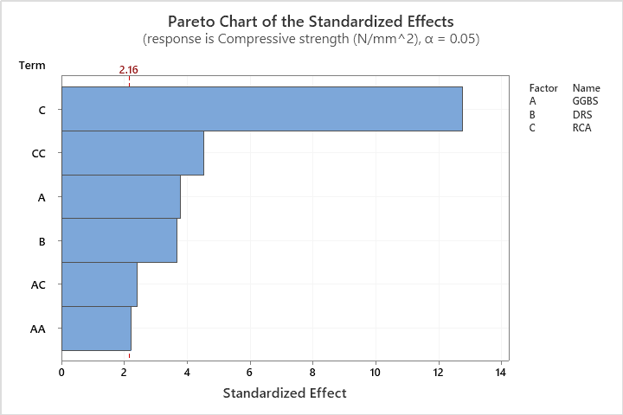
Fig S1 Pareto chart of the standard effects (Compressive strength).

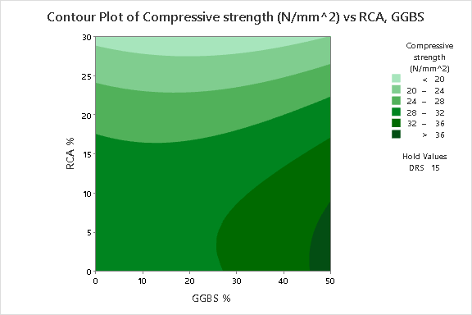 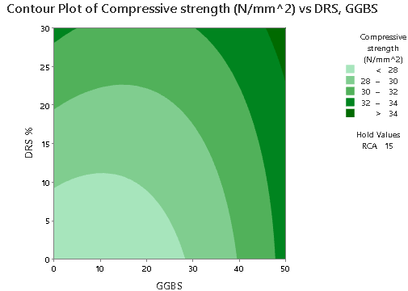
Fig S2(a) Fig S2(b)

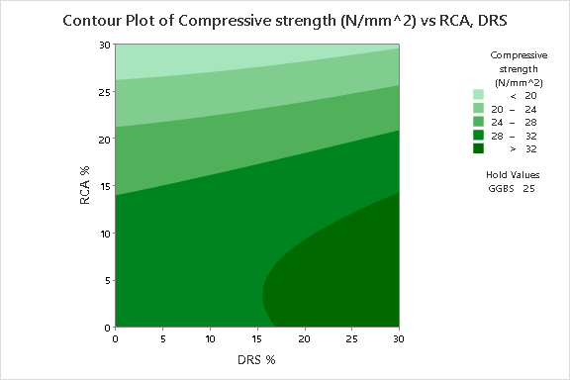

Fig S2(c)

Fig S2 Contour plot of Compressive strength vs a) RCA, GGBS b) DRS, GGBS c) RCA, DRS

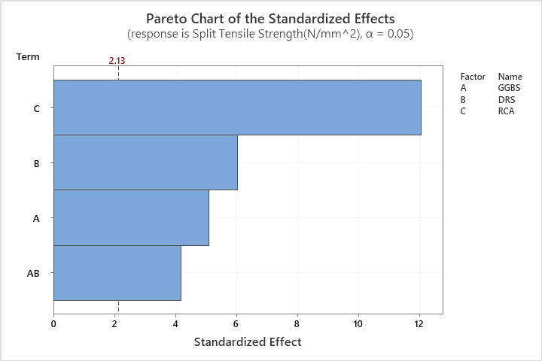
Fig S3. Pareto chart of the standardized effects (Split Tensile strength).

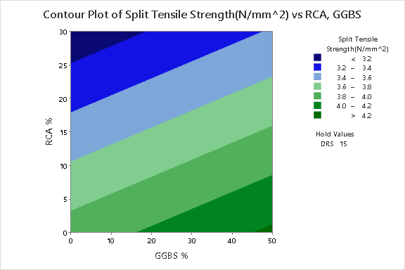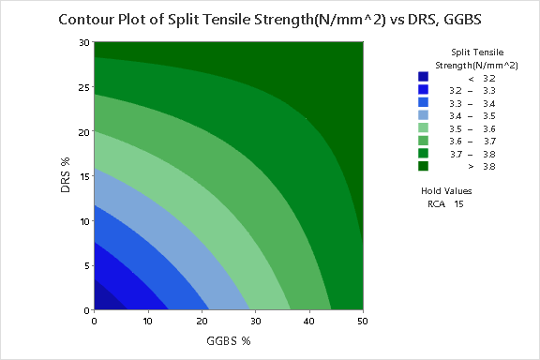

Fig S4 (a) Fig S4 (b)

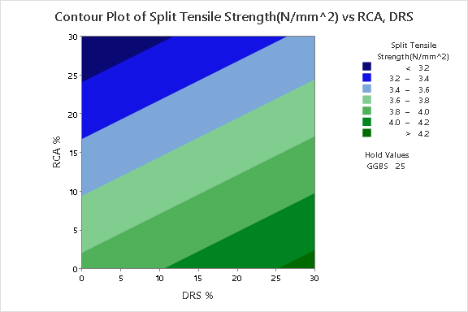

Fig S4 (c)

Fig S4 Contour plot of Split tensile strength vs (a) DRS, GGBS, (b) RCA, GGBS, (c) RCA, DRS.

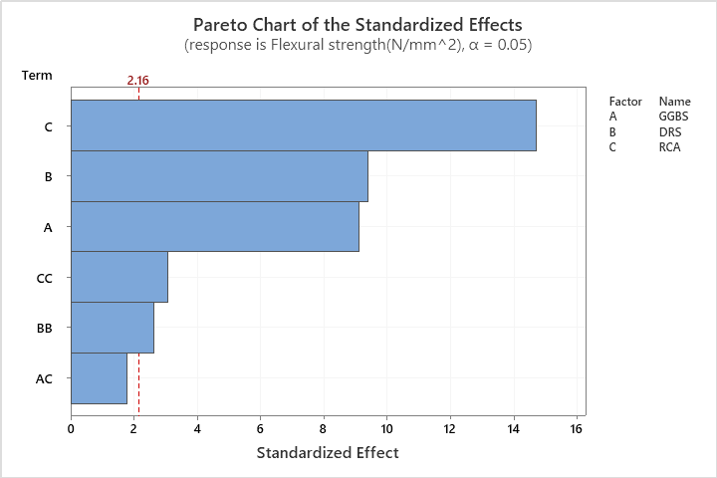
Fig S5 Pareto chart of the standard effects (Flexural strength).

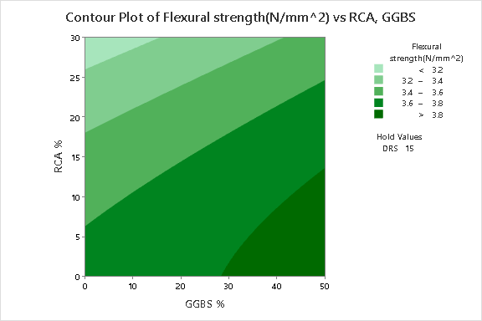 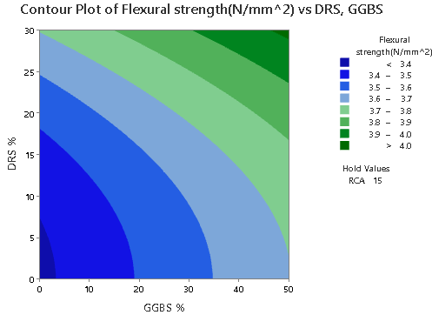Fig S6 (a) Fig S6 (b)

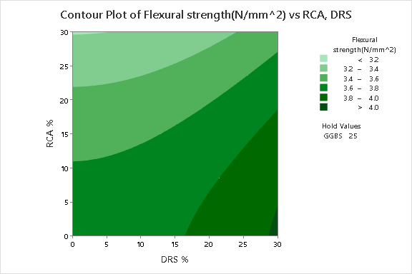

Fig S6 (c)

Fig S6 Contour plot of Flexural strength vs (a)DRS, GGBS, (b)RCA, GGBS, (c)RCA, DRS

