Table of Contents:
Section S1: Assembling of Mo_{4/3}C MXene with d-TiO₂ at various pH
Section S2: Experimental and DFT-simulated ELNES spectra of Mo_{4/3}C MXenes
Section S3: XAS-PEEM measurements for pristine d-TiO₂
Section S4: Electronic band alignment of Mo_{4/3}C and d-TiO₂
Section S5: Facet-selective electrostatic assembling (FSEA) of Mo_{4/3}C MXene with BiVO₄ and Cu₂O
Section S6: STEM-EELS measurements for Mo_{4/3}C MXenes
References:

Section S1: Assembling of Mo_{4/3}C MXene with d-TiO₂ at various pH
Figure S1-4 show scanning electron microscopy (SEM) and scanning transmission electron microscopy with energy dispersive X-ray spectroscopy (STEM-EDX) images and elemental maps of MXene and d-TiO₂ mixed at different pH levels, ranging from 1.5 to 11. The optimal pH level for the facet-selective electrostatic assembling (FSEA) of Mo_{4/3}C MXene and decahedron TiO₂ co-exposed with {101} and {001} facets (d-TiO₂) was found to be 2-3. At pH 4 and 4.5, MXene and d-TiO₂ self-assemble, but with less facet-selectivity compared to pH 2 and 3. At other pH levels, no significant facet-selectivity or assembling of MXene and d-TiO₂ was formed. This is because of their weak and similar negative electrostatic charges at pH higher than 6.55, which is the point of zero charge (PZC) for d-TiO₂. Notably, at pH 6.6 close to the PZC, d-TiO₂ remained pristine without assembling of MXene. One can predict the same facet-selective assembling at pH 6.55 of the PZC of d-TiO₂, as the (101) surface is positively charged while the (001) surface is negatively charged. However, it is assumed that surface potentials for both surfaces at the pH level would be too small to electrostatically attract or repulse the negatively charged MXene flakes. Therefore, the optimal pH level for the FSEA of Mo_{1.33}C and d-TiO₂ is located at pH 3, well below the PZC of d-TiO₂.
Figure S1. SEM (a) and STEM-EDX (b,c) images with elemental maps of Mo_{4/3}C MXene and d-TiO₂ self-assembled at pH 2. The high facet-selectivity is observed, as the TiO₂ (101) surface is preferentially covered by MXene flakes.

Figure S2. SEM images of Mo_{4/3}C MXene and d-TiO₂ self-assembled at pH 4 (left) and 4.5 (right) with low facet-selectivity.

Figure S3. SEM images of Mo_{4/3}C MXene and d-TiO₂ mixed at pH 5 (a), 6.6 (b), 7 (c), 9 (d), and 11 (e), where d-TiO₂ remains pristine.
Figure S4. SEM images of Mo_{4/3}C MXene and d-TiO₂ mixed at pH 1 (left) and 1.5 (right), where d-TiO₂ remains pristine.

Section S2: Experimental and DFT-simulated ELNES spectra of Mo_{4/3}C MXenes
Figure 2 shows electron energy loss near edge structures (ELNES) of Mo-M_{2,3} edges, similar to that from the pristine Mo_{4/3}C MXene, confirming the facet-selectivity of the assembling with d-TiO₂ crystals. The delayed maximum of Mo-M_{4,5} edges impedes the precise determination of the edge offset and the precise elemental quantification¹ and the intensity of Mo-M_{4,5} edges is relatively weak. Therefore, Mo-M_{2,3} edges, which represent transitions of electrons in 3p orbitals and are sharper than Mo-M_{4,5}, are analyzed. MoO₂ and MoO₃ references show distinctive differences in the ELNES of Mo-M_{2,3} and O-K edges, consistent with a previous report². MoO₃ shows a double-peak structure for the M₃ edge with a sharper and more intense peak at around 395 eV than the other peak at 397 eV compared to MoO₂. The ELNES of the O-K edge of MoO₂ and MoO₃ mainly consist of two peaks at 531.2 and 534.9 eV, dominant for MoO₃ and MoO₂, respectively.

To simulate ELNES spectra of Mo_{4/3}C MXene, the structures of the Mo_{4/3}C MXenes with O and F terminations were optimized using the DFT code of Vienna ab initio simulation package (VASP)^{3,4}. The generalized gradient approximation (GGA) was adopted with the functional described by Perdew, Burke, and Ernzerhof (PBE)⁵. The Kohn–Sham equations were solved with a plane-wave basis set using the projector-augmented wave method⁶. The cutoff energy for the plane-wave basis set was set to 500 eV. The convergence threshold for self-consistent field (SCF) iteration was set to 1.0 × 10^{–6} eV. The structure was relaxed until the forces on all of the atoms were less than 0.03 eV/Å. A gamma-centered k-point grid of 4×4×1 was employed for sampling the Brillouin zone. Grimme’s D3 dispersion correction formalism with Becke–Johnson damping was adopted^{7,8}. The ELNES spectra for the optimized Mo_{4/3}C MXene structures were calculated using the DFT plane-wave basis pseudopotential method within the Cambridge Serial Total Energy Package (CASTEP)⁹ implemented in the Materials Studio 2022 package. The exchange-correlation potential was described by the GGA-PBE functional. The on-the-fly generated (OTFG) ultra-soft pseudopotential^{10,11} was used to describe the interaction between electrons and ions. The plane-wave cutoff energy was set to 381 eV. The SCF tolerance was set to 2.0×10⁻⁶ eV/atom. To avoid artificial core-hole interactions, a supercell model was constructed so that each cell vector was at least 10 Å long, and a 1×1×1 k-point set was used.

Figure S5 shows DFT-simulated ELNES spectra for Mo_{4/3}C MXenes with F and O terminations. The simulated spectra are consistent with our experimental observation (Fig. 2c,d) that the spectral shapes of Mo-M_{2,3} and O-K edges of Mo_{4/3}C MXenes resemble that of the reference MoO₃ (Mo⁶⁺), thus suggesting that the main valence state of Mo_{4/3}C would be Mo⁶⁺. The additional peaks at 402 and 407 eV between Mo-M_{2,3} edges observed for Mo_{4/3}C (Fig. 2 and 3), which, however, do not appear in the DFT-simulated spectra, would be attributed to residual Sc that originates from an unetched parent 2D atomic laminate, (Mo_{2/3}Sc_{1/3})₂AlC, from which Mo_{4/3}C MXenes are exfoliated via chemical etching.
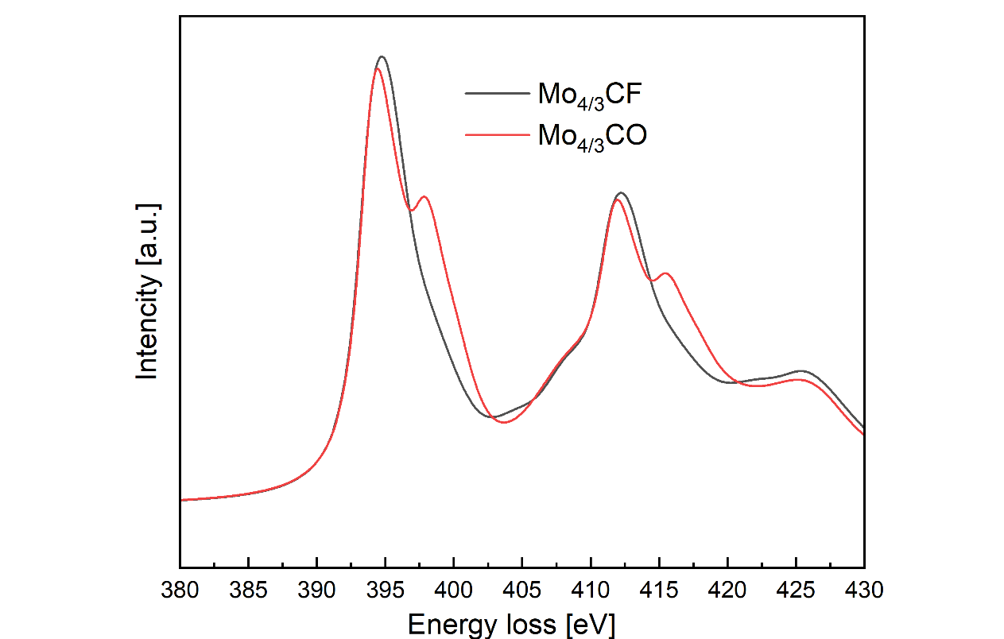
Figure S5. DFT-simulated ELNES spectra for Mo_{4/3}C MXene terminated with -F and -O.

Section S3: XAS-PEEM measurements for pristine d-TiO₂
Figure S6 shows synchrotron-based XAS-PEEM image and spectra of Ti-L_{2,3} edges for pristine d-TiO₂. The peak positions for the (001) and (101) are almost identical. In XAS, core-level electrons are excited into unoccupied states of the conduction band; therefore, a difference in work function between the two facets has no impact on XAS spectra. However, X-ray and ultraviolet photoelectron spectroscopy (XPS/UPS) demonstrated a difference between the (001) and (101) surfaces with the Fermi level of (101) being higher than for (001)¹². In XPS/UPS, the binding energy of core-level electrons excited to a vacuum level is measured with respect to the calibrated Fermi level. While XAS techniques probe deeper into the sample than surface-sensitive techniques of XPS/ UPS, the negligible influence of surface termination in our XAS analysis indicates that the difference in Fermi level between the (001) and (101) surface is highly localized within the (sub)surface region, extending only several nm in depth. This observation is consistent with a recent report that a substantial Fermi level difference of 0.65 eV between the (001) and (101) surfaces using highly surface-sensitive X-ray photoelectron spectromicroscopy¹³.
Figure S6. Synchrotron-based XAS-PEEM image (left) and spectra (right) of Ti-L_{2,3} edges for pristine d-TiO₂.

Section S4: Electronic band alignment of Mo_{4/3}C and d-TiO₂
The Mo_{4/3}C MXene films were spin-coated on Si substrates and quickly transferred into the load lock chamber of the ultra-high vacuum (UHV) system. The MXene films were then annealed at 573 K, sputter-cleaned by Ar⁺ ion, exposed to the atmosphere for 5 min, and transferred to a UHV chamber, to imitate a surface condition in practical environment. Ultraviolet photoelectron spectroscopy (UPS, HeI hν = 21.22) spectrum for the prepared sample was recorded with a Scienta-200 hemispherical analyzer and calibrated by referencing to the Fermi level and Au 4f7/2 peak position of the Ar⁺ ion sputter-cleaned gold foil (Fig. S7). The work function of the sample is determined to be 4.65 eV, derived from the secondary electron edge. The Fermi-Dirac onset is located at 0 eV of the calibrated Fermi level, confirming the metallic nature of the MXene and indicating no charging issues. Meanwhile, the work function and electron affinity of the single-crystal anatase TiO₂(101) surface prepared in comparable conditions were reported to be 3.65-3.90 and 3.60-3.80 eV¹⁴. Thus, the energy band alignment of the MXene/TiO₂(101) interface with the Schottky barrier is established, according to the electron affinity rule^{15,16} (Fig. S7). The Schottky barrier would efficiently trap photo-generated electrons, leading to enhanced photocatalytic reduction reactions.

Figure S7. UPS spectra of Mo_{4/3}C MXene and electronic band structures of MXene/TiO₂(101) interface.

Section S5: Facet-selective electrostatic assembling (FSEA) of Mo_{4/3}C MXene with BiVO₄ and Cu₂O
The surface zeta potentials of the aqueous solutions of single-crystal octahedral BiVO₄ co-exposed with the {010} and {110} facets and tetradecahedral CuO₂ co-exposed with {100} and {111} facets (250 µg/mL) as a function of pH were measured by dynamic light scattering analysis (Fig. S8). Point of zero charge (PZC) of BiVO₄ was determined to be 2.66, consistent with the previously reported range of 2.3-4.5¹⁷. However, a reasonable zeta potential curve for Cu₂O was not obtained because of its poor surface stability related to the unstable oxidation states depending on pH levels. Previous articles reported a large variation of PZC and isoelectric point (IEP) for CuO and Cu₂O ranging from 4 to 11.5¹⁸, suggesting the instability of Cu oxide and a difficulty in determining their PZC. The FSEA concept was further consolidated to be universally applicable to different oxides, by demonstrating the FSEA using Mo_{4/3}C MXenes and BiVO₄ and Cu₂O, where MXenes are selectively assembled with the BiVO₄ (110) and Cu₂O (100) surface at pH 1.5 and 11, respectively (Fig. 5). At other pH levels, no assembling or significant selectivity was observed. The {110} facets of BiVO₄ and the {100} facets of Cu₂O exhibit a more positive surface charge compared to the {010} and {111} facets at pH 1.5 and 11, respectively. This electrostatic property facilitates the selective assembly of negatively charged MXenes onto these specific crystallographic planes of BiVO₄ and Cu₂O.
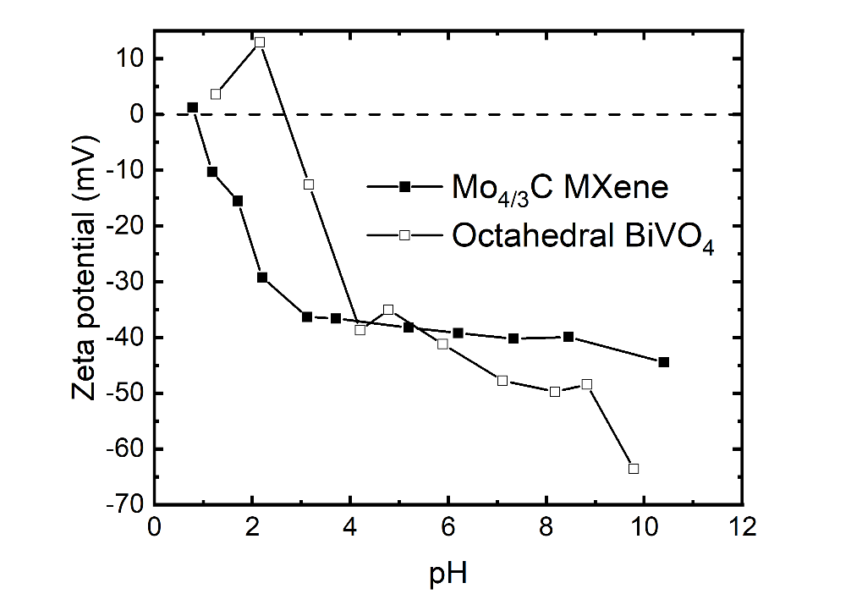
Figure S8. Zeta potential of Mo_{4/3}C MXene and octahedral BiVO₄ as a function of pH.

Section S6: STEM-EELS measurements for Mo_{4/3}C MXenes
Mo_{4/3}C MXene flakes were prepared by drop-casting an aqueous solution of the MXene onto TEM grids with 10 nm thick amorphous carbon support membrane for the STEM-EELS measurements. To remove the influence of the carbon membrane on the O-K edge spectra, the substrate spectrum was subtracted from the sample spectrum (MXene + substrate). The resulting net spectra of O-K edge for MXene and MoO₂ and MoO₃ references is shown in Fig. 2d.
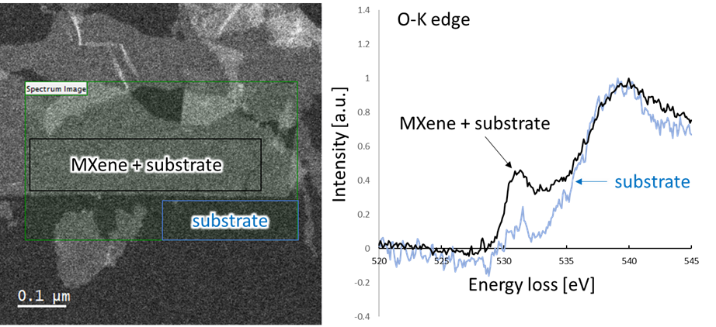
Figure S9. Removal of substrate contribution in the EELS measurements for pristine Mo_{4/3}C. The left panel shows a representative ADF-STEM image of pristine Mo_{4/3}C. The green rectangle indicates the area of EELS mapping. The right panel shows EELS spectra at the O-K edge obtained from a MXene monolayer supported by the amorphous carbon substrate (black rectangle) and from the same substrate (blue rectangle).

References
1 Hofer, F. EELS quantification of M edges by using oxidic standards. Ultramicroscopy 21, 63-68 (1987).
2 Lajaunie, L., Boucher, F., Dessapt, R. & Moreau, P. Quantitative use of electron energy-loss spectroscopy Mo-M2, 3 edges for the study of molybdenum oxides. Ultramicroscopy 149, 1-8 (2015).
3 Kresse, G. & Furthmüller, J. Efficient iterative schemes for ab initio total-energy calculations using a plane-wave basis set. Physical Review B 54, 11169 (1996).
4 Kresse, G. & Hafner, J. Ab initio molecular dynamics for open-shell transition metals. Physical Review B 48, 13115 (1993).
5 Perdew, J. P., Burke, K. & Ernzerhof, M. Generalized gradient approximation made simple. Physical Review Letters 77, 3865 (1996).
6 Blöchl, P. E. Projector augmented-wave method. Physical Review B 50, 17953 (1994).
7 Grimme, S., Ehrlich, S. & Goerigk, L. Effect of the damping function in dispersion corrected density functional theory. Journal of Computational Chemistry 32, 1456-1465 (2011).
8 Grimme, S., Antony, J., Ehrlich, S. & Krieg, H. A consistent and accurate ab initio parametrization of density functional dispersion correction (DFT-D) for the 94 elements H-Pu. The Journal of Chemical Physics 132 (2010).
9 Clark, S. J. et al. First principles methods using CASTEP. Zeitschrift für kristallographie-crystalline materials 220, 567-570 (2005).
10 Vanderbilt, D. Soft self-consistent pseudopotentials in a generalized eigenvalue formalism. Physical Review B 41, 7892 (1990).
11 Lejaeghere, K., Van Speybroeck, V., Van Oost, G. & Cottenier, S. Error estimates for solid-state density-functional theory predictions: an overview by means of the ground-state elemental crystals. Critical Reviews in Solid State and Materials Sciences 39, 1-24 (2014).
12 Kashiwaya, S., Toupance, T., Klein, A. & Jaegermann, W. Fermi level positions and induced band bending at single crystalline anatase (101) and (001) surfaces: origin of the enhanced photocatalytic activity of facet engineered crystals. Advanced Energy Materials 8, 1802195 (2018).
13 Zhang, W. et al. Facet-dependent photocatalytic performance and electronic structure of single-crystalline anatase TiO₂ particles revealed by X-ray photoelectron spectromicroscopy. Journal of Materials Chemistry C (2024).
14 Kashiwaya, S. et al. The work function of TiO2. Surfaces 1, 73-89 (2018).
15 Klein, A. et al. The Fermi energy as common parameter to describe charge compensation mechanisms: A path to Fermi level engineering of oxide electroceramics. Journal of Electroceramics 51, 147-177 (2023).
16 Klein, A. Energy band alignment at interfaces of semiconducting oxides: A review of experimental determination using photoelectron spectroscopy and comparison with theoretical predictions by the electron affinity rule, charge neutrality levels, and the common anion rule. Thin Solid Films 520, 3721-3728 (2012).
17 Kosmulski, M. The pH dependent surface charging and points of zero charge. X. Update. Advances in Colloid and Interface Science, 102973 (2023).
18 Kosmulski, M. Surface charging and points of zero charge. 216-220, USA, CRC Press, Taylor & Francis Group (2009).

