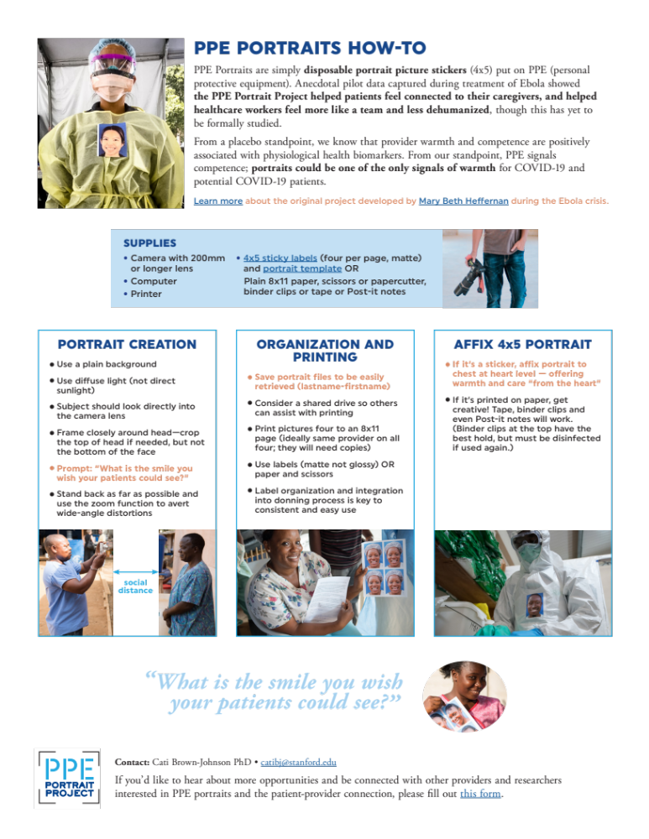
Appendix A. PPE Portraits How-To can be found at https://www.ppeportrait.org/create/2020/06/20/a-quick-ppe-portrait-how-to/. It is a quick guide to learning about PPE Portrait creation. This figure is our own, created by authorship team. Written consent for participation has been obtained from the participants shown.

