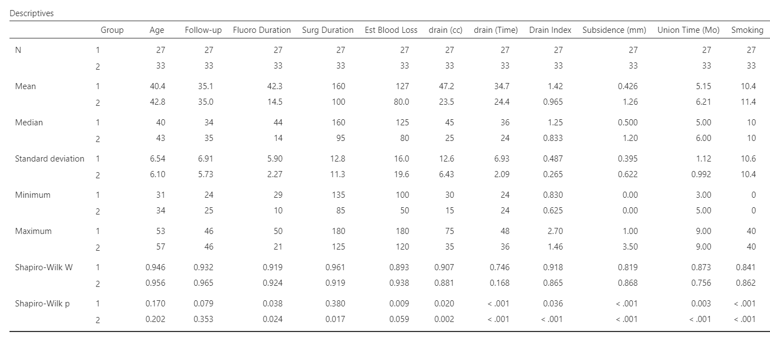
Table 1: Demographic and perioperative data of the groups

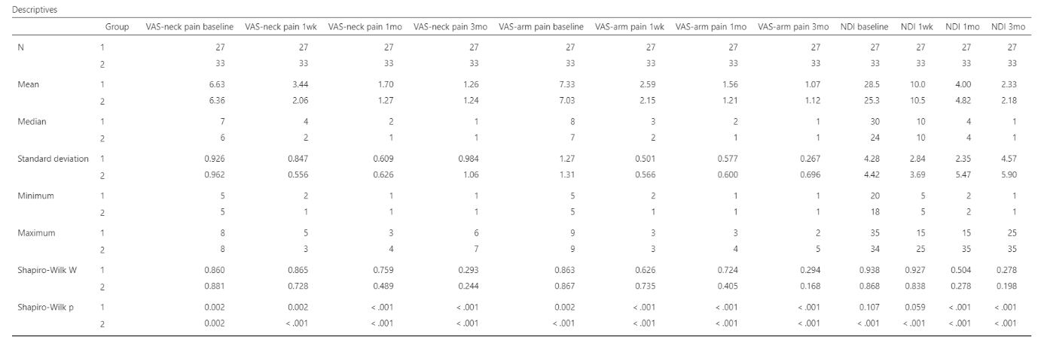
Table 2: VAS and NDI Scores of Group 1 and Group 2 Patients.

