Supplements:

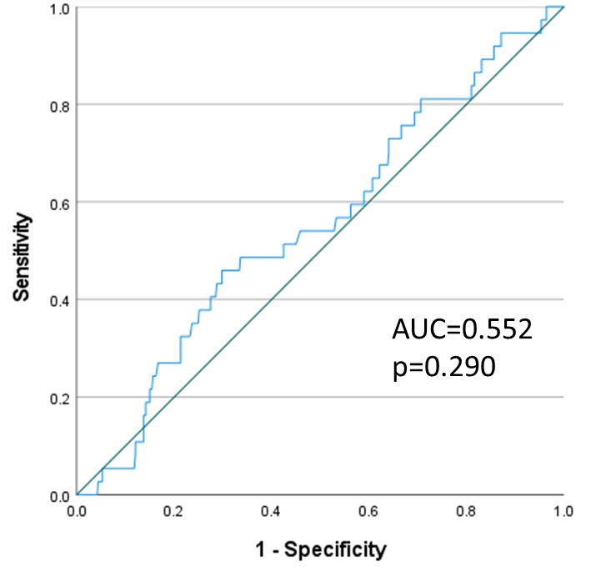
Suppl. Fig. 1: ROC-analysis for PTH levels three months after KTx and fracture occurrence. Based on this, we could not support a cut-off for PTH being associated with an increased fracture risk.

