Supplementary Information
Appendix A: Additional Tables and Figures
Table A1: Countries and Firms
Countries | 3-digit ISO | Firms # | Firms %
Albania | ALB | 140 | 3.40%
Armenia | ARM | 57 | 1.38%
Azerbaijan | AZE | 36 | 0.87%
Belarus | BLR | 128 | 3.11%
Bosnia and Herzegovina | BIH | 109 | 2.65%
Bulgaria | BGR | 76 | 1.85%
Croatia | HRV | 64 | 1.55%
Czech | CZE | 51 | 1.24%
Egypt | EGY | 320 | 7.77%
Estonia | EST | 60 | 1.46%
Georgia | GEO | 83 | 2.02%
Hungary | HUN | 61 | 1.48%
Israel | ISR | 112 | 2.72%
Jordan | JOR | 121 | 2.94%
Kazakhstan | KAZ | 69 | 1.68%
Kosovo | XKX | 41 | 1.00%
Kyrgyz | KGZ | 95 | 2.31%
Latvia | LVA | 79 | 1.92%
Lebanon | LBN | 192 | 4.66%
Lithuania | LTU | 57 | 1.38%
Moldova | MDA | 121 | 2.94%
Mongolia | MNG | 158 | 3.84%
Montenegro | MNE | 44 | 1.07%
Morocco | MAR | 125 | 3.04%
North Macedonia | MKD | 97 | 2.36%
Poland | POL | 84 | 2.04%
Romania | ROU | 113 | 2.74%
Russia | RUS | 329 | 7.99%
Serbia | SRB | 117 | 2.84%
Slovak | SVK | 21 | 0.51%
Slovenia | SVN | 69 | 1.68%
Tajikistan | TJK | 69 | 1.68%
Tunisia | TUN | 191 | 4.64%
Turkey | TUR | 370 | 8.99%
Ukraine | UKR | 128 | 3.11%
Uzbekistan | UZB | 130 | 3.16%
Total |  | 4,117 | 100%
Source: Business Environment and Enterprise Performance Survey, EBRD, 2011-2019.

Table A2: Numbers (Percentages) of Firms by R&D and Export Status
 | No. Firms with:
 | R&D | Innovation | Imitation | Only Innovation | Only Imitation | Total
New exporter | 141 | 106 | 96 | 45 | 35 | 441
New exporter | (32%) | (24%) | (22%) | (10%) | (8%) | (100%)
New non-exporter | 77 | 60 | 48 | 29 | 17 | 453
New non-exporter | (17%) | (13%) | (11%) | (6%) | (4%) | (100%)
Continuous exporter | 313 | 262 | 201 | 112 | 51 | 745
Continuous exporter | (42%) | (35%) | (27%) | (15%) | (7%) | (100%)
Continuous non-exporter | 438 | 400 | 299 | 139 | 38 | 2,478
Continuous non-exporter | (18%) | (16%) | (12%) | (6%) | (2%) | (100%)
Source: Business Environment and Enterprise Performance Survey, EBRD, 2011-2019.

Table A3: Correlation Matrix
 | Government ownership % | % Time dealing with regulations | Employees | Top manager’s experience | Real GDP per capita | Economic cleanness
Production | 0.005 | 0.029 | 0.142*** | -0.044* | 0.027 | 0.275***
Government ownership % | - | 0.083*** | 0.086*** | -0.019 | -0.012 | -0.049**
% Time dealing with regulations | - | - | 0.043* | 0.050** | 0.006 | -0.003
Employees | - | - | - | 0.006 | -0.059*** | -0.051**
Top manager’s experience | - | - | - | - | 0.065*** | 0.061***
Real GDP per capita | - | - | - | - | - | 0.116***
Source: Business Environment and Enterprise Performance Survey, EBRD, 2011-2019.
Note: ***, ** and * represent significance at 1%, 5% and 10% respectively.

Table A4: First and Second Step Results
 | Production | Dummy (New Exporter) | Dummy (New Non-exporter) | Dummy (Continuous Exporter) | Dummy (Continuous Non-exporter)
 | (i) | (ii) | (iii) | (iv) | (v)
Production IV | 0.980*** | - | - | - | -
Production IV | (0.024)
Average export ratio | - | 0.539** | 0.562** | 2.773*** | -3.194***
Average export ratio |  | (0.253) | (0.257) | (0.241) | (0.239)
Average import ratio | - | 0.022 | -0.954*** | -0.059 | 0.428**
Average import ratio |  | (0.251) | (0.248) | (0.246) | (0.206)
Foreign ownership % | - | -0.156 | 0.078 | 0.310* | -0.334*
Foreign ownership % |  | (0.210) | (0.206) | (0.181) | (0.187)
Dummy (international certificate) | - | 0.210** | -0.196* | 0.499*** | -0.477***
Dummy (international certificate) |  | (0.096) | (0.101) | (0.083) | (0.082)
Dummy (foreign technique) | - | 0.172* | -0.111 | 0.389*** | -0.333***
Dummy (foreign technique) |  | (0.101) | (0.112) | (0.093) | (0.090)
Economic openness | - | -0.101 | -0.451*** | 0.398*** | 0.018
Economic openness |  | (0.153) | (0.157) | (0.137) | (0.124)
Government ownership % | 0.825*** | 0.679 | -37.84 | -0.598 | 0.486
Government ownership % | (0.274) | (0.414) | (66.83) | (0.509) | (0.419)
% Time dealing with regulations | 0.058 | 0.184 | -0.531** | 0.111 | 0.176
% Time dealing with regulations | (0.119) | (0.210) | (0.251) | (0.198) | (0.178)
Dummy (business association) | -0.024 | 0.036** | 0.031 | 0.263*** | -0.230***
Dummy (business association) | (0.044) | (0.084) | (0.082) | (0.079) | (0.067)
Dummy (small) | -0.280*** | 0.237 | 0.170* | 0.263** | -0.343***
Dummy (small) | (0.051) | (0.101) | (0.097) | (0.102) | (0.079)
Dummy (medium) | -0.647*** | 0.183 | 0.262** | 0.812*** | -0.849***
Dummy (medium) | (0.061) | (0.122) | (0.117) | (0.112) | (0.097)
Dummy (large) | -0.802*** | 0.054 | 0.294* | 1.076*** | -1.040***
Dummy (large) | (0.086) | (0.170) | (0.169) | (0.150) | (0.145)
Top manager’s experience | 0.059 | -0.537 | 0.203 | 0.730** | -0.275
Top manager’s experience | (0.178) | (0.335) | (0.324) | (0.304) | (0.273)
Real GDP per capita | -0.097 | -0.457 | 0.670 | 0.602 | -0.634
Real GDP per capita | (0.266) | (0.541) | (0.511) | (0.526) | (0.438)
Economic cleanness | -1.106 | 5.201 | 12.54** | -3.903 | -6.565
Economic cleanness | (2.615) | (5.786) | (5.682) | (5.547) | (4.677)
Wald test statistics | 5.30** | 84.5*** | 91.1*** | 417.5*** | 363.4***
F/$χ^{2}$ statistics | 220.7*** | 35.38*** | 65.12*** | 609.7*** | 666.2***
Fixed effect (year) | Yes
Fixed effect (country) | Yes
Fixed effect (industry) | Yes
No. observations | 4,117
Note: ***, ** and * represent significance at 1%, 5% and 10% respectively. Standard errors are reported in parentheses. Column (i) reports the results of first-step estimation from Equation (14); columns (ii)~(v) report the results of second-step estimation from Equation (15).

Table A5: First Step Results of Adverse Causality Tests
 | R&D | Innovation | Imitation | Only Innovation | Only Imitation
 | (i) | (ii) | (iii) | (iv) | (v)
Financial constraint | -10.54*** | -13.23*** | -55.79** | -56.50* | -31.72
Financial constraint | (2.412) | (2.542) | (26.89) | (30.65) | (36.32)
Dummy (severe financial obstacle) | -4.093*** | -4.117*** | -3.573*** | -3.882*** | 0.114
Dummy (severe financial obstacle) | (0.521) | (0.529) | (0.547) | (1.060) | (1.937)
Dummy (medium financial obstacle) | -0.150 | -0.289 | 0.026 | -0.285 | 3.416
Dummy (medium financial obstacle) | (0.360) | (0.361) | (0.423) | (0.424) | (9.694)
Dummy (minor financial obstacle) | -0.103 | -0.358 | 0.086 | -0.275 | 3.745
Dummy (minor financial obstacle) | (0.361) | (0.363) | (0.424) | (0.426) | (9.694)
Government ownership % | 0.004 | 0.199 | -0.159 | 0.192 | -1.061
Government ownership % | (0.392) | (0.394) | (0.441) | (0.468) | (1.170)
% Time dealing with regulations | 0.443*** | 0.372** | 0.534*** | 0.026 | 0.300
% Time dealing with regulations | (0.170) | (0.176) | (0.180) | (0.221) | (0.241)
Dummy (business association) | 0.114* | 0.135* | 0.156** | 0.002 | 0.003
Dummy (business association) | (0.066) | (0.070) | (0.074) | (0.084) | (0.099)
Dummy (small) | 0.439*** | 0.466*** | 0.442*** | 0.241** | 0.152
Dummy (small) | (0.084) | (0.091) | (0.099) | (0.105) | (0.123)
Dummy (medium) | 0.772*** | 0.806*** | 0.741*** | 0.429*** | 0.237*
Dummy (medium) | (0.095) | (0.101) | (0.109) | (0.118) | (0.141)
Dummy (large) | 0.954*** | 1.002*** | 0.989*** | 0.368** | 0.424**
Dummy (large) | (0.125) | (0.131) | (0.137) | (0.162) | (0.191)
Top manager’s experience | 0.200 | 0.188 | -0.279 | 0.736** | 0.084
Top manager’s experience | (0.267) | (0.281) | (0.301) | (0.332) | (0.402)
Real GDP per capita | -0.780* | -0.549 | -0.802* | -0.315 | -0.878
Real GDP per capita | (0.399) | (0.421) | (0.447) | (0.505) | (0.604)
Economic cleanness | 10.99*** | 9.082** | 11.40*** | 4.183 | 8.740
Economic cleanness | (3.592) | (3.799) | (4.030) | (4.545) | (5.402)
Wald test statistics | 101.3*** | 111.6*** | 114.6*** | 89.0*** | 78.6***
$χ^{2}$ statistics | 131.7*** | 126.5*** | 115.4*** | 31.6** | 26.88**
Fixed effect (year) | Yes
Fixed effect (country) | Yes
Fixed effect (industry) | Yes
No. observations | 4,117
Note: ***, ** and * represent significance at 1%, 5% and 10% respectively. Standard errors are reported in parentheses. This table reports the results of first-step estimation from Equation (18).

Table A6: Determinants of Different R&D Strategies: VIF Tests
 | R&D | Innovation | Imitation | Only Innovation | Only Imitation
 | (i) | (ii) | (iii) | (iv) | (v)
Production | 1.793 | 1.818 | 2.310 | 1.900 | 1.247
New exporter | 4.360 | 4.414 | 4.461 | 4.515 | 4.078
New non-exporter | 2.738 | 2.687 | 2.972 | 2.701 | 2.415
Continuous exporter | 10.82 | 10.81 | 14.22 | 11.17 | 15.66
Continuous non-exporter | 7.546 | 7.498 | 10.57 | 7.559 | 10.72
Government ownership % | 1.241 | 1.260 | 1.581 | 1.280 | 1.312
% Time dealing with regulations | 1.253 | 1.247 | 1.706 | 1.217 | 1.685
Dummy (business association) | 1.522 | 1.518 | 1.996 | 1.549 | 1.997
Dummy (small) | 2.384 | 2.505 | 3.152 | 2.416 | 2.945
Dummy (medium) | 3.916 | 4.118 | 4.019 | 4.022 | 3.756
Dummy (large) | 2.768 | 2.923 | 4.296 | 2.751 | 3.591
Top manager’s experience | 1.183 | 1.184 | 1.320 | 1.188 | 1.317
Real GDP per capita | 2.166 | 2.207 | 2.933 | 2.266 | 3.170
Economic cleanness | 2.630 | 2.725 | 2.786 | 2.885 | 2.524

Table A7: Determinants of Different R&D Strategies, Addressing Multicollinearity: VIF Tests
 | R&D | Innovation | Imitation | Only Innovation | Only Imitation
 | (i) | (ii) | (iii) | (iv) | (v)
Production | 2.323 | 2.285 | 3.001 | 3.735 | 4.088
Dummy (new exporter) | 2.111 | 2.096 | 2.297 | 2.128 | 3.062
Dummy (continuous exporter) | 3.028 | 3.056 | 3.439 | 3.147 | 3.902
Dummy (continuous exporter) | 3.403 | 3.340 | 3.809 | 3.287 | 4.744
Government ownership % | 1.246 | 1.272 | 1.255 | 1.329 | 1.085
% Time dealing with regulations | 1.140 | 1.144 | 1.142 | 1.155 | 1.124
Dummy (business association) | 1.895 | 1.871 | 1.797 | 1.936 | 1.802
Dummy (small) | 2.086 | 2.213 | 2.265 | 2.185 | 2.088
Dummy (medium) | 2.706 | 2.824 | 2.883 | 3.102 | 3.103
Dummy (large) | 2.218 | 2.316 | 2.468 | 2.427 | 2.323
Top manager’s experience | 1.234 | 1.235 | 1.236 | 1.247 | 1.233
Real GDP per capita | 2.176 | 4.142 | 4.558 | 4.537 | 2.040
Economic cleanness | 4.016 | 3.649 | 5.062 | 1.267 | 5.604

Table A8: Determinants of Production $q$
 | (i) | (ii) | (iii) | (iv) | (v) | (vi) | (vii) | (viii) | (ix) | (x)
R&D Strategy | -3.724*** | -2.139* | -2.522** | -1.406 | -2.725** | -1.617 | 0.130 | 0.462 | -1.533 | -1.329
R&D Strategy | (1.318) | (1.297) | (1.133) | (1.114) | (1.097) | (1.076) | (1.567) | (1.532) | (2.164) | (2.111)
New exporter | - | 62.17*** | - | 62.18*** | - | 61.72*** | - | 63.03*** | - | 62.88***
New exporter |  | (21.55) |  | (21.56) |  | (21.56) |  | (21.55) |  | (21.55)
New non-exporter | - | 31.42*** | - | 31.74*** | - | 31.58*** | - | 31.98*** | - | 31.94***
New non-exporter |  | (4.131) |  | (4.123) |  | (4.127) |  | (4.120) |  | (4.121)
Continuous exporter | - | -7.698*** | - | -7.692*** | - | -7.845*** | - | -8.020*** | - | -8.018***
Continuous exporter |  | (2.093) |  | (2.099) |  | (2.089) |  | (2.093) |  | (2.089)
Continuous non-exporter | - | -22.31*** | - | -22.34*** | - | -22.36*** | - | -22.84*** | - | -22.81***
Continuous non-exporter |  | (5.144) |  | (5.150) |  | (5.145) |  | (5.140) |  | (5.138)
Government ownership % | 0.528 | 1.585*** | 0.696* | 1.689*** | 0.397 | 1.510*** | 0.553 | 1.603*** | 0.460 | 1.534***
Government ownership % | (0.365) | (0.382) | (0.371) | (0.385) | (0.371) | (0.388) | (0.371) | (0.386) | (0.392) | (0.406)
% Time dealing with regulations | 0.804*** | 1.156*** | 0.536*** | 1.003*** | 0.651*** | 1.079*** | 0.264* | 0.856*** | 0.321* | 0.906***
% Time dealing with regulations | (0.249) | (0.247) | (0.201) | (0.204) | (0.223) | (0.224) | (0.159) | (0.168) | (0.178) | (0.185)
Dummy (business association) | -0.220*** | -0.468*** | -0.258*** | -0.492*** | -0.257*** | -0.487*** | -0.349*** | -0.545*** | -0.349*** | -0.545***
Dummy (business association) | (0.075) | (0.080) | (0.073) | (0.077) | (0.071) | (0.075) | (0.060) | (0.065) | (0.060) | (0.065)
Dummy (small) | 0.056 | 0.425** | 0.120 | 0.532*** | 0.150 | 0.541*** | 0.373*** | 0.692*** | 0.346*** | 0.656***
Dummy (small) | (0.165) | (0.171) | (0.132) | (0.138) | (0.112) | (0.119) | (0.086) | (0.093) | (0.077) | (0.084)
Dummy (medium) | 0.129 | 0.753** | 0.207 | 0.959*** | 0.287 | 0.986*** | 0.730*** | 1.284*** | 0.684*** | 1.220***
Dummy (medium) | (0.312) | (0.325) | (0.246) | (0.261) | (0.194) | (0.213) | (0.135) | (0.157) | (0.099) | (0.129)
Dummy (large) | -0.005 | 0.876** | 0.422 | 1.130*** | 0.441 | 1.113*** | 1.117*** | 1.542*** | 1.073*** | 1.486***
Dummy (large) | (0.408) | (0.418) | (0.331) | (0.343) | (0.294) | (0.309) | (0.143) | (0.170) | (0.129) | (0.160)
Top manager’s experience | -0.006 | -0.326 | -0.101 | -0.386 | -0.405 | -0.557** | -0.242 | -0.511* | -0.214 | -0.442*
Top manager’s experience | (0.252) | (0.254) | (0.246) | (0.247) | (0.250) | (0.251) | (0.309) | (0.306) | (0.240) | (0.242)
Real GDP per capita | -3.748*** | -3.870*** | -3.225*** | -3.569*** | -3.378*** | -3.679*** | -2.876*** | -3.369*** | -3.034*** | -3.524***
Real GDP per capita | (0.492) | (0.498) | (0.415) | (0.428) | (0.434) | (0.447) | (0.394) | (0.411) | (0.441) | (0.456)
Economic cleanness | 60.61*** | 48.66*** | 54.23*** | 44.85*** | 55.49*** | 45.93*** | 48.57*** | 41.46*** | 50.18*** | 43.09***
Economic cleanness | (5.426) | (5.646) | (4.226) | (4.512) | (4.376) | (4.698) | (3.553) | (3.882) | (4.028) | (4.351)
Adjusted R² | 0.206 | 0.244 | 0.204 | 0.243 | 0.205 | 0.243 | 0.202 | 0.243 | 0.203 | 0.243
Fixed effect (year) | Yes
Fixed effect (country) | Yes
Fixed effect (industry) | Yes
No. observations | 4,117
Note: ***, ** and * represent significance at 1%, 5% and 10% respectively. Standard errors are reported in parentheses. In column (i) and (ii), R&D strategy is general R&D (either innovation or imitation). In column (iii) and (iv), R&D strategy is innovation. In column (v) and (vi), R&D strategy is imitation. In column (vii) and (viii), R&D strategy is only innovation. In column (ix) and (x), R&D strategy is only imitation.

Table A9: Determinants of Production $q$: VIF Tests
 | (i) | (ii) | (iii) | (iv) | (v)
R&D Strategy | 2.848 | 1.727 | 1.252 | 4.191 | 2.500
New exporter | 4.305 | 4.306 | 4.309 | 4.302 | 4.303
New non-exporter | 2.971 | 2.957 | 2.963 | 2.951 | 2.951
Continuous exporter | 10.50 | 10.55 | 10.45 | 10.49 | 10.44
Continuous non-exporter | 7.551 | 7.564 | 7.550 | 7.527 | 7.524
Government ownership % | 1.196 | 1.216 | 1.237 | 1.222 | 1.349
% Time dealing with regulations | 2.636 | 1.790 | 2.157 | 1.220 | 1.479
Dummy (business association) | 2.209 | 2.045 | 1.965 | 1.453 | 1.452
Dummy (small) | 1.003 | 3.541 | 4.831 | 2.940 | 2.412
Dummy (medium) | 2.474 | 1.596 | 1.064 | 4.735 | 3.881
Dummy (large) | 1.791 | 1.206 | 3.794 | 2.958 | 2.617
Top manager’s experience | 1.296 | 1.233 | 1.268 | 1.884 | 1.182
Real GDP per capita | 3.010 | 2.226 | 2.430 | 2.047 | 2.525
Economic cleanness | 4.844 | 3.092 | 3.354 | 2.288 | 2.873
Note: In column (i), R&D strategy is general R&D (either innovation or imitation). In column (ii), R&D strategy is independent innovation. In column (iii), R&D strategy is dependent imitation. In column (iv), R&D strategy is only innovation. In column (v), R&D strategy is only imitation.

Table A10: Determinants of Production $q$, Addressing Multicollinearity: VIF Tests
 | (i) | (ii) | (iii) | (iv) | (v)
R&D Strategy | 2.802 | 1.994 | 2.417 | 4.170 | 2.496
Dummy (new exporter) | 1.741 | 1.741 | 1.741 | 1.741 | 1.742
Dummy (continuous exporter) | 2.497 | 2.497 | 2.497 | 2.496 | 2.496
Dummy (continuous exporter) | 2.803 | 2.804 | 2.805 | 2.805 | 2.804
Government ownership % | 1.048 | 1.077 | 1.080 | 1.076 | 1.197
% Time dealing with regulations | 2.542 | 1.651 | 2.041 | 1.042 | 1.307
Dummy (business association) | 1.901 | 1.764 | 1.668 | 1.215 | 1.213
Dummy (small) | 1.976 | 1.683 | 4.138 | 2.407 | 1.933
Dummy (medium) | 2.834 | 1.523 | 2.526 | 4.122 | 2.305
Dummy (large) | 1.332 | 1.732 | 2.556 | 2.073 | 1.717
Age | 1.573 | 1.339 | 1.093 | 1.315 | 1.060
Top manager’s experience | 1.220 | 1.164 | 1.204 | 1.834 | 1.110
Real GDP per capita | 2.803 | 1.993 | 2.184 | 1.794 | 2.243
Economic cleanness | 4.314 | 2.635 | 2.837 | 1.873 | 2.400
Note: In column (i), R&D strategy is general R&D (either innovation or imitation). In column (ii), R&D strategy is independent innovation. In column (iii), R&D strategy is dependent imitation. In column (iv), R&D strategy is only innovation. In column (v), R&D strategy is only imitation.

Table A11: Determinants of Production $q$, Alternative Production Estimation
 | (i) | (ii) | (iii) | (iv) | (v) | (vi) | (vii) | (viii) | (ix) | (x)
R&D Strategy | -2.104** | -1.475 | -1.563* | -1.124 | -1.735** | -1.458* | 0.488 | 0.458 | -0.921 | -0.923
R&D Strategy | (1.058) | (0.955) | (0.909) | (0.820) | (0.878) | (0.792) | (1.251) | (1.128) | (1.724) | (1.555)
New exporter | 44.27** | 53.12*** | 44.16** | 53.03*** | 43.70** | 52.52*** | 45.11** | 53.70*** | 45.02** | 53.61***
New exporter | (17.59) | (15.87) | (17.60) | (15.87) | (17.60) | (15.87) | (17.60) | (15.87) | (17.60) | (15.87)
New non-exporter | 21.96*** | 6.179** | 22.24*** | 6.371** | 22.08*** | 6.198** | 22.51*** | 6.563** | 22.48*** | 6.536**
New non-exporter | (3.372) | (3.042) | (3.366) | (3.036) | (3.368) | (3.038) | (3.364) | (3.034) | (3.365) | (3.034)
Continuous exporter | -5.213*** | -1.351 | -5.171*** | -1.316 | -5.346*** | -1.425 | -5.533*** | -1.586 | -5.515*** | -1.572
Continuous exporter | (1.709) | (1.542) | (1.713) | (1.546) | (1.705) | (1.537) | (1.709) | (1.541) | (1.706) | (1.538)
Continuous non-exporter | -16.40*** | -13.60*** | -16.37*** | -13.57*** | -16.41*** | -13.54*** | -16.92*** | -13.98*** | -16.89*** | -13.95***
Continuous non-exporter | (4.199) | (3.789) | (4.204) | (3.792) | (4.199) | (3.787) | (4.197) | (3.785) | (4.196) | (3.784)
Government ownership % | 1.194*** | 0.906*** | 1.306*** | 0.985*** | 1.111*** | 0.831*** | 1.210*** | 0.913*** | 1.169*** | 0.870***
Government ownership % | (0.312) | (0.281) | (0.315) | (0.284) | (0.317) | (0.286) | (0.316) | (0.285) | (0.331) | (0.299)
% Time dealing with regulations | 0.980*** | 0.618*** | 0.848*** | 0.528*** | 0.924*** | 0.612*** | 0.685*** | 0.411*** | 0.720*** | 0.446***
% Time dealing with regulations | (0.202) | (0.182) | (0.166) | (0.150) | (0.182) | (0.165) | (0.137) | (0.124) | (0.151) | (0.136)
Dummy (business association) | -0.270*** | 0.029 | -0.287*** | 0.017 | -0.283*** | 0.028 | -0.346*** | -0.025 | -0.345*** | -0.024
Dummy (business association) | (0.065) | (0.059) | (0.063) | (0.056) | (0.061) | (0.055) | (0.053) | (0.048) | (0.053) | (0.048)
Dummy (small) | -0.055*** | 0.342*** | -0.142 | 0.284*** | -0.157 | 0.291*** | 0.318*** | 0.154** | 0.288*** | 0.183***
Dummy (small) | (0.139) | (0.126) | (0.113) | (0.102) | (0.097) | (0.087) | (0.076) | (0.068) | (0.068) | (0.062)
Dummy (medium) | -0.051 | 0.647*** | -0.216 | 0.538*** | -0.256 | 0.543*** | 0.576*** | 0.272** | 0.520*** | 0.325***
Dummy (medium) | (0.265) | (0.239) | (0.213) | (0.192) | (0.174) | (0.157) | (0.128) | (0.115) | (0.105) | (0.095)
Dummy (large) | 0.106 | 1.126*** | -0.094 | 0.993*** | -0.092 | 1.048*** | 0.551*** | 0.659*** | 0.504*** | 0.705***
Dummy (large) | (0.341) | (0.308) | (0.280) | (0.253) | (0.252) | (0.228) | (0.139) | (0.125) | (0.131) | (0.118)
Age | -0.455*** | -0.111 | -0.409*** | -0.080 | -0.363*** | -0.053 | -0.306** | -0.002 | -0.334*** | -0.029
Age | (0.127) | (0.114) | (0.119) | (0.107) | (0.110) | (0.099) | (0.119) | (0.108) | (0.110) | (0.099)
Top manager’s experience | -0.160 | 0.134 | -0.210 | 0.100 | -0.396* | -0.047 | -0.346 | -0.011 | -0.278 | 0.054
Top manager’s experience | (0.207) | (0.187) | (0.202) | (0.182) | (0.205) | (0.185) | (0.250) | (0.225) | (0.198) | (0.178)
Real GDP per capita | -2.009*** | -0.127 | -1.735*** | 0.061 | -1.847*** | -0.057 | -1.514*** | 0.225 | -1.629*** | 0.111
Real GDP per capita | (0.406) | (0.367) | (0.350) | (0.315) | (0.365) | (0.329) | (0.335) | (0.303) | (0.373) | (0.336)
Economic cleanness | 19.90*** | 21.30*** | 16.55*** | 23.58*** | 17.600*** | 22.28*** | 12.81*** | 26.34*** | 14.03*** | 25.13***
Economic cleanness | (4.609) | (4.158) | (3.683) | (3.322) | (3.835) | (3.459) | (3.170) | (2.859) | (3.553) | (3.204)
Adjusted R² | 0.101 | 0.170 | 0.100 | 0.169 | 0.101 | 0.170 | 0.099 | 0.169 | 0.099 | 0.169
Fixed effect (year) | Yes
Fixed effect (country) | Yes
Fixed effect (industry) | Yes
No. observations | 4,117
Note: ***, ** and * represent significance at 1%, 5% and 10% respectively. Standard errors are reported in parentheses. In column (i) and (ii), R&D strategy is general R&D (either innovation or imitation). In column (iii) and (iv), R&D strategy is innovation. In column (v) and (vi), R&D strategy is imitation. In column (vii) and (viii), R&D strategy is only innovation. In column (ix) and (x), R&D strategy is only imitation. In column (i), (iii), (v), (vii), and (ix), production is estimated by the LP method. In column (ii), (iv), (vi), (viii), and (x), production is estimated by the OP method.

Appendix B: Additional Figures
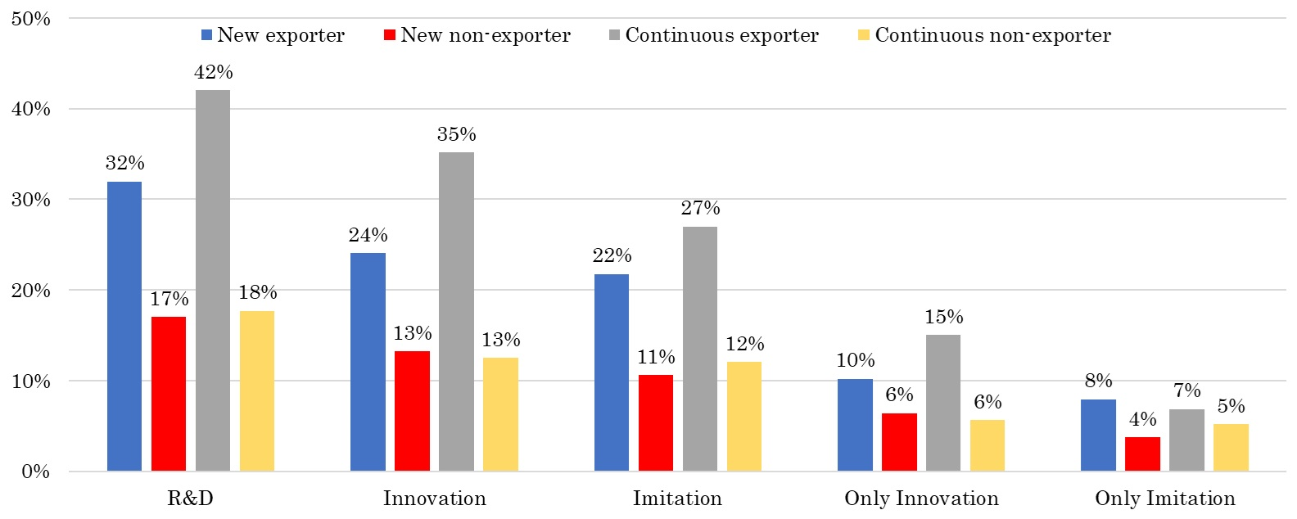
Figure B1: Percentages of Firms with Various R&D and Exporting Statuses
Source: Business Environment and Enterprise Performance Survey, EBRD, 2011-2019.

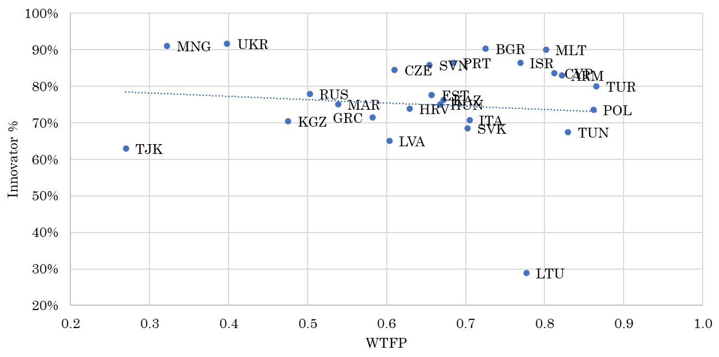
Figure B2: Percentages of Innovators and Welfare-related Total Factor Productivity, by Countries
Source: Information of innovators comes from Business Environment and Enterprise Performance Survey, EBRD, 2011-2019. Information of country-level welfare-related TFP (price adjusted) comes from Penn World Tables, Version 10.01.
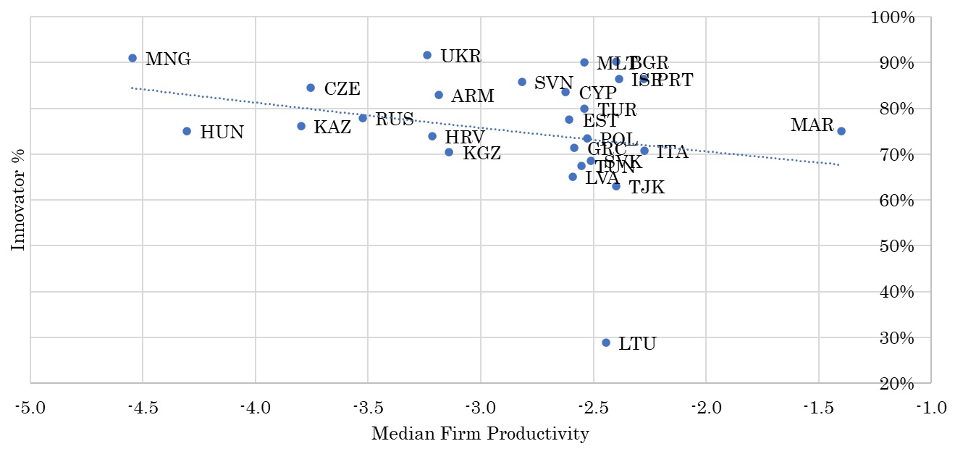
Figure B3: Percentages of Innovators and Median Firm Productivity, by Countries
Source: Business Environment and Enterprise Performance Survey, EBRD, 2011-2019.
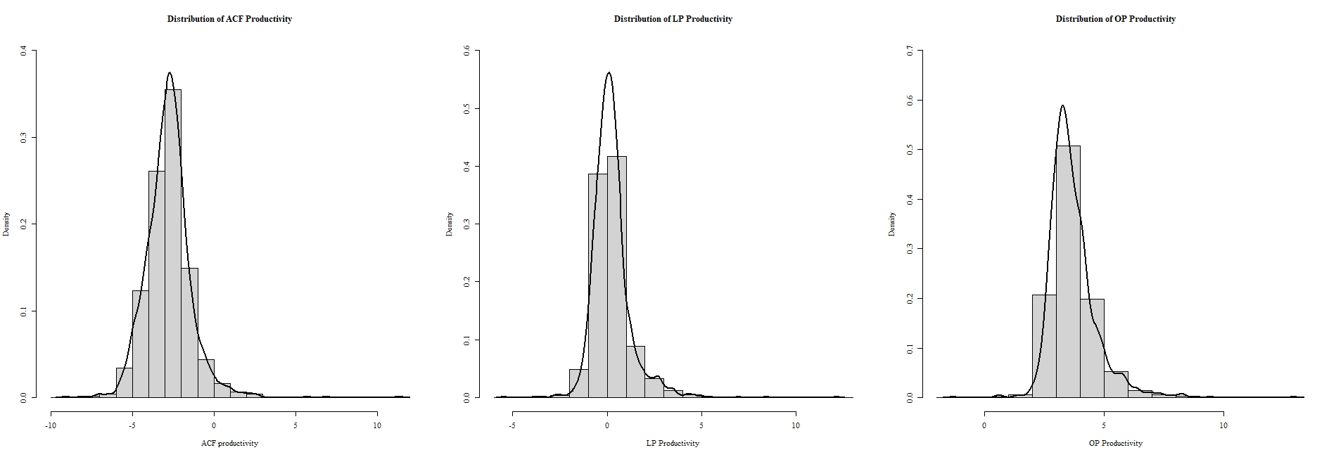
Figure B4: Distribution of Firm Productivity under Alternative Estimation Methods

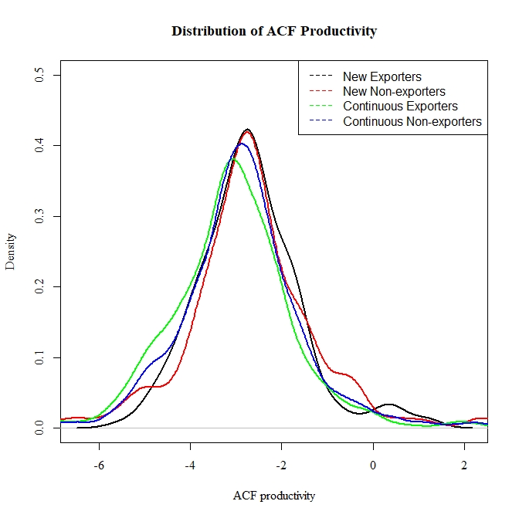
Figure B5: Distribution of ACF Productivity, by Exporting Statuses

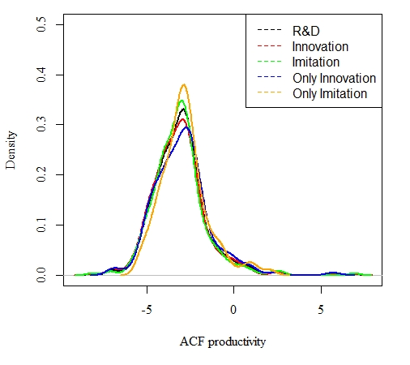
Figure B6: Distribution of ACF Productivity, by R&D Strategies

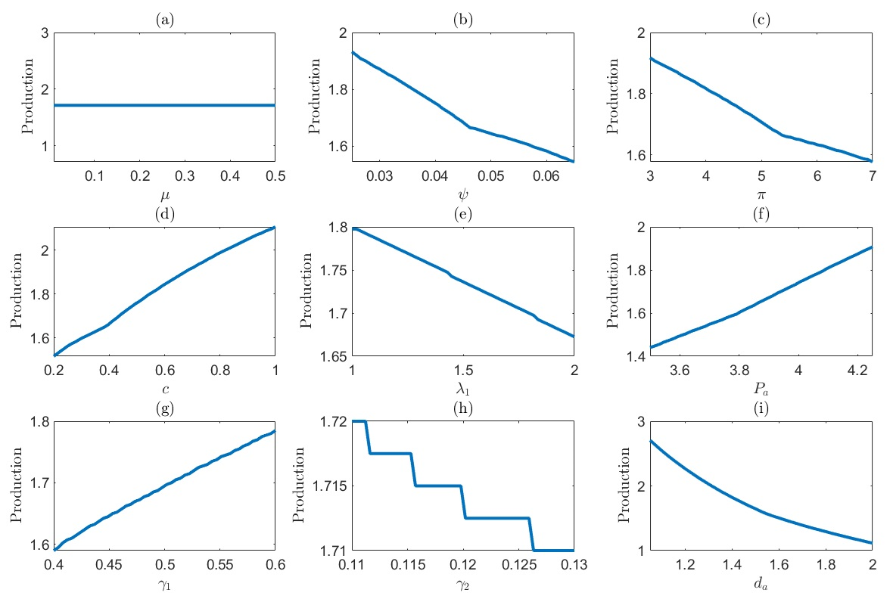
Figure B7: Sensitivity Test of $q_{4}^{*}$: Cutoff Production of Imitating Non-exporters to Innovate in the Next Period
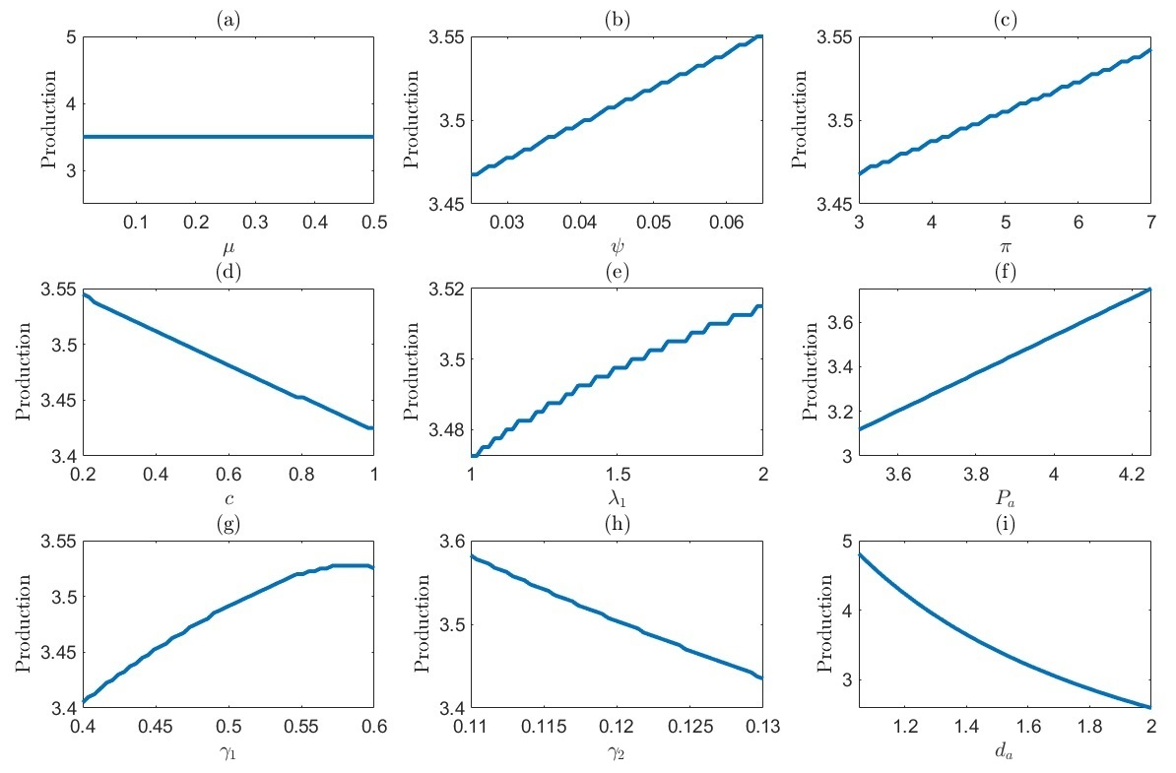
Figure B8: Sensitivity Test of $q_{7}^{*}$: Cutoff Production of Innovating Non-exporters to Innovate Again in the Next Period
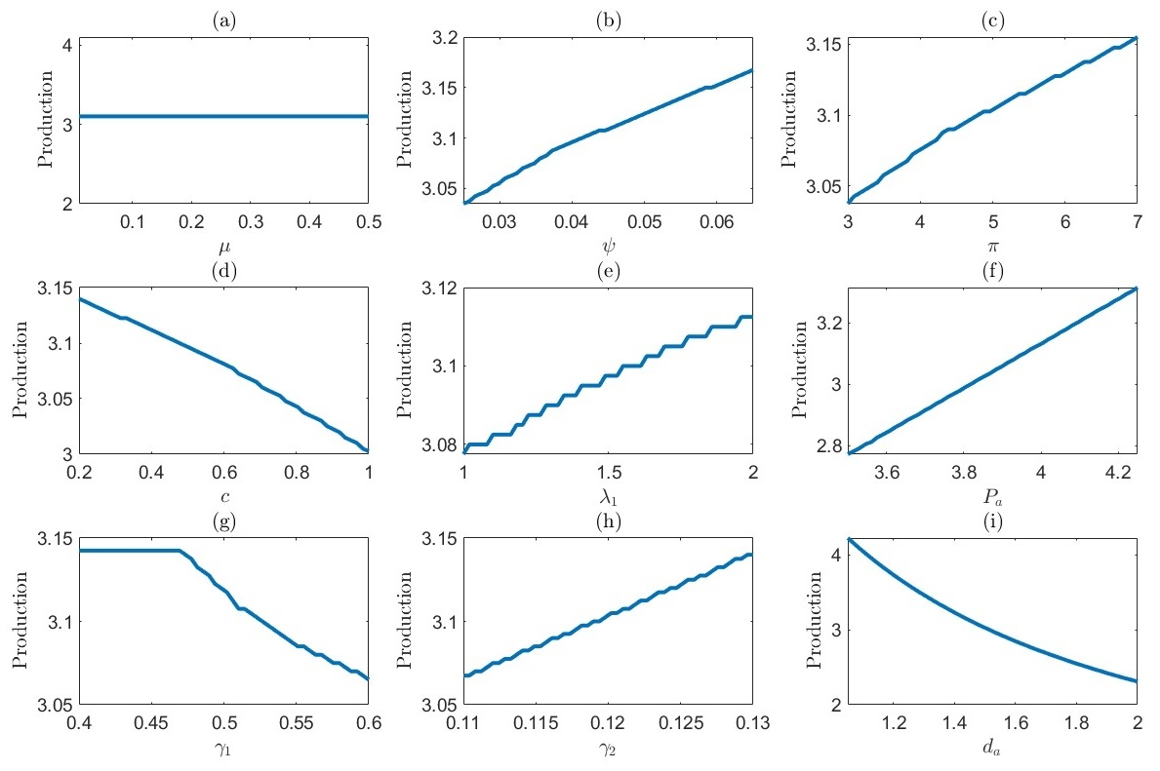
Figure B9: Sensitivity Test of $q_{5}^{*}$: Cutoff Production of Exporters to Imitate in the Next Period
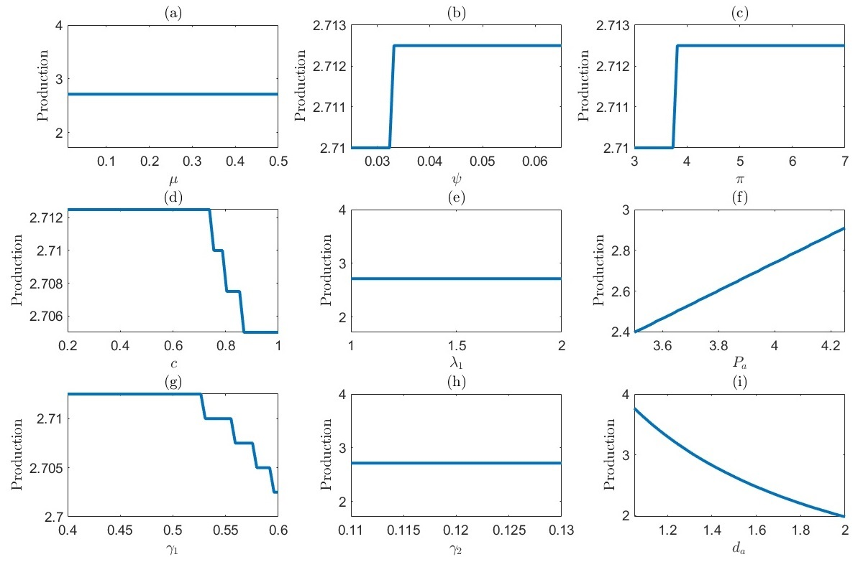
Figure B10: Sensitivity Test of $q_{9}^{*}$: Cutoff Production of Imitators to Export in the Next Period
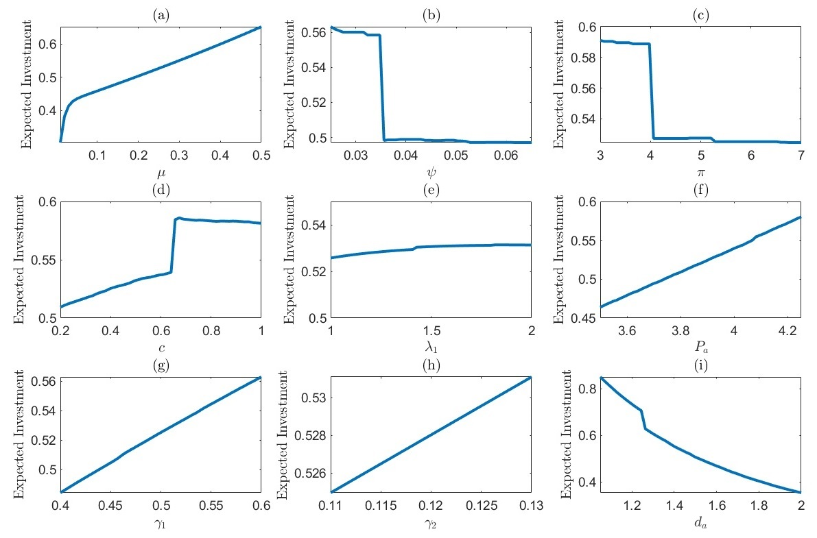
Figure B11: Sensitivity Test of Expected Investment of an Aggregate Economy
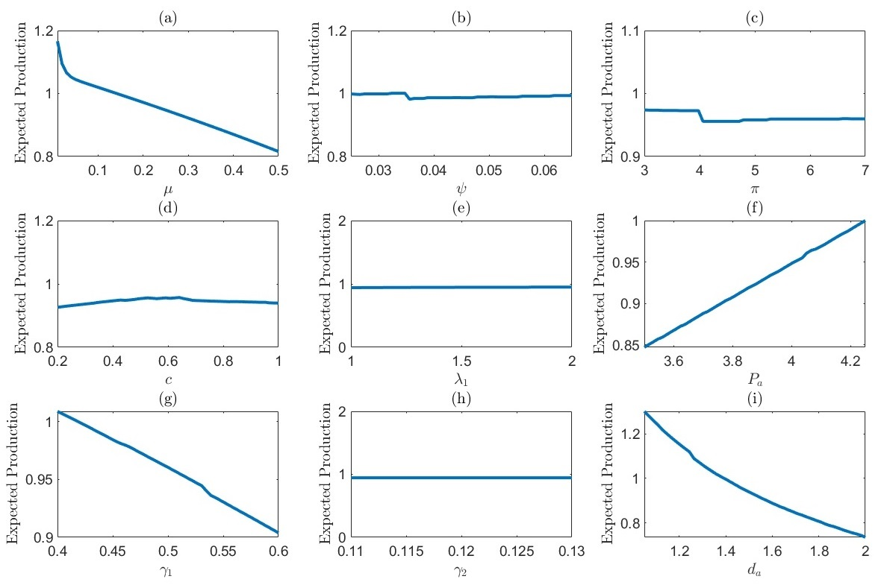
Figure B12: Sensitivity Test of Expected Production of an Aggregate Economy

