Supporting information
Unveiling the Ferroelectric Competition and Transition Mechanisms in Hybrid Organic-inorganic Perovskite Heterojunction
Enlong Li^{1,2}, Weixin He^{3,4}, Ruixue Wang^{1,5}, Chi Zhang¹, Hongmiao Zhou¹, Yu Liu¹, Yijia Yuan³,
Kian Ping Loh^{3,6}*, Junhao Chu^{1,2,5}, and Wenwu Li^{1,2}*
¹Shanghai Frontiers Science Research Base of Intelligent Optoelectronics and Perception, Institute of Optoelectronics, Department of Materials Science, Fudan University, Shanghai 200433, China.
²State Key Laboratory of Photovoltaic Science and Technology, Fudan University, Shanghai 200433, China.
³Department of Chemistry, National University of Singapore, Singapore 117543, Singapore.
⁴Department of Physics, National University of Singapore, Singapore117551, Singapore.
⁵Key Laboratory of Polar Materials and Devices, School of Physics and Electronic Science, East China Normal University, Shanghai 200241, China.
⁶Applied Physics Department, Hong Kong Polytechnic University, Hung Hom, Kowloon, Hong Kong SAR.
Email: chmlohkp@nus.edu.sg and liwenwu@fudan.edu.cn

Contents
Supplementary Note 1: The TCAD simulation of ferroelectric field effect transistor.
Supplementary Table 1 The parameters used in the TCAD simulation.
Supplementary Note 2: The Density function theory (DFT) calculations of ferroelectric materials.
Supplementary Note 3: The synthesis of HOIPF
Supplementary Fig.1. The transfer curves of TCAD simulation MoS₂ 2DFHT as a function of defect concentration.
Supplementary Fig.2. The transfer curves of TCAD simulation MoS₂ 2DFHT as a function of Pr value.
Supplementary Fig.3. The 3D view of the two-dimensional layered ferroelectric perovskite (EATMP)PbBr_{4.}
Supplementary Fig.4. The scheme of the crystallographic structure of (EATMP)PbBr_{4.}
Supplementary Fig.5. The PFM images of (EATMP)PbBr₄ film before and after box poling under -12 V tip voltage.
Supplementary Fig.6 The PFM images of (EATMP)PbBr₄ showing in-plane ferroelectric polarization.
Supplementary Fig.7 The second harmonic generation, differential scanning calory, and thermogravimetric analysis of (EATMP)PbBr₄ ferroelectric film.
Supplementary Fig.8 The density of state diagram of (EATMP)PbBr₄ with the Br01, Br03 and Br04 vacancy.
Supplementary Fig.9. The AFM images of (EATMP)PbBr₄ film.
Supplementary Fig.10 The AFM images of the N-type MoS₂, bipolar WSe_{2,} and P-type BP 2DFHTs.
Supplementary Fig.11 The Raman spectroscopy of N-type MoS₂, bipolar WSe_{2,} and P-type BP 2DFHTs.
Supplementary Fig.12 The reproducibility of polarity-dependent ferroelectric regulation in 2DFHTs.
Supplementary Fig.13 The transfer curves of 2DFHTs as a function sweeping ratio.
Supplementary Fig.14 The transfer curves of 2DFHTs as a function of sweeping times.
Supplementary Fig.15 Device performance of two-dimension transistor without ferroelectric layer.
Supplementary Fig.16 The volatile synaptic weight update properties of WSe₂ 2DFHTs.
Supplementary Fig.17. The voltage-dependent synaptic weight update of WSe₂ 2DFHT.
Supplementary Fig.18. The multi-level memory retention of WSe₂ 2DFHT
Supplementary Fig.19. The 2DFHTs based transfer learning neural network for image accuracy
Supplementary Note 1 TCAD simulation
The TCAD simulation of MoS₂ FET as well as BP FET is performed in the TCAD platform. The structure and grids of these FETs are built in the 2D version of the Structure Editor, in which the channel length of 2DFHT is set to be 10 μm and the thickness of the ferroelectric and semiconductor layer are 40 nm and 10 nm, respectively. The TCAD platform solves three equations listed below in every grid to find the answers to electrical potential, electron, and hole concentration:
$∇^{2}φ=-\frac{q}{ε}\left(N+p-n\right)$ (1)
$\left\{\begin{aligned}\frac{∂n}{∂t}=\frac{1}{q}∇∙\vec{J_{n}}+\left(G_{n}-R_{n}\right) \\ \frac{∂p}{∂t}=\frac{1}{q}∇∙\vec{J_{p}}+\left(G_{p}-R_{p}\right)\end{aligned}\right.$ (2)
$\left\{\begin{aligned}\vec{J_{n}}=nqμ_{n}\vec{E}+qD_{n}∇n \\ \vec{J_{p}}=pqμ_{p}\vec{E}-qD_{p}∇p\end{aligned}\right.$ (3)
Equation (1) is the Poisson equation where $φ$ is the electrical potential, $q$ is the elementary charge, $ε$ is the dielectric constant, $N$, $p$ and $n$ are the concentration of doping, hole and electron.
Equation (2) is the carrier continuity equation, where $\frac{∂n}{∂t}$ and $\frac{∂p}{∂t}$ are the first-order partial differential of electron and hole concentration concerning time, $\vec{J_{n}}$ and $\vec{J_{p}}$ are the electron and hole current density, $G_{n}$, $G_{p}$ and $R_{n}$, $R_{p}$ are the generation and recombination of electron and hole.
Equation (3) is the drift-diffusion equation where $μ_{n}$ and $μ_{p}$ are the mobility of electron and hole, $\vec{E}$ is the electric field strength, $D_{n}$ and $D_{p}$ are the diffusion coefficient of electron and hole.
Except for these three fundamental equations, TCAD will add equations declared in its “device” command to correct the electrical potential, electron, and hole concentration. Different densities of traps are placed at the contact region to simulate the defects. For mobility shift, scattering from the ionized impurity and gate oxide are under consideration, high field saturation phenomenon is also included. The “OldSlotboom” model is used for band narrowing while the interface-charge specified “Shockley-Read-Hall (SHR)” models are used for recombination.

Supplementary Table 1 The parameters used in the TCAD simulation
Material: BP
Parameter | Value
Band gap | 0.78 eV
Electron mass | 0.42 m₀
Hole mass | 0.35 m₀
Relative Epsilon | 8.3
ConstantMobility: | 500 cm²/(Vs)
Material: MoS₂
Parameter | Value
Band gap | 1.8 eV
Electron mass | 0.501 m₀
Hole mass | 0.588 m₀
Relative Epsilon | 4
ConstantMobility: | 100 cm²/(Vs)
Material: Ferroelectric Materials
Parameter | Value
Coercive Field | 1.2×10⁵ V/cm
Saturation Polarization | 1.45×10⁻⁵ C/cm²
Remanent Polarization | 1.38×10⁻⁵ C/cm²
Relative Epsilon | 40

Ferroelectrics Model: Ferroelectrics Model is activated in TCAD platform to illustrate the ferroelectric polarization in ferroelectric materials. First, the device computes an auxiliary field F_{aux} from the electric field F:
$\frac{d}{dt}F_{aux}(t)=\frac{{F(t)-F}_{aux}(t)}{τ_{E}}$ (4)

In which, τ_{E} is a material-specific time constant. Then from the auxiliary field, the device computes the auxiliary polarization P_{aux} which is an algebraic function of the auxiliary field F_{aux}:
${ P}_{aux}=c∙P_{s}∙tanh\left(w∙\left(F_{aux}±F_{c}\right)\right)+P_{off}$ (5)
Here, P_{s} is the saturation polarization and F_{c} is the coercive field, and:
$w=\frac{1}{2F_{c}}\ln{\frac{P_{s}{+P}_{r}}{P_{s}{-P}_{r}}}$ (6)
where P_{r} is the remanent polarization, P_{off} and c result from the polarization history of the material. Finally, from the auxiliary polarization and auxiliary field, the device computes the actual polarization P:
$\frac{d}{dt}P(t)=\frac{P_{aux}[F_{aux}(t)]-P(t)}{τ_{P}}(1+k_{n}\left|\frac{d}{dt}F_{aux}(t)\right|)$ (7)
Here, τ_{P} and k_{n} are material-specific constants.

Supplementary Note 2 Density function theory (DFT) calculations
All spin-polarized density functional theory (DFT) calculations were conducted using the Vienna ab initio simulation package (VASP). The projector augmented wave (PAW) pseudopotentials and a plane wave basis set with a kinetic cutoff energy of 500 eV were employed for all calculations. Additionally, the Perdew-Burke-Ernzerhof (PBE) format of the generalized gradient approximation (GGA) was used for the exchange correlation function. The convergence criteria for the total energy and the residual Hellmann-Feynman force were set to be less than 10⁻⁵ eV and 10⁻² eV Å⁻¹, respectively. The electronic structures of the perfect crystal were studied using the unit cell, where the Brillouin zone was sampled by a 5 × 3 × 3 Γ-centered k-point grid in the Monkhorst-Pack scheme. A supercell (2 × 1 × 1) was utilized to create the defected crystals, and a 2 × 2 × 2 Γ-centered k-point grid in the Monkhorst-Pack scheme was adopted for the corresponding calculations.⁵ The definition of defect formation energy ($ΔE_{formation}$) was given in the following equation,
$ΔE_{formation}=E_{without defect}-E_{with defect}-n_{Br}μ_{Br}$(8)
where $E_{without defect}$ and $E_{with defect}$ represented the total energy of the supercell without and with defect, respectively, $n_{Br}$ was the number of Br defect, and $μ_{Br}$ denoted the chemical potential of a single Br atom in vacuum.

Supplementary Note 3: the synthesis of HOIPF
Synthesis of (EATMP)PbBr₄: The bromoethylamine hydrobromide, trimethylphosphane, hydrobromic acid (HBr, 48 wt% in H2O), and lead (II) acetatetrihydrate (Pb(CH₃CO₂)2·3H₂O) were procured from Sigma-Aldrich without any further purification. A solution containing equal moles of bromoethylamine hydrobromide and trimethylphosphane was prepared by dissolving them in 50 ml of ethanol within a dry flask. The resulting mixed solvent was then heated and stirred in a silicon oil bath at 65℃ for two days. Upon solvent removal under reduced pressure, (2-aminoethyl)trimethylphosphanium bromide (EATMP·Br) was obtained in the form of white solids. Subsequently, an equimolar amount of EATMP·Br and Pb(CH₃CO₂)2·3H₂O was introduced into 5 ml of HBr, and the resultant (EATMP)PbBr₄ crystals were obtained by allowing the HBr solution to evaporate slowly in a fume hood.

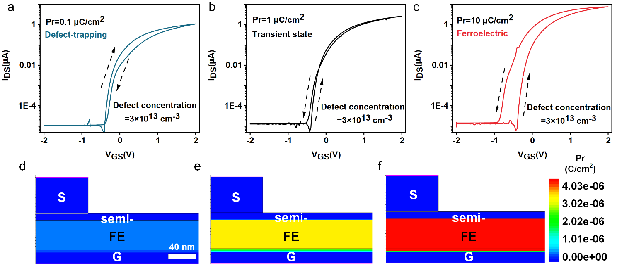Supplementary Fig.1｜The transfer curves of TCAD simulation MoS₂ 2DFHT with defect concentration of 3×10¹³ cm⁻³ and a Pr value of a) 0.1 μC/cm², b) 1 μC/cm² and c) 10 μC/cm². (d-e) The Pr value of 2DFHT associated with Supplementary Fig.1a-1c
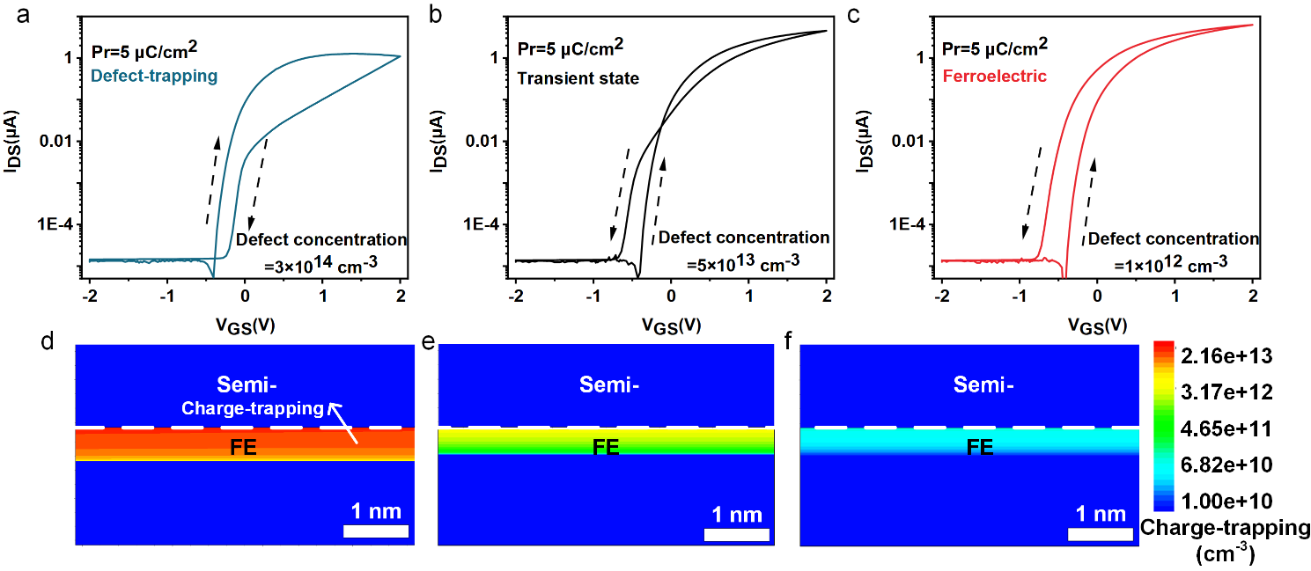
Supplementary Fig.2｜The transfer curves of TCAD simulation MoS₂ 2DFHT with Pr value of 5 μC/cm² and an electron defect concentration value of a) 3×10¹⁴ cm⁻³, b) 5×10¹³ cm⁻³ and c) 1×10¹² cm⁻³. (d-e) The trapped charges of 2DFHT are associated with Supplementary Fig.2a-2c.
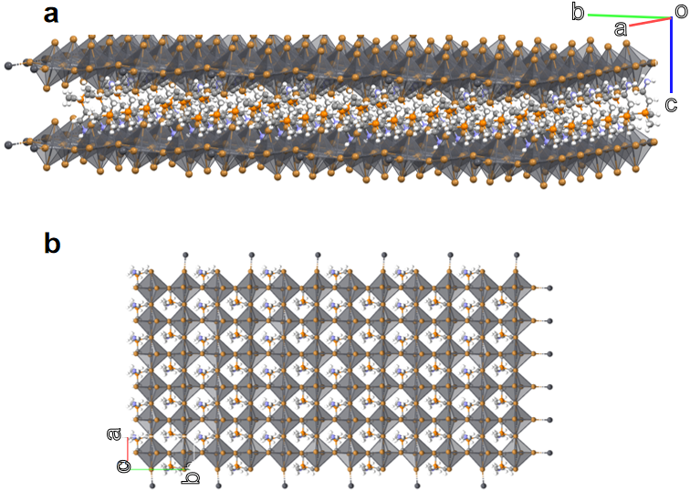
Supplementary Fig.3｜a) The 3D view of the two-dimensional layered perovskites, showing the infinite extension of perovskites in the a-b plane; b) The top view of the perovskite structure along the crystallographic c-axis, presenting the well-layered stacking of the perovskite sheet without any in-plane displacement.

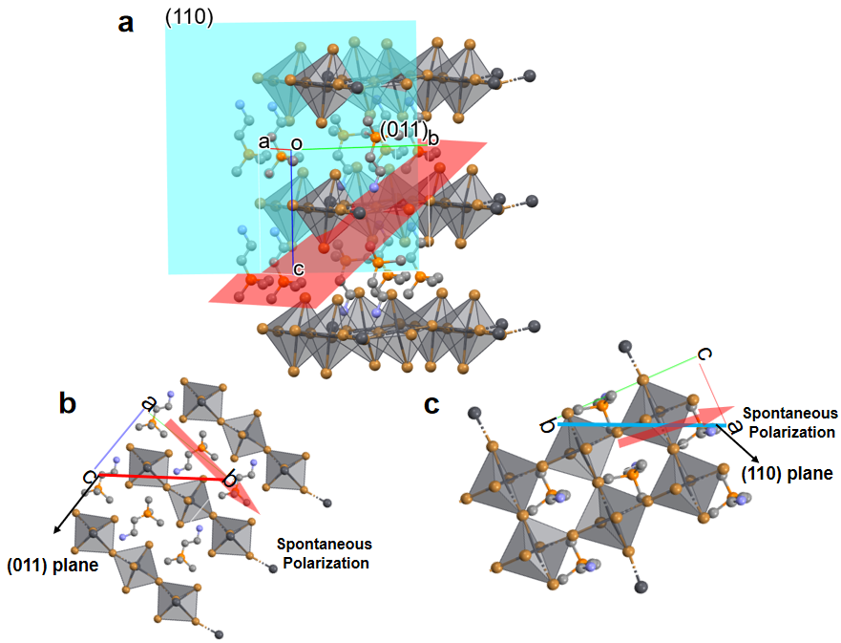
Supplementary Fig.4｜a) The scheme of (110) crystallographic plane and the (011) crystallographic plane in the crystal structure; b) the polar axis crystallographic b-axis presents angle to the (011) plane from the view along a-axis; c) the polar axis crystallographic b-axis presents angle to the (110) plane from the view along c-axis. Both b) and c) indicate the polar axis is tilted with respect to the substrate.

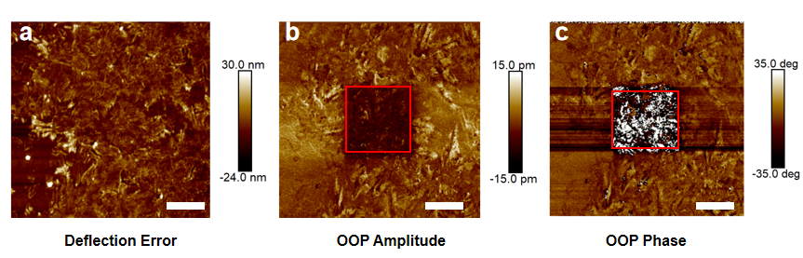
Supplementary Fig.5｜The deflection error map, PFM OOP amplitude and OOP phase change after box poling under -12 V tip voltage, the scale bar in the images is 6 μm.

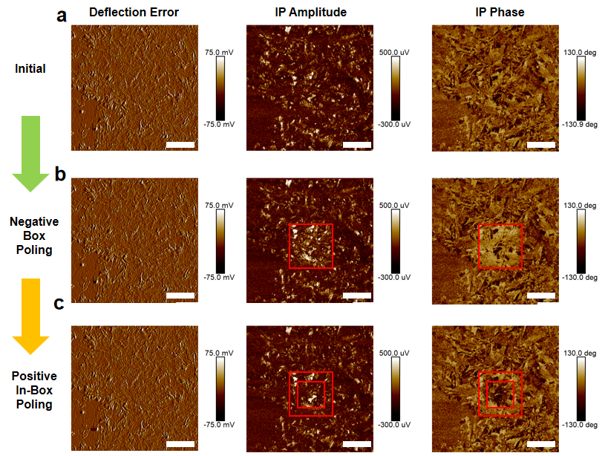
Supplementary Fig.6｜a) the initial deflection error map, IP amplitude, and IP phase image of the thin film sample, showing the multiple ferroelectric domains in the thin film; b) the deflection error map, IP amplitude, and IP phase image of the thin film sample after box poling operation, the identical IP phase in the box region reveals that the ferroelectric domains were driven to the same orientation. c) the deflection error map, IP amplitude, and IP phase image of the thin film sample after in-box poling operation, the switch of in-box region reveals the ferroelectric behavior of the perovskite thin film. The scale bar in the images is 6 μm.
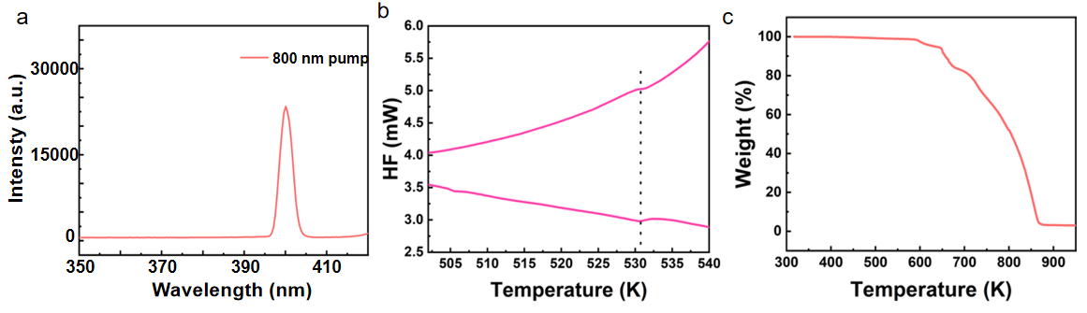
Supplementary Fig.7｜a) The second harmonic generation (SHG) of ETPB verifying the asymmetric polar structure of materials; b) The differential scanning calory (DSC) reveals the paraelectric to ferroelectric phase transition at around 530 K in the ETPB crystal; c) Thermogravimetric analysis (TGA) reveals the highly thermal stability of ETPB with the decomposition point over 600 K.

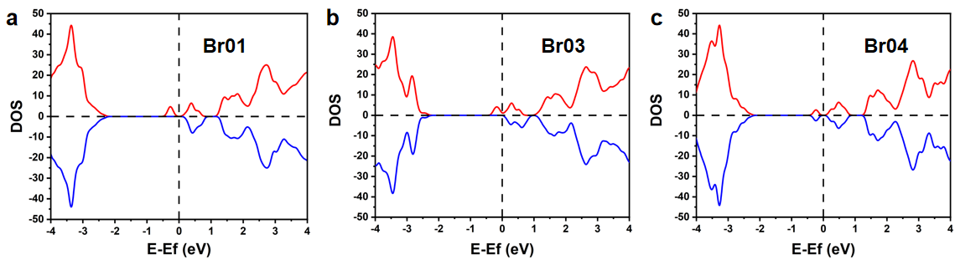
Supplementary Fig.8｜The density of state diagram of ETPB with the Br01, Br03, and Br04 vacancy, all of which show the fermi level upward shift and the presence of defect level below the fermi level in the bandgap, indicating the emergence of the electron trap due to the absence of Br atoms.

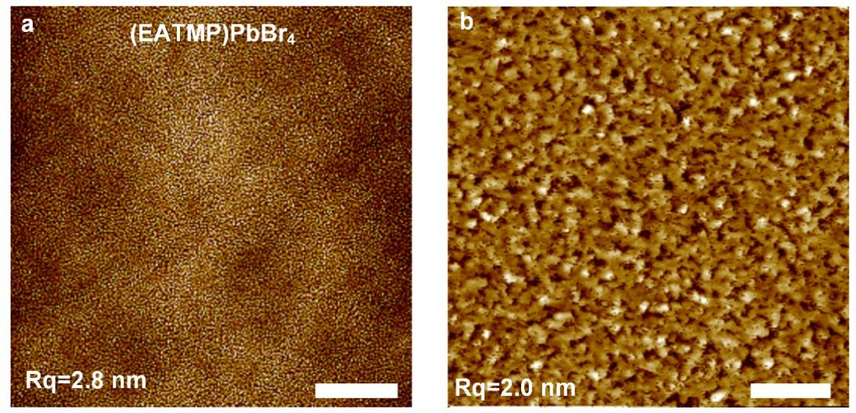
Supplementary Fig.9｜The AFM images of (EATMP)PbBr₄ under a scale range of a) 10 μm and b) 1 μm indicate a small roughness of the deposited ferroelectric films.

Supplementary Fig.10｜The AFM images of the N-type MoS₂, bipolar WSe_{2,} and P-type BP 2DFHTs indicate that the thickness of MoS₂, WSe_{2,} and BP is 5, 8, and 17 nm, respectively.
Supplementary Fig.11｜The Raman spectroscopy of a) MoS₂ and ferroelectric PVK/MoS₂ heterojunction, b) WSe₂ and ferroelectric PVK/WSe₂ heterojunction, c) BP and ferroelectric PVK/BP heterojunction, respectively. The consistent peaks of semiconductor films and heterojunction films indicate that ferroelectric films do not affect the properties of semiconductor films.

Supplementary Fig.12｜The double sweep transfer curves of six random devices from a) MoS₂ 2DFHTs, b) WSe₂ 2DFHTs, and c) BP 2DFHTs, respectively. All six devices exhibit the same hysteresis direction, illustrating the reproducibility of polarity-dependent macroscopic ferroelectric modulation.

Supplementary Fig.13｜a-c) The double sweep transfer curves of MoS_{2,} WSe₂ and BP 2DFHT as a function sweeping ratio. d-f) The extracted threshold voltages under different gate voltage sweep ratios of MoS_{2,} WSe2 and BP 2DFHT.
As shown in Supplementary Fig.13, the hysteresis windows of MoS₂ 2DFHT increase with the decrease of gate sweeping speed, which suggests the charge-trapping dominated modulation mechanism in the n-type MoS₂ 2DFHT. While, the hysteresis window of the p-region WSe₂ and p-type BP 2DFHT is independent of the sweeping speed of gate voltages, which is consistent with the ferroelectric polarization mechanism.

Supplementary Fig.14｜a) The double sweep transfer curves of a) MoS₂ 2DFHT, b) WSe₂ 2DFHT, and c) BP 2DFHT as a function of sweeping times.
Supplementary Fig.14a illustrates the transfer curves of the MoS₂ 2DFHT, where an increase in sweeping times leads to a gradual decrease in channel current, attributed to electron trapping in the ferroelectric layer. In contrast, the channel current of BP 2DFHT increases with the increase of sweeping times, due to the trapped electrons (Supplementary Fig.14c). Notably, the channel current in the n-region of the WSe₂ transistor decreases with the increase of sweeping times, accompanied by an increased current in the p-region (Supplementary Fig.14b). This can be ascribed to the trapping of electrons in the ferroelectric layer, leading to the decrease of electron currents and the increase of hole currents. Besides, the change of current is a reversible process, which can be restored by applying a gate voltage of 60 V for 100 s, providing further evidence of the FE switch

Supplementary Fig.15｜a) The double sweep transfer curves under different gate voltage sweeping ranges of a) MoS₂ transistor without ferroelectric layer. b) WSe₂ transistor without ferroelectric layer. c) BP transistor without ferroelectric layer.
As a comparison, Supplementary Fig.15 illustrates the transfer curves of three corresponding 2D transistors without the ETPB ferroelectric layer. As shown in Supplementary Fig.15, the devices lacking a ferroelectric layer fail to show the phenomenon of ferroelectric polarization, where the hysteresis window reverses as the gate voltage scan range expands. This confirms that the hysteresis and channel current regulatory behavior in 2DFHTs is due to polarization and defect trapping within the ferroelectric layer.

Supplementary Fig.16｜a) The potentiation and inhibition of post-synaptic currents of WSe₂ 2DFHT triggered by 10 V and -10 V gate voltage pulses with a pulse width of 100 ms. b) the paired-pulse facilitation (PPF) and paired-pulse facilitation depression (PPD) of WSe₂ 2DFHT under two continuous pulses of 10 V and -10 V gate voltage pulses with a pulse interval of 100 ms. The induced channel current of WSe₂ 2DFHT quickly returns to the initial state under small gate voltages, indicating the volatile synaptic weight update properties of devices.

Supplementary Fig.17｜The voltage-dependent synaptic weight update of WSe₂ 2DFHT. a) The potentiation synaptic weight update as a function of 50 gate voltage pulses of 10 V. b) The inhibition synaptic weight update as a function of 50 gate voltage pulses of -10 V. c) The transition state of synaptic weight update with inhibition to potentiation as a function of 50 gate voltage pulses of -40 V. d) The potentiation state of synaptic weight update as a function of 50 gate voltage pulses of -50 V.
The WSe₂ 2DFHT demonstrates synaptic weight updates, showing potentiation and inhibition due to the charge-trapping and release in the ferroelectric layer, respectively, at a low voltage of ±10 V. As the gate voltage gradually increases, the current undergoes a transitional state during the -40V pulse and ultimately shifts to fully enhanced synaptic behavior at -50V. This variation in synaptic activity signifies a transition from a defect-trapping mechanism to a ferroelectric polarization mechanism.

Supplementary Fig.18｜The multi-level memory retention of WSe₂ 2DFHT under a gate bias of -60 V with different pulse widths.

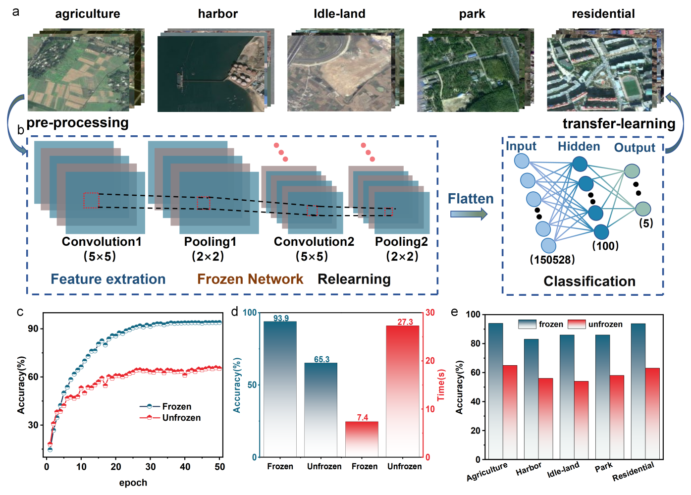
Supplementary Fig.19 a the five classes of Google map images for the train, validation, and recognition dataset. b the schematic of a transfer learning neural network consists of a convolutional neural network and a fully connected network. c the comparison of accuracy between networks with frozen and unfrozen feature information during the training epoch. d the accuracy and time efficiency of frozen and unfrozen neural networks. e the recognition accuracy of each image class under frozen and unfrozen neural networks.
Supplementary Fig.19a displays a selection of five image categories—agriculture, harbor, idle-land, park, and residential—harvested from the SIRI-WHU Google Earth dataset. Each category comprises 200 images divided into test and training classes. Supplementary Fig.19b shows the schematic neural network for transfer learning based on the LeNet model which consists of a feature extractor using a convolutional neural network (CNN), followed by a fully connected layer (FCL) for classification. The initial stage involves preprocessing the input images for the CNN, which includes splitting images into specific kernel weights and partitioning the dataset into training and testing subsets. The model is then instantiated with predefined input and output shapes, and the convolutional layers are set as frozen and unfrozen, which respectively represent retained or discarded the feature parameters extracted by the network. Upon completion of feature extraction through convolution operations, the image information is flattened and forwarded to the FCL for subsequent training processes. In the test case, the input data of images are sequentially passed to the transferred CNN and the learned FCL to recognize five classes of images with five neurons in the output layer of FCL. Supplementary Fig.19c illustrates a comparative analysis of recognition accuracies under 50 training epochs, showing a notable superiority in the frozen network, which achieved a recognition accuracy of 93.9%, compared to 64.3% in its unfrozen counterpart. Furthermore, the efficiency of the frozen network was significantly enhanced, recording a reduced training time of 7.4 seconds per epoch, versus 27.3 seconds for the unfrozen network, as depicted in Supplementary Fig.19d. Additional comparisons of recognition accuracies for the five image classes are presented in Supplementary Fig.19e, highlighting the enhanced capability of the network with preserved weights to more accurately distinguish among varied image types.

