Method:
The white-feather broilers were purchased from a poultry farm in Yuzhong County, Lanzhou. A total of 42 1-day-old broilers with similar weight and healthy feathers were randomly split into 7 groups, and the grouping of broilers was shown in table 1. The standard chicken feed was bought from Zhengda Co., LTD (Lanzhou, China). For the experimental procedures, six chickens in a cage housed at 22±1℃ and 60–75 % relative humidity. The care and use of laboratory animals in our study was approved by Lanzhou University Animal Ethics Committee, and all the relevant ethical regulations were followed. All broiler chickens in each group were weighed individually at each week during the full trial. The feed consumed for one group was monitored on a day basis.
Table 1. Experimental protocol for broilers
Sample ID | Adaptation period | Experimental period
(n=6) | (1-7_{th}) | (8-42_{th})
Control | Normal diet | Normal diet
SMZ+Tylosin₁ | Normal diet | Normal diet containing sulfadimidine and Tylenol tartrate (0.4 g/kg)
SMZ+Tylosin₂ | Normal diet | Normal diet containing sulfadimidine and Tylenol tartrate (0.2 g/kg)
OTC+PMX₁ | Normal diet | Normal diet containing polycolistin and oxytetracycline (0.4 g/kg)
OTC+PMX₂ | Normal diet | Normal diet containing polycolistin and oxytetracycline (0.2 g/kg)
AMX+PMX₁ | Normal diet | Normal diet containing polycolistin and amoxicillin (0.4 g/kg)
AMX+PMX₂ | Normal diet | Normal diet containing polycolistin and amoxicillin (0.2 g/kg)
Supplementary Information
Supplementary Figures
Supplementary Figure 1. Growth performance and immune activity of broiler chicken under the feed-additive regimens of antibiotics and the control. (A) Average daily gain (ADG; n = 6). (B) Average daily feed intake (ADFI; n = 6). (C) Feed conversion ratio (FCR; n = 6; c) were compared among the three treatment groups during the various periods. “*”: significantly changed (p < 0.05). The average daily gain (ADG) was measured per chicken, while the average daily feed intake (ADFI) and the feed conversion ratio (FCR) were measured six pens in each group. (D) Comparison of three immune organ indexes from thymus gland, bursa, and spleen, which were measured at the last day of the 42-day regiment. (E, F) Comparison of serum IgG and intestinal SIgA levels among the three groups on day 42. Bars show the mean ± SD (n=5 mice per group) **=P ﹤0.01; **** =P ﹤0.0001.
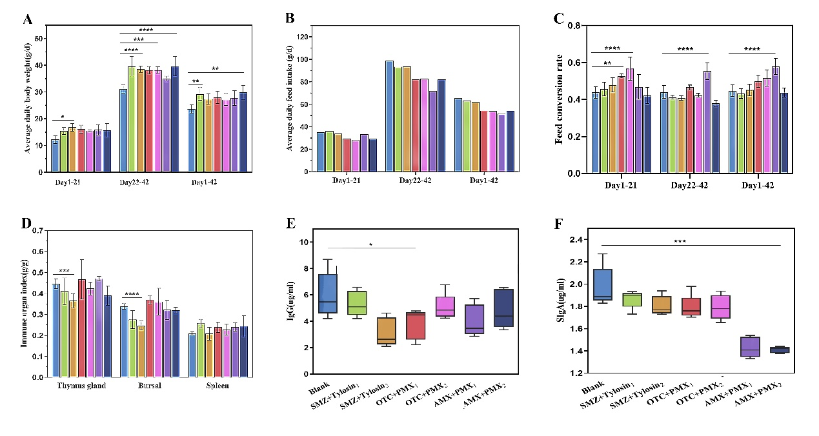
Supplementary Figure 2. Effects of antibiotics in chicken. ALT level (A), AST (B), MDA (C), and T-SOD activities (D), histological analysis of liver (E) and adipocyte (F) under a microscope (e, 600×) are shown. For A–D, values are expressed as the mean ± SEM (n = 6). (H)Liver/weight mass ratio in different groups. Statistical analyses were conducted using the one-way ANOVA. *p < 0.05, **p < 0.01, ***p < 0.001, ****p < 0.0001; ns: not significant.
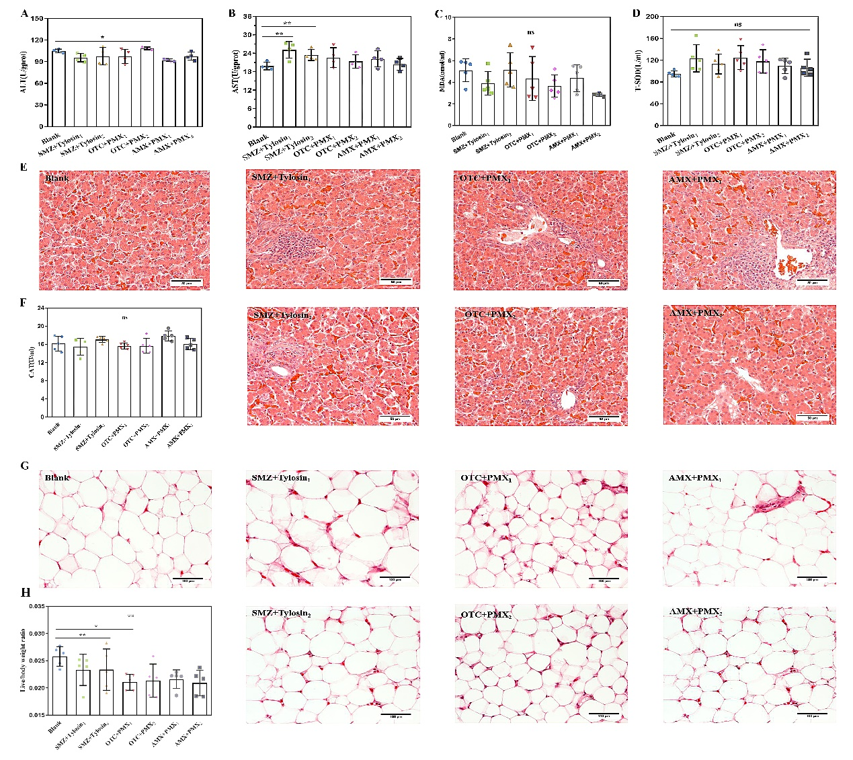
Supplementary Figure 3. The abundance box plot of the top12 differential genera based on Metastat analysis. The abscissa is the group name, and the ordinate is the relative abundance. (A) f_Planococcaceae. (B) g_Akkermansia. (C) g_Caproiciproducens. (D) g_Cutibacterium. (E) g_Enhydrobacter. (F) g_Cutibacterium. (G) g_Flavonifractor. (H) g_Kurthia. (I) g_Pediococcus. (J) g_Pseudomonas. (K) g_Sphingobium. (L) g_Thermus.
Supplementary Figure 4 Serum metabolome of chicken. (A) Drawing evolutionary tree based on sample normalization abundance. (B) PCA of all groups based on metabolomics data. (C) Heatmap analysis of fecal differential metabolites of chicken on day 35nd. (D) KEGG analysis of metabolites according to the selected differential metabolites and KEGG annotation ID.
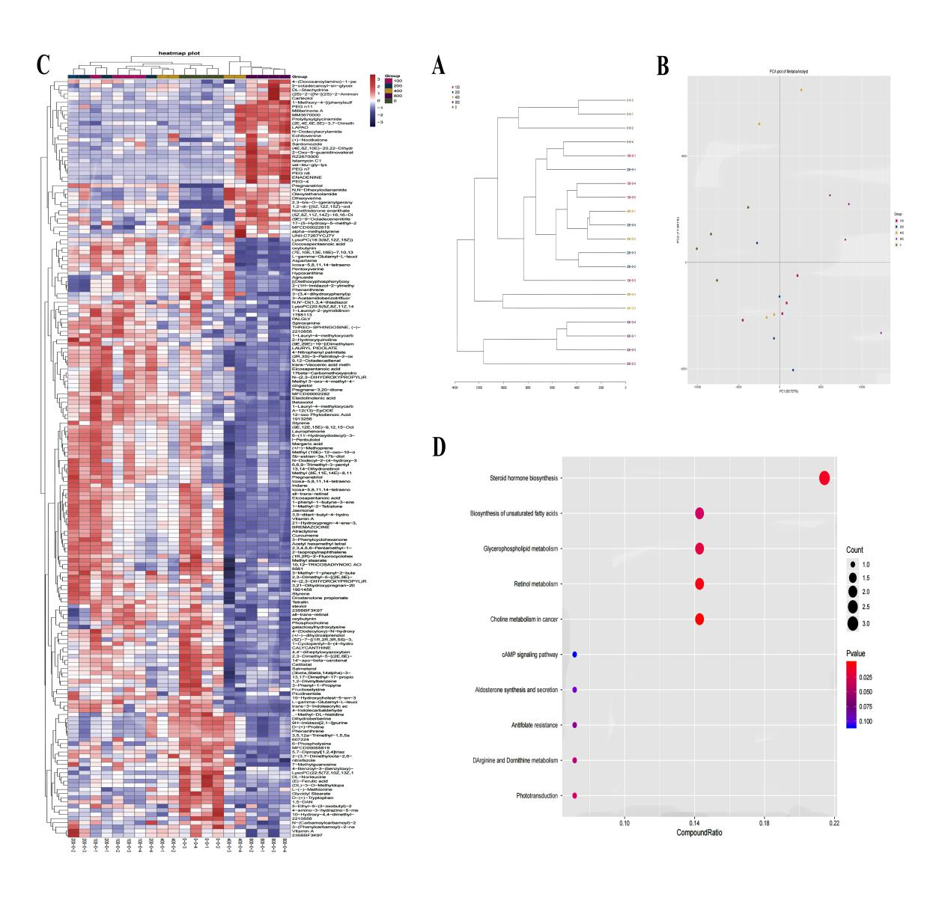

Supplementary Figure 5 Lipidomic of serum samples in chicken. (A) PCA of all groups based on lipid data. (B) PLS-DA of all groups. (C) Heatmap analysis of samples of chicken on day 35nd. (D) KEGG analysis of metabolites according to the selected differential metabolites and KEGG annotation ID.

