Table S1. qRT-PCR primer sequences.
Primer | Forward sequence | Reverse sequence | Size (bp)
18S | TTCGAGGCCCTGTAATTGGA | GCAGCAACTTTAATATACGCTATTGG | 123
IBA1 | TGCCATCCTAAAAATGATCCTGATG | AGATAGCTTTCTTGGCTGGGG | 86
CD45 | GCAGCTAGCAAGTGGTTTGTTC | AAACAGCATGCGTCCTTTCTC | 92
PROS1 | TTGCACTTGTAAACCAGGTTGG | CAGGAACAGTGGTAACTTCCAG | 132
GAS6 | CTCTCTCTGTGGCACTGGTA | CCTTGATCTCCATTAGGGCCAA | 105
GPR34 | CCTGATGTCCAGTAACATTCGC | CATGCAGGGAGTATCCTGGT | 116
TREM2 | TCTTTGTCACAGAGCTGTCC | TCATAGGGGCAAGACACCTG | 88
TMEM119 | CTTCCTGGATGGGATAGTGGAC | GCACAGACGATGAACATCAGC | 96
KI67 | gaggtgtgcagaaaatccaaa | ctgtccctatgacttctggttgt | 78
SOX2 | CCACCTACAGCATGTCCTACTCG | GGGAGGAAGAGGTAACCACAGG | 117
NESTIN | CTCAGCTTTCAGGACCCCAA | GTCTCAAGGGTAGCAGGCAA | 183
GLAST | GGTTGCTGCAAGCACTCATCAC | CACGCCATTGTTCTCTTCCAGG | 95
BLBP | GGCTTTGCCACTAGGCAGG | TGACCACTTTGTCTCCTTCTTGA | 76
GFAP | GAGGTTGAGAGGGACAATCTGG | GTGGCTTCATCTGCTTCCTGTC | 128
GLT-1 | TAGCCGCCATCTTTATAGCCC | CGGCTGTCAGAATGAGGAGC | 150
PLP-1 | GGCCACTGGATTGTGTTTCT | AGGTGGTCCAGGTGTTGAAG | 386-491
GalC | GCAACCTCCCGACTTCTAGTA | ACCACTCGTATCCTCGGAAATA | 199
TBR2 (EOMES) | CGGCCTCTGTGGCTCAAA | AAGGAAACATGCGCCTGC | 76
MAPT | CTCGCATGGTCAGTAAAAGCAA | GGGTTTTTGCTGGAATCCTGGT | 153
Synaptophysin  (SYP) | CTGCAATGGGTCTTCGCCA | ACTCTCGGTCTTGTTGGCAC | 96
PILRB | CCATCAAGGGGACCAAACTCA | TCTGAGTGCCCTTTGCTTTC | 118
BAX | TGGCAGCTGACATGTTTTCTGAC | TCACCCAACCACCCTGGTCTT | 195
IL-6 | TGCAATAACCACCCCTGACC | TGCGCAGAATGAGATGAGTTG | 104
IL-8 | AGACAGCAGAGCACACAAGC | ATGGTTCCTTCCGGTGGT | 62
IL-10 | TGCTGGAGGACTTTAAGGGTTA | GATGCCTTTCTCTTGGAGCTTA | 254
TNF-α | CAGCCTCTTCTCCTTCCTGAT | GCCAGAGGGCTGATTAGAGA | 123
TGF-β | CGCGTGCTAATGGTGGAAA | CTCGGAGCTCTGATGTGTTGAA | 97
IL-1β | AATCTGTACCTGTCCTGCGTGTT | TGGGTAATTTTTGGGATCTACACTCT | 78
IL-18 | AACAAACTATTTGTCGCAGGAAT | TGCCACAAAGTTGATGCAAT | 72

Supplementary Figures
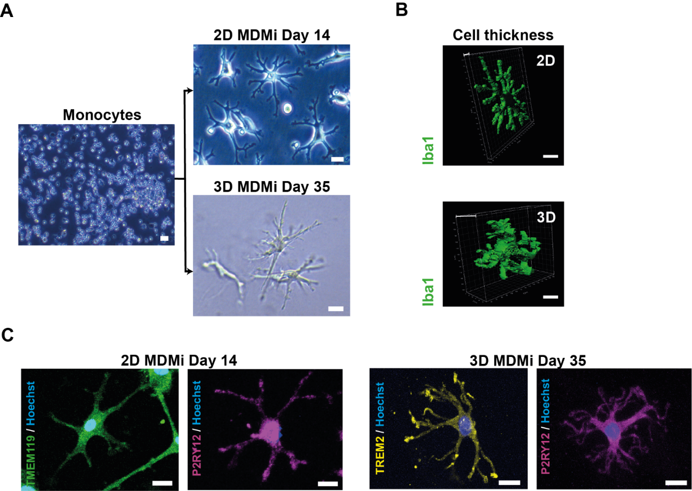
Fig. S1. 2D and 3D MDMi show different cell thickness and positive immunostaining for microglia-enriched markers. (A) Representative bright field images of monocytes and 2D and 3D MDMi after 14 (top) or 35 (bottom) days of differentiation, respectively. Scale bars, 25 μm. (B) 3D reconstruction images of Iba1-stained MDMi and thickness of 2D and 3D MDMi. Scale bars, 25 μm. (C) Immunofluorescence of 2D and 3D MDMi for TMEM119, P2RY12 and TREM2. Scale bars, 25 μm.

Fig. S2. Characterisation of differentiated ReNcell VM 2D and 3D cultures. (A) Immunostaining of 2D ReNcell VM cultures differentiated for 1 and 30 days shows expression of characteristic markers of neural progenitor cells (NPCs; Nestin), astrocytes (GFAP), oligodendrocyte progenitor cells (OPCs; GalC) and neurons (Doublecortin, DCX). Scale bars, 100 μm. (B) Ki67 mRNA expression in 2D ReNcell VM cultures differentiated for 1, 14 or 30 days (n = 3 independent experiments). (C) mRNA expression of a panel of radial glia (NPCs), astrocytes, OPCs and neuron markers in 2D ReNcell VM at days 1, 14 and 30 of spontaneous differentiation (n = 3 independent experiments). (D) Schematic of ReNcell VM cultures undergoing spontaneous differentiation for 1 day in 2D, or in 3D upon embedment in Matrigel. mRNA expression of (E) the proliferation marker Ki67 alongside the (F) the radial glia marker BLBP, the mature astrocyte marker GLT-1 and the mature neuron marker Synaptophysin (SYP) in 2D (n = 3 independent experiments) and 3D (n = 3 independent experiments) ReNcell VM cultures spontaneously differentiated for 1 day. One-way ANOVA with Tukey’s multiple comparison test in B, C; unpaired Student’s t test with or without Welch’s correction, two-tailed in E and F; *P < 0.05, **P < 0.01, ***P < 0.001, ****P < 0.0001.

Fig. S3. Characterisation of 2D MDMi and ReNcell VM co-cultures. MDMi co-culture with ReNcell VM-derived neuro-glial cells in 2D is insufficient for monocyte differentiation into MDMi, as monocytes retain a round morphology after 40 days in 2D co-culture. MDMi were stained for Iba1 and ReNcell VM were stained for β3-tubulin (TUBB3). Scale bar, 100 μm.

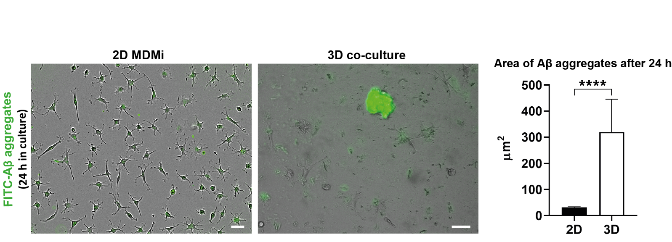
Fig. S4. FITC-Aβ peptides form larger aggregates in 3D compared to 2D after 24 h in culture. FITC-Aβ peptides were added to 2D MDMi and 3D co-cultures. Imaging was conducted following incubation for 24 h. Area of Aβ aggregates (µm²) was quantified for comparison between the 2D MDMi (n = 3) and 3D co-cultures (n = 3). Scale bars, 100 μm. Data are presented as mean ± SEM. Mann-Whitney test, two-tailed; ****P < 0.0001.

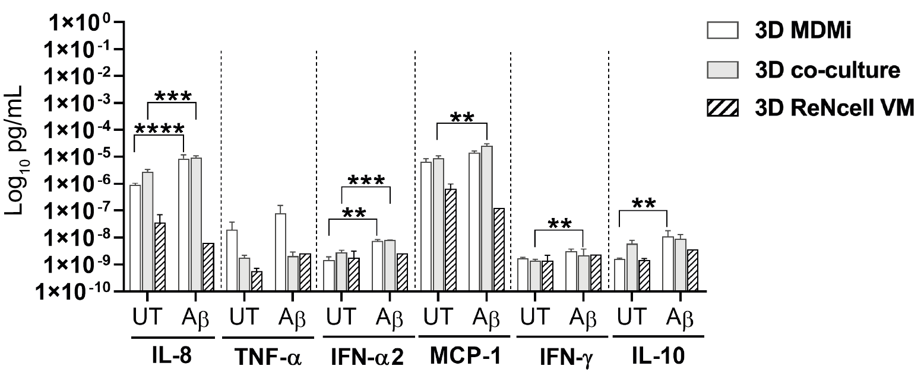
Fig. S5. Pro-inflammatory cytokine secretion profiles of 3D MDMi, 3D co-culture and 3D ReNcell VM. Concentration of secreted pro-inflammatory cytokines IL-8, TNF-α, IFN-α2, MCP-1, IFN-γ and IL-10 by 3D MDMi (n = 2) and ReNcell VM (n = 1) mono-cultures and 3D co-cultures (n = 3) upon exposure to FITC-Aβ aggregates for 7 days. Data are presented as mean ± SEM. Unpaired Student’s t test with or without Welch’s correction, two-tailed; **P < 0.01, ***P < 0.001, ****P < 0.0001.

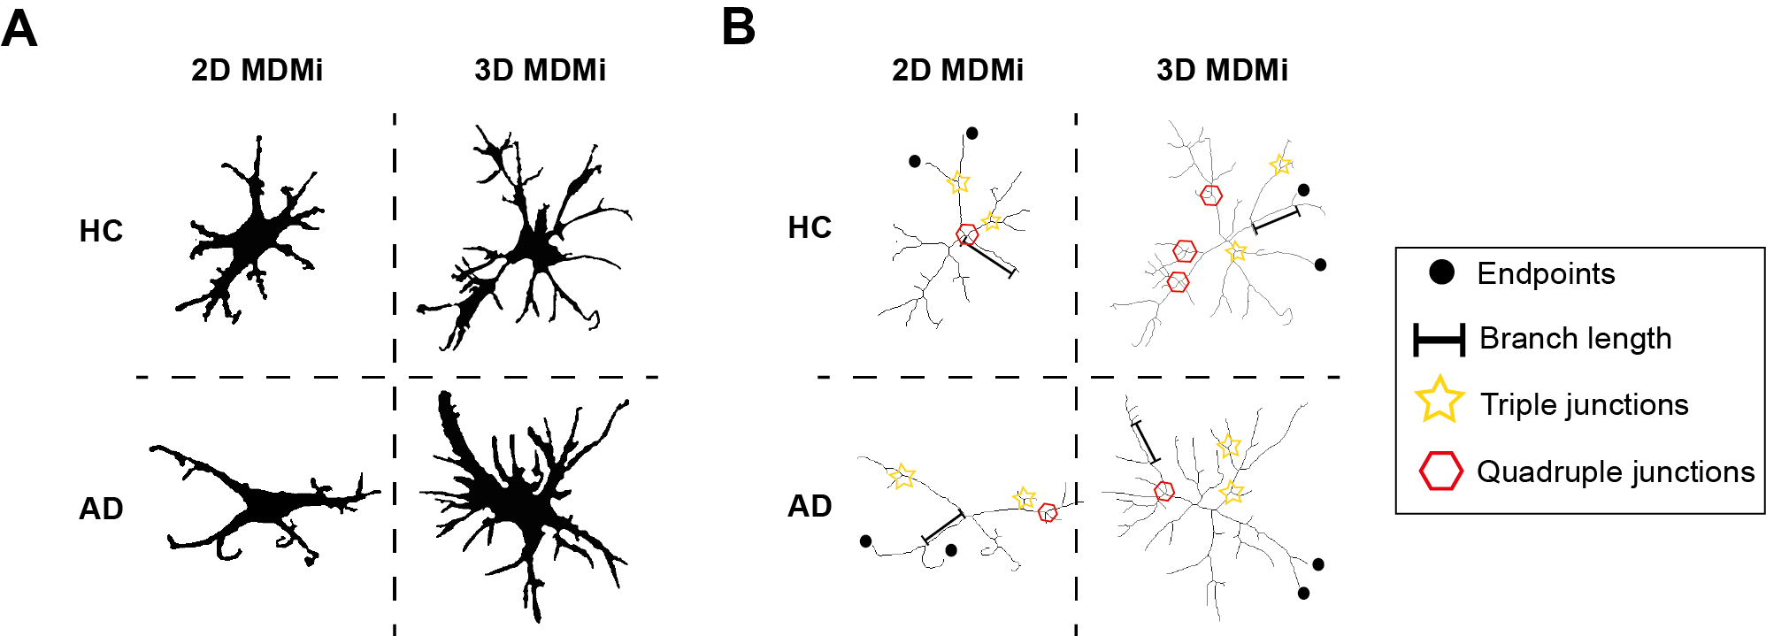
Fig. S6. Depiction of morphological parameter measurements in HC and AD MDMi in 2D and 3D mono-cultures. (A) Binary and (B) skeleton images of HC and AD MDMi in 2D and 3D mono-cultures showing the morphological parameters (endpoints, branch length, triple and quadruple junctions) analysed to estimate the branched structure and complexity of MDMi.
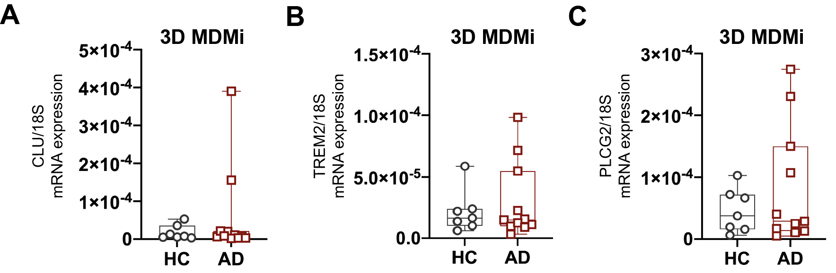

Fig. S7. Gene expression of AD risk genes in HC and AD 3D MDMi. qRT-PCR quantification of (A) CLU, (B) TREM2 and (C) PLCG2 mRNA expression in 3D MDMi mono-cultures from HC (n = 7) and AD (n = 11) donors. Data are presented as mean ± SD. Each single data point represents one biological replicate. Unpaired Student’s t test with or without Welch’s correction, two-tailed.

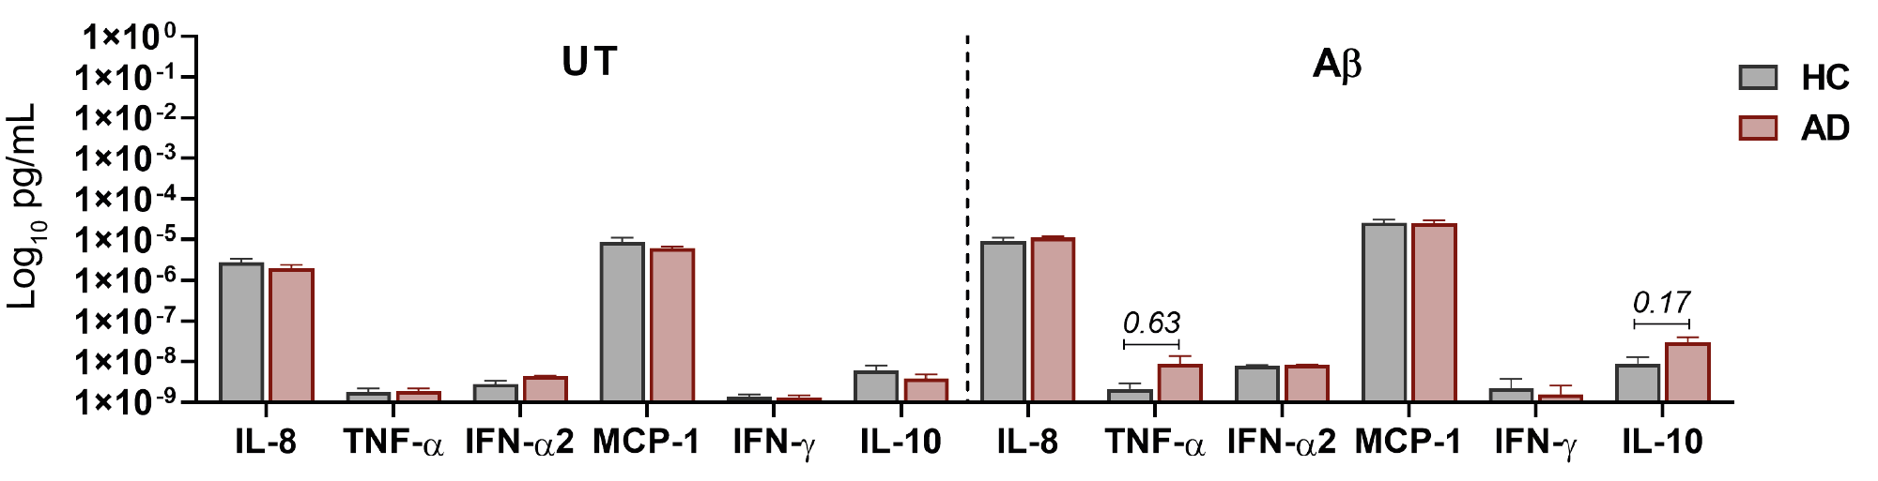

Fig. S8. Inflammatory cytokine secretion by HC and AD 3D co-cultures under untreated and Aβ-treated conditions. Concentration of secreted IL-8, TNF-α, IFN-α2, MCP-1, IFN-γ and IL-10 are displayed in HC (n = 3) and AD (n = 4) MDMi 3D co-cultures. Data are presented as mean ± SEM. Unpaired Student’s t test with or without Welch’s correction, two-tailed.

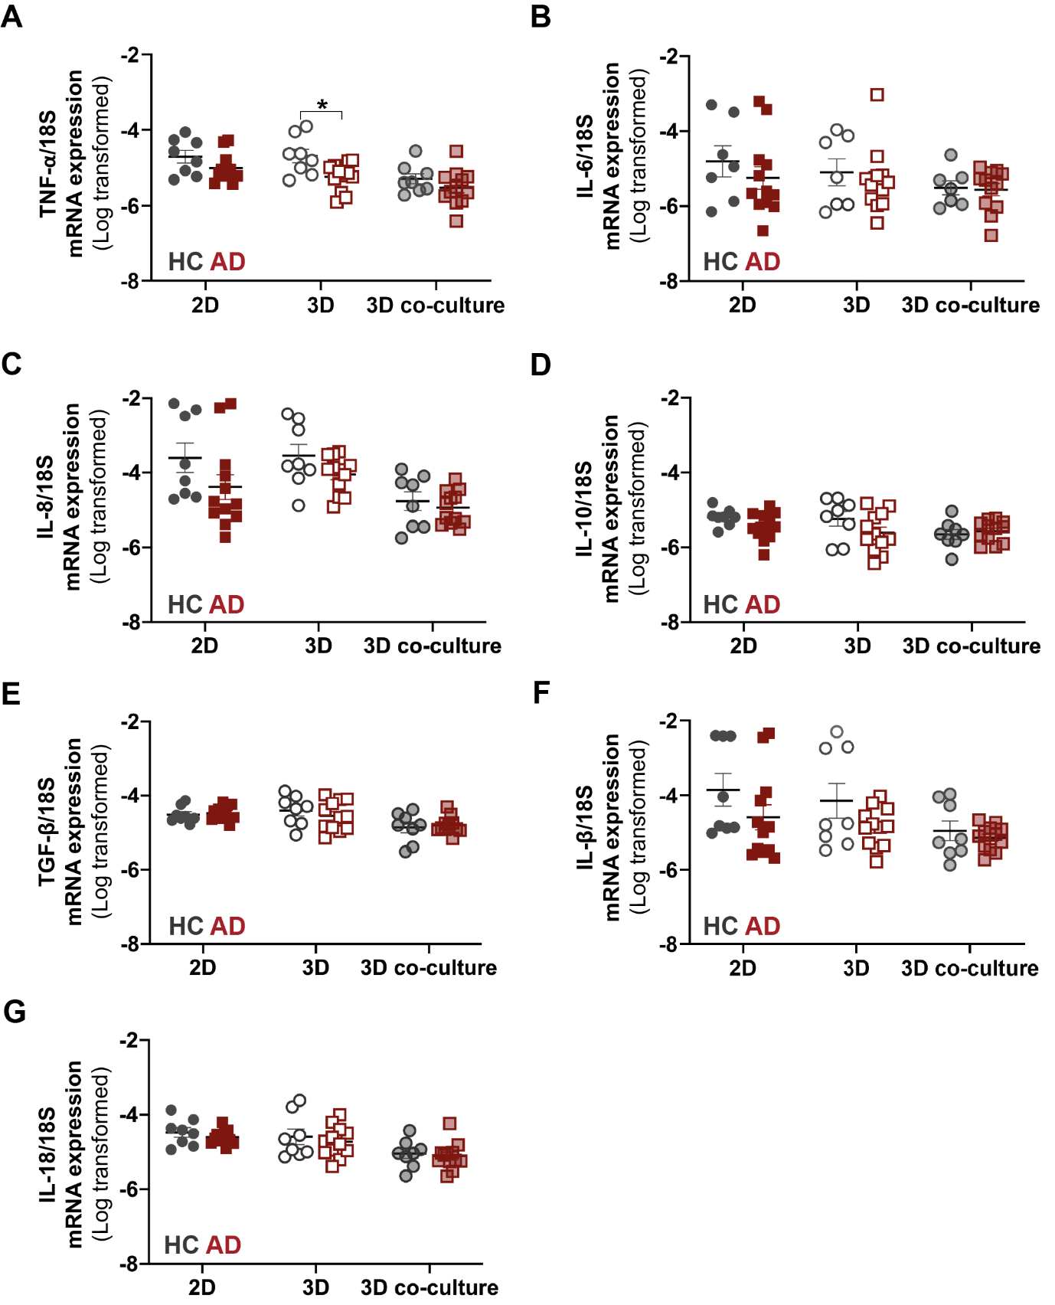
Fig. S9. Cytokine expression profiles in HC and AD MDMi 2D and 3D mono-cultures and 3D co-cultures. Log-transformed mRNA expression of the inflammatory cytokines (A) TNF-α, (B) IL-6, (C) IL-8, (D) IL-10, (E) TGF-β, (F) IL-1β and (G) IL-18 in HC (n = 7-8) and AD (n = 12) MDMi cultures. Data are presented as mean ± SD. Each single data point represents one biological replicate. Comparisons between HC and AD MDMi in either culture format were performed using unpaired Student’s t test with or without Welch’s correction, two-tailed; *P < 0.05.

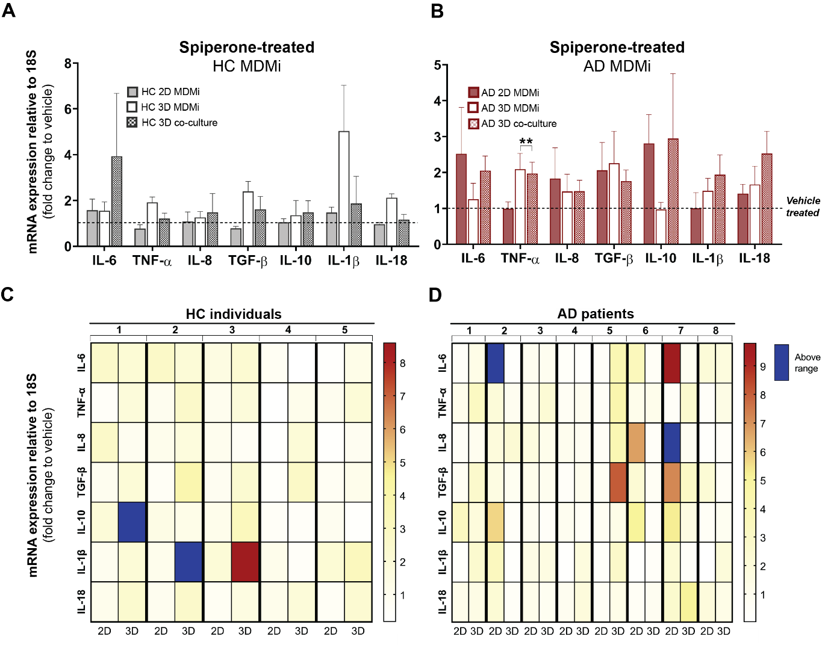
Fig. S10. Spiperone treatment induces cytokine expression responses that differ between culture format and are heterogeneous among HC and AD MDMi. Fold change in cytokine mRNA expression levels following 24 h exposure to 1µM spiperone compared to vehicle (DMSO)-treated cultures in (A) HC (n = 5) and (B) AD (n = 8) 2D and 3D MDMi mono-cultures and 3D co-cultures. Dotted black lines represent baseline responses of vehicle-treated cultures. Heat maps showing (C) HC (n = 5) and (D) AD (n = 8) donors-specific changes in mRNA expression from MDMi mono-cultures in 2D and 3D. Red-yellow colour spectrum represents relative fold change of mRNA expression after spiperone treatment compared to vehicle. Expression changes falling outside the displayed range are indicated in dark blue. Data are presented as mean ± SEM. One-way ANOVA with Dunnett’s multiple comparison test; **P < 0.01.

