Optimizing mathematical models for the efficacy and precise regimens of meropenem in RICU patients: a real-world prospective study

Supplementary file
Table of contents
Meropenem concentration affecting factors 2
Methods 2
Results 2
Discussions 3
Reference 3
Table S1 5
Table S2 8
Table S3 8
Fig. S1 9
Fig. S2 10
Fig. S3. 13
Fig. S4 13
Fig. S5 14

Meropenem concentration affecting factors

Methods
Multiple linear regression analyses were conducted to identify predictors of meropenem C_{trough} and C_{peak}.
Variables with a P < 0.05 were entered into the subsequent multiple linear. A forward stepwise (likelihood ratio) method was performed to determine the predictors using a significance level of 0.05 for entry and 0.10 for removal from the model. A variance inflation factor (VIF) of > 5 was considered indicative of multicollinearity.

Results
The result of the univariate analysis is shown in Table S1, Fig. S1, and Fig.S2. Subsequently, the statistically significant factors entered a stepwise multiple linear regression model of 97 C_{trough}, specifically, Infusion volume, Human albumin, Blood urea nitrogen (BUN), and base excess (BE) (P <0.05, Table S2). Similarly, dose, infusion volume, fluid transfusion volume, and CrCL (P <0.05, Table S3) entered the model of 118 C_{peak}. Moreover, these factors were not collinear with one another (VIF < 5) and were considered independent and not confounding. BUN (standardized coefficients β=-0.358, P <0.001) and CrCL (β=-0.399, P <0.001) contributed the most to the C_{trough} and C_{peak}, respectively. The results showed that the models fitted well (adjusted R² =0.679, 0.555, respectively) and were statistically significant (P < 0.001).

C_{trough}= -0.212*Infusion volume +0.255*Human albumin +0.572*BUN -0.358*BE +4.633
C_{peak} =0.395*dose - 0.277* infusion volume + 0.283*fluid transfusion volume - 0.399*CrCL - 0.251*sex*A (“A = 1” if the patient is male, otherwise “A = 0”)
We observed that for every 1 mmol/L increase in BUN levels, there was a corresponding increase of 0.572 mg/L in the C_{trough} of meropenem. Conversely, with each unit increase in CrCL, the C_{peak} of meropenem decreased by 0.399 mg/L. Additionally, when the infusion volume was increased by 1 mL, there was a tendency for C_{trough} and C_{peak} to decrease by 0.212 mg/L and 0.277 mg/L, respectively.

Discussions
Similar to the results of many studies,(3-5) this study found that the renal function, BUN and CrCL, have the greatest impact on the C_{trough} and C_{peak} of meropenem in RICU patients, respectively. This study is the first to find that BE and fluid transformation volume could reduce and increase C_{trough} in RICU patients, respectively. Weight or BMI may affect meropenem concentration and clinical efficacy,(6-9) although no direct impact was found in this study. The established joint predictors could help achieve ideal blood concentrations and reduce the occurrence of adverse reactions.

Reference
1. Casals G, Hernández C, Hidalgo S, Morales B, López-Púa Y, Castro P, et al. Development and validation of a UHPLC diode array detector method for meropenem quantification in human plasma. Clinical biochemistry. 2014;47(16-17):223-7.
2. Zou L, Meng F, Hu L, Huang Q, Liu M, Yin T. A novel reversed-phase high-performance liquid chromatographic assay for the simultaneous determination of imipenem and meropenem in human plasma and its application in TDM. Journal of pharmaceutical and biomedical analysis. 2019;169:142-50.
3. Ehmann L, Zoller M, Minichmayr IK, Scharf C, Maier B, Schmitt MV, et al. Role of renal function in risk assessment of target non-attainment after standard dosing of meropenem in critically ill patients: a prospective observational study. Critical care (London, England). 2017;21(1):263.
4. Minichmayr IK, Roberts JA, Frey OR, Roehr AC, Kloft C, Brinkmann A. Development of a dosing nomogram for continuous-infusion meropenem in critically ill patients based on a validated population pharmacokinetic model. The Journal of antimicrobial chemotherapy. 2018;73(5):1330-9.
5. Luque S, Benítez-Cano A, Larrañaga L, Sorlí L, Navarrete ME, Campillo N, et al. Pharmacokinetics and Pharmacodynamics of Meropenem by Extended or Continuous Infusion in Low Body Weight Critically Ill Patients. Antibiotics (Basel, Switzerland). 2021;10(6).
6. Alobaid AS, Wallis SC, Jarrett P, Starr T, Stuart J, Lassig-Smith M, et al. Effect of Obesity on the Population Pharmacokinetics of Meropenem in Critically Ill Patients. Antimicrobial agents and chemotherapy. 2016;60(8):4577-84.
7. Sjövall F, Alobaid AS, Wallis SC, Perner A, Lipman J, Roberts JA. Maximally effective dosing regimens of meropenem in patients with septic shock. The Journal of antimicrobial chemotherapy. 2018;73(1):191-8.
8. Benítez-Cano A, Luque S, Sorlí L, Carazo J, Ramos I, Campillo N, et al. Intrapulmonary concentrations of meropenem administered by continuous infusion in critically ill patients with nosocomial pneumonia: a randomized pharmacokinetic trial. Critical care (London, England). 2020;24(1):55.
9. Burger R, Guidi M, Calpini V, Lamoth F, Decosterd L, Robatel C, et al. Effect of renal clearance and continuous renal replacement therapy on appropriateness of recommended meropenem dosing regimens in critically ill patients with susceptible life-threatening infections. The Journal of antimicrobial chemotherapy. 2018;73(12):3413-22.

Table S1 Bivariate correlation analysis of C_{trough}, C_{peak}, and clinical efficacy.
 |  | C_{trough} |  |  | C_{peak} |  |  |  | Clinical efficacy
 |  | Coefficient |  | P-value | Coefficient |  | P-value |  | Coefficient |  | P-value
C_{trough} |  | 1.000 |  | / | 0.536** |  | <0.001 |  | -0.512** |  | <0.001
C_{peak} |  | 0.536** |  | <0.001 | 1.000 |  | / |  | -0.209* |  | 0.023
Clinical efficacy |  | -0.512** |  | <0.001 | -0.209* |  | 0.023 |  | 1.000 |  | /
C_{trough}/MIC |  | 0.478** |  | 0.001 | 0.216 |  | 0.205 |  | -0.463** |  | 0.001
C_{trough}/MIC >4 |  | 0.115 |  | 0.435 | 0.081 |  | 0.640 |  | -0.298* |  | 0.040
C_{trough}/MIC >3 |  | 0.306* |  | 0.035 | 0.248 |  | 0.146 |  | -0.292* |  | 0.044
Dosage (mg) |  | -0.162 |  | 0.154 | 0.233* |  | 0.011 |  | 0.168* |  | 0.049
Q8h/Q12h |  | 0.193 |  | 0.088 | -0.071 |  | 0.444 |  | 0.017 |  | 0.847
Infusion volume |  | -0.336** |  | 0.002 | -0.198* |  | 0.032 |  | 0.203* |  | 0.017
Infusion duration |  | -0.238 |  | 0.120 | -0.239* |  | 0.022 |  | 0.118 |  | 0.245
Level of infusion duration |  | -0.234 |  | 0.122 | -0.258* |  | 0.014 |  | 0.156 |  | 0.123
Theoretical infusion duration |  | -0.340** |  | 0.002 | -0.223* |  | 0.015 |  | 0.189* |  | 0.026
Level of theoretical infusion duration |  | -0.340** |  | 0.002 | -0.223* |  | 0.015 |  | 0.189* |  | 0.026
Daily dose (mg) |  | -0.297** |  | 0.008 | 0.126 |  | 0.173 |  | 0.066 |  | 0.443
Bacterial counting |  | 0.330** |  | 0.003 | 0.221* |  | 0.016 |  | -0.116 |  | 0.174
MIC |  | 0.131 |  | 0.363 | -0.011 |  | 0.927 |  | 0.084 |  | 0.458
Combined bacterial infection |  | 0.060 |  | 0.597 | 0.143 |  | 0.123 |  | 0.005 |  | 0.950
Combined fungal infection |  | -0.074 |  | 0.514 | 0.063 |  | 0.501 |  | 0.043 |  | 0.618
Combined drug-resistant bacterial |  | 0.045 |  | 0.692 | 0.073 |  | 0.434 |  | 0.046 |  | 0.593
Hospitalization duration (days) |  | 0.134 |  | 0.240 | 0.066 |  | 0.475 |  | 0.014 |  | 0.869
Sex |  | -0.078 |  | 0.492 | -0.283** |  | 0.002 |  | -0.020 |  | 0.817
Age |  | 0.127 |  | 0.263 | 0.102 |  | 0.272 |  | -0.054 |  | 0.532
Weight |  | 0.057 |  | 0.615 | -0.102 |  | 0.273 |  | 0.013 |  | 0.884
Height |  | 0.056 |  | 0.627 | -0.224* |  | 0.015 |  | -0.077 |  | 0.370
BMI |  | 0.060 |  | 0.597 | 0.007 |  | 0.942 |  | 0.049 |  | 0.569
APACHE II score |  | 0.183 |  | 0.166 | 0.015 |  | 0.886 |  | -0.330** |  | 0.001
SOFA score |  | 0.334* |  | 0.012 | 0.067 |  | 0.565 |  | -0.409** |  | <0.001
Fluid transfusion volume |  | 0.414** |  | <0.001 | 0.311** |  | 0.001 |  | -0.399** |  | <0.001
Effluent volume |  | 0.298** |  | 0.009 | 0.215* |  | 0.021 |  | -0.158 |  | 0.070
The difference between fluid transfusion volume and effluent volume |  | 0.065 |  | 0.568 | 0.037 |  | 0.688 |  | -0.214* |  | 0.012
T (℃) |  | 0.284* |  | 0.011 | 0.107 |  | 0.250 |  | -0.212* |  | 0.012
Blood pH |  | -0.152 |  | 0.182 | 0.094 |  | 0.311 |  | -0.069 |  | 0.419
P_{CO2} |  | -0.235* |  | 0.037 | -0.125 |  | 0.178 |  | 0.170* |  | 0.046
P_{O2} |  | 0.017 |  | 0.884 | 0.012 |  | 0.896 |  | 0.022 |  | 0.798
AST |  | 0.206 |  | 0.069 | 0.024 |  | 0.798 |  | -0.189* |  | 0.027
PTA% |  | -0.352** |  | 0.002 | -0.158 |  | 0.098 |  | 0.224* |  | 0.011
ALT |  | -0.167 |  | 0.141 | -0.095 |  | 0.306 |  | -0.014 |  | 0.874
C_{K+} |  | -0.006 |  | 0.959 | -0.034 |  | 0.714 |  | 0.056 |  | 0.517
C_{Na+} |  | 0.194 |  | 0.086 | 0.037 |  | 0.689 |  | -0.094 |  | 0.275
C_{Ca2+} |  | -0.073 |  | 0.523 | 0.197* |  | 0.032 |  | -0.062 |  | 0.467
C_{Lac} |  | 0.161 |  | 0.157 | 0.071 |  | 0.445 |  | -0.146 |  | 0.087
BE |  | -0.299** |  | 0.007 | -0.093 |  | 0.317 |  | 0.130 |  | 0.129
PT |  | 0.341** |  | 0.003 | 0.152 |  | 0.110 |  | -0.212* |  | 0.016
INR |  | 0.343** |  | 0.003 | 0.159 |  | 0.096 |  | -0.222* |  | 0.012
Total protein |  | -0.156 |  | 0.170 | 0.086 |  | 0.354 |  | 0.330** |  | <0.001
PAB |  | 0.500 |  | 0.667 | 0.500 |  | 0.667 |  | -0.894 |  | 0.106
ALB |  | -0.021 |  | 0.855 | 0.060 |  | 0.522 |  | 0.024 |  | 0.778
TBIL |  | 0.097 |  | 0.394 | -0.007 |  | 0.936 |  | -0.239** |  | 0.005
DBIL |  | 0.144 |  | 0.206 | 0.032 |  | 0.734 |  | -0.272** |  | 0.001
TBA |  | -0.036 |  | 0.751 | 0.010 |  | 0.915 |  | -0.174* |  | 0.041
BUN |  | 0.707** |  | <0.001 | 0.186* |  | 0.044 |  | -0.360** |  | <0.001
CREA |  | 0.707** |  | <0.001 | 0.326** |  | <0.001 |  | -0.301** |  | <0.001
UA |  | 0.531** |  | <0.001 | 0.087 |  | 0.348 |  | -0.182* |  | 0.032
CrCL |  | -0.704** |  | <0.001 | -0.373** |  | <0.001 |  | 0.284** |  | 0.001
WBC |  | 0.008 |  | 0.941 | -0.080 |  | 0.387 |  | -0.079 |  | 0.355
HGB |  | -0.565** |  | <0.001 | -0.141 |  | 0.129 |  | 0.407** |  | <0.001
RBC |  | -0.625** |  | <0.001 | -0.234* |  | 0.011 |  | 0.466** |  | <0.001
PLT |  | -0.505** |  | <0.001 | -0.207* |  | 0.024 |  | 0.395** |  | <0.001
NEUT% |  | 0.292** |  | 0.010 | 0.177 |  | 0.056 |  | -0.375** |  | <0.001
LYM% |  | -0.320** |  | 0.004 | -0.120 |  | 0.199 |  | 0.339** |  | <0.001
HCT% |  | -0.572** |  | <0.001 | -0.155 |  | 0.098 |  | 0.448** |  | <0.001
PCT |  | 0.611** |  | <0.001 | 0.205* |  | 0.028 |  | -0.383** |  | <0.001
CRP |  | 0.475** |  | <0.001 | 0.233* |  | 0.012 |  | -0.344** |  | <0.001
ESR |  | 0.243* |  | 0.037 | 0.127 |  | 0.178 |  | -0.077 |  | 0.383
IL-2 |  | -0.224 |  | 0.533 | 0.497 |  | 0.101 |  | 0.327 |  | 0.234
IL-4 |  | -0.612 |  | 0.060 | -0.102 |  | 0.753 |  | 0.541* |  | 0.037
IL-6 |  | 0.164 |  | 0.397 | 0.206 |  | 0.157 |  | -0.339* |  | 0.013
IL-10 |  | 0.164 |  | 0.651 | .580* |  | 0.048 |  | -0.327 |  | 0.234
TNF-α |  | -0.067 |  | 0.855 | -0.301 |  | 0.342 |  | 0.164 |  | 0.560
IFN-γ |  | -0.006 |  | 0.987 | 0.413 |  | 0.183 |  | 0.327 |  | 0.234
IL-17A |  | 0.103 |  | 0.776 | 0.245 |  | 0.442 |  | 0.262 |  | 0.345
CD4⁺T Lymphocyte percentage (%) |  | -0.142 |  | 0.470 | -0.221 |  | 0.182 |  | 0.241 |  | 0.110
T Lymphocyte percentage (%) |  | -0.139 |  | 0.481 | -0.179 |  | 0.283 |  | 0.305* |  | 0.042
B Lymphocyte percentage (%) |  | 0.161 |  | 0.422 | -0.184 |  | 0.277 |  | -0.172 |  | 0.264
CD8⁺T Lymphocyte percentage (%) | -0.134 |  | 0.498 |  |  | -0.143 |  | 0.391 |  | 0.182 | 0.233
Natural killer cell percentage (%) | -0.135 |  | 0.494 |  |  | 0.243 |  | 0.148 |  | -0.039 | 0.799
CD4⁺T/CD8 T Lymphocyte percentage | 0.021 |  | 0.914 |  |  | -0.189 |  | 0.230 |  | 0.136 | 0.350
Concomitant medication
Antifungal agents |  | 0.243* |  | 0.031 | 0.123 |  | 0.184 |  | -0.224** |  | 0.008
Antibacterial agents |  | 0.310** |  | 0.006 | 0.139 |  | 0.132 |  | -0.188* |  | 0.027
Proton pump inhibitor agents |  | 0.167 |  | 0.141 | 0.070 |  | 0.454 |  | -0.192* |  | 0.024
Respiratory agents |  | 0.042 |  | 0.713 | 0.075 |  | 0.417 |  | 0.086 |  | 0.317
Digestive system agents |  | 0.206 |  | 0.069 | 0.109 |  | 0.240 |  | -0.106 |  | 0.216
Hormonal agents |  | 0.046 |  | 0.688 | -0.068 |  | 0.464 |  | -0.042 |  | 0.622
Diuretic agents |  | -0.020 |  | 0.864 | 0.086 |  | 0.353 |  | 0.018 |  | 0.832
Sedative and analgesic agents |  | 0.006 |  | 0.959 | -0.104 |  | 0.261 |  | 0.006 |  | 0.945
Human albumin |  | 0.284* |  | 0.011 | 0.256** |  | 0.005 |  | -0.287** |  | 0.001
Blood transfusion |  | 0.280* |  | 0.012 | 0.156 |  | 0.092 |  | -0.304** |  | <0.001
*The variables were significant at the level of 0.05 (double tail). BE, base excess; BUN, Blood urea nitrogen; CrCL, Creatinine clearance.

Table S2 The multiple linear regression model about meropenem trough concentrationª
Variable | Unstandardized Coefficients |  | Standardized Coefficients | t | P value | VIF
 | B | Std. Error | β
Infusion volume | -0.076 | 0.032 | -0.212 | -2.354 | 0.024 | 1.107
Human albumin | 0.225 | 0.077 | 0.255 | 2.904 | 0.006 | 1.058
BUN | 0.638 | 0.102 | 0.572 | 6.231 | <0.001 | 1.154
BE | -0.566 | 0.136 | -0.358 | -4.163 | <0.001 | 1.012
Constant value | 4.633 | 3.513 |  | 1.319 | 0.195
F = 24.233 |  |  |  | <0.001
R² = 0.708 |  |  | Adjusted R² = 0.679
ª Durbin-Watson test value =1.900; 79 trough concentrations were selected and analyzed. BUN, Blood urea nitrogen; BE, base excess.

Table S3 The multiple linear regression model about meropenem peak concentrationª
Parameter | Unstandardized Coefficients |  | Standardized Coefficients | t | P value | VIF
 | B | Std. Error | β
Dose | 0.058 | 0.011 | 0.395 | 5.168 | <0.001 | 1.183
Infusion volume | -0.232 | 0.088 | -0.277 | -2.626 | 0.010 | 2.242
Level of infusion duration | -1.785 | 3.043 | -0.060 | -0.587 | 0.559 | 2.114
Fluid transfusion volume | 0.007 | 0.002 | 0.283 | 3.720 | <0.001 | 1.169
CrCL | -0.209 | 0.040 | -0.399 | -5.234 | <0.001 | 1.172
Human albumin | 0.269 | 0.161 | 0.127 | 1.672 | 0.098 | 1.174
Sex² | -11.365 | 3.306 | -0.251 | -3.438 | 0.001 | 1.078
Constant value | 14.181 | 11.659 |  | 1.216 | 0.227
F = 17.023 |  |  |  | <0.001
R² = 0.589 |  |  | Adjusted R² = 0.555
ªAdjusted R² = 0.555; Durbin-Watson test value =1.787; 91 peak concentrations were selected and analyzed. ²Compared to females. CrCL, Creatinine clearance.

Fig. S1 Correlation analysis between meropenem C_{tourgh} and its determinants. (A) Infusion volume, (B) Human albumin, (C) BUN, (D) BE(B).

Fig. S2 Correlation analysis between C_{peak} and its determinants. (A) Infusion duration, (B) Human albumin, (C) Infusion volume, (D) Sex, (E) Fluid transfusion volume, (F) CrCL.

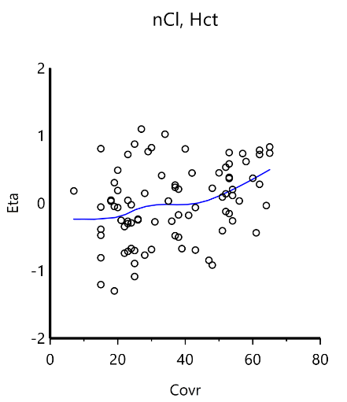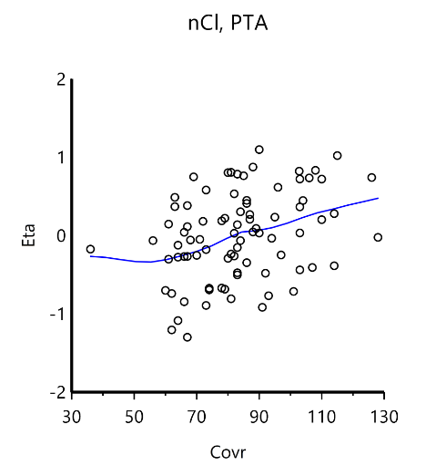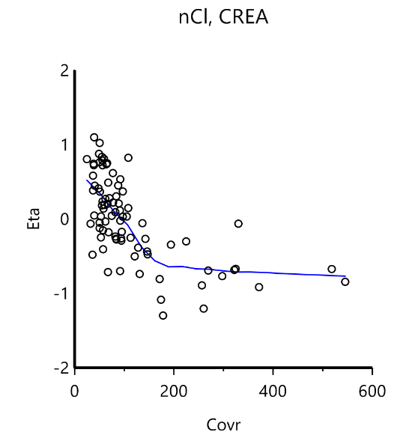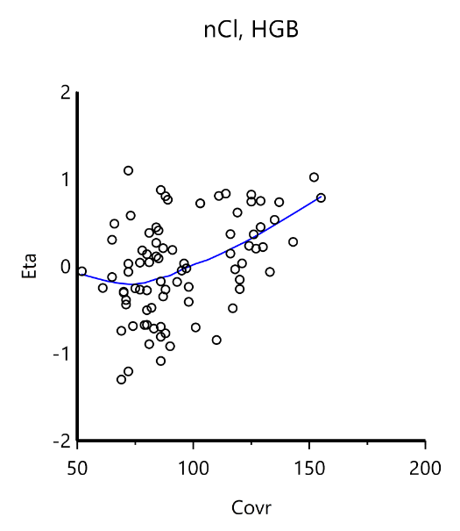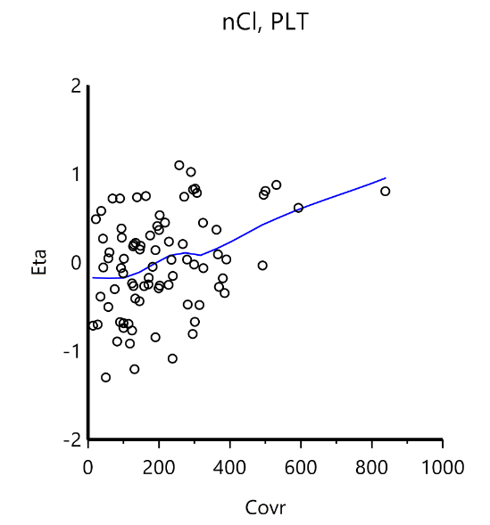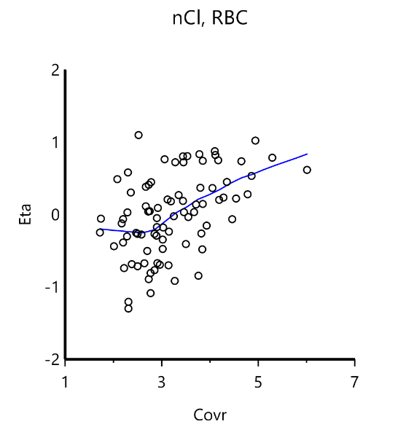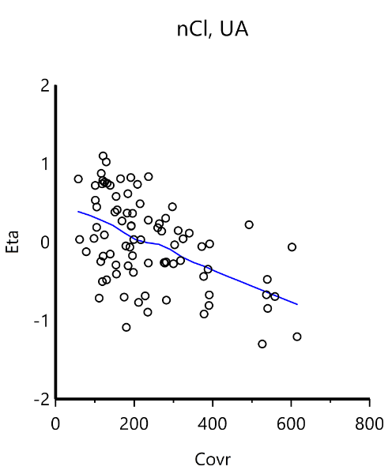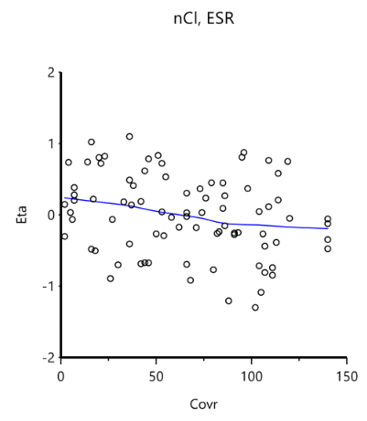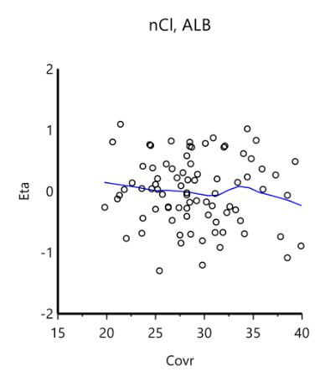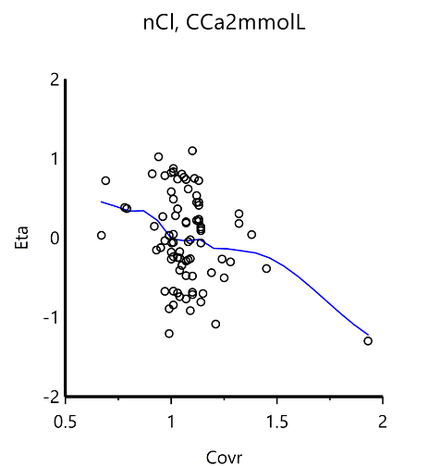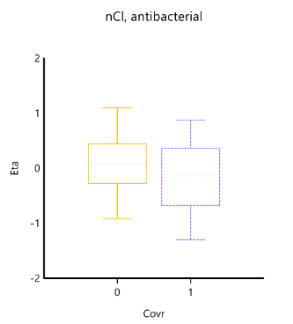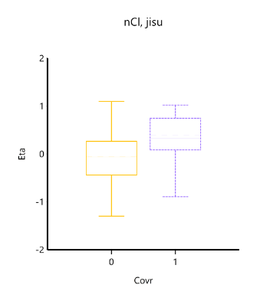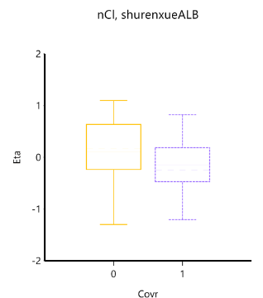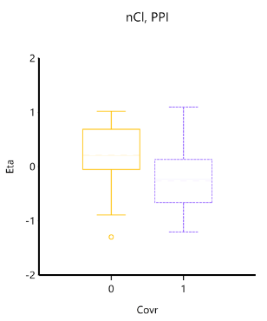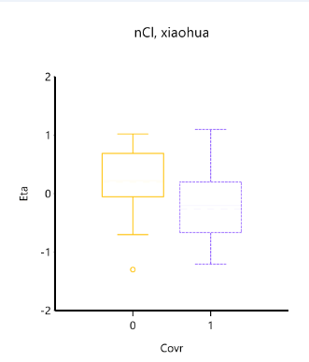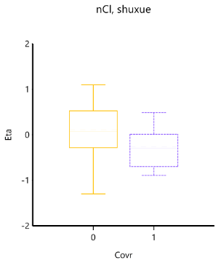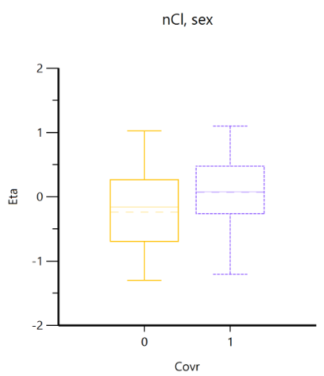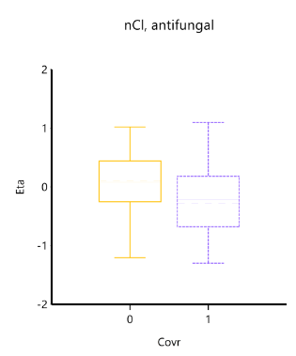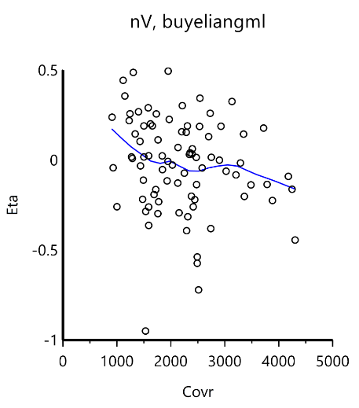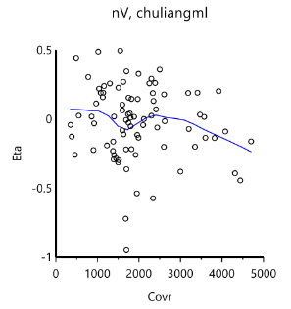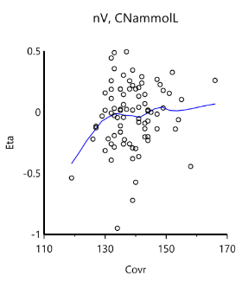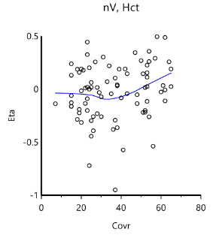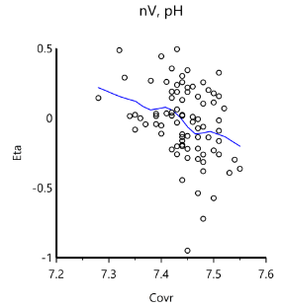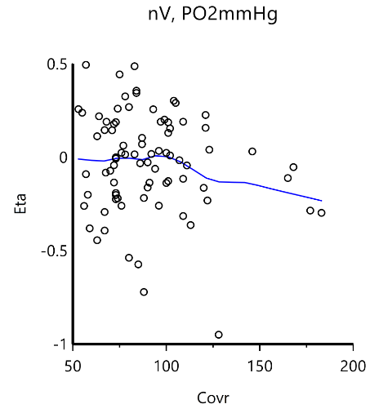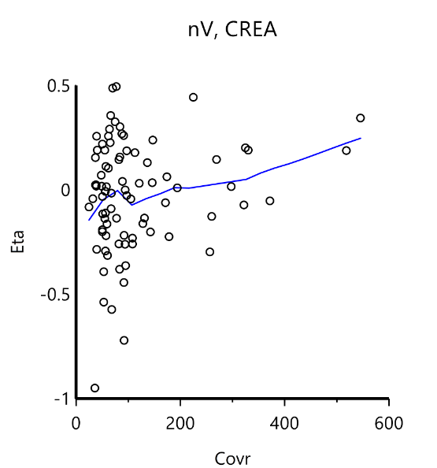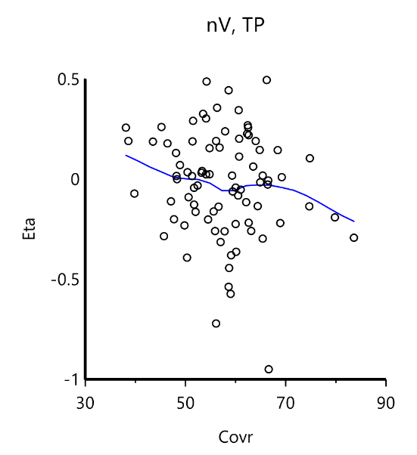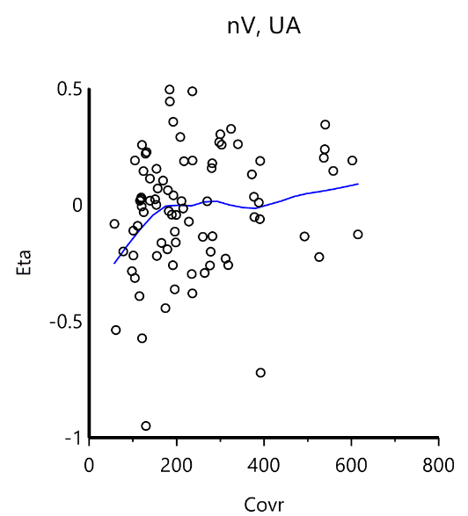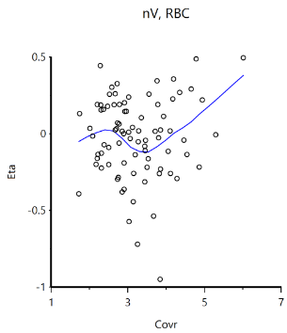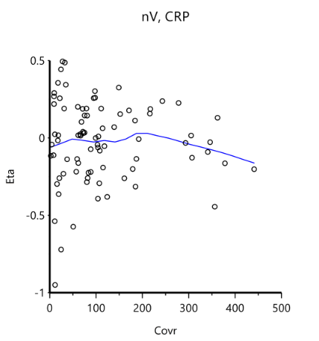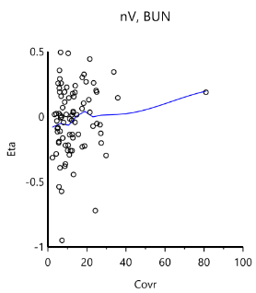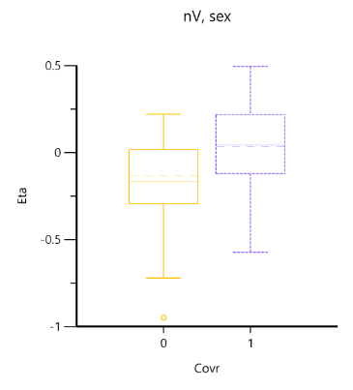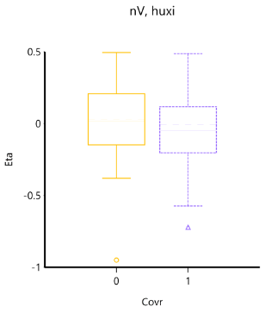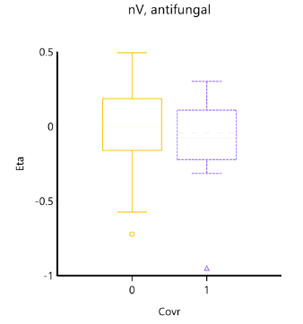

Fig. S3 Correlation between covariables (CL and V) and parameters. Hematocrit, prothrombin time activity, hemoglobin, platelet, RBC, calcium2+ concentration, creatinine, uric acid, erythrocyte sedimentation rate, serum albumin, CrCL, Na+ concentration, BUN, fluid transfusion volume, fluid output Volume, pH, partial pressure of oxygen, TP, and C-reactive protein were evaluated as the covariates.

Fig. S4 Goodness-of-fit plots of the final PPK model. (A, B) Meropenem concentration vs. individual predicted concentrations (IPRED) and population predicted concentrations (PRED); (C) Conditional weighted residuals (CWRES) vs. PRED; (D) CWRES vs. Time; The red lines in panels (C, D) represent smoothed regression lines. (E-G) QQ plots of eta of CL and V, and CWRES.

Fig. S5 The prediction corrected-visual predictive check (pc-VPC) of the final model. (A) time after dose (TAD) (h) vs. DV (mg/L); (B) IVAR (mg/L) vs. DV (mg/L). The blue dot represents the observed concentration. The red and black lines represent the 5th, 50th, and 95th quantiles of the observed and predicted concentration, and the blue shaded area represents the simulation-based 90% confidence intervals.

