Supplement to:
Reconsidering the ‘Predictive’ Value of Subjective Aging for Longevity and
the Impact of Confounding – Insights from Epidemiology
Adrian Richter^{1,2*}, Sarah K. Schäfer^{3,4,5*}, Susanne Wurm⁵, Wolfgang Hoffmann⁶ & Till Ittermann¹
¹ Section SHIP-KEF: Clinical-Epidemiological Research, Institute for Community Medicine, University Medicine Greifswald, Greifswald, Germany
² Epidemiology and Health Services Research, German Rheumatology Research Center, Berlin, Germany
³ Clinical Psychology and Psychotherapy for Children and Adolescents, Technische Universität Braunschweig, Braunschweig, Germany
⁴ Leibniz Institute for Resilience Research, Mainz, Germany
⁵ Section for Prevention Research and Social Medicine, Institute for Community Medicine, University Medicine Greifswald, Greifswald, Germany
⁶ Section Epidemiology of Health Care and Community Health, Institute for Community Medicine, University Medicine Greifswald, Greifswald, Germany
* AR and SKS made equal contributions to the manuscript.

Authors ORCID-IDs:
AR: https://orcid.org/0000-0002-3372-2021
SKS: https://orcid.org/0000-0001-9885-3252
SW: https://orcid.org/0000-0001-6924-8299
WH: https://orcid.org/0000-0002-6359-8797
TI: https://orcid.org/0000-0002-0154-7353

Corresponding author:
Dr. Adrian Richter
Section SHIP-KEF: Clinical-Epidemiological Research,
Institute for Community Medicine
Walther-Rathenau-Str. 48
17475 Greifswald
Tel.: (+49) 03834 – 75 41
Email: adrian.richter@med.uni-greifswald.de

Supplementary Table 1: Overview of studies examining the link between views on aging and mortality/survival.
Study ID | Sample description | FU | VoA construct | Methodological approach | Balancing design | Covariates in model¹ (#) | Baseline characteristics depending on VoA | Causal language² | Unadjusted Survival curves | Report on survival advantage in years
Benyamini (2020) | 851 participants of the Rutgers Aging and Health longitudinal study, aged 73 years on average | 10 years | VoA in terms of age group identify, comparative age, felt age, subjective nearness to death | Cox proportional-hazards regression model | No | Yes (5)  Age, sex, education, illness burden, recent chronic flare-ups/acute illnesses/ injuries | No (groups are contrasted) | Yes | No (adjusted Kaplan-Meier curves, no adjustment for age) | No
Kaspar (2021) | 1863 participants from a study on quality of life in North Rhine-Westphalia (NRW80+) | 3.5 years | SPA assessed using the AARC-SF (AARC-gains, AARC-losses) | Accelerated survival time analysis (also accelerated failure time) | No | Yes (17)  Age groups  gender, institutionalization,  engagement, optimism, perceived obsolescence, feeling needed, internal control, powerful others, chance, health conditions, ADL, iADL, 3 groups of cognitive status | No (no groups contrasted) | Yes | No (no curves presented) | No
Kotter-Grühn (2009) | 439 participants from the Berlin Aging Study (BASE), aged 70–100 years at baseline | 16 years | SPA assessed using the ATOA scale, subjective age | Cox proportional-hazards regression model | No | Yes (5)  Age, gender, SES, comorbidity, dementia | No (no groups contrasted) | Yes | No (no curves presented) | No
Levy (2002) | 660  participants from the Ohio Longitudinal Study of Aging and Retirement (OLSAR), aged 50–94 years at baseline | 23 years | SPA assessed using the ATOA scale | Cox proportional-hazards regression model | No | Yes (5)  Age; gender; race, SES, functional health | No (groups contrasted, but only for illustrative purposes, Cox regression model based on continuous data) | Yes | Yes | Yes (7.6 years)
Levy (2005) | 752 participants from the Ohio Longitudinal Study of Aging and Retirement (OLSAR), aged 50–87 years at baseline | 23 years | SPA assessed using the ATOA scale | Cox proportional-hazards regression model | No | Yes (7)  Age, gender, family status, functional health, self-rated health, SES, loneliness | Yes, but no statistical test (groups contrasted, but only for illustrative purposes, Cox regression model based on continuous data) | Yes | Yes | No
Levy (2018) | 4149 participants from the Health and Retirement Study (HRS), aged 50–99 years at baseline | 6 years | SPA assessed using the ATOA scale | Cox proportional-hazards regression model | No (stratification to check for robustness) | Yes (6)  Age, CRP, health (no. of diseases), sex, race, and education | No (groups contrasted, but only for illustrative purpose) | Yes | No (no curves presented) | Unclear (survival advantage of 12.4% reported based on median split)
Markides (1982) | 460 participants of a longitudinal study on older people in San Antonio, aged 60 years and older | 4 years | Subjective age | Discriminant function analysis | No | Yes (2)  objective health (weighted no. of diseases), life expectancy | No (no groups contrasted) | Yes | NA | NA
Lim (2013) | 292 patients undergoing chemotherapy for cancer, aged 26–85 years at baseline | 1 year | Subjective age | Cox proportional-hazards regression model | No | Yes (5)  Age, sex, cancer curable, number of symptoms, pain score | Yes (groups contrasted, data presented for both groups, but no statistical test) | Yes | Yes | No
McLachlan (2020) | 758 participants from the Lothian Birth Cohort 1936, aged 72.5 years on average | 6.8 years | Multidimensional SPA assessed using the AAQ | Cox proportional-hazards regression model | No | Yes (12, but separate models for brain-PAD and GrimAge)  Age, gender, education, social class, no. of chronic diseases, anxiety, depression, smoking status, alcohol consumption, 6m-walk, brain-PAD, GrimAge | No (no groups contrasted) | Yes, partly | No (no curves presented) | No
Maier (1999) | 526 participants from the Berlin Aging Study (BASE), aged 70–103 years at baseline | 3–6 years | SPA assessed as Dissatisfaction with aging (precursor of ATOA scale) | Cox proportional-hazards regression model | No | Yes (23)  Age, gender, education, marital status, equivalent income, occupational prestige, no. of illnesses, self-rated health,  perceptual speed, reasoning, memory, knowledge, fluency, pos. + neg. affect, agitation, dissatisfaction with life, extraversion, openness, emotional + social loneliness, support, close confidants | No (no groups contrasted) | Yes | No (no curves presented) | No
Rippon (2015) | 6489 participants of the English Longitudinal Study of Ageing (ELSA), aged 52 and older at baseline | 8 years | Subjective age | Cox proportional-hazards regression model | No | Yes (17)  Age, sex, wealth, ethnicity, baseline fair or poor self-rated health,  long-standing limiting illness, coronary heart disease, cancer, arthritis,  impaired mobility and activities of daily living, social isolation, social activities,  loneliness, delayed recall, verbal fluency, smoking, and physical activity. | No (groups contrasted, but analyses repeated with continuous variable) | Yes | No (no curves presented) | Report on 41% greater mortality risk for those who felt older (vs. younger) based on adjusted model
Sargent-Cox (2014) | 1507 participants of the Australian Longitudinal Study of Aging (ALSA), aged 65–103 years at baseline | 16 years | SPA assessed using the ATOA scale | Proportional-hazard Cox regression with a nonparametric baseline hazard function | No | Yes (9)  Age, sex, education, partnership, no. medical conditions, no. ADL, self-rated health, cognitive functioning, psychological functioning | No (no groups contrasted) | Yes | No (no curves presented) | Report on 12% greater mortality risk for one-point increase in SPA (i.e., more negative SPA) based on adjusted model
Schroyen (2020) | 140 participants with nonmetastatic cancer, aged 72.96 years on average | 6 years | SPA assessed using the AAQ | Cox proportional-hazards regression model | No | Yes (9)  Age, gender, education, primary cancer site, initial cancer (?), no. comorbities, cognitive functioning, mental health, physical health | No (groups contrasted, but only for illustrative purposes, Cox regression model based on continuous data) | Yes | Yes | Yes (reported in days)
Stephan (2018) | 6510 participants from the Health and Retirement Study (HRS), aged 50–107 years at baseline; 6494 participants from the National Health and Aging Trends Study  (NHATS), aged 65–105 years at baseline; 4898 participants from the  Midlife in the United States longitudinal survey (MIDUS), aged 24–75 years | HRS: 5 years; NHATS: 3 years; MIDUS: 18 years | Subjective age | Cox proportional-hazards regression model | No | Yes (11)  age, sex, race, marital status, education, no. medical conditions, depressive symptoms, physical activities, ADL, iADL, cognitive status | No (no groups contrasted) | Yes | No (no curves presented) | Report on increases in risk for mortality with older subjective age (increases of 1 SD) based on adjusted models per sample
Uotinen (2005) | 1165 participants from the Evergreen project, aged 65–84 years at baseline | 13 years | Subjective age (mentally and physically) | Cox proportional-hazards regression model | No | Yes (7)  Age, gender, education, no. diseases, self-rated health, cognitive status, mood | Yes (groups contrasted, data presented and statistically compared) | Yes, partly | No (no curves presented) | No
Veenstra (2021) | 1432 participants from the Norwegian Life Course, Ageing and Generation study (NorLAG), aged 67–85 years | 9.6 years | Subjective and ideal age | Cox proportional-hazards regression model | No | Yes (8)  Age, gender, education, living with partner, wealth, perceived control, physical health, smoking | No (no groups contrasted) | Yes | No (no curves presented) | Report on 10% increases in risk for mortality with older subjective age (increases of 1 SD) based on adjusted model
Wurm (2022) | 2400 participants from the German Ageing Survey (DEAS), aged 40–85 years at baseline | 23 years | Multidimensional SPA assessed using the AgeCog scales, subjective age | Cox proportional-hazards regression model | No | Yes (11)  Age, gender, education, no. of diseases, self-rated health, place of residency, loneliness, pos.+neg. affect, hope, life satisfaction | No (groups contrasted, but only for illustrative purposes, Cox regression model based on continuous data) | Yes | Yes | Not in main article, but in Supplementary Material (13 years)³
Zhang (2020) | 9683 participants from the Chinese Longitudinal Healthy Longevity Survey (CLHLS), aged 78–118 years at baseline | 8 years | SPA assessed using the ATOA scale | Latent growth models with survival analysis | No | Yes (6)  Age, gender, education, cognitive status, self-reported health, healthy lifestyle behaviors | No (no groups contrasted) | Yes | No (no curves presented) | No
Zhao (2017) | 13967 participants from the Chinese Longitudinal Healthy Longevity Survey (CLHLS), aged 65–100+ years at baseline | 9 years | Perceived uselessness as indicator of negative SPA | Cox proportional-hazards regression models | No | Yes (23)  Age, gender, ethnicity, education, residence, lifetime occupation, economic independence, family economic conditions,  marital status, frequently-contacted persons, concordance with children, concordance in living arrangement, intergenerational exchanges  smoking, alcohol consumption, regular exercise, leisure activities, social participation, ADL and IADL disabilities, cognitive impairment, chronic disease conditions, psychological  well-being | No (groups contrasted, data not presented) | No | No (no curves presented) | No
Note. Studies were selected based on the systematic review and meta-analysis by Westerhof et al. (2023). For the purpose of this overview, we included all studies examining mortality/survival as outcomes. Study IDs reflect first author and publication year.
AAQ = Attitudes to Ageing Questionnaire. AARC-SF = Awareness of Age-Related Change scale (AARC-SF). AgeCog scales = Aging-related Cognition scales. ATOA = Attitudes Towards Aging Scale. FU = follow-up period. NA = not applicable. SPA = self-perceptions of aging. VoA = Views on aging.
¹ Covariates were those variables in the respective model that were included in addition to VoA constructs.
² Studies were rated to use ‘causal’ language when they used the term ‘predict’ or ‘predictor’ to refer to the association of views on aging and mortality.
³ Information on a 13-year survival advantage from the Supplementary Material was part of later media communication related to this article.

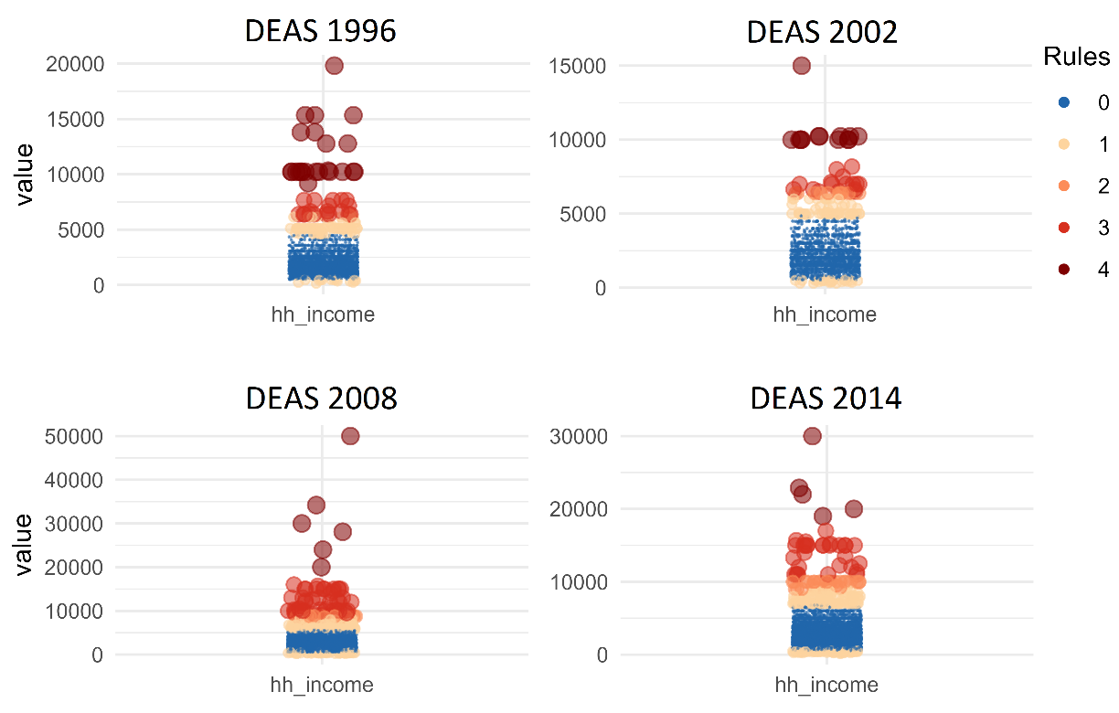
Supplementary Figure 1: Distribution and outlier classification of household income for all DEAS sample. The classification is generated using the R package dataquier (Richter et al., 2021) which has implemented four rules for univariate classification of outlier. Please see the respective documentation: https://dataquality.qihs.uni-greifswald.de/. Due to convergence issues of multiple imputations, household incomes classified as being an outlier (DEAS 1996: n=23 (0.76 %), DEAS 2002: n=13 (0.61 %), DEAS 2008: n=52 (1.12 %), DEAS 2014: n=64 (1.34 %)) were removed which resolved issues of multiple imputation.

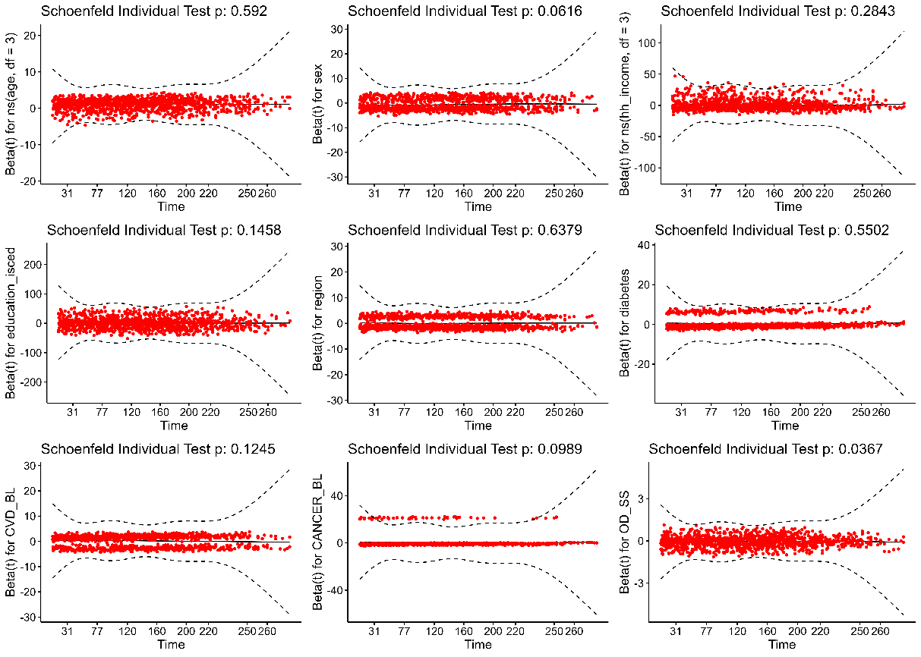
Supplementary Figure 2: Schoenfeld residuals of adjusted Cox-PH model in DEAS 1996 sample.

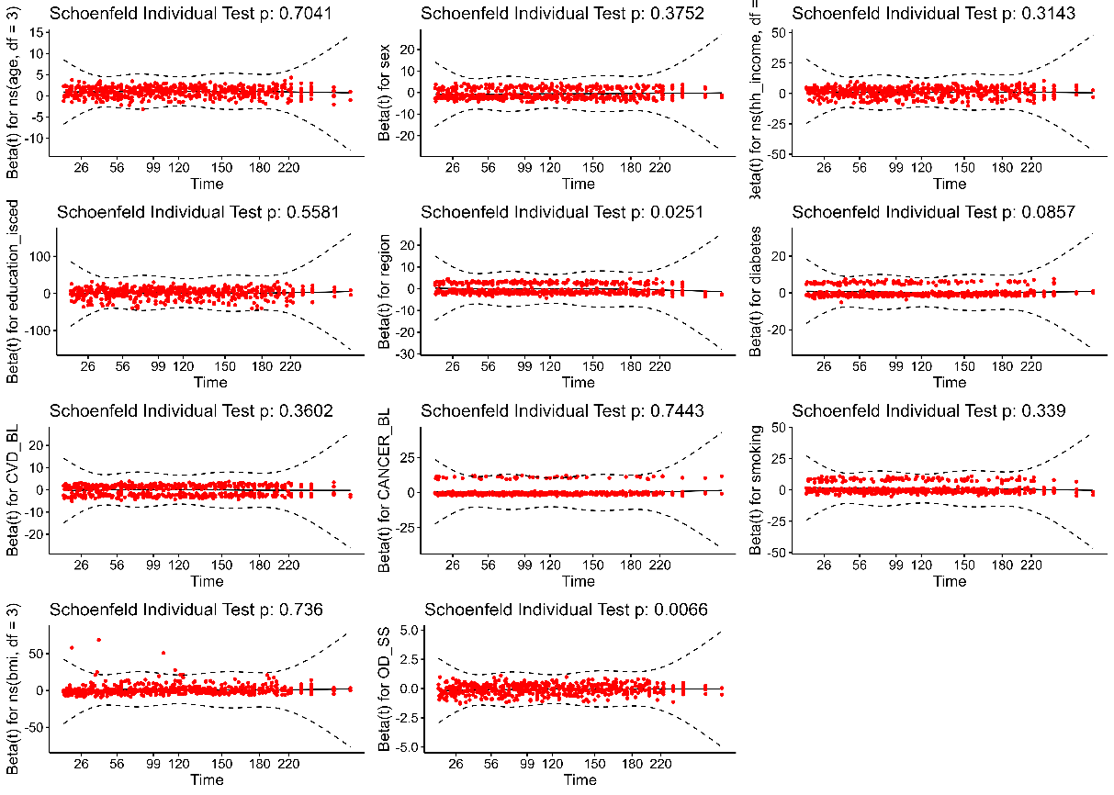
Supplementary Figure 3: Schoenfeld residuals of adjusted Cox-PH model in DEAS 2002 sample.
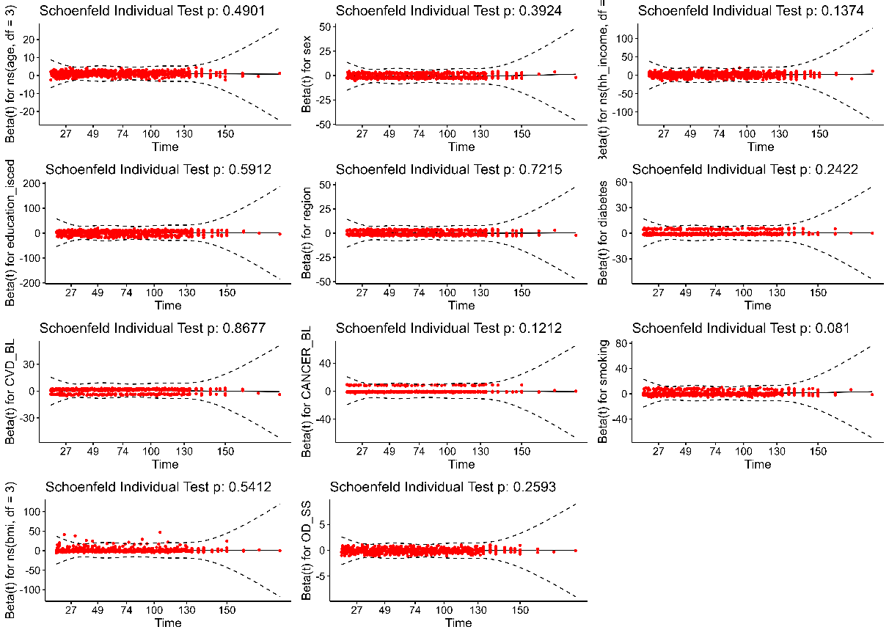

Supplementary Figure 4: Schoenfeld residuals of adjusted Cox-PH model in DEAS 2008 sample.

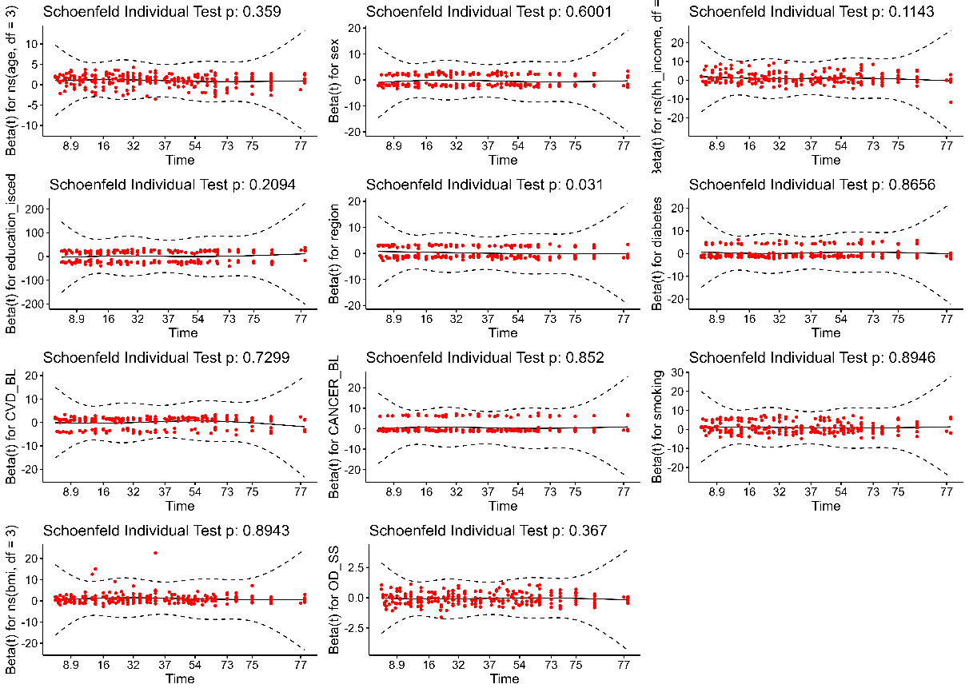

Supplementary Figure 5: Schoenfeld residuals of adjusted Cox-PH model in DEAS 2014 sample.

Supplementary Table 2: Participant characteristics of the DEAS 2002 sample. Participants were stratified according to a median split of the sum score of SPA ongoing development (SPA-OD) as this has been done in previous studies (Levy & Myers, 2005; Levy et al., 2002; Schroyen et al., 2020; Wurm & Schäfer, 2022).
 | SPA: ongoing development  (below median)  (N=730) | SPA: ongoing development (unknown)  (N=218) | SPA: ongoing development (above median)  (N=1172) | All  (N=2120)
Age (years)
Mean (SD) | 63.3 (12.3) | 60.3 (12.9) | 57.8 (11.5) | 59.9 (12.2)
Median [Min, Max] | 64.0 [40.0, 85.0] | 61.0 [40.0, 83.0] | 57.0 [40.0, 85.0] | 60.0 [40.0, 85.0]
Sex
male | 373 (51.1%) | 118 (54.1%) | 603 (51.5%) | 1094 (51.6%)
female | 357 (48.9%) | 100 (45.9%) | 569 (48.5%) | 1026 (48.4%)
Birth region
West | 476 (65.2%) | 145 (66.5%) | 778 (66.4%) | 1399 (66.0%)
East | 254 (34.8%) | 73 (33.5%) | 394 (33.6%) | 721 (34.0%)
Education (ISCED)
1 = low (ISCED 0-1) | 126 (17.3%) | 39 (17.9%) | 78 (6.7%) | 243 (11.5%)
2 = medium (ISCED 2-3) | 404 (55.3%) | 117 (53.7%) | 628 (53.6%) | 1149 (54.2%)
3 = high (ISCED 5-6) | 200 (27.4%) | 62 (28.4%) | 466 (39.8%) | 728 (34.3%)
Household income
Mean (SD) | 2000 (1030) | 2120 (1100) | 2460 (1290) | 2270 (1200)
Median [Min, Max] | 1800 [307, 7130] | 1920 [365, 7000] | 2100 [300, 8180] | 2000 [300, 8180]
Missing | 75 (10.3%) | 30 (13.8%) | 112 (9.6%) | 217 (10.2%)
Body mass index
Mean (SD) | 26.6 (4.78) | 26.4 (4.27) | 26.3 (4.24) | 26.4 (4.44)
Median [Min, Max] | 26.0 [15.2, 69.1] | 25.8 [17.9, 44.6] | 25.6 [16.7, 60.2] | 25.7 [15.2, 69.1]
Missing | 23 (3.2%) | 7 (3.2%) | 31 (2.6%) | 61 (2.9%)
Smoking behavior
never | 357 (48.9%) | 18 (8.3%) | 543 (46.3%) | 918 (43.3%)
previous | 235 (32.2%) | 9 (4.1%) | 339 (28.9%) | 583 (27.5%)
current | 128 (17.5%) | 7 (3.2%) | 275 (23.5%) | 410 (19.3%)
Missing | 10 (1.4%) | 184 (84.4%) | 15 (1.3%) | 209 (9.9%)
Diabetes
yes | 91 (12.5%) | 5 (2.3%) | 80 (6.8%) | 176 (8.3%)
no | 620 (84.9%) | 30 (13.8%) | 1070 (91.3%) | 1720 (81.1%)
Missing | 19 (2.6%) | 183 (83.9%) | 22 (1.9%) | 224 (10.6%)
Cardiovascular disorders at baseline
yes | 371 (50.8%) | 15 (6.9%) | 417 (35.6%) | 803 (37.9%)
no | 343 (47.0%) | 19 (8.7%) | 744 (63.5%) | 1106 (52.2%)
Missing | 16 (2.2%) | 184 (84.4%) | 11 (0.9%) | 211 (10.0%)
Cancer disease at baseline
yes | 47 (6.4%) | 1 (0.5%) | 39 (3.3%) | 87 (4.1%)
no | 661 (90.5%) | 33 (15.1%) | 1111 (94.8%) | 1805 (85.1%)
Missing | 22 (3.0%) | 184 (84.4%) | 22 (1.9%) | 228 (10.8%)
Observation time
Mean (SD) | 158 (62.2) | 159 (58.1) | 180 (52.4) | 171 (57.4)
Median [Min, Max] | 169 [1.00, 226] | 157 [6.00, 226] | 205 [3.00, 226] | 186 [1.00, 226]
Missing | 70 (9.6%) | 16 (7.3%) | 65 (5.5%) | 151 (7.1%)
Vital status
alive | 483 (66.2%) | 153 (70.2%) | 939 (80.1%) | 1575 (74.3%)
deceased | 247 (33.8%) | 65 (29.8%) | 233 (19.9%) | 545 (25.7%)

Supplementary Table 3: Participant characteristics of the DEAS 2008 sample. Participants were stratified according to a median split of the sum score of SPA ongoing development (SPA-OD) as this has been done in previous studies (Levy & Myers, 2005; Levy et al., 2002; Schroyen et al., 2020; Wurm & Schäfer, 2022).
 | SPA: ongoing development  (below median)  (N=1474) | SPA: ongoing development (unknown)  (N=1285) | SPA: ongoing development (above median)  (N=1871) | All  (N=4630)
Age (years)
Mean (SD) | 63.6 (11.8) | 59.8 (12.4) | 59.2 (11.1) | 60.8 (11.9)
Median [Min, Max] | 66.0 [40.0, 85.0] | 58.0 [40.0, 85.0] | 59.0 [40.0, 85.0] | 60.0 [40.0, 85.0]
Sex
male | 780 (52.9%) | 616 (47.9%) | 944 (50.5%) | 2340 (50.5%)
female | 694 (47.1%) | 669 (52.1%) | 927 (49.5%) | 2290 (49.5%)
Birth region
West | 945 (64.1%) | 946 (73.6%) | 1295 (69.2%) | 3186 (68.8%)
East | 529 (35.9%) | 339 (26.4%) | 576 (30.8%) | 1444 (31.2%)
Education (ISCED)
1 = low (ISCED 0-1) | 170 (11.5%) | 173 (13.5%) | 120 (6.4%) | 463 (10.0%)
2 = medium (ISCED 2-3) | 811 (55.0%) | 690 (53.7%) | 932 (49.8%) | 2433 (52.5%)
3 = high (ISCED 5-6) | 493 (33.4%) | 422 (32.8%) | 819 (43.8%) | 1734 (37.5%)
Household income
Mean (SD) | 2290 (1260) | 2340 (1330) | 2780 (1470) | 2510 (1390)
Median [Min, Max] | 2000 [250, 8800] | 2000 [230, 8750] | 2500 [185, 8750] | 2200 [185, 8800]
Missing | 95 (6.4%) | 242 (18.8%) | 164 (8.8%) | 501 (10.8%)
Body mass index
Mean (SD) | 26.8 (4.49) | 26.6 (4.74) | 26.3 (4.15) | 26.6 (4.43)
Median [Min, Max] | 26.3 [17.2, 49.6] | 25.9 [13.2, 74.7] | 25.9 [16.0, 52.0] | 26.0 [13.2, 74.7]
Missing | 32 (2.2%) | 43 (3.3%) | 41 (2.2%) | 116 (2.5%)
Smoking behavior
never | 713 (48.4%) | 35 (2.7%) | 888 (47.5%) | 1636 (35.3%)
previous | 482 (32.7%) | 28 (2.2%) | 581 (31.1%) | 1091 (23.6%)
current | 251 (17.0%) | 20 (1.6%) | 380 (20.3%) | 651 (14.1%)
Missing | 28 (1.9%) | 1202 (93.5%) | 22 (1.2%) | 1252 (27.0%)
Diabetes
yes | 188 (12.8%) | 139 (10.8%) | 154 (8.2%) | 481 (10.4%)
no | 1286 (87.2%) | 1146 (89.2%) | 1717 (91.8%) | 4149 (89.6%)
Cardiovascular disorders at baseline
yes | 939 (63.7%) | 668 (52.0%) | 985 (52.6%) | 2592 (56.0%)
no | 535 (36.3%) | 617 (48.0%) | 886 (47.4%) | 2038 (44.0%)
Cancer disease at baseline
yes | 114 (7.7%) | 84 (6.5%) | 112 (6.0%) | 310 (6.7%)
no | 1360 (92.3%) | 1201 (93.5%) | 1759 (94.0%) | 4320 (93.3%)
Observation time
Mean (SD) | 114 (40.5) | 109 (41.2) | 123 (36.2) | 116 (39.5)
Median [Min, Max] | 133 [1.00, 153] | 128 [1.00, 152] | 145 [6.00, 153] | 144 [1.00, 153]
Missing | 119 (8.1%) | 85 (6.6%) | 80 (4.3%) | 284 (6.1%)
Vital status
alive | 1178 (79.9%) | 1089 (84.7%) | 1671 (89.3%) | 3938 (85.1%)
deceased | 296 (20.1%) | 196 (15.3%) | 200 (10.7%) | 692 (14.9%)

Supplementary Table 4: Participant characteristics of the DEAS 2014 sample. Participants were stratified according to a median split of the sum score of SPA ongoing development (SPA-OD) as this has been done in previous studies (Levy & Myers, 2005; Levy et al., 2002; Schroyen et al., 2020; Wurm & Schäfer, 2022).
 | SPA: ongoing development  (below median)  (N=1622) | SPA: ongoing development (unknown)  (N=1165) | SPA: ongoing development (above median)  (N=1989) | All  (N=4776)
Age (years)
Mean (SD) | 64.4 (11.1) | 61.5 (12.1) | 59.7 (11.1) | 61.7 (11.6)
Median [Min, Max] | 65.0 [40.0, 85.0] | 61.0 [40.0, 85.0] | 59.0 [40.0, 85.0] | 62.0 [40.0, 85.0]
Sex
male | 832 (51.3%) | 653 (56.1%) | 970 (48.8%) | 2455 (51.4%)
female | 790 (48.7%) | 512 (43.9%) | 1019 (51.2%) | 2321 (48.6%)
Birth region
West | 1091 (67.3%) | 805 (69.1%) | 1373 (69.0%) | 3269 (68.4%)
East | 531 (32.7%) | 360 (30.9%) | 616 (31.0%) | 1507 (31.6%)
Education (ISCED)
1 = low (ISCED 0-1) | 131 (8.1%) | 116 (10.0%) | 76 (3.8%) | 323 (6.8%)
2 = medium (ISCED 2-3) | 873 (53.8%) | 613 (52.6%) | 985 (49.5%) | 2471 (51.7%)
3 = high (ISCED 5-6) | 618 (38.1%) | 436 (37.4%) | 927 (46.6%) | 1981 (41.5%)
Missing | 0 (0%) | 0 (0%) | 1 (0.1%) | 1 (0.0%)
Household income
Mean (SD) | 2590 (1430) | 2710 (1530) | 3130 (1610) | 2840 (1550)
Median [Min, Max] | 2200 [122, 8750] | 2500 [200, 8750] | 2880 [250, 8750] | 2500 [122, 8750]
Missing | 96 (5.9%) | 160 (13.7%) | 154 (7.7%) | 410 (8.6%)
Body mass index
Mean (SD) | 27.0 (4.72) | 26.8 (4.84) | 26.5 (4.33) | 26.8 (4.60)
Median [Min, Max] | 26.5 [15.6, 60.9] | 26.0 [16.1, 52.9] | 25.9 [16.7, 51.8] | 26.1 [15.6, 60.9]
Missing | 26 (1.6%) | 30 (2.6%) | 38 (1.9%) | 94 (2.0%)
Smoking behavior
never | 714 (44.0%) | 47 (4.0%) | 872 (43.8%) | 1633 (34.2%)
previous | 571 (35.2%) | 34 (2.9%) | 672 (33.8%) | 1277 (26.7%)
current | 326 (20.1%) | 18 (1.5%) | 436 (21.9%) | 780 (16.3%)
Missing | 11 (0.7%) | 1066 (91.5%) | 9 (0.5%) | 1086 (22.7%)
Diabetes
yes | 229 (14.1%) | 132 (11.3%) | 199 (10.0%) | 560 (11.7%)
no | 1393 (85.9%) | 1033 (88.7%) | 1790 (90.0%) | 4216 (88.3%)
Cardiovascular disorders at baseline
yes | 1058 (65.2%) | 655 (56.2%) | 1052 (52.9%) | 2765 (57.9%)
no | 564 (34.8%) | 510 (43.8%) | 937 (47.1%) | 2011 (42.1%)
Cancer disease at baseline
yes | 171 (10.5%) | 93 (8.0%) | 150 (7.5%) | 414 (8.7%)
no | 1451 (89.5%) | 1072 (92.0%) | 1839 (92.5%) | 4362 (91.3%)
Observation time
Mean (SD) | 65.5 (16.4) | 62.9 (17.6) | 68.2 (14.4) | 66.0 (16.0)
Median [Min, Max] | 73.0 [4.00, 81.0] | 72.0 [1.00, 81.0] | 74.0 [1.00, 80.0] | 73.0 [1.00, 81.0]
Missing | 37 (2.3%) | 34 (2.9%) | 28 (1.4%) | 99 (2.1%)
Vital status
alive | 1521 (93.8%) | 1088 (93.4%) | 1920 (96.5%) | 4529 (94.8%)
deceased | 101 (6.2%) | 77 (6.6%) | 69 (3.5%) | 247 (5.2%)
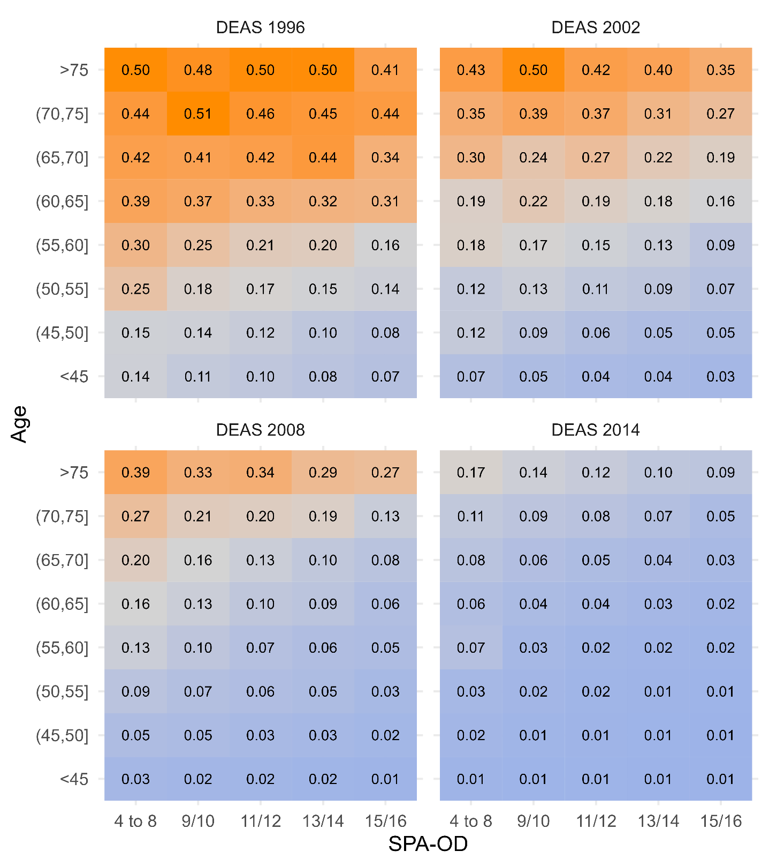

Supplementary Figure 6: Adjusted probabilities to decease in all DEAS samples obtained from Cox-PH models. The probabilities differ between samples due to differences of follow-up and different numbers of deceased participants. The sum score of SPA-OD ranges from 4 to 16, except for sum scores of 4 to 8 (low frequencies), two values of the score were summarized in groups.

Some variation for the probability to decease is observed along the SPA-OD sum score, i.e. the probability decreases to some extent with increasing SPA-OD. However, most impact on mortality and explanatory power has chronological age. Due to over-representation of older participants in groups with lower SPA-OD an unadjusted comparison of SPA-OD groups is severely biased. Therefore, the role of chronological age as a confounder of the association between SPA-OD and all-cause mortality is similar to maternal age in the association between birth rank order and the prevalence of down syndrome (Rothman & Greenland, 2005).
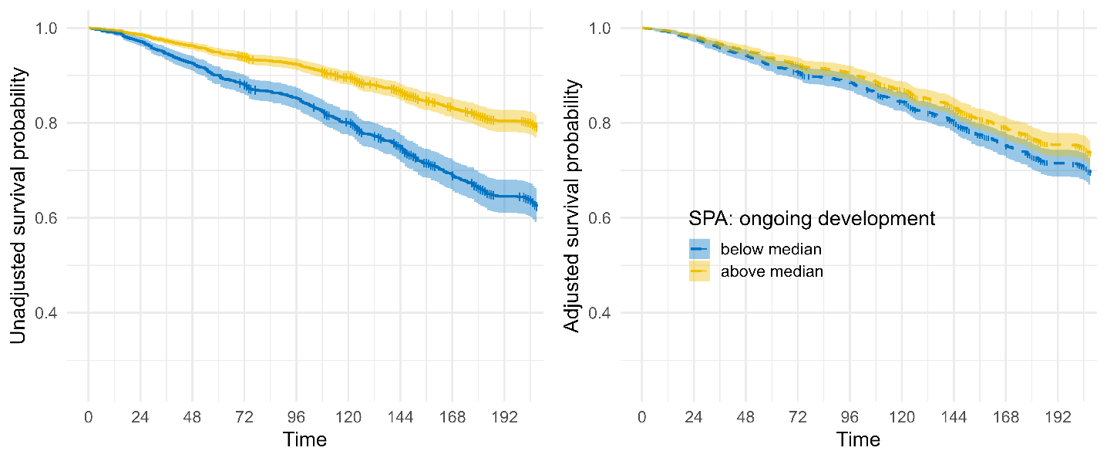
Supplementary Figure 7: Survival estimates in the DEAS 2002 sample (left panel: unadjusted, i.e. except for a stratification variable of SPA ongoing development no further covariate entered the Cox-PH model; right panel: estimated survival differences between strata of SPA ongoing development obtained from a Cox-PH model adjusted for age, sex, region of birth, education, household income, diabetes, cardiovascular disease, cancer, smoking, and BMI)

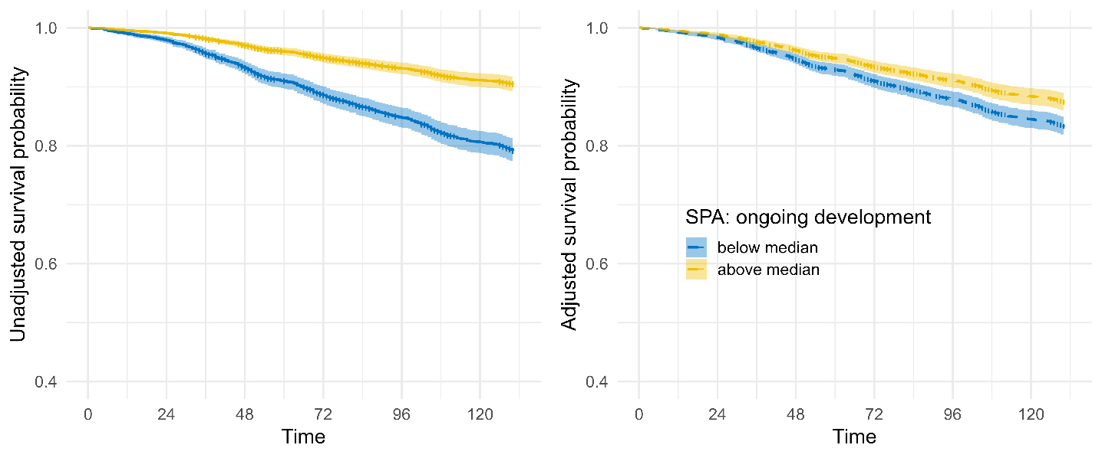
Supplementary Figure 8: Survival estimates in the DEAS 2008 sample (left panel: unadjusted, i.e. except for a stratification variable of SPA ongoing development no further covariate entered the Cox-PH model; right panel: estimated survival differences between strata of SPA ongoing development obtained from a Cox-PH model adjusted for age, sex, region of birth, education, household income, diabetes, cardiovascular disease, cancer, smoking, and BMI)

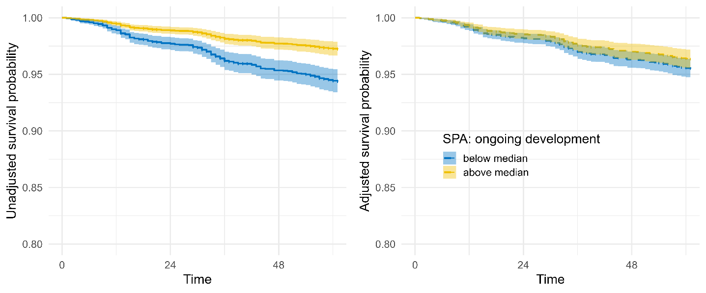
Supplementary Figure 9: Survival estimates in the DEAS 2014 sample (left panel: unadjusted, i.e. except for a stratification variable of SPA ongoing development no further covariate entered the Cox-PH model; right panel: estimated survival differences between strata of SPA ongoing development obtained from a Cox-PH model adjusted for age, sex, region of birth, education, household income, diabetes, cardiovascular disease, cancer, smoking, and BMI)

Supplementary Table 5: Integrated discrimination index and respective confidence intervals indicating the improvement in prediction (raw values, not converted into percent). Larger values correspond to better discrimination.
 | M2 vs M1 |  | M3 vs. M2 |  | M4 vs. M2 |  | M5 vs. M4
Sample | IDI | 95% CI | IDI | 95% CI | IDI | 95% CI | IDI | 95% CI
DEAS 1996 | 0.21706 | [0.21292; 0.22119] | 0.00499 | [0.00354; 0.00644] | 0.01005 | [0.00828; 0.01183] | 0.00271 | [0.00148; 0.00394]
DEAS 2002 | 0.15192 | [0.14726; 0.15657] | 0.00462 | [0.00197; 0.00728] | 0.01416 | [0.00976; 0.01857] | 0.00412 | [0.00171; 0.00652]
DEAS 2008 | 0.08731 | [0.08244; 0.09217] | 0.00758 | [0.00527; 0.00989] | 0.02520 | [0.02086; 0.02954] | 0.00390 | [0.00201; 0.00579]
DEAS 2014 | 0.01954 | [0.01714; 0.02195] | 0.00212 | [0.00079; 0.00346] | 0.01481 | [0.01032; 0.01931] | 0.00097 | [-0.00038; 0.00232]
* M1: Cox-PH model comprising only: SPA (ongoing development), M2: Age + Sex, M3: Age + Sex + SPA (ongoing development), M4: Full model w/o SPA (ongoing development), M4: Full model incl. SPA (ongoing development)

Supplementary Table 6: sensitivity analysis for the role of a comorbidity sum score: adjusted results from Cox-PH models of all-cause mortality for the DEAS 1996 sample after multiple imputation.
Covariate | DEAS 1996
 | HR | 95% CI
Age *
40 | 0.26 | [0.11; 0.61]
50 | 0.38 | [0.24; 0.62]
60 (ref.)
70 | 2.95 | [1.86; 4.70]
80 | 7.25 | [4.06; 12.95]
Female vs. male | 0.51 | [0.45; 0.58]
Education (ISCED, ref.=low)
medium (ISCED 2-3) | 0.99 | [0.84; 1.18]
high (ISCED 5-6) | 0.82 | [0.66; 1.01]
Birth region (East vs. West) | 1.14 | [1.00; 1.30]
Household income *
500 | 1.76 | [0.89; 3.48]
1000 | 1.33 | [0.83; 2.13]
1500 | 1.09 | [0.75; 1.59]
2000 (ref.)
3000 | 0.91 | [0.56; 1.49]
4000 | 0.83 | [0.44; 1.57]
5000 | 0.77 | [0.33; 1.80]
Comorbidities sum score | 1.04 | [1.01; 1.08]
SPA: ongoing development | 0.94 | [0.92; 0.96]
* age and household income were modelled using natural splines with three degrees of freedom to examine nonlinear associations with all-cause mortality; covariate effects are shown as contrasts of marginal means with reference categories selected from the center of the distribution (Shepherd & Rebeiro, 2017). HR=hazard ratio, CI=confidence interval.

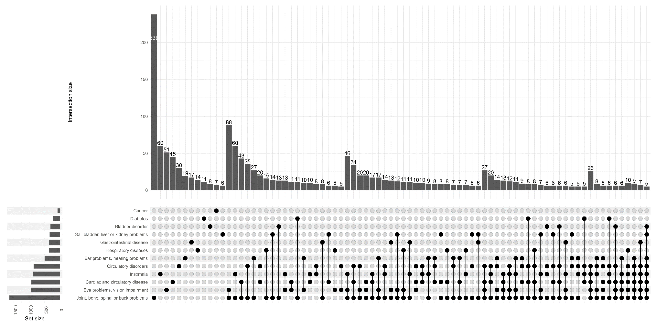
Supplementary Figure 10: Illustration of the frequencies of comorbidities and their combinations (max. 4th order) generated with ComplexUpset (Krassowski et al., 2022) for the DEAS 1996 sample. N=93 had a sum score of 1 with either having cardiovascular/circulatory disorders (45 + 30), diabetes (11), or cancer (7); n=88 had a score of 2 due to joint/bone problems and eye/vision impairment; n=46 had a score of 3 due to joint/bone problems + eye/vision impairment + insomnia.

Implications for science communication
Our findings along with personal experiences in media communication (authors SKS, SW) have also implications for science communication.

- We recommend to solely communicate on adjusted survival advantages when using observational data.
- We recommend not to use catchy and too simple headlines for press releases.
- Causal language should be avoided when analyses are based on association, even if those are longitudinal.
- Results should be communicated alongside with their limitations and evidence gaps. Information should include what can and cannot be concluded from the current analysis.
- If possible, explicitly state that results cannot be easily compared to analyses on mortality in other fields when analyses do not rigorously control for confounders and/or employ balancing methods.
- Yet, we acknowledge, that also adhering to those recommendations cannot prevent any catchy headline or causal language as those also often result from timely deadlines of journalists and (small) changes in statements in final stages of editing without approval by involved researchers. In such cases, additional information provided via institutional websites or personal social media might be helpful.

LIST OF ADDITIONAL REFERENCES

Benyamini, Y., & Burns, E. (2020). Views on aging: older adults’ self-perceptions of age and of health. European Journal of Ageing, 17(4), 477-487. https://doi.org/10.1007/s10433-019-00528-8
Kaspar, R., Wahl, H.-W., & Diehl, M. (2021). Awareness of Age-Related Change as a Behavioral Determinant of Survival Time in Very Old Age [Original Research]. Frontiers in Psychology, 12. https://doi.org/10.3389/fpsyg.2021.727560
Kotter-Grühn, D., Kleinspehn-Ammerlahn, A., Gerstorf, D., & Smith, J. (2009). Self-perceptions of aging predict mortality and change with approaching death: 16-year longitudinal results from the Berlin Aging Study. Psychology and aging, 24(3), 654.
Krassowski, M., Arts, M., Lagger, C., & Max. (2022). Complex-upsets. Version 1.3.5. In Zenodo. https://doi.org/10.5281/zenodo.7314197
Levy, B., & Bavishi, A. (2018). Survival advantage mechanism: Inflammation as a mediator of positive self-perceptions of aging on longevity. The Journals of Gerontology: Series B, 73(3), 409-412. https://doi.org/10.1093/geronb/gbw035
Levy, B., & Myers, L. M. (2005). Relationship between respiratory mortality and self-perceptions of aging. Psychology & Health, 20(5), 553-564. https://doi.org/10.1080/14768320500066381
Levy, B., Slade, M., Kunkel, S., & Kasl, S. (2002). Longevity increased by positive self-perceptions of aging. Journal of Personality and Social Psychology, 83(2), 261. https://doi.org/10.1037//0022-3514.83.2.261
Lim, M. Y., Stephens, E. K., Novotny, P., Price, K., Salayi, M., Roeker, L., Peethambaram, P., & Jatoi, A. (2013). Self-perceptions of age among 292 chemotherapy-treated cancer patients: Exploring associations with symptoms and survival. Journal of Geriatric Oncology, 4(3), 249-254. https://doi.org/10.1016/j.jgo.2013.02.001
Maier, H., & Smith, J. (1999). Psychological Predictors of Mortality in Old Age. The Journals of Gerontology: Series B, 54B(1), P44-P54. https://doi.org/10.1093/geronb/54B.1.P44
Markides, K. S., & Pappas, C. (1982). Subjective Age, Health, and Survivorship in Old Age. Research on Aging, 4(1), 87-96. https://doi.org/10.1177/016402758241004
McLachlan, K. J., Cole, J. H., Harris, S. E., Marioni, R. E., Deary, I. J., & Gale, C. R. (2020). Attitudes to ageing, biomarkers of ageing and mortality: the Lothian Birth Cohort 1936. J Epidemiol Community Health, 74(4), 377-383. https://doi.org/10.1136/jech-2019-213462
Richter, A., Schmidt, C. O., Krüger, M., & Struckmann, S. (2021). dataquieR: assessment of data quality in epidemiological research. Journal of Open Source Software, 6(61), 3093. https://doi.org/10.21105/joss.03093
Rippon, I., & Steptoe, A. (2015). Feeling Old vs Being Old: Associations Between Self-perceived Age and Mortality. JAMA Internal Medicine, 175(2), 307-309. https://doi.org/10.1001/jamainternmed.2014.6580
Rothman, K. J., & Greenland, S. (2005). Causation and Causal Inference in Epidemiology. American Journal of Public Health, 95(S1), S144-S150. https://doi.org/10.2105/ajph.2004.059204
Sargent-Cox, K. A., Anstey, K. J., & Luszcz, M. A. (2014). Longitudinal change of self-perceptions of aging and mortality. Journals of Gerontology Series B: Psychological Sciences and Social Sciences, 69(2), 168-173. https://doi.org/10.1093/geronb/gbt005
Schroyen, S., Letenneur, L., Missotten, P., Jérusalem, G., & Adam, S. (2020). Impact of self-perception of aging on mortality of older patients in oncology. Cancer Medicine, 9(7), 2283-2289. https://doi.org/10.1002/cam4.2819
Shepherd, B. E., & Rebeiro, P. F. (2017). Brief Report: Assessing and Interpreting the Association Between Continuous Covariates and Outcomes in Observational Studies of HIV Using Splines. J Acquir Immune Defic Syndr, 74(3), e60-e63. https://doi.org/10.1097/qai.0000000000001221
Stephan, Y., Sutin, A. R., & Terracciano, A. (2018). Subjective Age and Mortality in Three Longitudinal Samples. Psychosom Med, 80(7), 659-664. https://doi.org/10.1097/psy.0000000000000613
Uotinen, V., Rantanen, T., & Suutama, T. (2005). Perceived age as a predictor of old age mortality: a 13-year prospective study. Age and Ageing, 34(4), 368-372. https://doi.org/10.1093/ageing/afi091
Veenstra, M., Løset, G. K., & Daatland, S. O. (2021). Socioeconomic Inequalities in Mortality After Age 67: The Contribution of Psychological Factors [Original Research]. Frontiers in Psychology, 12. https://doi.org/10.3389/fpsyg.2021.717959
Wurm, S., & Schäfer, S. K. (2022). Gain- but not loss-related self-perceptions of aging predict mortality over a period of 23 years: A multidimensional approach. Journal of Personality and Social Psychology, No Pagination Specified-No Pagination Specified. https://doi.org/10.1037/pspp0000412
Zhang, X., Kamin, S. T., Liu, S., Fung, H. H., & Lang, F. R. (2020). Negative self-perception of aging and mortality in very old Chinese adults: the mediation role of healthy lifestyle. The Journals of Gerontology: Series B, 75(5), 1001-1009. https://doi.org/10.1093/geronb/gby136
Zhao, Y., Dupre, M. E., Qiu, L., & Gu, D. (2017). Changes in perceived uselessness and risks for mortality: evidence from a National sample of older adults in China. BMC public health, 17(1), 561. https://doi.org/10.1186/s12889-017-4479-1

