Supplementary information

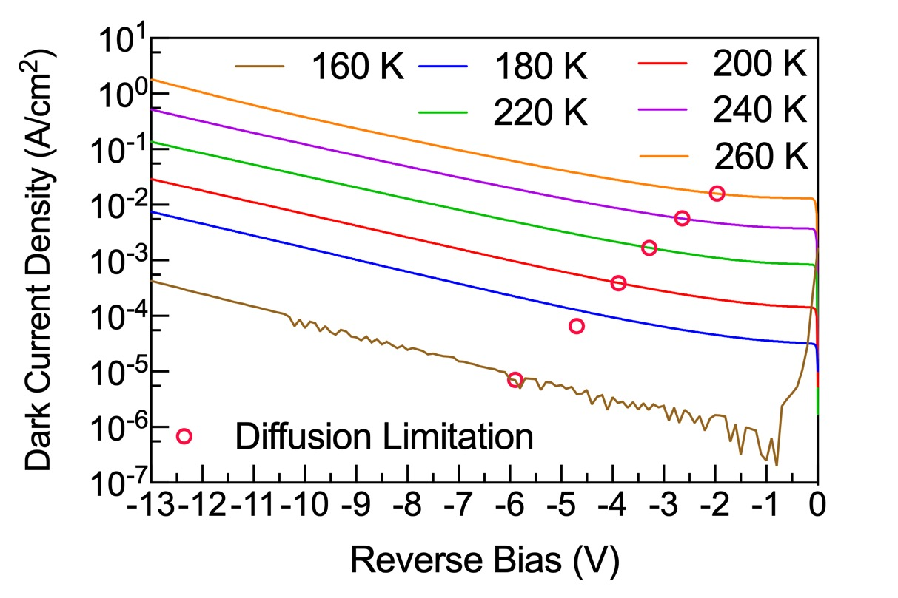
Fig. S1. Temperature dependent dark current of the MWIR SFDAM APDs.

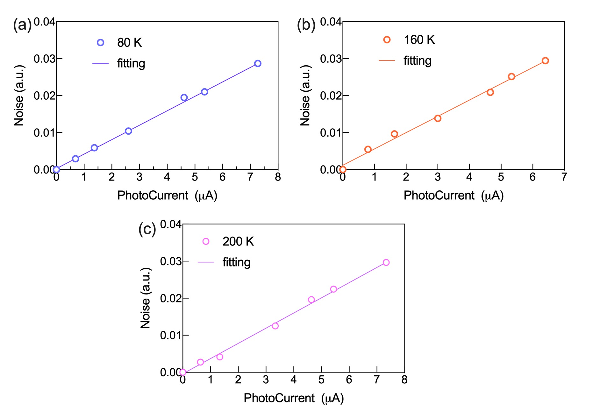
Fig. S2. linear fitting of the photocurrent and noise at unit gain bias at different temperature for SFDAM APDs.

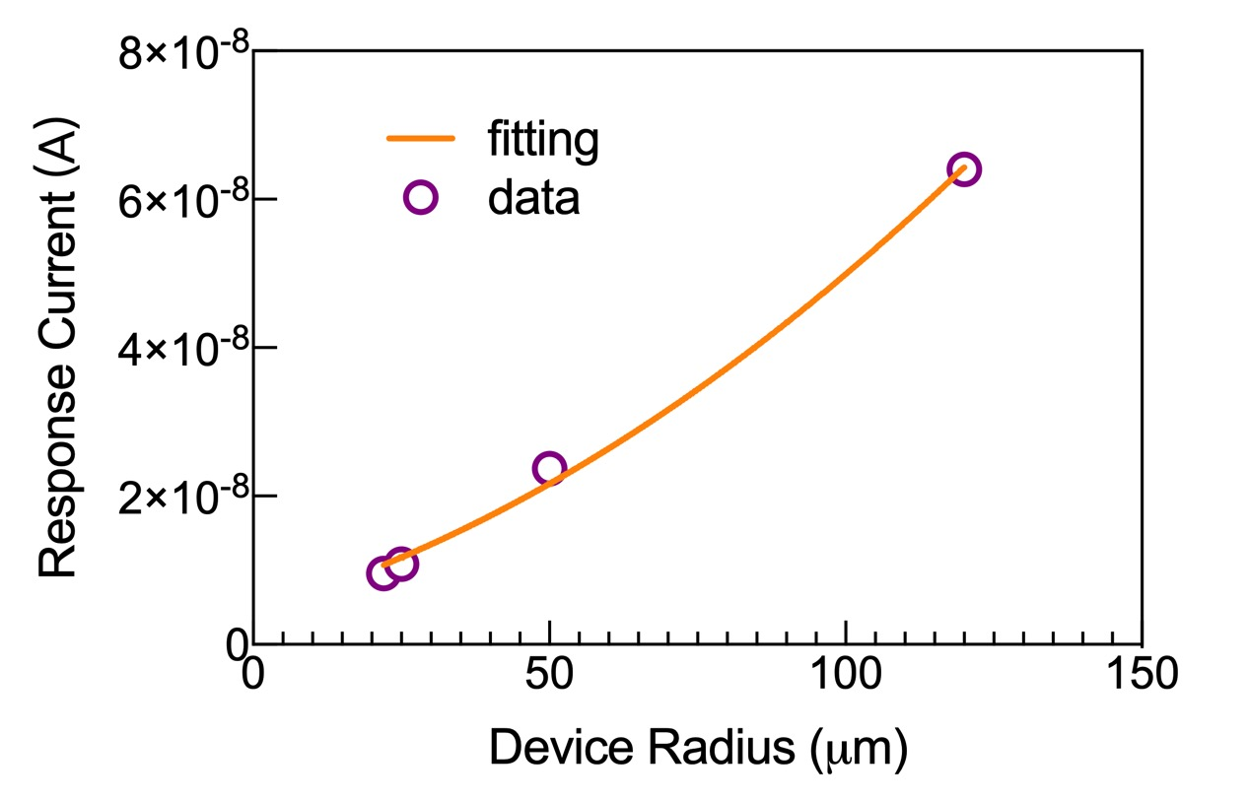
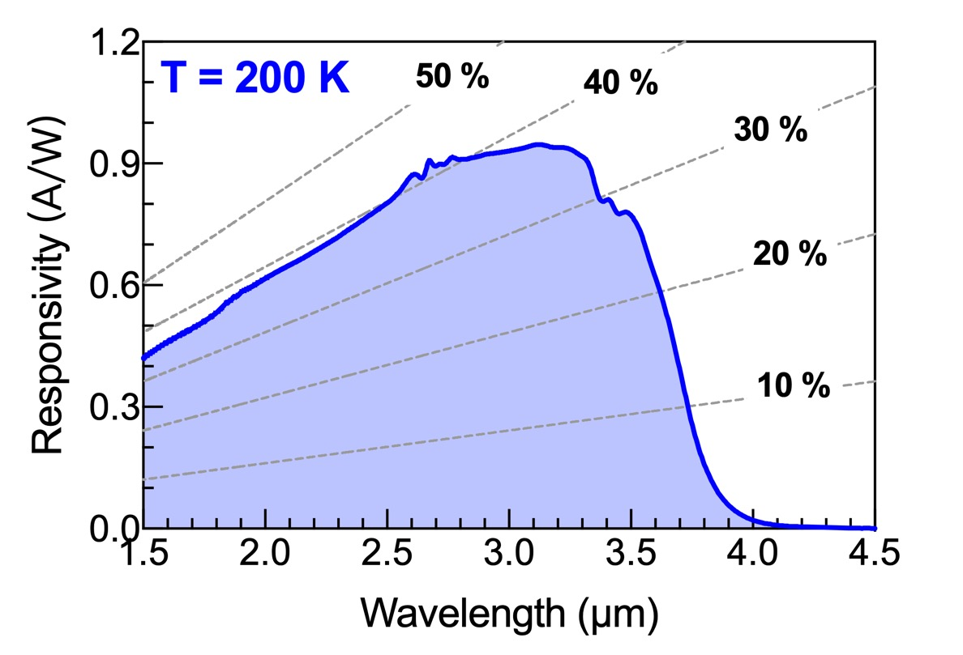
Fig. S3. (a) response photocurrent fitting of the different SFDAM APD radius for extracting lateral collection length at unit gain bias under 160 K temperature. (b) measured unity-gain external quantum efficiency and responsivity of a 100 µm × 100 µm APD device at 200 K.

