Negative correlation between microRNA and insulin sensitivity gene expression in adipose tissue with potential implications for diabetes and neurodegenerative diseases
Jakub Podraza¹, Michał Wąsowski², Marta Izabela Jonas³, Wojciech Lisik⁴, Maurycy Jonas⁴, Artur Binda⁵, Paweł Jaworski⁵, Wiesław Tarnowski⁵, Bartłomiej Noszczyk⁶, Monika Puzianowska-Kuźnicka ^{3,7}, Alina Kuryłowicz^{2,3*}
¹Warsaw University of Life Sciences, The Faculty of Biology and Biotechnology, Warsaw, 02-787 Poland
²Medical Centre of Postgraduate Education, Department of General Medicine and Geriatric Cardiology, Warsaw, 00-401, Poland
³ Mossakowski Medical Research Centre, Polish Academy of Sciences, Department of Human Epigenetics, Warsaw, 02-106, Poland
⁴ The Medical University of Warsaw, Department of General and Transplantation Surgery, Warsaw, 00-694, Poland
⁵ Medical Centre of Postgraduate Education, Department of General, Oncological and Bariatric Surgery, Warsaw, 00-401, Poland
⁶ Medical Centre of Postgraduate Education, Department of Plastic Surgery, Warsaw, 00-401, Poland
⁷Medical Centre of Postgraduate Education, Department of Geriatrics and Gerontology, Warsaw, 01-826, Poland

*Corresponding author: Alina Kuryłowicz, akurylowicz@imdik.pan.pl ORCID: 0000-0001-8632-4927

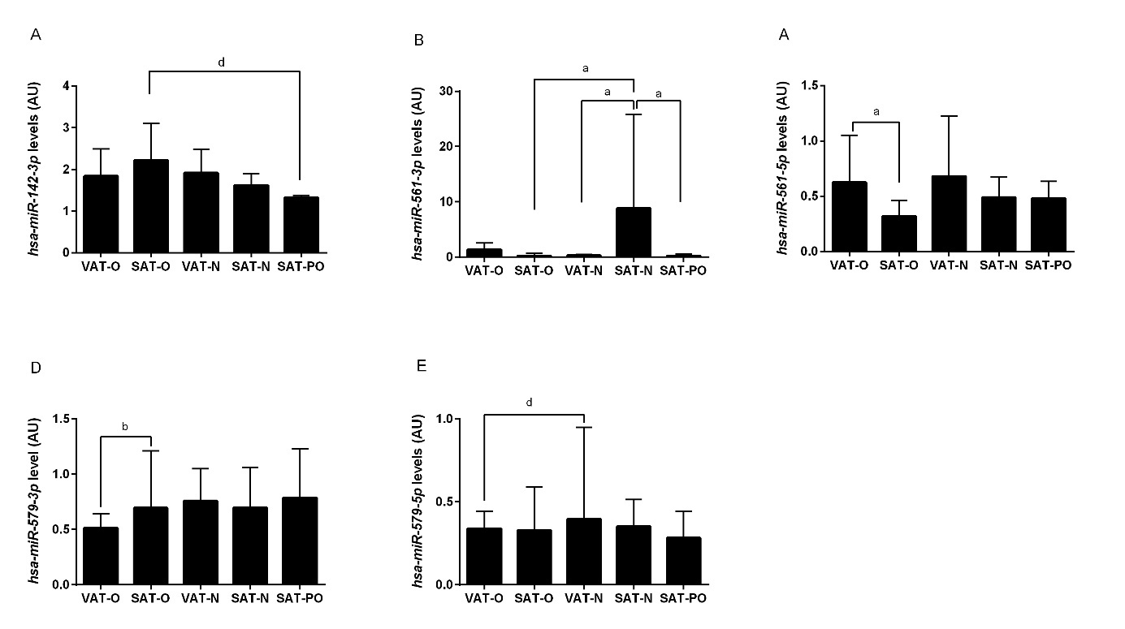
Supplementary Figure S1. Expression of hsa-miR-142-3p (A), hsa-miR-561-3p (B), hsa-miR-561-5p (C), hsa-miR-579-3p (D) and hsa-miR-579-5p (E) in the visceral (VAT) and subcutaneous (SAT) adipose tissues of the obese individuals before (O) and after surgically induced weight loss (PO) and in the normal-weight subjects (N). Results normalized to hsa-miR-103a-3p concentration are presented as the median with the interquartile range. “a” p < 0.0001; “b” p < 0.001; “d” p < 0.05.

 | Obese individuals  before weight loss  (N = 75) |  | Obese individuals  after weight loss  (N = 19) |  | P value
Males/Females | 13/62 |  | 4/15
 | Mean ± SD | Min–Max | Mean ± SD | Min–Max
Age (years) | 41.4 ± 10.2 | 20 - 62 | 41.5 ± 10.3 | 28 - 67 | NS
BMI (kg/m²) | 46.3 ± 5.5 | 40.1 - 59.5 | 27.2 ± 2.3 | 24.3 - 29.5 | P < 0.001
Adipose tissue (% body mass) | 47.1 ± 5.2 | 32.6 - 59.5 | 30.5± 3.3 | 24.8 - 34.0 | P < 0.001
Waist circumference (m) | 1.2 ± 0.2 | 1.0 - 1.7 | 0.9 ± 0.1 | 0.8 - 1.1 | P = 0.047
Weight loss (kg) | – | – | 47.8 ± 10.4 | 35.2 - 65.6 | -
TSH (mIU/l) | 1.8 ± 1.3 | 0.3 - 5.6 | 1.6 ± 0.2 | 1.1 - 1.3 | NS
Glucose (mmol/L) | 6.0 ± 1.4 | 3.5 - 11.1 | 4.8 ± 0.5 | 4.1 - 5.7 | P = 0.012
Total cholesterol (mmol/L) | 4.9 ± 1.1 | 2.4 - 7.9 | 4.6 ± 0.9 | 3.5 - 5.9 | P = 0.038
HDL cholesterol (mmol/L) | 0.97 ±0.3 | 0.75 - 1.3 | 1.12 ±0.2 | 0.9 - 1.29 | NS
Triglicerides (mmol/L) | 2.9±0.3 | 2.6 - 3.2 | 1.9±0.4 | 1.5 - 2.4 | P = 0.024
Triglicerides/HDL ratio* | 5.4 ±1.8 | 3.6-7.4 | 4.2±0.7 | 3.4-4.8 | P < 0.001
Supplementary Table 1. Basic clinical characteristics of the patients with obesity before and after weight-loss surgery.

*The triglycerides/HDL ratio was calculated in 58 subjects not taking hypolipemic drugs and in all patients after bariatric surgery.

HDL – high density lipoprotein, N – number of individuals, SD – standard deviation

 | Patients diagnosed  with type 2 diabetes  (N = 25) |  | Patients without  type 2 diabetes  (N = 50) |  | P value
Males/Females | 7/18 |  | 8/42
 | Mean ± SD | Min–Max | Mean ± SD | Min–Max
Age (years) | 46.2 ± 9.2 | 38.2 - 62 | 40.3 ± 10.3 | 20 - 60 | P = 0.048
BMI (kg/m²) | 46.3 ± 5.5 | 40.1 - 59.5 | 27.2 ± 2.3 | 24.3 - 29.5 | NS
Adipose tissue (% body mass) | 52.1 ± 4.2 | 45.1- 59.5 | 45.6 ± 10.1 | 32.6 – 55.2 | P = 0.04
Waist circumference (m) | 1.3 ± 0.2 | 1.1 - 1.7 | 1.2 ± 0.1 | 0.8 - 1.6 | NS
TSH (mIU/l) | 1.7 ± 1.4 | 0.6 - 4.4 | 1.6 ± 1.3 | 0.3 – 5.6 | NS
Glucose (mmol/L) | 8.7 ± 2.4 | 6.0 - 11.1 | 4.8 ± 0.6 | 3.5 - 5.5 | P = 0.008
Total cholesterol (mmol/L) | 5.2 ± 1.0 | 3.8 - 7.9 | 4.6 ± 0.9 | 2.4 - 5.9 | NS
HDL cholesterol (mmol/L) | 0.78 ±0.2 | 0.75 - 1.1 | 0.95 ±0.12 | 0.85 - 1.3 | NS
Triglicerides (mmol/L) | 3.2 ± 0.3 | 2.8 - 3.7 | 2.9 ± 0.3 | 2.6 - 3.4 | P = 0.046
Triglicerides/HDL ratio* | 6.4 ± 0.8 | 5.2 - 7.4 | 4.2 ± 0.6 | 3.6 - 5.3 | P = 0.02
Supplementary Table 2. Basic clinical characteristics of the patients with obesity before weight loss stratified by the presence of type 2 diabetes.

*The triglycerides/HDL ratio was calculated in 58 subjects not taking hypolipemic drugs.

HDL – high density lipoprotein, N – number of individuals, SD – standard deviationa

