Supplementary information

Characterization of aerosol particles during a high pollution episode over Mexico City
Giovanni Carabali ^{1*}, José Villanueva-Macias ², Luis Ladino ³, Harry Álvarez-Ospina ⁴, Graciela Raga ³, Gema Andraca-Ayala ³, Javier Miranda ⁵, Michel Grutter ³, Monserrat Silva ³ and David Riveros-Rosas ¹.

¹ Instituto de Geofísica, Universidad Nacional Autónoma de México (UNAM)
² Facultad de Química, Universidad Nacional Autónoma de México (UNAM)
³ Centro de Ciencias de la Atmósfera, Universidad Nacional Autónoma de México (UNAM)
⁴ Facultad de Ciencias, Universidad Nacional Autónoma de México (UNAM)
⁵ Instituto de Física, Universidad Nacional Autónoma de México (UNAM)
* Corresponding author: carabali@igeofisica.unam.mx

Supplementary Figures
Fig. S1. (a) Measurements of daily GHI during the HAP episode and low polluted days. (b) Correlation between the GHI anomaly and PM_{2.5} concentrations.

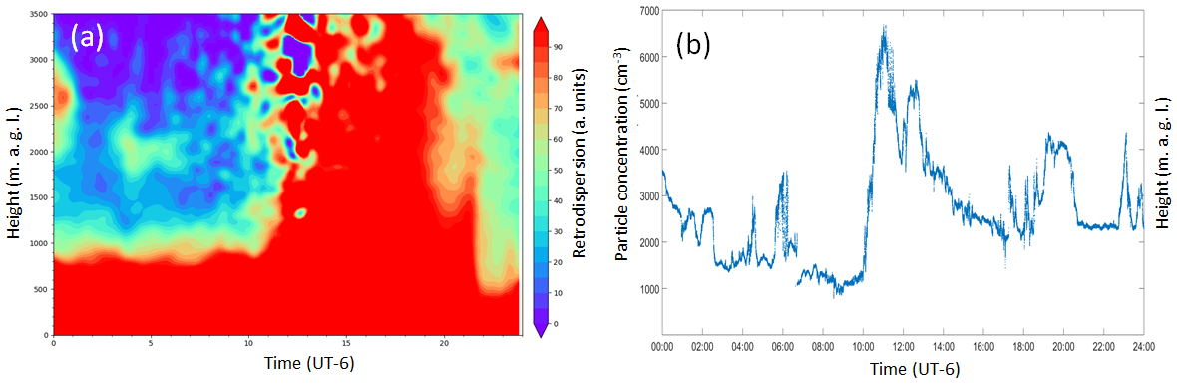
Fig. S2. (a) Backscatter profile from Ceilometer data measured in MC on May 14, 2019 and (b) particle number concentrations at AAO during the HAP episode.

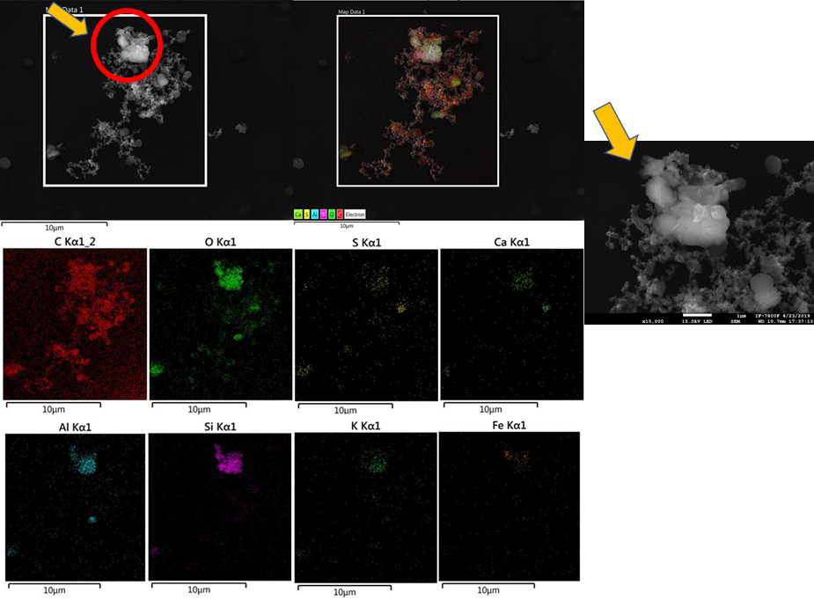

Fig. S3. EDS elemental mapping of soot agglomerate sampled in AAO during the HAP episode.

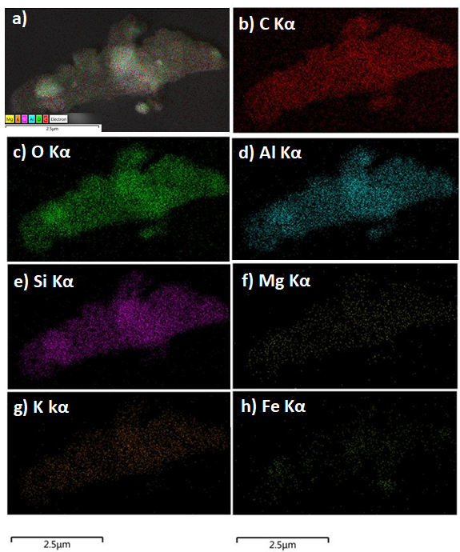

Fig. S4. EDS elemental mapping of individual mineral dust sampled AAO during the HAP episode

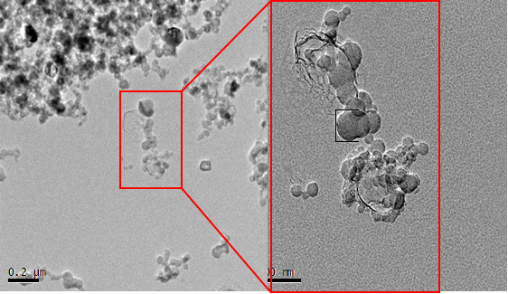

Fig. S5. Example of an externally mixed with a soot aggregate surrounded by other particles with different compositions (mainly sulfur).

Table S1. Global Horizontal Irradiance (GHI) and anomaly values for the HAP period and low polluted days of May 2019.

 | GHI (Wh/m²) | Anomaly (%)
HAP | 1041 | -7.81
Low Polluted Days | 1129 | -0.03

