Deciphering pH-Driven Dynamics of Prolyl Endopeptidases: Unveiling Structural insight in Celiac Disease using Computational Techniques

Awadhesh Kumar Verma^{a*}, Shubham Kumarª, Tanya Singhª, Anand Mohanª , Neeta Raj Sharmaª, Anil Kumar^{b}
ª School of Bioengineering and Biosciences, Lovely Professional University, Phagwara, Punjab, 144411, India
^{b} Gene Regulation Laboratory, National Institute of Immunology, Aruna Asaf Ali Marg, New Delhi - 110067, India
* Corresponding author: dradverma@gmail.com (Awadhesh Kumar Verma)

Supplementary Information

- Figures:

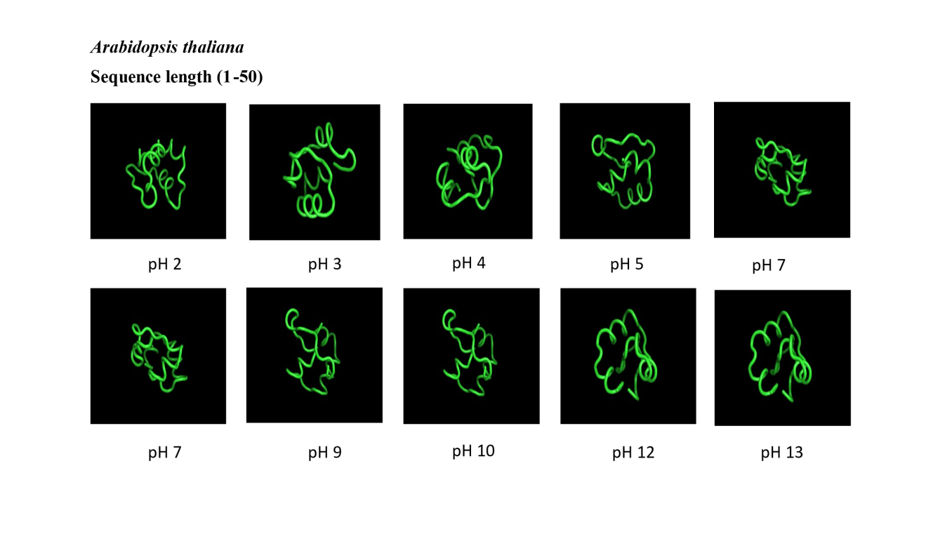
Figure.S1. 3D structures of Arabidopsis thaliana prolyl endopeptidase (sequence length 1-50) at various pH levels obtained using Pep-Fold4 prediction. The models depict predicted conformational changes in the protein structure due to varying pH conditions.

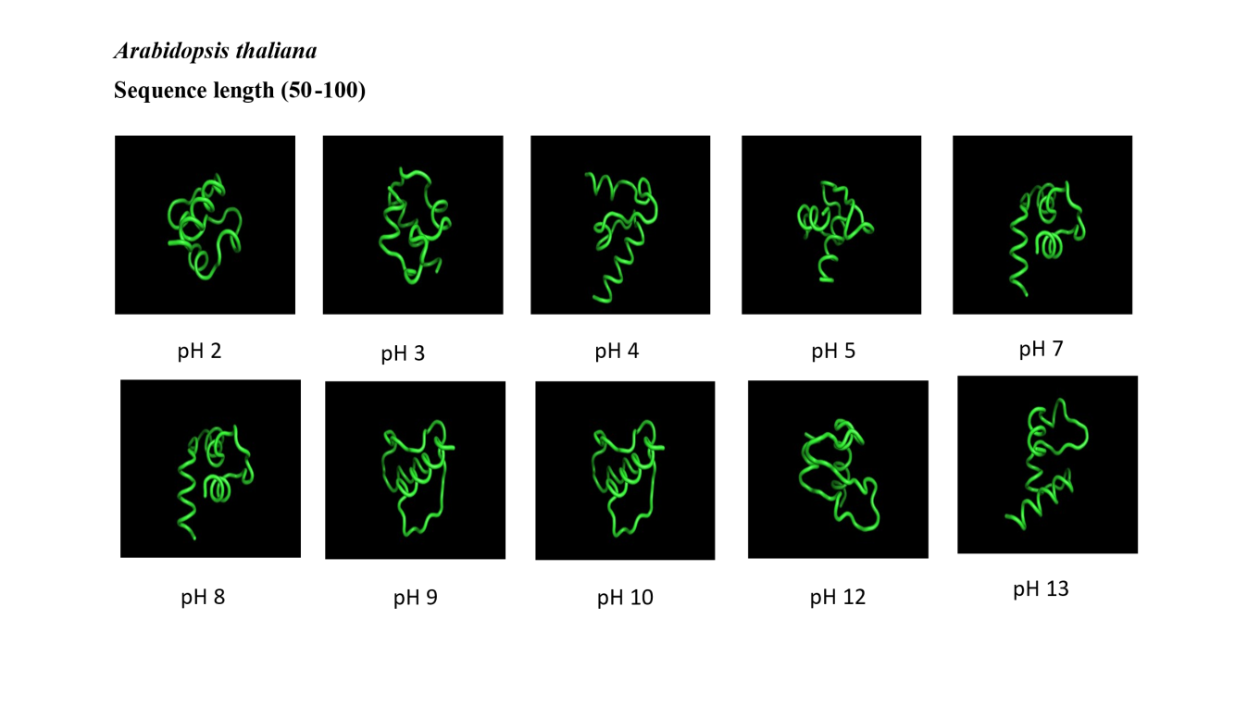
Figure.S2. 3D structures of Arabidopsis thaliana prolyl endopeptidase (sequence length 50-100) at various pH levels obtained using Pep-Fold4 prediction. The models depict predicted conformational changes in the protein structure due to varying pH conditions.
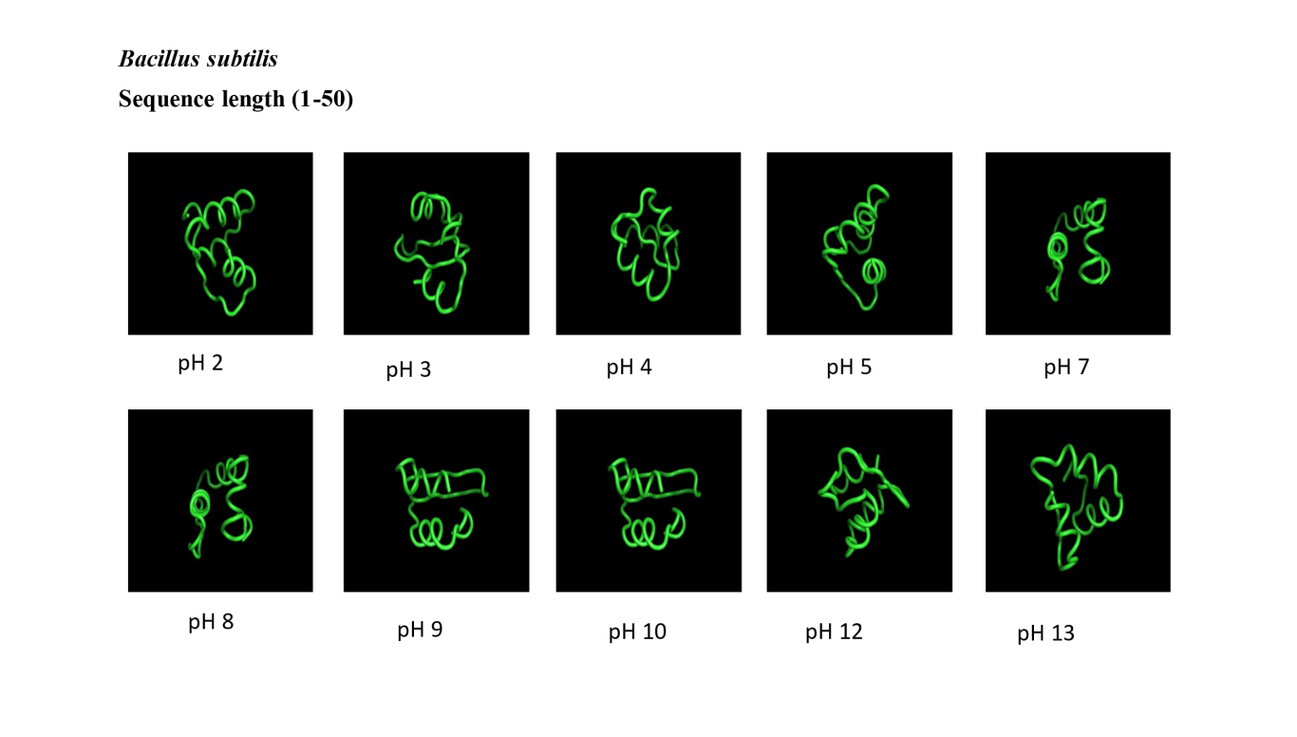
Figure.S3. 3D structures of Bacillus subtilis prolyl endopeptidase (sequence length 1-50) at various pH levels obtained using Pep-Fold4 prediction. The models depict predicted conformational changes in the protein structure due to varying pH conditions.

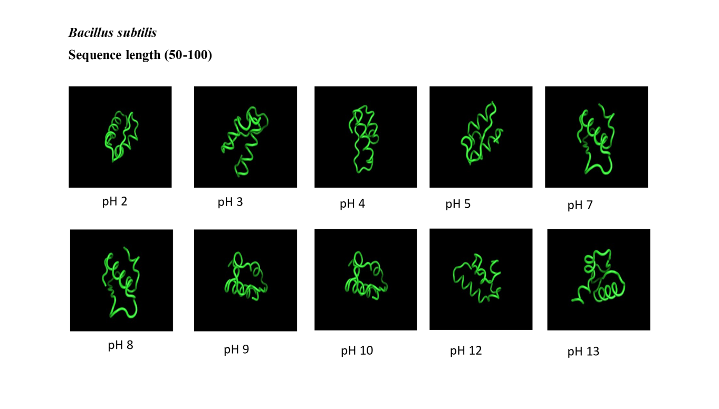
Figure.S4. 3D structures of Bacillus subtilis prolyl endopeptidase (sequence length 50-100) at various pH levels obtained using Pep-Fold4 prediction. The models depict predicted conformational changes in the protein structure due to varying pH conditions.

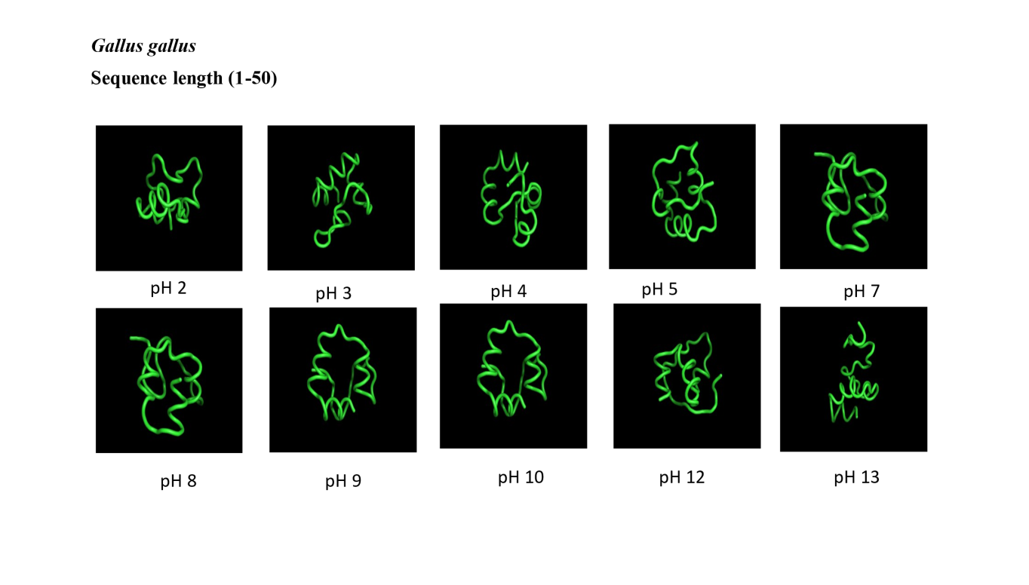
Figure.S5. 3D structures of Gallus gallus prolyl endopeptidase (sequence length 1-50) at various pH levels obtained using Pep-Fold4 prediction. The models depict predicted conformational changes in the protein structure due to varying pH conditions.

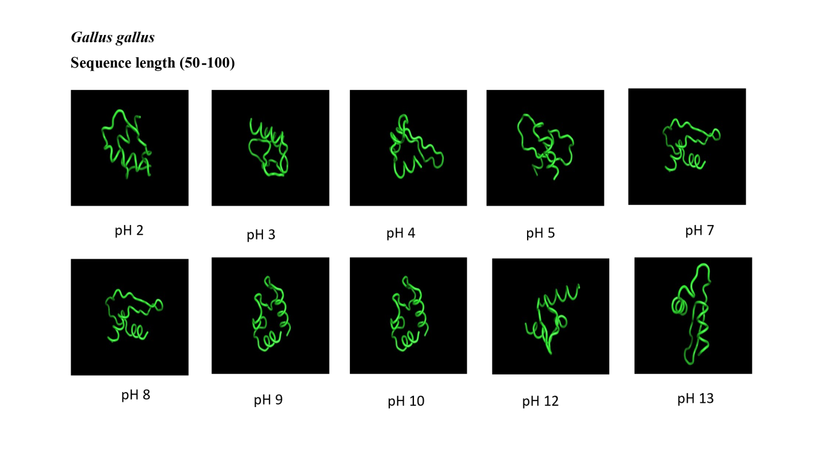
Figure.S6. 3D structures of Gallus gallus prolyl endopeptidase (sequence length 50-100) at various pH levels obtained using Pep-Fold4 prediction. The models depict predicted conformational changes in the protein structure due to varying pH conditions.

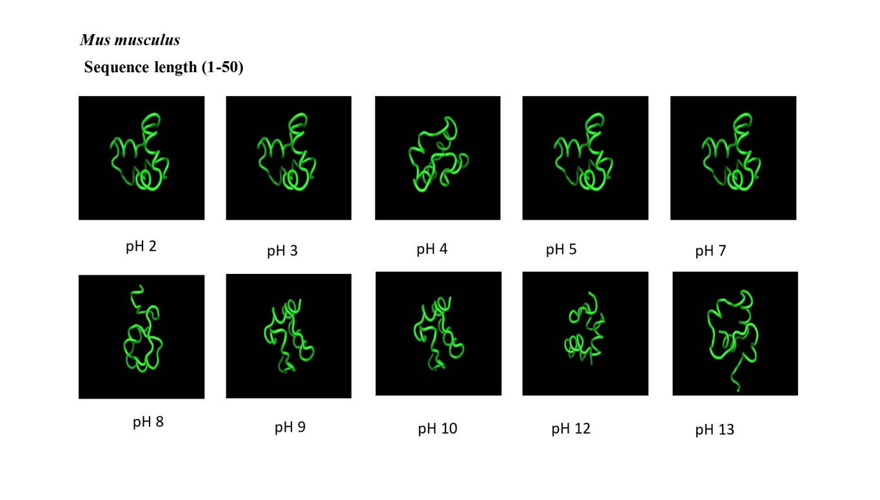
Figure.S7. 3D structures of Mus musculus prolyl endopeptidase (sequence length 1-50) at various pH levels obtained using Pep-Fold4 prediction. The models depict predicted conformational changes in the protein structure due to varying pH conditions.

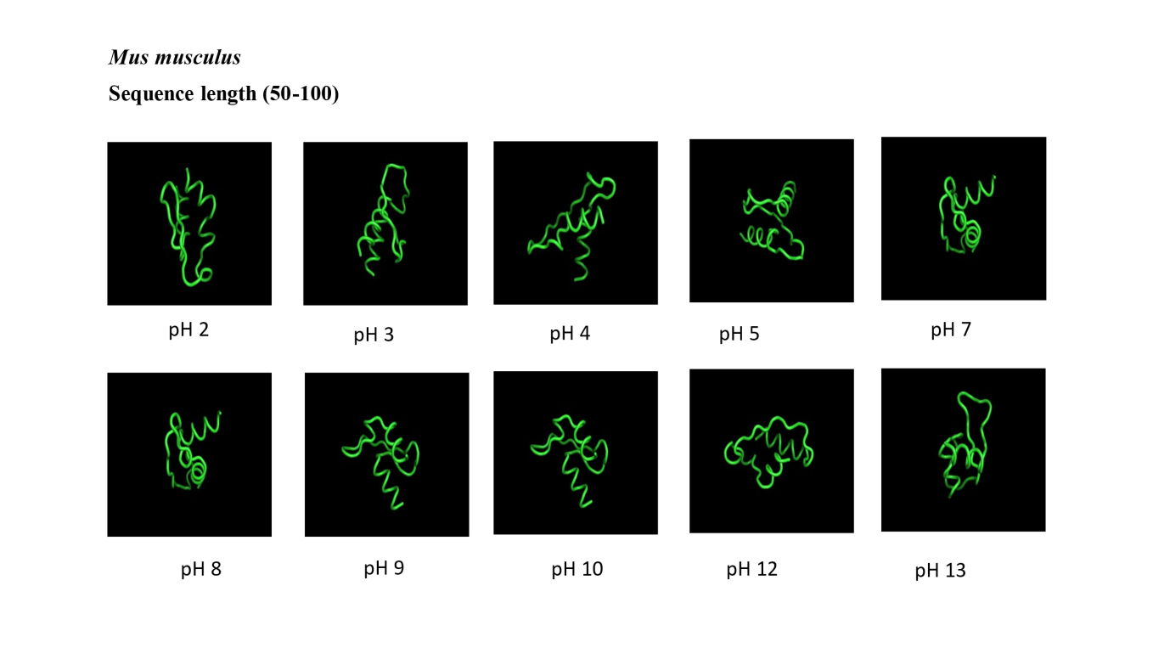
Figure.S8. 3D structures of Mus musculus prolyl endopeptidase (sequence length 50-100) at various pH levels obtained using Pep-Fold4 prediction. The models depict predicted conformational changes in the protein structure due to varying pH conditions.

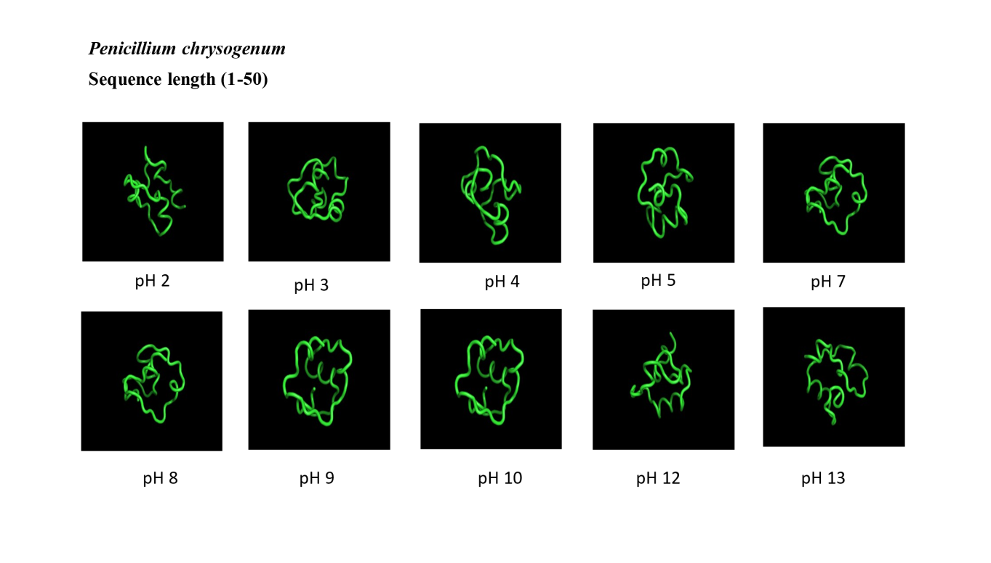
Figure.S9. 3D structures of Penicillium chryogenum prolyl endopeptidase (sequence length 1-50) at various pH levels obtained using Pep-Fold4 prediction. The models depict predicted conformational changes in the protein structure due to varying pH conditions.
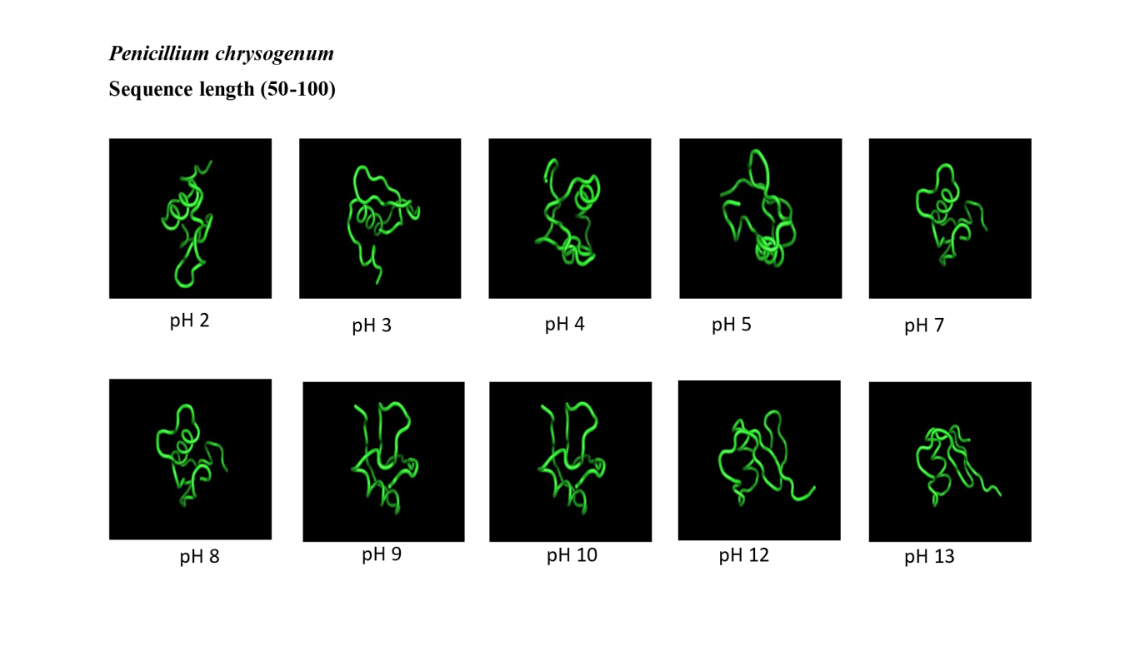
Figure.S10. 3D structures of Penicillium chryogenum prolyl endopeptidase (sequence length 50-100) at various pH levels obtained using Pep-Fold4 prediction. The models depict predicted conformational changes in the protein structure due to varying pH conditions.

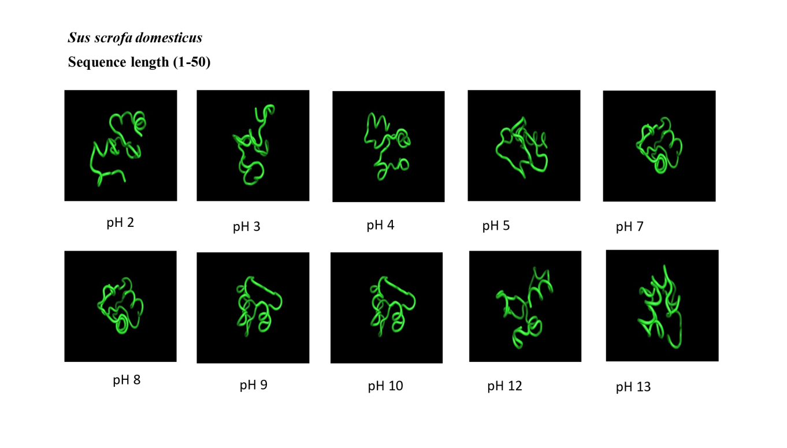
Figure.S11. 3D structures of Sus scrofa domesticus prolyl endopeptidase (sequence length 1-50) at various pH levels obtained using Pep-Fold4 prediction. The models depict predicted conformational changes in the protein structure due to varying pH conditions.
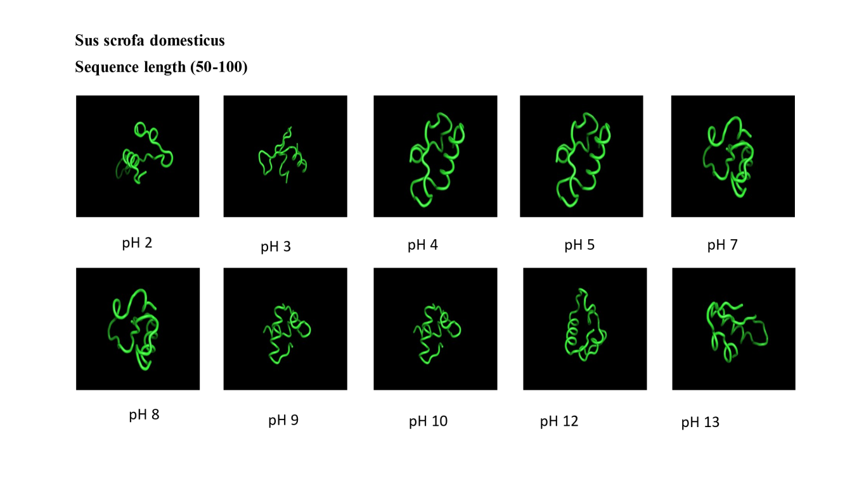
Figure.S12. 3D structures of Sus scrofa domesticus prolyl endopeptidase (sequence length 50-100) at various pH levels obtained using Pep-Fold4 prediction. The models depict predicted conformational changes in the protein structure due to varying pH conditions.

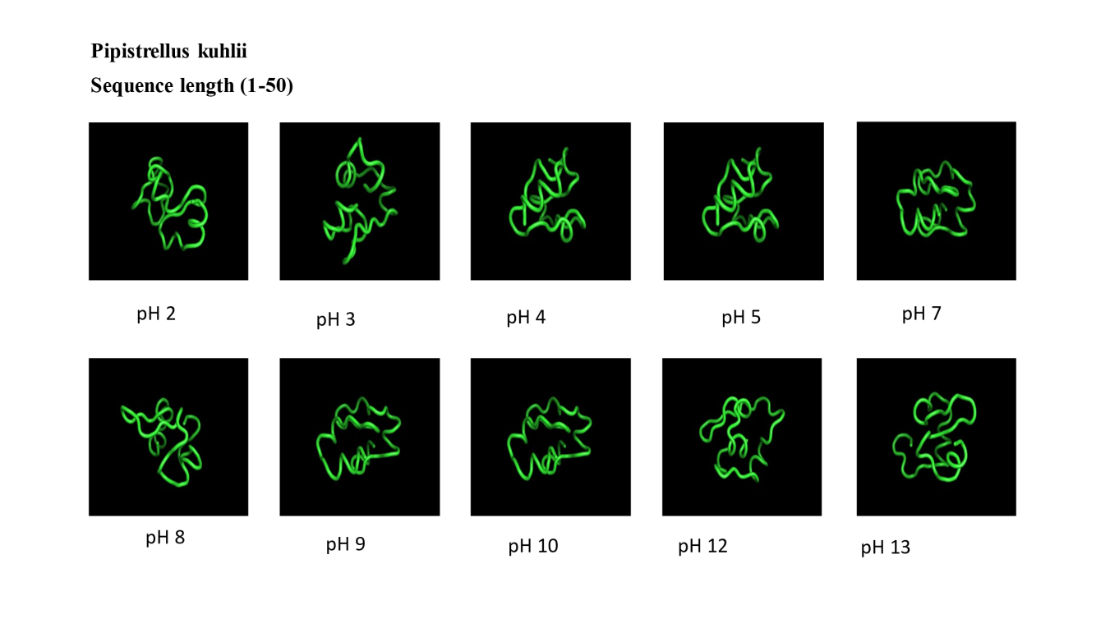
Figure.S13. 3D structures of Pipistrellus kuhlii prolyl endopeptidase (sequence length 1-50) at various pH levels obtained using Pep-Fold4 prediction. The models depict predicted conformational changes in the protein structure due to varying pH conditions.

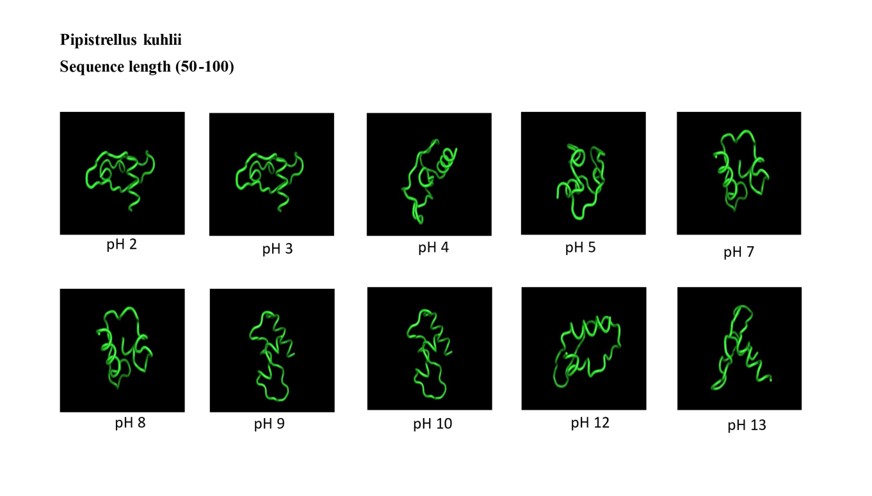
Figure.S14. 3D structures of Pipistrellus kuhlii prolyl endopeptidase (sequence length 50-100) at various pH levels obtained using Pep-Fold4 prediction. The models depict predicted conformational changes in the protein structure due to varying pH conditions.

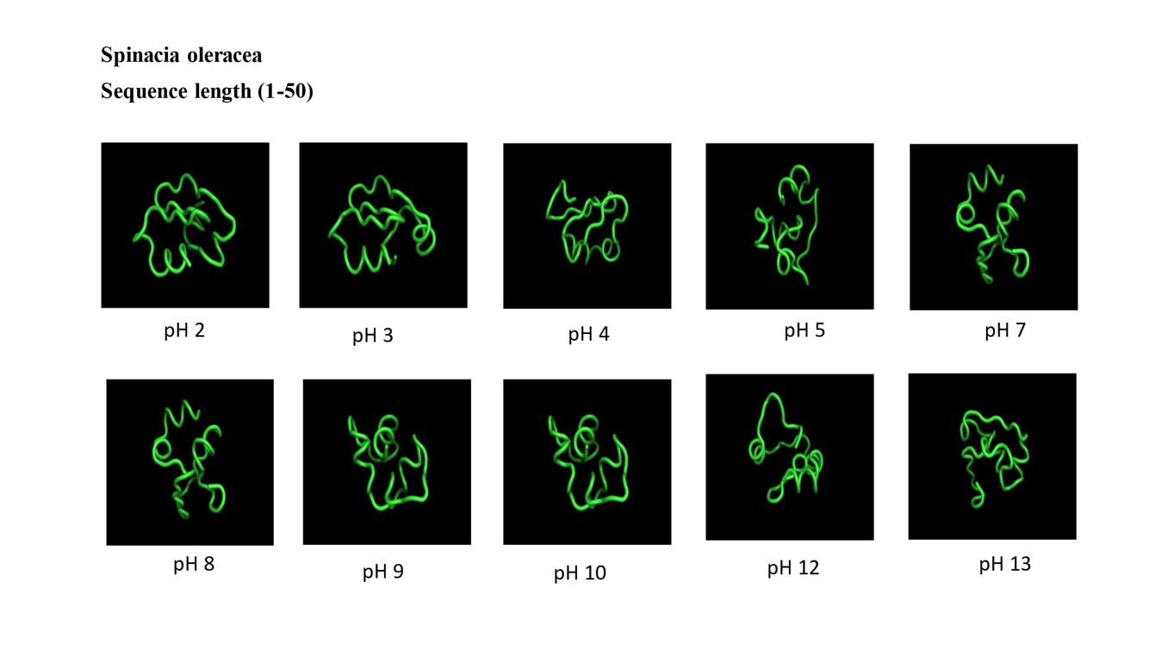
Figure.S15. 3D structures of Spinacia oleracea prolyl endopeptidase (sequence length 1-50) at various pH levels obtained using Pep-Fold4 prediction. The models depict predicted conformational changes in the protein structure due to varying pH conditions.

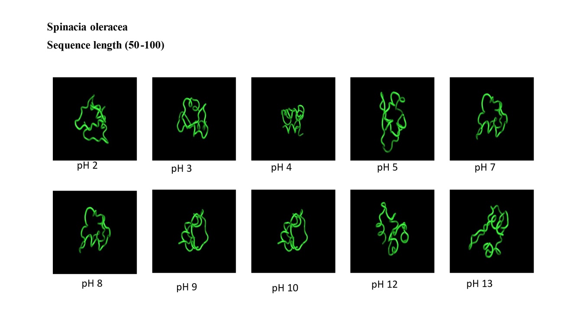
Figure.S16. 3D structures of Spinacia oleracea prolyl endopeptidase (sequence length 50-100) at various pH levels obtained using Pep-Fold4 prediction. The models depict predicted conformational changes in the protein structure due to varying pH conditions.

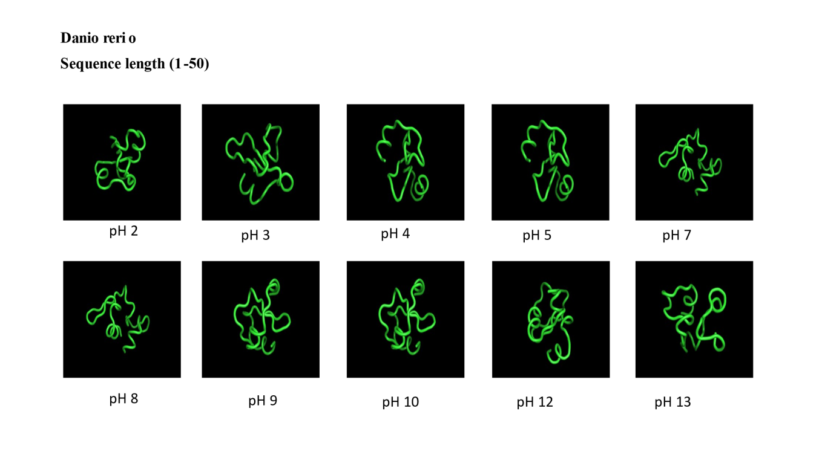
Figure.S17. 3D structures of Danio rerio prolyl endopeptidase (sequence length 1-50) at various pH levels obtained using Pep-Fold4 prediction. The models depict predicted conformational changes in the protein structure due to varying pH conditions.

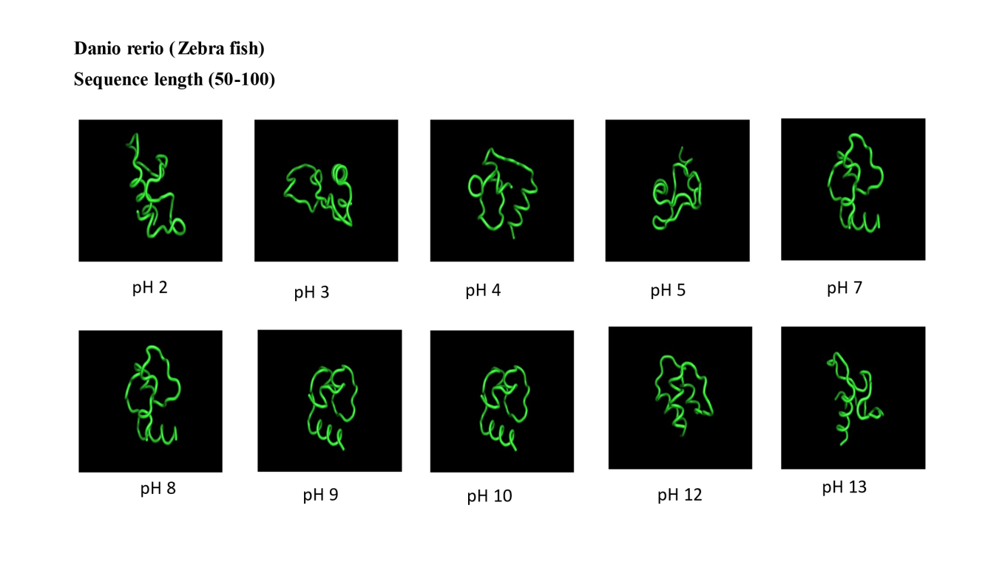
Figure.S18. 3D structures of Danio rerio prolyl endopeptidase (sequence length 50-100) at various pH levels obtained using Pep-Fold4 prediction. The models depict predicted conformational changes in the protein structure due to varying pH conditions.

Figure.S19. RMSD values for A. thaliana sequence length(1-50 and 50-100) across varying pH levels, calculated using PyMOL.

Figure.S20. RMSD values for B. subtilis sequence length(1-50 and 50-100) across varying pH levels, calculated using PyMOL.

Figure.S21. RMSD values for Pipistrellus kuhlii sequence length(1-50 and 50-100) across varying pH levels, calculated using PyMOL.

Figure.S22. RMSD values for Gallus gallus sequence length(1-50 and 50-100) across varying pH levels, calculated using PyMOL.

Figure.S23. RMSD values for Mus musculus sequence length (1-50 and 50-100) across varying pH levels, calculated using PyMOL.

Figure.S24. RMSD values for Sus scrofa sequence length(1-50 and 50-100) across varying pH levels, calculated using PyMOL.

Figure.S25. RMSD values for Danio rerio sequence length(1-50 and 50-100) across varying pH levels, calculated using PyMOL.

Figure.S26. RMSD values for Penicillium chryogenum sequence length(1-50 and 50-100) across varying pH levels, calculated using PyMOL.

Figure.S27. RMSD values for Spinacia oleracea sequence length(1-50 and 50-100) across varying pH levels, calculated using PyMOL.

(a)
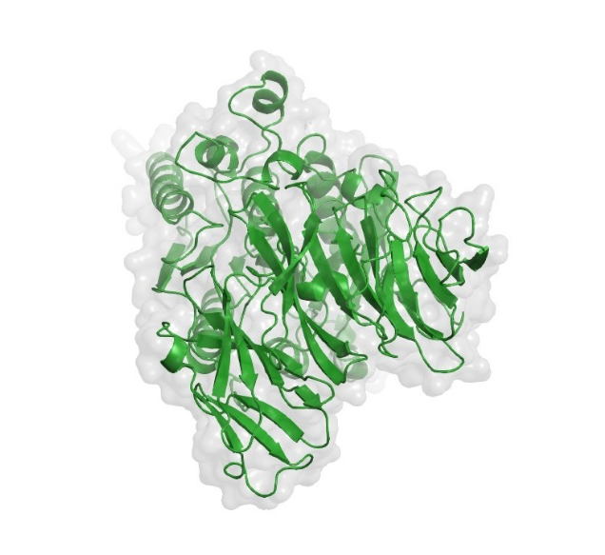

(b)
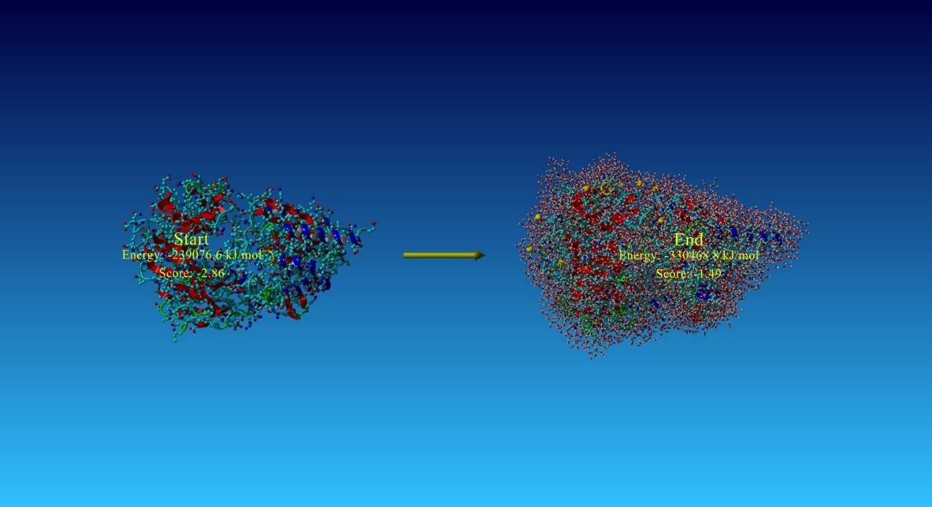
(c)
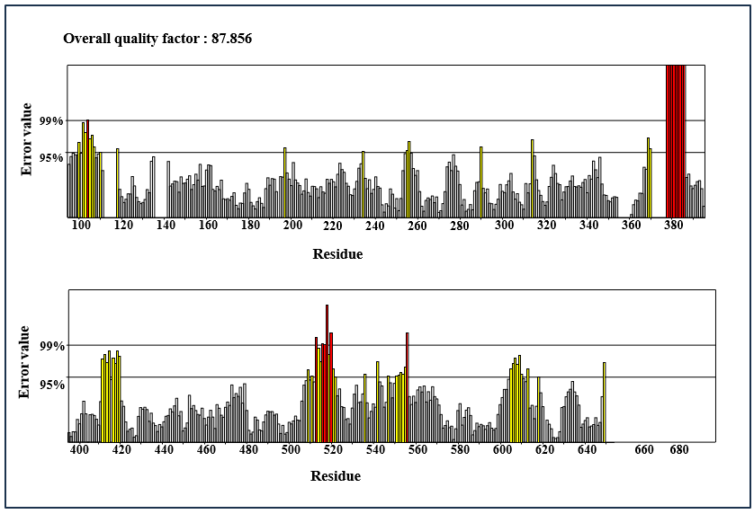

(d)
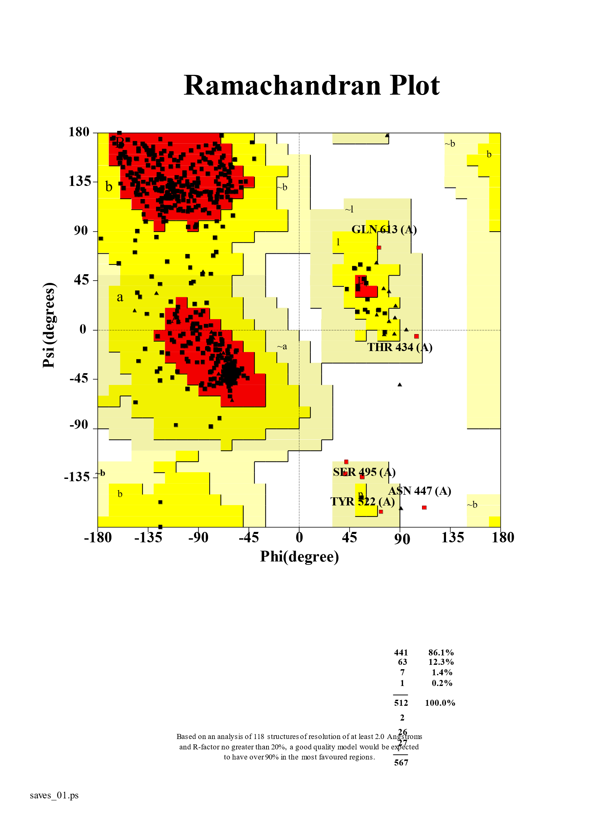
Figure.S28. (a) Top three homology models of human prolyl endopeptidase generated using Swiss-Model. The highlighted model (Model 2) was selected for further analysis. (b) Energy minimization of human prolyl endopeptidase (model 2) using YASARA software. (c) Evaluating structural dependability and model quality with ERRAT online tool. (d) ERRAT analysis shows a Ramachandran plot distribution, supporting the PEP (model 2) overall quality.

(a)
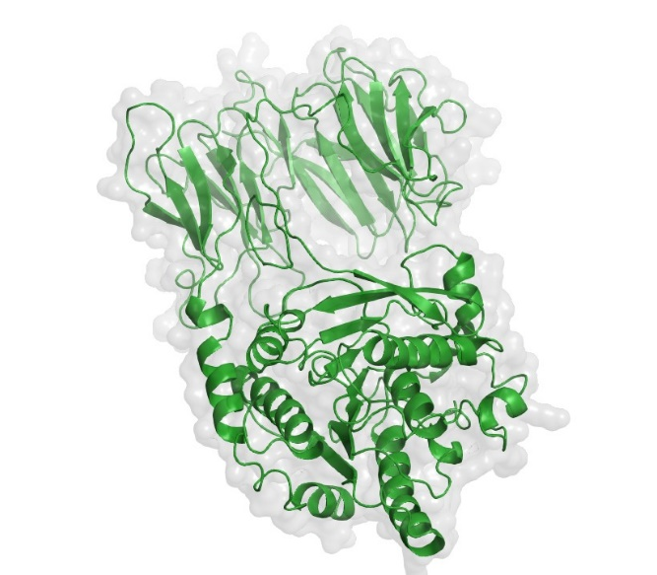

(b)
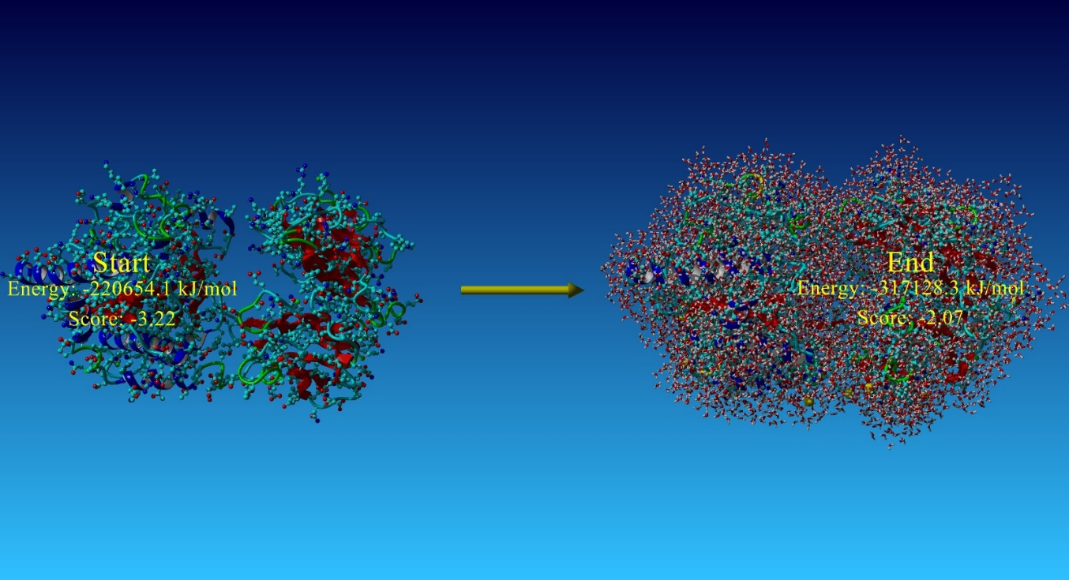

(c)
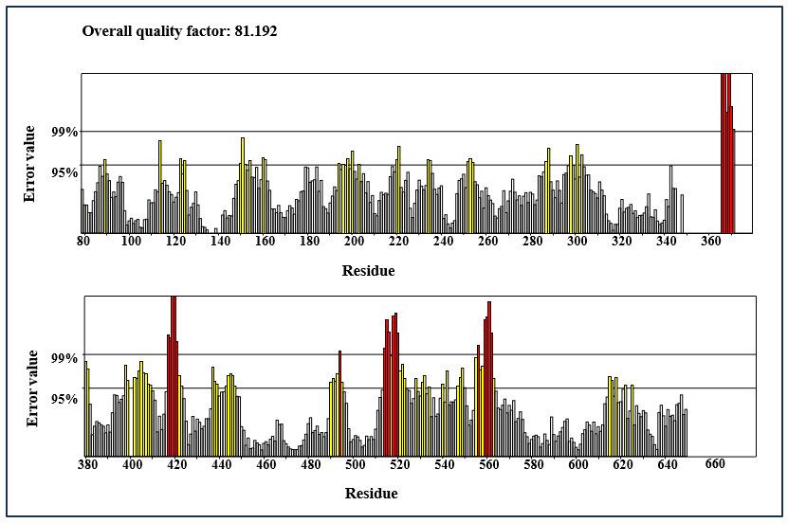
(d)
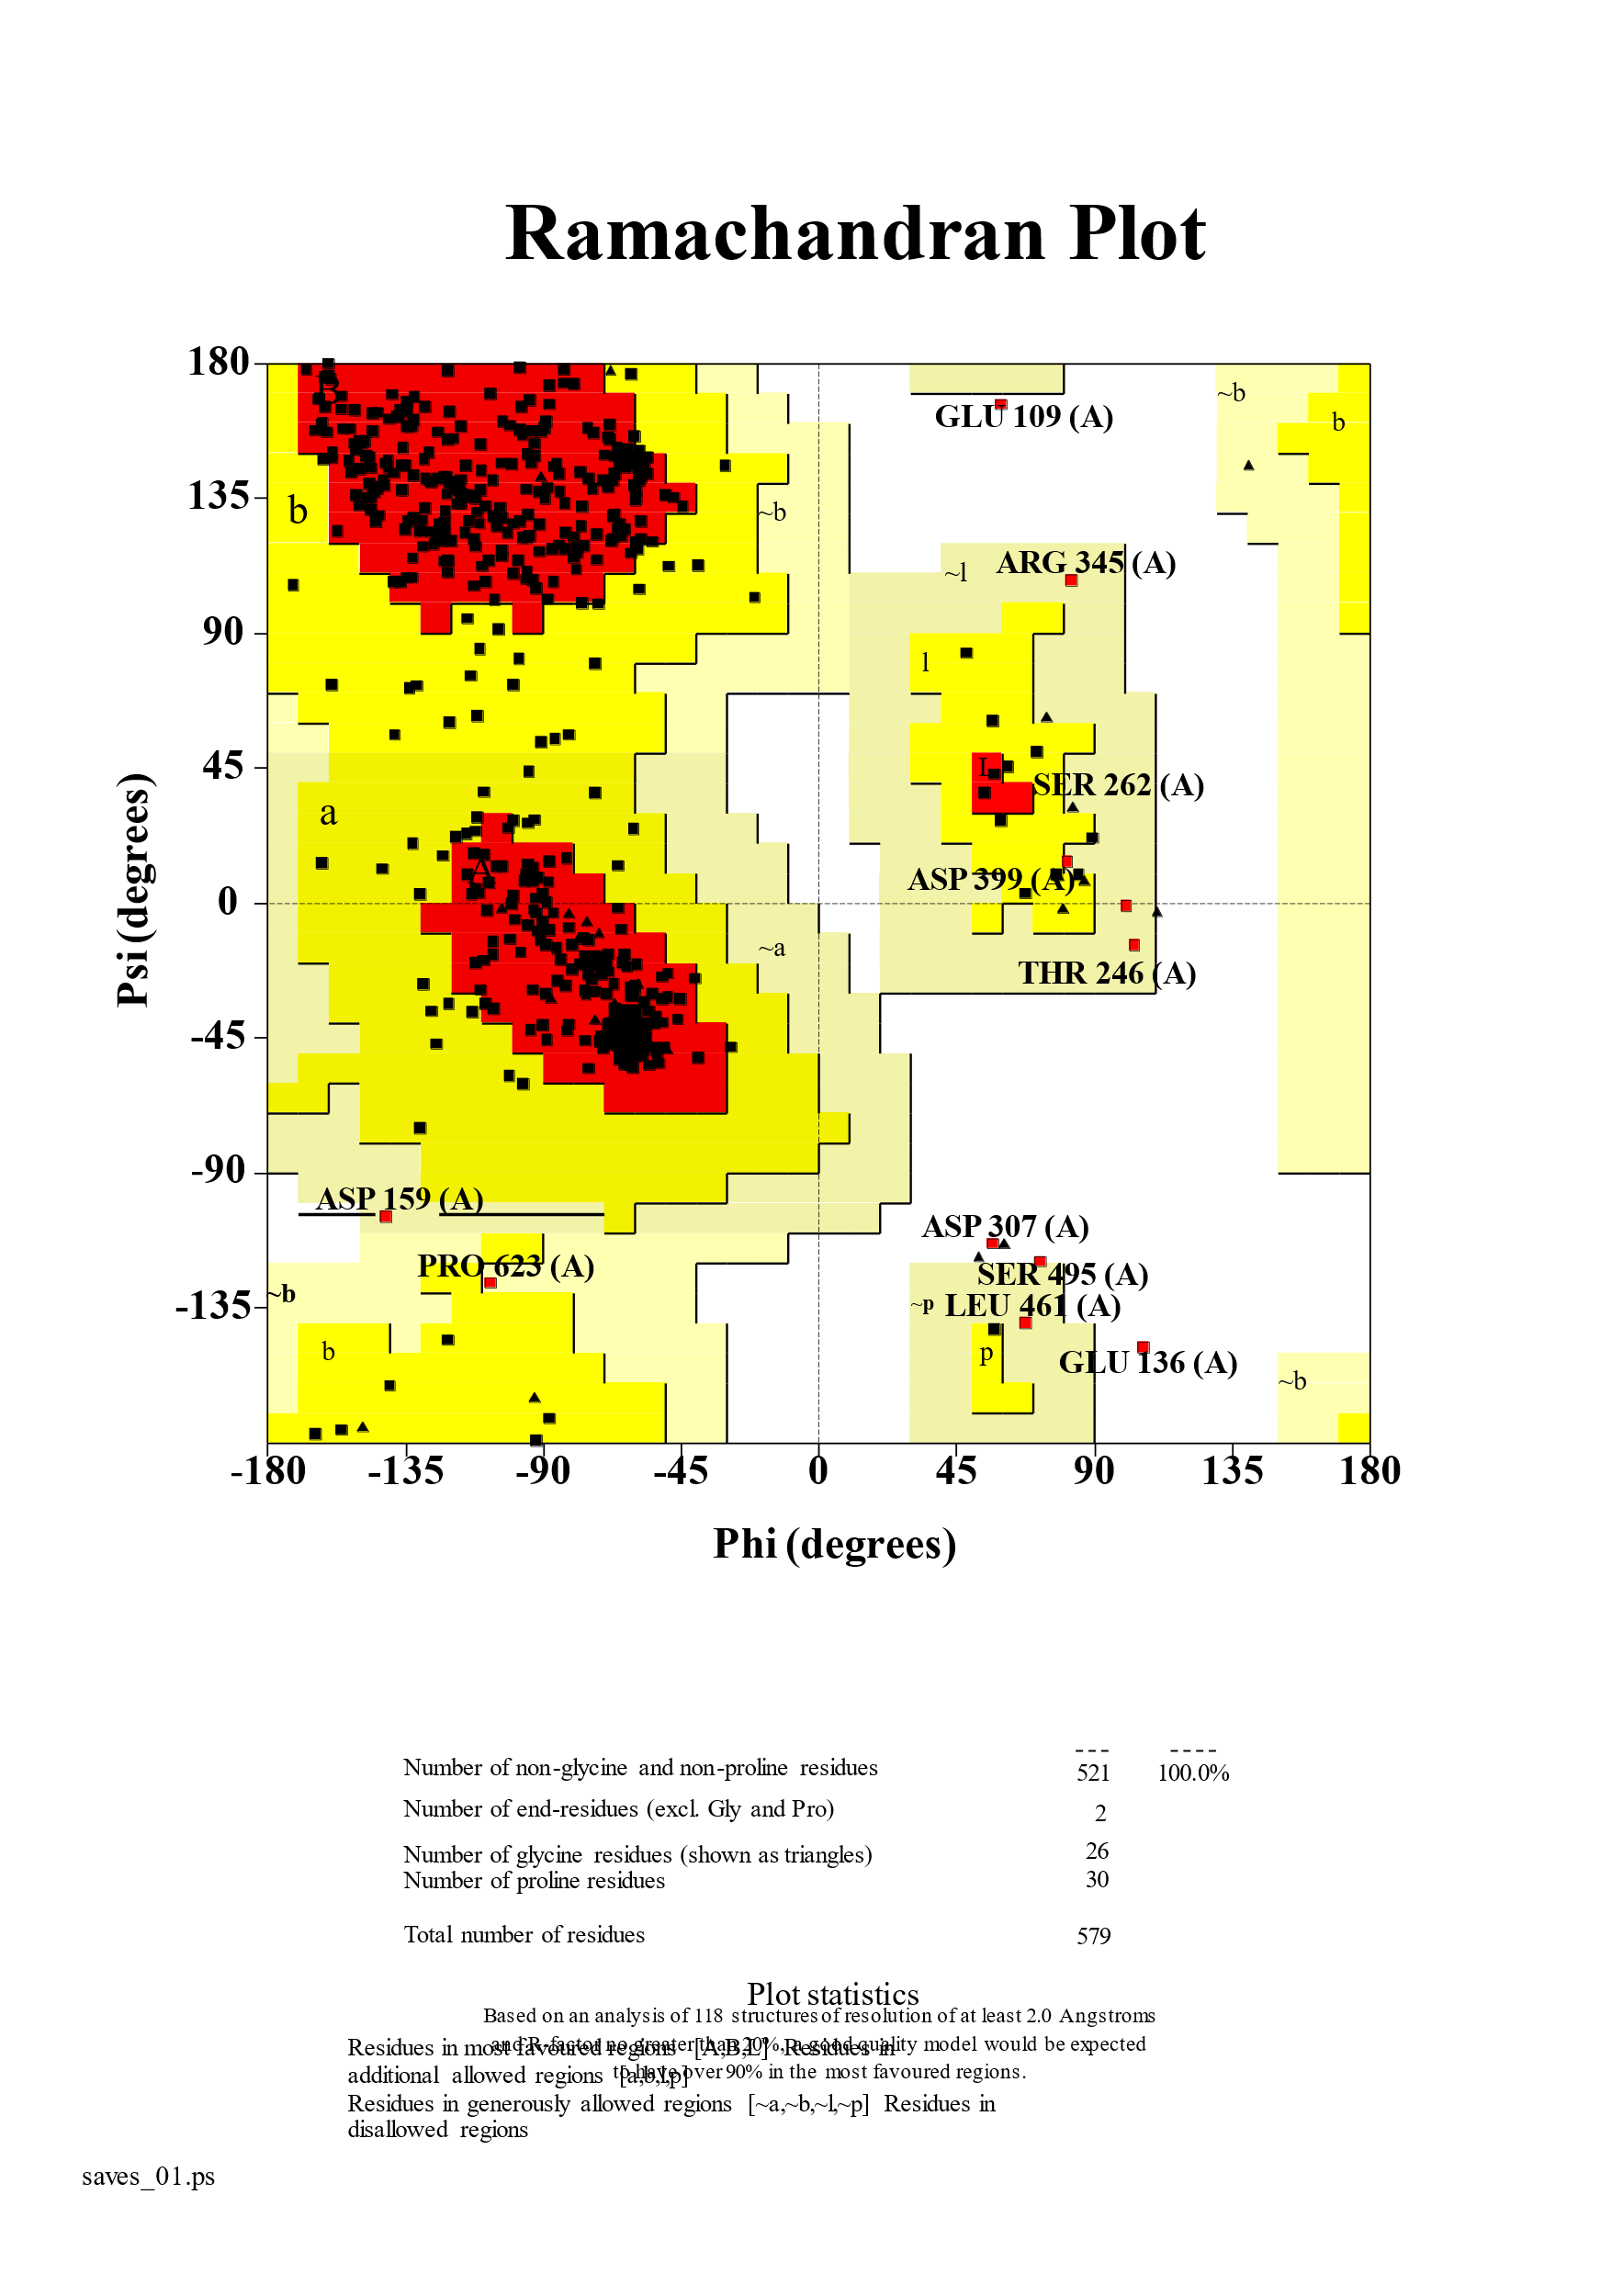
Figure.S29. (a) Top three homology models of human prolyl endopeptidase generated using Swiss-Model. The highlighted model (Model 3) was selected for further analysis. (b) Energy minimization of human prolyl endopeptidase (model 3) using YASARA software. (c) Evaluating structural dependability and model quality with ERRAT online tool. (d) ERRAT analysis shows a Ramachandran plot distribution, supporting the PEP (model 3) overall quality.

Figure.S30. Docking scores of gluten peptides (ligand) with prolyl endopeptidase (enzyme) of Homo sapiens sapiens (sequences 50-100 amino acids) at various pH levels. Lower scores indicate more favorable binding.

(b)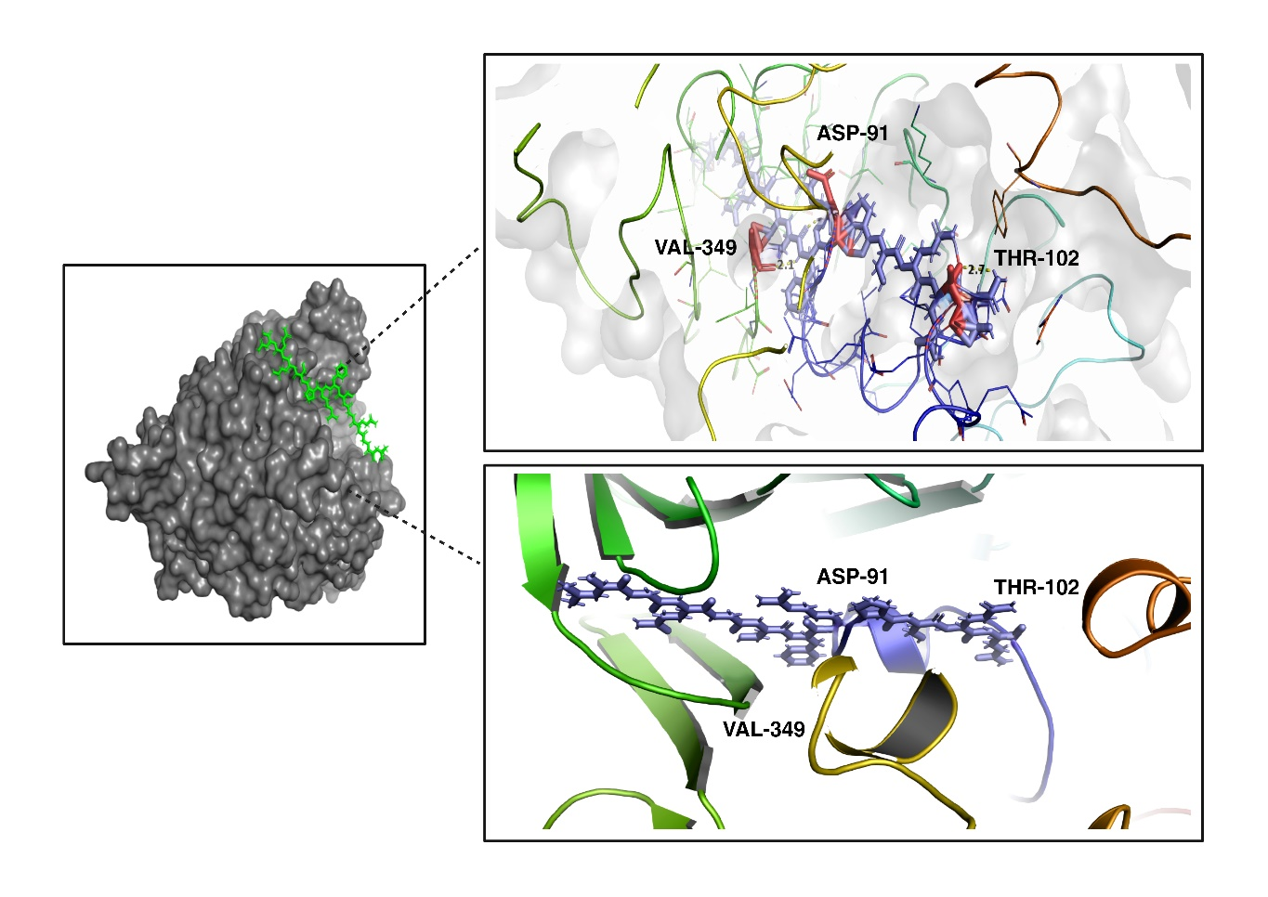
(c)
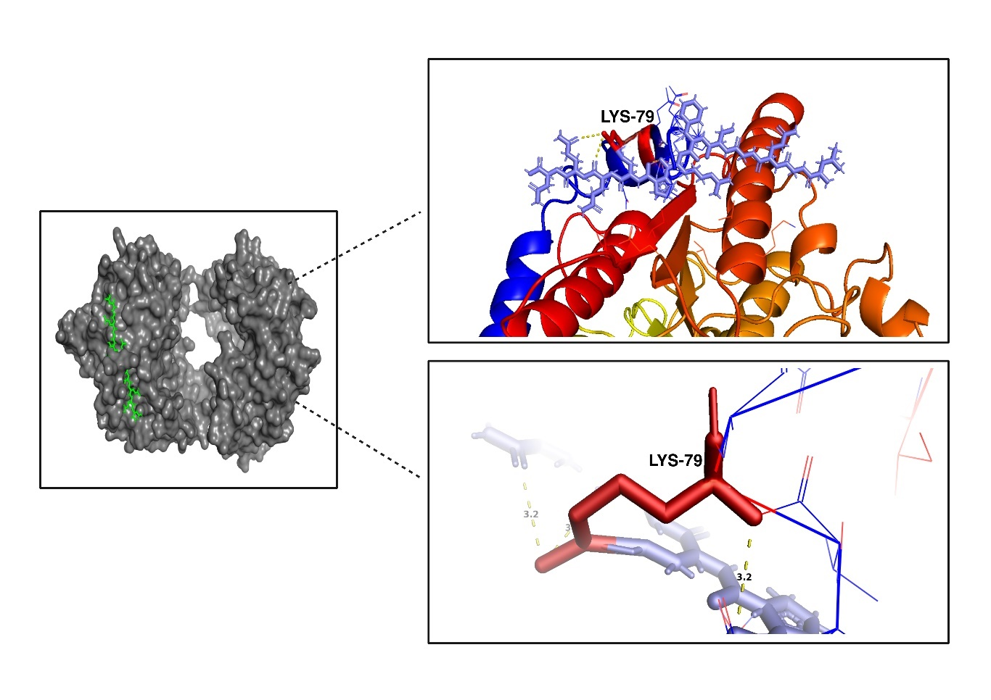
Figure.S31. (b) Molecular docking simulation suggests a possible binding mode for a gluten peptide in a ball-and-stick representation within the active site of Human PEP (model 2) in ribbon representation. (c) Molecular docking simulation suggests a possible binding mode for a gluten peptide in a ball-and-stick representation within the active site of Human PEP (model 3) in ribbon representation.

(b)
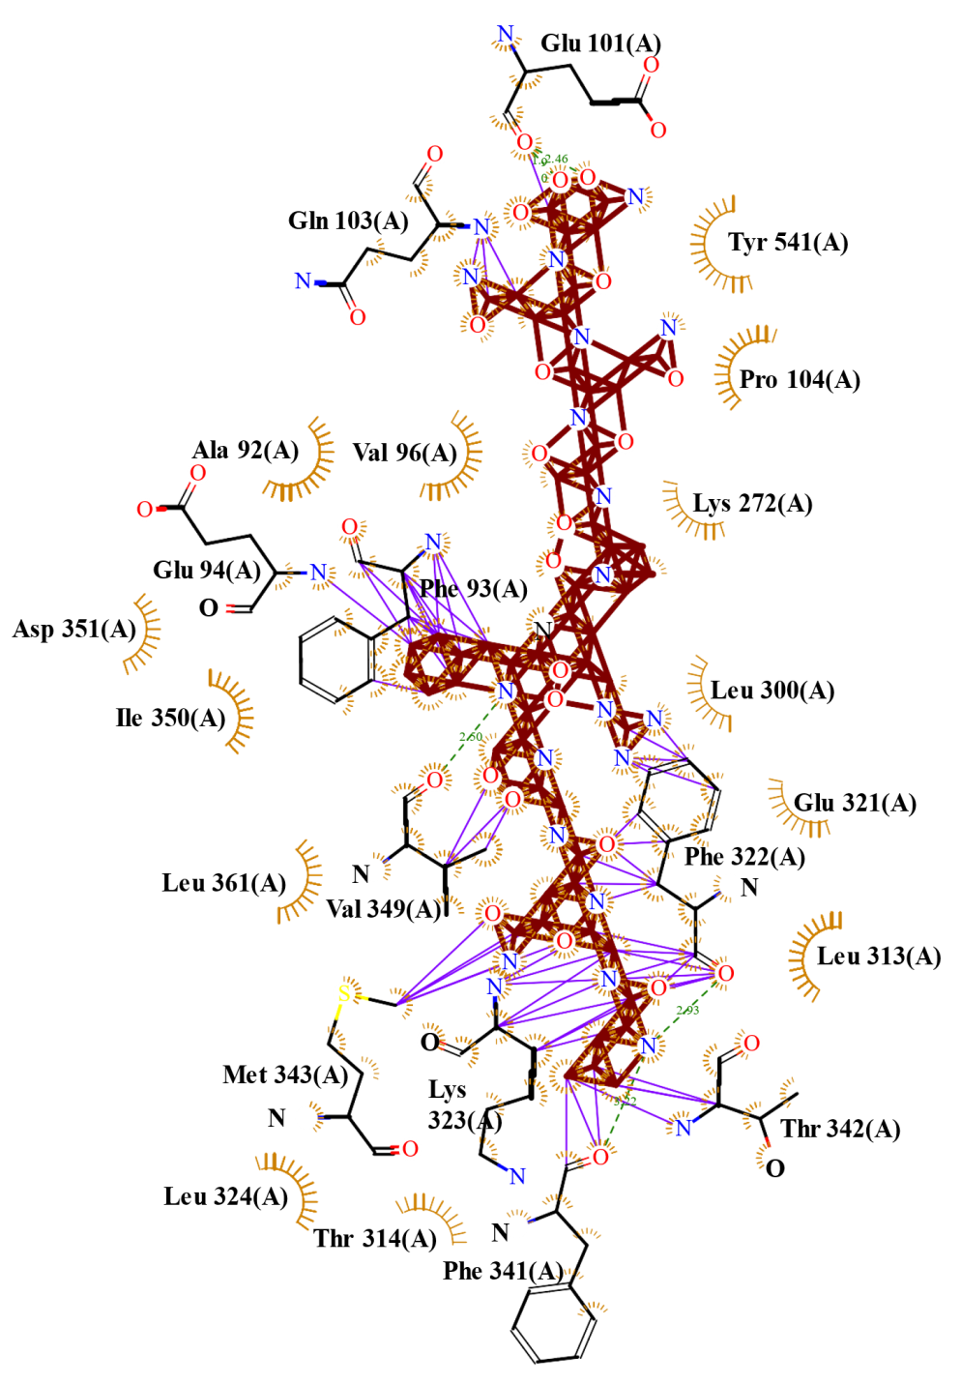

(c)
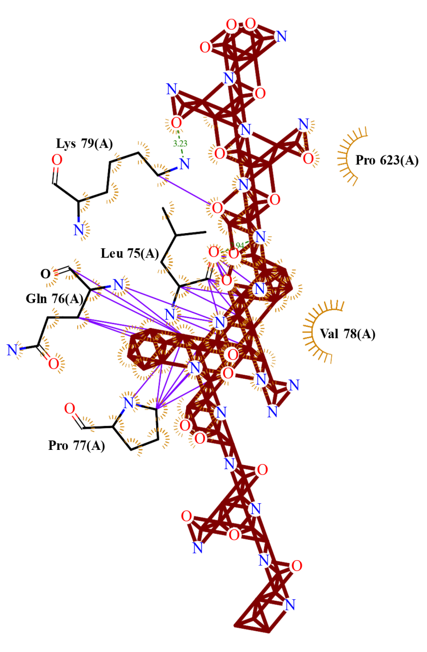
Figure.S32. (b) Snapshot showing the interaction between Prolyl endopeptidase (model 2) and Gluten peptide complex using LigPlot plus software. (c) Snapshot showing the interaction between Prolyl endopeptidase (model 3) and Gluten peptide complex using LigPlot plus software.
- Tables:
Table.S1. Root Mean Square Deviation (RMSD) of Arabidopsis thaliana structure at different pH levels of sequence length(1-50)
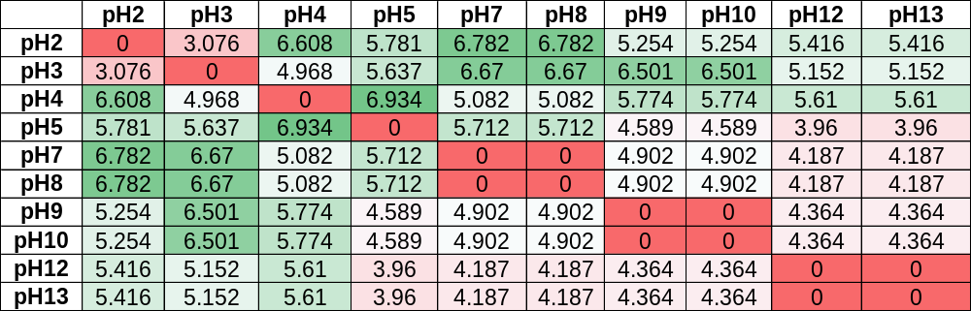

Table.S2. Root Mean Square Deviation (RMSD) of Arabidopsis thaliana structure at different pH levels of sequence length(50-100)
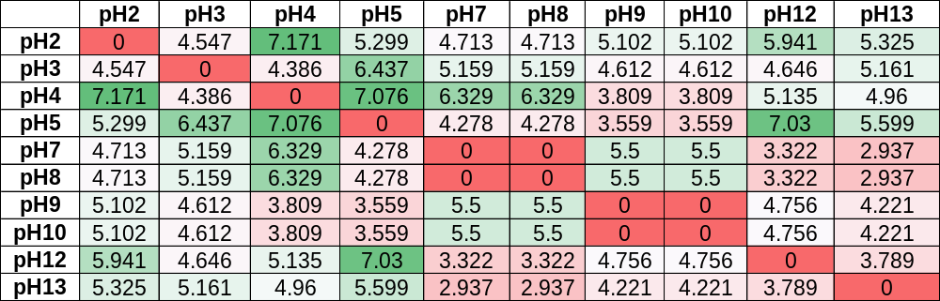

Table.S3. Root Mean Square Deviation (RMSD) of Bacillus subtilis structure at different pH levels of sequence length(1-50)
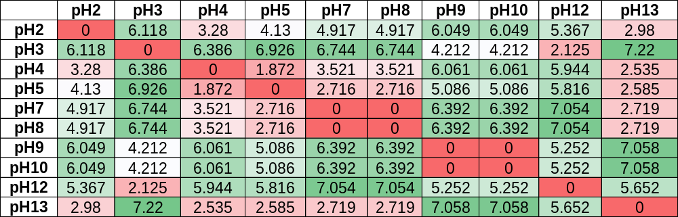

Table.S4. Root Mean Square Deviation (RMSD) of Bacillus subtilis structure at different pH levels of sequence length(50-100)
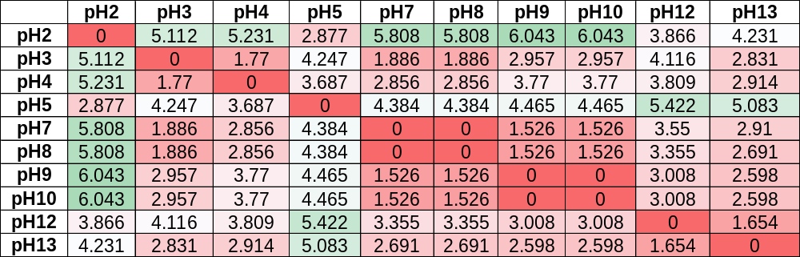

Table.S5. Root Mean Square Deviation (RMSD) of Pipistrellus kuhlii structure at different pH levels of sequence length(1-50)
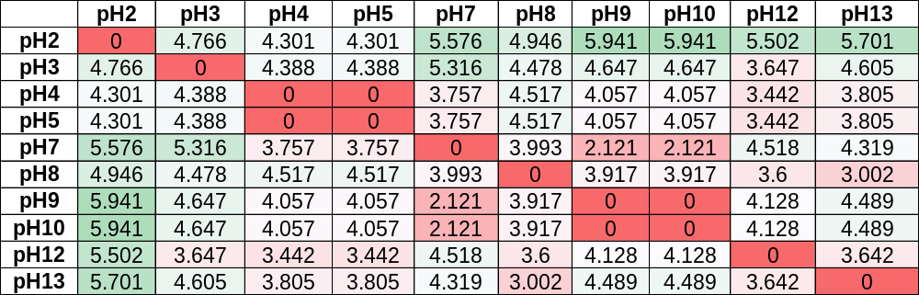

Table.S6. Root Mean Square Deviation (RMSD) of Pipistrellus kuhlii structure at different pH levels of sequence length(50-100)
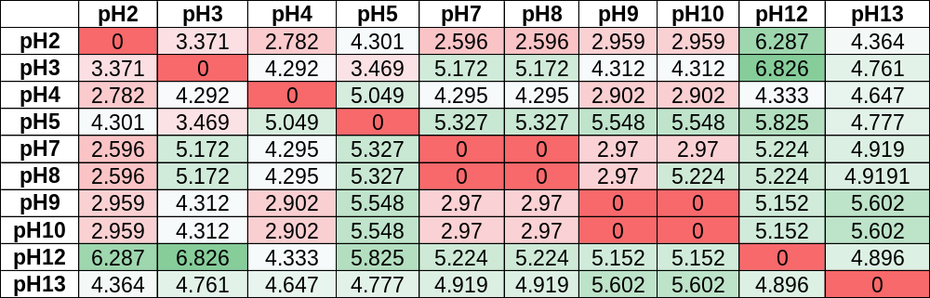

Table.S7. Root Mean Square Deviation (RMSD) of Gallus gallus structure at different pH levels of sequence length(1-50)
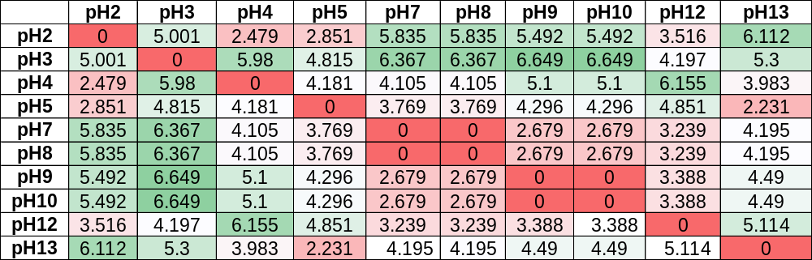

Table.S8. Root Mean Square Deviation (RMSD) of Gallus gallus structure at different pH levels of sequence length(50-100)
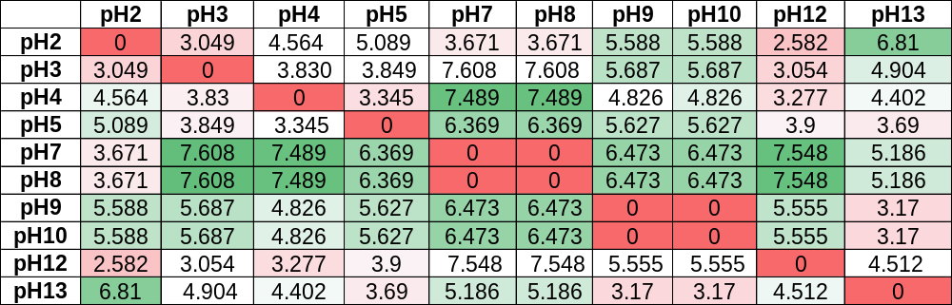

Table.S9. Root Mean Square Deviation (RMSD) of Mus musculus structure at different pH levels of sequence length(1-50)
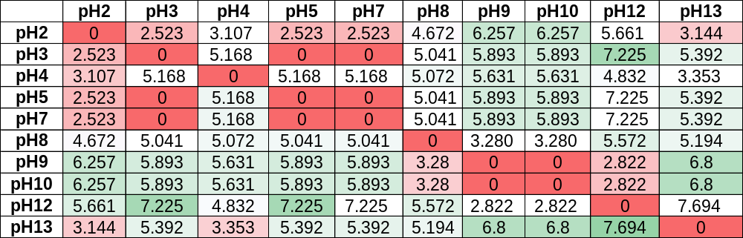

Table.S10. Root Mean Square Deviation (RMSD) of Mus musculus structure at different pH levels of sequence length(50-100)
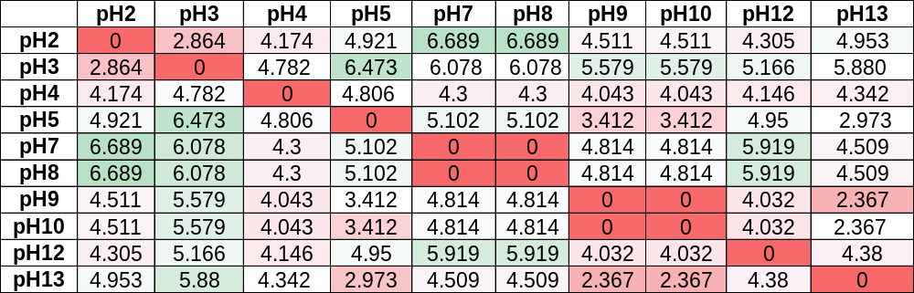

Table.S11. Root Mean Square Deviation (RMSD) of Sus scrofa domesticus structure at different pH levels of sequence length(1-50)
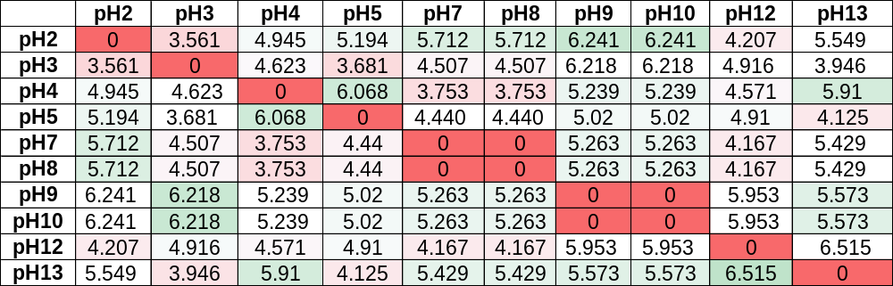

Table.S12. Root Mean Square Deviation (RMSD) of Sus scrofa domesticus structure at different pH levels of sequence length(50-100)
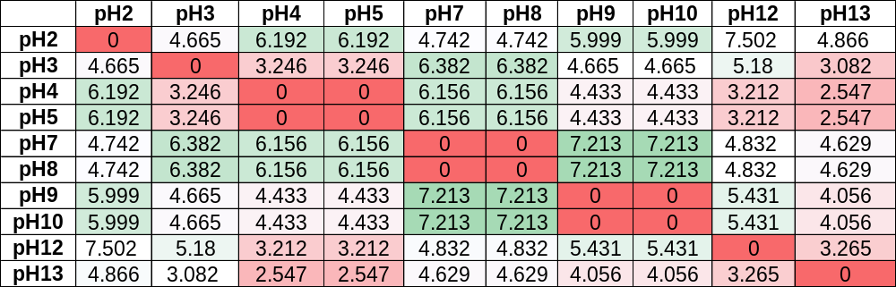

Table.S13. Root Mean Square Deviation (RMSD) of Danio rerio structure at different pH levels of sequence length(1-50)
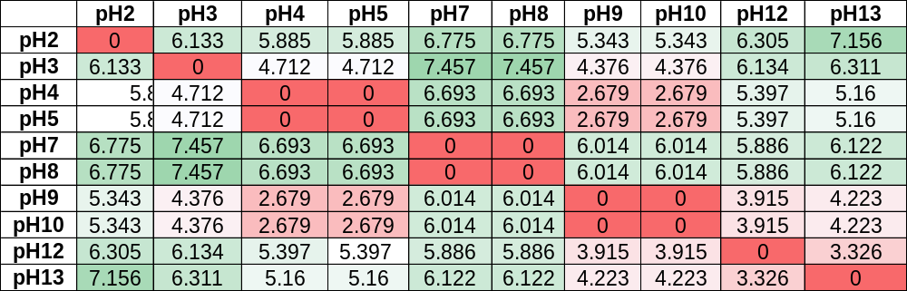

Table.S14. Table.S2. Root Mean Square Deviation (RMSD) of Danio rerio structure at different pH levels of sequence length(50-100)
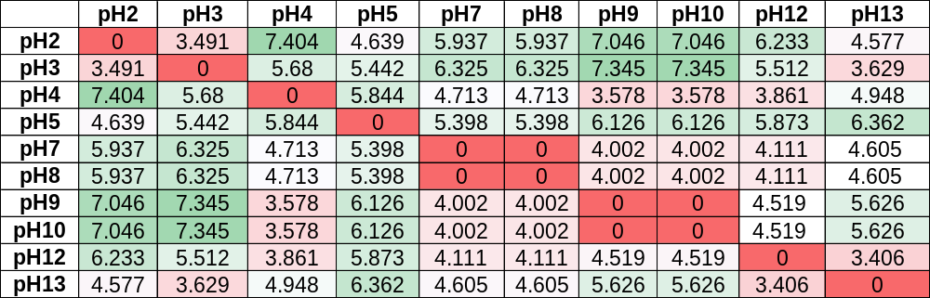

Table.S15. Root Mean Square Deviation (RMSD) of Penicillium chrysogenum structure at different pH levels of sequence length(1-50)
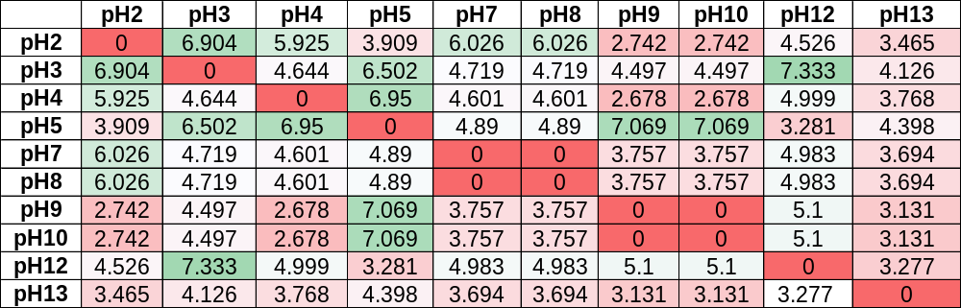

Table.S16. Root Mean Square Deviation (RMSD) of Penicillium chrysogenum structure at different pH levels of sequence length(50-100)
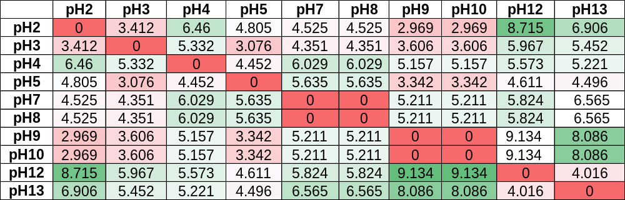

Table.S17. Root Mean Square Deviation (RMSD) of Spinacia oleracea structure at different pH levels of sequence length(1-50)
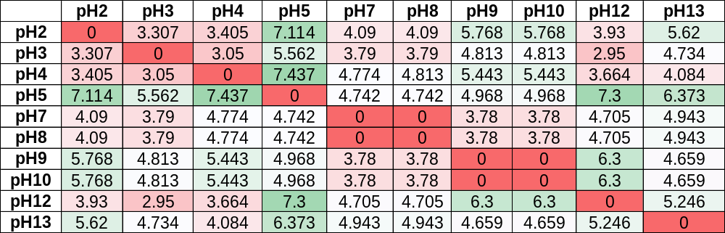

Table.S18. Root Mean Square Deviation (RMSD) of Spinacia oleracea structure at different pH levels of sequence length(50-100)
