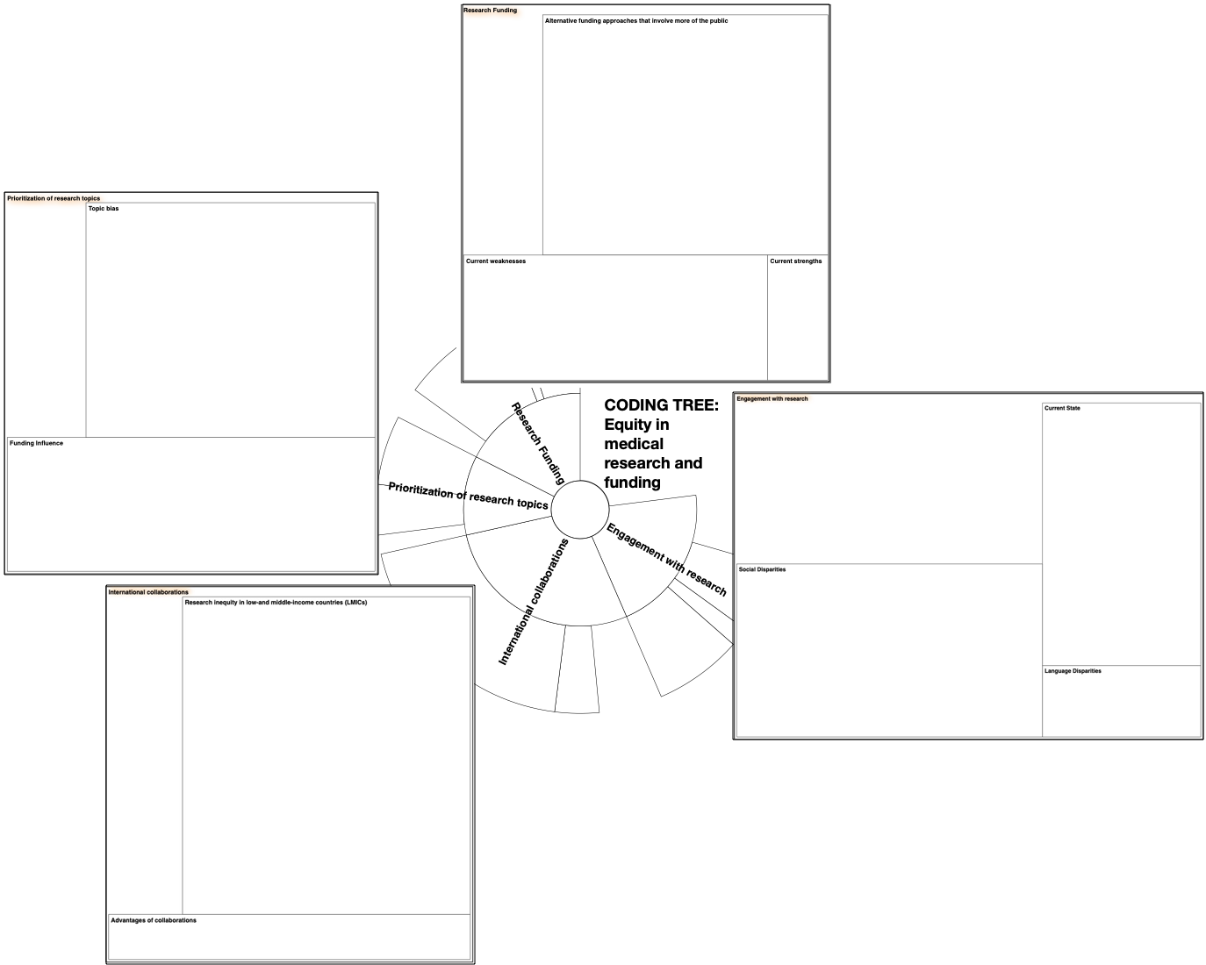

Supplementary Figure S1. Coding tree used for study, created on NVivo 12. The inner part of the figure shows the four identified main domains of inequity in medical research and funding - Engagement with research, research funding, prioritization of research topics, and international collaborations. Sub-topics of these domains were further identified, as shown in the outer treemaps for each domain of inequity. Areas of the treemap boxes are scaled to reflect the number of coding references in interviews; a larger area indicates more coding references.

