Supplementary Information

Periodically-modulated unipolar and bipolar orders in nematic fluids: towards miniaturized microscopic nonlinear photonics

Guang-Yang Zhang¹, Enjun Lin^{2,3}, Ze-Yu Wang¹, Jin-Tao Pan¹, Jidan Yang^{2,3,}‡, Minghui Deng^{2,3}, Yang Wei¹, Yong Ye¹, Ning Wang¹, Ling-Ling Ma^{1,}*, Yu Wang^{1,}*, Satoshi Aya^{2,3,}*, Yan-Qing Lu^{1,}*

¹National Laboratory of Solid State Microstructures, Key Laboratory of Intelligent Optical Sensing and Manipulation, Collaborative Innovation Center of Advanced Microstructures, College of Engineering and Applied Sciences, Nanjing University, Nanjing 210023, China.

²South China Advanced Institute for Soft Matter Science and Technology (AISMST), School of Emergent Soft Matter, South China University of Technology, Guangzhou 510640, China.

³Guangdong Provincial Key Laboratory of Functional and Intelligent Hybrid Materials and Devices, Guangdong Basic Research Center of Excellence for Energy and Information Polymer Materials, South China University of Technology, Guangzhou 510640, China.

*Correspondence to malingling@nju.edu.cn (L.-L.M.); yuwang87@nju.edu.cn (Y.W.); satoshiaya@scut.edu.cn (S.A.); yqlu@nju.edu.cn (Y.-Q.L.)

‡Current Address: College of Electronic and Optical Engineering & College of Flexible Electronics (Future Technology), Nanjing University of Posts and Telecommunications, Nanjing 210023, China.

Supplementary Information

Supplementary Section 1: Material synthesis flow
Materials
All commercial chemicals and solvents were used as received unless stated otherwise. 2-fluoro-4-methoxybenzoic acid (99%, Adamas), benzyl 4-hydroxy-2-(trifluoromethyl)benzoate (98%, Aladdin), 4-dimethylaminopyridine (DMAP, 99%, TCI), Dicyclohexylcarbodiimide (DCC, 99%, TCI), palladium on carbon (5%, Kaili Catalyst & New Materials Co., Ltd), 4-nitrophenol (99%, Adamas), Tetrahydrofuran (THF, reagent grade, Adamas), Dichloromethane (DCM, reagent grade, Adamas), Ethyl Alcohol (EtOH, reagent grade, Adamas), hydrochloric acid (HCl, reagent grade, Adamas), Magnesium sulfate anhydrous (anhydrous MgSO4, reagent grade, Adamas), Silica gel (Merck, 230-400 mesh).

Methods

Benzyl 4-((2-fluoro-4-methoxybenzoyl)oxy)-2-(trifluoromethyl)benzoate (A1): A three-necked round bottom flask was charged with 2-fluoro-4-methoxybenzoic acid (8.5 g, 0.05 mol), benzyl 4-hydroxy-2-(trifluoromethyl)benzoate (15 g, 0.05 mol), DMAP (0.2 g), DCM (100 mL), and were cooled to 5 ℃ with stirring. Then, DCC (12.5 g, 0.06 mol) was added along with 30 mL dichloromethane. The solution was stirred at the temperature range of 5 ℃ ~ 10 ℃ for 12 h. The filtrate was collected and washed with 50 mL HCl (1%). Then, the dichloromethane layer was collected, dried by anhydrous MgSO₄, and stripped of the solvent by rotary evaporation. Then, the 50-mL ethyl alcohol was added and recrystallized. Yield: 18.4 g (82.14%).

4-((2-fluoro-4-methoxybenzoyl)oxy)-2-(trifluoromethyl)benzoic acid (A2): A hydrogenating reactor was charged with A1 (15 g, 0.033 mol), THF (50 mL), palladium on carbon (1g, 5%). The reaction was for 12 hours. The filtrate was collected and stripped of the solvent by rotary evaporation. Then, the 50-mL ethyl alcohol was added and recrystallized. Yield: 10.4g (85.11%).

4-((4-nitrophenoxy)carbonyl)-3-(trifluoromethyl)pheny 2-fluoro-4-methoxybenzoate (NJU001): A three-necked round bottom flask was charged with A2 (8.0 g, 0.022 mol), 4-nitrophenol (3.4 g, 0.0245 mol), DMAP (0.1 g), DCM (100 mL), and were cooled to 5 ℃ with stirring. Then DCC (5.53 g, 0.0265 mol) was added along with 20-mL dichloromethane. The solution was stirred at the temperature range of 5 ℃ ~ 10 ℃ for 12 h. The filtrate was collected and washed with 50 mL HCl (1%). Then, the dichloromethane layer was collected and dried by anhydrous MgSO4, and the solvent was stripped by rotary evaporation. The solution was dry-loaded onto a silica gel column for purification with petroleum ether/ethyl acetate as eluent. Then, the 50-mL ethyl alcohol was added and recrystallized. Yield: 4.8g (99.3%).

¹H NMR (400 MHz, Chloroform-d) δ 8.39 (d, J = 8.8 Hz, 2H), 8.18 (d, J = 8.4 Hz, 1H), 8.12 (dd, J = 8.0, 0.5 Hz, 1H), 7.79 (s, 1H), 7.68 (d, J = 8.4 Hz, 1H), 7.51 (d, J = 8.8 Hz, 2H), 6.87 (d, J = 8.8 Hz, 1H), 6.78 (d, J = 12.8 Hz, 1H), 3.96 (s, 3H). ¹³C NMR (400 MHz, Chloroform-d) δ 165.88, 165.09, 163.21, 161.44, 155.08, 153.67, 145.69, 133.98, 132.99, 131.34, 126.25, 125.39, 123.59, 122.30, 121.77, 121.37, 110.79, 108.93, 102.58, 56.01.

Supplementary Section 2: Discussions on possible models for Pathway I and Pathway II
The characteristics of the Ising, Néel, Bloch, and Splay nematic models are described as follows (Fig. S8 and S12).

- The Ising model describes a lattice of discrete anti-polar domains that exist in either of two states¹: up (+1) or down (-1). A domain wall forms between domains with opposite polar directions where the polar order parameter diminishes, indicating a lack of alignment.
- The Néel and Bloch models also describe antiferroelectric systems¹, where the transition from one domain to another occurs through a region known as a Néel or Bloch wall. These walls allow for a smooth rotation of dipoles from one domain to the next, maintaining their polar magnitude rather than an abrupt change. For the Néel model, the dipoles rotate around an out-of-plane helical axis. In contrast, for the Bloch model, the helical axis is in-plane, which can provide a more energy-efficient transition compared to the sharp boundaries in the Ising model.
- The Splay nematic model describes alternating anti-polar domains with disclination lines separating them^{2,3}. Unlike the Ising model, the dipoles in the polar domain exhibit a splay deformation due to the dominant flexoelectricity effect.

Pathway I
Considering the unipolar ordered stripes in Pathway I confirmed by the second-harmonic generation interferometry (SHG-I) microscopy (Fig. 2c), we can directly rule out the Ising, Néel, and Bloch models.

Pathway II
The SHG-I imaging confirms the bipolar ordering in the Nx phase in Pathway II (Fig. 2d). Besides Bipolar model, described in the main text, possible models include Ising, Néel, Bloch, and Splay nematic models.

First, we exclude the Néel model because there is no SH signal in the transition regions between bipolar domains upon pumping circularly polarized fundamental wave (FW) (Fig. S6b). In contrast, the in-plane dipoles described by the Néel model will excite SH signals in this condition.

Second, we exclude the Bloch model by the fluorescence confocal polarizing microscopic (FCPM) observation⁴. As the dipoles in Bloch walls have varied out-of-plane components, the excited fluorescence intensity in these regions will be decreased compared to the in-plane dipoles in polar domains under the excitation of circularly polarized light. While, in our experiment, we observe a uniform fluorescence pattern (Fig. S10b) that was excited by circularly polarized light.

Third, we exclude the Ising and Splay nematic models based on polarized light microscopic (PLM) textures, which show no obvious disclination line in the transition regions (Fig. S12).

Supplementary Section 3: Nonlinear Malus's law
The second-order nonlinear optical tensor of the liquid-matter ferroelectric material under Kleinman condition in the local (primed) coordinate system (x’, y’, z’) is given by⁵:
$d=\left[\begin{matrix}0 & 0 & 0 & 0 & d_{31} & 0 \\ 0 & 0 & 0 & d_{31} & 0 & 0 \\ d_{31} & d_{31} & d_{33} & 0 & 0 & 0\end{matrix}\right]$. (S1)
The z’-axis is along the dipole. Here, the three-index notation of the susceptibility has been contracted to two indices in the usual way. There are only two independent coefficients, d₃₃ and d₃₁. The SH signal generated along z’ (extraordinary polarization) is driven by the d₃₃ coefficient for extraordinary FW and d₃₁ for ordinary FW.

For a linear polarization incidence ($E^{ω}={\left(E_{x}^{ω}{+E}_{y}^{ω}\right)=A}_{0}\left(\cos{ϕ{\hat{e}}_{x}}+\sin{ϕ{\hat{e}}_{y}}\right)$ in the laboratory coordinate (x, y, z)), where A₀ and ω are the amplitude and angular frequency of the FW, $ϕ$ is the polarization angle relative to the x-axis, and ${\hat{e}}_{x}$ (${\hat{e}}_{y}$) represents the unit vector of the x (y)-axis), we can describe it in the local coordinate system as $E_{x^{'}}=E_{x}^{ω}∙\cos{α+E_{y}^{ω}∙\sin{α}}$, $E_{y^{'}}=0$ and $E_{z^{'}}=E_{x}^{ω}∙\sin{α+E_{y}^{ω}∙\cos{α}}$. Then, the second-order nonlinear polarization can be analytically obtained as⁶
$P_{α}^{2ω}=2ε_{0}\left[\begin{matrix}0 & 0 & 0 & 0 & d_{31} & 0 \\ 0 & 0 & 0 & d_{31} & 0 & 0 \\ d_{31} & d_{31} & d_{33} & 0 & 0 & 0\end{matrix}\right]\left[\begin{matrix}{E_{x^{'}}}^{2} \\ {E_{y^{'}}}^{2} \\ \begin{matrix}{E_{z^{'}}}^{2} \\ 2E_{y^{'}}E_{z^{'}} \\ \begin{matrix}2E_{x^{'}}E_{z^{'}} \\ 2E_{x^{'}}E_{y^{'}}\end{matrix}\end{matrix}\end{matrix}\right]$
$={2A_{0}^{2}ε}_{0}d_{33}\cos^{2}\left(ϕ-α\right)\left(\cos{α{\hat{e}}_{x}}+\sin{α{\hat{e}}_{y}}\right)$ (S2)
$={2A_{0}^{2}ε}_{0}d_{33}\cos^{2}⁡(ϕ-α){\hat{e}}_{α}$.
$ε_{0}$ is the vacuum permittivity, $α$ the orientation of the dipole, and ${\hat{e}}_{α}$ the unit vector along $α$ direction. This expression can also be described by
$P_{α}^{2ω}={2A_{0}^{2}ε}_{0}d_{33}{\cos\left(ϕ-α\right)\left(\begin{matrix}\cos^{2}α & cosα sinα \\ cosα sinα & \sin^{2}α\end{matrix}\right)\left(\begin{matrix}cosϕ \\ sinϕ\end{matrix}\right)}$. (S3)
The intensity of the emitted SH wave is proportional to the quadruplicate magnitude of the electric field of FW $I^{2ω}(α)∝A_{0}^{4}\cos^{4}⁡(ϕ-α)$, and the phase of the nonlinear polarization can be expressed as $φ_{x}^{2ω}\left(α\right)=πu\left(α-0.5π\right)-πu(α-1.5π)$ and $φ_{y}^{2ω}(α)=πu(α-π)$, where u is a step function. In our case, for $ϕ=\frac{1}{2}π$, the vector orientation, intensity, and phase of the SH wave are provided in Fig. S13.

Supplementary Section 4: Simulations of linear and nonlinear perfect vector beams
The most charming characteristics of perfect vector beams (PVBs) are their (1) customized distributions of vectors, i.e., linear polarization, on the ring-shaped intensity profile; (2) invariant radii and intensity profiles under changing topological charges⁷⁻¹⁴. Here, we encode the axicon phase into a vortex phase to experimentally demonstrate the manipulation of both the linear and nonlinear PVBs. The optical axis distribution α is as follows:
$α=\frac{1}{2}ψ_{\text{V}}\left(φ\right)+\frac{1}{2}ψ_{\text{A}}\left(r\right)$. (S4)
where $ψ_{V}\left(φ\right)$ and $ψ_{\text{A}}\left(r\right)$ correspond to the vortex phase $ψ_{V}\left(φ\right)=lφ$, $l=2$ for instance (Fig. 4b-i) and the axicon phase $ψ_{\text{A}}\left(r\right)=\text{arg}\left[2\sum_{n=1}^{∞}{a_{n}}\sin\left(2π\frac{n}{T}r\right)\right]$, $r≥0$ (Fig. 4b-ii), respectively. Here, φ and r denote the azimuthal angle and the radial distance in the polar coordinate, $a_{n}$ represents the Fourier series coefficients, T represents the period of the superstructure in the radial direction, and T = 100 μm in our experiment.

The generation of linear PVBs can be simulated by employing the Jones matrix calculation^{15,16} to analyze the diffraction resulting from the light-matter interaction. Considering a half-wave plate with $α$ as its optical axis distribution, the Jones matrix is:
$J=\left[\begin{matrix}\cos{2α} & \sin{2α} \\ \sin{2α} & -cos{2α}\end{matrix}\right]$. (S5)
For a linear polarization $E_{in}=A_{0}\left(\cos{ϕ{\hat{e}}_{x}}+\sin{ϕ{\hat{e}}_{y}}\right)$ incidence, the output light field in the linear optical framework from the device is
$E_{out}=J∙E_{in}={A_{R}e}^{i(φ_{0}+ϕ)}|\left.R_{l}\right\rangle +A_{L}e^{-i(φ_{0}+ϕ)}|\left.L_{-l}\right\rangle$ (S6)
where ${\hat{e}}_{x}$ and ${\hat{e}}_{y}$ denote the unit vectors of the x- and y-axes, $φ_{0}$ is the initial phase, ϕ the polarization angle relative to the x-axis, $A_{R}$ and $A_{L}$ are the amplitudes of right-handed and left-handed circular polarization components, $|\left.R_{l}\right\rangle ={\frac{1}{\sqrt{2}}e}^{i2α}\left[\begin{matrix}1 \\ -i\end{matrix}\right]$, and $|\left.L_{-l}\right\rangle ={\frac{1}{\sqrt{2}}e}^{-i2α}\left[\begin{matrix}1 \\ i\end{matrix}\right]$. ±2α is the geometric phase. Then, the far-field light field can be calculated by $E_{PVB}=F[E_{out}]$. The vector distribution of the light field can be characterized by an analyzer:
$E_{A}=\left[\begin{matrix}\cos^{2}ϕ_{A} & sinϕ_{A}cosϕ_{A} \\ cosϕ_{A}sinϕ_{A} & \sin^{2}ϕ_{A}\end{matrix}\right]E_{PVB}$. (S7)
where $ϕ_{A}$ is the angle of the analyzer. Consequently, the linear PVB and its analyzed intensity profiles are calculated in Fig. S16.

One thing should be noted before simulating the nonlinear PVBs: the inherent polar nematic ordering for the toroidal polar topological superstructure still cannot be completely determined. According to our SHG-I analysis (Fig. S15), the relative orientations of regional dipoles are deduced from constructive or destructive interference observations. In contrast, the exact dipole orientations (e.g., 0 or π) or relative dipole orientations among different rings are still unknown due to the limited interference area in our experiment. So, two possible structural models (Model 1 and Model 2) are provided in Fig. S17. The difference is the dipole orientations in even concentric rings opposite between Model 1 and Model 2.

Then, we simulate the generated nonlinear PVBs based on the polar ordering in Model 1 and Model 2. The (near-field) nonlinear polarization excited from the toroidal polar topological superstructure is theoretically calculated according to Eq. (1) in the main text. Numerical simulations of the beam profile of far-field PVBs are performed by calculating the coherent superposition of the local vectorial light fields in the near field after Fourier transformation. The results are shown in Fig. S17. Obviously, the simulated light fields based on the structural Model 1 agree well with the nonlinear PVB obtained in our experiment and its analyzed intensity profile, while the simulated results from Model 2 deviate from our experimental results (Fig. 4e and Fig. S17). These results suggest that the nonlinear Malus’s law is verified, and it can be used to customize vector distribution on the perfect cylindrical beam with invariant radii and intensity profiles. The relationship between the far-field vector orientation and the dipole orientations in even and odd concentric rings in any azimuth direction φ is provided in Fig. S19.

Supplementary Section 5: Electric switching of the miniaturized nonlinear optical LC device
By harnessing the dynamic tunability of liquid-matter ferroelectric medium, we achieve tunable SH PVBs. A triangular electric field (V_{pp} = 0.12 V/μm and f = 0.5 Hz) is applied across the cell. Then, the toroidal polar topological LC superstructure undergoes a reversible switch between the initial state and a new formation characterized by emerging stripes against a green background (Fig. 4h,i). This phenomenon is attributed to the field-induced out-of-plane reorientation of dipoles in polar nematic regions; while the apolar nematic regions are unaffected due to the insufficient driving voltage (Fig. 4a, inset), which corroborates our proposed polar ordering of the Nx phase. Consequently, low-field driven, periodic tuning of SH PVB is enabled as shown in Fig. 4j. Besides the above-mentioned SH PVBs, our defect-free tailoring of the dipoles in the Nx phase enables more possibilities in manipulating the nonlinear light fields (Supplementary Section 4), providing a promising platform for advanced reconfigurable vectorial photonics.

Fig. S1.
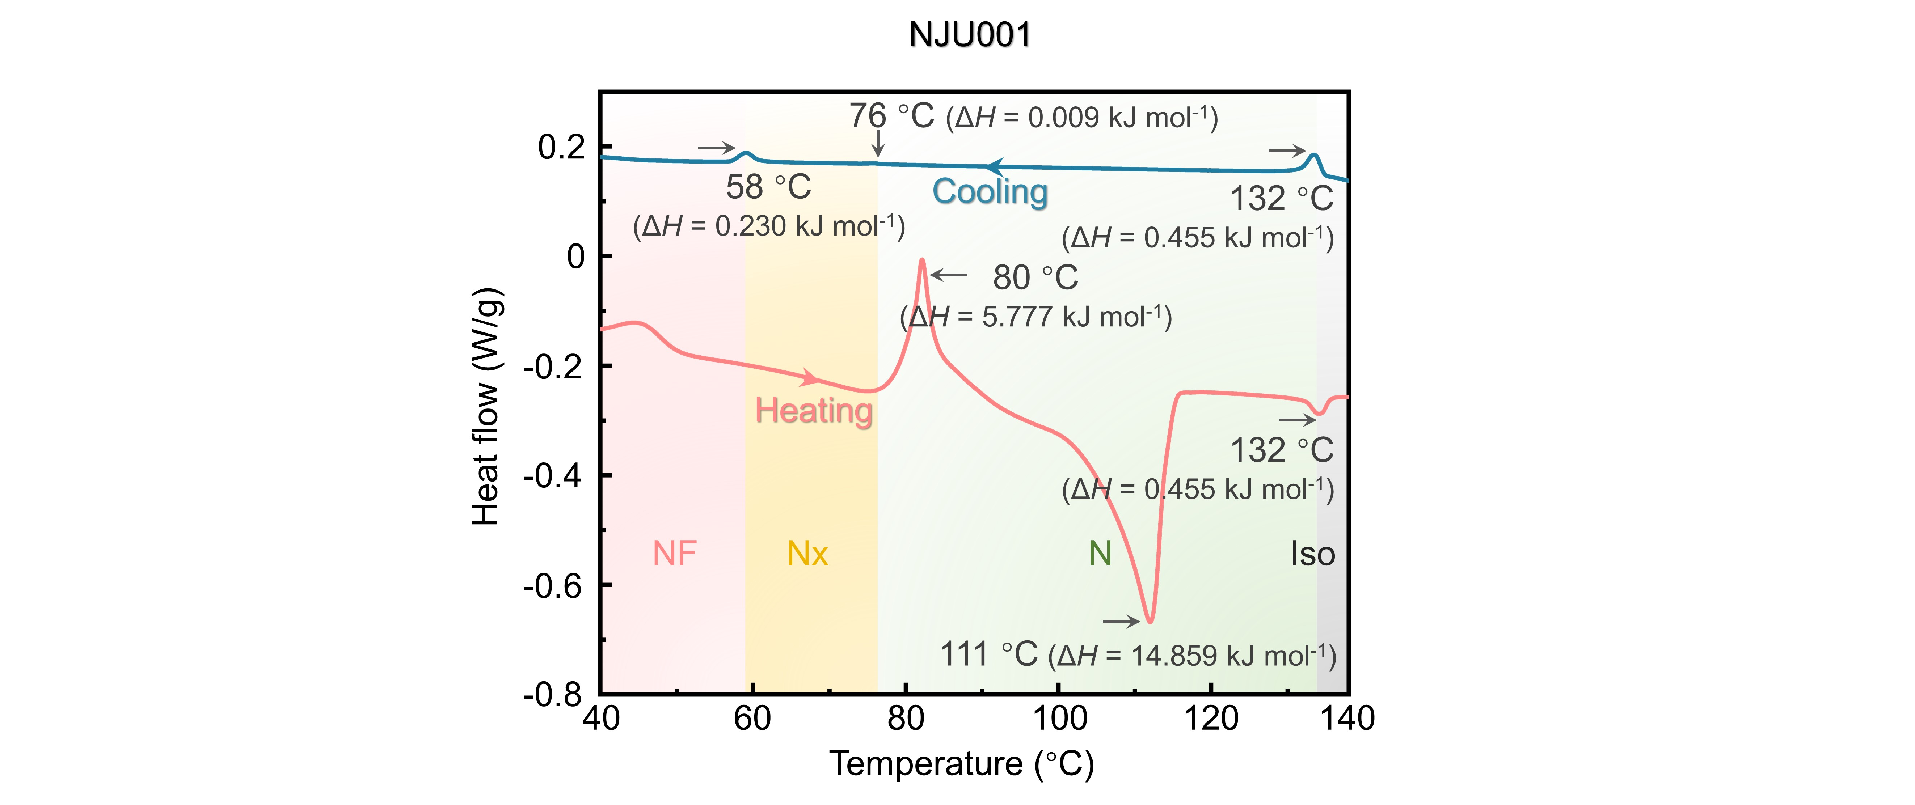
Fig. S1. Differential scanning calorimetry (DSC) traces of the NJU001 material. The heating (red line) and the cooling (blue line) rates are 5 ºC∙min⁻¹). This result is obtained by using the differential scanning calorimeter (Mettler-Toledo DSC1, STARe). According to the cooling process, the phase sequence of the NJU001 material follows isotropic (Iso) phase - 132 ºC - nematic (N) phase - 76 ºC - Nx phase - 58 ºC - ferroelectric nematic (NF) phase.

Fig. S2.
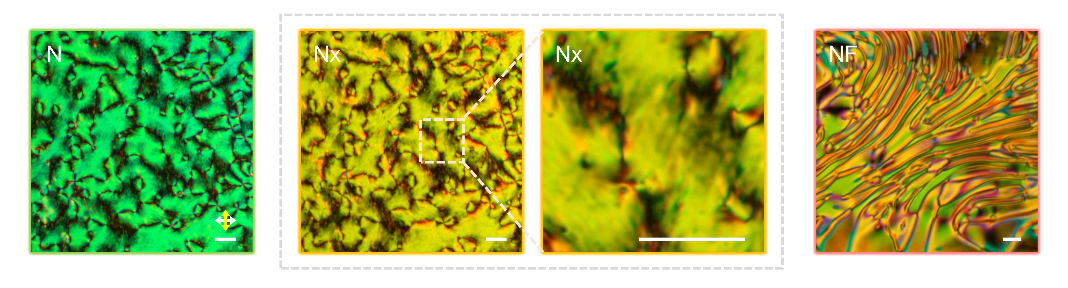
Fig. S2. PLM textures of the randomly aligned NJU001 material in N, Nx, and NF phases. The white and yellow arrows denote crossed polarizers. Scale bar: 25 μm.

Fig. S3.
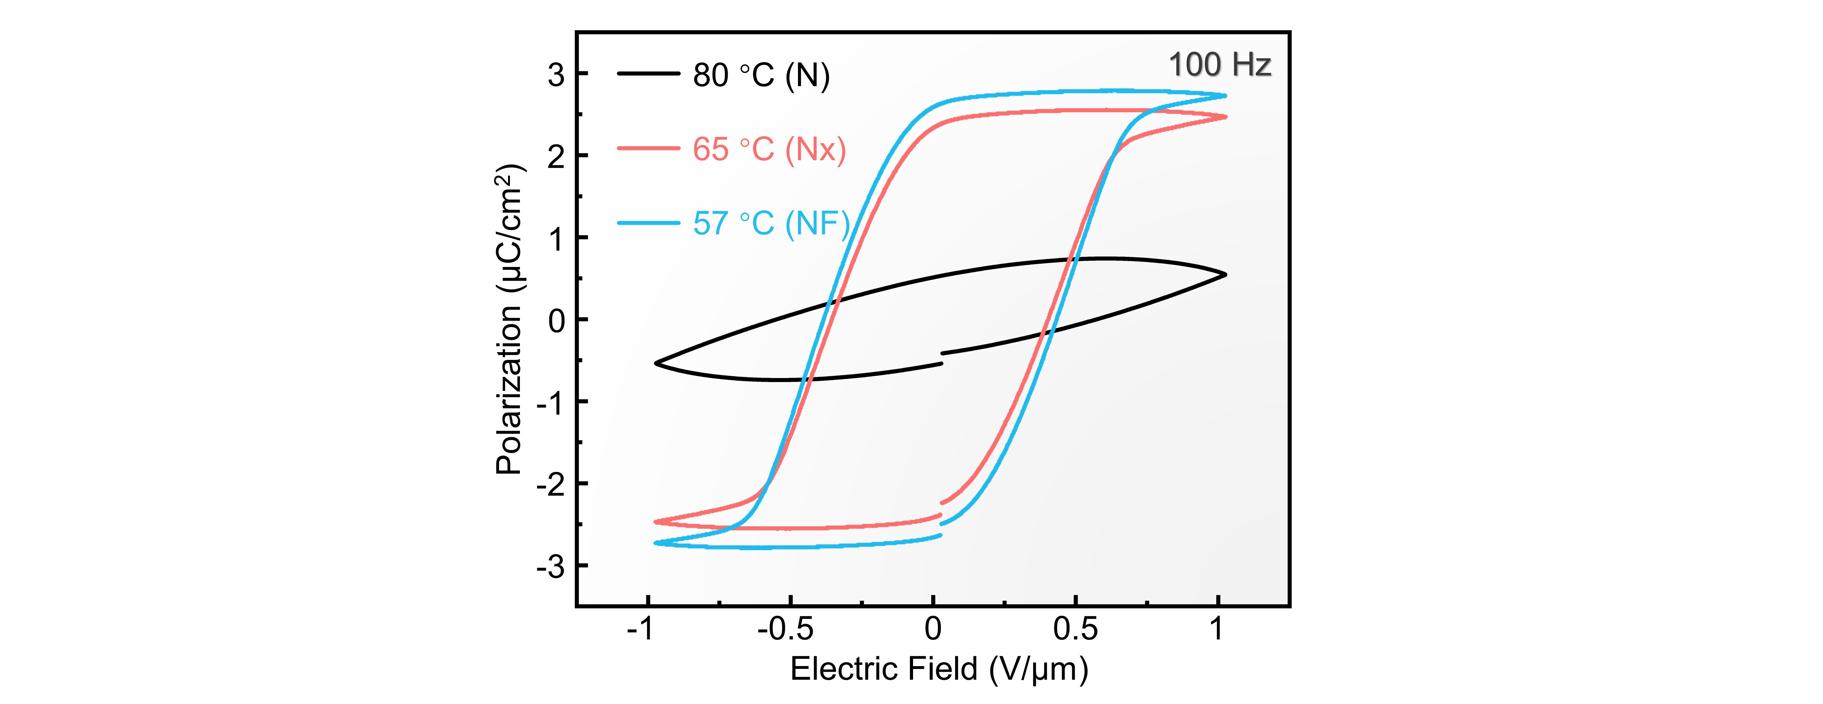
Fig. S3. P-E hysteresis loops of the NJU001 material upon a triangle-wave field application at different temperatures. The applied voltage is 10 V, and the frequency is 100 Hz.

Fig. S4.
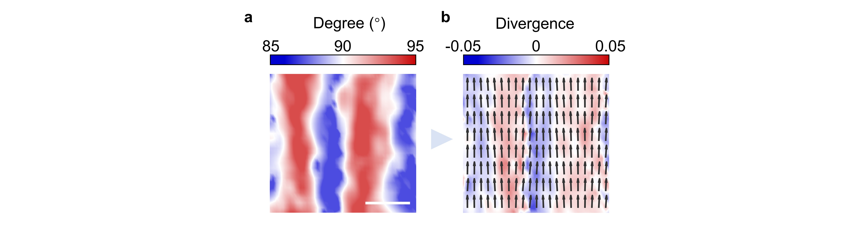
Fig. S4. Characterization of the spatial distribution of LC directors by PolScope. a, Colored map of the splay director distribution. b, Calculated divergence of the director distribution. Scalar bar: 2 μm.

Fig. S5.
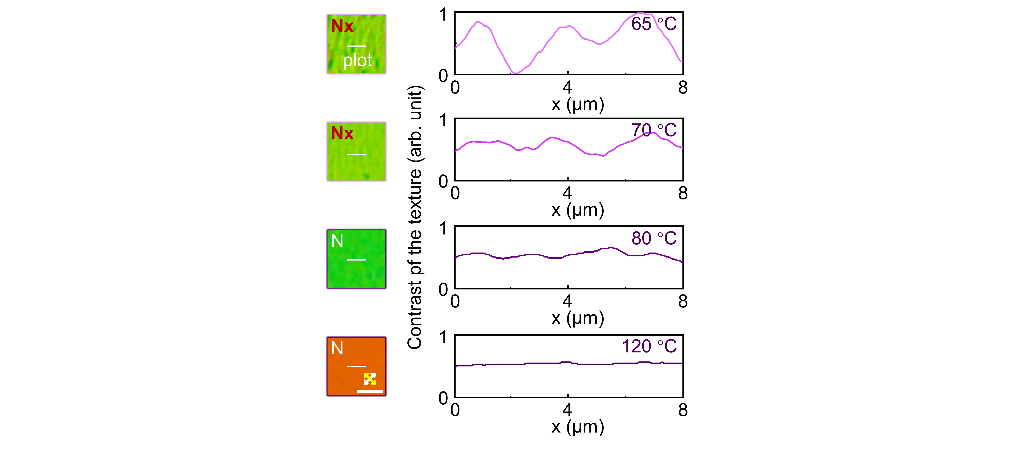
Fig. S5. Contrast of the PLM textures in different phases. The white and yellow arrows denote crossed polarizers. The blue bar represents the alignment direction. The white lines indicate the regions where the contrast profiles are extracted. Scale bar: 10 μm.

Fig. S6.
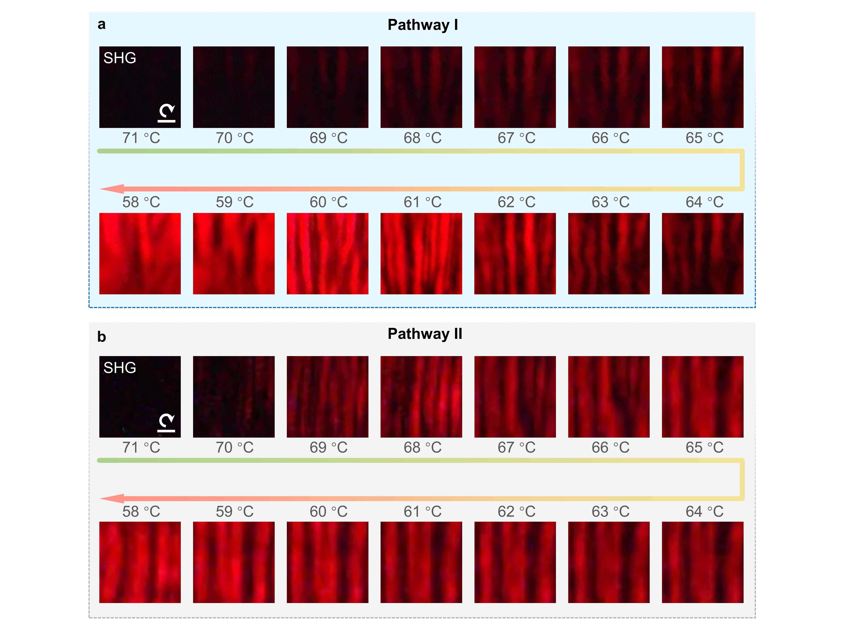
Fig. S6. Spatially-modulated SH signals excited from Nx stripes with circular polarization in Pathway I (a) and Pathway II (b). Scale bar: 5 μm.

Fig. S7.
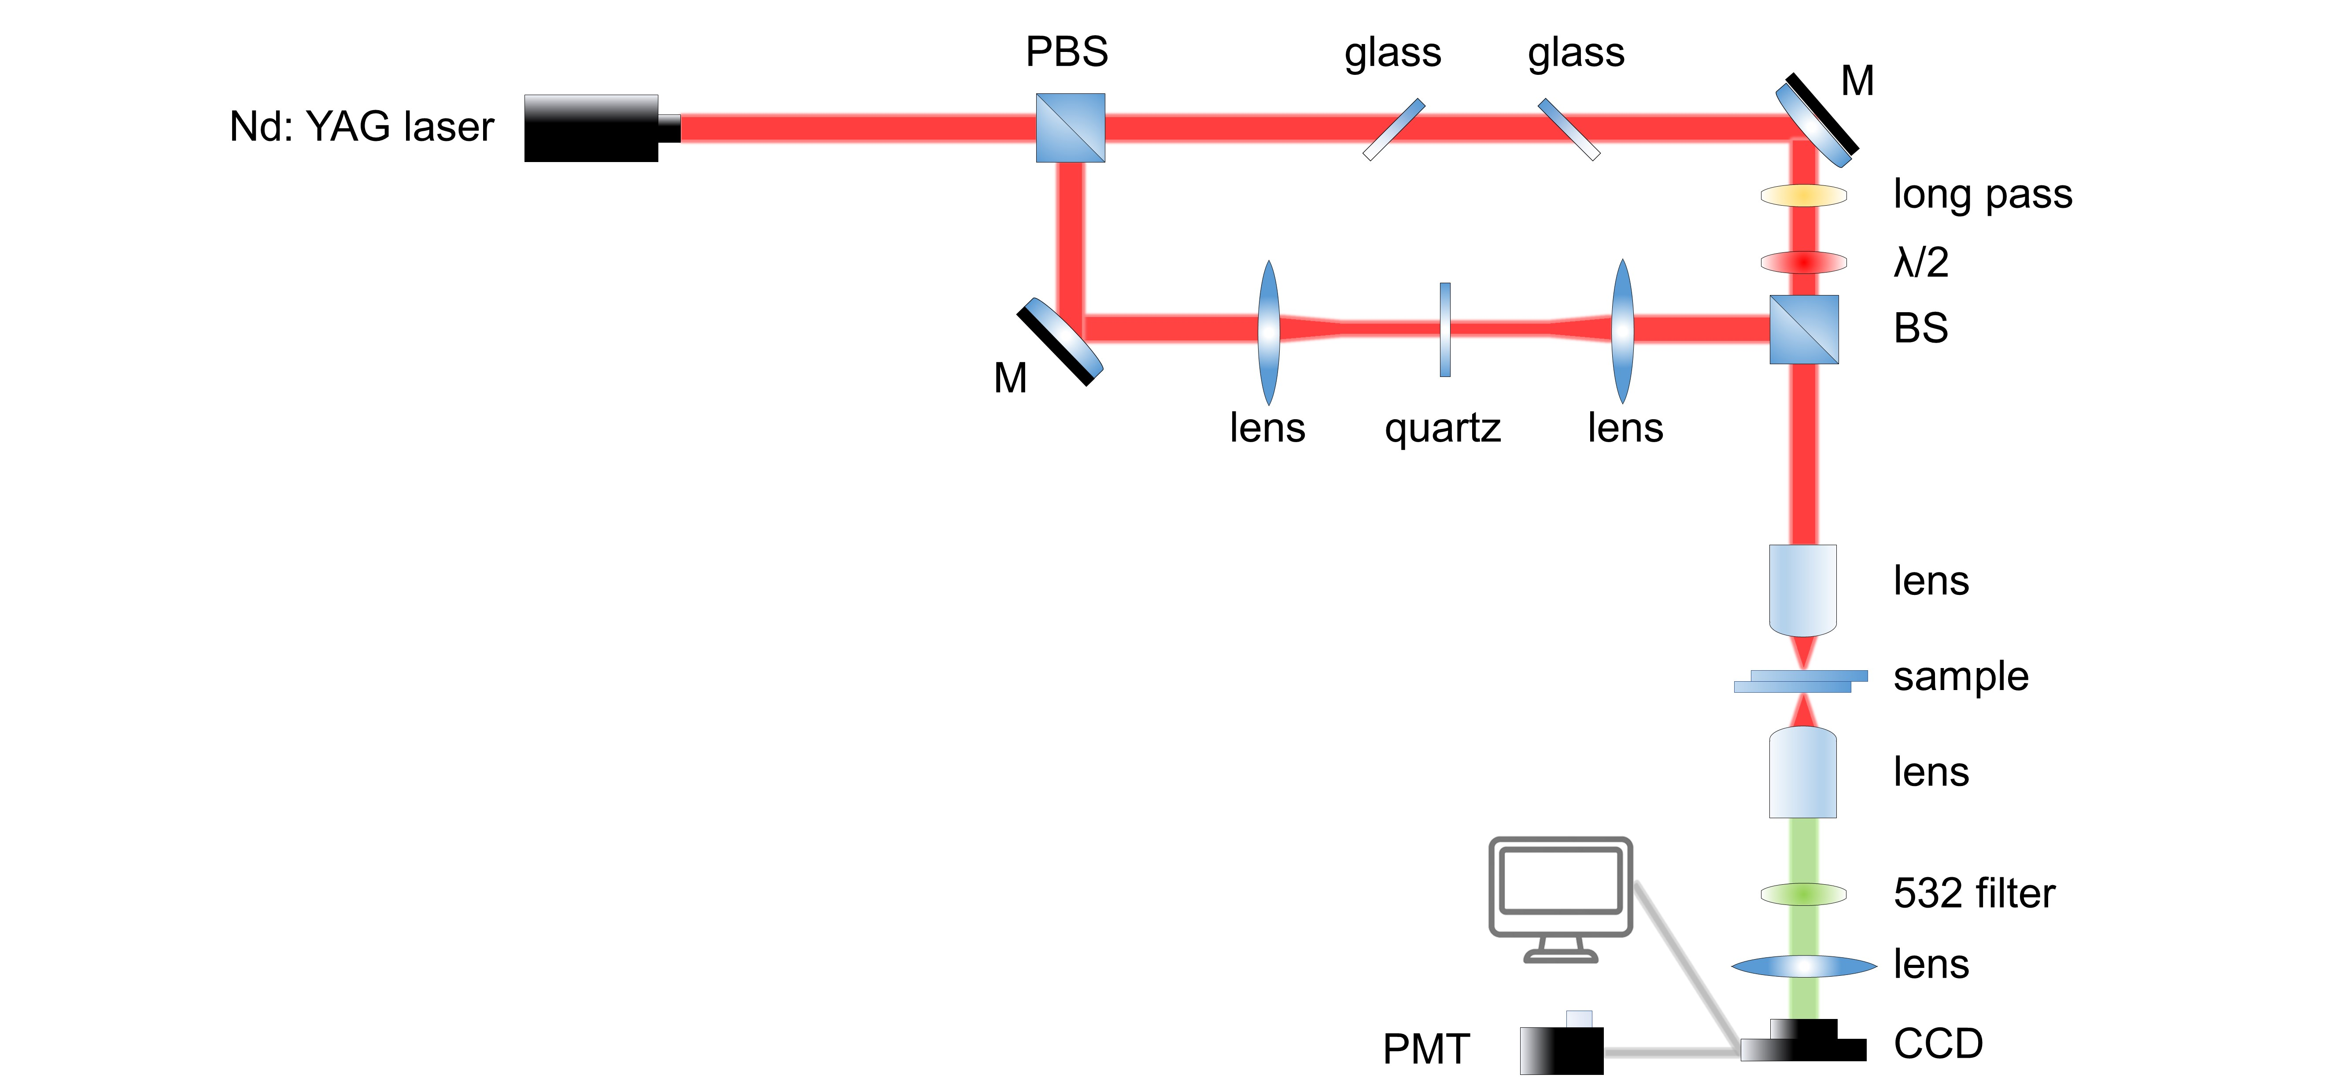
Fig. S7. Schematic of the SHG-I measuring system. M: mirror; PBS: polarization beam splitter; BS: beam splitter; CCD: charge-coupled device; PMT: photomultiplier tube.

Fig. S8.
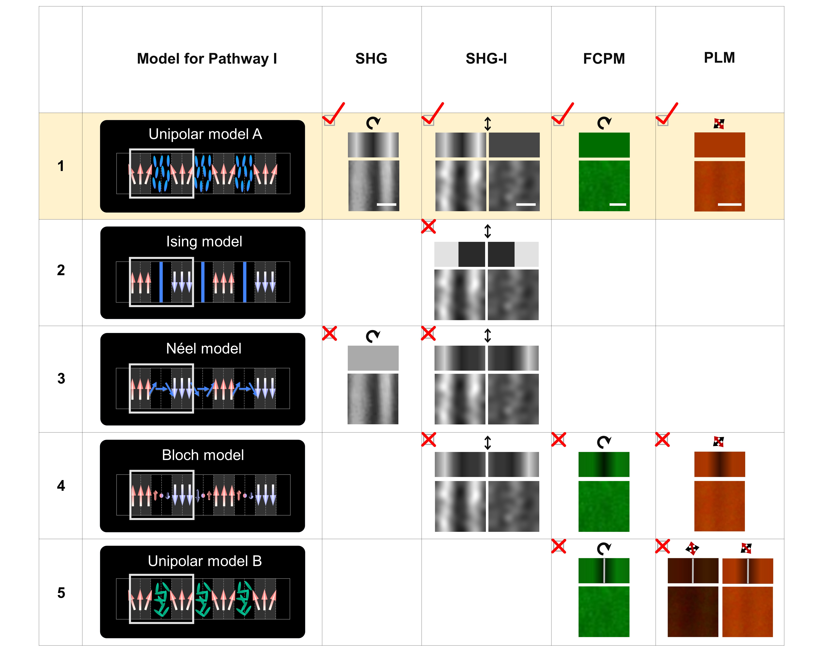
Fig. S8. Possible models (Unipolar model A, Ising model, Néel model, Bloch model, and Unipolar model B) for the polar ordering of the Nx phase in Pathway I. We employ SHG, SHG-I, FCPM, and PLM to characterize the polar ordering in the Nx phase in Pathway I. Both the schematics and experimental results are provided in the corresponding cell. The black and red arrows denote crossed polarizers. The experimental results correspond to the schematics of the ordering in white boxes in the second column. Scale bar: 2 μm.

Fig. S9.
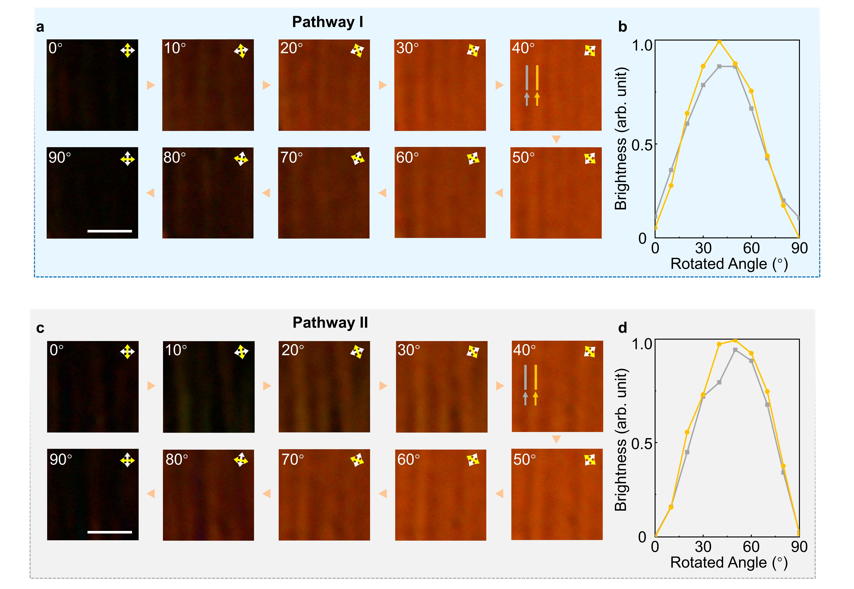
Fig. S9. PLM images of the sample in the Nx phase rotated under crossed polarizers and the brightness analysis. a,c, PLM textures under different rotation angles in Pathway I and Pathway II. The temperature is at 65 ℃. The white and yellow arrows denote crossed polarizers. Scale bar: 5 μm. b,d, Brightness profiles extracted from one of the Nx stripes (yellow) and the transition region (grey) between two stripes.

Fig. S10.
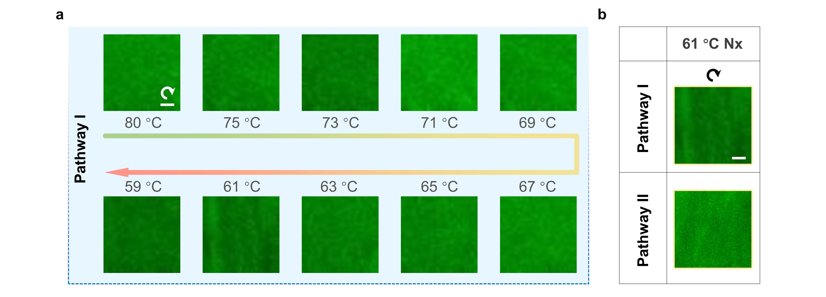
Fig. S10. FCPM images taken under circularly polarized light at different temperatures. Scale bar: 5 μm.

Fig. S11.
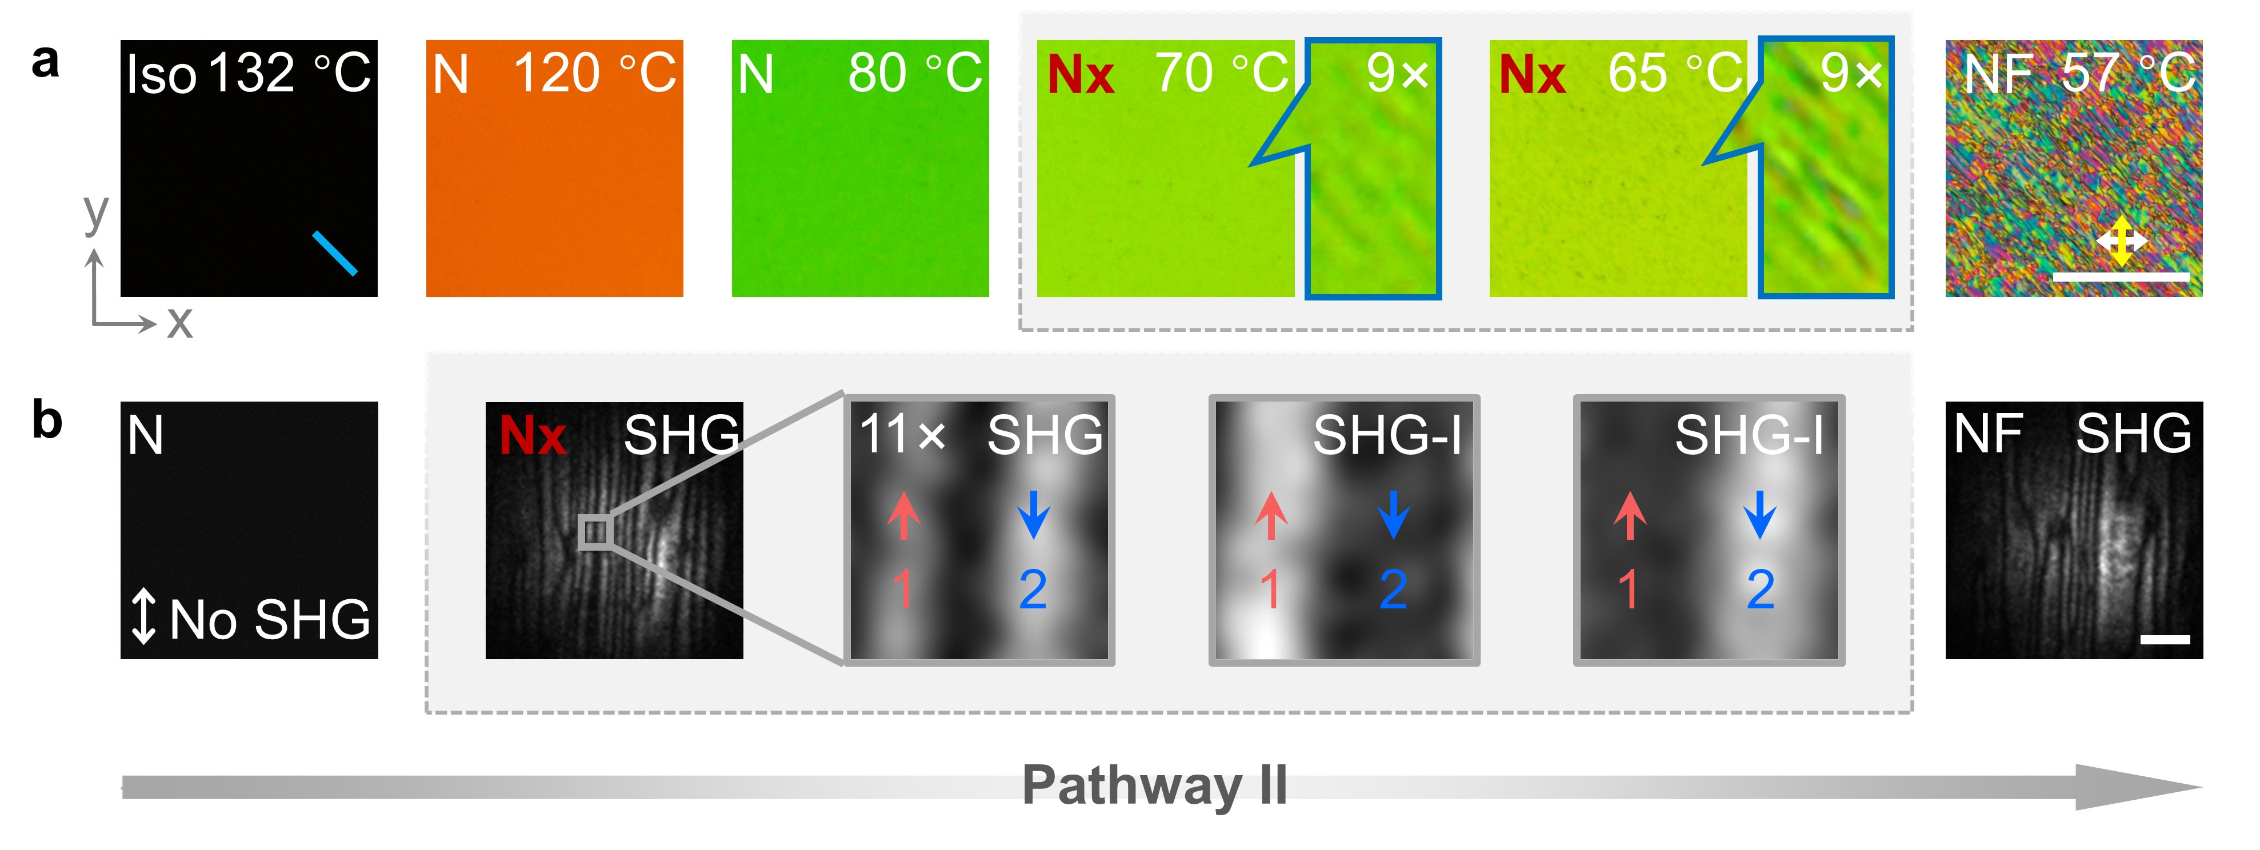
Fig. S11. Polar and orientational ordering of the Nx phase in Pathway II. a, PLM texture evolution as the temperature decreases. The white and yellow arrows denote crossed polarizers. The blue bar represents the alignment direction. Scale bar: 100 μm. c, SHG and SHG-I analysis of the polar ordering of the NJU001 material for Pathway II. The SHG images in the N and NF phases are at 80 °C and 57 °C, respectively; the rest of the SHG and SHG-I images are at 65 °C. The double-headed white arrows indicate the incident polarization. The red and blue arrows denote the polarization vectors in these regions. The Scale bar: 25 μm.

Fig. S12.
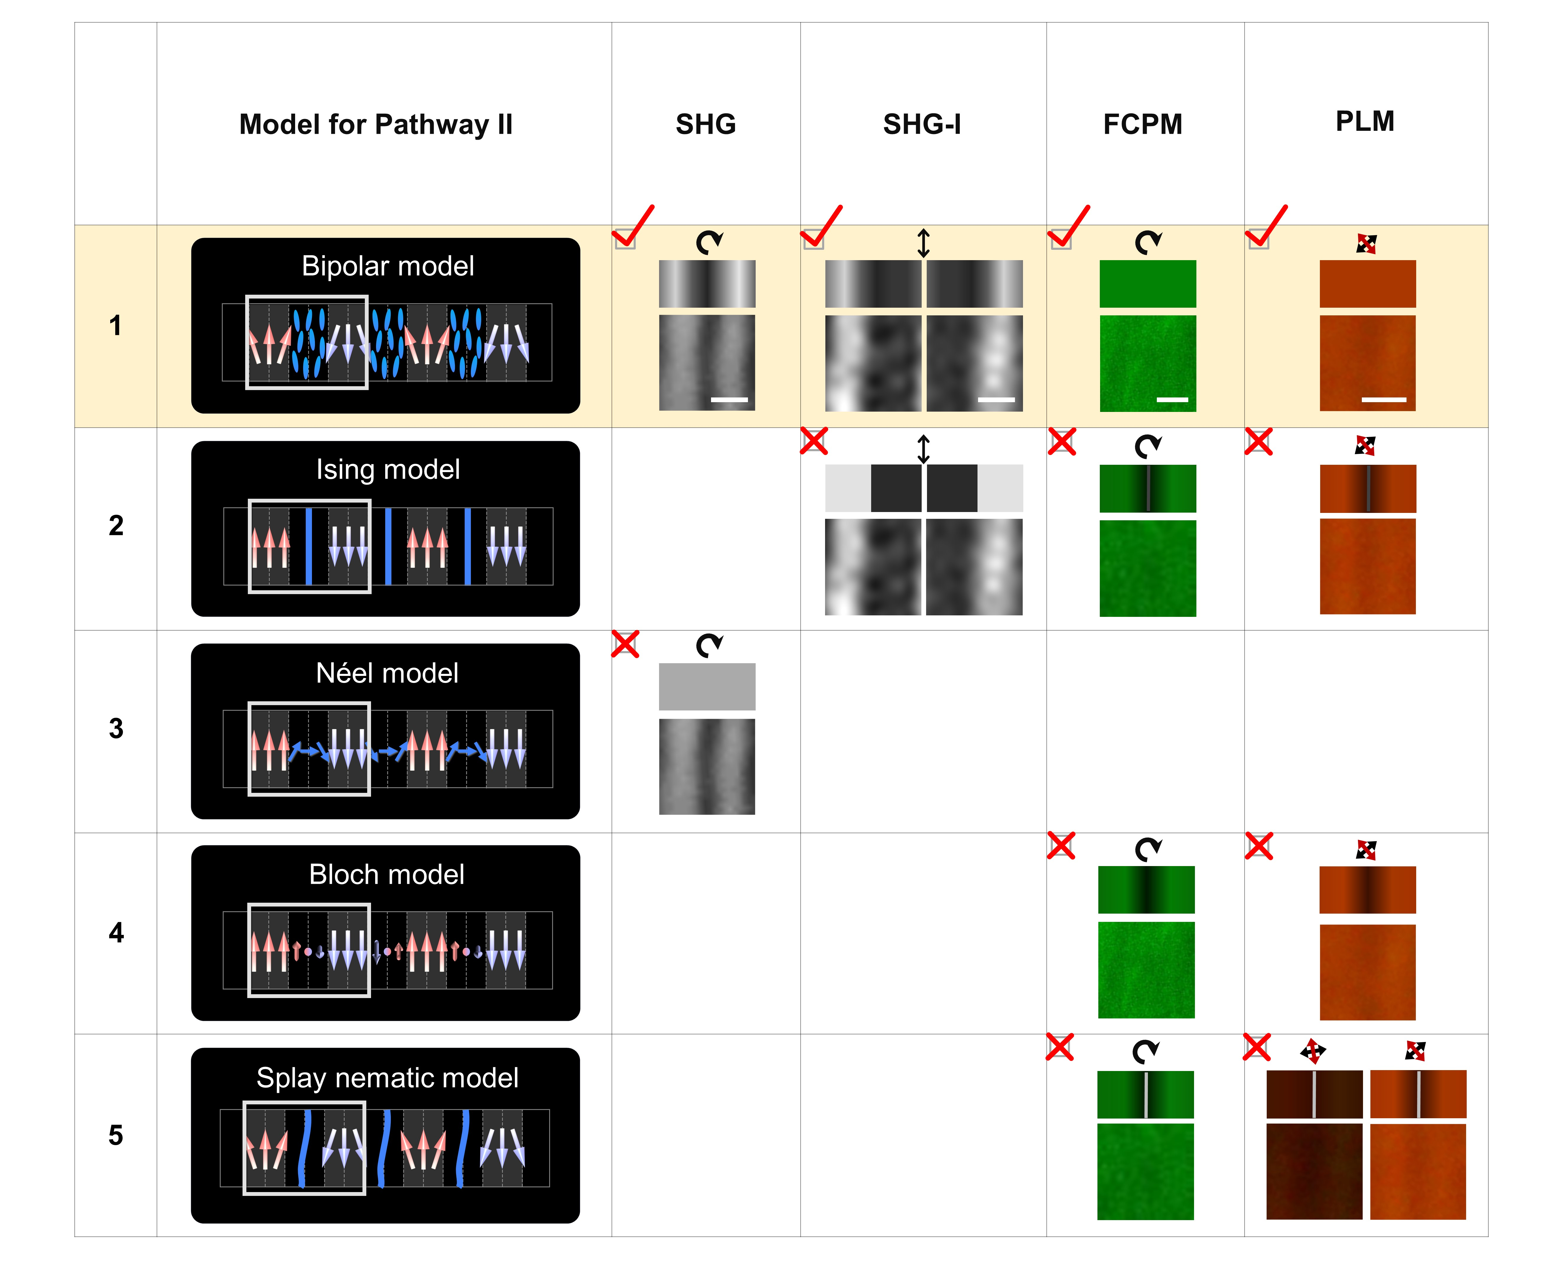
Fig. S12. Possible models (Bipolar model, Ising model, Néel model, Bloch model, and Splay nematic model) for the polar ordering of the Nx phase in Pathway II. We employ SHG, SHG-I, FCPM, and PLM to characterize the polar ordering in the Nx phase in Pathway II. Both the schematics and experimental results are provided in the corresponding cell. The black and red arrows denote crossed polarizers. The experimental results correspond to the schematics of the ordering in white boxes in the second column. Scale bar: 2 μm.

Fig. S13.
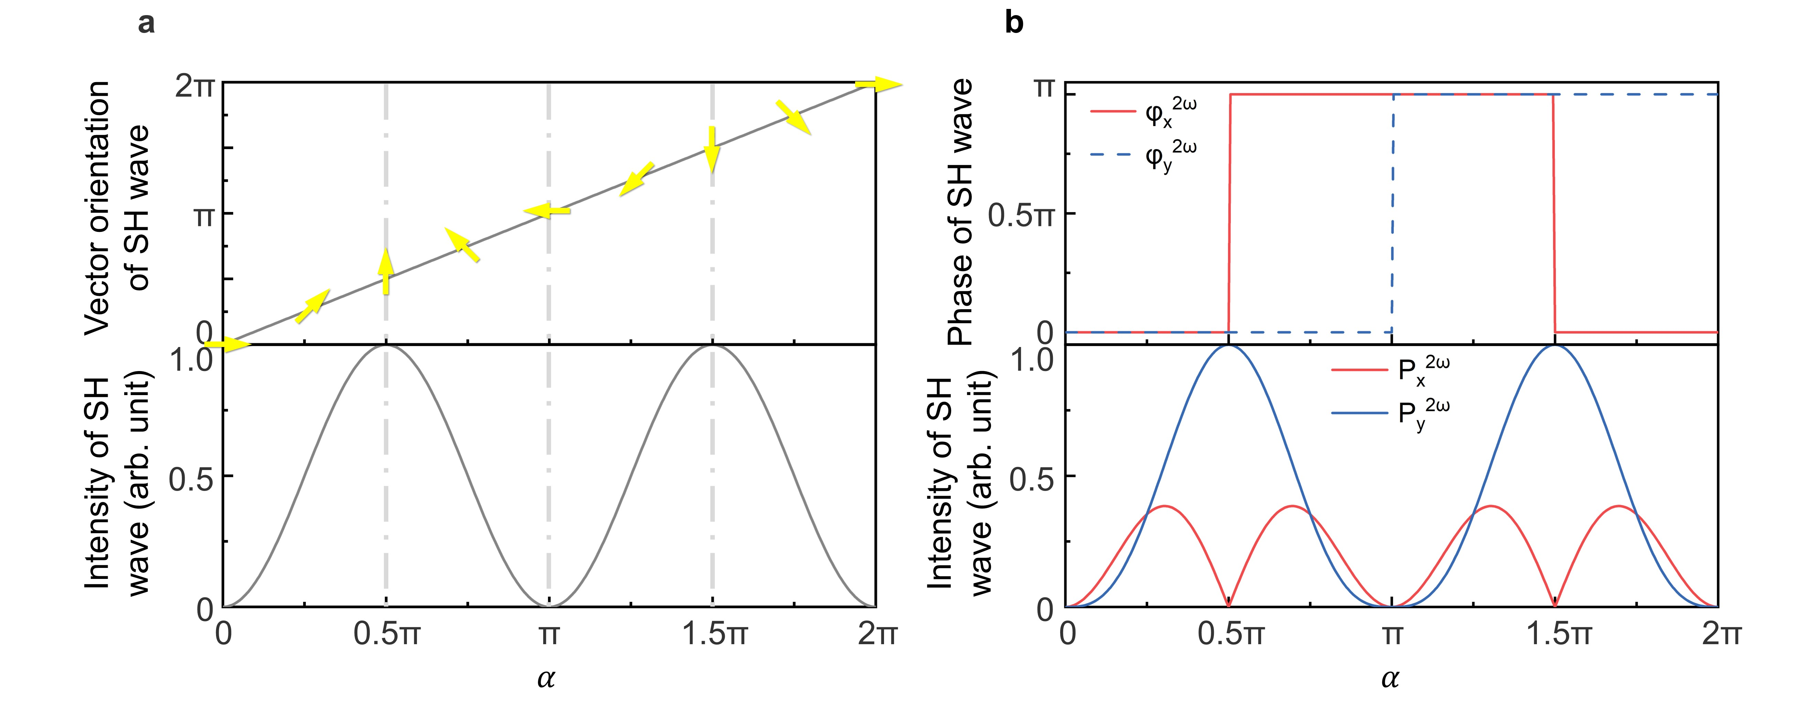
Fig. S13. Nonlinear polarization excited from a dipole. a, Dependencies of the vector orientation and intensity of the SH wave ($P_{α}^{2ω}$) on the orientation α of the dipole. $ϕ=\frac{1}{2}π$. The yellow arrows represent the vector orientation of SH wave. b, Dependencies of the phases and intensities of the SH wave components ($P_{x}^{2ω}$ and $P_{y}^{2ω}$) on the orientation α of the dipole.

Fig. S14.
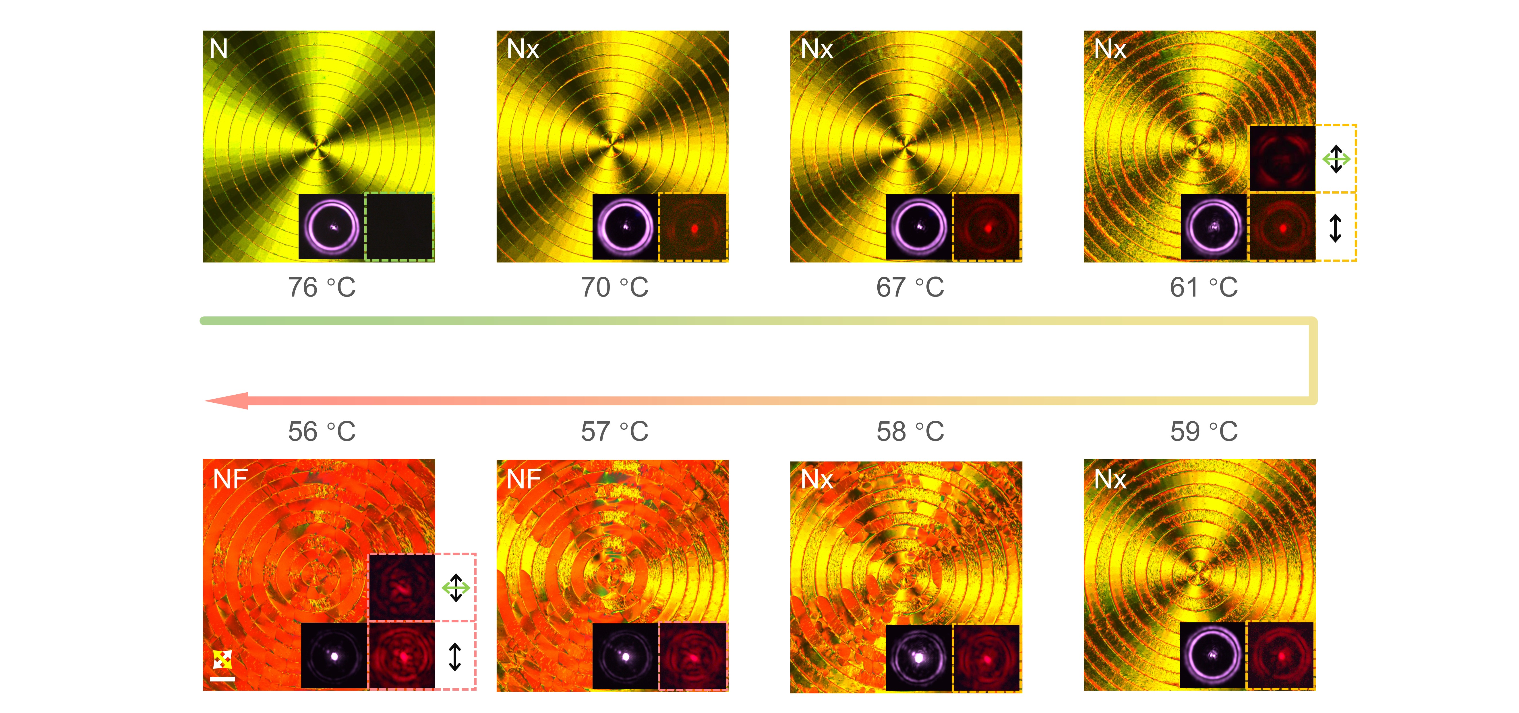
Fig. S14. Evolutions of PLM textures and corresponding nonlinear light fields generated by the topological polar superstructure. The white and yellow arrows indicate the crossed polarizers. The SH PVB is generated once the sample enters the Nx phase. Notably, the vectorial light field largely degrades when the sample transitions to the NF phase, which can be seen from the analyzed intensity profile at 56 ℃. The black and green double-headed arrows indicate the incident polarization of FW and the direction of the analyzer, respectively. Scale bar: 100 μm.

Fig. S15.
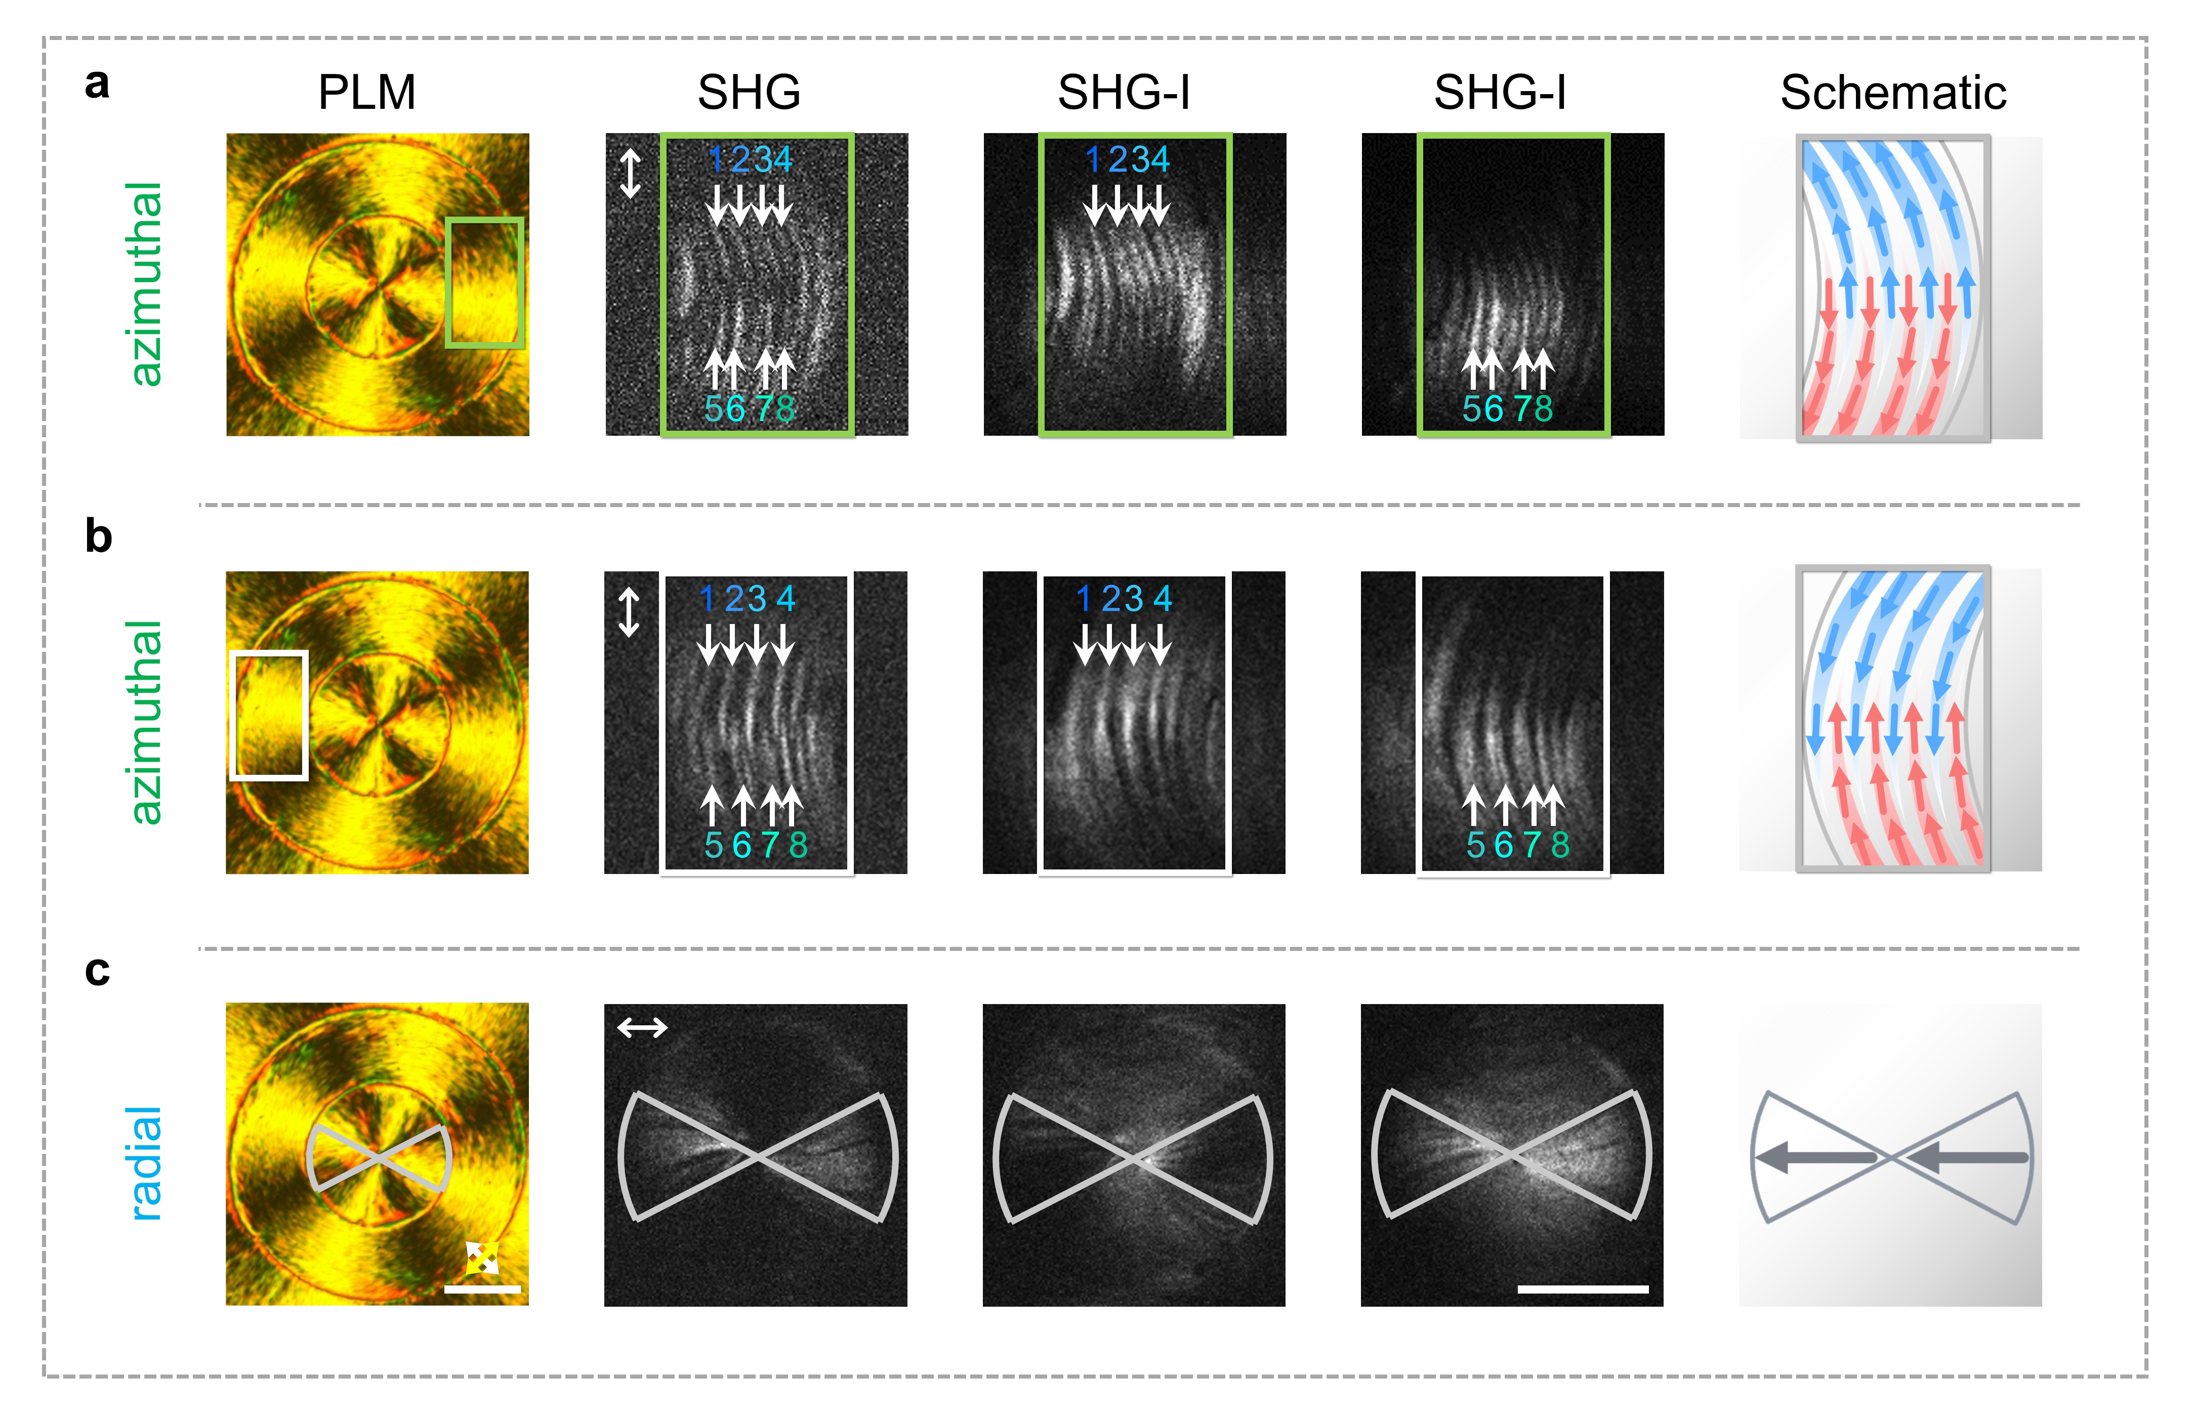
Fig. S15. Polar ordering characterization of the toroidal polar topological superstructure in the Nx phase by PLM, SHG, SHG-I imaging. Different geometric figures are used to indicate the regions for imaging, which include the radial and azimuthal alignments. Representative Nx stripes are numbered and indicated by single-headed white arrows. Their polarization vectors are characterized and represented by red and blue arrows in the schematics in the last column. The double-headed white arrows indicate the incident linear polarization. White and yellow arrows denote the crossed polarizers. Scale bar: 50 μm. Here, the relative orientations of regional dipoles are deduced from the constructive or destructive interference observations, while the exact dipole orientations (e.g., 0 or π) or relative dipole orientations among different rings are still unknown due to the limited interference area in our experiment. According to the above analysis, there are two possible polar configurations provided in Fig. S17.

Fig. S16.
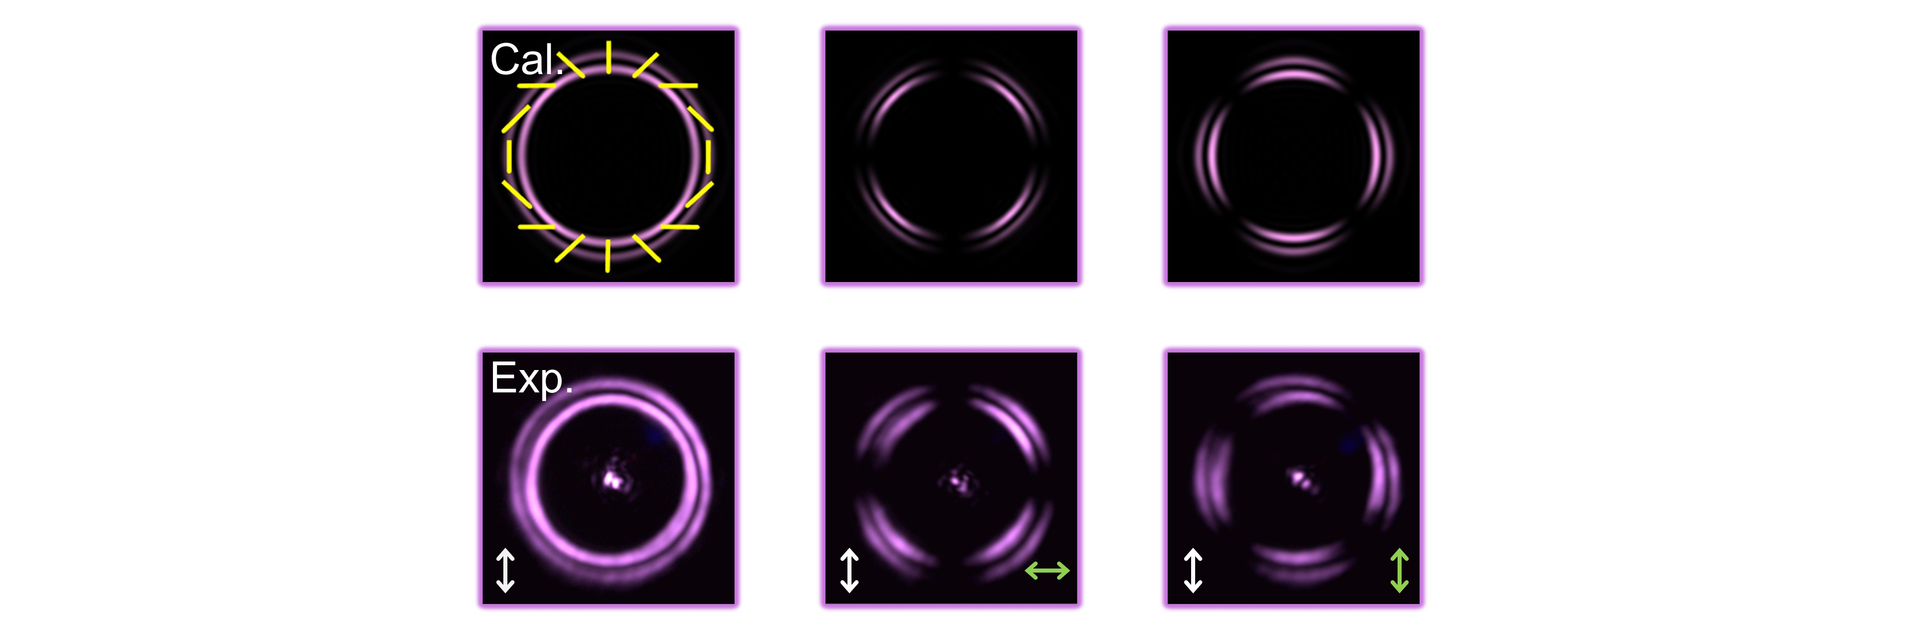
Fig. S16. Simulated and experimental results of the generated linear PVB. The white and green double-headed arrows indicate the incident polarization of FW and the direction of analyzer, respectively. The yellow bars represent the vector field of the linear PVB.

Fig. S17.
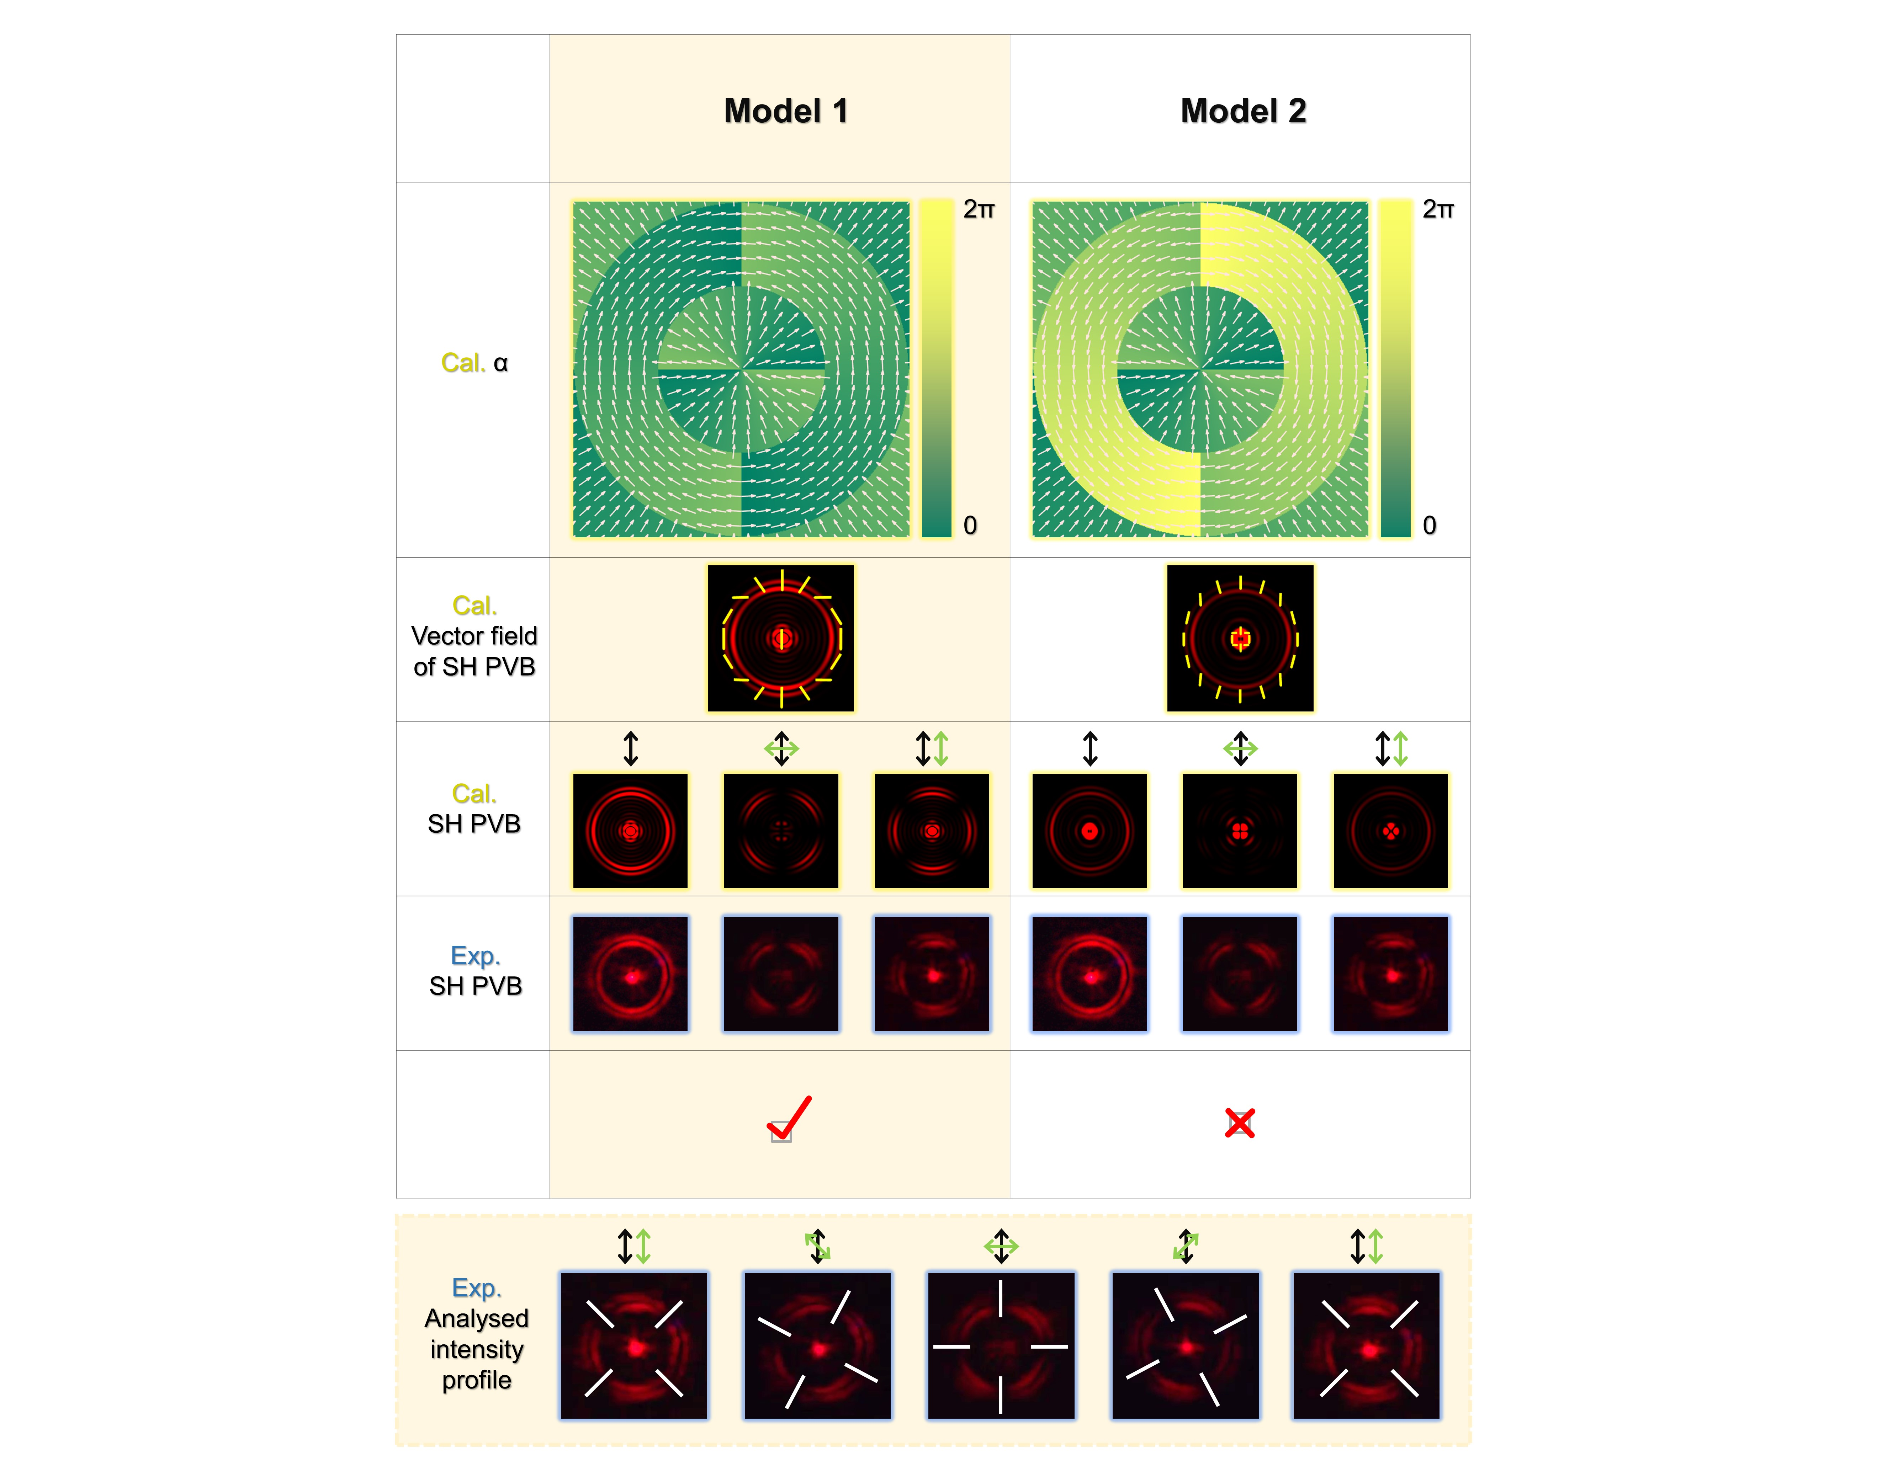
Fig. S17. Simulation of PVBs and their analyzed intensity profiles based on the structural Model 1 and 2. The black and green double-headed arrows indicate the incident polarization of FW and the direction of analyzer, respectively. The yellow bars represent the vector field of SH wave.

Fig. S18.
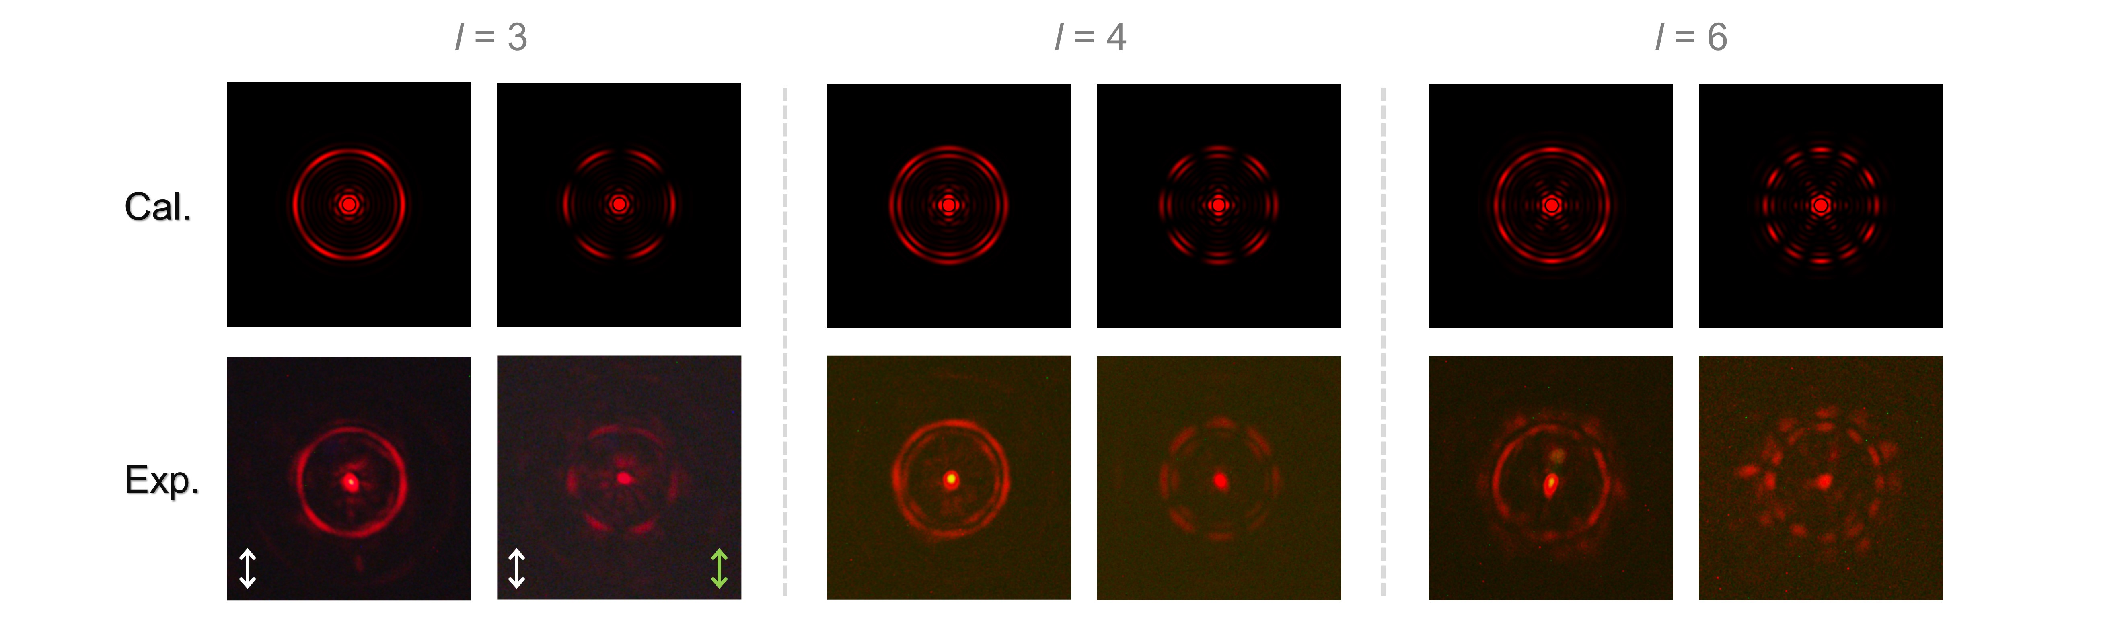
Fig. S18. Simulated and experimental results of the high-order PVBs with the topological charge l = 3, 4, and 6. The white and green double-headed arrows indicate the incident polarization of FW and the direction of the analyzer, respectively.

Fig. S19.
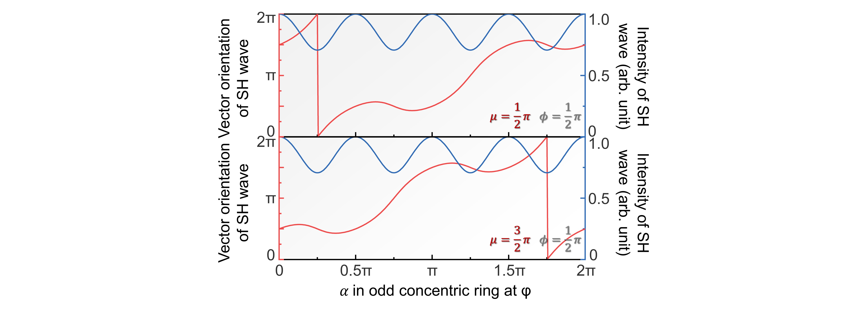
Fig. S19. Designing principle. We provide the relationships between the properties of far-field SH wave and the dipole orientation in the odd concentric rings in the radial direction of φ for $ϕ=\frac{π}{2}$. The dipoles in adjacent rings are orthogonally aligned to facilitate the manipulation of both linear and nonlinear PVBs. We set $μ=θ_{even}-θ_{odd}$, $θ∈(0, 2π)$ as the included angle between the dipoles in even and odd concentric rings, which has two choices, i.e., $μ=\frac{1}{2}π$ (upper panel) and $μ=\frac{3}{2}π$ (lower panel), to determine all the dipoles in the radial direction of φ. Here, although the intensity of SH wave exhibits a periodic modulation as α changes, which stems from the polarization dependency of the nonlinear polarization generation, it always remains at a relatively high level (ranging from 0.71 to 1). The vector orientation of SH wave covers from 0 to 2π by engineering the orthogonally aligned dipoles in even and odd concentric rings. For a certain target vector orientation in a specific φ, there can be multiple choices of dipole orientation combinations. By leveraging the two cases with $μ=\frac{1}{2}π$ and $μ=\frac{3}{2}π$, the design of vector distribution of SH wave in the range of 0 to 2π can be achieved in a more flexible manner.

Fig. S20.
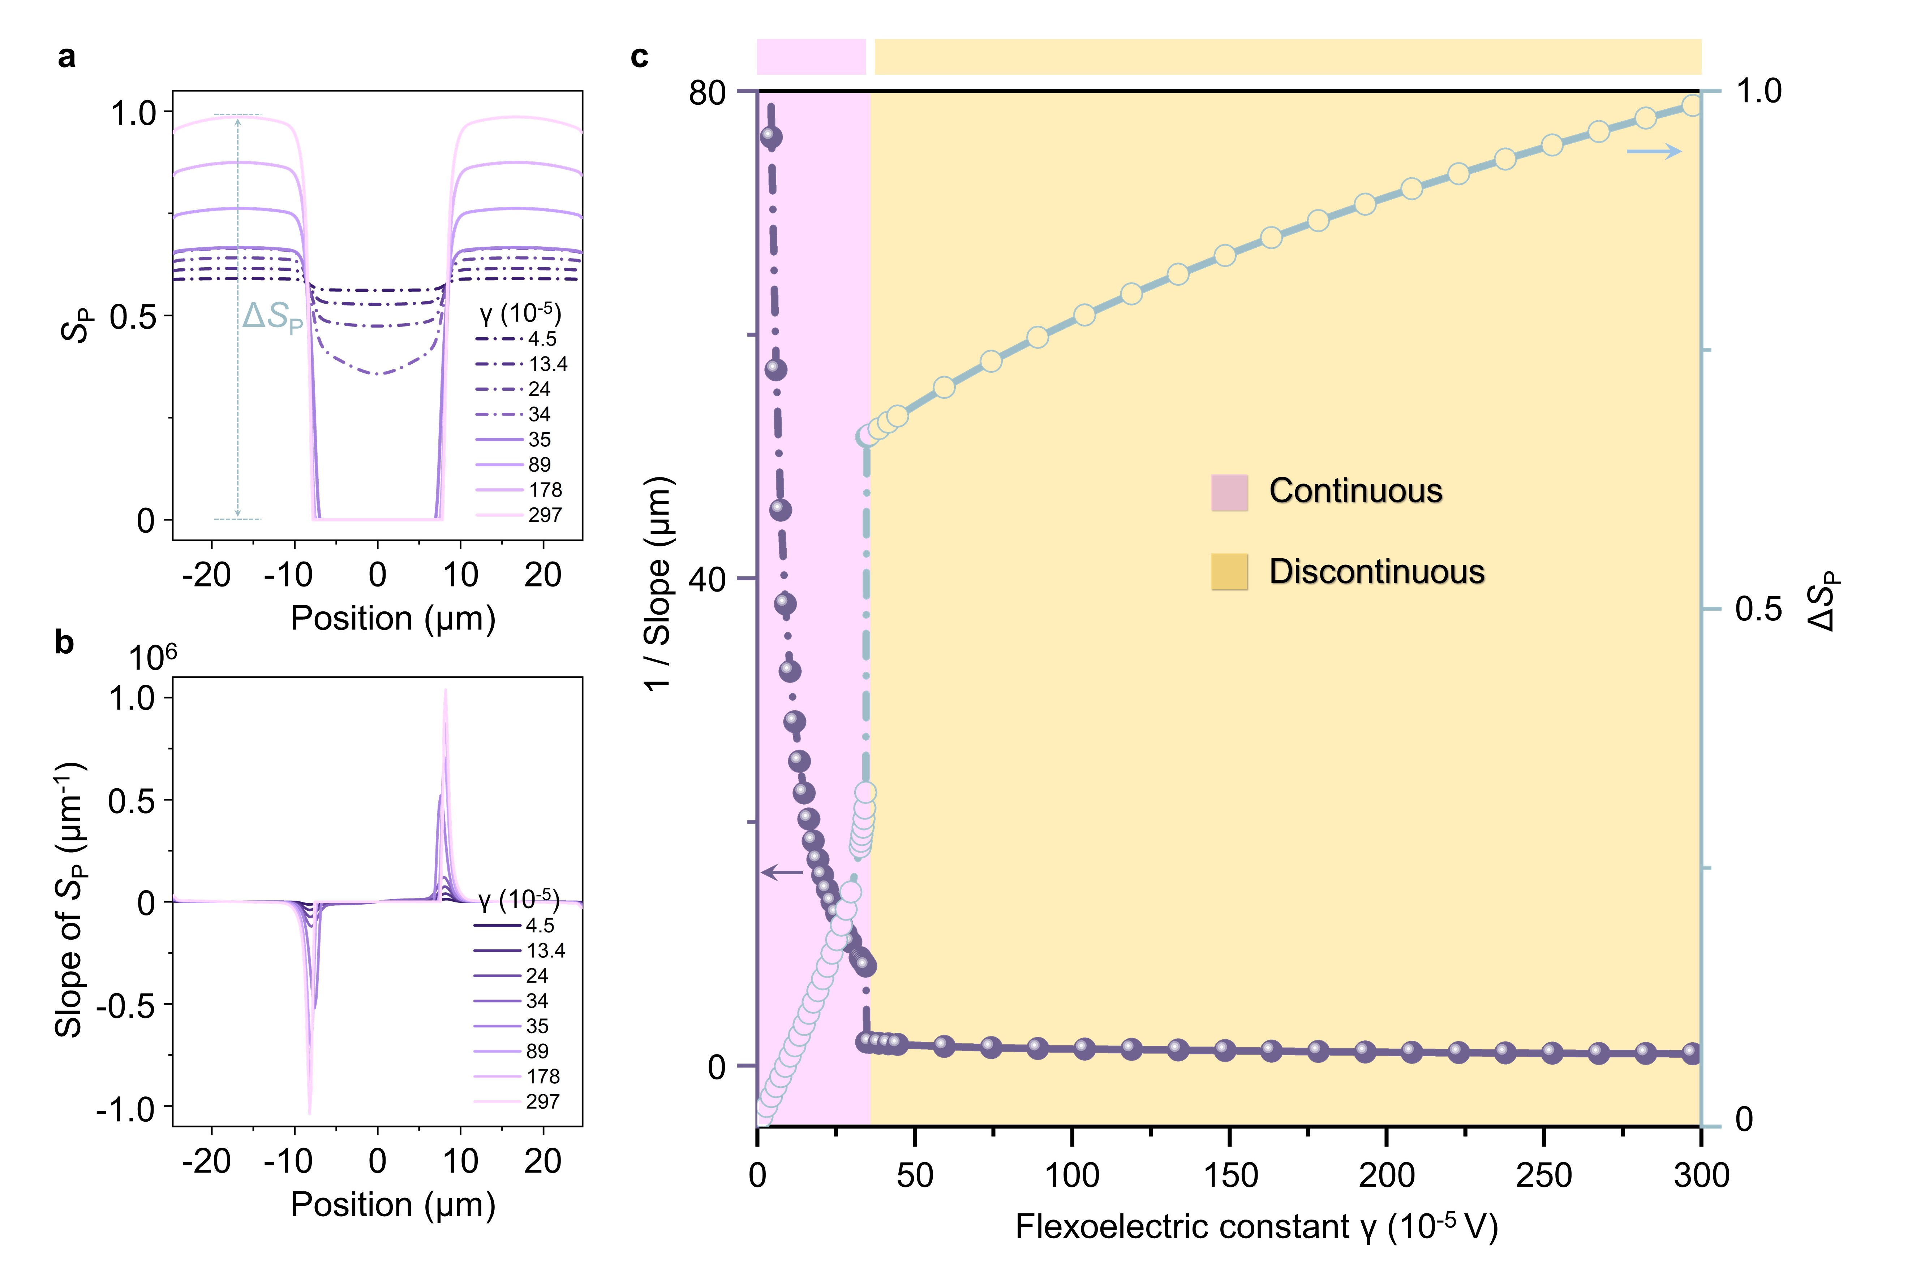
Fig. S20. Flexoelectric interaction merely competes against the polar Landau energy when $S$ and $S_{P}$ are decoupled. a, Polar orientational order parameters as a function of the coordinate with varied $γ$. ${∆S}_{P}=S_{P_max}-S_{P_min}$. b, Slope of $S_{P}$ as a function of the coordinate corresponding to (a). c, Relationships between the 1/slope and the flexoelectric constant, and ${∆S}_{P}$ and the flexoelectric constant. Quasi-continuity and discontinuity of the variation of polar orientational order parameters can be found. The maximum slope values of the lines in (b) with specific $γ$s are plotted in (c).

References
1 Nataf, G. F. et al. Domain-wall engineering and topological defects in ferroelectric and ferroelastic materials. Nat. Rev. Phys. 2, 634-648 (2020).
2 Mertelj, A. et al. Splay Nematic Phase. Phys. Rev. X 8, 041025 (2018).
3 Sebastian, N. et al. Ferroelectric-Ferroelastic Phase Transition in a Nematic Liquid Crystal. Phys. Rev. Lett. 124, 037801 (2020).
4 Smalyukh, I. I., Shiyanovskii, S. V. & Lavrentovich, O. D. Three-dimensional imaging of orientational order by fluorescence confocal polarizing microscopy. Chem. Phys. Lett. 336, 88-96 (2001).
5 Folcia, C. L., Ortega, J., Vidal, R., Sierra, T. & Etxebarria, J. The ferroelectric nematic phase: an optimum liquid crystal candidate for nonlinear optics. Liq. Cryst. 49, 899-906 (2022).
6 Boyd, R. W. Nonlinear optics. 3rd edn, (Academic Press, 2008).
7 Vaity, P. & Rusch, L. Perfect vortex beam: Fourier transformation of a Bessel beam. Opt. Lett. 40, 597 (2015).
8 Ahmed, H. et al. Dynamic control of hybrid grafted perfect vector vortex beams. Nat. Commun. 14, 3915 (2023).
9 Xu, R. et al. Perfect Higher-Order Poincaré Sphere Beams from Digitalized Geometric Phases. Phys. Rev. Appl. 10, 034061 (2018).
10 Yang, Q., Yang, Y., Li, H., Liu, H. & Chen, X. Nonlinear generation of vector beams by using a compact nonlinear fork grating. Photonics Res. 12, 1036 (2024).
11 Li, H., Liu, H., Yang, Y., Lu, R. & Chen, X. Nonlinear Generation of Perfect Vector Beams in Ultraviolet Wavebands. Chin. Phys. Lett. 39, 034201 (2022).
12 Ren, M. et al. Roadmap on nonlinear optics–focus on Chinese research. J. Phys. Photonics 5, 032501 (2023).
13 Li, H., Liu, H., Yang, Y., Lu, R. & Chen, X. Ultraviolet waveband vector beams generation assisted by the nonlinear frequency conversion. Appl. Phys. Lett. 119, 011104 (2021).
14 Liu, H., Li, H., Zheng, Y. & Chen, X. Nonlinear frequency conversion and manipulation of vector beams. Opt. Lett. 43, 5981 (2018).
15 Wu, S. T. & Yang, D. K. Fundamentals of liquid crystal devices. (John Wiley & Sons, 2014).
16 Yeh, P. & Gu, C. Optics of Liquid Crystal Displays. (John Wiley & Sons, 1999).

