Supplementary Information for
“A high-resolution compound vulnerability function for severe convective storm losses”
D. van Ederen^{1,2} , M.D.S. Fonseca Cerda¹, W.J.W. Botzen¹, J.C.J.H. Aerts^{1,3}, V. Lupi¹, P. Scussolini¹, K.B. Gubbels^{2,4,5}

1 Institute for Environmental Studies (IVM), Vrije Universiteit Amsterdam, Amsterdam, the Netherlands
2. Achmea, Zeist, the Netherlands
3. Deltares, Delft, the Netherlands
4. Tilburg University, Tilburg, the Netherlands
5. Actuarial Institute, Utrecht, the Netherlands

S1 Filtering the damage data
The insurance dataset provides weather-related residential building claims and policy holder information in the Netherlands from 1-1-2008 up to and including 31-8-2019. A temporal filtering makes sure that only weather-related residential building claims in the severe convective storm (SCS) season (April up to and including September) are retained. As the Dutch financial conglomerate insures a wide range of environmental- and weather-related damage to residential buildings, additional filters need to be applied in order to isolate claims resulting from SCS. Accordingly, residential building claims caused by summer windstorms (in particular the windstorms on 24 September 2012, 25 July 2015 and 13 September 2017), earthquakes, floods, lightning, meteorite impacts and frost are excluded from the sample.

S2 Normalizing ground up damages and calculating reconstruction values
The dependent variable of interest is the damage ratio which represents the ground up damage of a residential building as a ratio of its reconstruction value. This normalization allows for a more accurate comparison between the dependent variable’s observations because it partially corrects for the reconstruction value’s effect on the ground up damage: buildings with higher reconstruction values (originating from characteristics such as building size and materials) have more potential for damage simply because there is more value that can be damaged. However, as the damage does not rise proportionally with the reconstruction value, the effect of the reconstruction value on the ground up damage differs for differing reconstruction values. Therefore, in order to normalize the damage ratios more comprehensively, the study also included the reconstruction value as regressor in the models.

The reconstruction values of the residential buildings are calculated according to best practices in the Dutch insurance industry. This methodology is specifically designed for residential buildings and provided by the Dutch Association of Insurers. It receives a yearly update, incorporating changes in building costs, regulation (e.g. building codes) and methodology if necessary. The reconstruction value represents the costs of rebuilding a residential building according to the latest building codes, in case the building is damaged completely. It, therefore, excludes any value derived from a building’s location or the land it is placed on. The reconstruction value is approximated by multiplying a building’s volume ($m^{3})$ with a predetermined price which is tailored to the building’s type, the construction year and characteristics of the building’s structures. The baseline prices range from €740.- per $m^{3}$ building volume for terraced houses built after 2015, to €1040.- per $m^{3}$ building volume for detached houses built before and after 2015. The methodology distinguishes six building types: terraced houses, corner houses, semi-detached houses, detached houses, apartments situated up to and including the fourth floor, and apartments situated between the fifth and up to and including the eighth floor. There are two construction year categories: before and after 2015. Premiums and discounts can be applied to the baseline building volume prices to reflect characteristics of the building’s structures which are of further influence to the reconstruction value. Amongst others, these structures include the foundation, the roof, the exterior walls, solar panels and heat generation installations. The reader is referred to the latest version of the reconstruction value calculation manual of the Dutch Association of Insurers (called Herbouwwaardemeter Woningen 2024) for an overview of all building volume prices and optional price corrections (Verbond van Verzekeraars, 2024).

S3 Indexing the ground up damage and reconstruction values
The ground up damage and the reconstruction values used in the beta regressions are denoted in 2024 price levels. To adjust the price levels in which the damage data was originally denoted, a price index was derived from the development of the reconstruction value prices in the aforementioned methodology of the Dutch Association of Insurers. Table S1 contains this price index for the years 2008-2024, here 2015 was set as the reference year. The price index was constructed by taking the weighted average of the baseline volume prices of all building types, where the share of a particular building type in the total building stock served as its weight. The development of this weighted average building volume price in turn determined the evolution of the price index. The share of a particular building type in the total building stock was based on building stock information provided by the Central Agency for Statistics of the Netherlands (Centraal Bureau voor de Statistiek [CBS], 2023). Table S2 provides the allocated weights (i.e. shares in the total building stock) per building type, which were assumed to stay fixed over the period of interest.

Table S1. Price index Table S2. Building type weights
This table provides the weights which were used in the price index calculation.
Building type | Share in building stock
Terraced & Corner houses | 42%
Semi-detached houses | 9%
Detached houses | 13%
Apartments, floor 0 to 4 | 18%
Apartments, floor 5 to 8 | 18%
Year | Price Index
2008 | 86
2009 | 89
2010 | 90
2011 | 92
2012 | 94
2013 | 97
2014 | 98
2015 | 100
2016 | 107
2017 | 108
2018 | 110
2019 | 113
2020 | 127
2021 | 130
2022 | 141
2023 | 157
2024 | 162
This table provides the price
index which was used to adjust
the price levels of the ground
up damage and reconstruction
values.

S4 Measurement methodologies meteorological data
Hail data was provided by Wouters et al. (2019). Wind and precipitation data was retrieved from the Royal Netherlands Meteorological Institute (KNMI), which is the Dutch national weather service. The meteorological variables of interest are: the maximum expected hailstone size (MEHS), the daily maximum 3-second wind gust in a 10-minute period at 10 m height and the daily maximum one-hour cumulative precipitation and the daily 24-hour cumulative precipitation.

MEHS
The daily MEHS measurements are radar-based, calculated according to the hail detection algorithm proposed by Witt et al. (1998) and provided at a horizontal resolution of 1 km. To that end, a severe hail index (SHI) was constructed which serves as the main predictor of the MEHS. The SHI is a thermally weighted vertical integration of the reflectivity profile of a SCS, which in turn depends on the kinetic energy of hail, the height of the storm, the height of the environmental melting level and the height of the -20°C environmental temperature. The kinetic energy is calculated using radar reflectivity data and according to Waldvogel et al. (1978). The (environmental temperature) heights are produced by the numerical weather prediction model High-Resolution Limited Area Model (HiRLAM). For more information on the weather radars, HiRLAM and the MEHS modelling procedure, the reader is referred to section 3.1 in Wouters et al. (2019).

Wind gusts
The aforementioned wind gust metric was derived from the Dutch Offshore Wind Atlas (DOWA) and Winds of the North Sea in 2050 (WINS50) datasets (Koninklijk Nederlands Meteorologisch Instituut [KNMI], 2018; KNMI, 2019; KNMI, 2022). These are regional reanalysis based wind climatology datasets containing time series of hourly information on the wind speed, wind direction, temperature, pressure and relative humidity at 10 m to 600 m and for a horizontal resolution of 2.5 km. The reanalysis is based on the numerical weather prediction model HARMONIE-AROME which is nested in the European Centre for Medium-Range Weather Forecasts (ECMWF) reanalysis ERA5. The daily maximum 3-second wind gust in a 10-minute period at 10 m height is approximated by the hourly average wind speed at 140 m as per derivation from van den Brink (2019) who validated this relationship with empirical observations. For more information on the numerical weather prediction model HARMONIE-AROME, the reader is referred to the websites of both wind climatology datasets:
https://www.dutchoffshorewindatlas.nl/
https://www.wins50.nl/

Precipitation
The aforementioned precipitation metrics were derived from a climatological radar rainfall dataset containing time series of one hour precipitation depths at a horizontal resolution of 1 km, which have been adjusted employing validated and complete rain gauge data from KNMI rain gauge networks (KNMI, 2017). The rainfall dataset covers the entire land surface of the Netherlands and is updated on a monthly basis. The daily maximum one-hour cumulative precipitation equals the maximum one hour precipitation depth, measured between each full hour, over 24 hours between 00:00 AM and 23:59 PM UTC. The daily 24-hour cumulative precipitation equals the sum of these one hour precipitation depths. For more information on the weather radars, the rain gauge network and the derivation of the one hour precipitation depths from these data sources, the reader is referred to section 2.3 in Overeem et al. (2011).

Figure S1
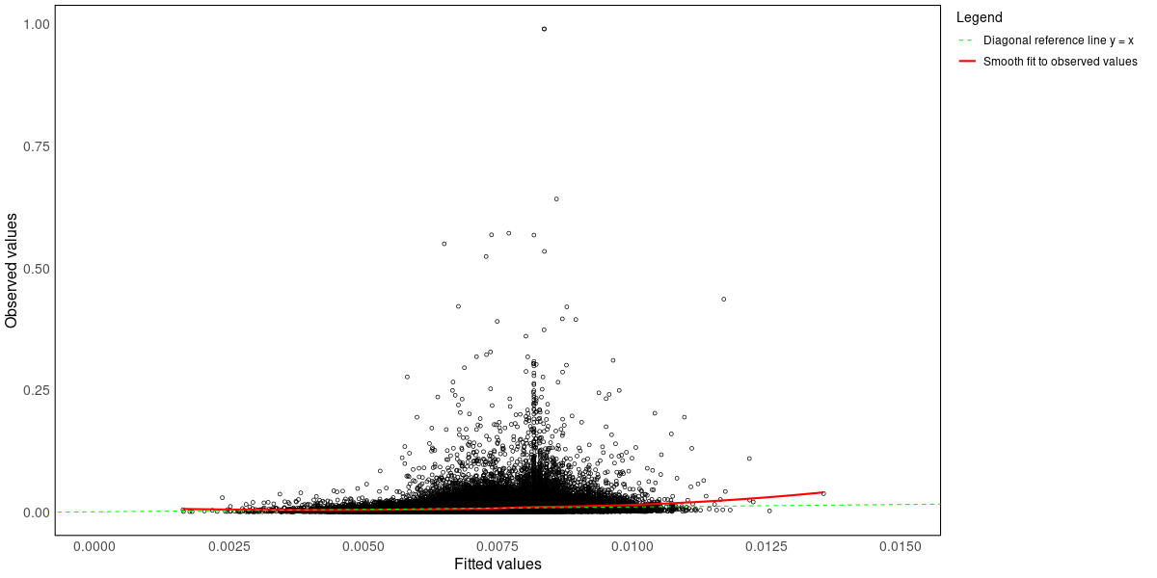
This figure shows the observed damage ratio values against the fitted values (i.e. the expected damage ratio estimates) of the compound vulnerability function. The dashed green line represents the diagonal reference line, which is designed to help identify the agreement between the observed damage ratio values and the expected damage ratio estimates. The red line is a smooth fit to the observed damage ratio values, reflecting their moving average. The expected damage ratio estimates correspond to the observed mean damage ratios when the red line overlaps with the dashed green reference line. The smooth fit is slightly higher than the reference line at higher fitted values, indicating that the model has a tendency to underestimate mean damage ratios at higher fitted values. Nonetheless, the figure shows that the model accurately predicts mean damage ratios as the observed mean damage ratios and the expected damage ratio estimates mostly coincide. However, the figure also highlights that the model is unable to accurately predict the damage ratio for individual residential buildings as the variation in observed damage ratio values (per fitted value) is large.
Figure S2
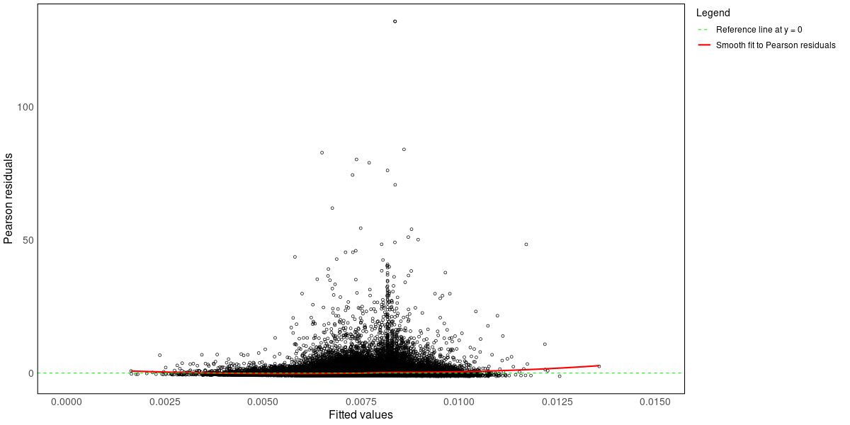
This figure shows the Pearson residuals against the fitted values (i.e. the expected damage ratio estimates) of the compound vulnerability function. The dashed green line represents a reference line at Pearson residuals equaling zero, and is designed to help identify any trend more easily. The red line is a smooth fit to the Pearson residuals, reflecting their moving average. Apart from a slight increase in the smooth fit for higher fitted values, the figure shows no significant patterns in the relationship between the Pearson residuals and the fitted values. Although the model has a tendency to underestimate damage ratios more at higher fitted values, it adequately captures the relationship between the dependent variable and regressors. Given the near zero smooth fit to the Pearson residuals, the figure shows that the model accurately predicts mean damage ratios. Nonetheless, the variation in Pearson residuals (per fitted value) is large, highlighting that the model is unable to accurately predict the damage ratio for individual residential buildings.
Figure S3
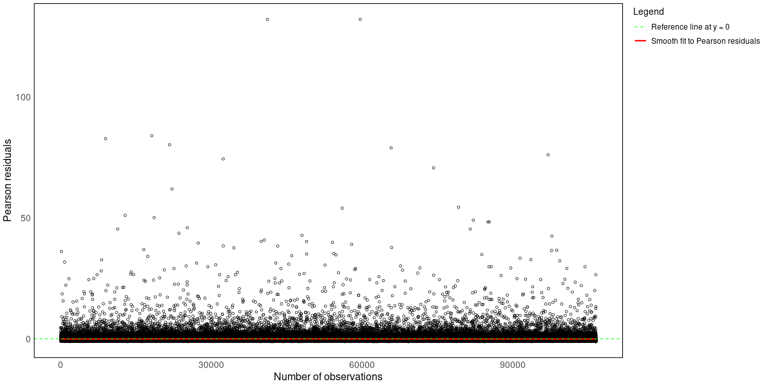
This figure shows the Pearson residuals against the indices of the observations of the compound vulnerability function. The dashed green line represents a reference line at Pearson residuals equaling zero, and is designed to help identify any trend more easily. The red line is a smooth fit to the Pearson residuals, reflecting their moving average. The figure shows no signs of a pattern in the relationship between the Pearson residuals and indices of the observations, which implies that the model adequately captures the relationship between the dependent variable and regressors.

Figure S4
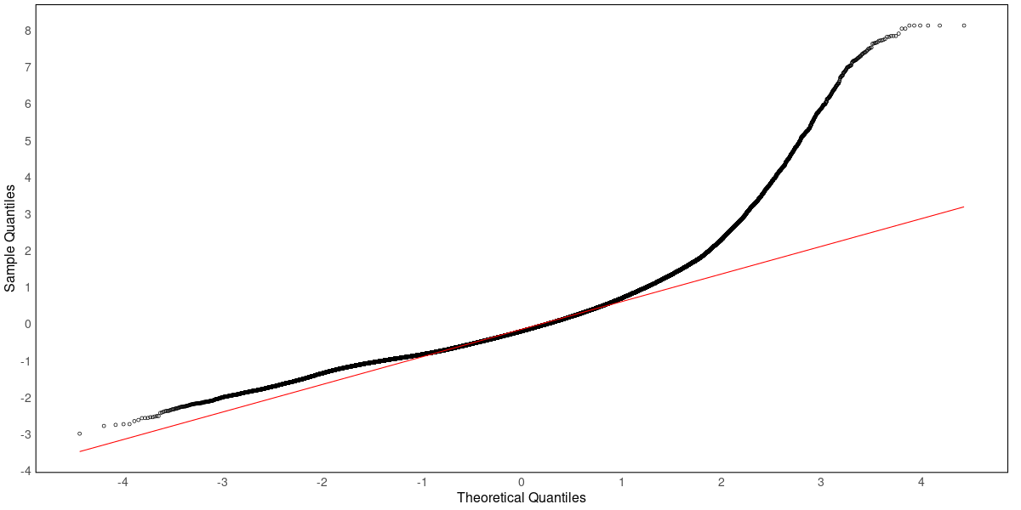
This figure shows the normal quantile-quantile plot of the compound vulnerability function where the residuals are quantile residuals as proposed by Dunn and Smyth (1996). With their approach, a model’s presumed non-normally distributed residuals can be mapped onto the standard normal distribution scale, such that they can be checked with familiar residuals diagnostics such as the normal quantile-quantile plot. The red line represents the diagonal reference line, and is designed to assess the adherence of the observed residuals to the theoretical quantiles. The figure highlights that the empirical damage ratio distribution has a heavier right tail than the theoretical damage ratio distribution, whereas its left tail is lighter than that of the theoretical damage ratio distribution. Note that the theoretical damage ratio distribution is the fitted beta distribution, which in this figure is also mapped onto the standard normal distribution scale.

Figure S5
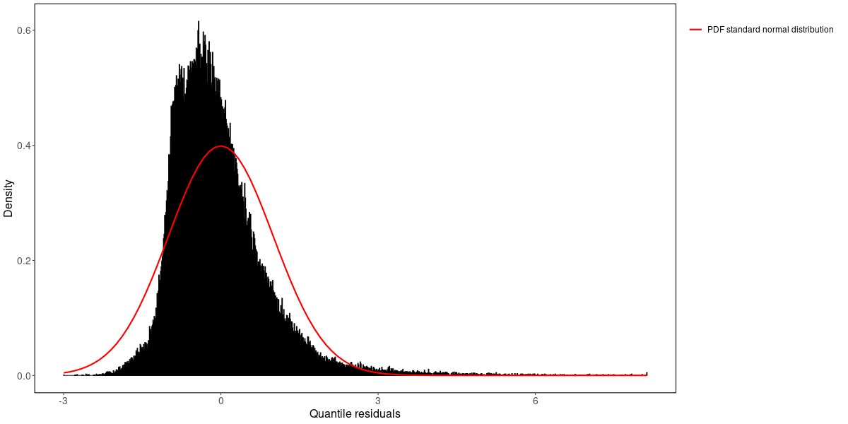
This figure shows the density of the residuals of the compound vulnerability function, where the residuals are quantile residuals as proposed by Dunn and Smyth (1996). With their approach, a model’s presumed non-normally distributed residuals can be mapped onto the standard normal distribution scale, such that they can be checked with familiar residuals diagnostics such as the standard normal density plot. The red line represents the density of the standard normal distribution, and is designed to assess the adherence of the observed residuals to the theoretical distribution. Similar to the quantile-quantile plot, this figure indicates that the empirical damage ratio distribution has a heavier right tail than the theoretical damage ratio distribution, whereas its left tail is lighter than that of the theoretical damage ratio distribution. In addition, the figure also highlights discrepancies between the central regions of the empirical damage ratio distribution and the theoretical damage ratio distribution. In particular, it shows that the empirical damage ratio distribution has relatively less support for damage ratios slightly above its expectation, whereas it has relatively more support for damage ratios slightly below its expectation. Note that the theoretical damage ratio distribution is the fitted beta distribution, which in this figure is converted to the depicted standard normal distribution.
Figure S6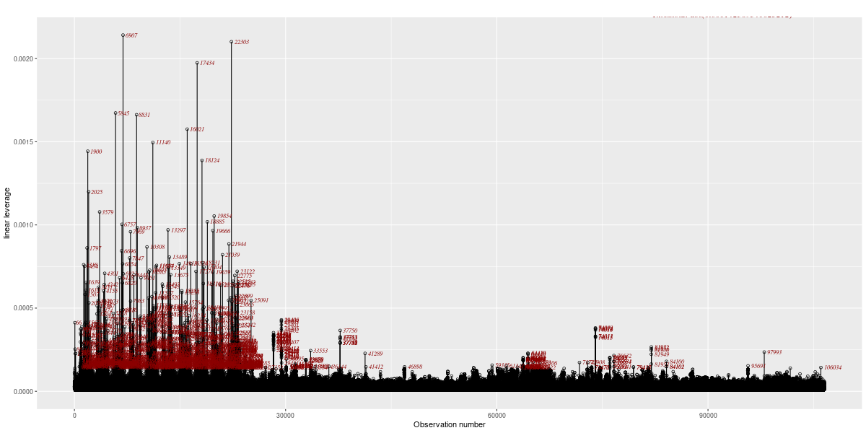
This figure shows the leverage values of all observations against their indices of the compound vulnerability function. The numbers in this figure correspond to the index values of the observations. This figure indicates that there are many high leverage observations. Nonetheless, a sensitivity analysis points out that they are not of influence as the regression parameters are at least robust to removing the top 1% (~1000 observations) of observations, ranked according to their leverage. This finding suggests that the prediction errors which accompanied the high leverage observations were not large enough to make them influential.

S5 Damage ratio tables
To facilitate the usage of the vulnerability functions, the following tables provide the end-user with the damage ratio output from the compound vulnerability function for an average residential building, which has a reconstruction value of €370,000.- denoted in 2024 price levels. The expected damage ratios (E[DR]) in percentages are reported for differing MEHS values in cm and 24-hour cumulative precipitation levels in mm. In addition, the 1st, 25th, 75th and 99th quantiles (Q) of the conditional beta distribution are also provided to describe the variance of the damage ratio estimates. Lastly, the 75% and 99% confidence interval (CI) for the expected damage ratio are also provided (and their quantiles) to describe the uncertainty in the expected damage ratio estimate.

With these damage ratios, the end-user can easily acquire the ground up damage, denoted in 2024 price levels, by multiplying the damage ratio with the related reconstruction value of €370,000.-. The output from the univariate vulnerability function roughly coincides with the output from the compound vulnerability function measured at a 24-hour cumulative precipitation levels of 0 mm, multiplied by 1.10.

24-hour cumulative precipitation levels of 0 mm

Table S3
MEHS | 1st Q | 25th Q | E[DR] | 75th Q | 99th Q
1 cm | 0.007 | 0.198 | 0.679 | 0.943 | 3.085
2 cm | 0.009 | 0.215 | 0.708 | 0.983 | 3.149
3 cm | 0.010 | 0.229 | 0.731 | 1.014 | 3.199
4 cm | 0.012 | 0.241 | 0.750 | 1.041 | 3.242
5 cm | 0.013 | 0.252 | 0.768 | 1.065 | 3.281
6 cm | 0.014 | 0.263 | 0.785 | 1.087 | 3.316
7 cm | 0.015 | 0.272 | 0.800 | 1.108 | 3.349
8 cm | 0.017 | 0.282 | 0.815 | 1.128 | 3.380
Expected damage ratios (%) and their 1st, 25th, 75th and 99th quantiles.

Table S4
Wind gust speed | 1st Q | 25th Q | 75% lower CI | 75th Q | 99th Q |  | 1st Q | 25th Q | 75% upper CI | 75th Q | 99th Q
1 cm | 0.007 | 0.195 | 0.674 | 0.936 | 3.073 |  | 0.007 | 0.202 | 0.685 | 0.951 | 3.097
2 cm | 0.008 | 0.212 | 0.701 | 0.974 | 3.135 |  | 0.009 | 0.219 | 0.714 | 0.991 | 3.163
3 cm | 0.010 | 0.225 | 0.723 | 1.004 | 3.183 |  | 0.011 | 0.234 | 0.738 | 1.024 | 3.214
4 cm | 0.011 | 0.237 | 0.743 | 1.030 | 3.225 |  | 0.012 | 0.246 | 0.758 | 1.051 | 3.259
5 cm | 0.012 | 0.247 | 0.760 | 1.053 | 3.262 |  | 0.014 | 0.258 | 0.777 | 1.077 | 3.299
6 cm | 0.013 | 0.257 | 0.776 | 1.075 | 3.296 |  | 0.015 | 0.269 | 0.794 | 1.100 | 3.336
7 cm | 0.015 | 0.266 | 0.791 | 1.095 | 3.328 |  | 0.016 | 0.279 | 0.810 | 1.122 | 3.370
8 cm | 0.016 | 0.275 | 0.805 | 1.114 | 3.358 |  | 0.018 | 0.289 | 0.826 | 1.142 | 3.402
The 75% confidence intervals of the expected damage ratios (%) and their 1st, 25th, 75th and 99th quantiles.

Table S5
Wind gust speed | 1st Q | 25th Q | 99% lower CI | 75th Q | 99th Q |  | 1st Q | 25th Q | 99% upper CI | 75th Q | 99th Q
1 cm | 0.007 | 0.191 | 0.667 | 0.926 | 3.057 |  | 0.008 | 0.206 | 0.691 | 0.960 | 3.113
2 cm | 0.008 | 0.207 | 0.694 | 0.963 | 3.117 |  | 0.010 | 0.224 | 0.722 | 1.002 | 3.180
3 cm | 0.009 | 0.220 | 0.715 | 0.992 | 3.164 |  | 0.011 | 0.239 | 0.747 | 1.036 | 3.234
4 cm | 0.010 | 0.231 | 0.733 | 1.017 | 3.204 |  | 0.013 | 0.252 | 0.768 | 1.065 | 3.280
5 cm | 0.011 | 0.241 | 0.749 | 1.039 | 3.240 |  | 0.014 | 0.264 | 0.788 | 1.091 | 3.322
6 cm | 0.013 | 0.250 | 0.764 | 1.060 | 3.272 |  | 0.016 | 0.276 | 0.806 | 1.115 | 3.360
7 cm | 0.014 | 0.259 | 0.779 | 1.079 | 3.302 |  | 0.017 | 0.287 | 0.823 | 1.138 | 3.396
8 cm | 0.015 | 0.267 | 0.792 | 1.097 | 3.331 |  | 0.019 | 0.297 | 0.839 | 1.160 | 3.430
The 99% confidence intervals of the expected damage ratios (%) and their 1st, 25th, 75th and 99th quantiles.

24-hour cumulative precipitation levels of 50 mm

Table S6
MEHS | 1st Q | 25th Q | E[DR] | 75th Q | 99th Q
0 cm | 0.009 | 0.218 | 0.713 | 0.989 | 3.160
1 cm | 0.014 | 0.264 | 0.788 | 1.091 | 3.322
2 cm | 0.017 | 0.285 | 0.821 | 1.136 | 3.392
3 cm | 0.020 | 0.302 | 0.847 | 1.171 | 3.447
4 cm | 0.022 | 0.317 | 0.870 | 1.202 | 3.495
5 cm | 0.024 | 0.331 | 0.891 | 1.229 | 3.538
6 cm | 0.026 | 0.344 | 0.910 | 1.254 | 3.577
7 cm | 0.028 | 0.356 | 0.928 | 1.278 | 3.613
8 cm | 0.030 | 0.367 | 0.945 | 1.300 | 3.648
Expected damage ratios (%) and their 1st, 25th, 75th and 99th quantiles.

Table S7
Wind gust speed | 1st Q | 25th Q | 75% lower CI | 75th Q | 99th Q |  | 1st Q | 25th Q | 75% upper CI | 75th Q | 99th Q
0 cm | 0.009 | 0.216 | 0.708 | 0.983 | 3.150 |  | 0.009 | 0.221 | 0.717 | 0.996 | 3.170
1 cm | 0.014 | 0.262 | 0.784 | 1.086 | 3.313 |  | 0.015 | 0.267 | 0.791 | 1.096 | 3.330
2 cm | 0.017 | 0.283 | 0.817 | 1.130 | 3.383 |  | 0.018 | 0.288 | 0.825 | 1.141 | 3.401
3 cm | 0.019 | 0.299 | 0.843 | 1.165 | 3.438 |  | 0.020 | 0.306 | 0.852 | 1.177 | 3.457
4 cm | 0.021 | 0.314 | 0.865 | 1.194 | 3.484 |  | 0.023 | 0.321 | 0.876 | 1.209 | 3.506
5 cm | 0.024 | 0.327 | 0.885 | 1.221 | 3.525 |  | 0.025 | 0.335 | 0.897 | 1.237 | 3.550
6 cm | 0.026 | 0.339 | 0.903 | 1.246 | 3.563 |  | 0.027 | 0.348 | 0.917 | 1.263 | 3.590
7 cm | 0.028 | 0.351 | 0.921 | 1.268 | 3.599 |  | 0.029 | 0.361 | 0.935 | 1.288 | 3.628
8 cm | 0.030 | 0.362 | 0.937 | 1.290 | 3.632 |  | 0.031 | 0.372 | 0.953 | 1.311 | 3.664
The 75% confidence intervals of the expected damage ratios (%) and their 1st, 25th, 75th and 99th quantiles.

Table S8
Wind gust speed | 1st Q | 25th Q | 99% lower CI | 75th Q | 99th Q |  | 1st Q | 25th Q | 99% upper CI | 75th Q | 99th Q
0 cm | 0.008 | 0.212 | 0.703 | 0.976 | 3.138 |  | 0.010 | 0.224 | 0.723 | 1.003 | 3.182
1 cm | 0.014 | 0.259 | 0.779 | 1.079 | 3.303 |  | 0.015 | 0.270 | 0.796 | 1.103 | 3.340
2 cm | 0.016 | 0.279 | 0.811 | 1.123 | 3.372 |  | 0.018 | 0.292 | 0.830 | 1.148 | 3.412
3 cm | 0.019 | 0.296 | 0.837 | 1.157 | 3.425 |  | 0.021 | 0.309 | 0.858 | 1.185 | 3.470
4 cm | 0.021 | 0.310 | 0.858 | 1.186 | 3.470 |  | 0.023 | 0.325 | 0.882 | 1.218 | 3.520
5 cm | 0.023 | 0.322 | 0.878 | 1.211 | 3.510 |  | 0.026 | 0.340 | 0.905 | 1.247 | 3.565
6 cm | 0.025 | 0.334 | 0.895 | 1.235 | 3.547 |  | 0.028 | 0.354 | 0.925 | 1.274 | 3.607
7 cm | 0.027 | 0.345 | 0.912 | 1.257 | 3.580 |  | 0.030 | 0.367 | 0.945 | 1.300 | 3.647
8 cm | 0.028 | 0.355 | 0.928 | 1.277 | 3.612 |  | 0.033 | 0.379 | 0.963 | 1.324 | 3.684
The 99% confidence intervals of the expected damage ratios (%) and their 1st, 25th, 75th and 99th quantiles.

24-hour cumulative precipitation levels of 100 mm

Table S9
MEHS | 1st Q | 25th Q | E[DR] | 75th Q | 99th Q
0 cm | 0.012 | 0.246 | 0.758 | 1.051 | 3.258
1 cm | 0.019 | 0.296 | 0.837 | 1.158 | 3.427
2 cm | 0.022 | 0.319 | 0.873 | 1.205 | 3.500
3 cm | 0.025 | 0.338 | 0.901 | 1.242 | 3.558
4 cm | 0.028 | 0.354 | 0.925 | 1.274 | 3.608
5 cm | 0.031 | 0.368 | 0.947 | 1.303 | 3.652
6 cm | 0.033 | 0.382 | 0.968 | 1.330 | 3.693
7 cm | 0.036 | 0.395 | 0.987 | 1.355 | 3.731
8 cm | 0.038 | 0.408 | 1.005 | 1.378 | 3.767
Expected damage ratios (%) and their 1st, 25th, 75th and 99th quantiles.

Table S10
Wind gust speed | 1st Q | 25th Q | 75% lower CI | 75th Q | 99th Q |  | 1st Q | 25th Q | 75% upper CI | 75th Q | 99th Q
0 cm | 0.012 | 0.241 | 0.750 | 1.041 | 3.242 |  | 0.013 | 0.251 | 0.765 | 1.061 | 3.275
1 cm | 0.018 | 0.292 | 0.830 | 1.148 | 3.412 |  | 0.019 | 0.301 | 0.845 | 1.167 | 3.442
2 cm | 0.021 | 0.314 | 0.865 | 1.195 | 3.485 |  | 0.023 | 0.324 | 0.880 | 1.215 | 3.515
3 cm | 0.024 | 0.333 | 0.893 | 1.232 | 3.542 |  | 0.026 | 0.343 | 0.908 | 1.252 | 3.574
4 cm | 0.027 | 0.348 | 0.917 | 1.264 | 3.591 |  | 0.029 | 0.359 | 0.933 | 1.285 | 3.624
5 cm | 0.030 | 0.363 | 0.939 | 1.292 | 3.635 |  | 0.032 | 0.374 | 0.956 | 1.314 | 3.669
6 cm | 0.032 | 0.376 | 0.959 | 1.318 | 3.675 |  | 0.035 | 0.388 | 0.977 | 1.342 | 3.711
7 cm | 0.035 | 0.389 | 0.977 | 1.343 | 3.712 |  | 0.037 | 0.402 | 0.996 | 1.367 | 3.750
8 cm | 0.037 | 0.401 | 0.995 | 1.366 | 3.747 |  | 0.040 | 0.414 | 1.015 | 1.391 | 3.786
The 75% confidence intervals of the expected damage ratios (%) and their 1st, 25th, 75th and 99th quantiles.

Table S11
Wind gust speed | 1st Q | 25th Q | 99% lower CI | 75th Q | 99th Q |  | 1st Q | 25th Q | 99% upper CI | 75th Q | 99th Q
0 cm | 0.011 | 0.236 | 0.741 | 1.028 | 3.222 |  | 0.013 | 0.257 | 0.775 | 1.074 | 3.295
1 cm | 0.017 | 0.286 | 0.822 | 1.137 | 3.394 |  | 0.020 | 0.307 | 0.854 | 1.179 | 3.461
2 cm | 0.021 | 0.308 | 0.857 | 1.183 | 3.467 |  | 0.024 | 0.330 | 0.889 | 1.227 | 3.534
3 cm | 0.023 | 0.326 | 0.884 | 1.220 | 3.523 |  | 0.027 | 0.349 | 0.918 | 1.265 | 3.593
4 cm | 0.026 | 0.342 | 0.908 | 1.251 | 3.572 |  | 0.030 | 0.366 | 0.943 | 1.298 | 3.644
5 cm | 0.028 | 0.356 | 0.929 | 1.279 | 3.614 |  | 0.033 | 0.381 | 0.966 | 1.328 | 3.690
6 cm | 0.031 | 0.369 | 0.948 | 1.304 | 3.653 |  | 0.036 | 0.396 | 0.988 | 1.356 | 3.733
7 cm | 0.033 | 0.381 | 0.966 | 1.328 | 3.690 |  | 0.039 | 0.410 | 1.008 | 1.382 | 3.773
8 cm | 0.035 | 0.393 | 0.983 | 1.350 | 3.723 |  | 0.042 | 0.423 | 1.027 | 1.408 | 3.811
The 99% confidence intervals of the expected damage ratios (%) and their 1st, 25th, 75th and 99th quantiles.

24-hour cumulative precipitation levels of 150 mm

Table S12
MEHS | 1st Q | 25th Q | E[DR] | 75th Q | 99th Q
0 cm | 0.015 | 0.269 | 0.794 | 1.100 | 3.336
1 cm | 0.023 | 0.322 | 0.878 | 1.212 | 3.511
2 cm | 0.027 | 0.347 | 0.915 | 1.260 | 3.586
3 cm | 0.030 | 0.366 | 0.944 | 1.299 | 3.646
4 cm | 0.034 | 0.384 | 0.970 | 1.333 | 3.697
5 cm | 0.037 | 0.399 | 0.993 | 1.363 | 3.743
6 cm | 0.040 | 0.414 | 1.014 | 1.391 | 3.785
7 cm | 0.043 | 0.428 | 1.034 | 1.417 | 3.825
8 cm | 0.045 | 0.441 | 1.053 | 1.441 | 3.862
Expected damage ratios (%) and their 1st, 25th, 75th and 99th quantiles.

Table S13
Wind gust speed | 1st Q | 25th Q | 75% lower CI | 75th Q | 99th Q |  | 1st Q | 25th Q | 75% upper CI | 75th Q | 99th Q
0 cm | 0.014 | 0.262 | 0.784 | 1.086 | 3.314 |  | 0.016 | 0.275 | 0.805 | 1.114 | 3.359
1 cm | 0.022 | 0.316 | 0.868 | 1.198 | 3.490 |  | 0.024 | 0.329 | 0.888 | 1.225 | 3.532
2 cm | 0.026 | 0.340 | 0.904 | 1.247 | 3.565 |  | 0.028 | 0.354 | 0.925 | 1.274 | 3.608
3 cm | 0.029 | 0.359 | 0.934 | 1.285 | 3.625 |  | 0.032 | 0.374 | 0.955 | 1.313 | 3.667
4 cm | 0.032 | 0.376 | 0.959 | 1.318 | 3.675 |  | 0.035 | 0.391 | 0.981 | 1.347 | 3.719
5 cm | 0.035 | 0.392 | 0.982 | 1.348 | 3.721 |  | 0.038 | 0.407 | 1.004 | 1.378 | 3.766
6 cm | 0.038 | 0.406 | 1.003 | 1.375 | 3.762 |  | 0.041 | 0.422 | 1.026 | 1.406 | 3.808
7 cm | 0.041 | 0.420 | 1.022 | 1.401 | 3.801 |  | 0.044 | 0.436 | 1.046 | 1.432 | 3.848
8 cm | 0.044 | 0.432 | 1.041 | 1.425 | 3.837 |  | 0.047 | 0.450 | 1.066 | 1.458 | 3.886
The 75% confidence intervals of the expected damage ratios (%) and their 1st, 25th, 75th and 99th quantiles.

Table S14
Wind gust speed | 1st Q | 25th Q | 99% lower CI | 75th Q | 99th Q |  | 1st Q | 25th Q | 99% upper CI | 75th Q | 99th Q
0 cm | 0.013 | 0.254 | 0.771 | 1.069 | 3.287 |  | 0.017 | 0.284 | 0.818 | 1.132 | 3.387
1 cm | 0.020 | 0.308 | 0.855 | 1.181 | 3.464 |  | 0.025 | 0.338 | 0.901 | 1.242 | 3.558
2 cm | 0.024 | 0.332 | 0.892 | 1.230 | 3.539 |  | 0.030 | 0.363 | 0.938 | 1.292 | 3.634
3 cm | 0.028 | 0.351 | 0.921 | 1.268 | 3.598 |  | 0.033 | 0.383 | 0.968 | 1.331 | 3.694
4 cm | 0.031 | 0.367 | 0.946 | 1.301 | 3.649 |  | 0.037 | 0.401 | 0.995 | 1.365 | 3.747
5 cm | 0.033 | 0.382 | 0.968 | 1.330 | 3.693 |  | 0.040 | 0.417 | 1.019 | 1.396 | 3.794
6 cm | 0.036 | 0.396 | 0.988 | 1.357 | 3.734 |  | 0.044 | 0.432 | 1.041 | 1.425 | 3.837
7 cm | 0.039 | 0.409 | 1.007 | 1.382 | 3.772 |  | 0.047 | 0.447 | 1.062 | 1.452 | 3.878
8 cm | 0.041 | 0.422 | 1.025 | 1.405 | 3.807 |  | 0.050 | 0.461 | 1.082 | 1.478 | 3.917
The 99% confidence intervals of the expected damage ratios (%) and their 1st, 25th, 75th and 99th quantiles.

Table S15 Table S16
 | Pearson residuals
mean | -0.028
std | 1.942
min | -1.220
Q25 | -0.705
Q50 | -0.448
Q75 | 0.040
max | 131.897
skewness | 17.865
kurtosis | 698.932
 | Quantile residuals
mean | -0.045
std | 0.929
min | -2.995
Q25 | -0.657
Q50 | -0.202
Q75 | 0.359
max | 8.126
skewness | 1.880
kurtosis | 10.696

This table provides the descriptive
statistics for the quantile residuals.
This table provides the descriptive
statistics for the Pearson
residuals.

References

Centraal Bureau voor de Statistiek. (2023). Woningvoorraad; woningtype op 1 januari, regio (updated on 22-09-2023) [Data set]. https://opendata.cbs.nl/#/CBS/nl/dataset/85035NED/table

Dunn, P. K., & Smyth, G. K. (1996). Randomized quantile residuals. Journal of Computational and Graphical Statistics, 5(3), 236-244

Koninklijk Nederlands Meteorologisch Instituut. (2017). Precipitation - 1 hour precipitation accumulations from climatological gauge-adjusted radar dataset for The Netherlands (1 km) in NetCDF4 format (Version 2) [Data set]. https://dataplatform.knmi.nl/dataset/rad-nl25-rac-mfbs-01h-netcdf4-2-0

Koninklijk Nederlands Meteorologisch Instituut. (2018). Dutch Offshore Wind Atlas - time series files from 2008-2017 at 10-600 meter height at individual 2.5 km grid location (Version 1) [Data set]. https://dataplatform.knmi.nl/dataset/dowa-netcdf-ts-singlepoint-1

Koninklijk Nederlands Meteorologisch Instituut. (2019). Dutch Offshore Wind Atlas - time series files for 2018 at 10-600 meter height at individual 2.5 km grid location (Version 1) [Data set].
https://dataplatform.knmi.nl/dataset/dowa-netcdf-ts-singlepoint-upd-1

Koninklijk Nederlands Meteorologisch Instituut. (2022). WINS50 - wind at 10-600 meter height for the Netherlands from HARMONIE-AROME as time series per grid point (Version 3) [Data set]. https://dataplatform.knmi.nl/dataset/wins50-ctl-nl-ts-singlepoint-3

Overeem, A., Leijnse, H., & Uijlenhoet, R. (2011). Measuring urban rainfall using microwave links from commercial cellular communication networks. Water Resour. Res., 47. doi:10.1029/2010WR010350

van den Brink, H.W. (2019). An effective parametrization of gust profiles during severe wind conditions. Environmental Research Communications, 2(1). doi: 10.1088/2515-7620/ab5777

Verbond van Verzekeraars. (2024). Herbouwwaardemeter Woningen 2024. Verbond van Verzekeraars. https://www.verzekeraars.nl/media/a0ehmis4/vvv-herbouwwaardemeter_2024_lr_def.pdf

Waldvogel, A., Schmid, W., & Federer, B. (1978). The kinetic energy of hailfalls. Part I: hailstone
spectra. Atmospheric Physics, 515 - 520

Witt, A., Eilts, M. D., Stumpf, G. J., Johnson, J. T. , Mitchell, E. D. W., & Thomas, K. W. (1998). An Enhanced Hail Detection Algorithm for the WSR-88D. Weather and Forecasting, 13(2), 286-303

Wouters, L., Boon, M., van Putten, D., van 't Veen, B., Koks, E., & de Moel, H. (2019). A Hail Climatology of the Netherlands. De Vrije Universiteit Amsterdam. https://research.vu.nl/en/publications/a-hail-climatology-of-the-netherlands

