Supplementary methods
Polygenic risk score (PRS) calculations
The Polygenic Risk Score (PRS) for IBD is built on genotype data gathered by the UK Biobank's exclusively designed Axiom Genotyping Microarray. This chip can detect 825,927 genetic variants and interpolates genome-wide figures. The GWAS summary statistics of IBD was considered as discovery set for SNP selection and risk allele weighting (https://www.ebi.ac.uk/gwas/studies/GCST004131). The PRS algorithm uses a Bayesian approach, combining data from different ancestral contexts and related traits, to compute a PRS value for each individual by meta-analysing specific traits. This value is obtained by multiplying the posterior effect size of all genetic variants with the dose of the corresponding allele and summing. We adjusted for first six PCs, sex, age, BMI and genotyping platform.

Figure Legends:
Supplementary Figure 1: Directed acyclic graph (DAG) for evaluation of covariates in the Cox proportional hazard analysis model in the UK Biobank.
TDindex: Townsend deprivation index; VD: Vitamin D deficiency; BMI: body mass index;
IBD: Inflammatory bowel disease; UC: Ulcerative colitis; CD: Crohn´s disease
Supplementary Figure 2: Association between life expectancy lost and biological aging(UC/CD) in the UK Biobank.
- Association between loss of life expectancy and KDMAgeAccel in the UK Biobank (UC; quartile analysis).
- Association between loss of life expectancy and PhenoAgeAccel in the UK Biobank (UC; quartile analysis).
- Association between loss of life expectancy and KDMAgeAccel in the UK Biobank (CD; quartile analysis).
- Association between loss of life expectancy and PhenoAgeAccel in the UK Biobank (CD; quartile analysis).
*IBD: Inflammatory bowel disease; UC: Ulcerative colitis; CD: Crohn´s disease
*Q2:2nd quartile; Q3:3rd quartile; Q4:4th quartile;
Supplementary Figure 3: Forest plot of subgroup interaction effects on KDMAgeAccel (IBD) in the UK Biobank.
*HR: hazard ratios;95% CI:95% confidence interval; Pi: P -value for interaction;
BMI: body mass index; IBD: Inflammatory bowel disease
Supplementary Figure 4: Forest plot of subgroup interaction effects on PhenoAgeAccel (IBD) in the UK Biobank.
*HR: hazard ratios;95% CI:95% confidence interval; Pi: P -value for interaction;
BMI: body mass index; IBD: Inflammatory bowel disease
Supplementary Figure 5: Forest plot of subgroup interaction effects on KDMAgeAccel (UC) in the UK Biobank.
*HR: hazard ratios;95% CI:95% confidence interval; Pi: P -value for interaction;
BMI: body mass index; UC: Ulcerative colitis
Supplementary Figure 6: Forest plot of subgroup interaction effects on PhenoAgeAccel (UC) in the UK Biobank.
*HR: hazard ratios;95% CI:95% confidence interval; Pi: P -value for interaction;
BMI: body mass index; UC: Ulcerative colitis
Supplementary Figure 7: Forest plot of subgroup interaction effects on KDMAgeAccel (CD) in the UK Biobank.
*HR: hazard ratios;95% CI:95% confidence interval; Pi: P -value for interaction;
BMI: body mass index; CD: Crohn´s disease
Supplementary Figure 8: Forest plot of subgroup interaction effects on PhenoAgeAccel (CD) in the UK Biobank.
*HR: hazard ratios;95% CI:95% confidence interval; Pi: P -value for interaction;
BMI: body mass index; CD: Crohn´s disease
Supplementary Figure 9: Dose-response association between KDMAgeAccel/PhenoAgeAccel and IBD risk as assessed by restricted cubic spline regression in the UK Biobank.
IBD: Inflammatory bowel disease

Supplementary Table 1：Baseline characteristics of participants of PhenoAge in AoU.
 | Participants of PhenoAge in AoU
 | Non-IBD | IBD
No. of participants, n | 6,284 | 254
Age (years), mean (SD) | 55.5 (14.5) | 50.4 (16.8)
Sex, n (%)
Female | 2,185 (34.8) | 97 (38.2)
Male | 3,571 (56.8) | 186 (73.2)
Ethnicity, n (%)
White | 2,185 (34.8) | 97 (38.2)
Black or African American | 3,571 (56.8) | 186 (73.2)
More than one population | 113 (1.8) | 8 (3.1)
Asian | 119 (1.9) | 4 (1.6)
Hispanic American | 1,286 (20.5) | 17 (6.7)
Other | 124 (2.0) | 2 (0.8)
Education (%)
High school degree | 1,775 (28.2) | 49 (19.3)
High school diploma or above | 4,509 (71.8) | 205 (80.7)
Smoking status, n (%)
Never | 4,256 (67.7) | 184 (72.4)
Some days | 657 (10.5) | 27 (10.6)
Every day | 1,371 (21.8) | 43 (16.9)
Alcohol intake frequency, n (%)
Never | 1,551 (24.7) | 64 (25.2)
Sometimes | 3,371 (53.6) | 132 (52.0)
Frequent | 1,362 (21.7) | 58 (22.8)
Drugs
Antibiotic, n (%) | 5,907 (94.0) | 242 (95.3)
Salicylic acid, n (%) | 3,743 (59.6) | 136 (53.5)
Insulin, n (%) | 1,677 (26.7) | 67 (26.4)
Disease
Depression, n (%) | 2,678 (42.6) | 126 (49.6)
Anxiety, n (%) | 3,080 (49.0) | 112 (44.1)
Biological age,non-accelerated aging , n (%) | 2,476 (39.4) | 81 (31.9)
Biological age, accelerated aging , n (%) | 3,808 (60.6) | 173 (68.1)

Supplementary Table 2：Association between accelerated biological aging and risk of Crohn's disease (CD) in the UK Biobank.
 | Model 1 |  | Model 2 |  | Model 3
 | HR (95% CI) | P-value | HR (95% CI) | P-value | HR (95% CI) | P-value
KDMAgeAccel
Continuous | 1.09(1.04-1.14) | <0.001 | 1.07(1.03-1.12) | 0.001 | 1.07(1.03-1.12) | 0.001
Quartile 1 | 1 (ref) | .. | 1 (ref) | .. | 1 (ref) | ..
Quartile 2 | 0.78(0.64-0.95) | 0.015 | 0.79(0.65-0.96) | 0.019 | 0.79(0.65-0.96) | 0.017
Quartile 3 | 1.06(0.88-1.28) | 0.550 | 1.05(0.87-1.26) | 0.621 | 1.05(0.87-1.26) | 0.613
Quartile 4 | 1.33(1.12-1.57) | <0.001 | 1.25(1.06-1.48) | 0.009 | 1.25(1.06-1.49) | 0.007
Non-accelerated aging | 1 (ref) | .. | 1 (ref) | .. | 1 (ref) | ..
Accelerated aging | 1.35(1.19-1.52) | <0.001 | 1.29(1.15-1.46) | <0.001 | 1.30(1.15-1.47) | <0.001
PhenoAgeAccel
Continuous | 1.09(1.08-1.11) | <0.001 | 1.08(1.07-1.10) | <0.001 | 1.08(1.07-1.10) | <0.001
Quartile 1 | 1 (ref) | .. | 1 (ref) | .. | 1 (ref) | ..
Quartile 2 | 1.32(1.10-1.59) | 0.003 | 1.31(1.09-1.57) | 0.004 | 1.31(1.09-1.57) | 0.004
Quartile 3 | 1.54(1.28-1.84) | <0.001 | 1.50(1.25-1.79) | <0.001 | 1.50(1.26-1.80) | <0.001
Quartile 4 | 2.72(2.30-3.22) | <0.001 | 2.47(2.09-2.92) | <0.001 | 2.47(2.09-2.92) | <0.001
Non-accelerated aging | 1 (ref) | .. | 1 (ref) | .. | 1 (ref) | ..
Accelerated aging | 2.10(1.87-2.35) | <0.001 | 1.92(1.71-2.16) | <0.001 | 1.93(1.72-2.17) | <0.001
1: Model 1 was adjusted for age, sex, Ethnicity, Townsend Deprivation Index(TDI), education, smoking, alcohol, BMI, vegetable, fruit, environment, exercise
2: Model 2 was adjusted for age, sex, Ethnicity, Townsend Deprivation Index(TDI), education, smoking, alcohol, BMI, vegetable, fruit, environment, exercise, history of antibiotic, history of salicylic acid, history of corticosteroid, history of immunoregulation
3: Model 3 was adjusted for age, sex, Ethnicity, Townsend Deprivation Index(TDI), education, smoking, alcohol, BMI, vegetable, fruit, environment, exercise, history of antibiotic, history of salicylic acid, history of corticosteroid, history of immunoregulation, history of cardiopathy, history of cancer, history of depression, history of anxiety, history of vitamin D deciency, history of appendectomy, genetic risk score for inflammatory bowel disease.
*BMI: body mass index

Supplementary Table 3：Association between accelerated biological aging and risk of Ulcerative Colitis(UC) in the UK Biobank.
 | Model 1 |  | Model 2 |  | Model 3
 | HR (95% CI) | P-value | HR (95% CI) | P-value | HR (95% CI) | P-value
KDMAgeAccel
Continuous | 1.06 (1.03-1.10) | <0.001 | 1.05 (1.01-1.08) | 0.005 | 1.05 (1.01-1.08) | 0.005
Quartile 1 | 1 (ref) | .. | 1 (ref) | .. | 1 (ref) | ..
Quartile 2 | 0.93 (0.81-1,07) | 0.305 | 0.93 (0.81-1.08) | 0.340 | 0.93 (0.81-1.08) | 0.350
Quartile 3 | 1.14 (1.00-1.31) | 0.550 | 1.14 (0.99-1.30) | 0.070 | 1.14 (0.99-1.30) | 0.070
Quartile 4 | 1.25 (1.10-1.42) | <0.001 | 1.19 (1.04-1.35) | 0.009 | 1.19 (1.04-1.35) | 0.009
Non-accelerated aging | 1 (ref) | .. | 1 (ref) | .. | 1 (ref) | ..
Accelerated aging | 1.23 (1.13-1.35) | <0.001 | 1.20 (1.09-1.31) | <0.001 | 1.19 (1.09-1.31) | <0.001
PhenoAgeAccel
Continuous | 1.06 (1.05-1.07) | <0.001 | 1.05 (1.04-1.06) | <0.001 | 1.05 (1.04-1.06) | <0.001
Quartile 1 | 1 (ref) | .. | 1 (ref) | .. | 1 (ref) | ..
Quartile 2 | 1.28 (1.13-1.45) | <0.001 | 1.26 (1.11-1.44) | <0.001 | 1.26 (1.11-1.44) | <0.001
Quartile 3 | 1.50 (1.32-1.70) | <0.001 | 1.46 (1.29-1.66) | <0.001 | 1.46 (1.29-1.65) | <0.001
Quartile 4 | 2.09 (1.85-2.35) | <0.001 | 1.91 (1.69-2.15) | <0.001 | 1.89 (1.68-2.14) | <0.001
Non-accelerated aging | 1 (ref) | .. | 1 (ref) | .. | 1 (ref) | ..
Accelerated aging | 1.63 (1.50-1.78) | <0.001 | 1.51 (1.38-1.64) | <0.001 | 1.50 (1.37-1.63) | <0.001
1: Model 1 was adjusted for age, sex, Ethnicity, Townsend Deprivation Index(TDI), education, smoking, alcohol, BMI, vegetable, fruit, environment, exercise
2: Model 2 was adjusted for age, sex, Ethnicity, Townsend Deprivation Index(TDI), education, smoking, alcohol, BMI, vegetable, fruit, environment, exercise, history of antibiotic, history of salicylic acid, history of corticosteroid, history of immunoregulation
3: Model 3 was adjusted for age, sex, Ethnicity, Townsend Deprivation Index(TDI), education, smoking, alcohol, BMI, vegetable, fruit, environment, exercise, history of antibiotic, history of salicylic acid, history of corticosteroid, history of immunoregulation, history of cardiopathy, history of cancer, history of depression, history of anxiety, history of vitamin D deciency, history of appendectomy, genetic risk score for inflammatory bowel disease.
*BMI: body mass index

Supplementary Table 4 : Association between PhenoAgeAccel and risk of IBD in AoU.
 | Model 1 |  | Model 2 |  | Model 3
 | HR (95% CI) | P-value | HR (95% CI) | P-value | HR (95% CI) | P-value
Quartile 1 | 1 (ref) | .. | 1 (ref) | .. | 1 (ref) | ..
Quartile 2 | 1.82 (1.23-2.68) | 0.002 | 1.84 (1.25-2.71) | 0.002 | 1.86 (1.26-2.75) | <0.001
Quartile 3 | 1.63 (1.09-2.46) | 0.018 | 1.66 (1.10-2.50) | 0.016 | 1.67 (1.11-2.52) | 0.015
Quartile 4 | 2.68 (1.81-3.98) | <0.001 | 2.81 (1.88-4.19) | <0.001 | 2.90 (1.93-4.34) | <0.001
Non-accelerated aging | 1 (ref) | .. | 1 (ref) | .. | 1 (ref) | ..
Accelerated aging | 1.54 (1.17-2.04) | 0.002 | 1.55 (1.17-2.06) | 0.002 | 1.57 (1.18-2.09) | 0.002
*IBD: inflammatory bowel disease
* Adjusted for sex, race, education, smoking, Alcohol, BMI, frequency emotional, anxiety, antibacterial, salicylic acid, vitamin D deficiency, self reported overall health status, depression, degree of movement that can be performed.

Supplementary Table 5 : Association between PhenoAgeAccel and risk of CD in AoU.
 | Model 1 |  | Model 2 |  | Model 3
 | HR (95% CI) | P-value | HR (95% CI) | P-value | HR (95% CI） | P-value
Quartile 1 | 1 (ref) | .. | 1 (ref) | .. | 1 (ref) | ..
Quartile 2 | 2.47 (1.45-4.22) | <0.001 | 2.49 (1.46-4.25) | <0.001 | 2.53 (1.48-4.33) | <0.001
Quartile 3 | 2.09 (1.18-3.68) | 0.011 | 2.11 (1.20-3.73) | 0.010 | 2.16 (1.22-3.81) | 0.008
Quartile 4 | 4.21 (2.46-7.19) | <0.001 | 4.27 (2.48-7.35) | <0.001 | 4.52 (2.61-7.82) | <0.001
Non-accelerated aging | 1 (ref) | .. | 1 (ref) | .. | 1 (ref) | ..
Accelerated aging | 1.80 (1.25-2.57) | 0.002 | 1.78 (1.24-2.56) | 0.002 | 1.82(1.26-2.63) | 0.001
*CD: Crohn's disease
* Adjusted for sex, race, education, smoking, Alcohol, BMI, frequency emotional, anxiety, antibacterial, salicylic acid, vitamin D deficiency, self reported overall health status, depression, degree of movement that can be performed.

Supplementary Table 6 : Association between PhenoAgeAccel and risk of UC in AoU.
 | Model 1 |  | Model 2 |  | Model 3
 | HR (95% CI) | P-value | HR (95% CI) | P-value | HR (95% CI) | P-value
Quartile 1 | 1 (ref) | .. | 1 (ref) | .. | 1 (ref) | ..
Quartile 2 | 1.49 (0.94-2.36) | 0.010 | 1.50 (0.95-2.38) | 0.081 | 1.53 (0.97-2.42) | 0.070
Quartile 3 | 1.30 (0.80-2.12) | 0.242 | 1.30 (0.79-2.12) | 0.298 | 1.29 (0.79-2.11) | 0.315
Quartile 4 | 2.12 (1.32-3.40) | 0.002 | 2.23 (1.38-3.60) | 0.001 | 2.22 (1.37-3.59) | 0.001
Non-accelerated aging | 1 (ref) | .. | 1 (ref) | .. | 1 (ref) | ..
Accelerated aging | 1.28 (0.92-1.80) | 0.146 | 1.30 (0.92-1.82) | 0.131 | 1.29 (0.92-1.81) | 0.145
* UC：Ulcerative Colitis
* Adjusted for sex, race, education, smoking, alcohol, BMI, frequency emotional, anxiety, antibacterial, salicylic acid, vitamin D deficiency, self reported overall health status, depression, degree of movement that can be performed.

Supplementary Table 7 : Association between KDMAgeAccel and the dynamic transitions of IBD(CD/UC) and death.
 | Baseline-IBD |  | Baseline-death |  | IBD-death
 | HR (95% CI) | P-value | HR(95%CI) | P-value | HR (95% CI) | P-value
Continuous | 1.05(1.03-1.08) | <0.001 | 1.13(1.12-1.15) | <0.001 | 1.10(1.00-1.20) | 0.045
Quartile 1 | 1 (ref) | .. | 1 (ref) | .. | 1 (ref) | ..
Quartile 2 | 0.91(0.81-1.03) | 0.129 | 0.90(0.86-0.94) | <0.001 | 1.21(0.80-1.84) | 0.366
Quartile 3 | 1.27(1.05-1.53) | 0.067 | 1.11(1.07-1.16) | <0.001 | 1.50(1.01-2.23) | 0.044
Quartile 4 | 1.21(1.09-1.36) | <0.001 | 1.59(1.53-1.65) | <0.001 | 1.52(1.05-2.20) | 0.027
Non-accelerated aging | 1 (ref) | .. | 1 (ref) | .. | 1 (ref) | ..
Accelerated aging | 1.22(1.13-1.32) | <0.001 | 1.40(1.36-1.43) | <0.001 | 1.21(0.96-1.53) | 0.102
 | Baseline-CD |  | Baseline-death |  | CD-death
Continuous | 1.07(1.03-1.12) | 0.001 | 1.14(1.12-1.15) | <0.001 | 1.04(0.91-1.19) | 0.544
Quartile 1 | 1 (ref) | .. | 1 (ref) | .. | 1 (ref) | ..
Quartile 2 | 0.79(0.65-0.96) | 0.017 | 0.90(0.87-0.94) | <0.001 | 0.69(0.35-1.35) | 0.280
Quartile 3 | 1.05(0.87-1.26) | 0.613 | 1.12(1.07-1.16) | <0.001 | 1.18(0.66-2.12) | 0.571
Quartile 4 | 1.25(1.06-1.49) | 0.007 | 1.59(1.53-1.65) | <0.001 | 1.23(0.72-2.13) | 0.447
Non-accelerated aging | 1 (ref) | .. | 1 (ref) | .. | 1 (ref) | ..
Accelerated aging | 1.30(1.15-1.47) | <0.001 | 1.39(1.36-1.43) | <0.001 | 1.52(1.04-2.22) | 0.032
 | Baseline-UC |  | Baseline-death |  | UC-death
Continuous | 1.05(1.01-1.08) | 0.005 | 1.13(1.12-1.15) | <0.001 | 1.17(1.04-1.31) | 0.007
Quartile 1 | 1 (ref) | .. | 1 (ref) | .. | 1 (ref) | ..
Quartile 2 | 0.93(0.81-1.08) | 0.350 | 0.90(0.86-0.94) | <0.001 | 1.67(0.98-2.85) | 0.060
Quartile 3 | 1.14(0.99-1.30) | 0.070 | 1.11(1.07-1.16) | <0.001 | 2.06(1.24-3.42) | 0.005
Quartile 4 | 1.19(1.04-1.35) | 0.009 | 1.58(1.53-1.65) | <0.001 | 2.10(1.30-3.39) | 0.003
Non-accelerated aging | 1 (ref) | .. | 1 (ref) | .. | 1 (ref) | ..
Accelerated aging | 1.19(1.09-1.31) | <0.001 | 1.40(1.36-1.43) | <0.001 | 1.24(0.94-1.63) | 0.129
* IBD: Inflammatory bowel disease; UC: Ulcerative colitis; CD: Crohn´s disease
* Adjusted for age, sex, Ethnicity, Townsend Deprivation Index(TDI), education, smoking, alcohol, BMI, vegetable, fruit, environment, exercise, history of antibiotic, history of salicylic acid, history of corticosteroid, history of immunoregulation, history of cardiopathy, history of cancer, history of depression, history of anxiety, history of vitamin D deciency, history of appendectomy, genetic risk score for inflammatory bowel disease.

Supplementary Table 8 : Association between PhenoAgeAceel and the dynamic transitions of IBD(CD/UC) and death.
 | Baseline-IBD |  | Baseline-death |  | IBD-death
 | HR (95% CI) | P-value | HR (95% CI) | P-value | HR (95% CI) | P-value
PhenoAgeAccel
Continuous | 1.06(1.05-1.07) | <0.001 | 1.06(1.06-1.06) | <0.001 | 1.06(1.04-1.08) | <0.001
Quartile 1 | 1 (ref) | .. | 1 (ref) | .. | 1 (ref) | ..
Quartile 2 | 1.25(1.12-1.40) | <0.001 | 1.11(1.07-1.15) | <0.001 | 1.12(0.75-1.67) | 0.586
Quartile 3 | 1.42(1.28-1.58) | <0.001 | 1.23(1.19-1.28) | <0.001 | 1.59(1.10-2.31) | 0.015
Quartile 4 | 1.96(1.76-2.17) | <0.001 | 1.80(1.75-1.87) | <0.001 | 1.86(1.31-2.65) | <0.001
Non-accelerated aging | 1 (ref) | .. | 1 (ref) | .. | 1 (ref) | ..
Accelerated aging | 1.57(1.46-1.69) | <0.001 | 1.60(1.57-1.64) | <0.001 | 1.44(1.17-1.77) | <0.001
 | Baseline-CD |  | Baseline-death |  | CD-death
Continuous | 1.08(1.07-1.10) | <0.001 | 1.06 (1.06-1.06) | <0.001 | 1.06(1.02-1.09) | <0.001
Quartile 1 | 1 (ref) | .. | 1 (ref) | .. | 1 (ref) | ..
Quartile 2 | 1.31(1.09-1.57) | 0.004 | 1.11(1.07-1.15) | <0.001 | 2.19(1.13-4.22) | 0.020
Quartile 3 | 1.50(1.26-1.80) | <0.001 | 1.24(1.19-1.28) | <0.001 | 1.97(1.02-3.79) | 0.043
Quartile 4 | 2.47(2.09-2.92) | <0.001 | 1.81(1.75-1.87) | <0.001 | 2.29(1.25-4.19) | 0.007
Non-accelerated aging | 1 (ref) | .. | 1 (ref) | .. | 1 (ref) | ..
Accelerated aging | 1.93(1.72-2.17) | <0.001 | 1.61(1.57-1.65) | <0.001 | 1.28(0.93-1.76) | 0.135
 | Baseline-UC |  | Baseline-death |  | UC-death
Continuous | 1.05(1.04-1.06) | <0.001 | 1.06(1.06-1.06) | <0.001 | 1.07(1.04-1.09) | <0.001
Quartile 1 | 1 (ref) | .. | 1 (ref) | .. | 1 (ref) | ..
Quartile 2 | 1.26(1.11-1.44) | <0.001 | 1.11 (1.07-1.15) | <0.001 | 0.84(0.51-1.35) | 0.465
Quartile 3 | 1.46(1.29-1.65) | <0.001 | 1.23(1.19-1.28) | <0.001 | 1.42(0.93-2.20) | 0.104
Quartile 4 | 1.89(1.68-2.14) | <0.001 | 1.81(1.75-1.87) | <0.001 | 1.79(1.19-2.69) | 0.005
Non-accelerated aging | 1 (ref) | .. | 1 (ref) | .. | 1 (ref) | ..
Accelerated aging | 1.50(1.37-1.63) | <0.001 | 1.61(1.57-1.64) | <0.001 | 1.60(1.25-2.04) | <0.001
* IBD: Inflammatory bowel disease; UC: Ulcerative colitis; CD: Crohn´s disease
* Adjusted for age, sex, Ethnicity, Townsend Deprivation Index(TDI), education, smoking, alcohol, BMI, vegetable, fruit, environment, exercise, history of antibiotic, history of salicylic acid, history of corticosteroid, history of immunoregulation, history of cardiopathy, history of cancer, history of depression, history of anxiety, history of vitamin D deciency, history of appendectomy, genetic risk score for inflammatory bowel disease.
Supplementary Table 9：Association between dietary habits and medications and IBD risk.
 | Hazard ratio (95% CI) | P- value
KDMAgeAccel
Antibiotic | 1.69 (1.30-2.19) | <0.001
Salicylic acid | 1.20 (1.11-1.30) | <0.001
Corticosteroid | 3.69 (3.03-4.49) | <0.001
Immunoregulation | 5.27 (4.37-6.36) | <0.001
Dried fruit | 0.96 (0.93-0.98) | <0.001
Cooked vegetable | 0.97 (0.95-0.99) | 0.008
PhenoAgeAccel
Antibiotic | 1.68 (1.33-2.11) | <0.001
Salicylic acid | 1.20 (1.11-1.28) | <0.001
Corticosteroid | 3.15 (2.61-3.81) | <0.001
Immunoregulation | 4.62 (3.83-5.57) | <0.001
Dried fruit | 0.95 (0.93-0.98) | <0.001
Cooked vegetable | 0.97 (0.95-0.99) | 0.006
† Adjusted for chronological age, sex, ethnicity, education smoking, and alcohol intake.

Supplementary Table 10：Association between dietary habits and medications and KDMAgeAccel/PhenoAgeAccel.
 | Hazard ratio (95%CI) | P-value
KDMAgeAccel
Antibiotic | 1.83 (1.37-2.44) | <0.001
Salicylic acid | 1.19 (1.09-1.30) | <0.001
Corticosteroid | 3.57 (2.84-4.49) | <0.001
Immunoregulation | 5.31 (4.29-6.57) | <0.001
Dried fruit | 0.97 (0.95-1.00) | 0.098
Cooked vegetable | 0.96 (0.94-0.99) | 0.014
PhenoAgeAccel
Antibiotic | 1.57 (1.21-2.04) | <0.001
Salicylic acid | 1.16 (1.07-1.26) | <0.001
Corticosteroid | 2.57 (2.06-3.20) | <0.001
Immunoregulation | 3.61 (2.91-4.48) | <0.001
Dried fruit | 0.97 (0.95-1.00) | 0.094
Cooked vegetable | 0.97 (0.95-0.99) | 0.026
† Adjusted for chronological age, sex, ethnicity, education smoking, and alcohol intake.

Supplementary Table 11：Mediating effects of biological aging acceleration on the association between dietary habits, medications and IBD.
 | β (95%CI) | P value
KDMAgeAccel
Antibiotic | 0.11 (0.07-0.16) | <0.001
Salicylic acid | 0.19 (0.18- 0.20) | <0.001
Corticosteroid | 0.44 (0.39-0.49) | <0.001
Immunoregulation | 0.41 (0.36-0.47) | <0.001
Dried fruit | -0.05 (-0.05--0.04) | <0.001
Cooked vegetable | -0.01 (-0.02--0.01) | <0.001
PhenoAgeAccel
Antibiotic | 1.00 (0.89-1.12) | <0.001
Salicylic acid | 0.73 (0.70- 0.76) | <0.001
Corticosteroid | 3.39 (3.26- 3.52) | <0.001
Immunoregulation | 4.96 (4.80- 5.11) | <0.001
Dried fruit | -0.14 (-0.14--0.13) | <0.001
Cooked vegetable | -0.08 (-0.08--0.07) | <0.001
† Adjusted for chronological age, sex, ethnicity, education smoking, and alcohol intake.

Supplementary Table 12：Mediating proportions of biological aging acceleration on the association between dietary habits, medications and IBD.
 | Mediation proportion % (95% CI) # | P-value
KDMAgeAccel
Antibiotic | 1.3 (0.8-2.2) | <0.001
Salicylic acid | 6.4 (4.7-9.8) | <0.001
Corticosteroid | 2.4 (1.7-3.5) | <0.001
Immunoregulation | 1.9 (1.3-3.0) | <0.001
Dried fruit | 8.1 (5.3-24.2) | <0.001
Cooked vegetable | 2.2 (1.3-4.1) | <0.001
PhenoAgeAccel
Antibiotic | 13.8 (10.5-18.9) | <0.001
Salicylic acid | 25.8 (19.2-34.1) | <0.001
Corticosteroid | 20.0 (17.8-22.7) | <0.001
Immunoregulation | 20.7 (19.0-23.0) | <0.001
Dried fruit | 22.1 (18.0-54.2) | <0.001
Cooked vegetable | 13.0 (10.7-23.6) | <0.001
95% confidence intervals were generated from 1000 bootstrap samples: adjusting for chronological age, sex, ethnicity, education and alcohol intake.#

Supplementary Table 13：Association of biological aging acceleration with risk of occurrence of IBD after exclusion of individuals diagnosed with IBD within 2 years of baseline.
 | KDMAgeAccel |  | PhenoAgeAccel
 | HR（95% CI） | P-value | HR（95% CI） | P-value
IBD | 1.19(1.09-1.29) | <0.001 | 1.48(1.36-1.64) | <0.001
UC | 1.31(1.15-1.49) | <0.001 | 1.83(1.61-2.08) | <0.001
CD | 1.15(1.04-1.26) | 0.008 | 1.42(1.29-1.56) | <0.001
*IBD: Inflammatory bowel disease; UC: Ulcerative colitis; CD: Crohn´s disease

Supplementary Figure 1: Directed acyclic graph (DAG) for evaluation of covariates in the Cox proportional hazard analysis model in the UK Biobank.
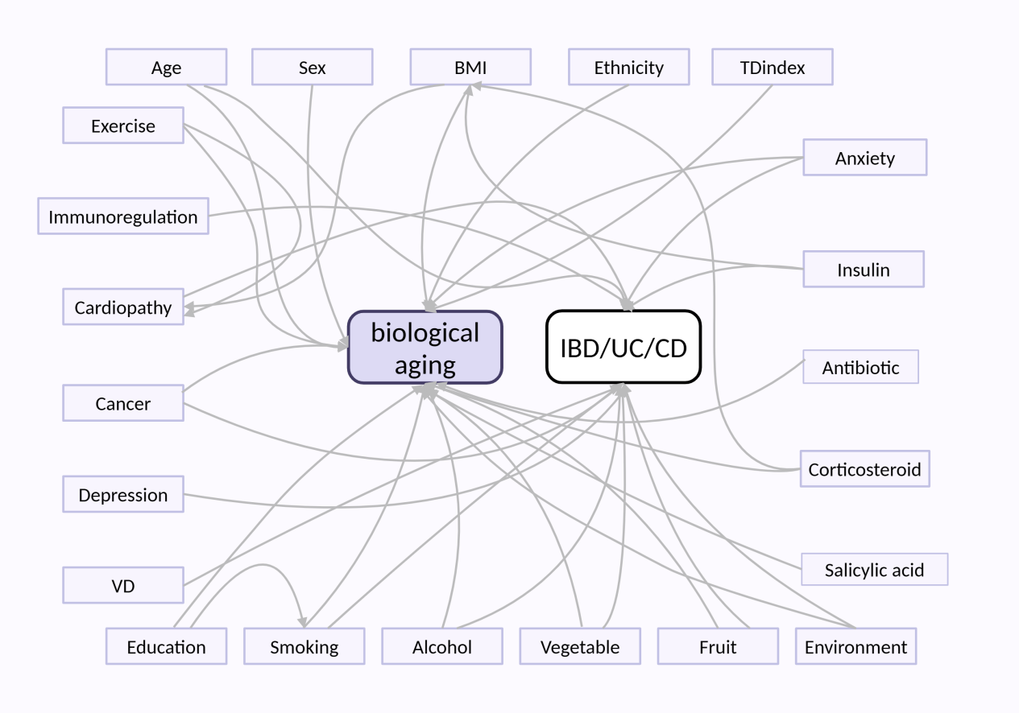

Supplementary Figure 2: Association between life expectancy lost and biological aging (UC/CD)
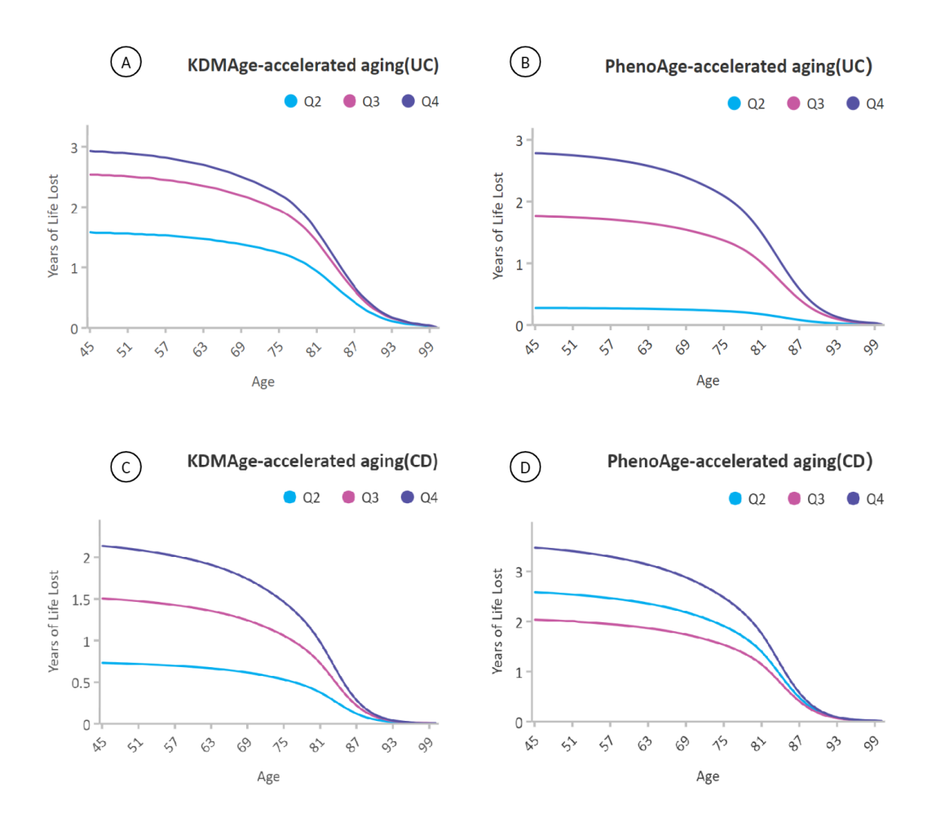

Supplementary Figure 3: Forest plot of subgroup interaction effects on KDMAgeAccel (IBD).
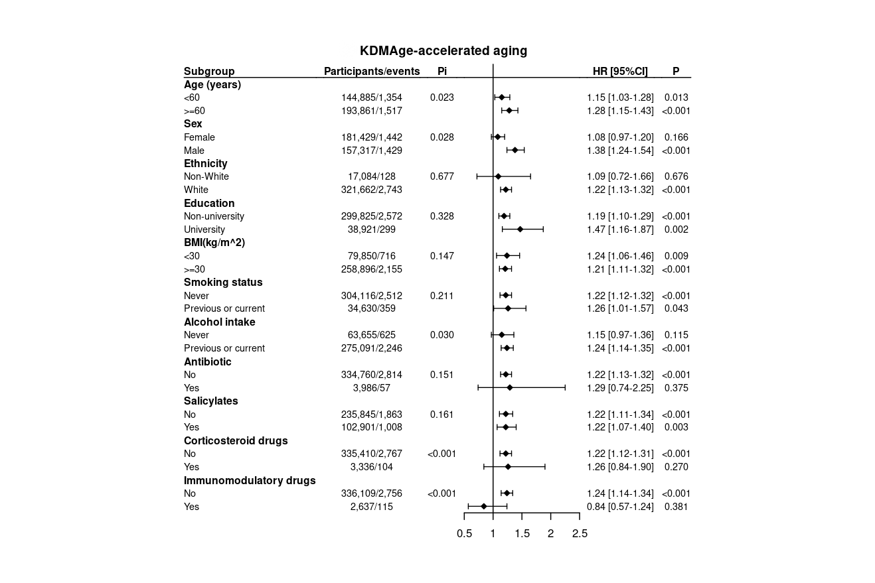

Supplementary Figure 4: Forest plot of subgroup interaction effects on PhenoAgeAccel (IBD).

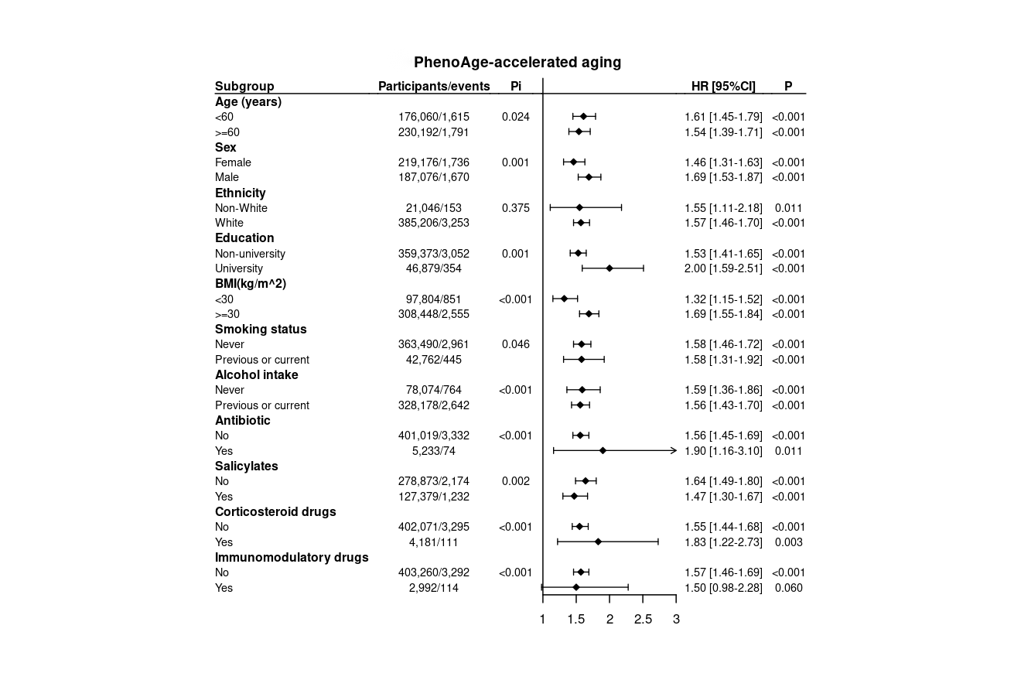

Supplementary Figure 5:Forest plot of subgroup interaction effects on KDMAgeAccel (UC).
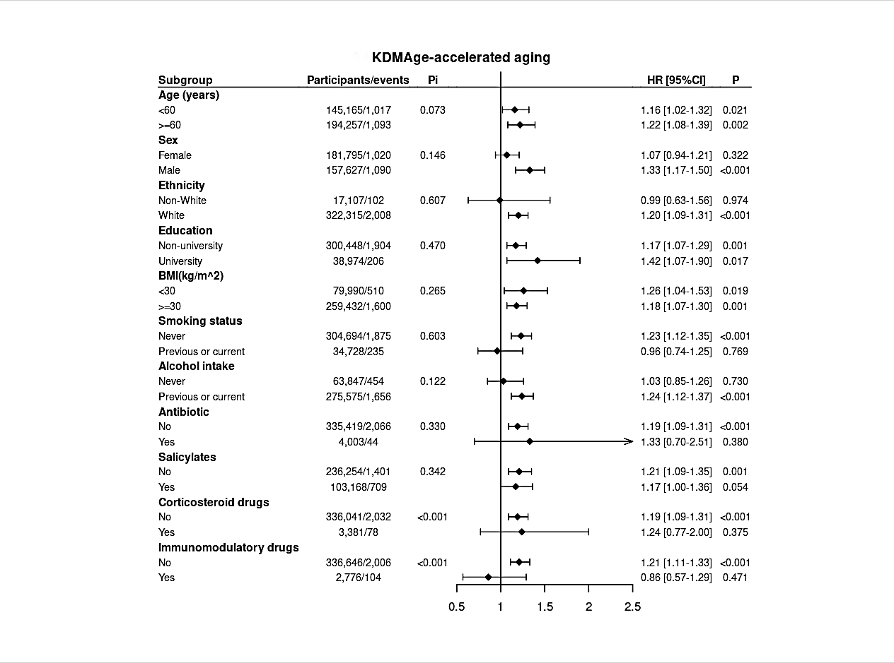

Supplementary Figure 6: Forest plot of subgroup interaction effects on PhenoAgeAccel (UC).
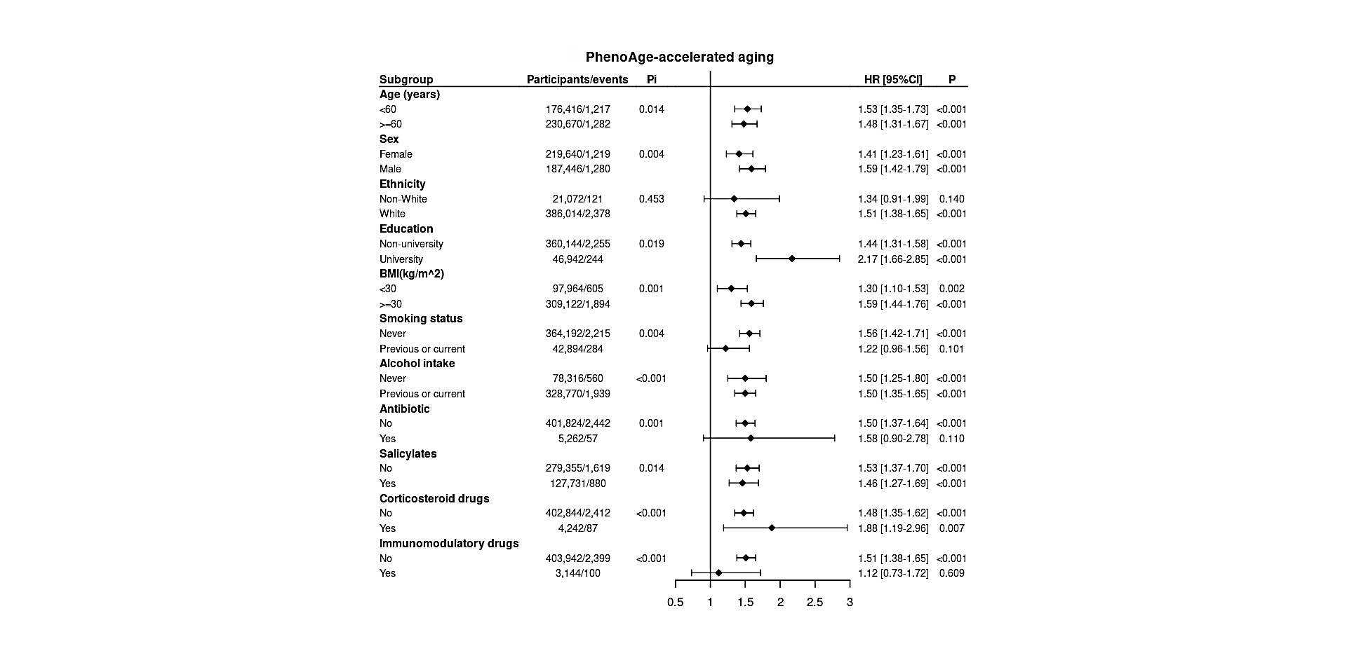

Supplementary Figure 7: Forest plot of subgroup interaction effects on KDMAgeAccel (CD).
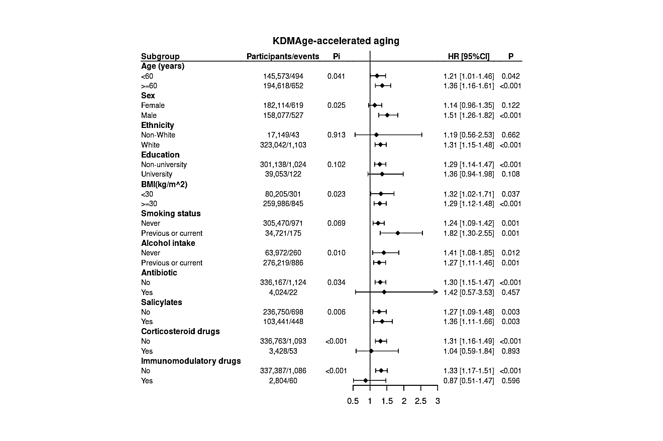
Supplementary Figure 8: Forest plot of subgroup interaction effects on PhenoAgeAccel (CD).

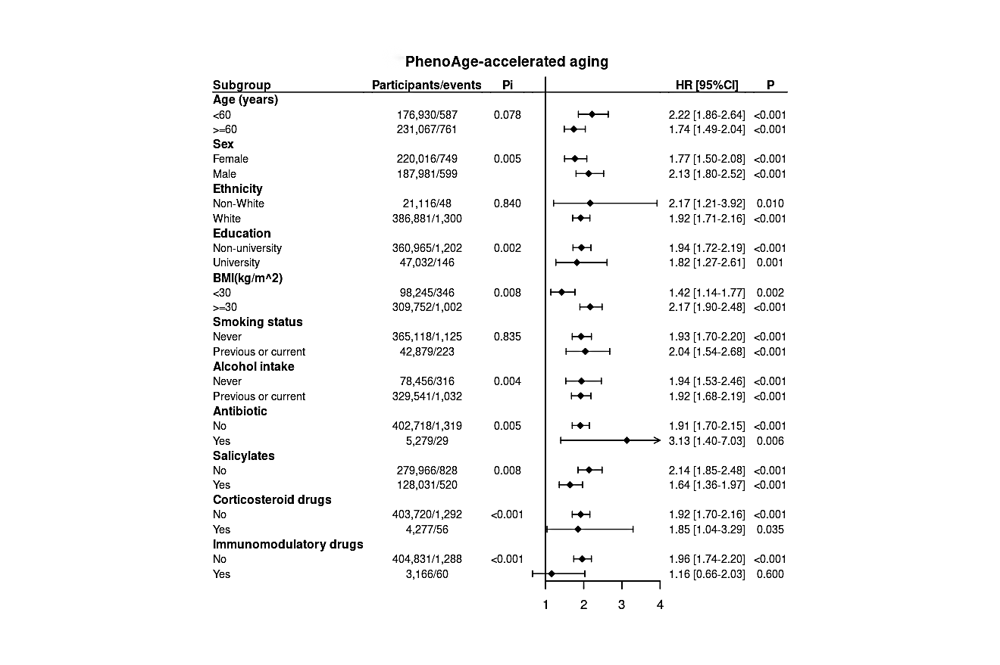

Supplementary Figure 9: Dose-response association between KDMAgeAccel/PhenoAgeAccel and IBD risk as assessed by restricted cubic spline regression.
