Supplementary Information

Arrhythmia in the Amazon: La Niña influence on riverine organic molecular signatures
Martin R. Kurek¹*, Aron Stubbins², Travis Drake³, Jose M.S. Moura⁴, R. Max Holmes⁵, Helena Osterholz^{6,7}, Thorsten Dittmar^{7,8}, Bernhard Peucker-Ehrenbrink⁹, Miyuki Mitsuya⁴, Robert G.M. Spencer¹

¹Department of Earth, Ocean and Atmospheric Science, Florida State University, Tallahassee, FL, USA
²Departments of Marine and Environmental Science, and Civil and Environmental Engineering, and Chemistry and Chemical Biology, Northeastern University, Boston, MA, USA
³Department of Environmental Systems Science, Swiss Federal Institute of Technology, ETH Zurich, Switzerland
⁴Center for Interdisciplinary Formation, Federal University of Western Para, Santarém, PA, Brazil
⁵Woods Hole Research Center, Falmouth, MA, USA
⁶Marine Chemistry, Leibniz Institute for Baltic Sea Research Warnemünde, Rostock, Germany
⁷Institute for Chemistry and Biology of the Marine Environment (ICBM), University of Oldenburg, Oldenburg, Germany
⁸Helmholtz Institute for Functional Marine Biodiversity (HIFMB) at the University of Oldenburg, Oldenburg, Germany
⁹Woods Hole Oceanographic Institution, Woods Hole, MA, USA

*Corresponding author: mrk19f@my.fsu.edu

Supplemental figures and tables:
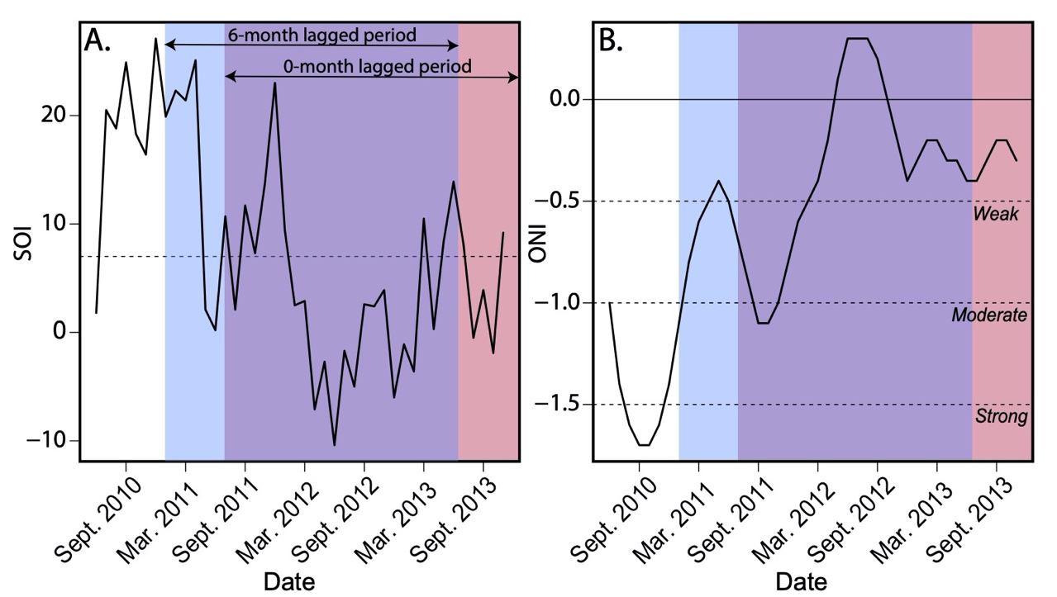
Figure S1. (A) Monthly Southern Oscillation Index (SOI) from June 2010 to November 2013 with data obtained from the Australian Government Bureau of Meteorology. Sustained SOI values above 7 (dashed line) are typical of La Niña events. (B) Monthly Oceanic Niño Index (ONI) from June 2010 to November 2013 with data obtained from the National Oceanic and Atmospheric Administration (NOAA). Values below -1.5 indicate a strong La Niña event, values between -1.0 and -1.5 indicate a moderate La Niña event and values between -0.5 and -1.0 indicate a weak La Niña event. The shaded pink regions correspond to the months from the study period (July 2011 to November 2013) and a 0-month lag in index values. The shaded blue region spans index values 6 months prior to the start of the study period illustrating a 6-month lag. The overlap between the regions signifies SOI and ONI values that occurred during both the 0-month and 6-month lag periods.

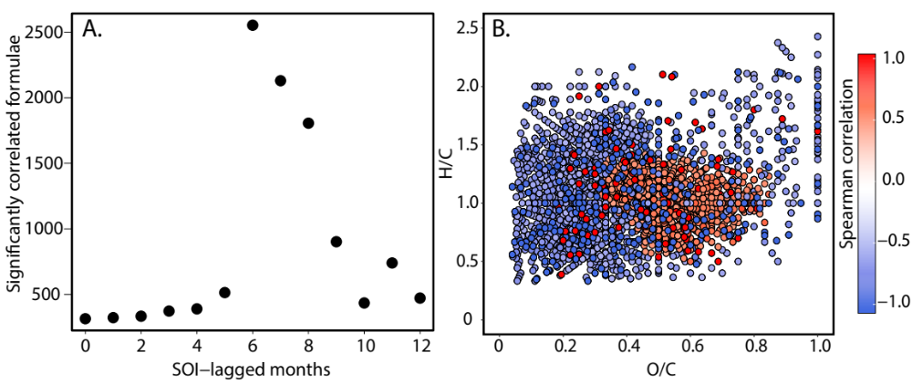
Figure S2. (A) Total number of significantly correlated molecular formulae with SOI values lagging from 0 to 12 months. (B) van Krevelen diagram of formulae correlated with SOI values from a 6-month lag period. Red points are positively correlated with SOI values while blue points are negatively correlated with SOI values.

Table S1. Mean values for FT-ICR MS-derived DOM compositions in the La Niña year (August 2011 to July 2012) and the normal year (August 2012 to July 2013) of the study period. Statistical significance (α=0.05) between the two means was evaluated using a T-test.

 | August 2011-July 2012  ‘La Niña year’ | August 2012-July 2013  ‘normal year’ | p
Mass (Da) | 428.1332 | 404.7946 | 0.0014
H/C | 1.09 | 1.12 | 0.0029
O/C | 0.40 | 0.39 | 0.014
C_{OX} | -0.29 | -0.34 | 0.0042
AI_{mod} | 0.36 | 0.35 | 0.0029
n_{Formula} | 7523 | 6289 | 0.0080
S/C (x10³) | 5.9 | 6.5 | 0.030
P/C (x10³) | 3.5 | 4.6 | 0.0039
N/C (x10³) | 30.8 | 29.6 | 0.33
% IOS | 6.0 | 4.8 | 0.0018

Supplemental methods:
Anion concentrations (Cl⁻ and SO₄²⁻) were measured using a Dionex ion chromatography system using a modified procedure outlined in Voss et al¹. Undiluted samples were injected twice on an anion column (IonPacAS15, 4mm, with ASRS 300 suppressor) and eluted with 50% 75 mM NaOH and 50% Milli-Q water. Analytical response was evaluated against serial dilutions using an internal standard (SpecPure ion chromatography standards; Alfa Aesar) and IAPSO standard seawater certified reference material (CRM, Batch P160). Final concentrations were calculated using a 5-point calibration curve with Chromeleon software and no blank correction. CRM concentrations were always within ± 3% of reported values for Cl⁻ and SO₄²⁻.
Cation concentrations (Na⁺, Mg²⁺, K⁺, Ca²⁺) were determined from single collect, inductively coupled plasma, magnetic sector mass spectrometry (ICPMS) using the Thermo Scientific Element2 ICMPS of the WHOI Plasma Facility with methods described in Voss et al.¹ and Brown et al.² Water samples (1.8 mL) were pipetted into 2 mL screwcap autosampler vials and centrifuged (10 minutes at 7000 rpm) in a clean laboratory. The supernatant (1 mL) was transferred to another 2 mL vial and small amounts of indium and rhenium internal standards were added and the pH was adjusted to ≤ 2 with HNO₃. The concentrations of the internal standard isotopes were adjusted such that typical count rates were ~500,000 counts per second (cps, 10¹¹ Ω resistor). Sample vials were placed on a vibrating shaker before being loaded into an autosampler and analyzed by self-aspiration at medium (m/Δm ~3000, Ca) and high (m/Δm ~10,000, Na, Mg, K) mass resolving powers. Concentrations were determined with 7-point calibration curves using serial dilutions of NIST 1640a and SLRC-5 (National Research Council Canada) as certified reference materials. Whenever possible, count rates were collected for more than one isotope per element in order to check for the presence of isobaric interferences. Analytical blanks were prepared identical to the samples using Milli-Q water. Analytical results were corrected for blank, drift and isobaric interferences. External reproducibility (2 standard deviation) was generally within ±5%.
Samples were acidified and measured for SiO₂ using colorimetry on an Astoria Analzyer with methods modified from Mann et al.³

References

- Voss, B. M. Tracing river chemistry in space and time: Dissolved inorganic constituents of the Fraser River, Canada. Geochimica et Cosmochimica Acta 124, 283-308 (2014).
- Brown, K. A. et al. Geochemistry of Small Canadian Arctic Rivers with Diverse Geological and Hydrological Settings. Journal of Geophysical Research: Biogeosciences 125, 1-21 (2020).
- Mann, P. J. et al. Controls on the composition and lability of dissolved organic matter in Siberia's Kolyma River basin. Journal of Geophysical Research: Biogeosciences 117, 1-15 (2012).

