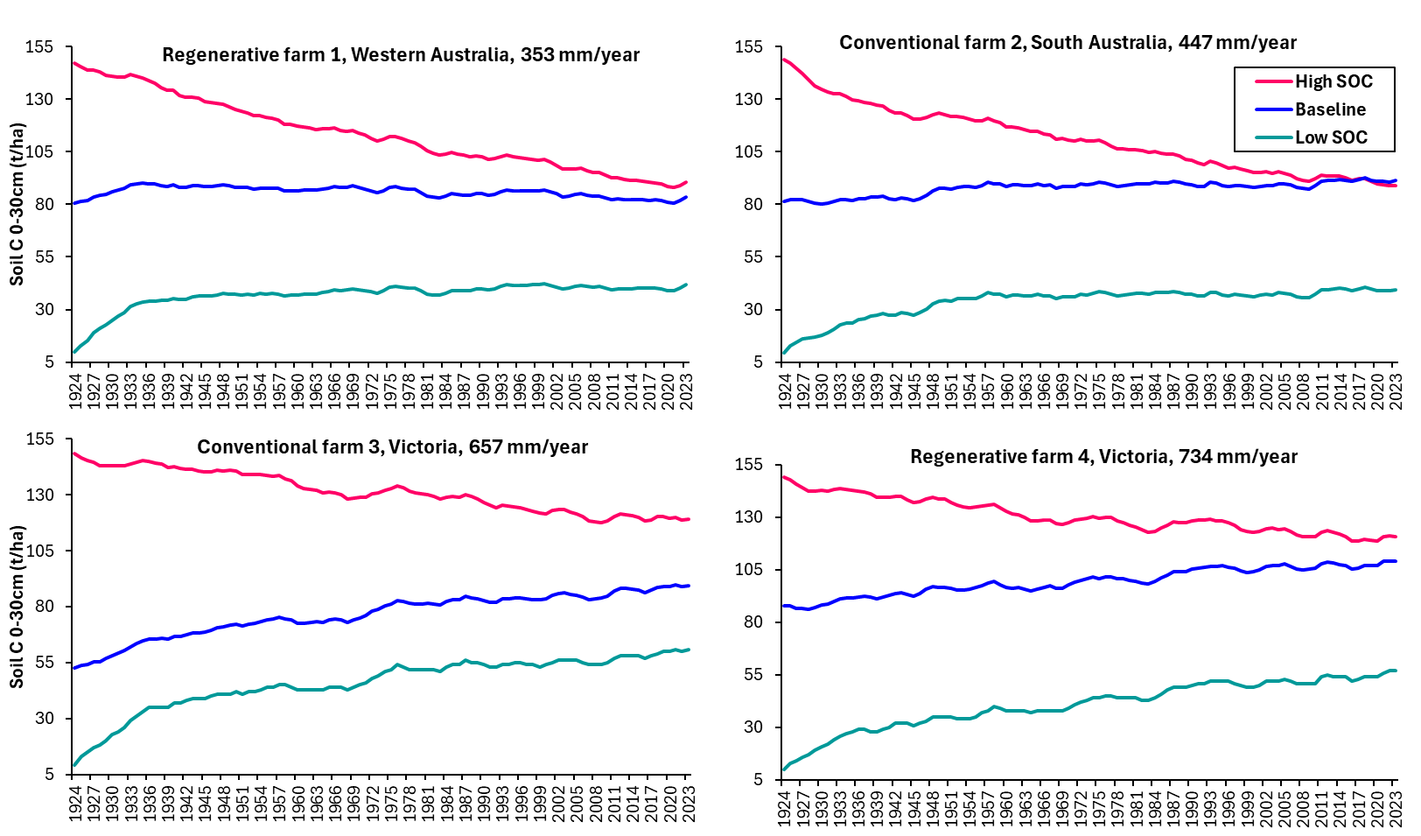
Fig. S1. Long-term soil organic carbon (SOC) in the soil surface (0-30 cm) for the Baseline, low (0.3%) and high (6%) antecedent SOC levels in four regions across southern Australia.
Fig. S2. Change in gross margins per DSE for high and low productivity botanical compositions relative to Baseline species across sheep and SOC prices.
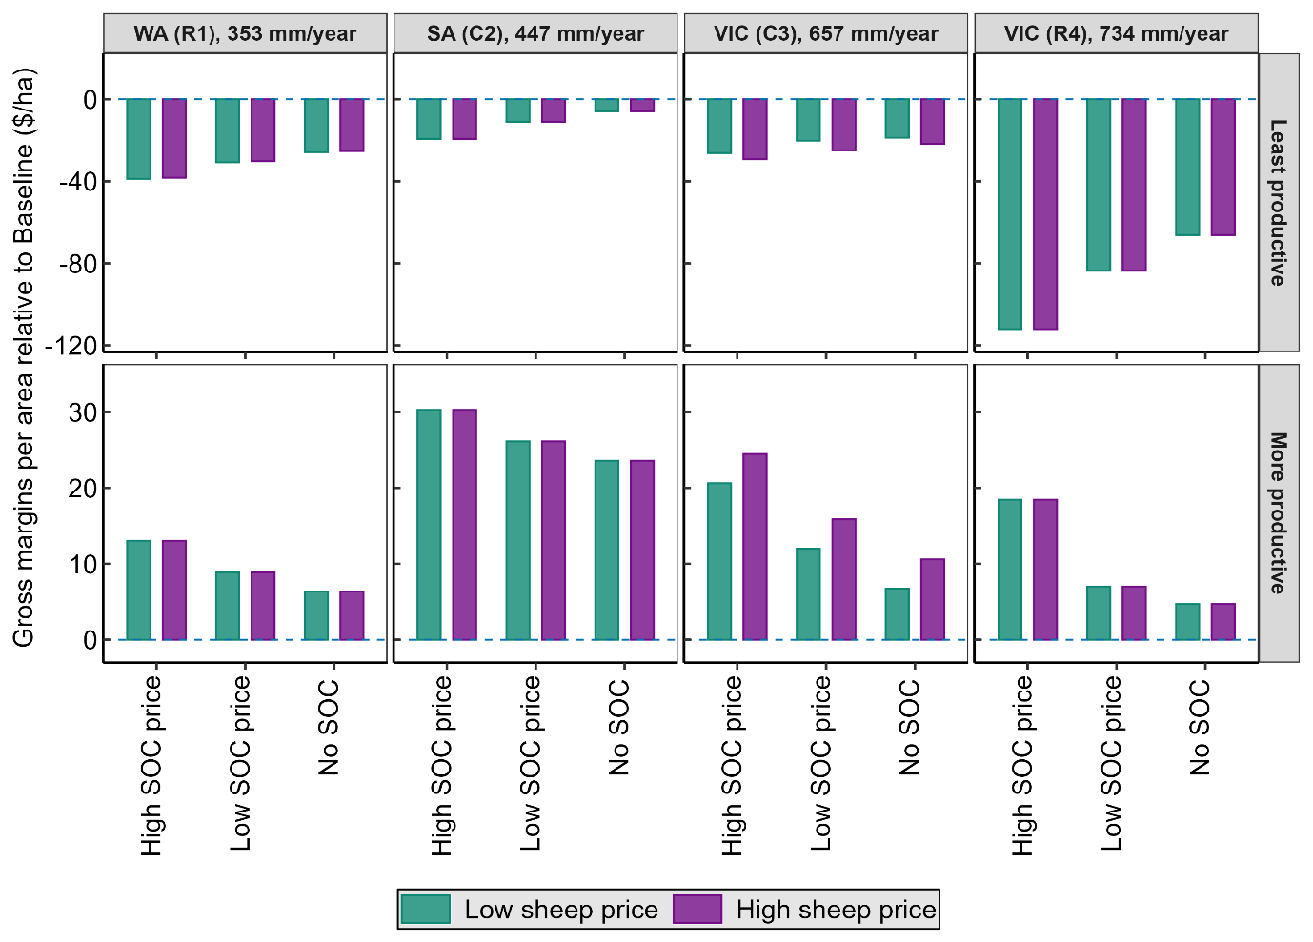
Fig. S3. Change in gross margins per hectare for high and low productivity botanical compositions relative to Baseline species across sheep and SOC prices.
Fig. S4. Change in carbon income for high and low productivity botanical compositions relative to each Baseline at high and low carbon prices.
Fig. S5. Total annual and relative supplementary feed costs for botanical compositions. Relative supplementary feed cost computed as change in total supplementary feed cost for the most and least productive botanical compositions compared with the Baseline for each farm.
Fig. S6. Carbon emissions costs associated with botanical composition and sheep price. Relative GHG emissions cost computed relative to the Baseline GHG emissions for each case study farm.
Fig. S7. Gross margins per dry sheep equivalent (DSE) and per grazed area relative to the SOC sequestration of the Baseline, low (0.3%) and high (6%) antecedent SOC levels. Gross margins were computed for high (yellow points) and low (green points) sheep prices, combined with three levels of GHG emissions costs: high (red outline), low (purple outline), and none (blue outline).
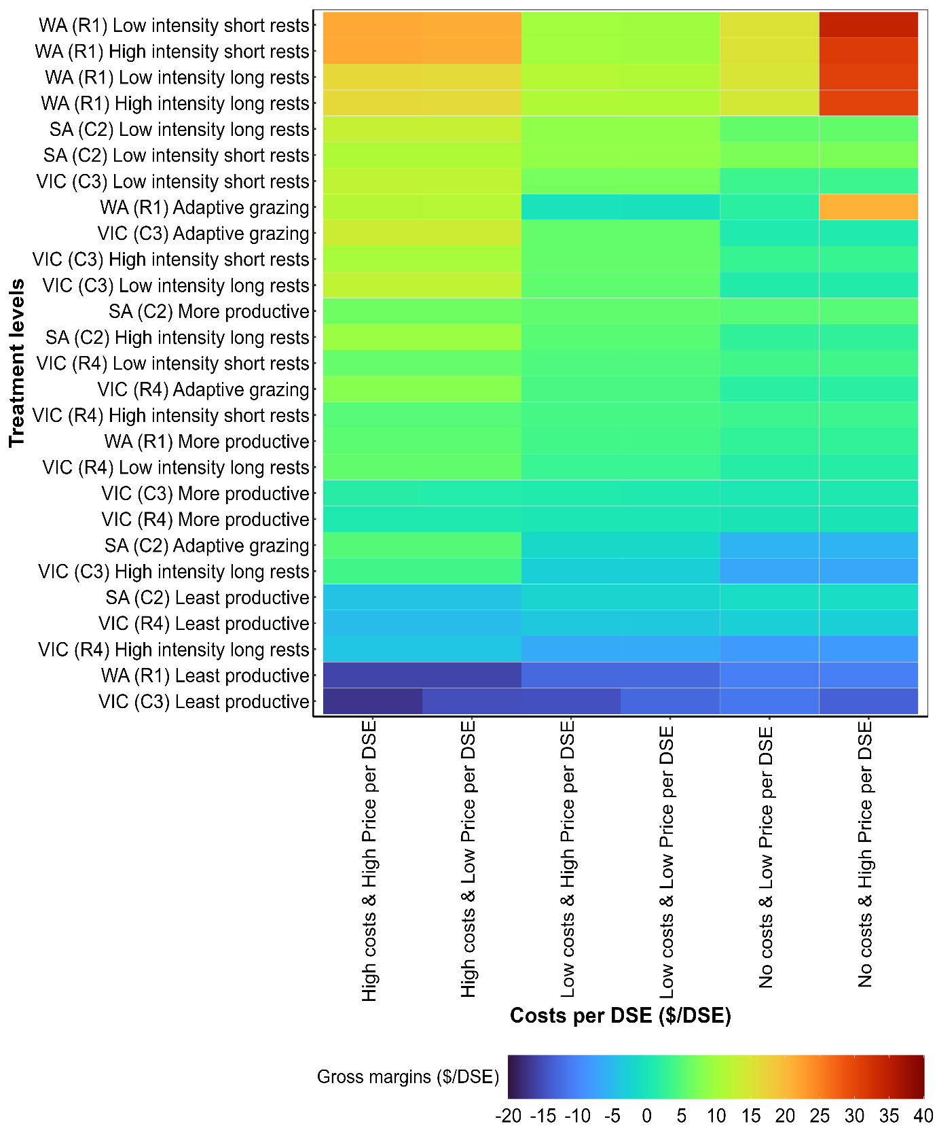
Fig. S8. Relative change in gross margin per dry sheep equivalent (DSE) in relation to costs associated with supplementary feeding and GHG emissions. Gross margins are contrast across all farms, pasture species and grazing regimes.
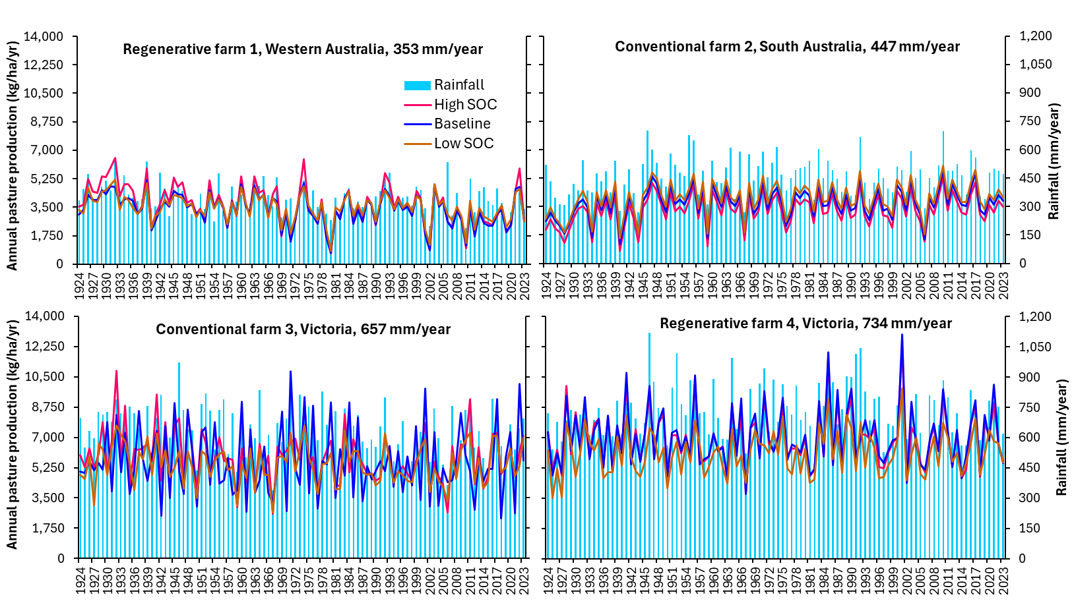
Fig. S9. Annual rainfall and pasture production associated with low (0.3%), high (6%) and Baseline antecedent SOC stocks.

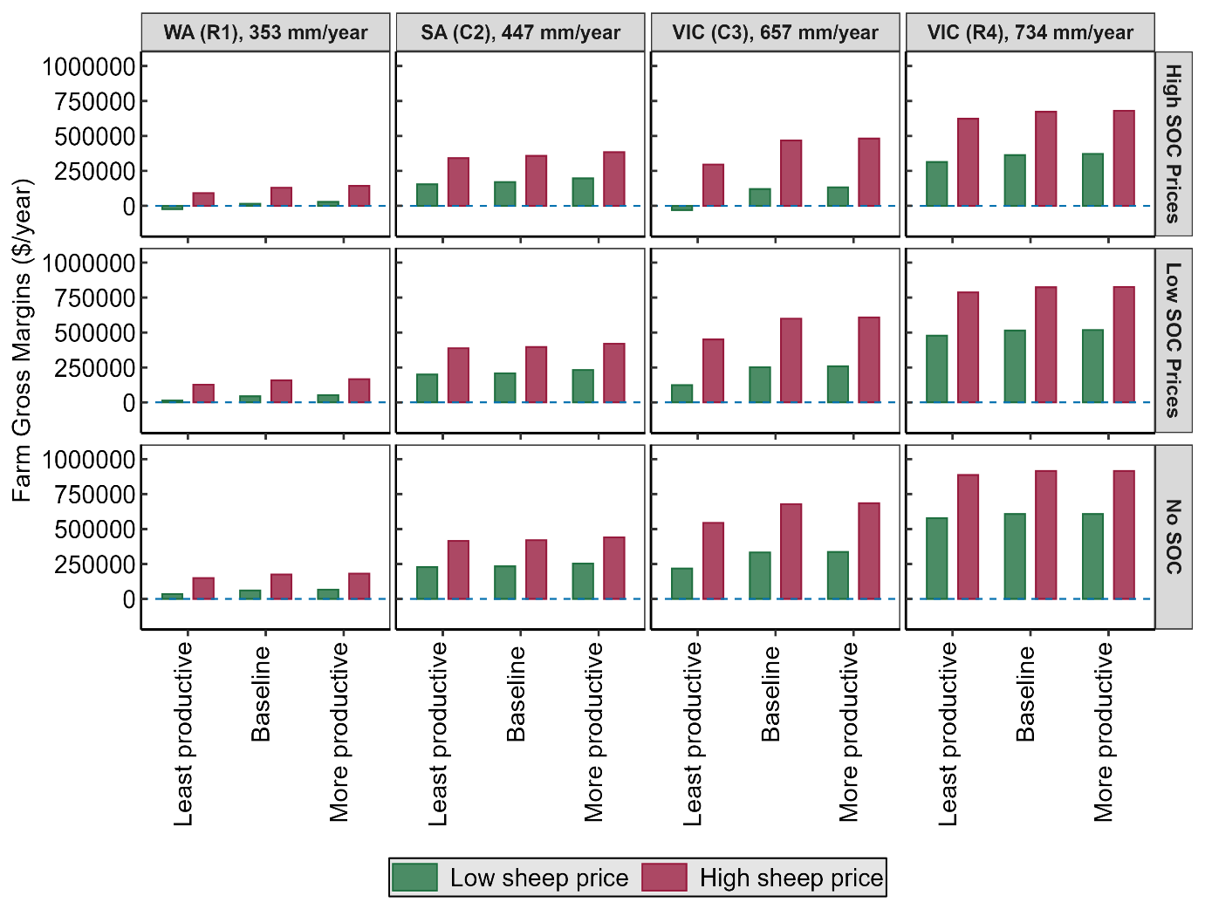
Fig. S10. Influence of pasture diversity on gross margins across a rainfall gradient for high and low sheep and carbon prices.

Table S1. Soil organic carbon (SOC) sequestration, annualised GHG emissions and carbon footprint for the highest and lowest productivity pasture botanical compositions. Absolute SOC sequestration depicted as the change in SOC stocks over 100 years (1924-2023).
 | Pasture type | WA (R1),  353 mm/year | SA (C2),  447 mm/year | VIC (C3),  657 mm/year | VIC (R4),  734 mm/year
Change in absolute SOC (t C/ha)
More productive |  | 6 | 15 | 40 | 25
Least productive |  | -4 | -5 | -5 | -3
Baseline |  | 3 | 10 | 37 | 21
SOC sequestration (t CO₂e/ha/yr)
More productive |  | 0.02 | 0.06 | 0.25 | 0.21
Least productive |  | -0.02 | -0.02 | -0.03 | -0.03
Baseline |  | 0.01 | 0.04 | 0.23 | 0.10
Net farm emissions (t CO₂e/ha/yr)
More productive |  | 0.4 | 0.7 | 3.6 | 5.6
Least productive |  | 0.6 | 0.9 | 4.2 | 6.0
Baseline |  | 0.5 | 0.8 | 3.8 | 5.7
CH₄ emissions (t CO₂e/ha/yr)
More productive |  | 0.3 | 0.7 | 3.2 | 4.9
Least productive |  | 0.4 | 0.7 | 3.4 | 5.0
Baseline |  | 0.3 | 0.7 | 3.2 | 5.0
N₂O emissions (t CO₂e/ha/yr)
More productive |  | 0.04 | 0.04 | 0.41 | 0.79
Least productive |  | 0.05 | 0.04 | 0.43 | 0.82
Baseline |  | 0.04 | 0.05 | 0.42 | 0.80
CO₂ emissions (t CO₂e/ha/yr)
More productive |  | 0.09 | 0.06 | 0.26 | 0.09
Least productive |  | 0.09 | 0.06 | 0.26 | 0.09
Baseline |  | 0.09 | 0.06 | 0.26 | 0.09
Emissions intensity of wool including sequestration (kg CO₂e/kg CFW¹)
More productive |  | 19.5 | 25.3 | 24.8 | 29.6
Least productive |  | 26.3 | 31.0 | 30.2 | 31.7
Baseline |  | 22.1 | 27.4 | 25.7 | 30.4
Emissions intensity of sheep meat including sequestration (kg CO₂e/kg LW²)
More productive |  | 5.3 | 4.5 | 4.5 | 5.3
Least productive |  | 7.3 | 5.6 | 5.4 | 5.7
Baseline |  | 5.9 | 4.9 | 4.6 | 5.5
¹CFW = Clean fleece weight; ²LW = live weight

Table S2. Absolute soil organic carbon (SOC) accrual and relative change in SOC for low and high antecedent SOC levels in the upper soil layer (0-30 cm) over 100-years (1924-2023). Relative SOC was computed as the change in absolute SOC compared with the Baseline over the same period.
Antecedent SOC levels | WA (R1), 353 mm/year | SA (C2), 447 mm/year | VIC (C3), 657 mm/year | VIC (R4), 734 mm/year
Soil type | Sandy loam and medium clay | Sandy soils | Clay-rich soils | Sandy loam
Absolute SOC (t C/ha)
Baseline | 3 | 10 | 37 | 21
Low SOC (0.3%) | 32 | 30 | 52 | 47
High SOC (6%) | -57 | -60 | -30 | -28
Relative SOC (t C/ha)
Low SOC (0.3%) | 29 | 20 | 15 | 26
High SOC (6%) | -60 | -70 | -67 | -49
Table S3. Absolute soil organic carbon (SOC) accrual and relative change in SOC for low and high antecedent SOC levels in the lower soil layer (30-50 cm) over 100-years (1924-2023). Relative SOC was computed as the change in absolute SOC compared with the Baseline over the same period.
Antecedent SOC levels | WA (R1), 353 mm/year | SA (C2), 447 mm/year | VIC (C3), 657 mm/year | VIC (R4), 734 mm/year
Soil type | Sandy loam and medium clay | Sandy soils | Clay-rich soils | Sandy loam
Absolute SOC (t C/ha)
Baseline | -5 | -4 | -6 | -5
Low SOC (0.3%) | 1 | 1 | 2 | 2
High SOC (6%) | -11 | -11 | -9 | -10
Relative SOC (t C/ha)
Low SOC (0.3%) | 6 | 5 | 8 | 7
High SOC (6%) | -6 | -7 | -3 | -5

Table S4. Soil organic carbon (SOC) sequestration, annualised GHG emissions and emissions intensities for the baseline, low (0.3%) and high (6%) antecedent SOC levels within the upper (0-30 cm), across four case study farms. Negative SOC sequestration represents SOC loss and increase in net GHG emissions, while positive SOC sequestration represents SOC accrual and decrease in net GHG emissions.
Antecedent SOC levels | WA (R1),  353 mm/year | SA (C2),  447 mm/year | VIC (C3),  657 mm/year | VIC (R4),  734 mm/year
SOC sequestration (t CO₂e/ha/year)
Baseline | 0.01 | 0.04 | 0.23 | 0.18
Low SOC (0.3%) | 0.12 | 0.13 | 0.32 | 0.41
High SOC (6%) | -0.21 | -0.25 | -0.18 | -0.23
Net farm emissions (t CO₂e/ha/year)
Baseline | 0.5 | 0.8 | 3.9 | 5.7
Low SOC (0.3%) | 0.4 | 0.6 | 3.4 | 5.0
High SOC (6%) | 0.7 | 1.0 | 4.4 | 6.3
CH₄ emissions (t CO₂e/ha/year)
Baseline | 0.3 | 0.7 | 3.4 | 5.0
Low SOC (0.3%) | 0.3 | 0.6 | 3.0 | 5.0
High SOC (6%) | 0.4 | 0.7 | 3.5 | 5.1
N₂O emissions (t CO₂e/ha/year)
Baseline | 0.04 | 0.05 | 0.43 | 0.80
Low SOC (0.3%) | 0.04 | 0.04 | 0.43 | 0.66
High SOC (6%) | 0.04 | 0.05 | 0.44 | 0.72
CO₂ emissions (t CO₂e/ha/year)
Baseline | 0.13 | 0.06 | 0.26 | 0.09
Low SOC (0.3%) | 0.13 | 0.06 | 0.26 | 0.09
High SOC (6%) | 0.13 | 0.06 | 0.26 | 0.09
Emissions intensity of wool including sequestration (kg CO₂e/kg CFW)
Baseline | 24.0 | 36.3 | 26.5 | 30.4
Low SOC (0.3%) | 17.9 | 29.9 | 25.5 | 28.9
High SOC (6%) | 34.9 | 50.0 | 30.4 | 33.1
Emissions intensity of sheep meat including sequestration (kg CO₂e/kg LW)
Baseline | 6.4 | 6.5 | 4.8 | 5.5
Low SOC (0.3%) | 4.8 | 5.4 | 4.6 | 5.2
High SOC (6%) | 9.4 | 9.0 | 5.5 | 6.0

Table S5. Average pasture productivity, supplementary feed intake, and liveweight for Baseline, low (0.3%) and high (6%) antecedent SOC levels across four regions.
Antecedent SOC levels | WA (R1), 353 mm/year | SA (C2), 447 mm/year | VIC (C3), 657 mm/year | VIC (R4), 734 mm/year
Average monthly pasture growth rate (kg/ha/day)
Baseline | 9 | 10 | 16 | 19
Low SOC (0.3%) | 10 | 10 | 15 | 17
High SOC (6%) | 10 | 10 | 16 | 19
Mean annual pasture production (kg/ha/yr)
Baseline | 3,386 | 3,608 | 5,808 | 7,045
Low SOC (0.3%) | 3,484 | 3,592 | 5,440 | 6,122
High SOC (6%) | 3,460 | 3,604 | 5,873 | 6,908
Average annual supplementary feed intake (kg/animal/yr)
Baseline | 24 | 47 | 19 | 18
Low SOC (0.3%) | 21 | 47 | 21 | 21
High SOC (6%) | 22 | 47 | 19 | 18

Table S6. Effects of grazing regime on absolute SOC storage and relative change in the topsoil SOC (0-30 cm) across four regions. Absolute SOC accrual was calculated as the change in SOC stocks over 100-years (1924-2023) relative to the initial year (1924). Relative change in SOC was calculated as the change in absolute SOC compared with the Baseline.
Grazing regime | WA (R1), 353 mm/year | SA (C2), 447 mm/year | VIC (C3), 657 mm/year | VIC (R4), 734 mm/year
Change in absolute SOC (t C/ha) 0-30 cm
Adaptive grazing | 27 | 23 | 79 | 45
High intensity long rests | 23 | 22 | 72 | 42
Low intensity long rests | 19 | 17 | 70 | 36
High intensity short rests | 15 | 12 | 69 | 29
Low intensity short rests | 7 | 5 | 66 | 24
Set stocked (Baseline) | 3 | 10 | 37 | 21
Relative change in SOC (t C/ha) 0-30 cm
Adaptive grazing | 24 | 13 | 42 | 24
High intensity long rests | 20 | 12 | 35 | 21
Low intensity long rests | 16 | 7 | 33 | 15
High intensity short rests | 12 | 2 | 32 | 8
Low intensity short rests | 4 | -5 | 29 | 3

Table S7. Effects of grazing regime on topsoil (0-30 cm) soil organic carbon (SOC) sequestration, net GHG emissions (carbon, enteric methane and nitrous oxide) and emissions intensity of wool and sheep meat across four regions in southern Australia depicted along a rainfall gradient.
Grazing regime | WA (R1), 353 mm/year | SA (C2), 447 mm/year | VIC (C3), 657 mm/year | VIC (R4), 734 mm/year
Carbon sequestration (t CO₂e/year)
Adaptive grazing | -0.10 | -0.10 | -0.48 | -0.38
High intensity long rests | -0.08 | -0.09 | -0.44 | -0.35
Low intensity long rests | -0.07 | -0.07 | -0.43 | -0.30
High intensity short rests | -0.06 | -0.05 | -0.42 | -0.24
Low intensity short rests | -0.03 | -0.02 | -0.40 | -0.20
Set stocked (Baseline) | -0.01 | -0.04 | -0.23 | -0.18
Net farm emissions (t CO₂e/year)
Adaptive grazing | 0.08 | 0.32 | 1.96 | 4.52
High intensity long rests | 0.13 | 0.48 | 2.31 | 4.95
Low intensity long rests | 0.13 | 0.44 | 2.18 | 4.89
High intensity short rests | 0.25 | 0.59 | 2.80 | 5.39
Low intensity short rests | 0.22 | 0.57 | 2.48 | 5.21
Set stocked (Baseline) | 0.47 | 0.76 | 3.85 | 5.71
CH₄ emissions (t CO₂e/year)
Adaptive grazing | 0.07 | 0.31 | 1.97 | 4.21
High intensity long rests | 0.10 | 0.46 | 2.25 | 4.57
Low intensity long rests | 0.09 | 0.43 | 2.13 | 4.43
High intensity short rests | 0.18 | 0.54 | 2.59 | 4.79
Low intensity short rests | 0.13 | 0.49 | 2.36 | 4.68
Set stocked (Baseline) | 0.35 | 0.68 | 3.36 | 4.96
N₂O emissions (t CO₂e/year)
Adaptive grazing | 0.07 | 0.31 | 1.97 | 4.21
High intensity long rests | 0.10 | 0.46 | 2.25 | 4.57
Low intensity long rests | 0.09 | 0.43 | 2.13 | 4.43
High intensity short rests | 0.18 | 0.54 | 2.59 | 4.79
Low intensity short rests | 0.13 | 0.49 | 2.36 | 4.68
Set stocked (Baseline) | 0.35 | 0.68 | 3.36 | 4.96
CO₂ emissions (t CO₂e/year)
Adaptive grazing | 0.09 | 0.06 | 0.26 | 0.09
High intensity long rests | 0.09 | 0.06 | 0.26 | 0.09
Low intensity long rests | 0.09 | 0.06 | 0.26 | 0.09
High intensity short rests | 0.09 | 0.06 | 0.26 | 0.09
Low intensity short rests | 0.09 | 0.06 | 0.26 | 0.09
Set stocked (Baseline) | 0.09 | 0.06 | 0.26 | 0.09
Emissions intensity of wool including sequestration (kg CO₂e/kg CFW)
Adaptive grazing | 3.7 | 15.2 | 12.2 | 24.1
High intensity long rests | 6.2 | 23.0 | 14.8 | 26.4
Low intensity long rests | 6.0 | 21.2 | 13.9 | 26.6
High intensity short rests | 11.7 | 28.3 | 18.5 | 28.8
Low intensity short rests | 10.3 | 27.2 | 16.1 | 27.8
Set stocked (Baseline) | 22.1 | 36.3 | 26.5 | 30.4
Emissions intensity of sheep meat including sequestration (kg CO₂e/kg LW)
Adaptive grazing | 1.0 | 2.7 | 2.2 | 4.3
High intensity long rests | 1.7 | 4.1 | 2.7 | 4.8
Low intensity long rests | 1.6 | 3.8 | 2.5 | 4.8
High intensity short rests | 3.1 | 5.1 | 3.3 | 5.2
Low intensity short rests | 2.8 | 4.9 | 2.9 | 5.0
Set stocked (Baseline) | 5.9 | 6.5 | 4.8 | 5.5

Table S8. Long-term average pasture productivity, supplementary feed intake and liveweight.
Grazing regime | WA (R1), 353 mm/year | SA (C2), 447 mm/year | VIC (C3), 657 mm/year | VIC (R4), 734 mm/year
Average monthly pasture growth rate (kg/ha/day)
Adaptive grazing | 13 | 15 | 22 | 25
Low intensity long rests | 12 | 14 | 20 | 23
High intensity short rests | 12 | 13 | 20 | 23
Low intensity short rests | 12 | 13 | 20 | 23
High intensity long rests | 11 | 12 | 19 | 22
Set stocked (Baseline) | 9 | 10 | 16 | 19
Mean annual pasture production (kg/ha/yr)
Adaptive grazing | 4,704 | 5,223 | 8,243 | 8,986
Low intensity long rests | 4,552 | 4,998 | 7,306 | 8,571
High intensity short rests | 4,468 | 4,887 | 7,245 | 8,354
Low intensity short rests | 4,401 | 4,877 | 7,205 | 8,256
High intensity long rests | 4,231 | 4,647 | 7,063 | 8,171
Set stocked (Baseline) | 3,386 | 3,608 | 5,808 | 7,045
Average annual supplementary feed intake (kg/animal/yr)
Adaptive grazing | 43 | 66 | 16 | 12
High intensity long rests | 14 | 39 | 42 | 45
Low intensity long rests | 13 | 28 | 15 | 13
Low intensity short rests | 12 | 23 | 9 | 7
High intensity short rests | 12 | 22 | 8 | 6
Set stocked (Baseline) | 24 | 47 | 19 | 18

Table S9. Impacts of pasture botanical composition on gross margins per year, per dry sheep equivalent (DSE), and per grazed area across four case study sheep farms, depicted along a rainfall gradient. Gross margins were computed under high and low sheep prices, as well as with high, low, and no GHG emissions costs.
Pasture type | Emission costs | WA (R1), 353 mm/year |  | SA (C2), 447 mm/year |  | VIC (C3), 657 mm/year |  | VIC (R4), 734 mm/year
Pasture type | Emission costs | Low Price | High Price | Low Price | High Price | Low Price | High Price | Low Price | High Price
Gross margin ($/year)
Least productive | High costs | -23,766 | 90,962 | 153,641 | 341,186 | -30,355 | 295,736 | 314,091 | 622,904
Least productive | Low costs | 12,504 | 127,232 | 199,279 | 386,824 | 123,466 | 449,558 | 477,511 | 786,325
Least productive | No costs | 34,734 | 149,462 | 227,251 | 414,796 | 217,744 | 543,836 | 577,672 | 886,485
Baseline | High costs | 15,066 | 129,241 | 170,350 | 357,895 | 120,394 | 467,298 | 363,411 | 672,224
Baseline | Low costs | 43,276 | 157,451 | 208,790 | 396,335 | 251,593 | 598,497 | 514,319 | 823,132
Baseline | No costs | 60,566 | 174,741 | 232,350 | 419,895 | 332,006 | 678,910 | 606,811 | 915,624
More productive | High costs | 28,104 | 142,279 | 196,534 | 384,079 | 132,761 | 481,978 | 371,528 | 680,342
More productive | Low costs | 52,160 | 166,335 | 231,386 | 418,932 | 258,796 | 608,012 | 517,403 | 826,217
More productive | No costs | 66,904 | 181,079 | 252,747 | 440,293 | 336,043 | 685,259 | 606,811 | 915,624
Gross margin per dry sheep equivalent ($/DSE)
Least productive | High costs | -10 | 37 | 38 | 84 | -3 | 30 | 31 | 62
Least productive | Low costs | 5 | 52 | 49 | 95 | 12 | 45 | 48 | 79
Least productive | No costs | 14 | 61 | 56 | 102 | 22 | 54 | 58 | 89
Baseline | High costs | 6 | 53 | 42 | 88 | 12 | 47 | 36 | 67
Baseline | Low costs | 18 | 65 | 51 | 98 | 25 | 60 | 51 | 82
Baseline | No costs | 25 | 72 | 57 | 104 | 33 | 68 | 61 | 92
More productive | High costs | 12 | 59 | 48 | 95 | 13 | 48 | 37 | 68
More productive | Low costs | 21 | 69 | 57 | 103 | 26 | 61 | 52 | 83
More productive | No costs | 28 | 75 | 62 | 109 | 34 | 69 | 61 | 92
Gross margin per grazed area ($/ha)
Least productive | High costs | -24 | 91 | 178 | 394 | -51 | 493 | 714 | 1,416
Least productive | Low costs | 13 | 127 | 230 | 447 | 206 | 749 | 1,085 | 1,787
Least productive | No costs | 35 | 149 | 263 | 480 | 363 | 906 | 1,313 | 2,015
Baseline | High costs | 15 | 129 | 197 | 414 | 201 | 779 | 826 | 1,528
Baseline | Low costs | 43 | 157 | 241 | 458 | 419 | 997 | 1,169 | 1,871
Baseline | No costs | 61 | 175 | 269 | 485 | 553 | 1,132 | 1,379 | 2,081
More productive | High costs | 52 | 166 | 227 | 444 | 221 | 803 | 844 | 1,546
More productive | Low costs | 28 | 142 | 267 | 484 | 431 | 1,013 | 1,176 | 1,878
More productive | No costs | 67 | 181 | 292 | 509 | 560 | 1,142 | 1,379 | 2,081

Table S10. Effects of grazing regime on annual gross margins per dry sheep equivalent (DSE) and per grazed area. Gross margins were quantified under high and low sheep prices, as well as with high, low, and zero GHG emissions costs.
Grazing regime | Emission costs | WA (R1), 353 mm/year |  | SA (C2), 447 mm/year |  | VIC (C3), 657 mm/year |  | VIC (R4), 734 mm/year
Grazing regime | Emission costs | Low Price | High Price | Low Price | High Price | Low Price | High Price | Low Price | High Price
Gross margins ($/year)
Baseline | Low costs | 43,276 | 157,451 | 185,853 | 373,398 | 206,189 | 553,093 | 473,431 | 782,245
Baseline | High costs | 15,066 | 129,241 | 147,413 | 334,958 | 71,326 | 418,230 | 322,523 | 631,337
Baseline | No costs | 60,566 | 174,741 | 209,413 | 396,958 | 288,847 | 635,751 | 565,923 | 874,737
Low intensity long rests | Low costs | 70,816 | 185,544 | 220,328 | 407,874 | 260,871 | 607,775 | 504,163 | 812,977
Low intensity long rests | High costs | 67,344 | 182,072 | 200,426 | 387,972 | 195,647 | 542,551 | 378,923 | 687,737
Low intensity long rests | No costs | 72,944 | 187,672 | 232,526 | 420,072 | 300,847 | 647,751 | 580,923 | 889,737
High intensity long rests | Low costs | 70,135 | 184,863 | 206,415 | 393,960 | 177,249 | 524,153 | 407,973 | 716,787
High intensity long rests | High costs | 67,283 | 182,011 | 185,645 | 373,190 | 107,747 | 454,651 | 282,423 | 591,237
High intensity long rests | No costs | 71,883 | 186,611 | 219,145 | 406,690 | 219,847 | 566,751 | 484,923 | 793,737
Low intensity short rests | Low costs | 66,709 | 181,438 | 221,851 | 409,397 | 274,461 | 621,365 | 518,133 | 826,947
Low intensity short rests | High costs | 54,805 | 169,534 | 192,525 | 380,071 | 197,147 | 544,051 | 381,423 | 690,237
Low intensity short rests | No costs | 74,005 | 188,734 | 239,825 | 427,371 | 321,847 | 668,751 | 601,923 | 910,737
High intensity short rests | Low costs | 66,747 | 181,476 | 220,825 | 408,370 | 264,659 | 611,563 | 512,815 | 821,629
High intensity short rests | High costs | 54,905 | 169,634 | 191,809 | 379,354 | 176,247 | 523,151 | 372,323 | 681,137
High intensity short rests | No costs | 74,005 | 188,734 | 238,609 | 426,154 | 318,847 | 665,751 | 598,923 | 907,737
Adaptive grazing | Low costs | 41,862 | 156,590 | 179,003 | 366,549 | 264,103 | 611,007 | 514,649 | 823,463
Adaptive grazing | High costs | 43,102 | 157,830 | 167,099 | 354,645 | 209,047 | 555,951 | 401,623 | 710,437
Adaptive grazing | No costs | 41,102 | 155,830 | 186,299 | 373,845 | 297,847 | 644,751 | 583,923 | 892,737
Gross margins per dry sheep equivalent ($/DSE)
Baseline | Low costs | 18 | 65 | 46 | 92 | 21 | 55 | 47 | 78
Baseline | High costs | 6 | 53 | 36 | 83 | 7 | 42 | 32 | 63
Baseline | No costs | 25 | 72 | 52 | 98 | 29 | 64 | 57 | 87
Low intensity long rests | Low costs | 29 | 76 | 54 | 101 | 26 | 61 | 50 | 81
Low intensity long rests | High costs | 28 | 75 | 49 | 96 | 20 | 54 | 38 | 69
Low intensity long rests | No costs | 30 | 77 | 57 | 104 | 30 | 65 | 58 | 89
High intensity long rests | Low costs | 29 | 76 | 51 | 97 | 18 | 52 | 41 | 72
High intensity long rests | High costs | 28 | 75 | 46 | 92 | 11 | 45 | 28 | 59
High intensity long rests | No costs | 29 | 76 | 54 | 100 | 22 | 57 | 48 | 79
Low intensity short rests | Low costs | 27 | 74 | 55 | 101 | 27 | 62 | 52 | 83
Low intensity short rests | High costs | 22 | 69 | 47 | 94 | 20 | 54 | 38 | 69
Low intensity short rests | No costs | 30 | 77 | 59 | 105 | 32 | 67 | 60 | 91
High intensity short rests | Low costs | 27 | 74 | 54 | 101 | 26 | 61 | 51 | 82
High intensity short rests | High costs | 23 | 70 | 47 | 94 | 18 | 52 | 37 | 68
High intensity short rests | No costs | 30 | 77 | 59 | 105 | 32 | 67 | 60 | 91
Adaptive grazing | Low costs | 17 | 64 | 44 | 90 | 26 | 61 | 51 | 82
Adaptive grazing | High costs | 18 | 65 | 41 | 87 | 21 | 56 | 40 | 71
Adaptive grazing | No costs | 17 | 64 | 46 | 92 | 30 | 64 | 58 | 89
Gross margin per grazed area ($/ha)
Baseline | Low costs | 43 | 157 | 215 | 432 | 344 | 922 | 1,076 | 1,778
Baseline | High costs | 15 | 129 | 170 | 387 | 119 | 697 | 733 | 1,435
Baseline | No costs | 61 | 175 | 242 | 459 | 481 | 1,060 | 1,286 | 1,988
Low intensity long rests | Low costs | 71 | 186 | 255 | 472 | 435 | 1,013 | 1,146 | 1,848
Low intensity long rests | High costs | 67 | 182 | 232 | 449 | 326 | 904 | 861 | 1,563
Low intensity long rests | No costs | 73 | 188 | 269 | 486 | 501 | 1,080 | 1,320 | 2,022
High intensity long rests | Low costs | 70 | 185 | 239 | 455 | 295 | 874 | 927 | 1,629
High intensity long rests | High costs | 67 | 182 | 215 | 431 | 180 | 758 | 642 | 1,344
High intensity long rests | No costs | 72 | 187 | 253 | 470 | 366 | 945 | 1,102 | 1,804
Low intensity short rests | Low costs | 67 | 181 | 256 | 473 | 457 | 1,036 | 1,178 | 1,879
Low intensity short rests | High costs | 55 | 170 | 223 | 439 | 329 | 907 | 867 | 1,569
Low intensity short rests | No costs | 74 | 189 | 277 | 494 | 536 | 1,115 | 1,368 | 2,070
High intensity short rests | Low costs | 67 | 181 | 255 | 472 | 441 | 1,019 | 1,165 | 1,867
High intensity short rests | High costs | 55 | 170 | 222 | 439 | 294 | 872 | 846 | 1,548
High intensity short rests | No costs | 74 | 189 | 276 | 493 | 531 | 1,110 | 1,361 | 2,063
Adaptive grazing | Low costs | 42 | 157 | 207 | 424 | 440 | 1,018 | 1,170 | 1,872
Adaptive grazing | High costs | 43 | 158 | 193 | 410 | 348 | 927 | 913 | 1,615
Adaptive grazing | No costs | 41 | 156 | 215 | 432 | 496 | 1,075 | 1,327 | 2,029

Table S11. Gross margins per year, per dry sheep equivalent (DSE), and per grazed area for the Baseline, low (0.3%) and high (6%) antecedent surface SOC (0-30 cm).
SOC level | Emission costs | WA (R1), 353 mm/year |  | SA (C2), 447 mm/year |  | VIC (C3), 657 mm/year |  | VIC (R4), 734 mm/year
SOC level | Emission costs | Low Price | High Price | Low Price | High Price | Low Price | High Price | Low Price | High Price
Gross margin ($/year)
High SOC | High costs | -31,899 | 82,276 | 97,113 | 284,658 | -1,352 | 345,552 | 282,723 | 591,537
High SOC | Low costs | 26,738 | 140,913 | 166,739 | 354,284 | 168,280 | 515,184 | 458,307 | 767,121
High SOC | No costs | 62,677 | 176,853 | 209,413 | 396,958 | 272,248 | 619,152 | 565,923 | 874,737
Baseline | High costs | 15,066 | 129,241 | 147,413 | 334,958 | 71,326 | 418,230 | 322,523 | 631,337
Baseline | Low costs | 43,276 | 157,451 | 185,853 | 373,398 | 206,189 | 553,093 | 473,431 | 782,245
Baseline | No costs | 60,566 | 174,741 | 209,413 | 396,958 | 288,847 | 635,751 | 565,923 | 874,737
Low SOC | High costs | 38,453 | 153,181 | 166,413 | 353,958 | 100,293 | 447,197 | 356,823 | 665,637
Low SOC | Low costs | 54,573 | 169,301 | 193,073 | 380,618 | 214,621 | 561,525 | 480,885 | 789,699
Low SOC | No costs | 64,453 | 179,181 | 209,413 | 396,958 | 284,693 | 631,597 | 556,923 | 865,737
Gross margin per dry sheep equivalent ($/DSE)
High SOC | High costs | -13 | 34 | 24 | 70 | 0 | 35 | 28 | 59
High SOC | Low costs | 11 | 58 | 41 | 87 | 17 | 52 | 46 | 77
High SOC | No costs | 26 | 72 | 52 | 98 | 27 | 62 | 57 | 87
Baseline | High costs | 6 | 53 | 36 | 83 | 7 | 42 | 32 | 63
Baseline | Low costs | 18 | 65 | 46 | 92 | 21 | 55 | 47 | 78
Baseline | No costs | 25 | 72 | 52 | 98 | 29 | 64 | 57 | 87
Low SOC | High costs | 16 | 63 | 41 | 87 | 10 | 45 | 36 | 67
Low SOC | Low costs | 22 | 69 | 48 | 94 | 21 | 56 | 48 | 79
Low SOC | No costs | 26 | 73 | 52 | 98 | 28 | 63 | 56 | 87
Gross margin per grazed area ($/ha)
High SOC | High costs | -32 | 82 | 112 | 329 | -2 | 576 | 643 | 1,344
High SOC | Low costs | 27 | 141 | 193 | 410 | 280 | 859 | 1,042 | 1,743
High SOC | No costs | 63 | 177 | 242 | 459 | 454 | 1,032 | 1,286 | 1,988
Baseline | High costs | 15 | 129 | 170 | 387 | 119 | 697 | 733 | 1,435
Baseline | Low costs | 43 | 157 | 215 | 432 | 344 | 922 | 1,076 | 1,778
Baseline | No costs | 61 | 175 | 242 | 459 | 481 | 1,060 | 1,286 | 1,988
Low SOC | High costs | 38 | 153 | 192 | 409 | 167 | 745 | 811 | 1,513
Low SOC | Low costs | 55 | 169 | 223 | 440 | 358 | 936 | 1,093 | 1,795
Low SOC | No costs | 64 | 179 | 242 | 459 | 474 | 1,053 | 1,266 | 1,968

Table S12. Relative change in pasture productivity, SOC stocks, GHG emissions and supplementary feed intake for cell grazing regimes and pasture species. Relative change was quantified as the difference between emanating from each intervention and the corresponding Baseline.
Parameter | WA (R1), 353 mm/year |  | SA (C2), 447 mm/year |  | VIC (C3), 657 mm/year |  | VIC (R4), 734 mm/year
Average monthly pasture growth rate (kg/ha/day)
Cell grazing regime
Adaptive grazing | +4 |  | +5 |  | +6 |  | +6
Low intensity long rests | +3 |  | +4 |  | +4 |  | +4
High intensity short rests | +3 |  | +3 |  | +4 |  | +4
Low intensity short rests | +3 |  | +3 |  | +4 |  | +4
High intensity long rests | +2 |  | +2 |  | +3 |  | +3
Pasture type
More productive mix | +1 |  | +1 |  | 0 |  | +1
Least productive mix | -3 |  | -4 |  | -10 |  | -5
Set stocked (Baseline) | 9 |  | 10 |  | 16 |  | 19
Mean annual pasture production (kg/ha/yr)
Cell grazing regime
Adaptive grazing | +1,318 |  | +1,615 |  | +2,435 |  | +1,941
Low intensity long rests | +1,166 |  | +1,390 |  | +1,498 |  | +1,526
High intensity short rests | +1,082 |  | +1,279 |  | +1,437 |  | +1,309
Low intensity short rests | +1,015 |  | +1,269 |  | +1,397 |  | +1,211
High intensity long rests | +845 |  | +1,039 |  | +1,255 |  | +1,126
Pasture type
More productive mix | +352 |  | +315 |  | +196 |  | +253
Least productive mix | -1,136 |  | -1,305 |  | -3,508 |  | -1,855
Set stocked (Baseline) | 3,386 |  | 3,608 |  | 5,808 |  | 7,045
Relative SOC (t C/ha) 0-30 cm
Cell grazing regime
Adaptive grazing | +24 |  | +13 |  | +42 |  | +24
High intensity long rests | +20 |  | +12 |  | +35 |  | +21
Low intensity long rests | +16 |  | +7 |  | +33 |  | +15
High intensity short rests | +12 |  | +2 |  | +32 |  | +8
Low intensity short rests | +4 |  | -5 |  | +29 |  | +3
Pasture type
More productive mix | +2 |  | +3 |  | +4 |  | +3
Least productive mix | -7 |  | -15 |  | -41 |  | -23
Set stocked (Baseline) | 3 |  | 10 |  | 37 |  | 21
Annual net GHG emissions (t CO₂e/yr)
Cell grazing regime
Adaptive grazing |  | -387 |  | -381 |  | -1,133 |  | -523
High intensity long rests |  | -336 |  | -241 |  | -926 |  | -332
Low intensity long rests |  | -340 |  | -274 |  | -1,002 |  | -359
High intensity short rests |  | -220 |  | -145 |  | -632 |  | -139
Low intensity short rests |  | -248 |  | -166 |  | -822 |  | -218
Pasture type
More productive mix |  | +104 |  | +99 |  | +247 |  | +114
Least productive mix |  | -54 |  | -40 |  | -72 |  | -66
Set stocked (Baseline) |  | 466 |  | 657 |  | 2,252 |  | 2,511
Average annual supplementary feed intake (kg/animal/yr)
Cell grazing regime
Adaptive grazing |  | +19 |  | +19 |  | -3 |  | -6
High intensity long rests |  | -10 |  | -8 |  | +23 |  | +27
Low intensity long rests |  | -11 |  | -19 |  | -4 |  | -5
Low intensity short rests |  | -12 |  | -24 |  | -10 |  | -11
High intensity short rests |  | -12 |  | -25 |  | -11 |  | -12
Pasture type
More productive mix |  | -6 |  | -28 |  | +2 |  | 0
Least productive mix |  | +25 |  | +7 |  | +89 |  | +40
Set stocked (Baseline) |  | 24 |  | 47 |  | 19 |  | 18

Table S13. Costs associated with livestock sales (commissions and levies) as well as land, pasture and stock management
Contant costs ($/year) | WA (R1), 353 mm/year | SA (C2), 447 mm/year | VIC (C3), 657 mm/year | VIC (R4), 734 mm/year
Land management costs | 25,000 | 7,883 | 18,455 | 13,000
Pasture management costs | 100,047 | 52,160 | 232,419 | 105,748
Stock management costs | 63,274 | 43,672 | 124,076 | 130,067
Selling costs - low | 23,850 | 36,076 | 67,417 | 60,303
­ high | 29,116 | 44,914 | 83,872 | 74,855

Table S14. Annual supplementary feed costs ($/year) for cell grazing, pasture species diversity and antecedent soil organic carbon (SOC) levels
Treatment | WA (R1), 353 mm/year | SA (C2), 447 mm/year | VIC (C3), 657 mm/year | VIC (R4), 734 mm/year
Pasture type
Baseline | 25,351 | 57,176 | 82,412 | 54,000
Least productive | 52,009 | 65,691 | 104,087 | 174,000
More productive | 19,013 | 33,114 | 50,710 | 54,000
Antecedent SOC levels
High SOC | 23,239 | 57,176 | 82,412 | 54,000
Low SOC | 22,289 | 57,176 | 88,412 | 63,000
Cell grazing regimes
Low intensity long rests | 13,798 | 34,062 | 70,412 | 39,000
High intensity long rests | 14,860 | 47,444 | 51,412 | 45,000
Low intensity short rests | 12,737 | 26,763 | 49,412 | 18,000
High intensity short rests | 13,837 | 29,780 | 52,412 | 21,000
Adaptive grazing | 45,640 | 80,289 | 73,412 | 66,000

Table S15. Annual GHG emission abatement costs ($/year) for cell grazing, pasture species diversity and initial soil organic carbon (SOC) levels
Treatment | WA (R1), 353 mm/year |  | SA (C2), 447 mm/year |  | VIC (C3), 657 mm/year |  | VIC (R4), 734 mm/year
Treatment | Low Price | High Price | Low Price | High Price | Low Price | High Price | Low Price | High Price
Pasture type
Baseline | 17,708 | 46,600 | 24,966 | 65,700 | 87,818 | 231,100 | 95,418 | 251,100
Least productive | 21,660 | 57,000 | 28,732 | 75,610 | 94,975 | 249,935 | 99,743 | 262,481
More productive | 15,656 | 41,200 | 23,451 | 61,713 | 82,825 | 217,961 | 92,903 | 244,483
Antecedent SOC levels
High SOC | 27,997 | 73,677 | 34,314 | 90,300 | 99,788 | 262,600 | 103,702 | 272,900
Low SOC | 14,326 | 37,700 | 20,520 | 54,000 | 77,330 | 203,500 | 82,954 | 218,300
Cell grazing regimes
Low intensity long rests | 4,788 | 12,600 | 14,554 | 38,300 | 49,742 | 130,900 | 81,776 | 215,200
High intensity long rests | 4,940 | 13,000 | 15,808 | 41,600 | 52,630 | 138,500 | 82,802 | 217,900
Low intensity short rests | 8,284 | 21,800 | 18,658 | 49,100 | 56,582 | 148,900 | 87,134 | 229,300
High intensity short rests | 9,348 | 24,600 | 19,456 | 51,200 | 63,802 | 167,900 | 90,136 | 237,200
Adaptive grazing | 3,002 | 7,900 | 10,488 | 27,600 | 44,764 | 117,800 | 75,544 | 198,800

