Supplementary Information
Development of an environmentally friendly formulation of silk fibroin associated with fatty acid from Astrocaryum murumuru Mart. fat, effective against larvae of the Aedes aegypti vector

Victor H. S. Marinhoª, Fernando B. Nevesª, David E. Q. Jimenezª, Fabio R. Oliveiraª, Abrahão Victor T. L. T. Santos^{b}, Ricardo M. A. Ferreira^{c}, Raimundo N. P. Souto^{c}, José C. T. Carvalho^{b}, Sérgio A. Yoshioka^{d}, Irlon M. Ferreira^{a,*}

ªBiocatalysis and Applied Organic Synthesis Laboratory, Federal University of Amapá, Campus Universitário Marco Zero do Equador, Rodovia Juscelino Kubitschek de Oliveira Km 02, Bairro Zerão, CEP: 68902-280, Macapá, AP, Brazil.
^{b}Drug Research Laboratory, Federal University of Amapá, Campus Universitário Marco Zero do Equador, Rodovia Juscelino Kubitschek de Oliveira Km 02, Bairro Zerão, CEP: 68902-280, Macapá, AP, Brazil.
^{c}Artropod Laboratory, Federal University of Amapá, Campus Universitário Marco Zero do Equador, Rodovia Juscelino Kubitschek de Oliveira Km 02, Bairro Zerão, CEP: 68902-280, Macapá, AP, Brazil.
^{d}Biochemistry and Biomaterials Laboratory, Institute of Chemistry of São Carlos, University of São Paulo, Universidade de São Paulo, Av. Trabalhador São-Carlense, 400, 13560-970, São Carlos, SP, Brazil.
*Corresponding author:irlon.ferreira@gmail.com

Characterization of murumuru oils and derivatives by FT-IR

Murumuru fat
Yellow oil; FTIR ν_{max}(cm⁻¹) (pure) = 2931, 2850, 1740, 1655, 1465, 1371, 1164.
Murumuru FAEE
Yellow oil; FTIR ν_{max}(cm⁻¹) (pure) = 2930, 2853, 1740, 1655, 1462, 1376, 1169.
Murumuru FAPE
Yellow oil; FTIR ν_{max}(cm⁻¹) (pure) = 2923, 2853, 1747, 1653, 1462, 1379, 1169.
Murumuru FABE
Yellow oil; FTIR ν_{max}(cm⁻¹) (pure) = 2950, 2854, 1743, 1686, 1466, 1371, 1164.

Fig. 2 FTIR spectra of Murumuru fat and derivatives

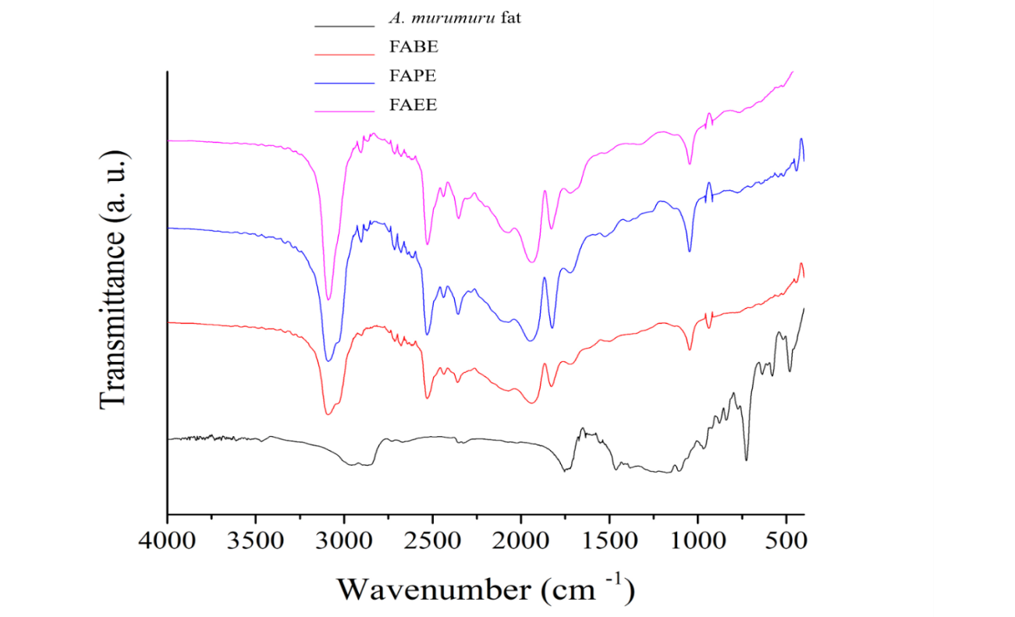

Murumuru FAEE

Fig. 3 CG-MS of Murumuru esterification reaction with ethanol
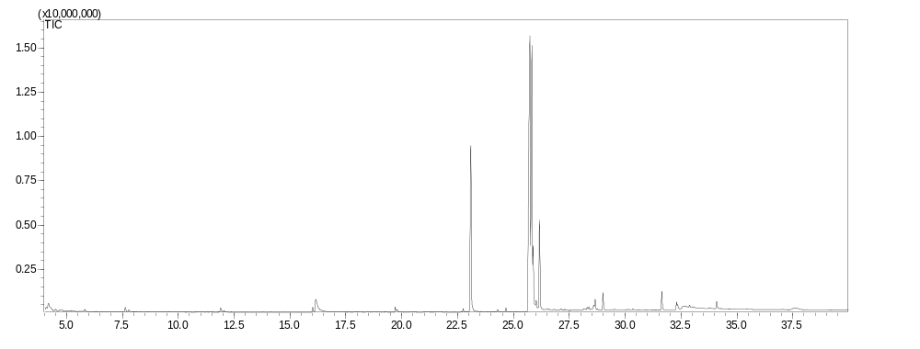
4
3
1
2

Fig. 3a CG-MS of Hexadecanoic acid ethyl ester 1 (96% similarity)
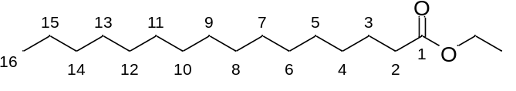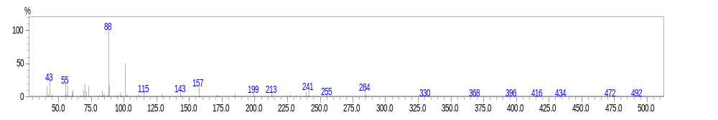

Fig. 3b CG-MS of ethyl (9Z, 12Z)-octadeca-9,12-dienoate 2 (94% similarity)
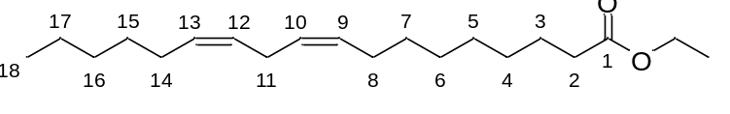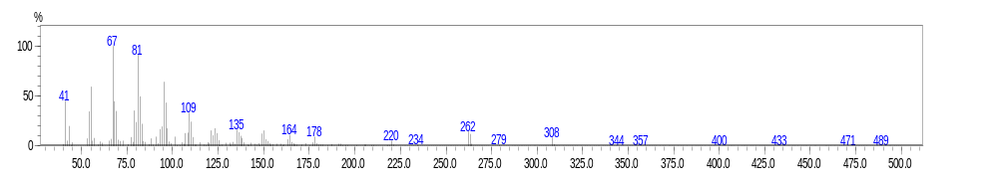

Fig. 3c CG-MS of Ethyl oleate 3 (93% similarity)
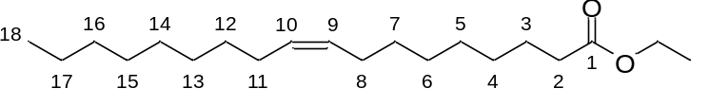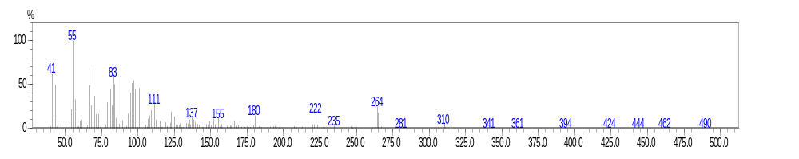

Fig. 3d CG-MS ethyl (E)-octadec-9-enoate 4 (94% similarity)
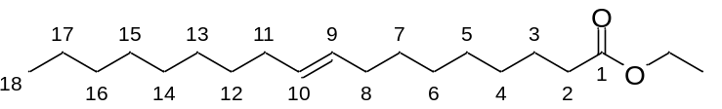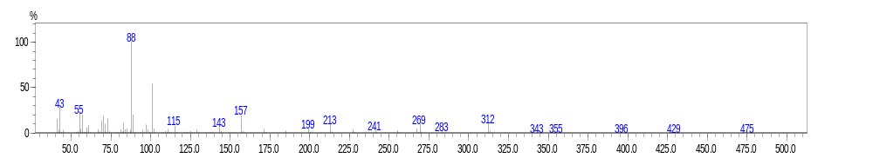

Murumuru FAPE

Fig. 4 CG-MS of Murumuru esterification reaction with propanol
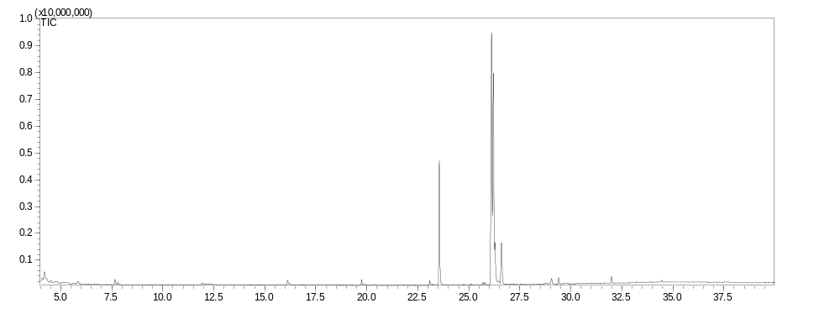
4
1
3
2

Fig. 4a CG-MS of Hexadecanoic acid propyl ester 1 (95% similarity)
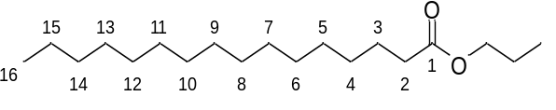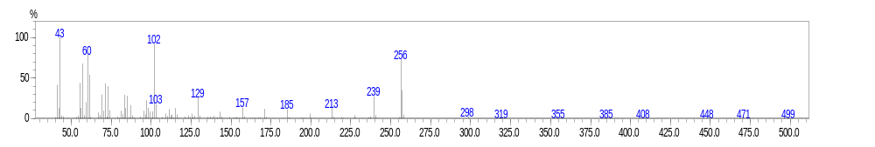

Fig. 4b CG-MS propyl linoleate 2 (88% similarity)
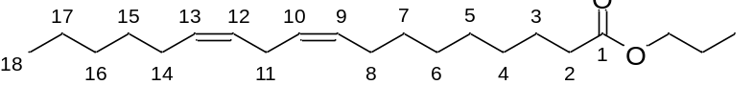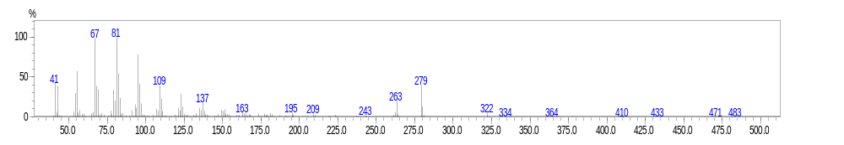

Fig. 4c. CG-MS propyl oleate 3 (89% similarity).
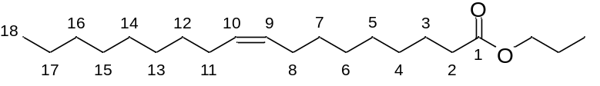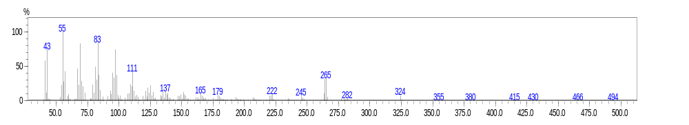

Fig. 4d CG-MS propyl (E)-octadec-9-enoate 4 (92% similarity)
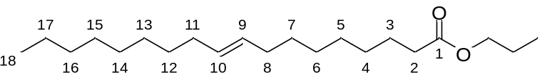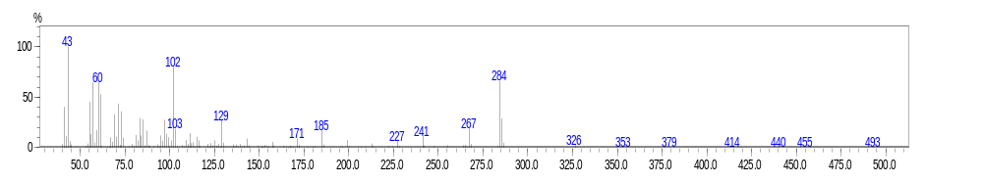

Murumuru FABE

Fig. 5 CG-MS of Murumuru esterification reaction with butanol
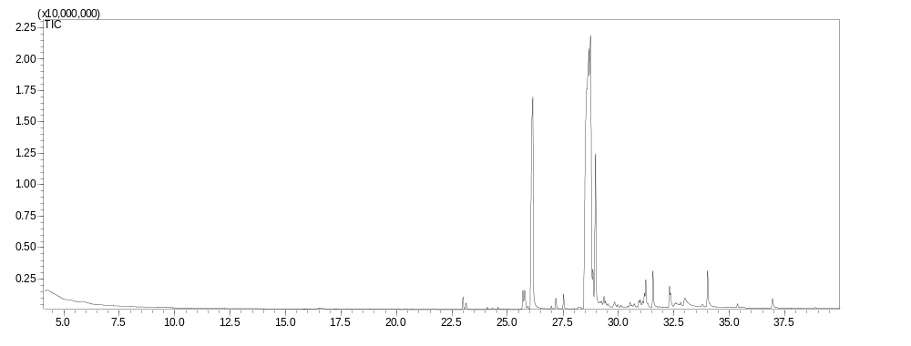
4
3
2
1

Fig. 5a CG-MS of Hexadecanoic acid butyl ester 1 (95% similarity)
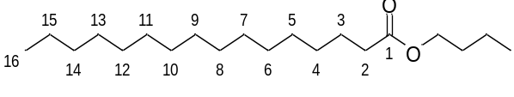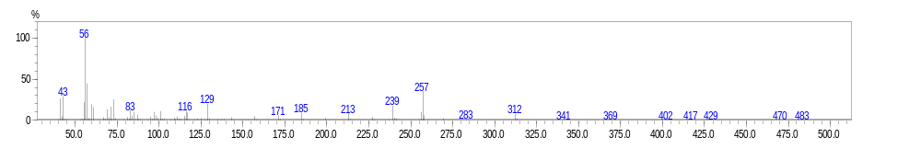

Fig. 5b CG-MS of butyl linoleate 2 (91% similarity)
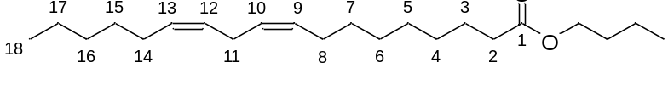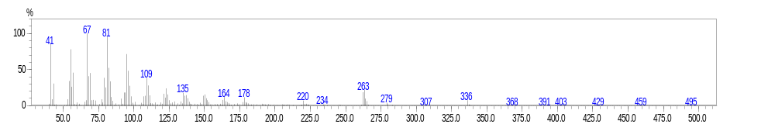

Fig. 5c CG-MS of butyl oleate 3 (91% similarity) 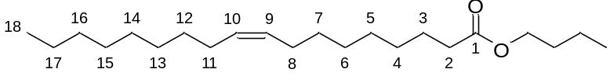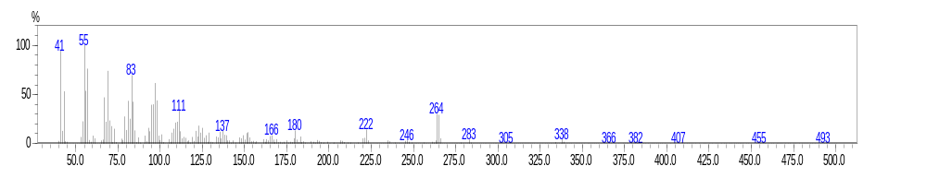

Fig. 5d CG-MS of butyl (E)-octadec-9-enoate 4 (93% similarity)
