Table 2. Droplet size distribution, PDI and Zeta of emulsions prepared with esters and silk fibroin.
Fatty acid ester | Time (days) | Size (nm) | PDI | Zeta (mV)
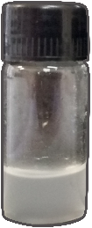  FAEE-SF | 0 | 702.5 (±92.43) | 0.709 (±0.08) | -53.9 (±4.50)
 | 7 | 512.9 (±152.35) | 0.528 (±0.15) | -40.4 (±0.76)
 | 14 | 315.7 (±5.96) | 0.415 (±0.01) | -33.6 (±6.20)
 | 21 | 229.4 (±8.31) | 0.396 (±0.03) | -33.3 (±0.65)
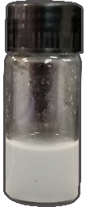  FAPE-SF | 0 | 274.06 (±2.41) | 0.452 (±0.02) | -46.4 (±5.31)
 | 7 | 293.3 (±20.43) | 0.419 (±0.02) | -38.4 (±0.78)
 | 14 | 293.5 (±11.50) | 0.439 (±0.02) | -30.7 (±2.94)
 | 21 | 280.5 (±14.16) | 0.415 (±0.04) | -34.9 (±3.84)
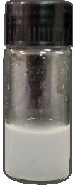  FABE-SF | 0 | 215.5 (±1.57) | 0.320 (±0.03) | -43.6 (±5.42)
 | 7 | 248.9 (±6.25) | 0.419 (±0.02) | -46.0 (±2.21)
 | 14 | 235.3 (±8.73) | 0.366 (±0.02) | -29.5 (±1.85)
 | 21 | 217.5 (±0.85) | 0.338 (±0.01) | -25.6 (±3.24)

