Supplementary information
Harnessing cell-surface CD26 proteolysis-targeting chimeras for molecular targeted therapy against non-small cell lung cancer
Guangjian Zhang^{1,4,7}, Bohao Liu^{1,4,7,} Deqian Qiao¹, Xingzhuo Zhu^{1,4}, Jiaqi Huang^{1,4}, Rui Gao³, Linjuan Zhang⁵, Jizhao Wang^{1,4*}, Yinjuan Huang^{2*}, Qiuyu Gong^{1,4,6*}
¹Department of Thoracic Surgery, The First Affiliated Hospital of Xi’an Jiaotong University, Xi’an 710061, P. R. China
²State Key Laboratory for Mechanical Behavior of Materials, Shaanxi International Research Center for Soft Matter, School of Materials Science and Engineering, Xi’an Jiaotong University, Xi’an 710049, P. R. China
³Department of Nuclear Medicine, The First Affiliated Hospital of Xi’an Jiaotong University, Xi’an 710061, P. R. China
⁴Key Laboratory of Enhanced Recovery After Surgery of Integrated Chinese and Western Medicine, Administration of Traditional Chinese Medicine of Shaanxi Province, The First Affiliated Hospital of Xi’an Jiaotong University, Xi’an 710061, P. R. China
⁵Department of Anaesthesiology, The First Affiliated Hospital of Xi’an Jiaotong University, Xi’an 710061, P. R. China
⁶Key Laboratory of Optic-Electric Sensing and Analytical Chemistry for Life Science, Ministry of Education, Qingdao University of Science and Technology, Qingdao 266042, P. R. China
⁷These authors contributed equally to this work.

*Corresponding Authors:
Jizhao Wang, Email: wangjz1104@xjtu.edu.cn;
Yinjuan Huang, Email: huangyj@xjtu.edu.cn;
Qiuyu Gong, Email: gongqiuyu@xjtu.edu.cn
Figure S1. The detailed syntheses routes of degraders P1 to P4.
Figure S2. The ¹H NMR spectrum of P4-1-A (300 MHz, DMSO-d6, 298K).
Figure S3. The ¹³C NMR spectrum of P4-1-A (75 MHz, DMSO-d6, 298K).

Figure S4. The ¹H NMR spectrum of P4-1 (300 MHz, DMSO-d6, 298K).
Figure S5. The ¹³C NMR spectrum of P4-1 (75 MHz, DMSO-d6, 298K).

Figure S6. The ¹H NMR spectrum of P4-2-A (300 MHz, DMSO-d6, 298K).
Figure S7. The ¹³C NMR spectrum of P4-2-A (75 MHz, DMSO-d6, 298K).
Figure S8. The ¹H NMR spectrum of P4-2 (300 MHz, DMSO-d6, 298K).
Figure S9. The ¹³C NMR spectrum of P4-2 (75 MHz, CDCl₃, 298K).

Figure S10. The ¹H NMR spectrum of P4-3-A (300 MHz, DMSO-d6, 298K).
Figure S11. The ¹³C NMR spectrum of P4-3-A (75 MHz, DMSO-d6, 298K).

Figure S12. The ¹H NMR spectrum of P4-3 (300 MHz, DMSO-d6, 298K).
Figure S13. The ¹³C NMR spectrum of P4-3 (75 MHz, CDCl₃, 298K).

Figure S14. The ¹H NMR spectrum of P4-4-A (300 MHz, DMSO-d6, 298K).
Figure S15. The ¹³C NMR spectrum of P4-4-A (75 MHz, DMSO-d6, 298K).

Figure S16. The ¹H NMR spectrum of P4-4 (300 MHz, DMSO-d6, 298K).
Figure S17. The ¹³C NMR spectrum of P4-4 (75 MHz, CDCl₃, 298K).

Figure S18. The inhibition rate of different compounds towards CD26 (DPP4). 0.5 % DMSO was used as co-solvent.
Figure S19. The western blot of CD26 from cytoplasm and membrane of H460, H1299 and BEAS-2B cells.
Figure S20. The western blot of CD26 from H460 and H1299 cells. Cells were treated with P4-3 (1.0 μΜ) for different time at 37 °C. 0.5 % DMSO was used as co-solvent.
Figure S21. Up: The western blot of CD26 from H1299 and BEAS-2B cells. Cells were treated with P4-3 for 9 hours at 37 °C. Down: The western blot of DPP7, DPP8, DPP9 and FAP from H1299 and BEAS-2B cells. Cells were treated with P4-3 (1.0 μΜ) for 9 hours at 37 °C. 0.5 % DMSO was used as co-solvent. DMSO represents 0.5 % DMSO in buffers.
Figure S22. The western blot of CD26 from H460 cells of different systems. Cells were treated with Chloroquine (10, 20 μΜ) for 12 hours only or with Chloroquine (10, 20 μΜ) for 12 hours firstly and then treated with P4-3 (1.0 μΜ) for 9 hours at 37 °C. 0.5 % DMSO was used as co-solvent.

Figure S23. The western blot of CD26 from H460 cells of different systems. Cells were treated with MG-132 (5 μM) or Alogliptin (5 μM) for 9 hours only or with MG-132 (5 μM) or Alogliptin (5 μM) for 9 hours firstly and then treated with P4-3 (1.0 μΜ) for 9 hours at 37 °C. 0.5 % DMSO was used as co-solvent.
Figure S24. Cell viabilities of H460, H1299, A549 and PC9 cells treated with different compounds for different time at 37 °C. N=3. * p < 0.05, ** p < 0.01, *** p < 0.005. ANOVA Dunnett’t test. 0.5 % DMSO was used as co-solvent. DMSO represents 0.5 % DMSO in buffers.
Figure S25. The western blot of CD26 from H460, H1299, PC9, A549 and BEAS-2B cells.
Figure S26. (a) Cell viabilities of BASE-2B cells treated with different compounds for 48 hours at 37 °C. (b) Cell proliferative curves of BASE-2B cells, negative control (NC) and siRNA-transfected BASE-2B cells. N=3. Inset shows the western blot of CD26 of BASE-2B cells, NC and siRNA-transfected BASE-2B cells. 0.5 % DMSO was used as co-solvent. DMSO represents 0.5 % DMSO in buffers.
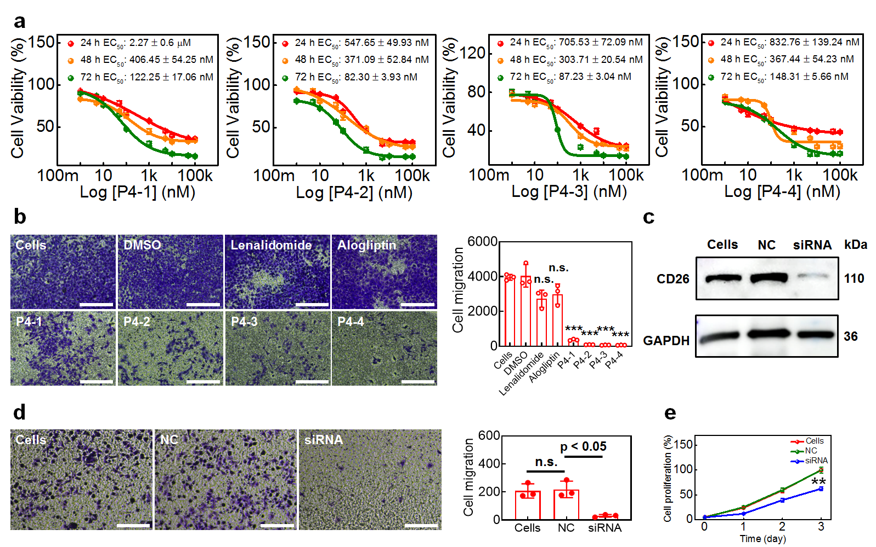
Figure S27. (a) Cell viabilities of H1299 cells treated with different concentrations of degraders for different time. N=3. (b) Left: the representative photos of cresyl violet-staining H1299 cells treated with P4-3 (final concentration: 0.9 μM) for 24 hours. Scale bar 50 μm. Right: the statistics of cell migration numbers of different systems. n.s.: no significance. ***: p < 0.001 compared to cells group. ANOVA Dunnett’t test. (c) The western blot of CD26 of H1299 cells, NC and siRNA-transfected H1299 cells. (d) Left: the representative photos of cresyl violet-staining H1299 cells, NC and siRNA-transfected H1299 cells. Scale bar 50 μm. Right: the statistics of cell migration numbers of different systems. n.s.: no significance. ANOVA Dunnett’t test. (e) The proliferative curves of H1299 cells, NC and siRNA-transfected H1299 cells. N=3, **: p < 0.01 compared to cells and NC groups. ANOVA Dunnett’t test. 0.5 % DMSO was used as co-solvent. DMSO represents 0.5 % DMSO in buffers. Note: the siRNA experiments here can be used as positive controls.

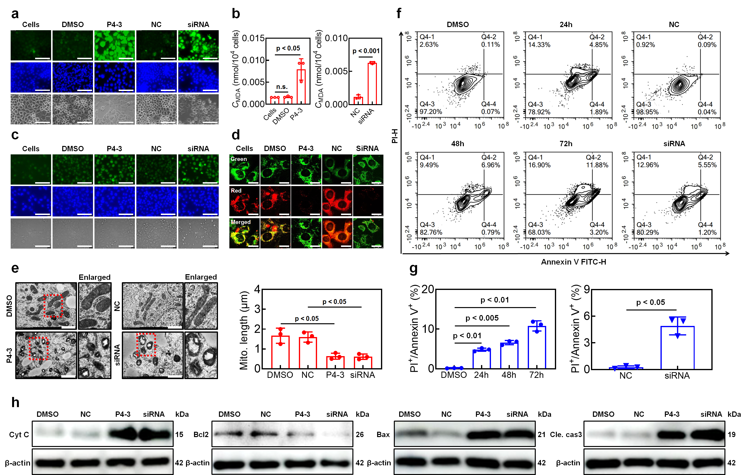
Figure S28. (a) The representative fluorescent images of H1299 cells under different conditions treated with DCFH-DA (10 μM). Scale bar 25 μm. (b) The MDA concentrations of H1299 cells under different conditions. n.s.: no significance. ANOVA Dunnett’t test for left panel, and two-tailed test for right panel. (c) The representative fluorescent images of H1299 cells under different conditions treated with γ-H₂AX (50 μM). Scale bar 25 μm. (d) The representative confocal fluorescent images of H1299 cells under different conditions treated with JC-1 probe (25 μM). Scale bar 10 μm. (e) Left: the representative TEM images mitochondria in H1299 cells under different conditions. Scale bar 1 μm. Right: the statistics of mitochondrial lengths of different systems. ANOVA Dunnett’t test. P4-3 concentration: 0.9 μM. Time: 24 hours. (f) Flow cytometry results of H1299 cells treated with P4-3 (90 nM) for different time/H1299 cells treated with NC and siRNA. (g) The statistics of H1299 cell ratios of PI+/Annexin+ under different conditions. ANOVA Dunnett’t test. (h) The western blot of cytochrome C, Bcl2, Bax and cleaved caspase 3 in H1299 cells of different groups. 0.5 % DMSO was used as co-solvent. DMSO represents 0.5 % DMSO in buffers. P4-3 concentration: 0.9 μM. Time: 24 hours. Note: the siRNA experiments here can be used as positive controls.

Figure S29. The representative fluorescent images of BASE-2B cells under different conditions treated with DCFH-DA (50 μM) and MDA concentrations of BASE-2B cells under different conditions. P4-3 concentration: 10 μM. Time: 24 hours. Scale bar 50 μm. 0.5 % DMSO was used as co-solvent. DMSO represents 0.5 % DMSO in buffers.
Figure S30. The representative fluorescent images of BASE-2B cells under different conditions treated with γ-H₂AX (50 μM). P4-3 concentration: 10 μM. Time: 24 hours. Scale bar 50 μm. 0.5 % DMSO was used as co-solvent. DMSO represents 0.5 % DMSO in buffers.
Figure S31. (a) The representative H&E staining results of heart, liver, spleen, lung, kidney and pancreas from mice treated without or with P4-3 (0.6 mg/kg, 1.0 % DMSO was used as co-solvent, every 3 days one time, 4 times). Scale bar 20 μm. (b) The body weights, Alanine transaminase (ALT), Creatinine (CREA) and α-Amylase concentrations of mice from different groups (N = 6). Mice were treated as mentioned before. Two-tailed test.
Figure S32. (a) Flow cytometry results and statistics of CD3+, CD8+ and CD4+ T cells in mice spleen. Two-tailed test. (b) The numbers and concentrations of lymphocytes and monocytes in mice serum. Mice were treated without or with P4-3 (0.6 mg/kg, 1.0 % DMSO was used as co-solvent, every 3 days one time, 4 times). Two-tailed test.
Figure S33. The MDA concentrations of subcutaneous tumors from mice treated without or with P4-3 (0.6 mg/kg, 1.0 % DMSO was used as co-solvent, every 3 days one time, 4 times, intravenous injections-I.V. injection). Two-tailed test.
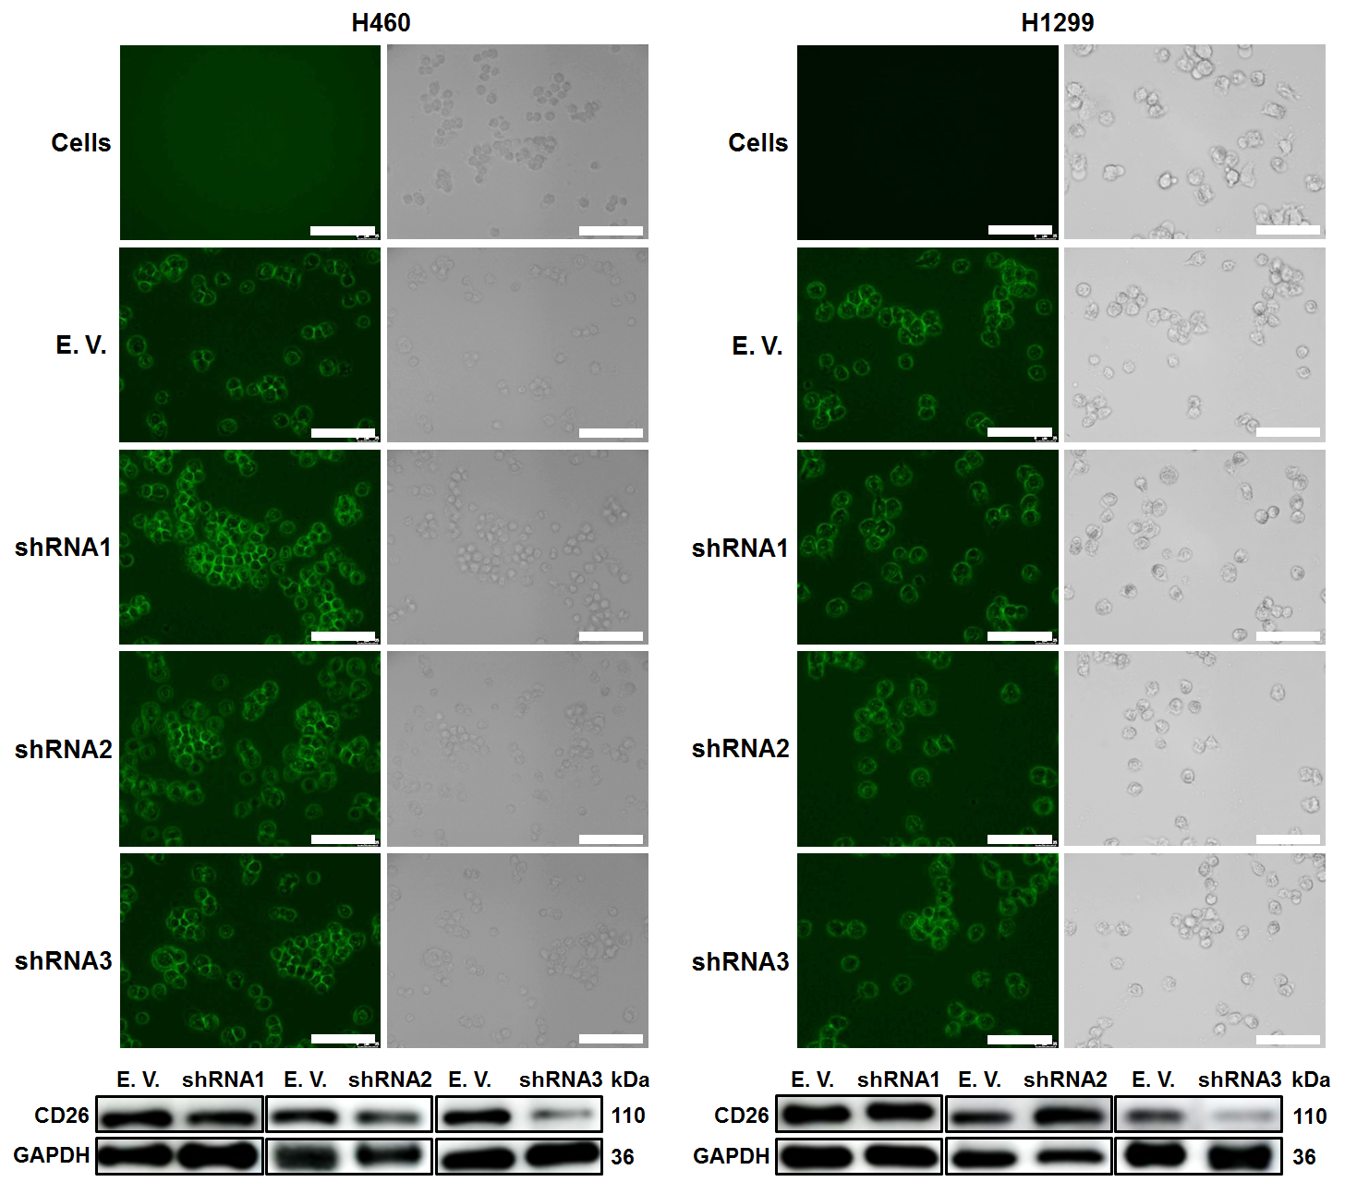
Figure S34. Up: the representative fluorescent images of H460 and H1299 cells transfected without or with shRNAs. Down: western blot of CD26 in H460 and H1299 cells of different systrms. Scale bar 25 μm.
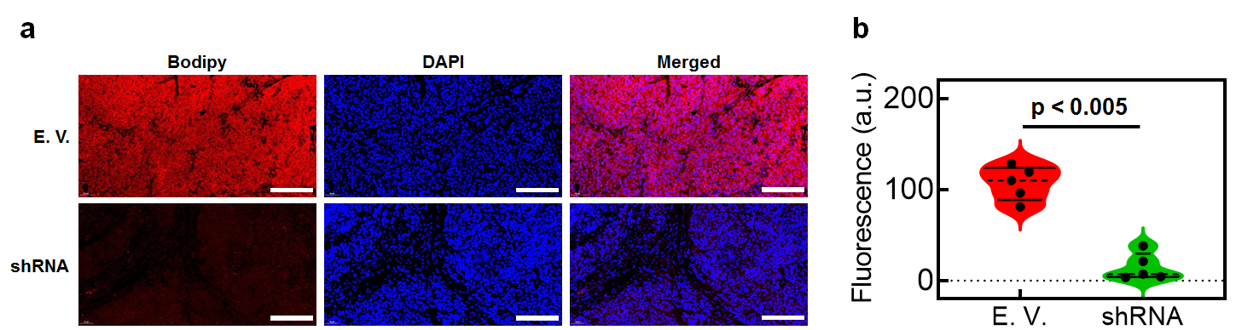
Figure S35. (a) The representative CD26 immunofluorescence images of tumors constructed by E. V.-transfected H460 cells and shRNA-transfected H460 cells. Scale bar 50 μm. The images were obtained after tumor formation for 15 days. (b) The statistics of fluorescent intensities of corresponding CD26 immunofluorescence images. Two-tailed test.
Figure S36. The MDA concentrations of subcutaneous tumors from mice inoculated with empty vector (E. V.) and shRNA transfected H460 cells. Two-tailed test.
Figure S37. (a) The schematic diagram of establishment of metastases and the therapy models. (b) Left: the photos of metastases of different groups after therapy. The blue arrow or circle refers to the tumors. Right: the statistics of tumors volumes in lung. Two-tailed test. Control group means mice bearing metastases I.V. injected by buffers containing 1.0 % DMSO. P4-3 group means mice bearing metastases I.V. injected by P4-3 containing 1.0 % DMSO as co-solvent. (c) The representative H&E and TUNEL staining results of different groups after therapy. Scale bar of H&E 50 μm. Scale bar of TUNEL 20 μm. (d) The schematic diagram of establishment of metastases derived from E. V. and shRNA-transfected H460 cells. (e) Left: the photos of metastases from different groups after 17 days. The blue arrow refers to the tumors. Right: the statistics of tumors volumes in lung. Two-tailed test. (f) The representative H&E and TUNEL staining results of different groups after 17 days. Scale bar of H&E 50 μm. Scale bar of TUNEL 20 μm.
Figure S38. The body weights of mice in metastases model.
Figure S39. The representative images of tumor organoids treated with staurosporine (50 μΜ, 24 hours). Scale bar 25 μm. 1.0 % DMSO was used as co-solvent.
Figure S40. Up: the representative images of tumor organoids treated without or with different concentrations of alogliptin for 24 hours. Scale bar 50 μm. Down: the inhibition rate of alogliptin towards organoids. 1.0 % DMSO was used as co-solvent. DMSO represents 1.0 % DMSO in buffers. ANOVA Dunnett’t test.
Figure S41. Up: the representative images of paracancer organoids treated without or with different concentrations of P4-3 for 24 hours or treated with staurosporine (50 μΜ, 24 hours). Scale bar 25 μm. Down: the inhibition rate of different compounds towards paracancer organoids. 1.0 % DMSO was used as co-solvent. DMSO represents 1.0 % DMSO in buffers. ANOVA Dunnett’t test.
Table S1. The sequence and titer of E. V. and different shRNAs.
Name | Sequence | Titer
Empty vector | TTCTCCGAACGTGTCACGT | 1.50E+9TU/ml
shRNA1 | GGAGGCATTCCTACACAGCTT | 3.00E+9TU/mL
shRNA2 | GTGACATGGGCAACACAAGAA | 3.00E+9TU/mL
shRNA3 | ATGCAACTTCCATACAAATCA | 2.00E+9TU/mL

