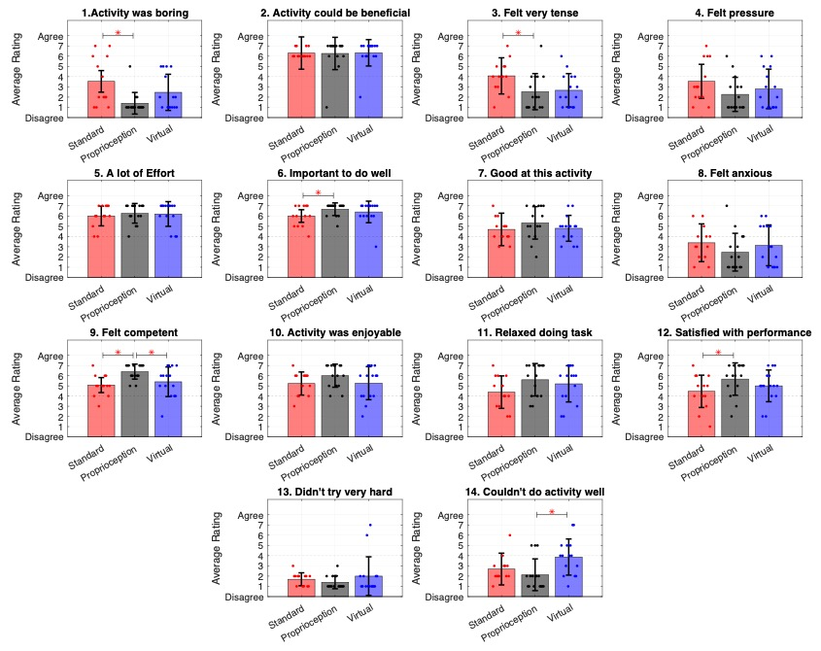
Supplemental Figure 1: Subject responses across all 14 questions of the abbreviated IMI Questionnaire. The IMI Subscales reported in the main text were comprised of the average response values to questions as follows: Value/Usefullness comprised responses to question 2, Effort/Importance comprised responses to questions 5, 6, and 13, Competency comprised responses to questions 7, 9, 12, 14, Interest/Enjoyment comprised responses to questions 1 and 10, and Pressure/Tension comprised responses to questions 3, 4, 8 and 11. For averaging, responses to questions 1, 3, 4, 8,13, and 14, were scored as 7-the response value, such that all responses were affirmatory of the Subscale header.

