Supplementary Information for
A carbon nanotube based electron source with 0.3eV energy spread and an unconventional time delay
Ke Chen^{1,6}†, Chao Yu³†, Xiaowei Wang⁴†, Shenghan Zhou², Li Wang⁴, Yusong Qu^{1,6}, Aiwei Wang^{1,6}, Fan Xiao⁴, Zhenjun Li^{1,6}, Chi Li^{1,6}*, Jiayu Dai⁴*, Xiangang Wan⁵*, Ruifeng Lu³*, Qing Dai^{1,2,6}*
¹CAS Key Laboratory of Nanophotonic Materials and Devices, National Center for Nanoscience and Technology, Beijing 100190, China.
²Institute of Information Functional Materials, School of Materials Science and Engineering, Shanghai Jiao Tong University, Shanghai 200240, China.
³Institute of Ultrafast Optical Physics, Department of Applied Physics and MIIT Key Laboratory of Semiconductor Microstructure and Quantum Sensing, Nanjing University of Science and Technology, Nanjing 210094, China
⁴Department of Physics, National University of Defense Technology, Changsha 410073, China.
⁵National Laboratory of Solid-State Microstructures and School of Physics, Collaborative Innovation Center of Advanced Microstructures, Nanjing University, Nanjing 210093, China.
⁶Center of Materials Science and Optoelectronics Engineering, University of Chinese Academy of Sciences, Beijing, China.
†These authors contributed equally to this work.
*e-mail: daiqing@sjtu.edu.cn, rflu@njust.edu.cn, xgwan@nju.edu.cn, jydai@nudt.edu.cn, lichi@nanoctr.cn

This PDF file includes:

Fig. S1. Characterization of CNTs.
Fig. S2. Experimental setup.
Fig. S3. Characterization of the pulse width and spectrum of a laser.
Fig. S4. Photoemission electron energy spectrum of CNT tips.
Fig. S5. SEM image of a tungsten nanotip.
Fig. S6. Dependency of energy spectrum on τ.
Fig. S7. Measurement of electron dynamics in the perpendicular polarization mode.
Fig. S8. Autocorrelation experiments at different laser intensities.
Fig. S9. Time-dependent density distribution of CNT at different laser intensities.
Fig. S10. TDDFT simulation calculation result for the a: (10, 6), b: (11, 1), c: (9, 4) carbon nanotube, which genuinely exists in our samples.

Figures

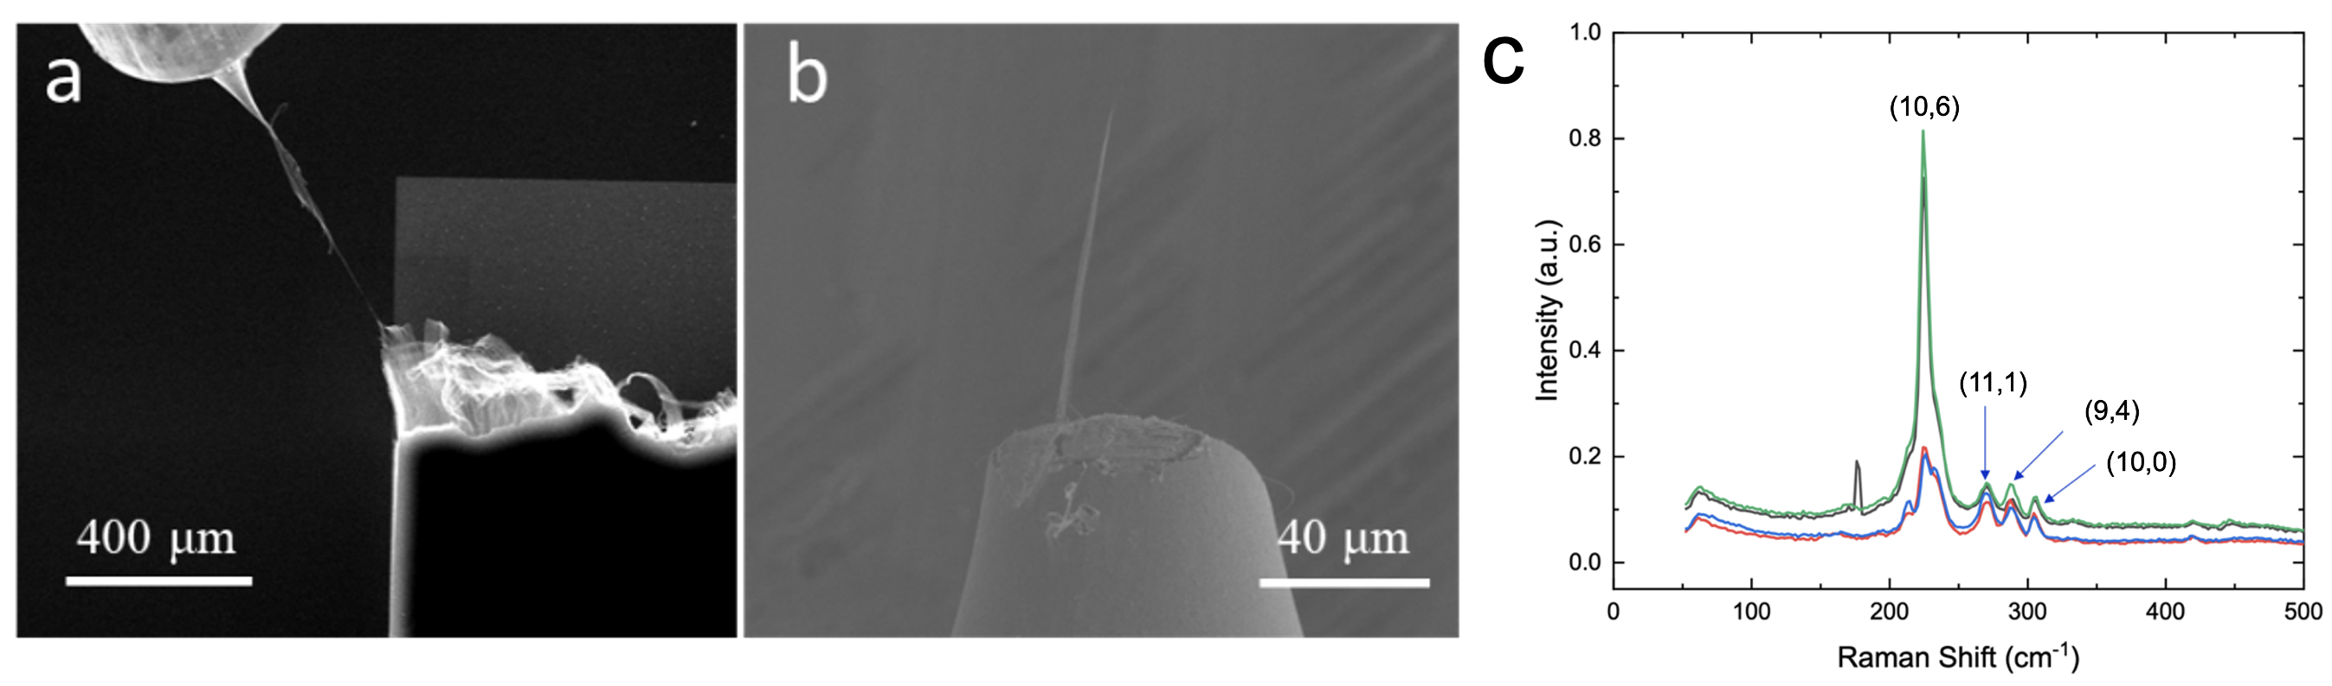
Supplementary Figure S1. Characterization of CNTs. a. Assembling CNT tips in SEM. b. SEM image of CNT tips. c. Raman spectrum of CNTs: By analyzing the Radial Breathing Mode in the Raman spectrum of CNTs, we calculated the diameters of CNTs, which range from 0.8 to 1.5 nm. Additionally, chirality index was identified corresponding to peaks’ position, such as (10, 0), (10, 6), (11, 1), and (9, 4).

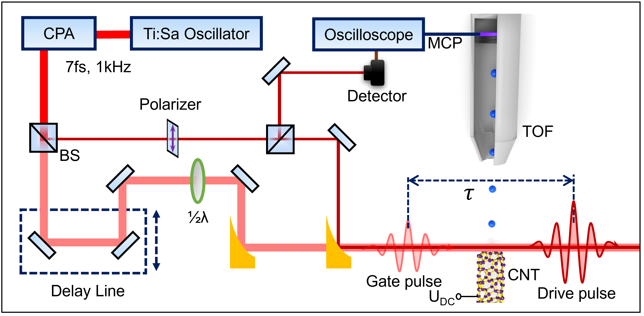
Supplementary Figure S2. Experimental setup. 7 fs few-cycle laser system and the electron energy spectrum were measured using a time-of-flight (TOF) electron spectrometer. Laser polarization adjustable by 1/2 wave plate.

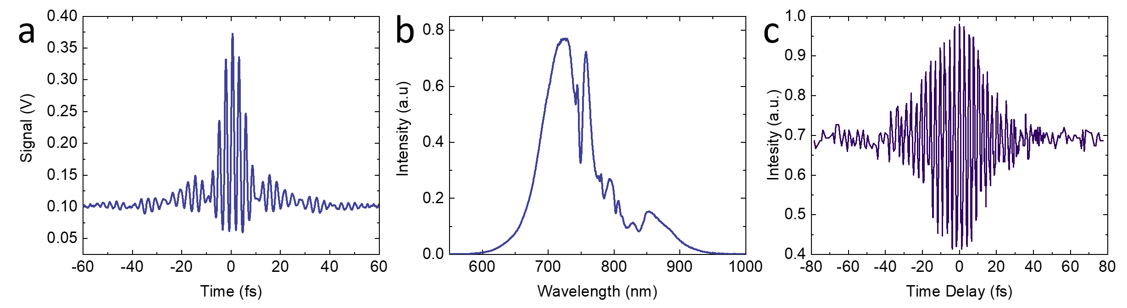
Supplementary Figure S3. Characterization of the pulse width and spectrum of a laser. a. Autocorrelation measurement of the pulse width for 7 fs laser pulse. b. The spectral range of the laser is 600-950 nm. c. Interference autocorrelation of two laser beams. The moment corresponding to the maximum interference intensity was identified as the zero-delay position.

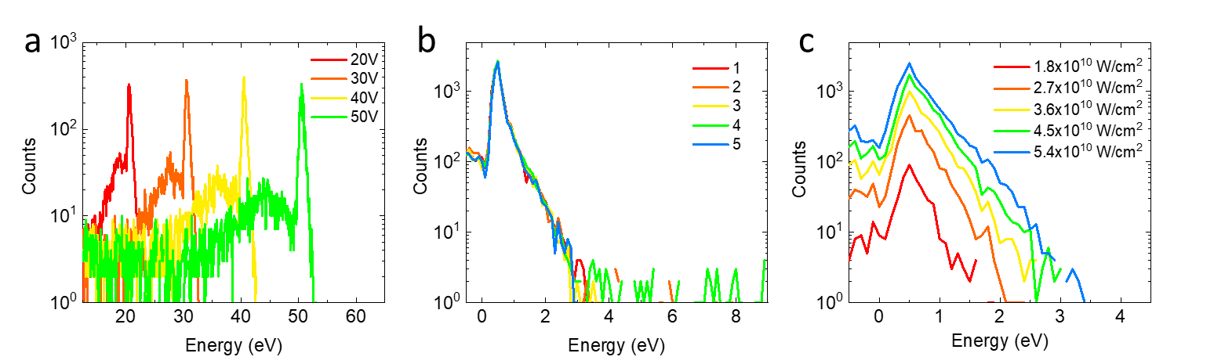
Supplementary Figure S4. Photoemission electron energy spectrum of CNT tips. a. Electron energy spectra at different collection biases (-20V, -30V, -40V, -50V). b. Repeated testing of electron energy spectra under identical conditions. c. Electron energy spectra of CNT tips at different laser intensities.

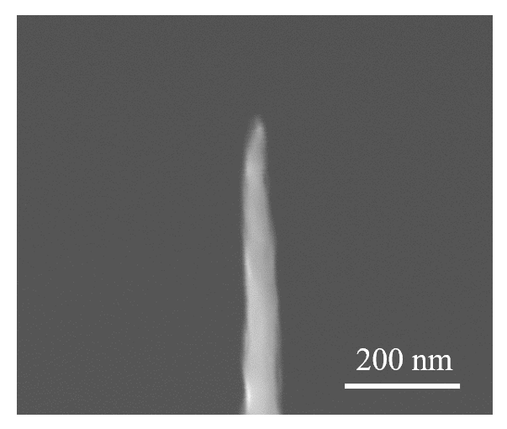
Supplementary Figure S5. SEM image of a tungsten nanotip.

Supplementary Figure S6. Dependency of energy spectrum on τ. The red solid dots are the experimentally measured cutoff energy and the red solid line is the fitted cutoff energy.

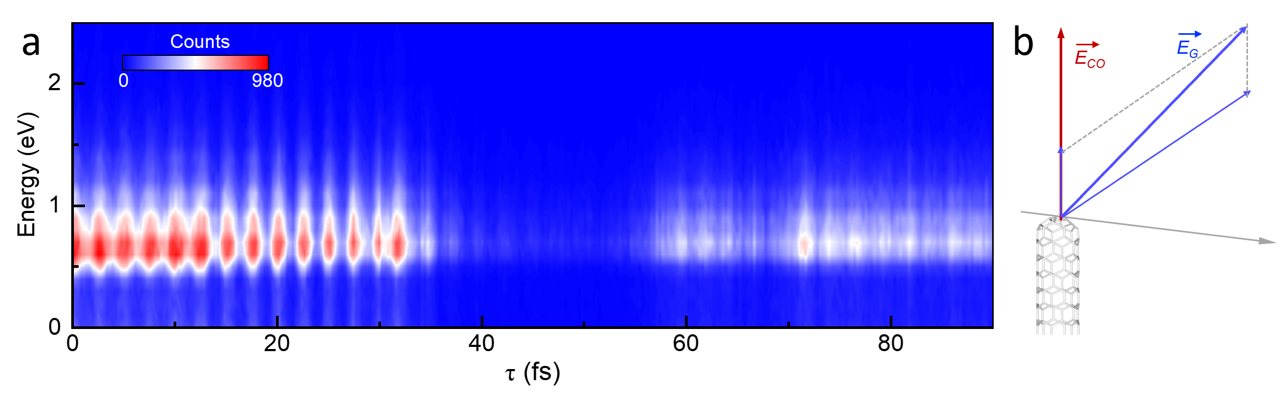
Supplementary Figure S7. Measurement of electron dynamics in the perpendicular polarization mode. a. The dependency of electron energy spectrum on τ, obtained in the perpendicular polarization mode. b. Since the polarization directions of the two pulses are not exactly orthogonal, the gate pulse (blue arrow) has a component in the direction of the drive pulse (red arrow).

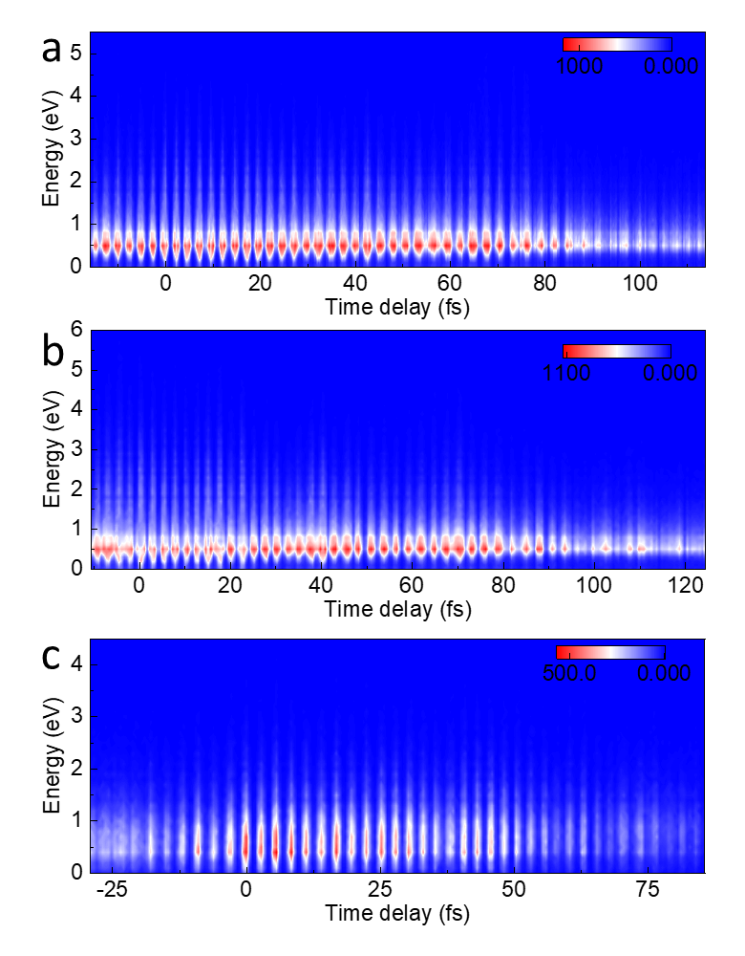
Supplementary Figure S8. Autocorrelation experiments at different laser intensities.

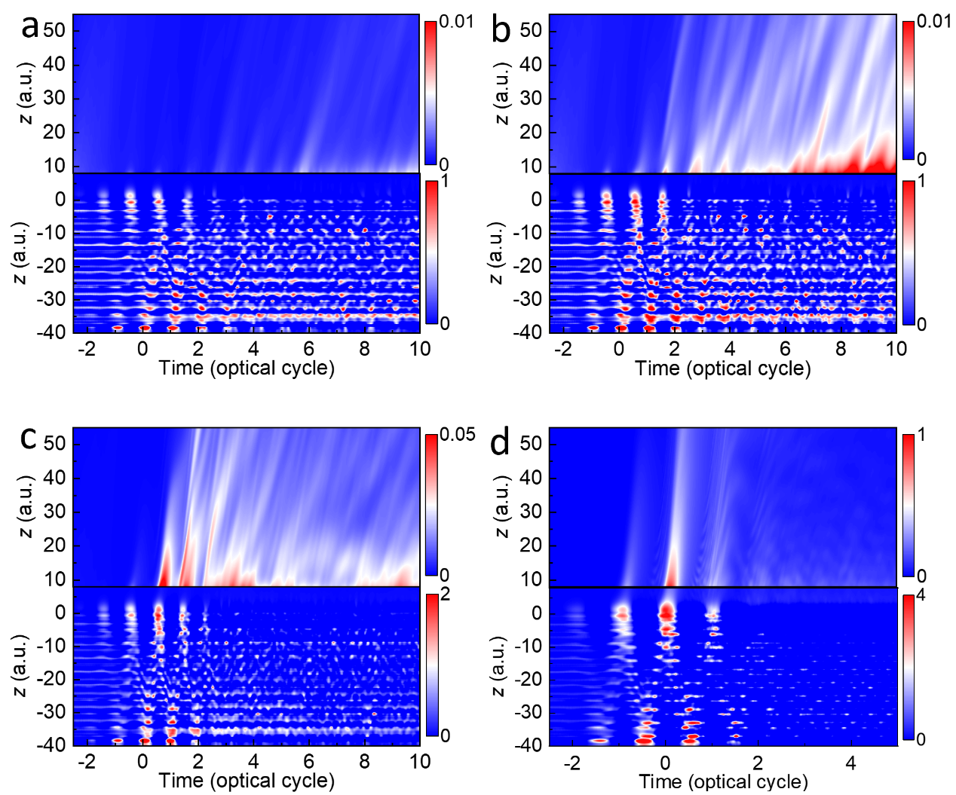
Supplementary Figure S9. Time-dependent density distribution of CNT at different laser intensities. a. Time-dependent density distribution of carbon nanotubes at I = 2.0×10¹² W/cm². b. Time-dependent density distribution of carbon nanotubes at I = 3.0×10¹² W/cm². c. Time-dependent density distribution of carbon nanotubes at I = 6.0×10¹² W/cm². d. Time-dependent density distribution of carbon nanotubes at I = 5.0×10¹³ W/cm².

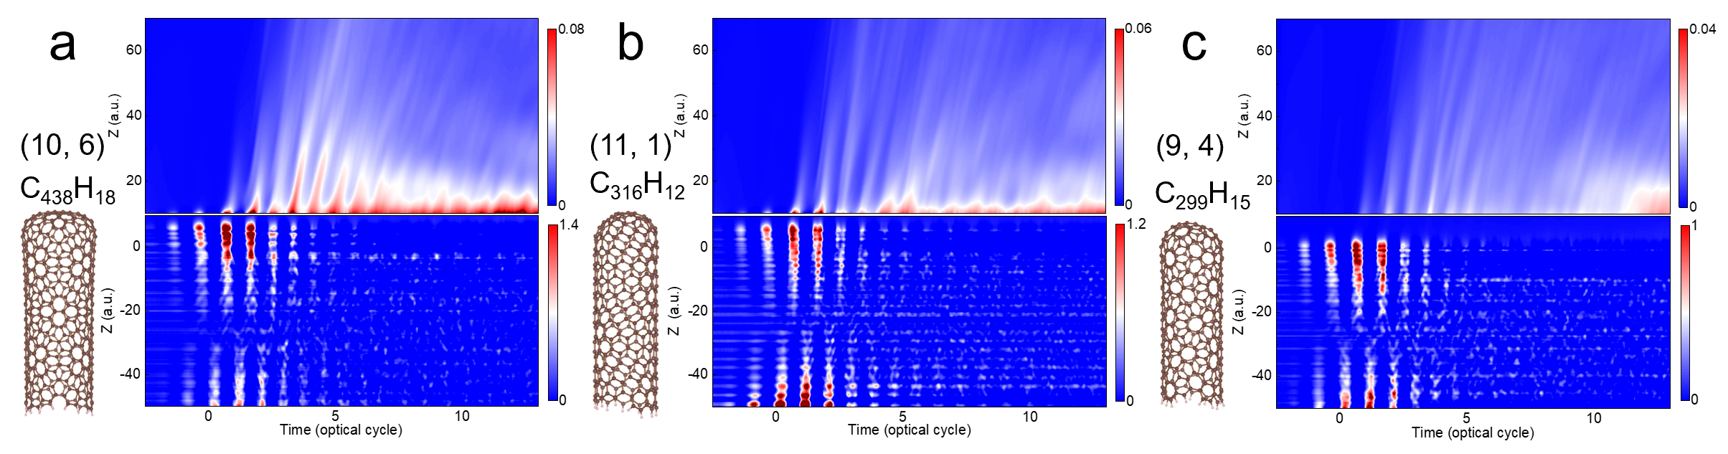
Supplementary Figure S10. TDDFT simulation calculation result for the a: (10, 6), b: (11, 1), c: (9, 4) carbon nanotube, which genuinely exists in our samples. The results of three models all demonstrate consistency with the proposed delayed electron emission mechanism. The simulation system is as large as possible, containing more than 300 atoms.

