Additional File 3. Design/Build Design Meeting Protocols
Design Meeting Description: From June to July 2022, 6 2-hour design meetings were held with community stakeholders (4 patients, 2 parents, and 12 providers). Using the digital canvas MURAL (1), which allows participants to add sticky notes, images, drawings, or charts to a digital whiteboard, participants engaged in structured activities like brainstorming and interactive feedback sessions to facilitate collaborative, visual brainstorming and real-time input from all participants. Each meeting started with a reflection activity to set goals, followed by a review of and feedback on drafted materials. Stakeholders shared personal experiences and suggested implementation strategies. All meetings were recorded, transcribed, and used to guide the generation and refinement of a list of suggested implementation strategies.

Below are the “Design” Meeting protocols and visual depictions of the MURAL canvas created during the meetings. The protocol includes enumerated segments, each of which correspond by number to a portion of the accompanying MURAL. Key takeaways derived from all activities in each “design” meeting are listed at the end of each protocol.

Provider Design Meeting #1: Provider Perspectives on Continuing Education Programs and Reflections on the Design Process
Overview: The goal of the first meeting was to develop strategies for implementing Gender-Affirming Psychotherapy practices among providers.
Structure of meeting: 120-minute session divided into 5 parts:
- Reflect
  - Time: 15 Minutes
  - Prompt: Reflect on a positive continuing education (CE) experience. It can be something recent, or something that you experienced a long time ago. Use the green sticky notes to type out your answers to the questions.
  - Instructions: Allow providers to answer the questions on MURAL using the green sticky notes. When the timer ends, summarize key themes across the answers from providers. Also use this time to ask follow-up questions to clarify the providers' responses and note feedback.
  - Example Questions: What were you learning? What made this continuing education course a positive experience? What was the instructor like? What did this experience look like (in-person, asynchronous online, synchronous online)? What could have improved this experience?
- Thinking and Feeling
  - Time: 15 Minutes
  - Prompt: Help us fill out this section. Ideally, how are you feeling during each of these steps? What are you thinking? What questions might you have?
  - Instructions: Have providers to review example thoughts and feelings from patients at various stages of care on MURAL. Providers will use "faces" to describe their emotions and green sticky notes to share their thoughts at each stage. After the timer ends, summarize key themes from the providers' responses and ask follow-up questions for clarity.
  - Example Steps: Publicizing gender-affirming stance, scheduling appointments, receiving intake forms, and filling out the required documentation.
- Break
  - Time: 10 Minutes
- Opportunity Finding
  - Time: 15 Minutes
  - Prompt: Review the mapped educational topics from the Knowledge and Practice list. Does this mapping feel accurate? Feel free to move things around, or duplicate them if necessary. Is anything missing from these educational topics?
  - Instructions: Begin by having providers read gender-affirming care knowledge domains (yellow sticky notes) and gender-affirming practices (blue sticky notes). Providers then use sticky notes (color-coded by type of feedback) and symbols (e.g. heart) for responses. Summarize the key themes from these responses and ask follow-up questions to clarify the providers' feedback.
  - Example Knowledge Domains: Access to gender-affirming care is unequal, understand basic terminology, and understand that being transgender or transitioning does not inherently have negative mental health consequences, but the associated discrimination often does.
  - Example Practices: Set up sliding scale/pro bono slots for financial accessibility, create and maintain a strong referral network, and introduce yourself with pronouns.
- Design an Educational Tool
  - Time: 20 Minutes
  - Prompt: Choose a gender-affirming psychotherapy practice or domain from the content above, and use 5 minutes to fill out each box: What will the tool cover? Who will instruct? How will it be taught? What will it look like? This exercise is for generating ideas and inspiration, so think creatively without worrying about the final product.
  - Instructions: Refer providers to the previous activity for guidance on choosing a gender-affirming practice or knowledge domain. Providers will complete each box on MURAL within a 4-minute timer for focused input. After filling out all four boxes, use remaining time to address follow-up questions or answer any questions from providers about this first design meeting.
  - Example Questions: What topic(s) would this tool cover? Who is the instructor? How is this training taught? What does this training look like?
Design Session 1 Takeaways:
- Introduce MURAL before the first meeting to familiarize participants.
- Providers prefer casual, interactive tools over formal presentations.
- Emphasize experiential learning, inclusive spaces, and effective communication

Design Session 1 MURAL:
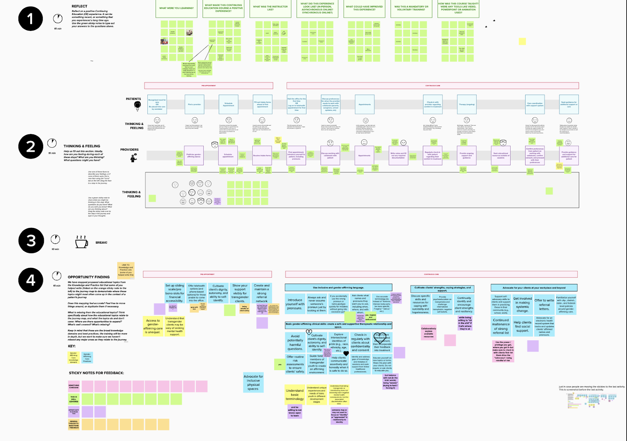
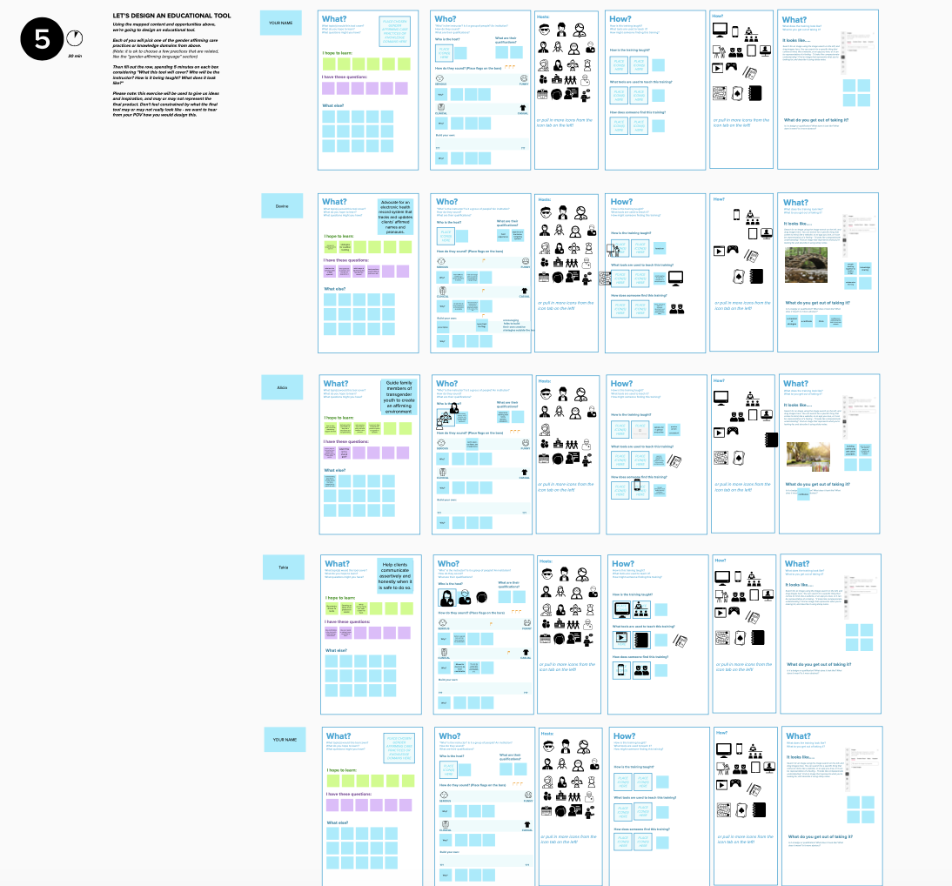

Provider Design Meeting #2: Provider Perspectives on Synchronous and Asynchronous Learning Tools concerning Gender-Affirming Psychotherapy Knowledge Domains and Practices
Overview: The goal of the second meeting was for providers to reflect on the best ways to learn through synchronous and asynchronous platforms.
Structure of meeting: 120-minute session divided into 7 parts:
- Introductions
  - Time: 10 Minutes
  - Instructions: Researchers and providers introduce themselves and are then introduced to the content of the design meeting. If a refresher on MURAL is requested, review the necessary steps to access the application.
- Individual Reflections
  - Time: 5 Minutes
  - Prompt: Reflect on a previous Continuing Education course.
  - Instructions: Have providers answer the questions (examples listed below) on MURAL using the purple sticky notes. When the timer ends, record key themes across the answers from providers. Use this time to ask follow-up questions to clarify the providers' responses and note feedback.
  - Example Questions: What were you learning? What went well in this course? What could have improved the experience? How was the course taught? What tools did the instructor use?
- Group Brainstorm
  - Time: 20 Minutes
  - Prompt: Using the information from above as a starting point, brainstorm different types of synchronous and asynchronous learning tools you have heard of, had direct experience with, or can think of.
  - Instructions: Allow providers 10 minutes to add examples of synchronous and asynchronous learning tools on MURAL using the purple and blue sticky notes. Once providers have brainstormed a list, take 10 minutes to ask what they like/dislike about each tool and what each is best suited for. Researchers and providers record these responses by adding sticky notes summarizing likes or dislikes to the learning tools.
  - Example Learning Tools: Synchronous Learning Tools: Roleplay, small group discussion; Asynchronous Learning Tools: Video, slides.
- Break
  - Time: 5 Minutes
- Group Review of Learning Objectives, and Matching Them to Learning Tools
  - Time: 25 Minutes
  - Prompt: Review the learning objectives on the blue sticky notes and match them with the best tool to teach them. Synchronous tools are written on pink sticky notes while asynchronous tools are on green. Think creatively about which tools might work best for you, even if they're not the traditional choices.
  - Instructions: Allow providers to review the sticky notes containing gender-affirming knowledge domains and practices. In a large group, ask providers to match synchronous and asynchronous tools to content. Ask follow-up questions to clarify how providers envision the different learning tools being utilized.
  - Example Learning Objectives: Create and maintain a strong referral network, show your support visibility for transgender clients, always ask and never assume someone’s pronoun just by looking at them.
  - Example Learning Tools: Synchronous Learning Tools: Roleplay, small group discussion; Asynchronous Learning Tools: Video, slides.
- Individually Design a Module
  - Time: 30 Minutes
  - Prompt: Choose a learning objective paired with a learning tool, and fill out the questions in each box. Additionally, consider how a provider could find this module, how someone could access it digitally, and whether it has visuals or relies on sound.
  - Instructions: Refer providers to the previous activity to choose a learning objective paired with a learning tool to guide this activity.
  - Example Questions: In this module, I hope to learn __; How do you complete this module? After completing this module, what learning objective from above are you hoping to complete next?
- Feedback on Module Design
  - Time: 30 Minutes
  - Prompt: While listening to other providers present their learning modules, use the orange circular sticky notes to highlight areas you find strong, note any questions you have, or provide feedback on the overall module.
  - Instructions: Have providers share out their plans for a learning module. Encourage providers to use the yellow circular sticky notes to provide feedback on each other’s module designs. Also use this time to ask follow-up questions to clarify the providers' responses and note feedback.
Design Session 2 Takeaways:
- Roleplay is effective for practicing and getting comfortable with new skills. If roleplay is not available, videos are a good alternative.
- Ongoing training (e.g., follow-up sessions) is vital.
- Advocacy training should be straightforward and actionable.
- Resources for patients and parents and mandatory training are important.
Design Session 2 MURAL: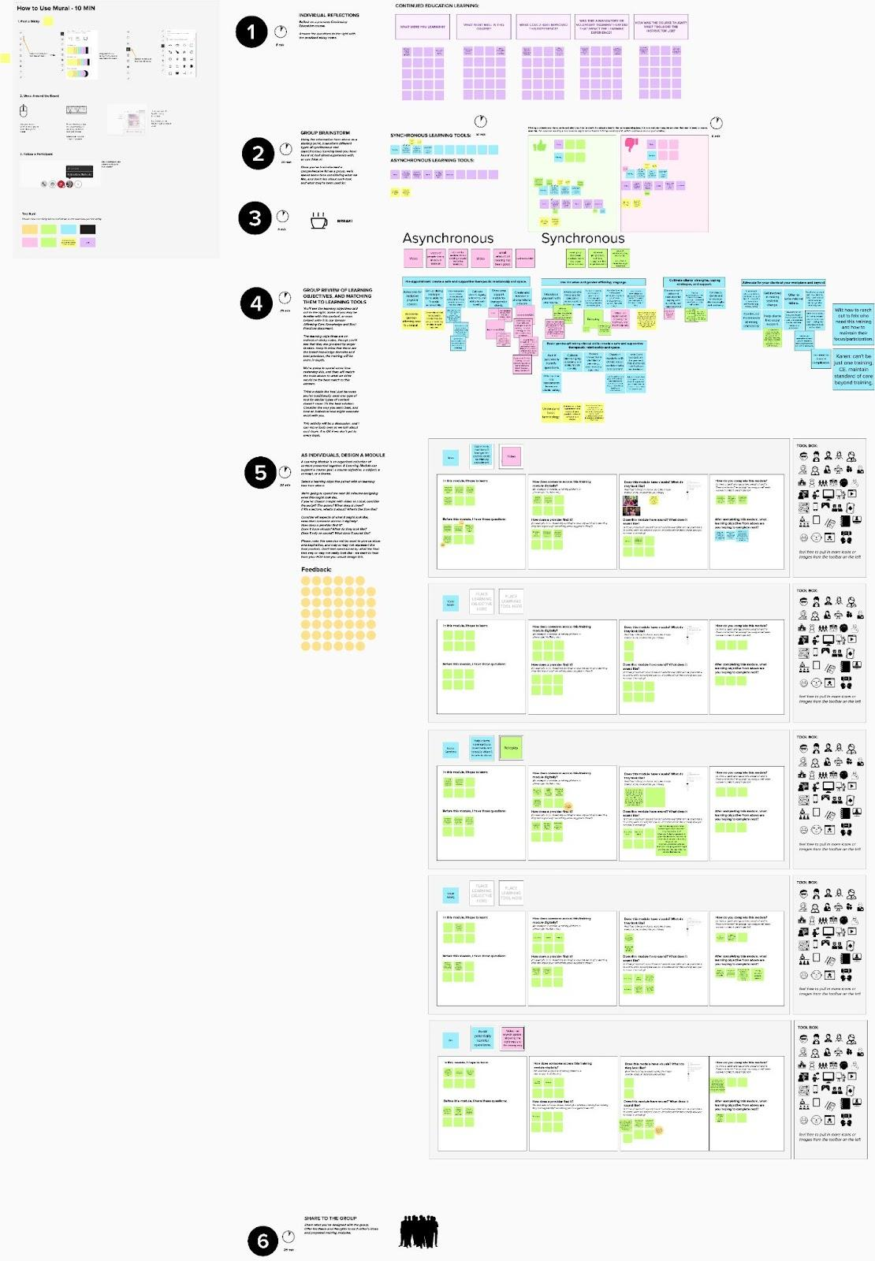

Provider Design Meeting #3: Provider Perspectives on Aesthetics and Sequence of Gender-Affirming Psychotherapy Training

Overview: The goal of the third meeting was to utilize feedback from providers on how to teach content effectively to both knowledgeable and novice providers.
Structure of meeting: 120-minute session divided into 5 parts:
- Introductions
  - Time: 5 Minutes
  - Instructions: Researchers and providers introduce themselves and are then introduced to the content of the design meeting. Remind providers what a design meeting is and how their input is being utilized in the final training.
- Moodboards
  - Time: 45 Minutes
  - Prompt: How might this tool look and feel?
  - Instructions: Have providers review the moodboards– visual collage of images, text, and design elements that represent potential styles for the training– on MURAL. Providers record their reactions using blue sticky notes for general feedback and yellow sticky notes for suggestions for improvement. Record key themes from the providers' responses and ask follow-up questions for clarification.
  - Example Questions: What color schemes, layout, and photos resonate with you? What tone would you want the information to be presented in? Who is presenting the information?
- Break
  - Time: 10 Minutes
  - Instructions: Take this time to review Knowledge and Practice Learning Objectives
- Sequence
  - Time: 15 Minutes
  - Prompt: In small groups, discuss what you think the ideal sequence for this content is, and why. How do you envision this coming together?
  - Instructions: Divide providers into two small groups, with at least one researcher in each group. Ask providers to sort knowledge and best practices domains into the sequence they think would work best for provider training. Ask follow-up questions to clarify how providers prioritize information and the temporal order of the presented information.
  - Example Questions: What does someone need to know first? If you were teaching this to a friend, where would you want them to start? Does it need to be sequential? Or should you choose your own adventure?
- Share out / Discussion
  - Time: 20 Minutes
  - Instructions: Give each group 5 minutes to share what they worked on and came up with. Ask providers follow-up questions on their sequences and note recurring themes across groups.
  - Example Questions: What strategies would you use to increase engagement? How might you persuade someone unlikely to do this training to be interested in it?
Design Session 3 Takeaways:
- A motivational introduction is crucial to connect with audiences who might not immediately see the relevance of the content.
- Inclusive language and understanding transgender clients’ concerns are essential.
- Topics like advocacy should be optional and there should be shorter, focused training sessions for better accessibility and effectiveness.
Design Session 3MURAL:
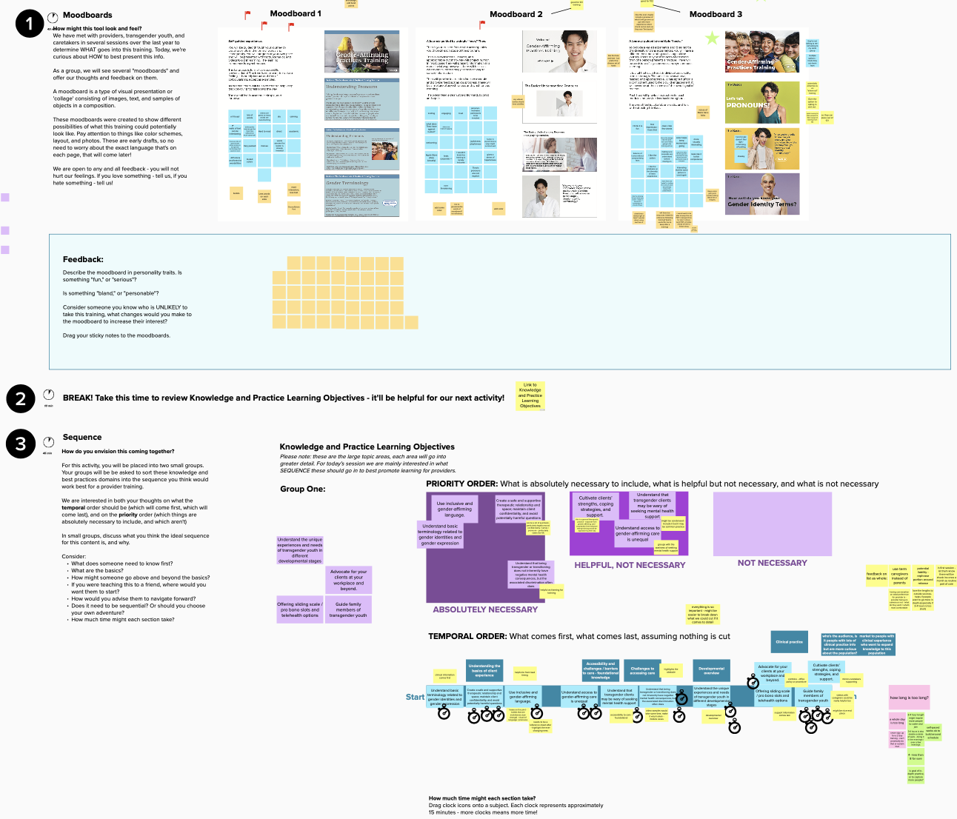

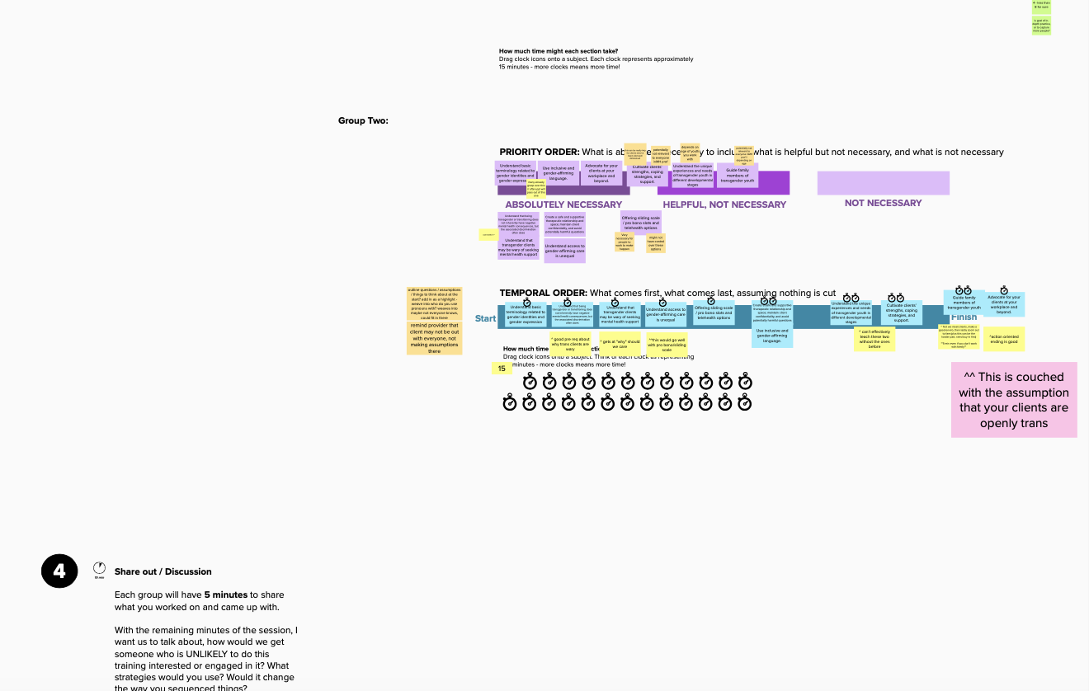

Provider Design Meeting #4: Provider Perspectives on Aesthetics of Training and Uses of Implementation Strategy Across Scenarios.

Overview: The goal of the fourth meeting was to utilize feedback from providers on how to teach content effectively to both knowledgeable and novice providers.
Structure of meeting: 120-minute session divided into 4 parts
- Introductions
  - Time: 5 Minutes
  - Instructions: Researchers and providers introduce themselves and are then introduced to the content of the design meeting. Remind providers what a design meeting is and how their input is being utilized in the final training.
- Moodboards
  - Time: 45 Minutes
  - Prompt: How might this tool look and feel?
  - Instructions: Have providers review the moodboards on MURAL. Providers record their reactions using blue sticky notes for general feedback and yellow sticky notes for suggestions for improvement. Record key themes from the providers' responses and ask follow-up questions for clarification.
  - Example Questions: What color schemes, layout, and photos resonate with you? What tone would you want the information to be presented in? Who is presenting the information?
- Break
  - Time: 10 Minutes
  - Instructions: Take this time to review Knowledge and Practice Learning Objectives.
- Scenarios for Providers
  - Time: 55 Minutes
  - Prompt: What might this experience look like in a few different scenarios?
  - Instructions: Pair providers with researchers and ask them to consider how they might design a page for a particular scenario. Providers use sticky notes, photos, and icons to add comments or visuals to their workspaces. Facilitate by asking prompting questions to encourage reflection on how this page could be best utilized in the training.
  - Example Scenarios: A provider is interacting with an asynchronous lesson; A provider is reviewing trainings to fulfill their CEU needs. This training is 1 of many options; A provider is referencing the training during a session with a patient’s caregiver.
  - Example Questions: What does this page look like? How does someone navigating it feel? What questions might they have before they get to this page? What answers does the page provide them? Think of someone you know who is the LEAST likely to want to complete this training - how would you increase their interest and engagement?
Design Session 4 Takeaways:
- Avoid text-heavy designs and utilize engaging videos, visuals and modern colors to create a more approachable, less clinical presentation
- Gender identity should be framed in a positive, affirming way.
- Include providing basic knowledge on gender diversity, developing conversational skills, and fostering open, accepting attitudes as key components of working with parents.
- Storytelling can be used to educate parents in a way that avoids provoking defensiveness or self-blame.

Design Session 4 MURAL: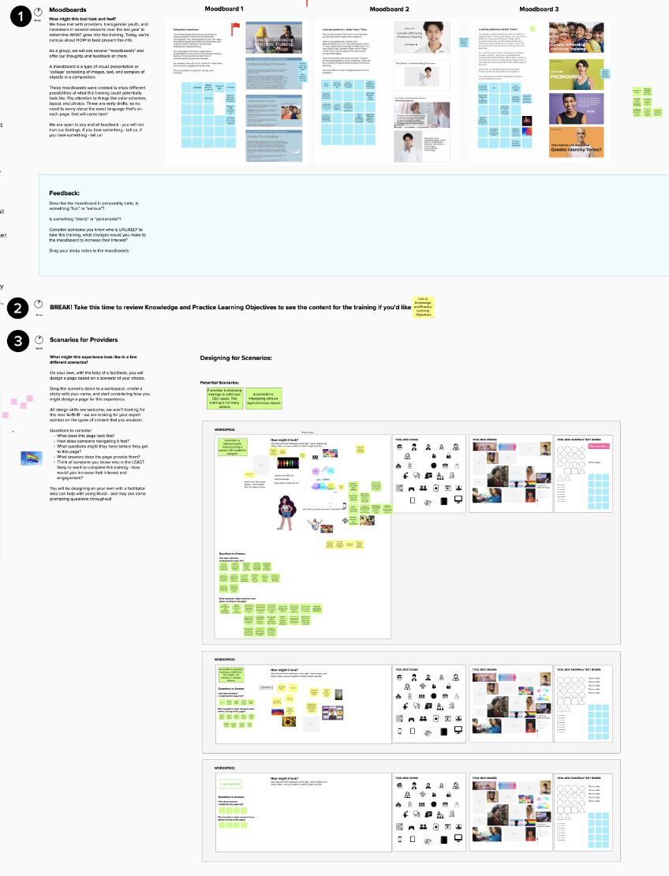

Patient Design Meeting #5: Perspectives from Patients on Content and Format of the Implementation Strategy.

Overview: The goal of the fifth meeting was to utilize feedback from trans and nonbinary patients on how to teach content effectively to providers. They were encouraged to reflect on their personal experiences and suggest hot to best support their unique needs.
Structure of meeting: 120-minute session divided into 6 parts:
- Introductions
  - Time: 5 Minutes
  - Instructions: Researchers and providers introduce themselves and are then introduced to the content of the design meeting. Remind youth what a design meeting is and how their input is being utilized in the final training.
- Design a Video & Script
  - Time: 45 Minutes
  - Prompt: Researchers have determined what goes into this training, but not how to best present this information. Write and draw out your ideas for a video on a specific subject from the training.
  - Instructions: Pair each youth with a researcher to select a topic from the blue sticky notes and fill in the storyboard, which outlines planned shots for a film or TV production through a sequence of drawings, directions, and dialogue. Guide the youth in using icons, photos, and text to develop their idea for a training video.
  - Example Questions: If you could explain this subject to a provider, how would you do so? What visuals would be important to convey this lesson? How does this video sound? Is it funny? Serious? Is there a particular person (like a host) who could deliver this lesson really well?
- Share
  - Time: 10 Minutes
- Break
  - Time: 5 Minutes
- Design a Video & Script
  - Time: 45 Minutes
  - Prompt: Researchers have determined what goes into this training, but not how to best present this information. Write and draw out your ideas for a video on a specific subject from the training.
  - Instructions: Pair each parent with a researcher to choose a topic from the blue sticky notes and to fill in the storyboard. Guide the youth in using icons, photos, and text to develop their idea for a training video.
  - Example Questions: If you could explain this subject to a provider, how would you do so? What visuals would be important to convey this lesson? How does this video sound? Is it funny? Serious? Is there a particular person (like a host) who could deliver this lesson really well?
- Share
  - Time: 15 Minutes
Design Session 5 Takeaways:
- Transness should be presented as normal and positive.
- Each trans youth has unique needs and recognizes that not all trans youth want to discuss their gender identity.
- Incorporating the perspectives of parents to trans children would offer a more comprehensive perspective in the training.
Design Session 5 MURAL:
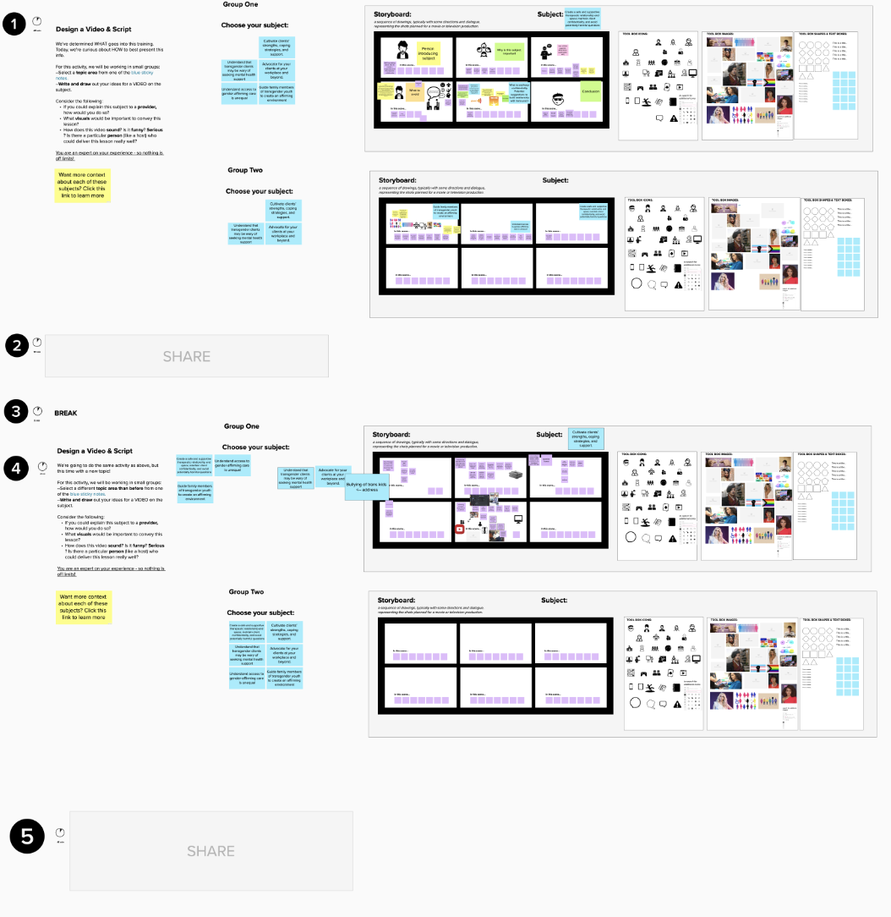

Parents Design Meeting #6: Perspectives from Caregivers on Content and Format of Implementation Strategy.

Overview: The goal of the sixth meeting was to utilize feedback from the parents of trans and nonbinary on how to teach the training content to providers. Parents were encouraged to reflect on their personal experiences so that the training best supported their unique needs.
Structure of meeting: 120-minute session divided into 6 parts:
- Introductions
  - Time: 5 Minutes
  - Instructions: Researchers and providers introduce themselves and are then introduced to the content of the design meeting. Remind parents what a design meeting is and how their input is being utilized in the final training.
- Design a Storyboard & Script
  - Time: 45 Minutes
  - Prompt: Researchers have determined what goes into this training, but not how to best present this information to mental health care providers. Write and draw out your ideas for a video on a specific subject from the training.
  - Instructions: Pair each parent with a researcher to choose a topic from the blue sticky notes and to fill in the storyboard. Guide the parents in using icons, photos, and text to develop their idea for a training video.
  - Example Questions: Consider how you felt at the beginning of your journey with the trans children in your life - what would have helped you then? If you could explain this subject to a provider, how would you choose to do so? What visuals would be important to convey this lesson? How does this script sound? Is it funny? Serious? Is there a particular person you think could deliver this lesson really well?
- Share
  - Time: 15 Minutes
  - Instructions: Let each group share what they worked on.
- Break
  - Time: 5 Minutes
- Design a Therapist Online Profile
  - Time: 30 Minutes
  - Prompt: Imagine that you are helping the trans child in your life find a provider. Design an online profile listing for a therapist who just finished this training and may be a good fit for your client.
  - Instructions: Pair parents with the same researcher in breakout rooms. The researcher should guide the caregiver through filling out the therapist online profile in MURAL by asking prompting questions to encourage reflection on how this page could be best structured for parents of trans and nonbinary youth.
  - Example Questions: What would make this person stand out to me? What would communicate trust? Would it be helpful to know if a provider completed this training? If so - why is it important? What would this training be called when listed on a site like this? What's a red flag on a provider's profile? What would make me want to reach out to this person?
- Share
  - Time: 15 Minutes
  - Instructions: Let each group share what profile they designed. Encourage parents to ask questions and offer feedback on the other profiles.
Design Session 6 Takeaways:
- Remain sensitive to parents’ experiences, including feelings of loss and isolation.
- Provide empirical evidence demonstrating the benefits of GAP to help parents make informed decisions about therapy for their child.
- Keeping parents informed on treatment progress while maintaining confidentiality fosters trust and strengthens the therapeutic relationship.
- Maintain a sense of hope when working with families and trans youth while remaining non-judgmental.
Design Session 6 MURAL:
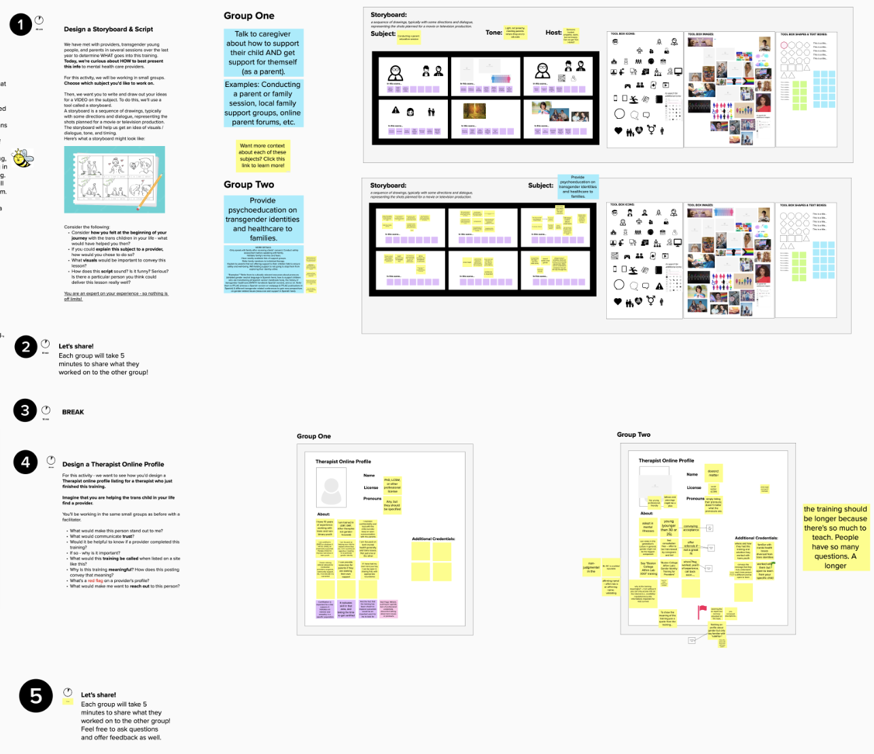

References
1. MURAL [Internet]. 2024 [cited 2024 Sep 12]. MURAL. Available from: https://mural.co/

