Additional File 7. Implementation Strategy and Training Tool Example Material

Clinic Demographic Form

Name (you go by):
First Name
Last Name

Can we use this name in conversation with your caregivers/other clinicians?
Yes
No
Depends

If you chose "depends" above, please describe:

_________________________________________________________________________

Pronouns (check all that apply):
they/them
she/her
he/him
choose not to disclose
another set of pronouns

If you chose "another set of pronouns" above, please describe:

_________________________________________________________________________
Can we use these pronouns in conversation with your caregivers/other clinicians?
Yes
No
Depends

If you chose "depends" above, please describe:

_________________________________________________________________________

Gender (check all that apply):
boy
genderfluid
genderqueer
girl
man
non-binary
two spirit
woman
unsure
choose not to disclose
another gender

if you chose "another gender" above, please describe:

_________________________________________________________________________

Transgender:
Transgender
Not transgender
Unsure

If you chose "unsure" above, please describe:

_________________________________________________________________________

Sexual orientation (check all that apply):
bisexual
gay
lesbian
homosexual
straight or heterosexual
pansexual
queer
unsure
choose not to disclose
another sexual orientation:

If you chose "another sexual orientation" above, please describe:

_________________________________________________________________________

Race (check all that apply):
American Indian or Alaska Native
Asian/Asian-American
Black or African American
Native Hawaiian or other Pacific Islander
Middle Eastern/North African
Latin American
Choose Not to Disclose
More than one race; please describe

If you chose more than one race, please describe:

_________________________________________________________________________

Ethnicity:
Hispanic
Non-Hispanic
Other/additional ethnicity:

If you chose "Other/additional ethnicity" above, please describe:

_________________________________________________________________________

What language are you most comfortable speaking?

_________________________________________________________________________

What other languages are spoken in your home?

_________________________________________________________________________

What other languages do you speak?

_________________________________________________________________________

Religion/Spirituality:

________________________________________________________________________

Provider Story: EHR

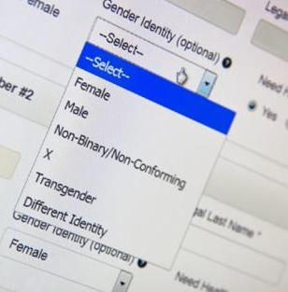
“I updated our intake forms, which was a win!”
I work in a group practice, and one issue that’s come up a lot is how not inclusive electronic medical records are in terms of logging gender versus sex. I keep my own detailed notes, but then I have to report deadnames and birth-assigned sex in our clinic records and in the EMR for insurance purposes and whatnot.
It was sometimes pretty upsetting and triggering for patients to see that they would be misgendered on all of their records because that’s the way the EMR worked. And on top of that, sometimes other staff - like our front desk staff - would use some patients' deadnames or incorrect pronouns when making calls, because that’s all we had available in the records. So of course, that was distressing to a lot of trans patients.
I knew we could do better, so I consulted with colleagues and read more about what other practices were doing. Ultimately, we decided to focus on updating our intake forms to be more inclusive. We now have questions and write-in spots on our provider- and patient-facing intake forms for affirmed name pronouns. For example, there are options for pronouns like: she/her, he/him, they/them, another set of pronouns where you can type them in, or write “prefer not to disclose.”
In our practice we also do re-evaluations every 6 months, so on those forms too, we have a spot where we re-assess clients' names and pronouns by simply asking for them again. It might sound awkward but I’ve made it pretty conversational. I usually say something like “I know we asked for your name and pronouns when you first started treatment here, but because identities are fluid and people sometimes have name changes, we also ask regularly throughout treatment. And today is one of those times. What name would you like me to use?”
Based on each intake or re-evaluation session, we add notes to the front page of our EMR so that everyone - including providers and staff - have easy access to each patient’s affirmed name and pronouns.
We also trained all of our front desk staff to be attentive to affirmed names and pronouns and know exactly where to look on the EMR to find them. When we first changed the intake forms, we had a full clinic meeting to explain the changes and provide information about deadnames, pronouns, gender vs. sex, all that important stuff. It’s also a standard part of onboarding for any new hire now.
Despite those successes, we still haven’t changed the actual EMR system and I can’t change the EMR our practice purchased. They still require birth-assigned name in the name field, and only offer three genders: “M,” “F,” or “Other.” Hopefully we can change that when it’s time to renew, but shifting over to a new EMR is not as easy as changing one document.
I sent in feedback to the EMR company suggesting that they change "sex" to "sex assigned at birth" or "sex according to your insurance carrier.” The company responded saying that they’re working on this change now! Honestly, I was surprised they even read suggestions - so that’s hopeful. In any case, that change may or may not happen, but it’s progress. And I’m proud of that.

Mandate Language
Example language that can be used when explaining the importance of and mandating an intervention.

The partner clinic’s CEO encouraged training participation and emphasized the leadership’s prioritization of GAP implementation by sharing (paraphrased by partner clinic champion provider):

“We all need to take this [gender-affirming psychotherapy] very seriously. It’s aligned with our values. It will be brought up in future conversations about raises and promotions. And we will ask you whether you completed the training if you ask for money for other trainings.”

Gender Dysphoria Discussion

Learn how to discuss a gender dysphoria diagnosis from an example session
See below to learn about how his provider talks to his 12 year-old nonbinary client, River, about gender dysphoria. For context, River has been wanting hormone blockers [definition: medications contain stable amounts of gonadotropin-releasing hormone (GnRH) analogs, which help suppress sex hormones]. Their provider thinks this may be a good idea given that River is quite worried about their voice deepening and growing any facial hair like their brothers have when they turned 14 years old.
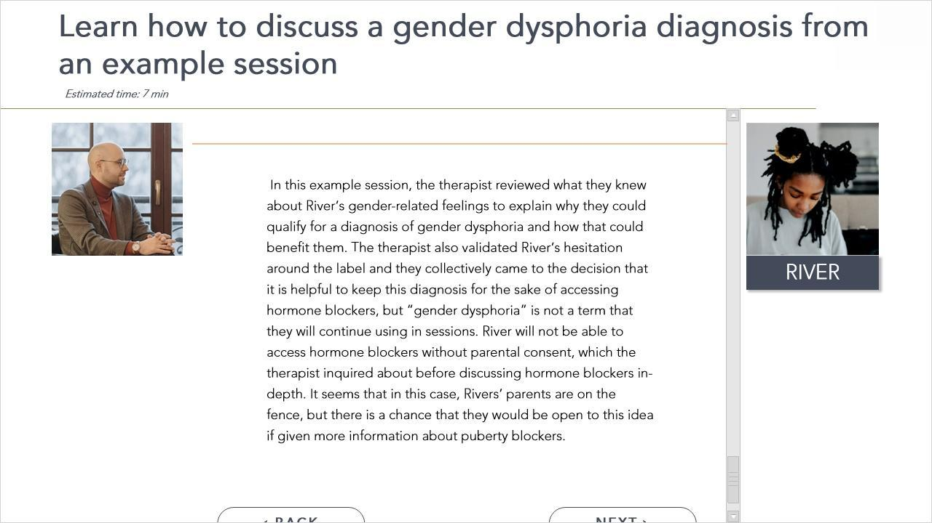
Provider: So last time we discussed that you’re worried about your voice changing and your facial hair starting to grow in. Is that accurate?
Client: Yeah, I’m still not exactly sure about my gender identity. I think I’m nonbinary and I want to present as a more androgynous person. My facial hair is already starting to grow and my voice has started to crack. I hate it. I look terrible as a boy and I’m going to be miserable if I become “a man.” I don’t think I can handle looking like my brothers did post-puberty, it doesn’t feel right and it makes me feel hopeless.
Provider: I hear you say that you are still exploring your gender identity and that the effects of puberty, such as growing facial hair and your voice deepening, are upsetting you and causing feelings of hopelessness. Am I getting that right?
Client: Yeah, I think so.
Provider: That makes a lot of sense. Puberty can cause distress for many adolescents, in particular those who may identify as transgender and nonbinary. There are medical interventions, such as hormone blockers, that you can pursue. Are you familiar with hormone blockers?
Client: I have heard of them, and I think I would like to start taking them.
Provider: Thank you for sharing that with me. Can I ask, have you talked to your parents about the idea of hormone blockers?
Client: I have, that’s actually what we were talking about when they first agreed to have me come see you so I could learn more about what that means. They’re honestly pretty nervous about me going on blockers, but if I come back with more information, they might get on board. I’m hopeful, but not sure.
Provider: Ah, that makes sense. I know this idea can be overwhelming for some parents, but it’s not that unusual for trans and nonbinary young people your age. As you probably know, we will need your parents’ consent before we can move forward. What questions can I answer for you - or your parents - about the pros and cons of puberty blockers?
Client: Okay, yeah. Well one thing I was wondering is if I need to get diagnosed for gender dysphoria before I can start any type of hormone treatment? I feel weird about having a medical diagnosis for my genuine gender identity, you know?
Provider: I hear you: there are benefits and drawbacks to receiving a diagnosis of gender dysphoria. The benefit is that if I referred you to a pediatric endocrinologist - in other words, a doctor who specializes in hormones, including those that start at puberty - they would ask me if your feelings about your gender are intense and have lasted a long time.
Client: I couldn’t tell you exactly how long they lasted though. It’s not like I woke up one morning and wrote down in my calendar - I officially feel weird about my gender today, you know?
Provider: Yes! That would be pretty weird to write down. So, according to the diagnosis of gender dysphoria, we just need to confidently say that you’ve felt this way consistently for 6 months. I think that’s true for you, is that right?
Client: Yeah, definitely. It’s been a few years at least, I just didn’t have the words to describe how I felt and I didn’t know who to talk to about this.
Provider: Sure, I hear you. Well, with that information in mind, you do qualify for a diagnosis of gender dysphoria. If you are open to it, I could write this up in my notes and that diagnosis would help you get a prescription for puberty blockers, like you’d wanted. But, even if we both decide to put this in our notes, that doesn’t mean that the words “gender dysphoria” best describe your experience.
Client: I don’t think those words are me. And… It still feels like I’m being diagnosed for my transness, but I get why that might be helpful in this one case. So I’m okay with you writing that in your notes, even though it’s not a perfect diagnosis for me personally.
Provider: I understand. In that case I will write down “gender dysphoria” in your file, but with the caveat that we will keep working in sessions to find words that are more true for you personally. Does that sound good?
Client: Yeah, okay!
In this example session, the therapist reviewed what they knew about River’s gender-related feelings to explain why they could qualify for a diagnosis of gender dysphoria and how that could benefit them. The therapist also validated River’s hesitation around the label and they collectively came to the decision that it is helpful to keep this diagnosis for the sake of accessing hormone blockers, but “gender dysphoria” is not a term that they will continue using in sessions. River will not be able to access hormone blockers without parental consent, which the therapist inquired about before discussing hormone blockers in-depth. It seems that in this case, Rivers’ parents are on the fence, but there is a chance that they would be open to this idea if given more information about puberty blockers.

Practice explaining dysphoria
In this step, you will explain what gender dysphoria is and why (or why not) you might diagnose a client with gender dysphoria. Use your own words and explain this in a way that feels natural to you.
_________________________________________________________________________________________________________________________________________________________________________________________________________________________________________________________

Referral Activity

Join a group of gender-affirming providers in New England!
To join the New England Gender Specialists listserv you just learned about, go to: https://groups.google.com/g/new-england-gender-specialists and ask to join.

Start a referral list
To start a referral list of your own, identify the providers in your area who have expertise and availability to take on new young transgender and nonbinary clients. We started this list for you but we need your help filling it out!
- Please fill out the google form → by adding at least 1 new provider. Resources for finding providers are in the form and we also recommend Google. We will review your additions and update the form regularly.
- Providers find that it’s helpful to update their referral list as things change. For example, if a client provides an endorsement or warning about a particular provider, you can add that information in the form to help others navigate care.
- You can save the link to this google form if you want to update it in the future: https://docs.google.com/forms/d/e/1FAIpQLScPiFOzVNJOmRCrYALId8gnhrafw7GUNMa4L3Q6-l0vA2Z0eg/viewform?pli=1
- When you’re done, click submit on the form.
We encourage you to save the link to this google sheet to see the regularly growing list!

Youth Story

To enhance exposure to the population and address multiple learner needs, all stories had a read-aloud option with a voice matching the affirmed gender of the youth in the story, and a stock photo of the stakeholder.

Story 1: “I don’t know if ‘nonbinary’ is exactly the right term”
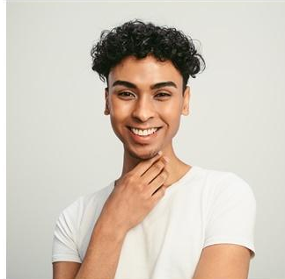
I recently told my parents that I identify as nonbinary. I wasn’t afraid about coming out to them because they’ve always been good about LGBTQ things - like my mom’s brother is gay and that’s never been a problem in our family. So I was caught off guard that they didn’t get what I meant by “nonbinary.” They kept saying like, “Oh you’re trans, you want to be a girl,” even though I explained, “No I’m not really a boy or a girl, that’s what ‘nonbinary’ means.” And it wasn’t getting through to them exactly how I understood it.
This has been really hard for me so I brought it up with my provider, Dr. Chuang. To be honest, I don’t know if “nonbinary” is exactly the right term, but I thought my parents would understand it better than if I called myself something like “genderfluid” or “gender nonconforming.” I kind of like “genderfluid,” because it captures how some days I feel more girl than boy, or the other way around, or neither. But I also like “gender nonconforming” because it’s more broad and kind of lets me express myself however I want without boxing me in. Maybe both work? Maybe it’ll change in the future? I’m not sure.
What I do know is that Dr. Chuang has made our therapy sessions a safe space to have these talks. He even taught me a new word the other day: “gender euphoria,” which means something like feeling amazing about your gender or expression. It was so cool to hear that feeling good while exploring gender identity is a thing. I’ve heard so much about people’s gender dysphoria, I thought that’s what I would always feel.
On top of letting me talk about these things without judging me, Dr. Chuang is helping me figure out how to talk to my parents about my gender identity. We practice different conversations I might have and he’s helped me understand where my parents might be coming from, which helps me feel less angry at them for not being immediately supportive like I thought they would be.

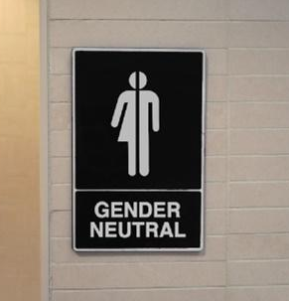
Provider Story: Inclusive Bathrooms

“I re-labeled the bathrooms at my clinic”
A sentiment I’ve heard a lot from my trans and gender diverse clients is that they sometimes feel unwelcome or uncomfortable in clinics. Of course, medical and mental health care settings can be sterile and intimidating. And when you pair that with the fact that many trans clients are coming in with a history of negative experiences with providers, you can understand how they might feel wary or intimidated when they enter a new provider’s space.
That’s why, in my clinic, I try to make a conscious effort to make my support for trans identities visible from the get-go. I put rainbow and trans flag decorations in the waiting room and I even bought some pins with pronouns that stay at the front desk for any clients who want them. I know all of this might sound cheesy or even over the top, but it can really be a source of comfort for clients to see these tangible signs of support and know that gender identity is something providers here are actively thinking about. And it was super easy for me and my colleagues to make these changes.
We’ve also done some work around our bathrooms. Right now, we have only two multi-stall bathrooms, and since our office is pretty old, we need to use keys for the bathrooms. Before, the keys and bathrooms were labeled as “Ladies’” and “Men’s” bathrooms which signal a binary understanding of gender that we know isn’t accurate. Since we can’t yet add a third all-gender bathroom - that would require renovation and I don’t know if it’ll happen - I asked for permission to change the way we labeled the bathrooms to be more inclusive.
Our director let me add descriptive signs like, “Bathroom with four urinals and three stalls with toilets,” just so clients can know what to expect and can decide which to use based on that information. We also asked neighboring businesses with proper all-gender bathrooms if our clients can sometimes use them, and let our clients know which are available to them. This definitely isn’t a perfect solution, and hopefully someday we can have proper all-gender bathrooms in our space. But we’ve heard from some clients that these changes made them feel more comfortable in our space.

Example Certificate
