Distribution of micro (Fe, Zn, Cu, and Mn) and risk (Al, As, Cr, Ni, Pb, and Cd) elements in the organs of Rumex alpinus L.

^{ac}* Michaela Jungová, ^{a b} Michael O. Asare, ª Vladimíra Jurasová, ª Michal Hejcman

ª Department of Ecology, Faculty of Environmental Sciences, Czech University of Life Sciences, Prague, Kamýcká 129, Prague 6 – Suchdol CZ165 00, Czech Republic.
^{b} Department of Agroenvironmental Chemistry and Plant Nutrition, Czech University of Life Sciences, Kamýcká 129, CZ-165 21 Prague 6, Czech Republic.
^{c}Crop Research Institute, Drnovská 507/73, 161 06 Prague 6 – Ruzyně, Czech Republic

*Correspond author email: jungovam@fzp.czu.cz (Jungová M.)

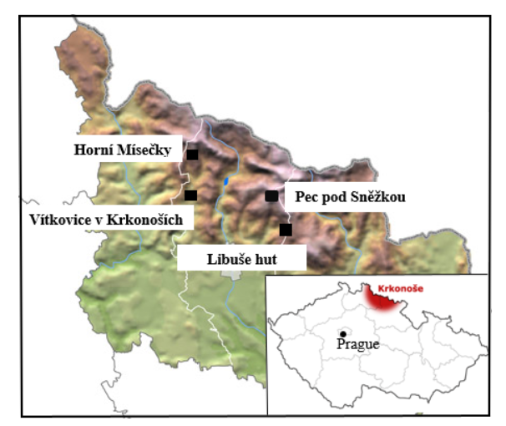

Figure S1. Specific locations of study sites in the Krkonoše (Giant) Mountains; Czech Republic: Horní Mísečky (HM), Vítkovice v Krkonoších (VT), Libuše hut (LB), and Pec pod Sněžkou (PC).

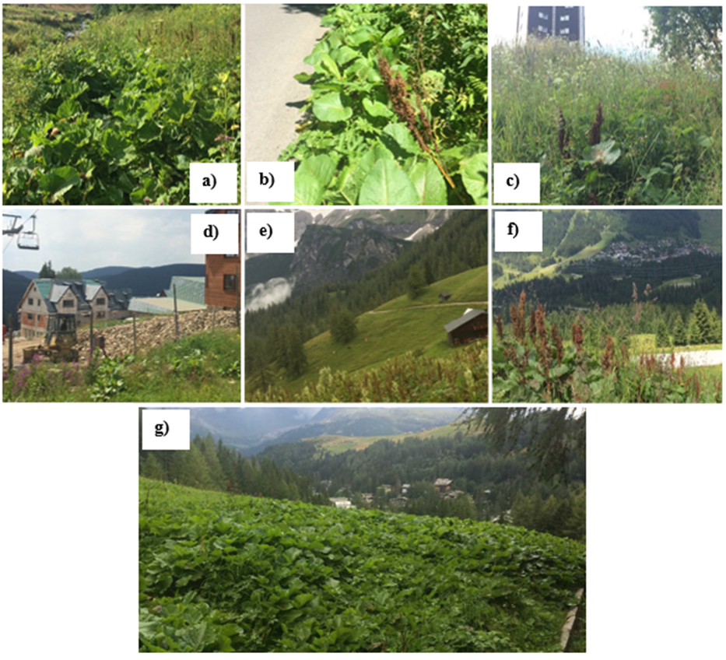
Figure S2. Rumex alpinus stands in (a) Libuše hut, (b) Vítkovice v Krkonoších, (c) Pec pod Sněžkou, (d) Horní Mísečky, (e) Ramsau am Dachstein (DCH), (f) Zillertal (ZL), and (g) Madesimo (MD).

Table S1. The mean values of individual organs described in the graphs of individual elements. Mean of plant total concentration (Mean ± SE) of elements in organs of R. alpinus, these numbers correspond to columns of mean values in Figures 3-6. The p-value for each element was obtained by one-way ANOVA. Using Tukey (HSD) post hoc test, organs with the same letter were not significantly different.
Elements |  | Emerging leaves | Mature leaves | Senescent leaves | Petiole | Stem | Rhizome | F-value | P-value | Normal value *
Fe | (mg kg⁻¹) | 106 ± 8.8^{ab} | 110 ± 10^{ab} | 245 ± 50c | 39.2 ± 3.3ª | 45 ± 4.4ª | 177 ± 23^{bc} | 11.5 | < 0.001 | 30 – 300 ⁽³⁾
Zn | (mg kg⁻¹) | 45.3 ± 2.4^{ab} | 40.1 ± 3.6ª | 42.9 ± 9.1ª | 28.6 ± 2.5ª | 32 ± 5.1ª | 75 ± 12.5^{b} | 4.6 | < 0.001 | 10 – 150 ⁽²⁾
Cu | (mg kg⁻¹) | 8.9 ± 0.6ª | 8.3 ± 0.5ª | 4.6 ± 0.4^{b} | 3.8 ± 0.3^{bc} | 2.5 ± 0.3^{c} | 5.3 ± 0.4^{b} | 33.8 | < 0.001 | 4 – 15 ⁽⁶⁾
Mn | (mg kg⁻¹) | 38.8 ± 3.6^{ab} | 17.1 ± 13.5^{b} | 145 ± 17c | 41.3 ± 5.0^{ab} | 27.9 ± 4.5ª | 33.3 ± 4.3^{ab} | 21.7 | < 0.001 | 40 – 200 ⁽⁴⁾
Al | (mg kg⁻¹) | 79 ± 10ª | 99.8 ± 14.5ª | 214 ± 40^{ab} | 361 ± 106 ^{b} | 94 ± 8.7ª | 181 ± 24^{ab} | 5.3 | < 0.001 | _
As | (mg kg⁻¹) | 1.2 ± 0.3ª | 1.2 ± 0.2ª | 1.9 ± 0.4ª | 1.8 ± 0.4ª | 1.2 ± 0.3ª | 1.2 ± 0.3ª | 1.6 | 0.173 | 1 - 1.7 ⁽¹⁾
Cr | (mg kg⁻¹) | 0.6 ± 0.1ª | 0.6 ± 0.1ª | 1.0 ± 0.2^{ab} | 0.5 ± 0.1ª | 1.7 ± 0.3^{b} | 1.7 ± 0.4^{b} | 7.0 | < 0.001 | 0.1 - 0.5 ⁽¹⁾
Ni | (mg kg⁻¹) | 1.7 ± 0.2ª | 1.6 ± 0.3ª | 1.6 ± 0.4ª | 1.3 ± 0.3ª | 1.4 ± 0.2ª | 2.4 ± 0.4ª | 1.8 | 0.128 | 0.5 – 5 ⁽⁵⁾
Pb | (mg kg⁻¹) | 3.9 ± 0.7ª | 3.1 ± 0.4ª | 3.4 ± 0.5ª | 3.2 ± 0.5ª | 3.3 ± 0.4ª | 2.7 ± 0.3ª | 0.6 | 0.674 | 0.5 – 10 ⁽²⁾
Cd | (mg kg⁻¹) | 0.17 ± 0.04ª | 0.19 ± 0.07ª | 0.22 ± 0.06ª | 0.33 ± 0.11ª | 0.63 ± 0.15ª | 1.25 ± 0.24^{b} | 10.5 | < 0.001 | 0.05 – 2 ⁽²⁾
* – no material;1 adapted from Kabata-Pendias and Pendias (2001); 2—adapted from Pugh et al. ( 2002); 3—adapted from Levy et al. ( 1999); 4—Mahler ( 2004); 5—Allen (1989); 6—adapted from Guleryuez et al. ( 2008)

