Supplement Information
Probabilistic Greedy Algorithm Solver Using Magnetic Tunneling Junctions for Traveling Salesman Problem
Ran Zhang¹, Xiaohan Li¹, Caihua Wan^{1, 2, 6, *}, Raik Hoffmann³, Meike Hindenberg³, Yingqian Xu¹, Shiqiang Liu¹, Dehao Kong¹, Shilong Xiong¹, Shikun He⁴, Alptekin Vardar³, Qiang Dai⁴, Junlu Gong⁴, Yihui Sun⁴, Zejie Zheng⁴, Thomas Kämpfe^{3, 5, *}, Guoqiang Yu^{1, 2, 6} and Xiufeng Han^{1, 2, 6, *}
¹Beijing National Laboratory for Condensed Matter Physics, Institute of Physics, University of Chinese Academy of Sciences, Chinese Academy of Sciences, Beijing 100190, China
²Center of Materials Science and Optoelectronics Engineering, University of Chinese Academy of Sciences, Beijing 100049, China
³Fraunhofer IPMS, Center Nanoelectronic Technologies, 01109 Dresden, Germany
⁴Zhejiang Hikstor Technology Co. Ltd, Hangzhou 311305, China
⁵TU Braunschweig, Institute for CMOS Design, 38106 Braunschweig, Germany
⁶Songshan Lake Materials Laboratory, Dongguan, Guangdong 523808, China
E-Mail: thomas.kaempfe@ipms.fraunhofer.de ; wancaihua@iphy.ac.cn ; xfhan@iphy.ac.cn

Supplement I: Measurement and program-controlled system description
The setup used for testing and characterizing spin-transfer torque magnetic tunneling junction (STT-MTJ) devices combines precise electrical measurements and multi-device control, integrating hardware and software components to ensure fast, accurate, and reliable data acquisition.
Hardware configuration
The MTJ samples are arranged on a silicon die with a structure comprising from top to bottom capping/CoFeB/Mo/CoFeB/MgO/CoFeB/Mo/[Co/Pt]_{n}-based synthetic anti-ferromagnetic layers. These samples connect to the measurement system through a high-precision probe card with a 100 µm pitch and 25 individual pins, ensuring minimal contact resistance and high reproducibility. Signals from the probe card are routed via SMB-Dupont micro coaxial cables to an adapter board, which serves as a signal conditioning interface. The adapter board connects to SHDB62M-DB62M-LL type DB62 cables, known for shielding properties that reduce interference, ensuring the accurate transfer of signals to the high-resolution measurement instruments within the NI PXIe system.
The instrumentation consists of a source measure unit (SMU) and a pattern generator module integrated into the NI PXIe system. The NI PXIe-4163 SMU has 24 independent channels, each capable of delivering up to ±10 V and measuring currents down to nanoampere levels, allowing for precise sourcing and measurement operations. The pattern generator applies voltage or current pulses to induce switching in the magnetic free layer of the MTJ, enabling the study of dynamic stochastic behavior. The pulse duration and intervals are controlled with high precision to capture time-sensitive switching events.
Software and control system
The Python-based control program acts as the central coordinator of the experimental process, interfacing with the NI PXIe system to manage data acquisition and device control. The program employs a continuous loop structure where each iteration involves reading the current state of the MTJ devices, processing the data according to a specified algorithm, and then adjusting the excitation voltage for the next step.
Data acquisition is initiated through the SMU module, which measures the resistance states of the MTJs after each applied voltage pulse. The Python program uses the NI-DAQmx driver to communicate with the SMU, retrieving measurements as arrays of resistance values that are timestamped and stored for analysis. Once the data are read, they undergo a filtering process to remove any electrical noise and ensure data integrity.
Based on the processed resistance data, the program calculates the corresponding switching probability using statistical methods. The feedback mechanism uses a predefined mathematical relationship between the switching probability and the applied voltage, which is typically modeled as a sigmoidal function. The program determines the required voltage directly from this relationship, calculating it based on the desired switching probability for the next iteration. This voltage is then applied to the MTJ in the next step, ensuring a precise adjustment that aligns with the defined model rather than relying on observed values to make incremental changes.
This approach enables real-time tuning of the MTJ excitation voltage based on a deterministic relationship between probability and voltage. This ensures consistency across measurements. The algorithm's output is directly mapped to the necessary voltage adjustments, allowing for continuous adaptation to maintain the target probabilistic behavior.
Data acquisition and processing
The adaptive control process involves a real-time loop where data acquisition, processing, and voltage adjustment occur continuously. After reading the resistance data from the SMU, the Python program applies statistical algorithms to calculate the switching probability for each device.
In each iteration, the desired switching probability serves as input to the model, which outputs the voltage that should be applied in the next step. This calculated voltage is set on the pattern generator, which updates the excitation conditions for the MTJ accordingly. The entire process repeats for each iteration, ensuring that the MTJ maintains the desired stochastic characteristics by precisely adjusting the applied voltage as determined by the established sigmoid relationship.
The use of a defined mathematical model for determining the excitation voltage ensures that adjustments are both accurate and predictable. This method enables the algorithm to fine-tune the random number generation process effectively, making it suitable for applications in probabilistic computing and stochastic optimization.
System integration and communication
The components of the measurement system are tightly integrated for efficient communication and data exchange. The NI-DAQmx drivers facilitate interaction with the NI PXIe system, allowing for synchronized operations such as simultaneous pulse application and resistance measurement. Measurement data is timestamped and stored in a structured database, ensuring traceability and enabling systematic investigation of the effects of various experimental parameters on switching behavior.
This setup for characterizing MTJ-based true random number generators provides high-precision control over electrical stimuli and supports adaptive testing with real-time feedback. The integration of the NI PXIe system, high-speed data acquisition, and Python-based software creates a versatile and efficient platform, forming a strong foundation for exploring MTJ-based optimization frameworks and applications in probabilistic computing.

Supplement II: Bayesian inference network for transforming Bernoulli random numbers into arbitrary probability distributions
This section describes a method for converting basic Bernoulli random numbers into random numbers that follow arbitrary probability distribution functions (PDFs) using a Bayesian inference network. The approach enables the generation of random numbers with specified statistical properties directly at the hardware level, which is highly beneficial for applications in stochastic computing, probabilistic algorithms, and hardware-accelerated optimization tasks. The technique leverages the tunable switching probability of magnetic tunnel junctions (MTJs) to implement a multi-bit true random number generator (TRNG) that can produce random outputs following a desired PDF.
Concept Overview
The fundamental building block for this approach is a Bernoulli random number generator, which produces binary outcomes (0 or 1) with a probability p of switching to '1' and 1−p of switching to '0'. By configuring the switching probability p of the MTJs through a controlled voltage, these Bernoulli random numbers can be generated with high precision. However, many applications require random numbers with more complex distributions than a simple Bernoulli process can provide.
To transform these basic Bernoulli outputs into multi-bit random numbers that follow a specific PDF, a Bayesian network is utilized. The network encodes the relationships between a series of binary random variables, allowing the construction of higher-resolution random numbers with controlled statistical properties.
Bayesian Network Structure
The Bayesian network used for this transformation is organized in layers, where each layer corresponds to a bit in the final output random number. For example, a 4-bit random number generator would have four layers in the network, with each layer corresponding to one binary digit. The nodes in each layer represent binary random variables whose output probabilities depend on the states of the nodes in the preceding layers.
The conditional dependencies between these nodes are defined by a conditional probability table (CPT), which specifies the probability of each node's output (0 or 1) given the states of the parent nodes. The CPT serves as the core mechanism that allows the network to shape the distribution of the final multi-bit output according to the desired PDF.
Algorithm for Transformation from Bernoulli to Arbitrary Distributions
The algorithm for generating random numbers with a specified PDF using the Bayesian network proceeds as follows:
- Initialization of the Network:
  - The network consists of multiple layers of nodes, where each node represents a bit in the output random number. For an n-bit generator, there are n layers in the network.
  - Each node's output is influenced by the preceding nodes through directed edges, with the probability of each node's state determined by the CPT.
- Setting the Probability for the First Node (Most Significant Bit):
  - The first node (corresponding to the most significant bit) is initialized with a switching probability p that directly maps to a portion of the target PDF. This probability is determined based on the cumulative distribution function (CDF) of the desired PDF.
  - The voltage applied to the MTJ representing the first node is set according to the inverse relationship between the switching probability and voltage, ensuring that the MTJ's output reflects the specified probability.
- Conditional Probability Adjustment for Subsequent Nodes:
  - For each subsequent node, the switching probability is adjusted based on the states of all previous nodes. The CPT provides the conditional probabilities for the current node, considering the binary values of the parent nodes.
  - The switching probability for each node is calculated as: , where S_{i}​ represents the set of possible output values for the network given the states of the previous nodes, and P(N) is the probability from the desired distribution.
  - The appropriate voltage for the MTJ at this layer is then set using the calculated conditional probability and the corresponding inverse switching function.
- Cascading the Random Number Generation:
  - The process continues sequentially through all layers of the network. The output of each node determines the switching conditions for the following nodes, effectively "cascading" the random number generation process.
  - The nonvolatile nature of the MTJs ensures that the state of each node can be maintained until the final output random number is fully determined.
- Final Output Generation:
  - After all nodes in the network have been evaluated, the final random number is constructed from the outputs of each node. The resulting multi-bit number follows the specified probability distribution.
Example: Generating a 4-Bit Random Number with a Specified PDF
To illustrate the process, consider a 4-bit TRNG designed to produce random numbers from 0 to 15 with a given PDF P(N). The network consists of four layers (nodes A, B, C, and D), corresponding to the four bits of the output.
- Determine p_{A} ​ for Node A (Most Significant Bit):
  - Let p_{A}​ be the probability of node A switching to '1'. This is calculated based on the cumulative probabilities for outputs 8 to 15: .
  - The voltage for node A is set to achieve this switching probability.
- Calculate p_{B}∣A for Node B:
  - The probability for node B depends on the output of node A:
    - If A=1, then: .
    - If A=0, then: .
  - The appropriate voltage for node B is then set based on p_{B}∣A.
- Set Conditional Probabilities for Nodes C and D:
  - The switching probabilities for nodes C and D are determined similarly, taking into account the states of all preceding nodes (A and B for C, and A, B, and C for D). The CPT guides the probability settings for each conditional branch.
  - The voltages for nodes C and D are set accordingly, ensuring that the network outputs values that follow the target PDF.
Conditional Probability Table (CPT): The overall conditional probability table of the 4 MTJs is summarized in Supplementary Table I, where S(i, j)=$\sum_{N=i}^{j}{P(N)}$. The respective driving voltages for each MTJ can be back-calculated using V_{A/B/C/D}=σ_{A/B/C/D}⁻¹(P).

Supplementary Table I. Conditional Probability Table (CPT). P is the sampling probability and O is the outcome of the sampling. S(i, j)=$\sum_{N=i}^{j}{P(N)}$.
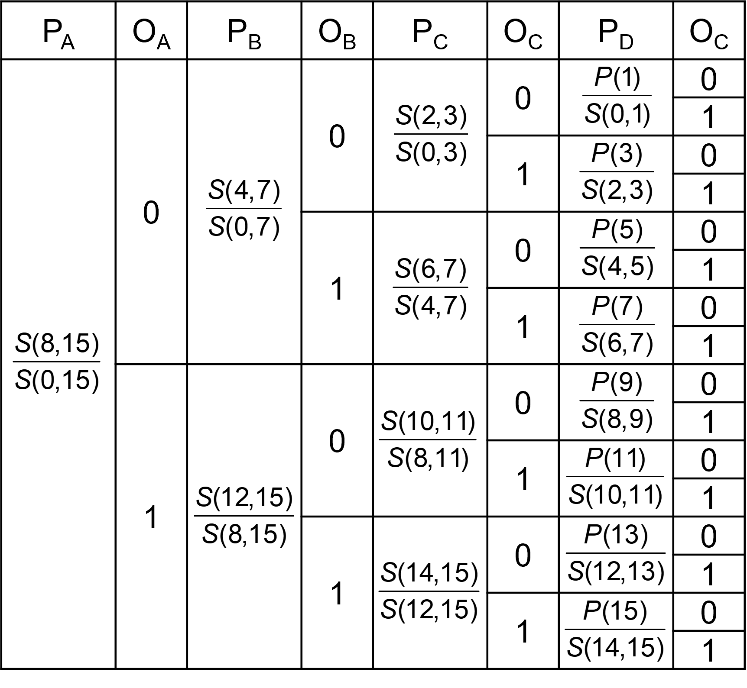

Supplement III: Detailed derivation of the Probabilistic Greedy Algorithm for solving the Traveling Salesman Problem (TSP)
This supplement provides a comprehensive explanation of the probabilistic greedy algorithm used for solving the Traveling Salesman Problem (TSP). It elaborates on the theoretical convergence of the algorithm, the role of the temperature parameter k_{B}T, and the distinctions between this approach and the Boltzmann Machine (BM) algorithm. Although both algorithms share the characteristic of theoretical convergence, they differ in terms of how they handle the temperature parameter and the complexity associated with the number of simultaneously considered nodes.
Problem Definition and Background
The TSP is a fundamental combinatorial optimization problem that involves finding the shortest possible route for a salesman to visit a set of cities exactly once and then return to the starting city. The complexity of the problem increases exponentially with the number of cities, making exact solutions computationally infeasible for large instances. Various heuristic and probabilistic methods, such as simulated annealing, genetic algorithms, and greedy algorithms, have been developed to provide approximate solutions.
The classic greedy algorithm for solving the TSP selects the nearest unvisited city at each step. While this deterministic approach is computationally efficient, it often results in suboptimal solutions because it can become trapped in local minima. To address this limitation, the probabilistic greedy algorithm introduces a controlled degree of randomness into the city selection process, enabling the algorithm to escape local minima and explore a broader range of potential solutions.
Overview of the Probabilistic Greedy Algorithm
The probabilistic greedy algorithm modifies the traditional greedy approach by incorporating randomness into the selection of the next city. At each step, the probability of selecting a city is determined not solely by its distance from the current city but also by a temperature parameter k_{B}T, which adjusts the level of randomness in the selection process. The temperature parameter influences the balance between exploration (randomness) and exploitation (favoring shorter distances).
Probability Distribution for City Selection
The algorithm assigns a probability P_{j}​ to each unvisited city j, calculated as:
,
where:
- d_{ij}​ is the distance from the current city i to an unvisited city j,
- U is the set of all unvisited cities,
- k_{B}T is the temperature parameter that determines the impact of distance on the selection probability.
Noticeably, there is a specialty for the case of the second to last city. Clearly, once the last second to last city is chosen, the last city is automatically determined. Supposing the last two cities are k and l, and the current city is m, therefore, the probability of the second to last city being k is determined as following.
Therefore, finding a complete route S returning to the starting city is the joint probability of P_{j}.
Here S is the total distance of the travelling loop.
The probability distribution P_{j}​ ensures that cities closer to the current city have a higher likelihood of being selected, but the influence of distance diminishes as k_{B}T increases. The temperature parameter thus acts as a control knob:
- Low k_{B}T: When k_{B}T → 0, the algorithm behaves like a traditional greedy algorithm, with the nearest city being almost always chosen. The selection process is nearly deterministic.
- High k_{B}T: When k_{B}T → ∞, the selection probabilities become uniform across all unvisited cities, making the selection process entirely random.
- Intermediate k_{B}T: For values between these extremes, the algorithm allows some degree of randomness, helping it avoid local minima and explore different regions of the solution space.
- At a fixed T, the shortest loop with the smallest S thus has the highest probability P(S) of being sampled in experiment, which ensures the convergence of this probabilistic greedy algorithm.
Finding the Optimal Temperature Parameter
A critical step in the probabilistic greedy algorithm is determining the appropriate value of k_{B}T. The goal is to find a temperature that provides a good balance between exploration and exploitation, allowing the algorithm to efficiently find high-quality solutions without excessively random behavior or determinism.
The optimal k_{B}T is typically identified through empirical testing or a calibration phase in which the algorithm is run multiple times with different k_{B}T values. Once a suitable k_{B}T is found, it remains fixed for all subsequent iterations of the algorithm. This choice of a fixed temperature simplifies the implementation and avoids the need for its dynamic adjustments during the search process.
Convergence Mechanism with a Fixed Temperature
After identifying an optimal k_{B}T, the algorithm proceeds by repeatedly constructing routes using the fixed probability distribution. Each iteration of the algorithm represents an independent attempt to find a shorter path. The stochastic nature of city selection ensures that different paths may be explored in each iteration, even if the initial city remains the same.
- Fixed Temperature Advantage: Keeping k_{B}T fixed ensures that the probabilistic behavior is consistent across all iterations. Each run of the algorithm uses the same probability distribution for city selection, which helps in systematically exploring the solution space without the complications of dynamically adjusting the temperature.
- Iterative Refinement: By repeatedly constructing tours with the fixed k_{B}T, the algorithm can find increasingly shorter paths over multiple iterations. Each run has the potential to discover a new local minimum or even the global minimum due to the probabilistic nature of the selection process. Over many repetitions, the algorithm converges towards an optimal or near-optimal solution.
- Sampling and Accumulation: The algorithm effectively samples from the space of possible tours. As the number of iterations increases, the probability of finding a tour with a shorter total distance improves. This sampling-based approach ensures convergence over time by accumulating solutions that represent better approximations of the optimal path.
Theoretical Convergence Analysis
The theoretical basis for the convergence of the probabilistic greedy algorithm lies in its ability to explore many possible solutions due to the probabilistic selection of cities. Since the algorithm can, in principle, sample any possible tour (given enough iterations), the probability of finding the optimal solution approaches one as the number of iterations increases.
The algorithm's convergence rate depends on:
- The quality of the chosen k_{B}T: A well-selected temperature increases the likelihood of finding high-quality solutions in fewer iterations by balancing randomness and deterministic behavior.
- The number of iterations: More iterations lead to a higher probability of discovering shorter paths, as the algorithm can explore more regions of the search space.
Differences from the Boltzmann Machine (BM) Algorithm
While the probabilistic greedy algorithm and the Boltzmann Machine (BM) algorithm share similarities in using a temperature parameter to control randomness, they differ significantly in how they treat the temperature parameter as well as the number of nodes considered simultaneously:
- Fixed vs. Annealing Temperature: In the probabilistic greedy algorithm, once an optimal k_{B}T is found, it remains unchanged. The algorithm does not involve an annealing process where the temperature is gradually decreased over time. This contrasts with the BM algorithm, which typically employs an annealing process , starting with a high temperature and gradually lowering it to reduce randomness.
- Node Consideration and Entanglement Complexity: The probabilistic greedy algorithm evaluates one decision at a time, selecting the next one from the unvisited cities based on the current state and distances. In other words, all the remaining cities are evaluated before a real sampling is drawn. In contrast, the BM algorithm with n² binary variables for a n-city TSP adopts the Gibbs sampling protocol, that is, updating only one variable in the n² nodes and keeping all other variables fixed. This locality of the sampling protocol therefore limits the entanglement complexity of the BM algorithm, which accounts for the better performance of the Probabilistic Greedy Algorithm than the BM.
Practical Implications of the Fixed Temperature Approach
The choice of using a fixed k_{B}T has several advantages for practical applications:
- Simplified Algorithm Design: Keeping the temperature constant after finding an optimal value simplifies the algorithm's design and implementation. There is no need for a complex annealing schedule or adaptive temperature control.
- Parallelization Opportunities: Since each iteration is independent of the others, the algorithm can be easily parallelized, with multiple runs executed simultaneously to explore different regions of the search space. This parallelism can significantly speed up the convergence process.
- Suitable for Resource-Constrained Environments: The fixed temperature approach reduces computational overhead compared to methods that require dynamic adjustments. It is particularly useful when computational resources are limited and when rapid convergence is desired.
Convergence Characteristics and Limitations
While the probabilistic greedy algorithm with a fixed temperature parameter has desirable convergence properties, it also has limitations:
- Dependence on the Initial Selection of k_{B}T: The algorithm's performance is highly dependent on finding a suitable k_{B}T. If the chosen temperature does not strike an appropriate balance, the algorithm may either get trapped in local minima (if k_{B}T is too low) or fail to refine solutions effectively (if k_{B}T is too high).
- Lack of Global Consideration: Since decisions are made sequentially, the algorithm does not account for the overall tour configuration at each step. This limitation contrasts with algorithms like the BM that consider the entire configuration simultaneously, potentially leading to better results for highly complex instances.
The use of the probabilistic greedy algorithm for solving the TSP provides a practical and flexible approach by introducing a controlled degree of randomness into the selection process. By fixing the temperature parameter k_{B}T after an initial calibration and performing repeated trials, the algorithm achieves convergence through iterative refinement, accumulating increasingly better solutions. Its simplicity, suitability for parallel execution, and ability to maintain theoretical convergence make it an effective choice for solving large-scale TSP instances where traditional greedy algorithms and exhaustive methods may fall short.
The differences in handling temperature and node consideration compared to the Boltzmann Machine algorithm highlight the trade-offs in terms of entanglement complexity and computational requirements. While both approaches can theoretically converge to the optimal solution, the probabilistic greedy algorithm provides a simpler and more resource-efficient path to high-quality solutions for practical TSP problems.

