Supporting Information for

A Zea mays alanyl-tRNA synthetase mutant is seedling-lethal and suggests a retrograde signal from plastid rrn16 leader derived lncRNAs

Authors- Anuradha Dhingra, Indra Adhikari, Christopher D. Rock*

*Correspondence: Chris Rock
Email: chris.rock@ttu.edu [ORCID: 0000-0002-2090-0650]

This PDF file includes:

Supporting text
Figures S1 to S12
Legends for Dataset: Tables S1 to S6
SI References

Other supporting materials for this manuscript include the following:

Datasets S1 to S6, Excel File 18 Mbytes

Supporting Information Text
Plant material, isolation of alb-605F mutant
The seeds for the maize genetic stock line 605F: wilty1/wi1, yellow endosperm1/y1, Plant pigment/Pl (genetic background line “2006-980-10/980-5”, provenance unknown), were obtained from the Maize Genetics Cooperation Stock Center (University of Illinois, Urbana; http://maizecoop.cropsci.uiuc.edu/) and progeny were observed to segregate 3:1 in certain lines for an albino phenotype from crosses or self-fertilizations of heterozygous parents, demonstrating it is a nuclear-encoded recessive allele (Supplemental Fig. S1) independently of the recessive wilty1 and linked y1 loci which map to Chr. 6 (1). The alb-605F mutant was observed to be seedling lethal and unable to survive past the three-leaf seedling stage, both in the greenhouse and field, with apparent phenotypic severity correlated with low temperature stress in the field versus greenhouse (SI Fig. S1). A line segregating for alb-605F was back crossed (BC) into the reference genome B73 stock background (obtained from the U.S. National Plant Germplasm System, accession PI550473) for two generations in the years 2019 and 2020 before selfing progeny lines in 2021. It is explained that contrary to standard practice, the lines for wild type BSA phenotyping did not segregate alb-605F because they served a dual purpose: map-based analysis of wilty1 (2) from the same 605F parental stocks that segregated alb-605F in a previous BC generation. Thus, wild type individuals for genomic DNA pooling are not siblings of alb-605F individuals, because they shared a generational meiosis from BC1 or BC2; the wild type ‘cousin’ hybrids segregating from a wi1/+ heterozygote self-fertilization (wi1/+, ALB⁺/ALB⁺) were pooled for BSA.
The seeds for the mapping population were sown in the greenhouse under normal daylight/night and temperature conditions for phenotype scoring. For Bulk-Segregant re-sequencing Analysis (BSA-seq), plant tissue samples from young leaves were collected from 89 homozygous recessive alb-605F individuals and 205 homozygous wild type individuals (WT hybrid cousins), the latter from self-fertilization of wi1/+, ALB+/ALB+ genotype line from BC2 that did not segregate alb-605F phenotype (SI Fig. S2).
Cloning of alb-605F locus by bulk-segregant whole genome resequencing analysis (BSA-Seq)
For creating the bulk-segregant pools, equal amount of fresh individual young plant leaves (no root or stem) was pooled in aliquots of 25 individuals scored for phenotype. Genomic DNA was extracted from pools of 25 leaves ground to powder with mortar and pestle under liquid N₂ using the Qiagen DNAeasy Plant DNA extraction kit and quantified using Nanodrop spectrophotometer (ND-1000, Thermo Fisher, Waltham, MA) and qualified as high molecular weight by agarose gel electrophoresis. The extracted gDNA was sheared as per the required 550 bp insert size for the genomic library preparation, using Covaris M220 ultra sonicator (Woburn, MA). 200 ng of the isolated DNA was suspended into 52.5 µL of the resuspension buffer (Illumina TruSeq Nano DNA kit; San Diego, CA) and transferred to the Covaris tubes to be subjected to fragmentation with 50 Watts peak incident power, 20% duty factor, 200 cycles per burst for 45 seconds at 20 ℃. Genomic libraries were prepared with the Illumina TruSeq Nano DNA library prep kit according to the manufacturer’s instructions. The IDT for Illumina UD DNA dual indexes were used for bar-coding the libraries and completed libraries were validated for insert size (2 X 150 bp) and quantified on Agilent 2100 Bioanalyzer using high-sensitivity DNA chips. The equimolar pool of the indexed genomic libraries was subjected to the adapter blocking reagent (Illumina cat # 20024144) and sequenced on an S4 lane of Illumina NovaSeq 6000, 2 x 150 bp, as fee-for-service by the University of California-San Francisco IGM Genomics Center.

BSA-seq bioinformatics pipeline
The raw reads obtained from the BSA-seq in fastq format were mapped to Zea mays chloroplast genome (PRJNA124; NC_001666.2)(3) or B73 chloroplast genome KF241981.1 (4) and mitochondrial genome (PRJNA16736; NC_007982.1) (5) version 4 using Bowtie2 v2.4.2 (6) to measure the percentage of reads mapping to both these organelles (Supplemental Table S1). The highest ratio, comparing ZmAlaRS mutant to WT library paired read classes mapping to the chloroplast genome were discordant read pairs, consistent with recombination events associated with observed elevated organelle genome copy number in the mutant. For whole genome re-sequencing data analysis, the raw reads were sorted, merged, and PCR duplicate artifacts marked using Picard Tools (http://broadinstitute.github.io/picard/). The reads were aligned to the Zea mays B73 whole genome reference assembly_v4, GCA_000005005.6 (7) with BWA-aligner v.0.7.17 (8), and Genome Analysis ToolKit (GATK; Broad Institute) pipeline (9) was used to identify de novo Single Nucleotide Polymorphisms (SNPs) and Insertion/deletions (Indels). SNPs and Indel datasets from HapMap2 (10) and HapMap3 (11) were used to filter out per chromosome with indel aligner tool the known SNPs/Indels in the genome data per chromosome using BCF Tools ver. 1.9 (12). The GATK Haplotype caller tool was used to create the GVCF files and the R package “QTLseqr” (13) was further used to visualize and map the causal mutation to a chromosome.
Indel marker PCR-based chromosome walking and alb-605F interval fine mapping
A 10 Mb Chr. 9 region spanning the mapping interval for the causal mutation was thus filtered to keep only the homozygous (recessive) SNPs/Indels for the alb-605F dataset and homozygous reference for the WT hybrid cousin datasets using the SnpSift function of the SnpEff_v5 tool (14). The de novo variants were further annotated based on codon translation and the effect of the SNP/Indel on the annotated gene structure. All SNPs and Indels within the 10 Mb interval identified for mapping the mutation were categorized into Low, Moderate, and High functional effect candidate SNPs/Indels (Supplemental Table S5) and cross-checked for effect of the SNP/Indel in structure of the respective genes visualized in the Phytozome web browser (https://phytozome-next.jgi.doe.gov/info/Zmays_RefGen_V4).
In the BSA seq mutant pool dataset the candidate ZmAlaRS/Zm00001d044745 gene had a SnpEff call of ‘High Effect’ due to a two-nucleotide deletion (ref coordinate Chr. 9: 1,016,059) that results in a predicted translational frameshift in the N-terminal catalytic domain residue Ile⁹³. This candidate stood out among all others by virtue of a large region of 14 kbp that has 846 homozygous recessive SNPs/Indels with no evidence in the BSA-seq alb-605F library interrogation of recombination breakpoints or heterozygous SNPs relative to the B73 reference genome (SI Fig. S4A). The two deleted nucleotides in exon3 were validated by Sanger sequencing of a PCR amplicon from genomic template DNA extracted from homozygous mutant (SI Fig. S5), and RNA-seq analysis of eight expressed transcript variants (SI Fig S4; SI Datafile S2) supported the working hypothesis for ZmAlaRS/Zm00001d044745. We discounted linked other candidate genes because they had evidence for heterozygous SNPs/Indels in the alb-605F homozygote genomic library (SI Table S5). Primers (SI Table S3) flanking 100 bp upstream and downstream of candidate Indels larger than 30 bp in size were designed to focus on flanking candidate genes (SI Fig. S6A).
To fine map the alb-605F interval, Indel marker primer-based PCR chromosome walking was performed (15). The output from GATK analysis identified numerous Indels in the QTLseqr-delimited mapping interval. Indels of 15 bp or longer in length were chosen and primers were designed to flank these Indels by 100-150 bp to generate ~300 bp amplicon sizes for ease of scoring amplicon polymorphisms in pools of alb-605F sibling or WT hybrid cousin genomic DNA template pools amplified and run on 1% or 2% agarose gels, depending on amplicon polymorphism sizes. Genomic DNA extracted from 89 alb-605F mutants as four distinct pools of 25 independent individuals, or pools of 25 independent WT individuals (205 total) in eight separate pools used for BSA-seq were used as template for genotyping of Indel PCR markers. The candidate causal two nt deletion was further verified using Sanger sequencing (Azenta Life Sciences, Burlington, MA) of PCR amplicons. The details of the primers are listed in Supplemental Table S3. For each PCR reaction, 25 µL reaction volume was created using 12.5 µL of GoTaq® Hot Start master mix (Promega, Madison WI), one µL of DNA extract at a concentration of 10-20 ng/µL, one µL of 1 mM primer mix, and nuclease-free water. The initial denaturation was carried out at 95°C for 5 mins, followed by 30 cycles of denaturation at 95°C (30 sec), annealing temperature at 61°C (30 sec), extension at 72°C (30 sec), and final round of extension (polishing) at 72°C for 7 mins. These reaction volumes and settings were used for all four primer sets (P1, P2, P3, and P4). P3 primer pair maps within ZmAlaRS gene spanning a GATK-called 93 nt insertion present in the third intron of the gene; P3 amplicons from pools of 25 homozygous alb-605F sibling templates showed no evidence of recombination break points in all four alb-605F template pools, whereas other distal up- and down-stream mapping primer pairs manifested faint reference bands as evidence of heterozygous segregation of dimorphic amplicon alleles with recombination breakpoints in pools (SI Fig. S6B). We used CDS of ZmAlaRS/Zm00001d044745 in TargetP 2.0 (18) to see the presence of signal peptide for organellar transport.
Complementation tests
For complementation test studies, seeds were obtained from the Maize Genome Database (https://www.maizegdb.org/) for 12 lines mapped to chromosome 9S and reported to have “albino”, “luteus”, “yellow”, “white”, and “virescent” seedling phenotypes (Supplemental Table S4) or to have a Mutator TE insertion in, or adjacent to, the candidate locus (16, 17). The candidate Mutator allele UFMu-1041912 did not segregate albino when heterozygous individuals were selfed (data not shown), nor when crossed with alb-605F/+ heterozygotes, perhaps because evidence showed the Mu insertion sequenced for an amplicon from a homozygous mutant was found to be in the Zm00001d044745/AlaRS ATG start codon (Supplemental Fig. S7A; data not shown), suggesting an alternative in-frame start codon may be functional from within the flanking Mu TE insertion.
A Bmu-Illumina stock_89370.7 with sequencing evidence (http://teosinte.uoregon.edu/mu-illumina/GRMZM2G154664; 9:1338979-1339410) (17) of a Mutator TE insertion near exon3 of ZmAlaRS was confirmed by Sanger sequencing of albino-segregating phenocopy homozygote template PCR amplicon (SI Table S4; SI Fig. S7B) to be inserted 88 bp from our claimed causal two nucleotide deletion and 42 bp downstream from the identified PIF-Harbinger TE insertion site in intron3 of candidate ZmAlaRS locus Zm00001d044745 haplotype (SI Fig S4B). SI Fig. S8 shows PCR genotyping results of heteroallelic complementation test chlorotic mutant progeny seedings from two reciprocal crosses between alb-605F segregating stock crossed with BMu_89370.7 heterozygous albino-segregating stock. These results validate our cloning by BSA-seq of the alb-605F locus. The chlorotic phenotype of non-complementing heteroallelic mutant progeny (SI Fig. S8, individuals #7- 10) is consistent with one or both mutant allele haplotypes being leaky or hypomorphic, like observed with several maize photosynthetic mutants with different or haploinsufficient alleles (18-21)
Plants heterozygous for these 12 mutant candidate alleles of the candidate gene that conditioned a segregating albino phenotype were crossed to heterozygotes of the albino-605F mutant. Two mutant stocks out of nine (3510C w*-N627B and 4511D w*-N1893) showed atypical evidence of lack of complementation, manifesting rare (not 3:1 ratios) albino seedlings obtained in the progeny from crosses made to heterozygous parent alb/+. Progeny from a cross of alb/+ to 4208K wl*-N1857 showed a variegated phenotype (but not 3:1) where the plant had longitudinal sectors of white and green on the leaves (not shown). These candidate independent albino alleles from EMS-treated stocks (22) were not verified. Notwithstanding, it is noted that there exists evidence for gene modifiers of mutations essential for chloroplast translation (23) and further genetic interaction tests with these candidate ZmAlaRS alleles could provide further allelic series materials for structure/function analyses on the alb-605F mechanism of action and transcript isoforms.
Transcriptomic analysis of photosynthetic mutants; mRNA-seq (BSR-seq) library preparation
For bulk-segregant mRNA-seq (BSR-seq), young leaf tissues (no root or stem) from 25 individuals scored for phenotype were pooled independently for each replicate sample library for a total of six libraries: namely three alb-605F biological replicates and three WT segregating sibling biological replicates. Total RNA was extracted according to manufacturer protocol using the Sigma-Aldrich Spectrum Plant Total RNA extraction kit. The RNA was quantified on Nanodrop ND-1000 spectrophotometer and RNA quality and quantity assayed on the Agilent 2100 Bioanalyzer instrument using Agilent RNA 6000 Nano Total RNA analysis kit. For ribosomal RNA analysis, total RNA was extracted using TRIzol™ (Invitrogen, ThermoFisher) and analyzed by Agilent TapeStation automated electrophoresis system to characterize rRNA sizes and integrity, and by agarose/formaldehyde gel electrophoresis as described in (24). One µg of total RNA was taken forward per sample to prepare mRNA-seq libraries by Illumina TruSeq stranded total RNA seq kit (RiboZero Plant) with time-dependent hydrolysis step to yield an average RNA fragment size of 150 nt according to the manufacturer protocol. The IDT for Illumina UD RNA dual indexes (catalogue # 20020591) were used for indexing the libraries and finished libraries run on 6% native PAGE gel and bands between ~ 260 to 310 bp were excised and purified by subjecting to gel breaker (Thermo Fisher Scientific 1st Engineering Gel Breaker Tubes) as described (25). The individual libraries were validated and quantified with an Agilent 2100 Bioanalyzer using High-sensitivity DNA chip. The equimolar pool of the transcriptomic libraries was subjected to the Illumina adapter blocking reagent (cat # 20024144) and sequenced 2 x 50 bp on an Illumina NovaSeq6000 S4 platform.
BSR-seq bioinformatics analysis
The raw reads obtained in the fastq format were quality checked by using FastQC (https://www.bioinformatics.babraham.ac.uk/projects/fastqc/) and the B73 chloroplast genome KF241981.1 (4) scrutinized versus the standard chloroplast reference genome (PRJNA124; NC_001666.2)(3) to assess if observed SNPs in RNAseq reads mapping to the rrn16S leader sequence were transcribed from chloroplast, or nucleus, and/or mitochondrial loci. No SNPs were found in RNAseq data versus the B73 chloroplast genome, which is assumed to be harbored in the subject genotypes. We downloaded Kendrick et al. dataset (26) from NCBI/SRA repository PRJNA825557 using SraToolkit (https://trace.ncbi.nlm.nih.gov/Traces/sra/sra.cgi?view=software"). Quality control metrics for gDNAseq and RNAseq libraries are provided in Supplemental Table S1, including quantification of chloroplast 16S, 23S, and cytoplasmic 18S and 28S rRNAs removed from the unfiltered raw BSR-seq dataset by bowtie2 pre-process filtering with 16S, 23S, 18S, and 28S rRNAs downloaded from RNACentral (27), magicBLAST (28) and kallisto counts (29) quantitation of unremoved rrn16S/23S leader sequence (30) in the alb-605F libraries and those oligo-dT primed RNA-seq library datasets of Kendrick et al. (26). The raw reads were either mapped to the Zea mays B73 cDNA version 4 reference genome files ‘Zmays_493_RefGen_V4.transcript_primaryTranscriptOnly.fa’ (GCA_000005005.6, available for download at https://phytozome-next.jgi.doe.gov/) containing 39,498 full length transcript sequences, to which was concatenated 174 MIRNA hairpins from miRBase22 (31), and 10,834 long non-coding RNAs (32-34), parsed to break very lncRNAs into 25,000 nt unique species, from RNACentral (27)(https://rnacentral.org/). The resultant fasta file of 50,506 primary transcript sequences was used as subject for ‘gene level’ analysis, and for annotation of gene ontology bins using Mercator4.7 (Oct. 2024) (35, 36) (https://mapman.gabipd.org/app/mercator). In exploratory data analysis pilot experiments the 131,496 transcript variant file ‘Zmays_493_RefGen_V4.transcript.fa’ was indexed for probe- or gene level counts quantification using the kallisto pseudoaligner tool (37) in strand-specific mode (option --rf-stranded corresponded to sense strand of stranded library). Input Counts for kallisto were restricted to genes with >1 cumulative raw read in the Count file spanning 23 genotype samples. For transcript/probe level input for MapMan, and for gene level analysis reported in Supplemental Table S2, the outputs from kallisto mappings were analyzed using DESeq2 version 1.44.0 (38) using both the Likelihood Ratio and Wald tests. The R package “ggplot” was used to generate PCA (Principal Component Analysis) of the transcriptome data.
To view the various metabolic processes and pathways differentially expressed (DE) in the total RNA-seq datasets, output from DESeq2 gene level primary transcripts with padj < 0.001was parsed into MapMan and PageMan v3.6.0RC1 with custom ontology bin annotations from Mercator4 portal, and X4.4 and X4.5 Zea mays pathways mappings as reference (downloaded from https://mapman.gabipd.org/mapmanstore) (35, 36, 39). Supplemental Table S2A lists all 41,827 primary transcript ‘gene level, sense’, and Supplemental Table S2B the complete 50,506 primary transcript_IDs for antisense DE results corresponding to the MapMan gene ontology bin notations. For overrepresentation of biological process bins, a bin-wise Wilcoxon Bonferroni–Hochberg corrected rank sum test for 3× (most stringent) factor overrepresentation analysis cutoff was applied to derive Z scores, which approximate relative numbers of standard deviations from the median (Supplemental Table S6) and adjust probabilities. The algorithm tests the median fold-change (overall positive or negative for bin) within the particular ontological group against the median fold-change of all genes not in that ontological group.

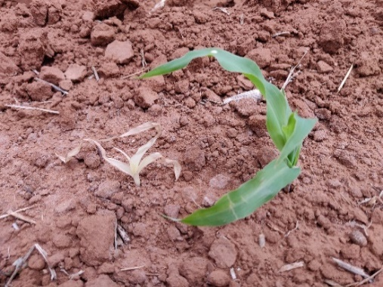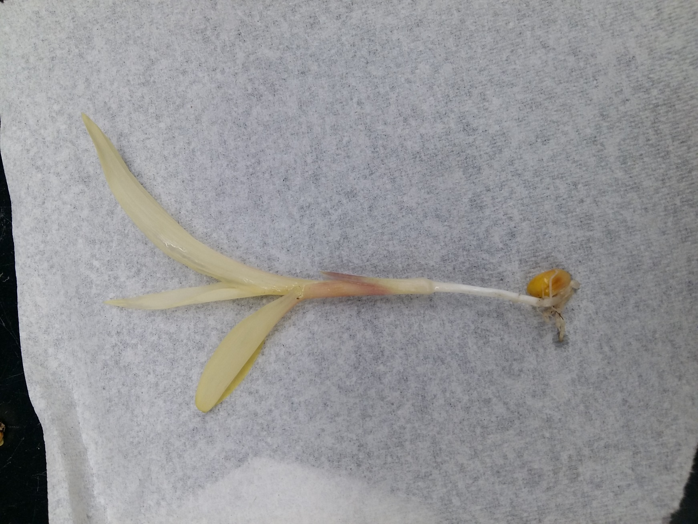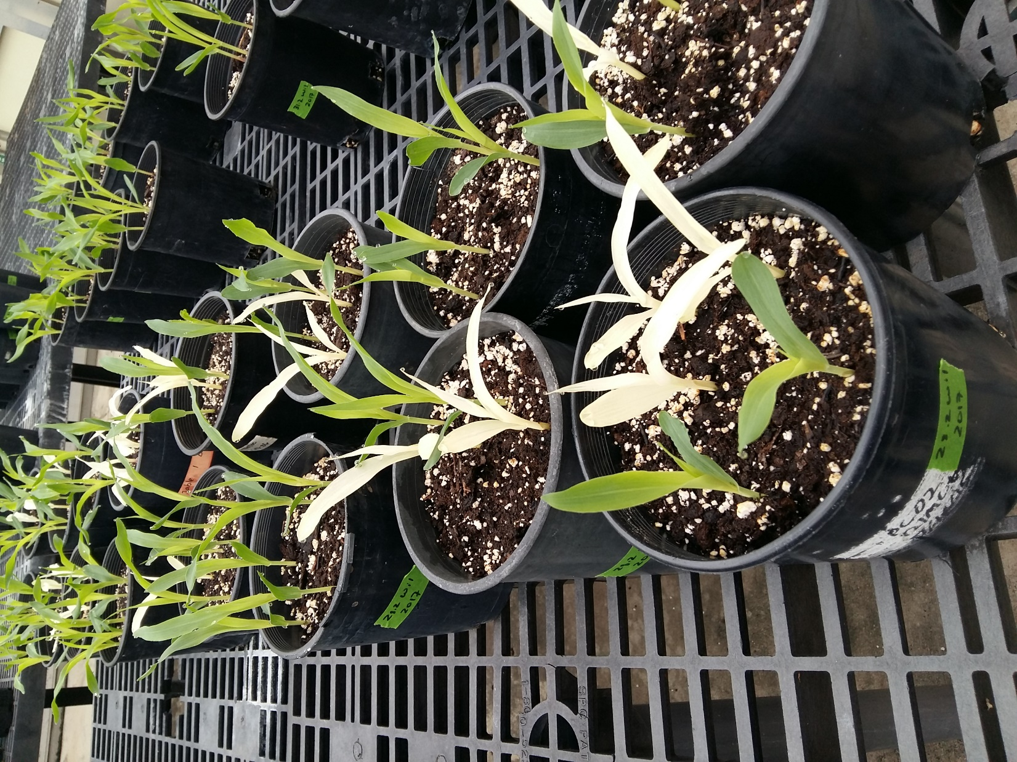

Fig. S1 (Left) Two-week old alb-605F mutant showing the albino phenotype with pale yellow leaves. (Right top) Two-week-old alb-605F mutant vs. wild type (WT) sibling growing under field conditions; note much smaller mutant size and white leaves suggestive of pleiotropic cool temperature effect (19). The WT sibling plant is green and grows normally whereas the alb-605F mutant shows albino phenotype with yellowish white leaves. (Right bottom) 10-day old plants segregating for alb-605F in B73 background grown under greenhouse conditions.

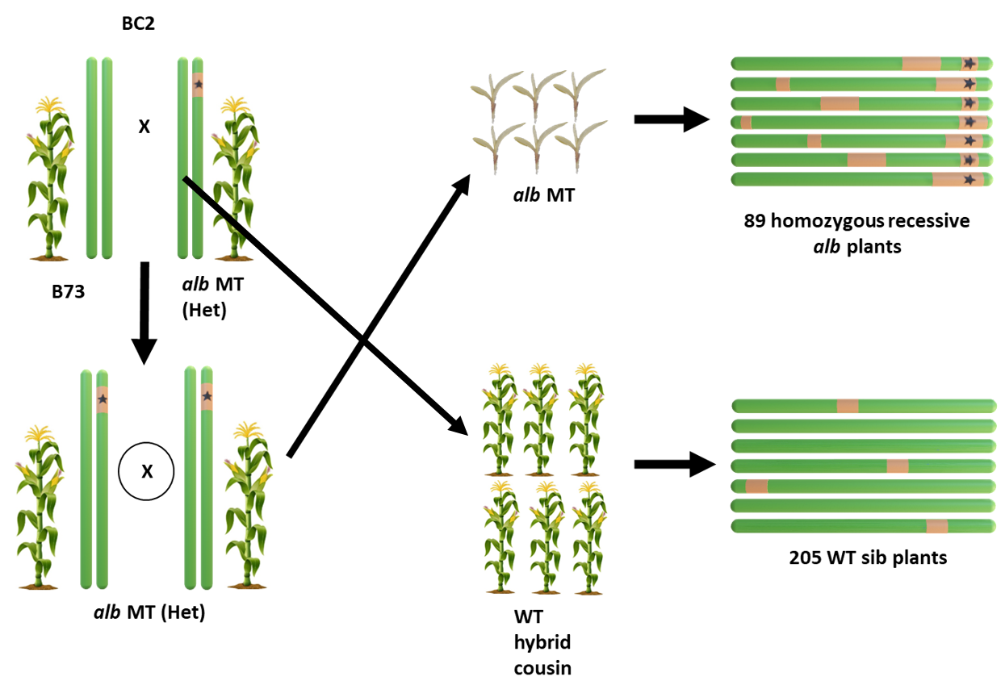

Fig. S2 The workflow for Bulk-segregant whole genome re-sequencing (BSA-seq). Lines segregating for the alb-605F phenotype were back crossed into the reference genome B73 stock background for two generations (BC2) and the progeny were selfed to generate the mapping populations. For BSA-seq, leaf tissue samples were collected from 89 homozygous recessive alb-605F individuals and 205 homozygous reference WT hybrid B73-backcrossed cousin individuals that did not segregate albino. The genomic DNA was pooled, and DNA libraries were prepared and sequenced on Illumina Novaseq 6000 platform.

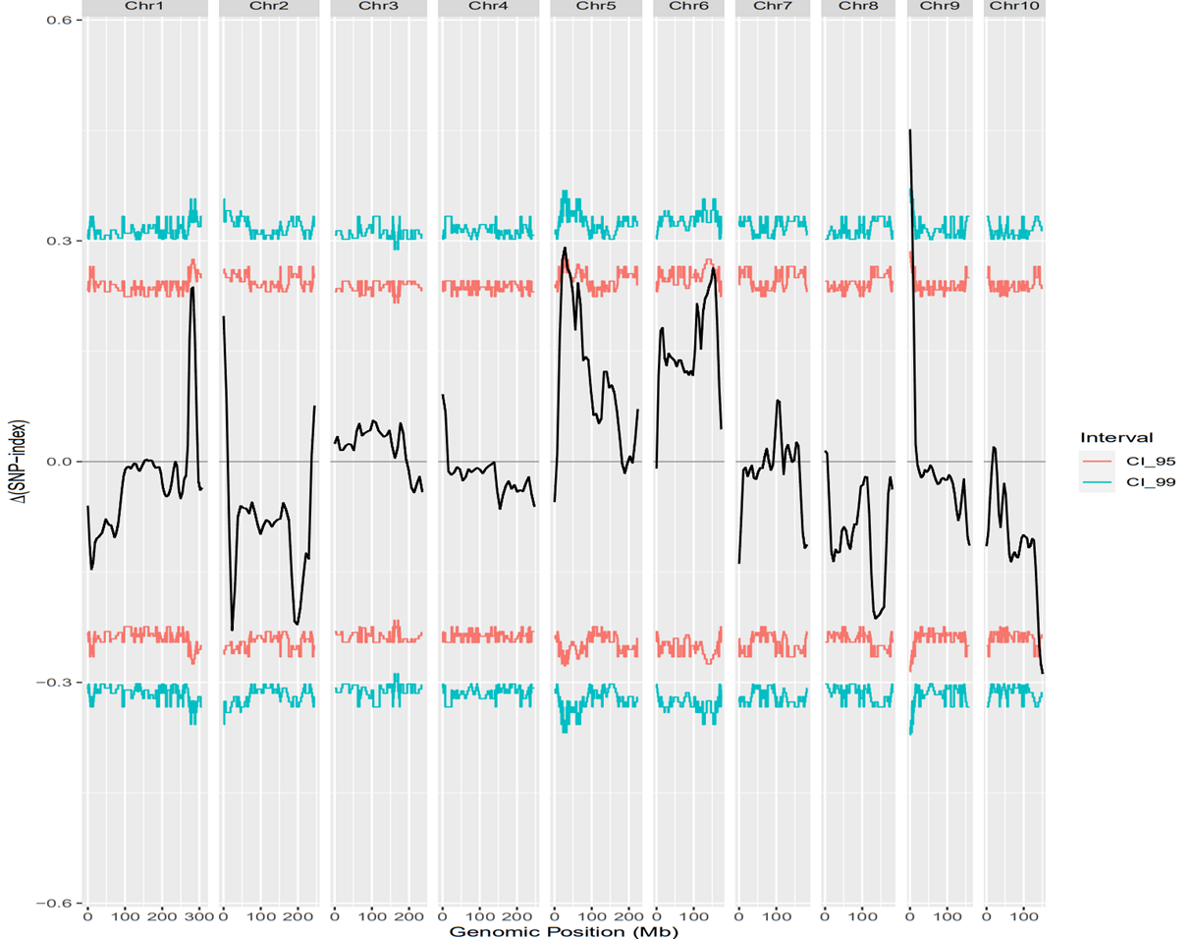
Fig. S3 The alb-605F mutation is mapped to short arm of Chr. 9 after filtering out the known SNPs/Indels of hapmap2 and hapmap3 from the raw data. A single peak is obtained at short arm of Chr. 9 with more than 99 percentile confidence interval.

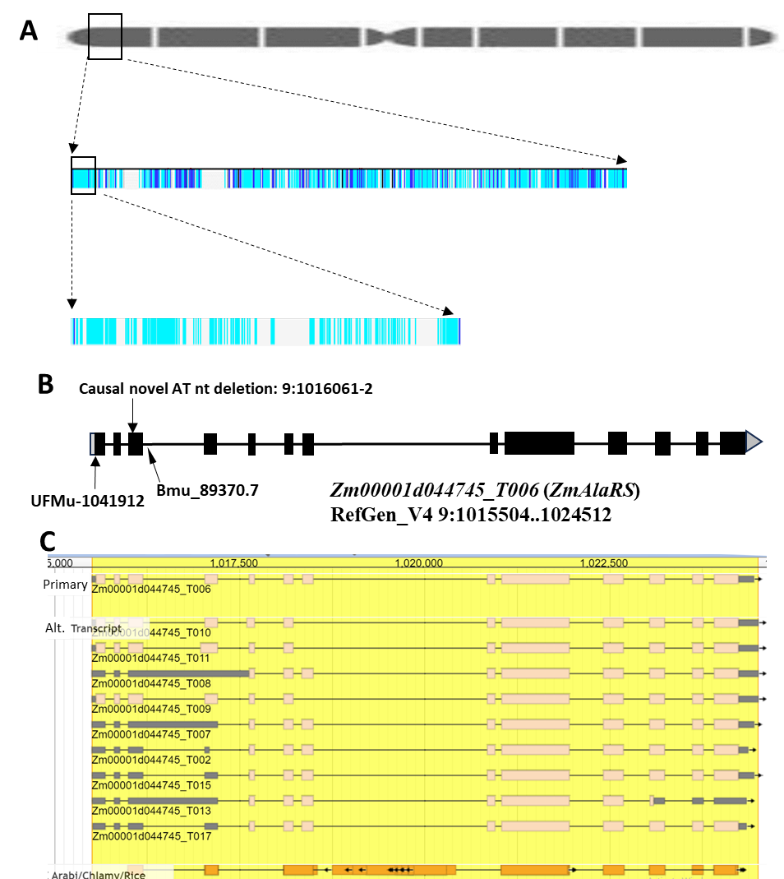
Fig S4 (A) Visualization of segregating SNPs/Indels identified by GATK analysis for Chr. 9 using IGV (Integrative genomics viewer) tool. The dark blue lines represent the heterozygous SNPs/Indels and light blue lines represent the homozygous recessive SNPs/Indels in the alb-605F mutant. The longest interval containing no heterozygous SNP/Indel was identified to be 14,268 bp long. This interval had single gene identified as top candidate - alanyl tRNA synthetase (AlaRS). (B, C) The causal mutation is identified to be two nucleotide deletion (AT deleted) leading to frameshift mutation in the 3rd exon of the gene.

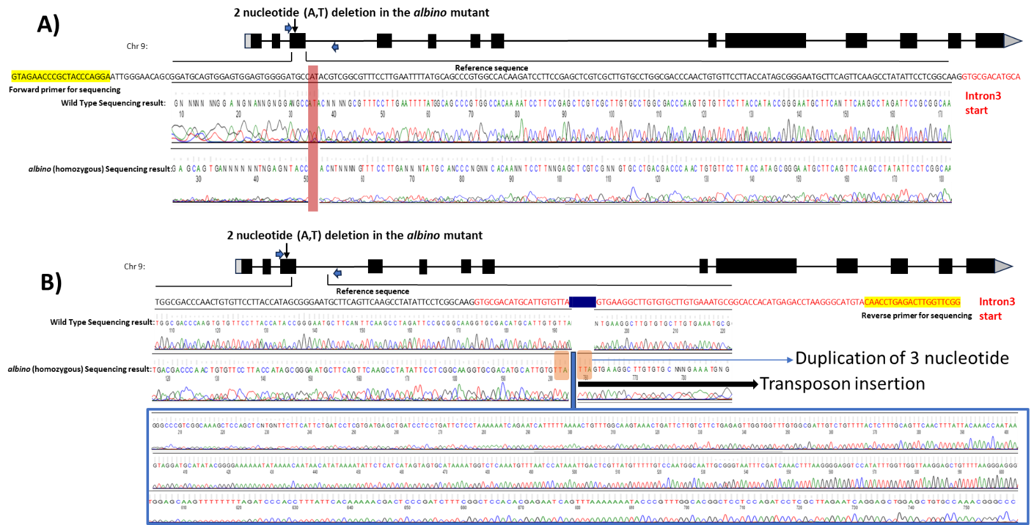
Fig. S5 Sanger sequencing of primer pair3 amplicon identifies (A) causal alb-605F two nucleotide frameshift deletion in Exon3 of ZmAlaRS (Zm00001d044745) and (B) additional locus complexity from a PIF-Harbinger transposon insertion event in parental Maize Genetics Co-Op stock 605F with three nt duplication at the insertion site. The Transposon is annotated as PIF_Harbinger_TIR_transposon consensus class when the insert sequence is blasted (40) in MaizeGDB Zm-B73-REFERENCE-NAM-5.0 (https://www.maizegdb.org/).

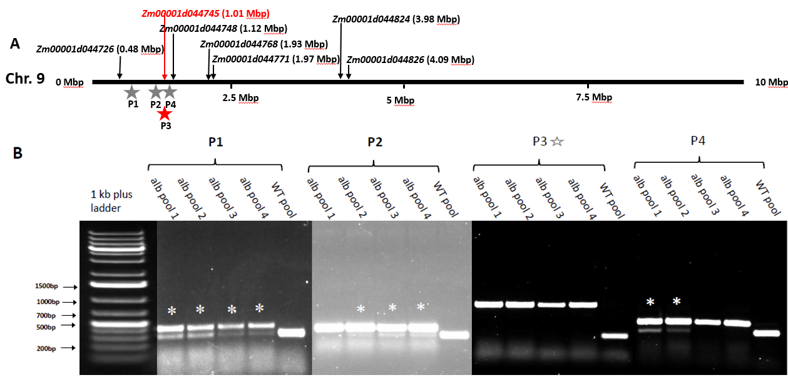
Fig S6 Map-based cloning of alb-605F. (A) Position of primers designed flanking Indels of > 15 bp nearby the causal gene- ZmAlaRS (red star, Primer pair3, red vertical arrow). Other discounted candidate gene positions shown as black vertical arrows. Stars designate discriminating primer pairs P1- 0.6 Mbp, P2- 0.9 Mbp, and P4- 1.1 Mbp. (B) Evidence of recombination breakpoints in the alb-605F genomic DNA pool for primers 1, 2, and 4, where two amplicon bands (asterisks *) are observed denoting heterozygous amplicon patterns in independent alb-605F mutant pools. For Primer pair3 (unfilled star label), which is located in ZmAlaRS, there is no evidence of recombination breakpoints in any alb-605F mutant pools which show only a single amplicon wild type reference band from alb-605F genomic DNAs.
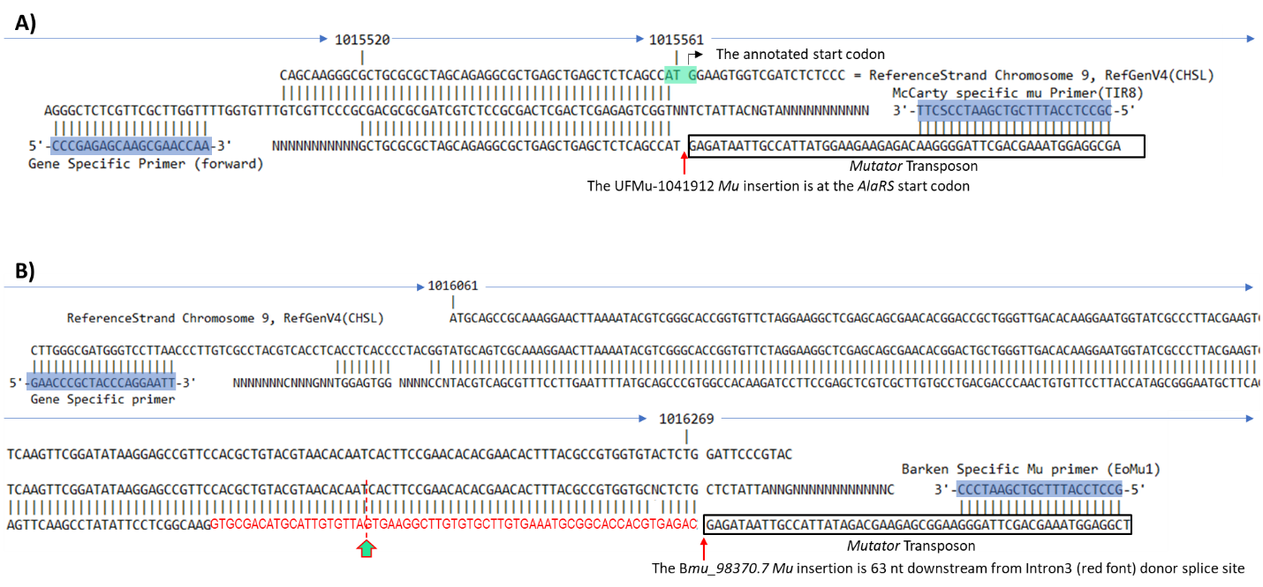
Fig. S7 Identification of candidate independent alb-605F locus alleles by Sanger sequencing of amplicons from PCR using McCarty and Barkan Mutator homozygous stock templates with Mutator transposon-specific and ZmAlaRS/Zm00001d044745 target gene primers. (A) UFMu-1041912 Mutator transposon is located at the predicted ATG translation start site of Zm00001d044745/ZmAla-RS. Heterozygous UFMu-1041912 plant self-pollination, and crosses of heterozygous plants with alb-605F/+ heterozygotes did not segregate albino phenotype, consistent with interpretation a cryptic ATG translation start codon (e.g. aa128) in UFMu-1041912 homozygotes may be functional for ZmAlaRS/Zm00001d044745 activity. (B) Bmu_illumina_98370.7 homozygous stock has an insertion site 42 bases downstream from the PIF-Harbinger transposon insertion site in intron3 (red font) of the claimed alb-605F allele (denoted with green vertical arrow). BLASTing (40) of boxed sequences into NCBI core nucleotide database finds 98-100% identity to Mutator SeqIDs U19613.1/JX843286.1 (1,723/1,831 bp) and X53604.1 (1,419 bp), respectively.

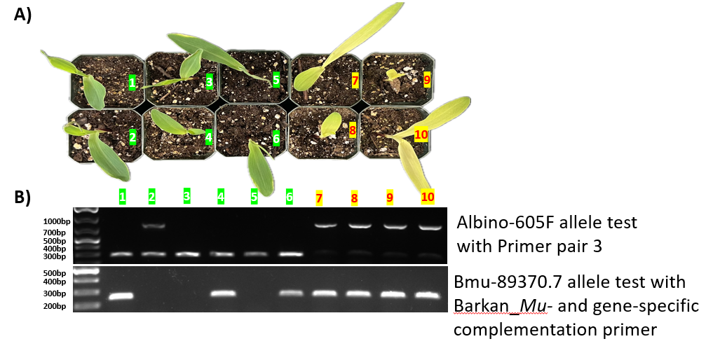
Fig S8 Reciprocal complementation crosses between alb-605F and BMu_89370.7 heterozygous albino-segregating stocks yield heteroallelic chlorotic mutant progeny based on genotypes which correlate perfectly with the presence (chlorotic) or absence (green) of a novel Mu insertion allele. Out of 16 germinated kernels, 11 originated from alb-605F heterozygous stock as male parent (segregated 8:3 wild type:albino); five germinated seedlings originated from Mu_illumina_89370.7 heterozygote parent as male (segregated 3:2 wild type: albino). (A) Top down photographic image of the 10 earliest-germinated plants selected for PCR genotyping. Six seedlings (numbered 1-6) exhibited a wild-type green leaf phenotype, while four seedlings (numbered 7- 10) were phenotypically albino/chlorotic, suggesting one or both mutant alleles are hypomorphic. (B) Agarose gel electrophoresis results from PCR genotyping of genomic DNA from the samples in panel “A.” The upper panel displays PCR results using gene-specific primers, while the lower panel shows results using a combination of Mu-specific plus a different gene-specific primer than the upper panel. Molecular phenotypes identified by PCR bands for alleles of wild type (322 bp, upper panel), alb-605F (880 bp; upper panel, Primer pair 3), and Mu_89307.7 (252 bp, lower panel). Taken together these results indicate that plants 1, 4, and 6 (lower panel) are heterozygous for Mu_illumina_89370.7 allele; Plant 3 and 5 are homozygous wild type (322 bp band); Plant 2 is heterozygous for alb-605F allele; and albino/chlorotic scored plants 7, 8, 9, and 10 are heterozygous for both alb-605F and Mu_illumina_89370.7 alleles which correlate to failure to reciprocally complement albino phenotype and validate cloning alb-605F locus.

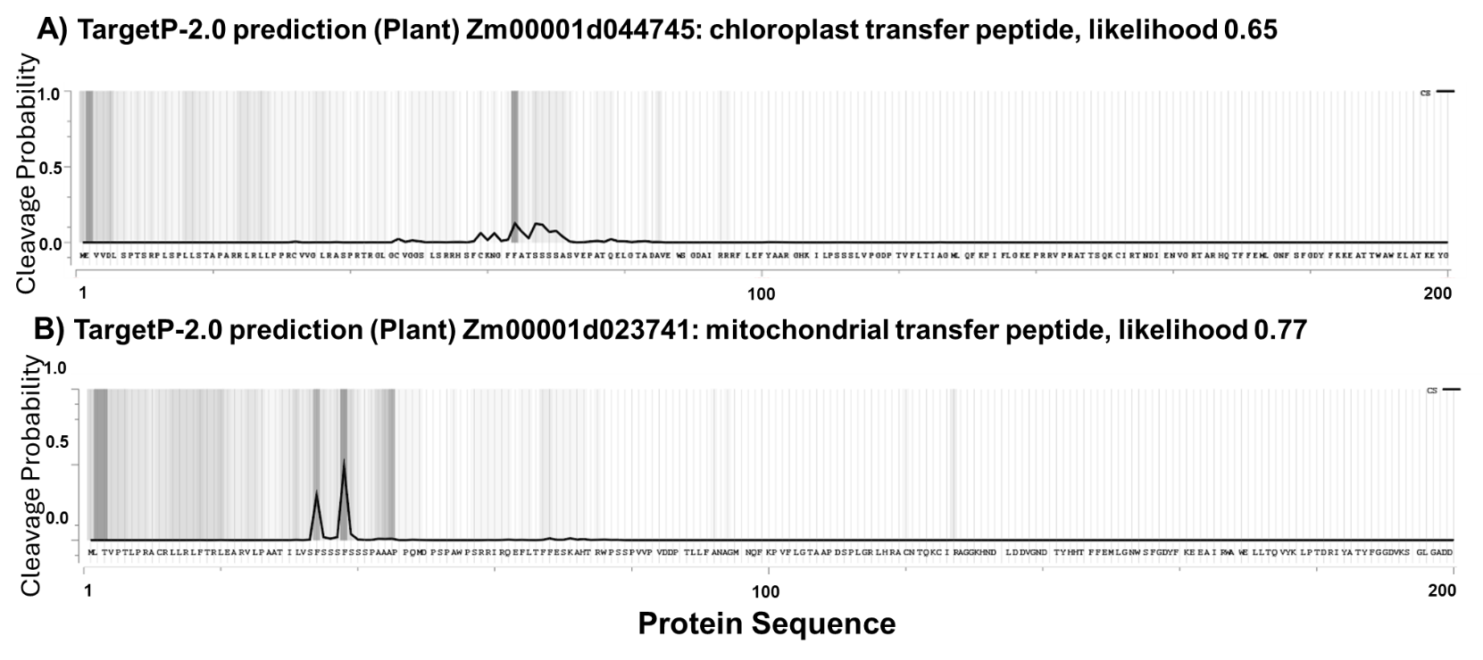
Fig. S9 TargetP-2.0 prediction of organellar sub-localization of (A) alb-605F locus polypeptide AlaRS/Zm00001d044745 to the chloroplast, and (B) closest paralogue Zm00001d023741 to the mitochondria. There are four other more distant ZmAlaRS paralogues in maize (Zm00001d031239, Zm00001d031241, Zm00001d031236, and Zm00001d008498) without predicted organellar targeting peptides other than Zm00001d023741, which shares 37% identity and 55% similarity to Zm00001d044745 and is predicted (P= 0.48) to be cleaved at SSF-SS consensus AA38-39.

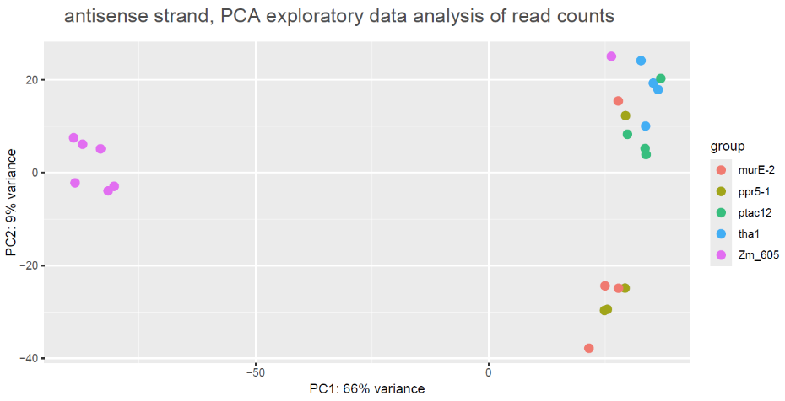
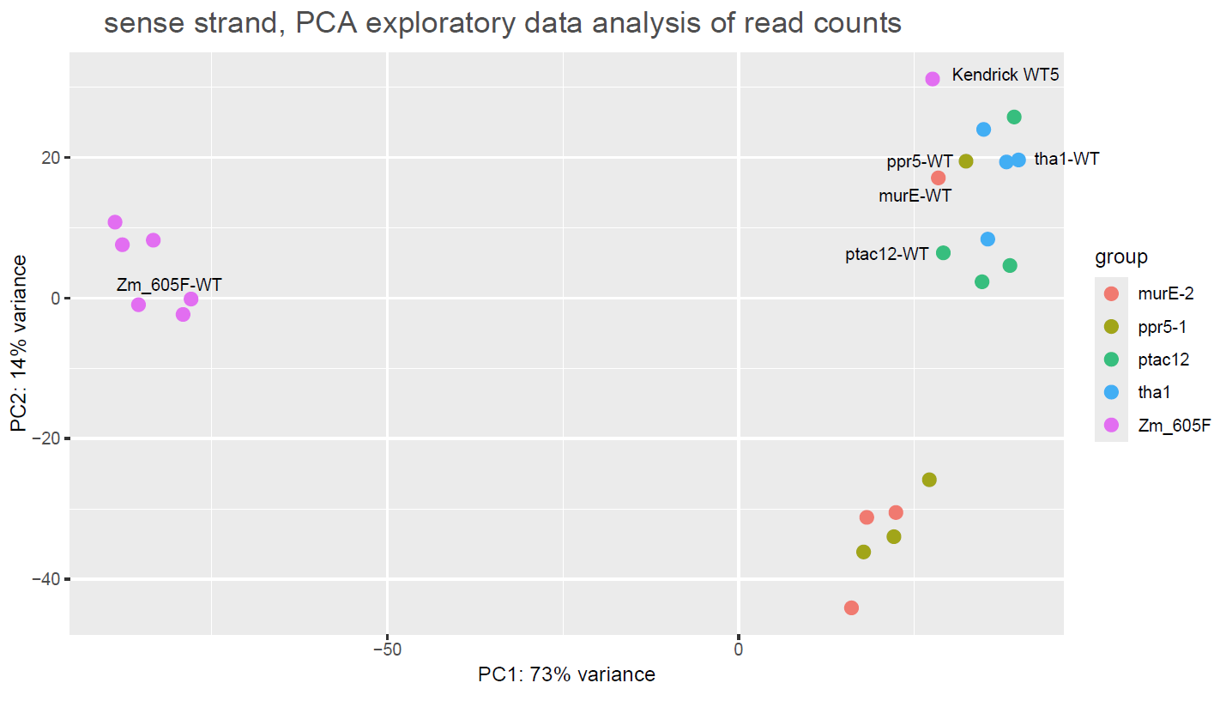
Fig. S10 Principal Component analysis (PCA) of the RNA-seq libraries (upper, sense strand; lower, antisense) for alb-605F and Kendrick et al. (26) photosynthetic mutants analyzed at gene level.

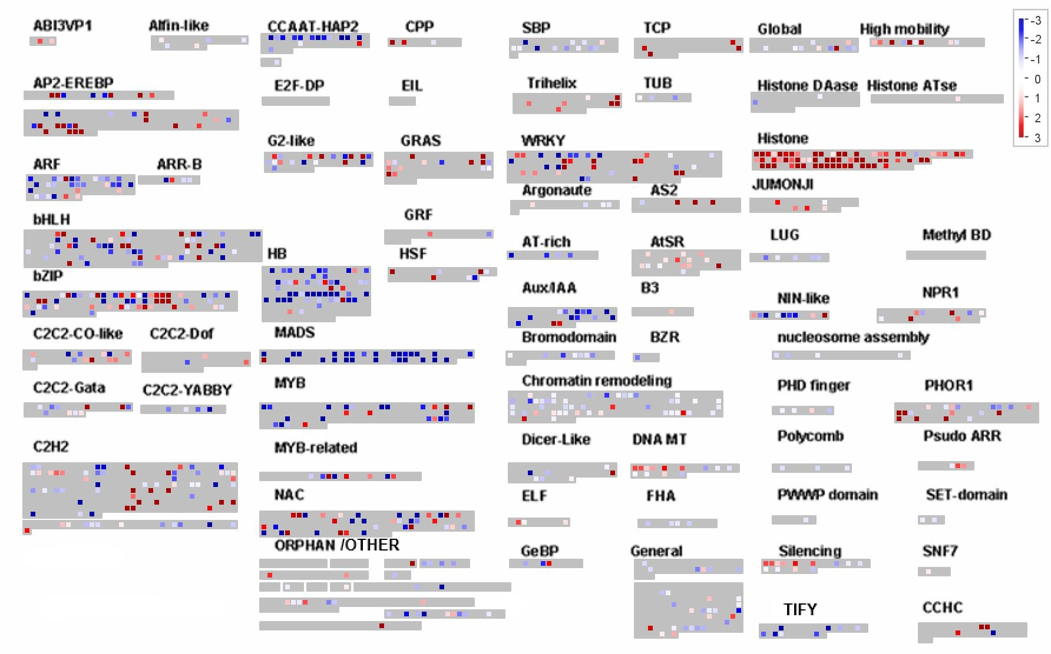

Fig. S11 alb-605 Transcription Factor Family differential expression (L2FC; up-regulated red, down-regulated blue) as represented by MapMan. Note extreme up-regulation of histone genes including H1 linker (far right pixels).

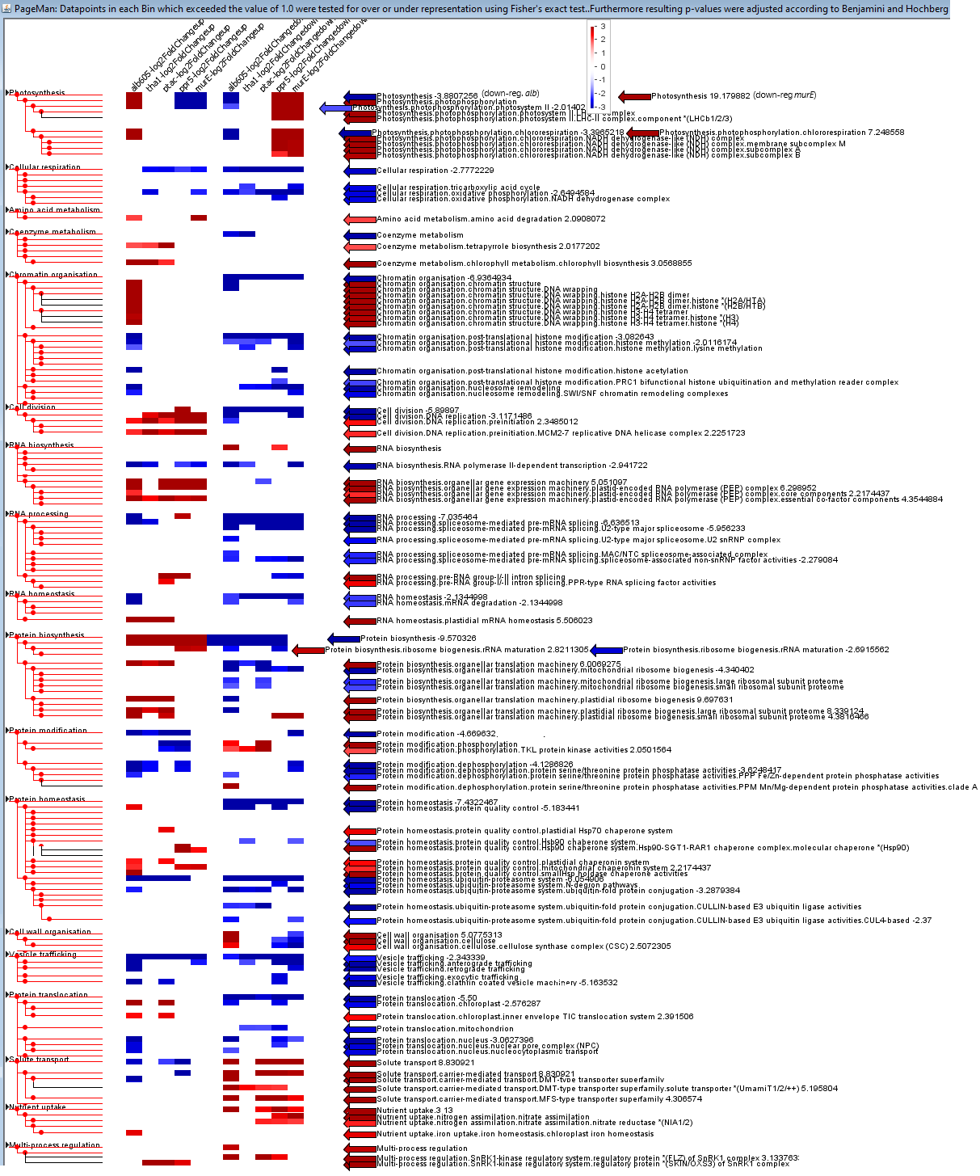
Fig. S12 PageMan gene ontology over-representation analysis of Kendrick et al. (26) genotypes compared side-by-side with alb-605F mutant using Fisher's exact test and L2FC > 1 as a cut-off. Only those bins with both alb-605F and/or at least one of the tha1, ptac12, ppr5, and murE mutants significantly over-represented (red) or under-represented (blue) for up-regulated (left columns) and down regulated (right) are shown. Alb-605F has similar over-represented genes to tha1-1 and ptac12-2 chlorotic mutants than to null ppr5-1 and murE-2 mutants (41). Supports Table 2 for correlations of alb-605F and photosynthetic mutant organellar rRNA LFC and base expressions, and Suppl Fig. S11.

List of Supplemental Dataset Legends (1 separate Excel file of Tables; 18 Mbytes)
Supplemental Table S1: gDNA and RNA libraries quality control parameters.
Supplemental Table S2: Gene level plus long non-coding RNA sense (A) and antisense (B) RNA-seq differential expression (Wald test) (38) results for alb-605F vs. WT siblings, and four photosynthetic mutants tha1, ptac12, ppr5-1, and murE-2 (26) which vary by increasing physiologic phenotypic severity, respectively.
Supplemental Table S3: Sequence of the primers used for Indel walking and genotyping alb-605F mutant alleles.
Supplemental Table S4: List of Maize Genetic Co-op and Mutator reverse genetic stock lines tested for alb-605F complementation.
Supplemental Table S5: List of all the SNPs/Indels candidate causal alb-605F genes identified by SnpEff software (14) within the fine mapped 10 Mbp interval on short arm of Chr. 9.
Supplemental Table S6: Wilcoxon Rank Sum statistics from gene-level DE results of MapMan analysis (35, 36) of dataset SI Table S2A.

Literature Cited/References

1. Van Horn J (1963) Location of wilted (wi) on chromosome 6. Maize Genet Coop Newslett 37:137. Available at https://mnl.maizegdb.org/mnl/137/113Horn.pdf.
2. Postlethwait SN & Nelson OEJ (1957) A chronically wilted mutant of maize. Am J Bot 44:628-633.
3. Maier RM, Neckermann K, Igloi GL, & Kössel H (1995) Complete sequence of the maize chloroplast genome: gene content, hotspots of divergence and fine tuning of genetic information by transcript editing. J Mol Biol 251(5):614-628.
4. Bosacchi M, Gurdon C, & Maliga P (2015) Plastid genotyping reveals the uniformity of cytoplasmic male sterile-T maize cytoplasms. Plant Physiol 169(3):2129-2137.
5. Clifton SW, et al. (2004) Sequence and comparative analysis of the maize NB mitochondrial genome. Plant Physiol 136(3):3486-3503.
6. Langmead B & Salzberg SL (2012) Fast gapped-read alignment with Bowtie 2. Nat Meth 9(4):357-359.
7. Jiao Y, et al. (2017) Improved maize reference genome with single-molecule technologies. Nature 546:524-527.
8. Li H & Durbin R (2009) Fast and accurate short read alignment with Burrows-Wheeler transform. Bioinformatics 25(14):1754-1760.
9. Van der Auwera GA, et al. (2013) From fastQ data to high-confidence variant calls: the Genome Analysis ToolKit best practices pipeline. Curr Protoc Bioinformatics 43(1):11.10.11-11.10.33.
10. Chia J-M, et al. (2012) Maize HapMap2 identifies extant variation from a genome in flux. Nat Genet 44(7):803-807.
11. Bukowski R, et al. (2017) Construction of the third generation Zea mays haplotype map. GigaScience 7(4):gix134.
12. Li H, et al. (2009) The Sequence Alignment/Map format and SAMtools. Bioinformatics 25(16):2078-2079.
13. Mansfeld BN & Grumet R (2018) QTLseqr: an R package for bulk segregant analysis with next-generation sequencing. Plant Genome 11(2):180006.
14. Cingolani P, et al. (2012) A program for annotating and predicting the effects of single nucleotide polymorphisms, SnpEff. Fly 6(2):80-92.
15. Gallavotti A & Whipple CJ (2015) Positional cloning in maize (Zea mays subsp. mays, Poaceae). Applic Plant Sci 3(1):13.
16. Settles AM, et al. (2007) Sequence-indexed mutations in maize using the UniformMu transposon-tagging population. BMC Genomics 8:116.
17. Williams-Carrier R, et al. (2010) Use of Illumina sequencing to identify transposon insertions underlying mutant phenotypes in high-copy Mutator lines of maize. Plant J. 63(1):167-177.
18. Udy DB, Belcher S, Williams-Carrier R, Gualberto JM, & Barkan A (2012) Effects of reduced chloroplast gene copy number on chloroplast gene expression in maize. Plant Physiol 160(3):1420-1431.
19. Barkan A (1993) Nuclear mutants of maize with defects in chloroplast polysome assembly have altered chloroplast RNA metabolism. Plant Cell 5(4):389-402.
20. Beick S, Schmitz-Linneweber C, Williams-Carrier R, Jensen B, & Barkan A (2008) The pentatricopeptide repeat protein PPR5 stabilizes a specific tRNA precursor in maize chloroplasts. Mol Cell Biol 28(17):5337-5347.
21. Schmitz-Linneweber C, et al. (2006) A pentatricopeptide repeat protein facilitates the trans-splicing of the maize chloroplast rps12 pre-mRNA. Plant Cell 18(10):2650-2663.
22. Neuffer MG, Coe EH, & Wessler SR (1997) Mutants of maize (Cold Spring Harbor Laboratory Press, Plainview, N.Y.) p 468.
23. Parker N, Wang Y, & Meinke D (2014) Natural variation in sensitivity to a loss of chloroplast translation in Arabidopsis. Plant Physiol 166(4):2013-2027.
24. Ausubel FM, et al. (2005) Current Protocols in Molecular Biology. p New York: John Wiley & Sons.
25. Mittal M, Dhingra A, Dawar P, Payton P, & Rock CD (2023) The role of microRNAs in responses to drought and heat stress in peanut (Arachis hypogaea). Plant Genome 16(3):e20350.
26. Kendrick R, Chotewutmontri P, Belcher S, & Barkan A (2022) Correlated retrograde and developmental regulons implicate multiple retrograde signals as coordinators of chloroplast development in maize. Plant Cell 34(12):4897-4919.
27. Consortium R (2021) RNAcentral 2021: secondary structure integration, improved sequence search and new member databases. Nucleic Acids Res 49(D1):D212-d220.
28. Boratyn GM, Thierry-Mieg J, Thierry-Mieg D, Busby B, & Madden TL (2019) Magic-BLAST, an accurate RNA-seq aligner for long and short reads. BMC Bioinformatics 20(1):405-405.
29. Pimentel HJ, Bray N, Puente S, Melsted P, & Pachter L (2017) Differential analysis of RNA-Seq incorporating quantification uncertainty. Nat Meth 14:687-690.
30. Strittmatter G, Gozdzicka-Jozefiak A, & Kössel H (1985) Identification of an rRNA operon promoter from Zea mays chloroplasts which excludes the proximal tRNAValGAC from the primary transcript. EMBO J 4(3):599-604.
31. Kozomara A, Birgaoanu M, & Griffiths-Jones S (2019) miRBase: from microRNA sequences to function. Nucleic Acids Research 47(D1):D155-D162.
32. Li L, et al. (2014) Genome-wide discovery and characterization of maize long non-coding RNAs. Genome Biol 15(2):1-15.
33. Zhang W, et al. (2014) Identification of maize long non-coding RNAs responsive to drought stress. PLOS ONE 9(6):e98958.
34. Han L, Mu Z, Luo Z, Pan Q, & Li L (2018) New lncRNA annotation reveals extensive functional divergence of the transcriptome in maize. Journal of Integrative Plant Biology 61(4):394-405.
35. Schwacke R, et al. (2019) MapMan4: A refined protein classification and annotation framework applicable to multi-omics data analysis. Mol Plant 12(6):879-892.
36. Bolger M, Schwacke R, & Usadel B (2021) MapMan visualization of RNA-seq data using Mercator4 functional annotations. Solanum tuberosum: Methods and Protocols, eds Dobnik D, Gruden K, Ramšak Ž, & Coll A (Springer US, New York, NY), pp 195-212.
37. Bray NL, Pimentel H, Melsted P, & Pachter L (2016) Near-optimal probabilistic RNA-seq quantification. Nat Biotech 34:525-527.
38. Love MI, Huber W, & Anders S (2014) Moderated estimation of fold change and dispersion for RNA-seq data with DESeq2. Genome Biol. 15:550.
39. Usadel B, et al. (2006) PageMan: an interactive ontology tool to generate, display, and annotate overview graphs for profiling experiments. BMC Bioinformatics 7:535.
40. Altschul SF, Gish W, Miller W, Myers EW, & Lipman DJ (1990) Basic local alignment search tool. J Mol Biol 215(3):403-410.
41. Williams-Carrier R, Zoschke R, Belcher S, Pfalz J, & Barkan A (2013) A major role for the plastid-encoded RNA polymerase complex in the expression of plastid transfer RNAs. Plant Physiol 164(1):239-248.

