Supplemental Figures File. Plant Cell Reports manuscript
Authors: A. Dhingra, I. Adhikari, and C.D. Rock
Title: Mutations in a Zea mays alanyl-tRNA synthetase condition an albino phenotype and suggest retrograde signaling affects replication-dependent histone transcription.

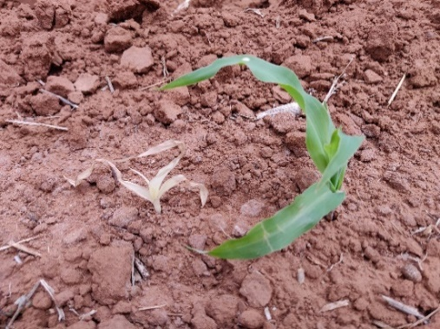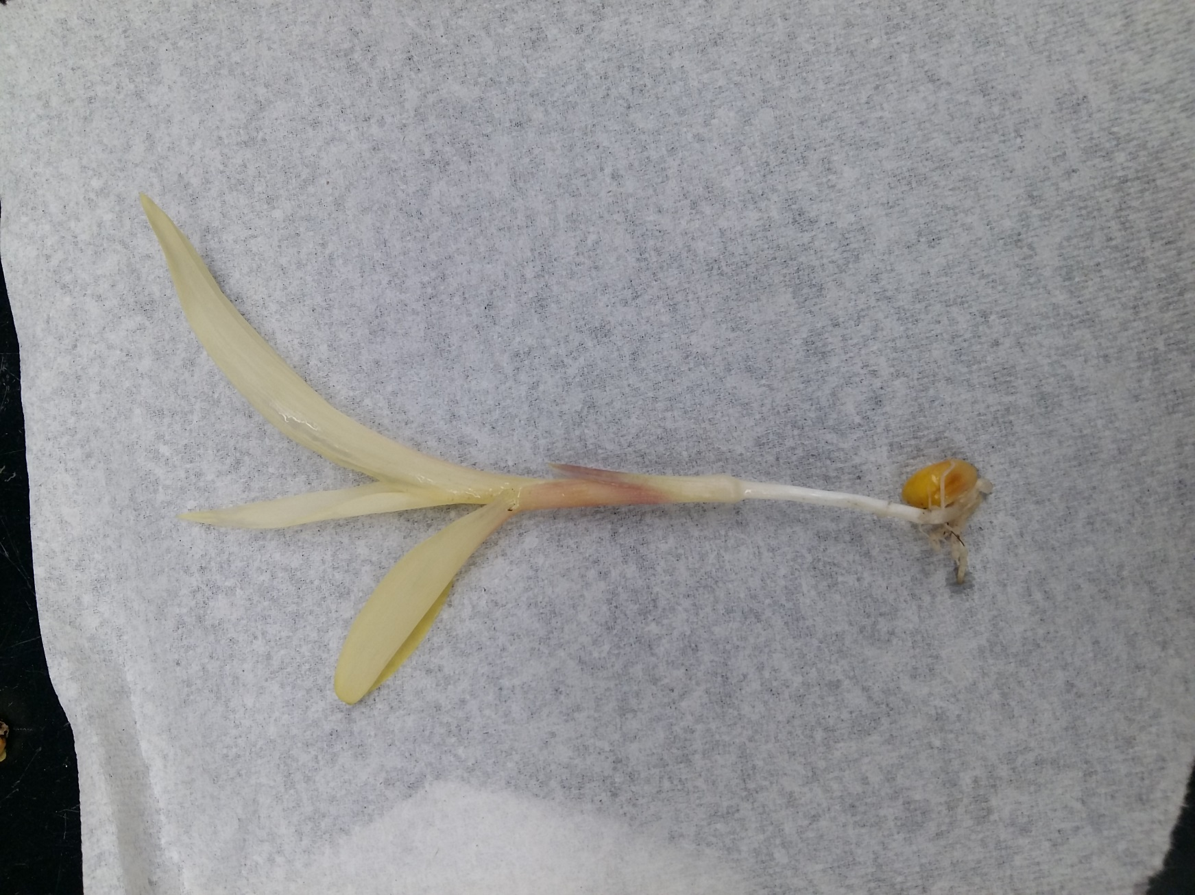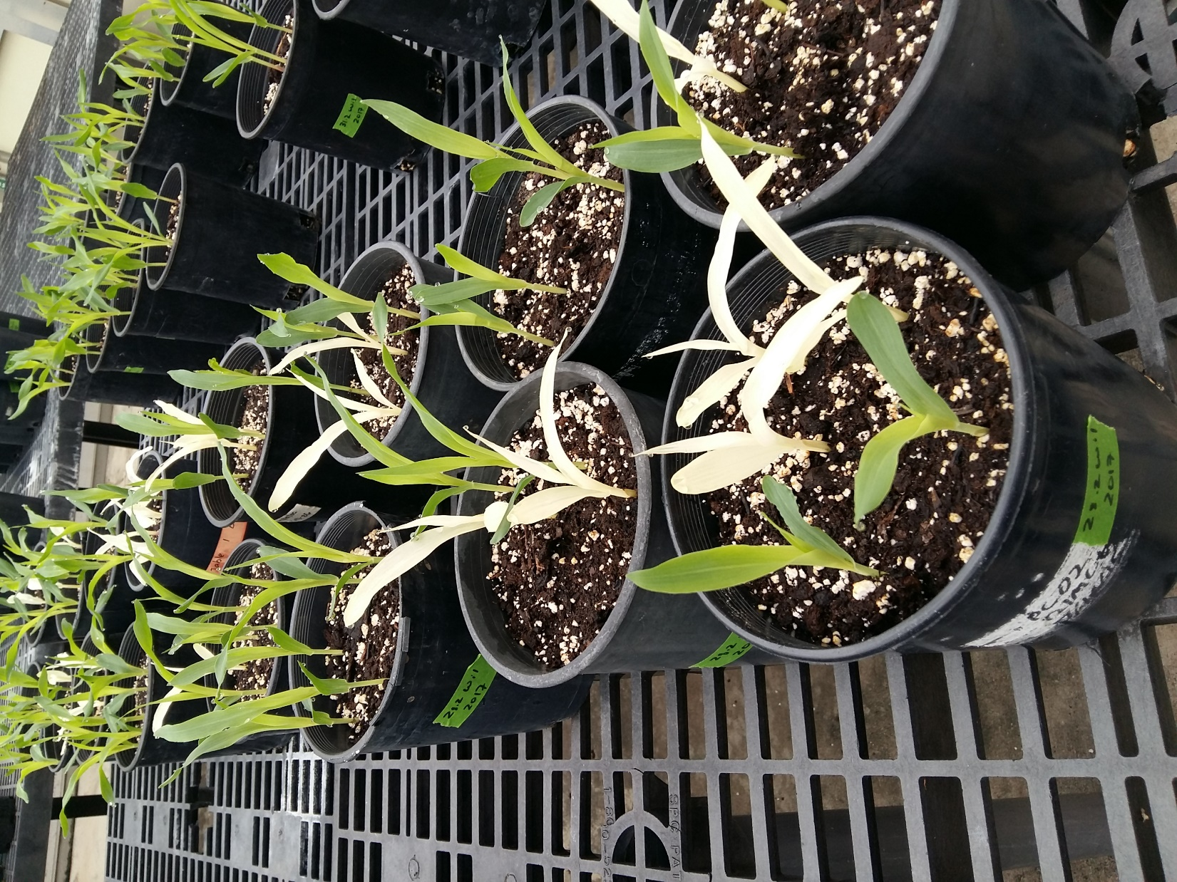
Fig. S1 (Left) Two-week old alb-605F mutant showing the albino phenotype with yellowish white leaves. (Right top) Two-week-old alb-605F mutant vs. wild type (WT) hybrid cousin growing under the field conditions; note much smaller mutant size suggestive of pleiotropic cool temperature effect (Barkan, 1993). The WT hybrid plant is green and growing normally. The alb-605F mutant shows albino phenotype with yellowish white leaves. (Right bottom) 10-day old plants segregating for alb-605F in B73 background grown under greenhouse conditions.
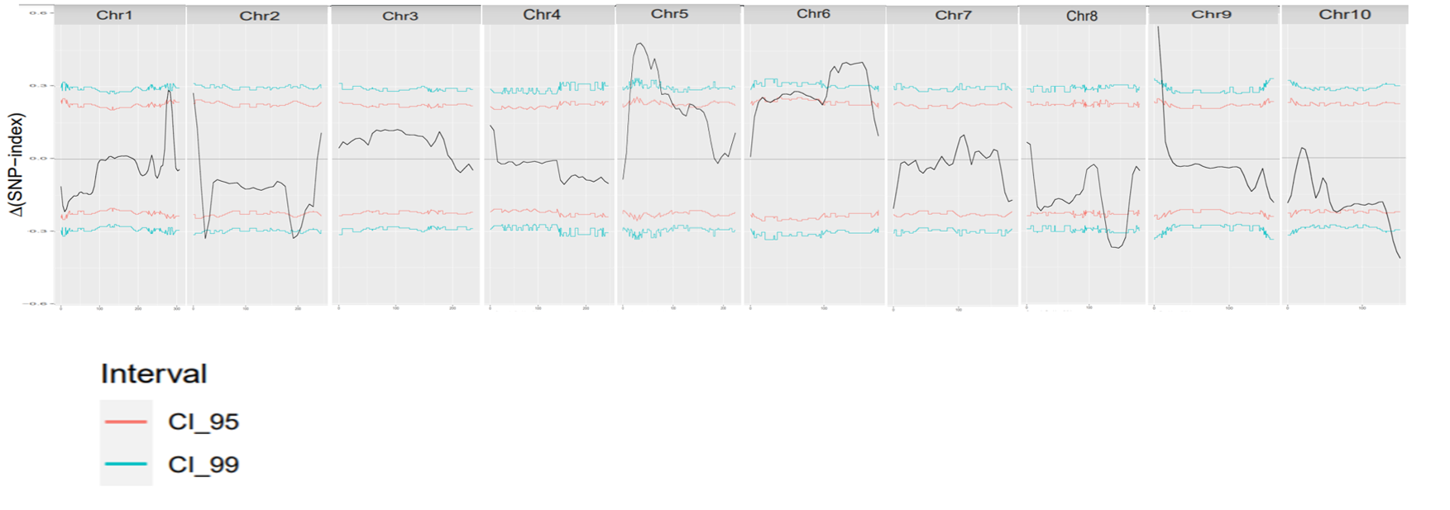
Fig. S2 The delta SNP-index of raw unfiltered reads (before removal of HapMap2 and HapMap3 SNPs) of alb-605F vs WT hybrid cousin plotted using QTLseqr, using window size of 10Mb. Delta SNP index is obtained from the number of reads with the variant allele differing from the reference genome. The delta SNP-index shows multiple peaks due to background noise, but one signal on the top of Chr. 9 is very far above the CI_99 threshold, indicating the most likely map interval of the causal alb-605F mutation.

Fig. S3 [below] Sanger sequencing of primer pair3 amplicon identifies (A) causal alb-605F two nucleotide frameshift deletion in Exon3 of ZmAlaRS (Zm00001d044745) and (B) additional locus complexity from a PIF-Harbinger transposon insertion event in parental Maize Genetics Co-Op stock 605F with three nt duplication at the insertion site. The Transposon is annotated as PIF_Harbinger_TIR_transposon consensus class when the insert sequence is blasted in MaizeGDB Zm-B73-REFERENCE-NAM-5.0 (https://www.maizegdb.org/).
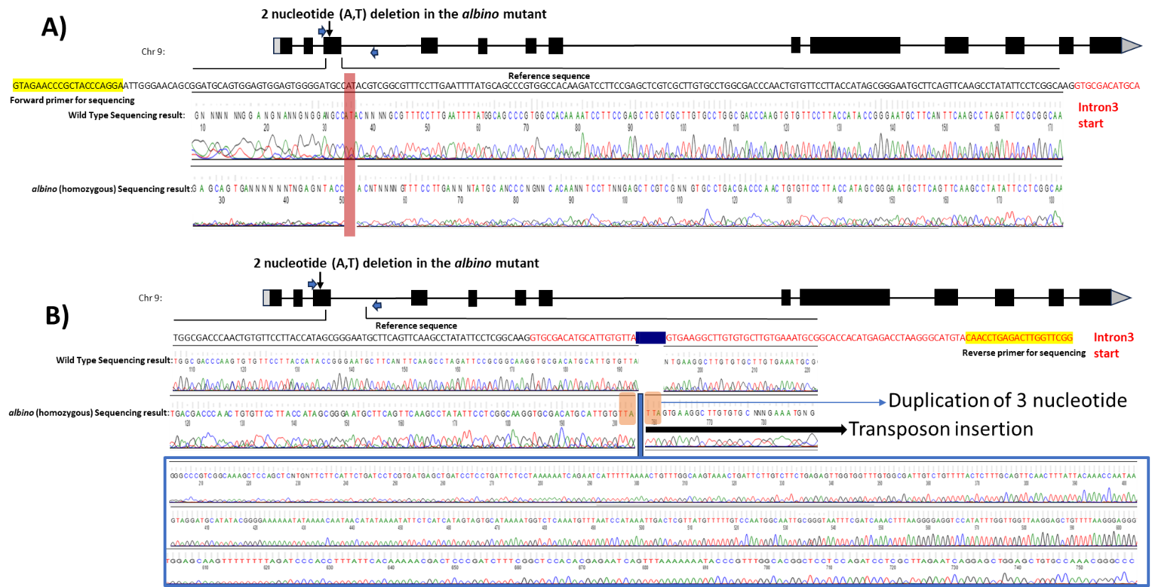
Fig. S4 [below] Identification of candidate independent alb-605F locus alleles by Sanger sequencing of amplicons from PCR using McCarty and Barkan Mutator homozygous stock templates with Mutator transposon-specific and ZmAlaRS/Zm00001d044745 target gene primers. (A) UFMu-1041912 Mutator transposon is located at the predicted ATG translation start site of Zm00001d044745/ZmAla-RS. Heterozygous UFMu-1041912 plant self-pollination, and crosses of heterozygous plants with alb-605F/+ heterozygotes did not segregate albino phenotype, consistent with interpretation a cryptic ATG translation start codon (e.g. aa128) in UFMu-1041912 homozygotes may be functional for ZmAlaRS/Zm00001d044745 activity. (B) Bmu_illumina_98370.7 homozygous stock has an insertion site 42 bases downstream from the PIF-Harbinger transposon insertion site in intron3 (red font) of the claimed alb-605F allele (denoted with green vertical arrow). BLASTing of boxed sequences into NCBI core nucleotide database finds 98-100% identity to Mutator SeqIDs U19613.1/JX843286.1 (1,723/1,831 bp) and X53604.1 (1,419 bp), respectively.

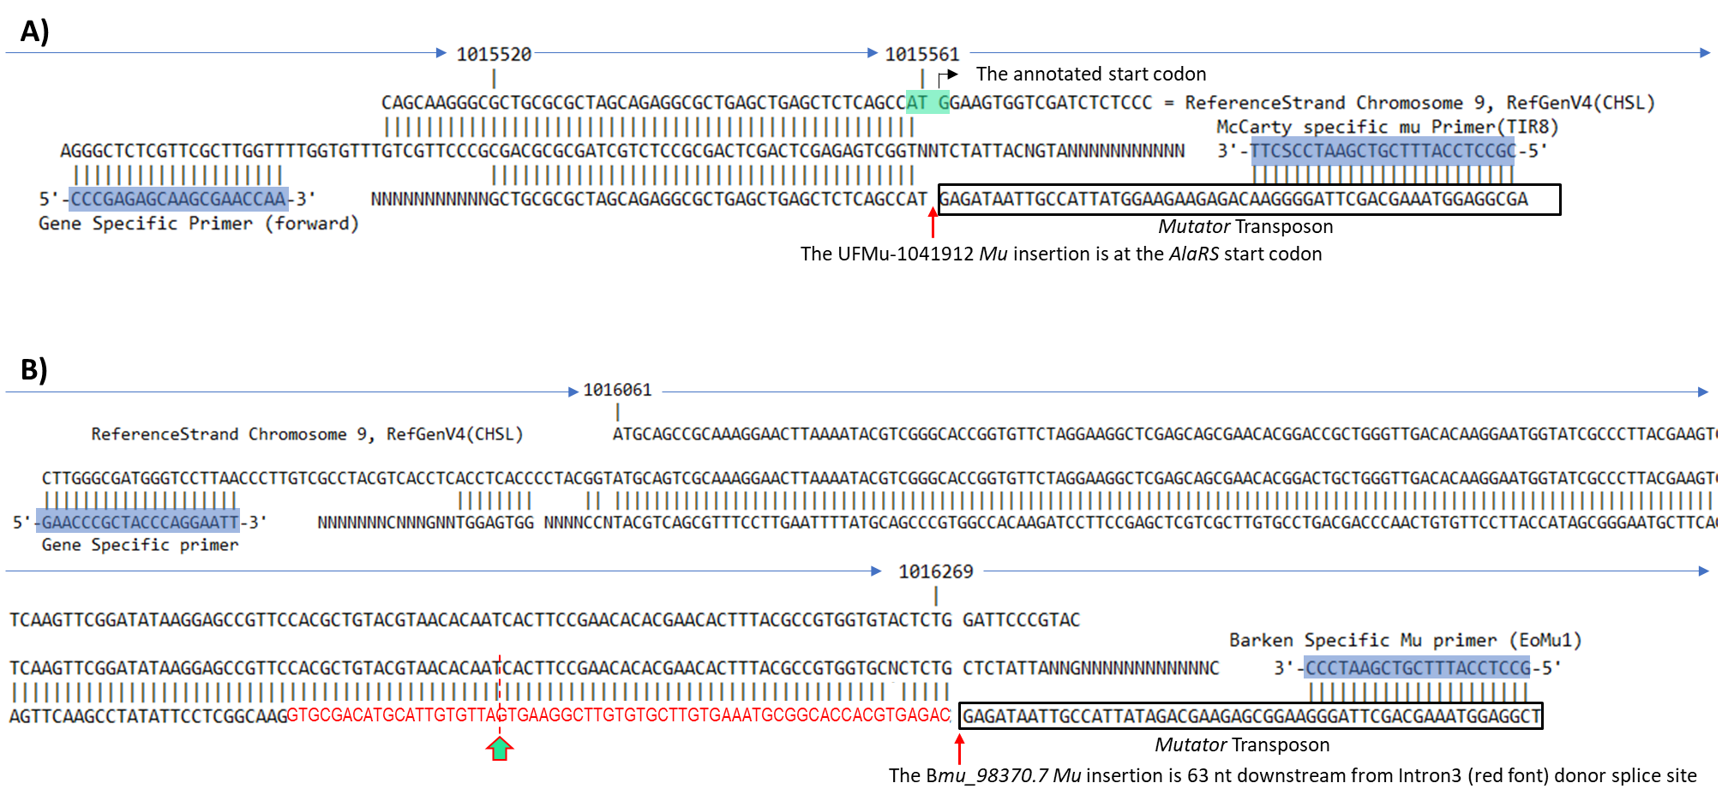
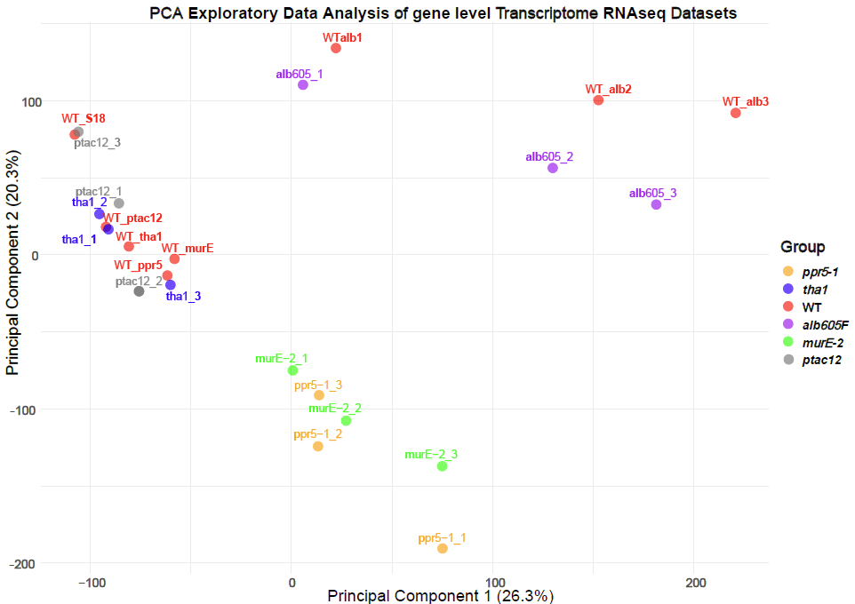
Fig. S5 Principal Component analysis (PCA) of the RNA-seq libraries for alb-605F and Kendrick et al. photosynthetic mutants (2022) analyzed at gene level.

Fig. S6 [below] (Top) Albino phenotype segregating in the original parent stock of 3510 w*-N627B, 4208K wl*-N1857, 450D v*-N829A, and Bmu-illumina_89370.7. (Bottom) Rare albino seedlings obtained from complementation test crosses with parents in the top panel and the heterozygous alb-605F/+ plants.

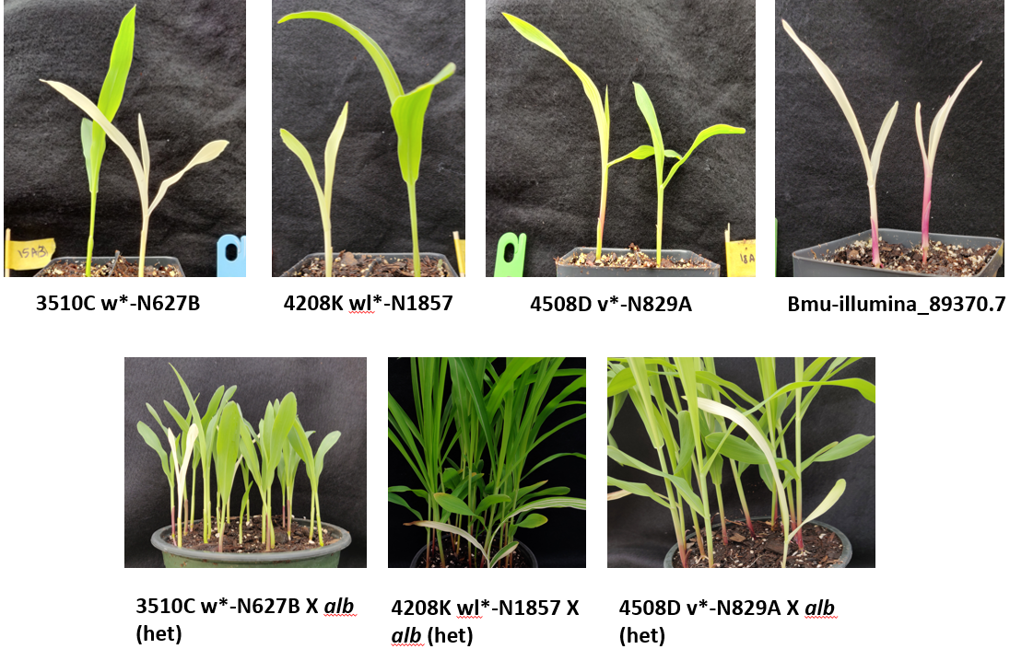

Fig. S7 [below] TargetP-2.0 prediction of organellar sub-localization of (A) alb-605F locus polypeptide AlaRS/Zm00001d044745 to the chloroplast, and (B) closest paralogue Zm00001d023741 to the mitochondria. There are four other more distant ZmAlaRS paralogues in maize (Zm00001d031239, Zm00001d031241, Zm00001d031236, and Zm00001d008498) without predicted organellar targeting peptides other than Zm00001d023741, which shares 37% identity and 55% similarity to Zm00001d044745 and is predicted (P= 0.48) to be cleaved at SSF-SS consensus AA38-39.
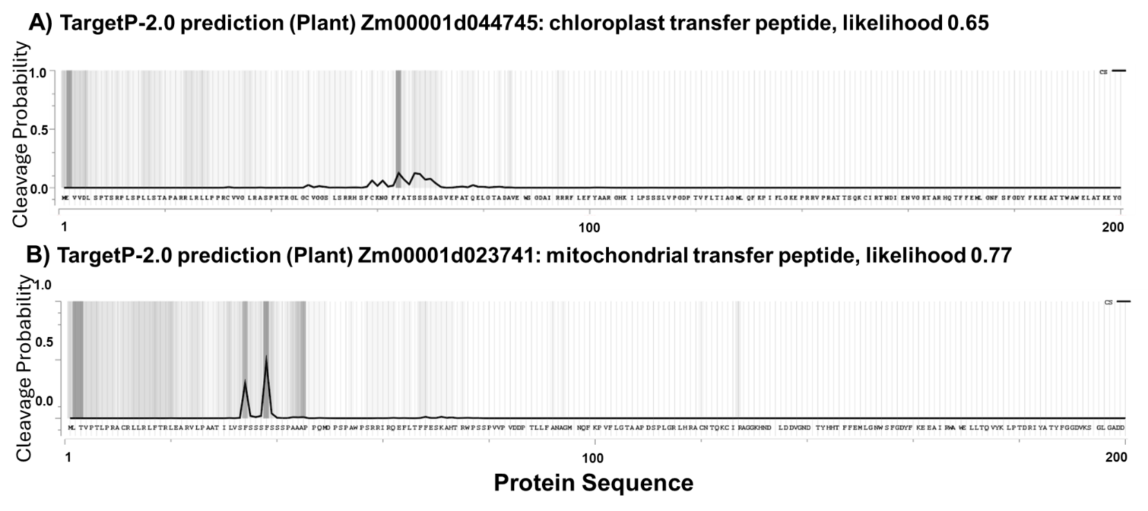

Fig. S8 [below] MapMan representation of protein kinase and select PP2C-A phosphatase superfamily genes differentially expressed in alb-605F seedlings.
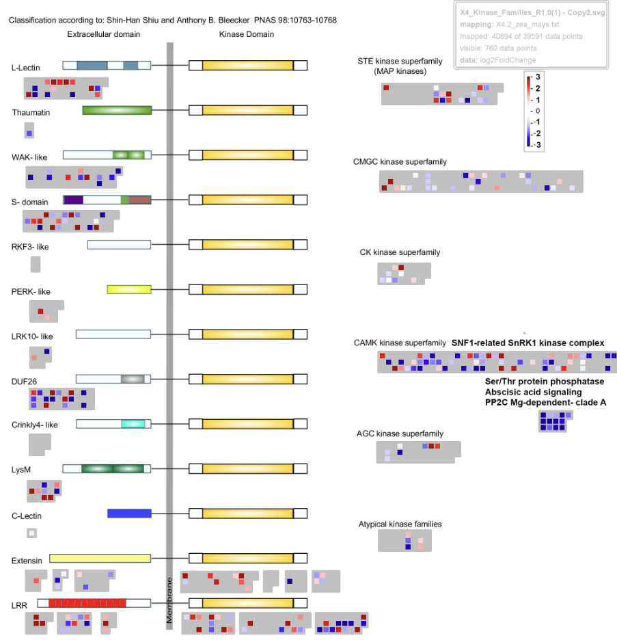
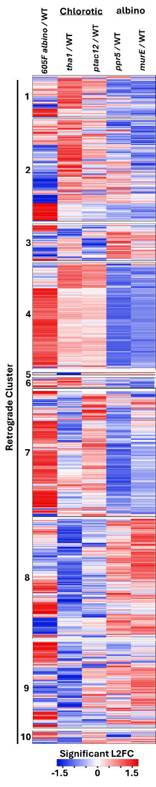
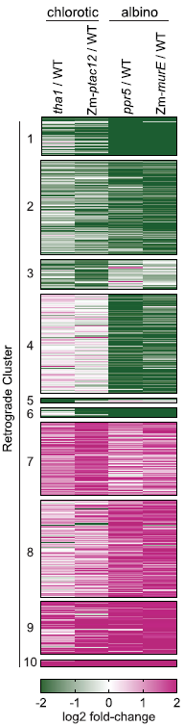
Fig. S9 [below] Heatmap comparison of 1,740 alb-605F significantly differentially expressed transcript-level genes, hierarchically arranged within retrograde clusters and organized side-by-side with Kendrick et al (2022, Fig. 2A; reproduced by permission of Oxford University Press) results for all 2,733 DE genes. The alb-605F mutant clusters are more similar with the topologies of tha1 and ptac12 chlorotic mutant DE genes than with null ppr5-2 and murE-2 mutants. Supports Table 3 for correlations of alb-605F and photosynthetic mutant organellar rRNA LFC and base expressions, and Suppl Fig. S5. Heatmap was with online software http://heatmapper.ca/expression/.
List of Supplemental Tables (separate Excel file, 6 Mbytes)
Supplemental Table S1: gDNA and RNA libraries quality control parameters.
Supplemental Table S2: Gene level RNA-seq analysis of alb-605F vs. WT hybrid cousin library pools.
Supplemental Table S3: Sequence of the primers used for Indel walking and genotyping alb-605F mutant alleles.
Supplemental Table S4: List of Maize Genetic Co-op and Mutator reverse genetic stock lines tested for alb-605F complementation.
Supplemental Table S5: List of all the SNPs/Indels candidate causal alb-605F genes identified by SnpEff software within the fine mapped 10 Mbp interval on short arm of Chr. 9.
Supplemental Table S6: Wilcoxon Rank Sum statistics from select transcript-level DE results of MapMan analysis.

