Extended Data
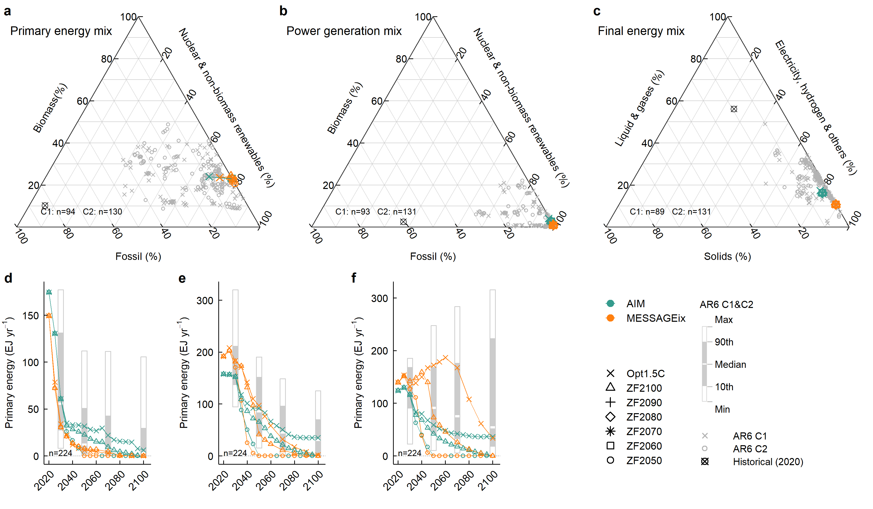
Extended Data Fig. 1 | Fossil fuel phase-out and energy system transformation. a–c, Energy mix for primary energy (a), power generation (b), and final energy (c) in 2100. Coloured symbols represent energy mixes by scenario and model. Grey symbols represent the energy mixes of the Intergovernmental Panel on Climate Change Sixth Assessment Report (IPCC AR6) C1 and C2 scenarios for 2100. Black symbols represent the historical energy mix for 2020, based on the International Energy Agency (IEA) energy balance³⁸. d–f, Annual primary energy supply from coal (d), crude oil (e) and natural gas (f) from 2020 to 2100. Box plots illustrate primary energy supply from fossil fuels in IPCC AR6 C1 and C2 scenarios in 2030, 2050, 2070 and 2100. In this study, primary energy accounting was based on the direct equivalent method, which systematically reduces the contribution of non-combustible energy sources such as hydro, nuclear, solar, and wind energy compared to combustible fuels³⁹.

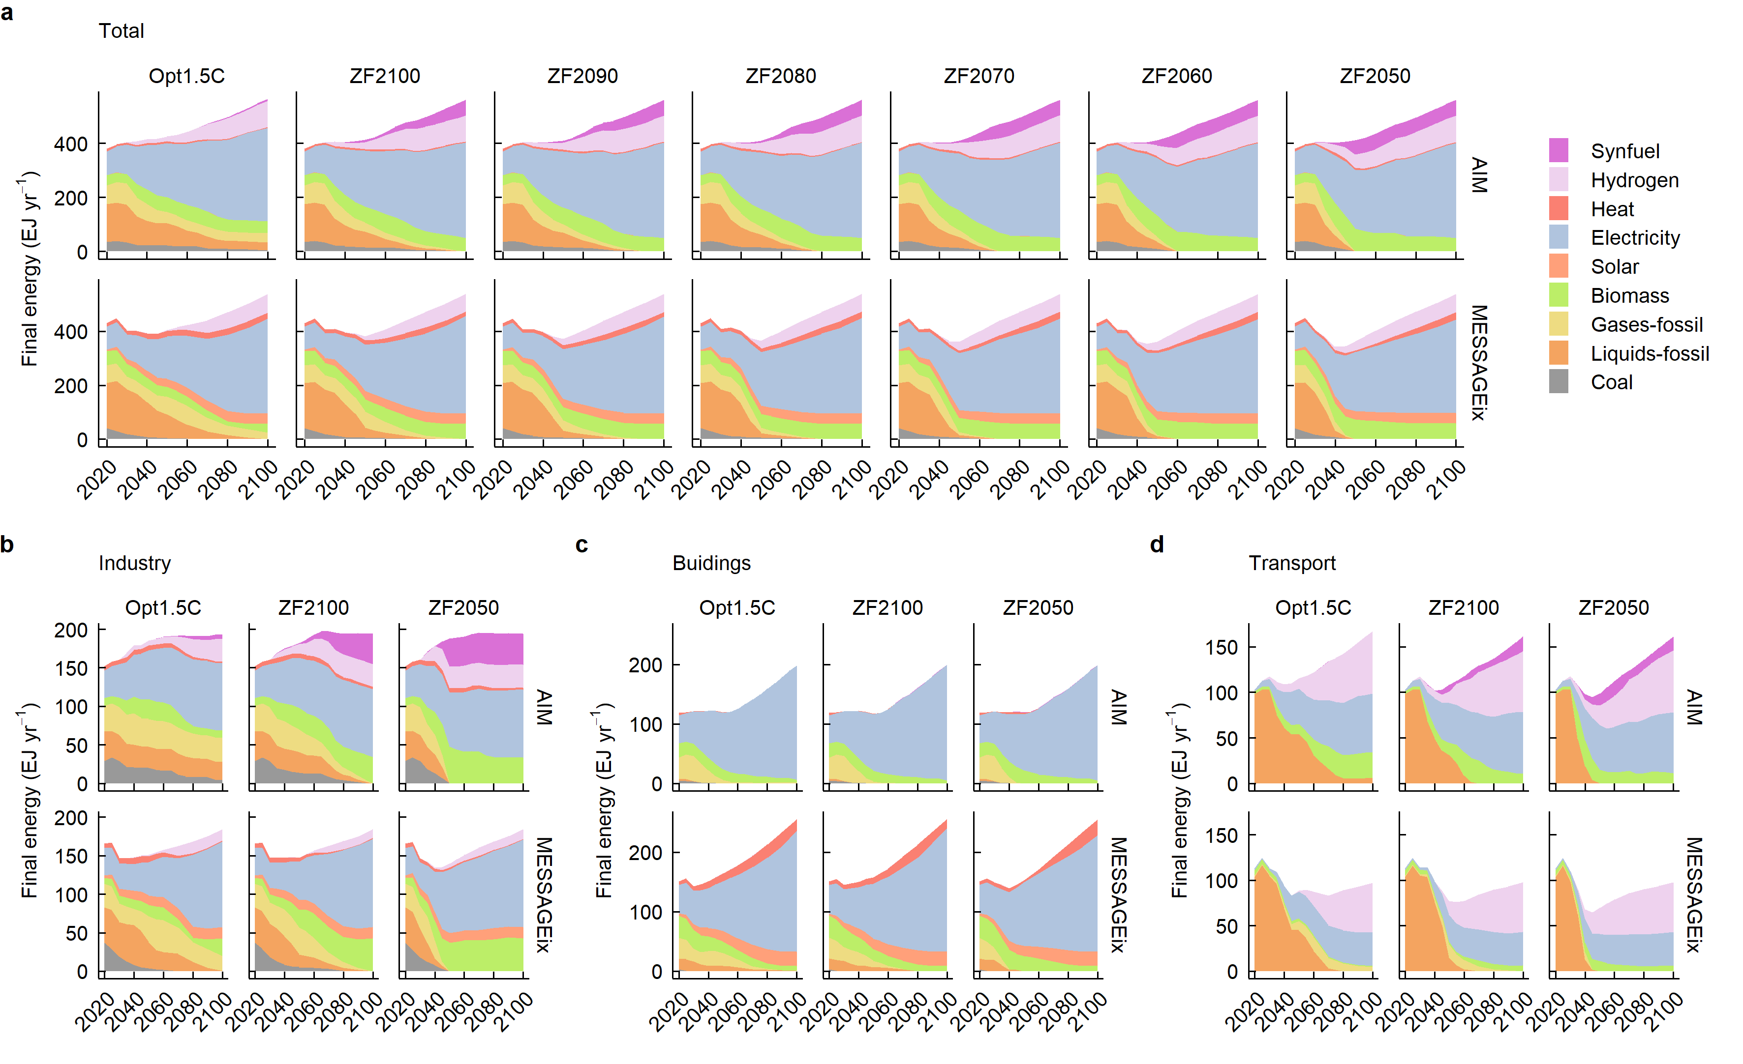
Extended Data Fig. 2 | Transformation to ZF energy systems in energy demand sectors. a, Final energy consumption during the period 2020–2100. b–d, Final energy consumption in industry (b), buildings (c) and transportation (d) sectors in the Opt1.5C, ZF2100 and ZF2050 scenarios during the period 2020–2100.

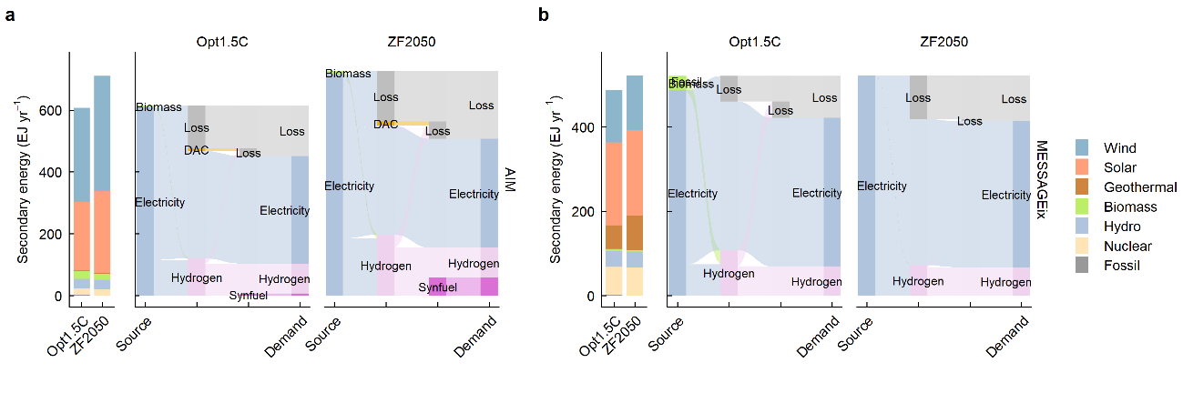
Extended Data Fig. 3 | Energy system transformation in energy supply sectors driven by a full phase-out of fossil fuels. a, b, Power generation mixes and secondary energy flow in the Opt1.5C and ZF2050 scenarios of AIM-Technology (a) and MESSAGEix-GLOBIOM (b) in 2100.

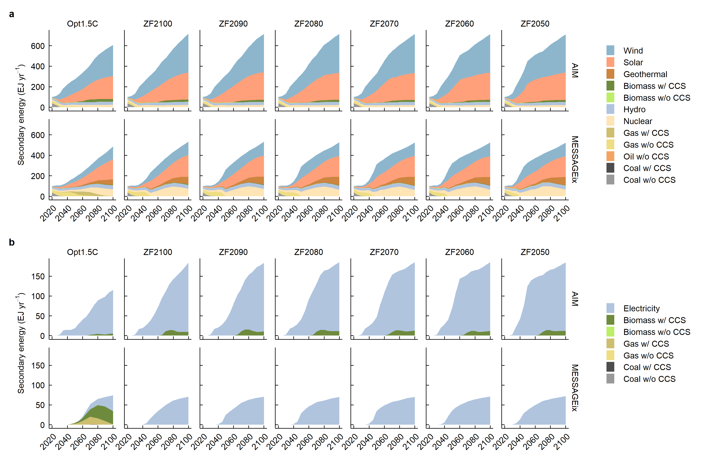
Extended Data Fig. 4 | Power and hydrogen generation. a, Power generation during the period 2020–2100. b, Hydrogen generation during the period 2020–2100.

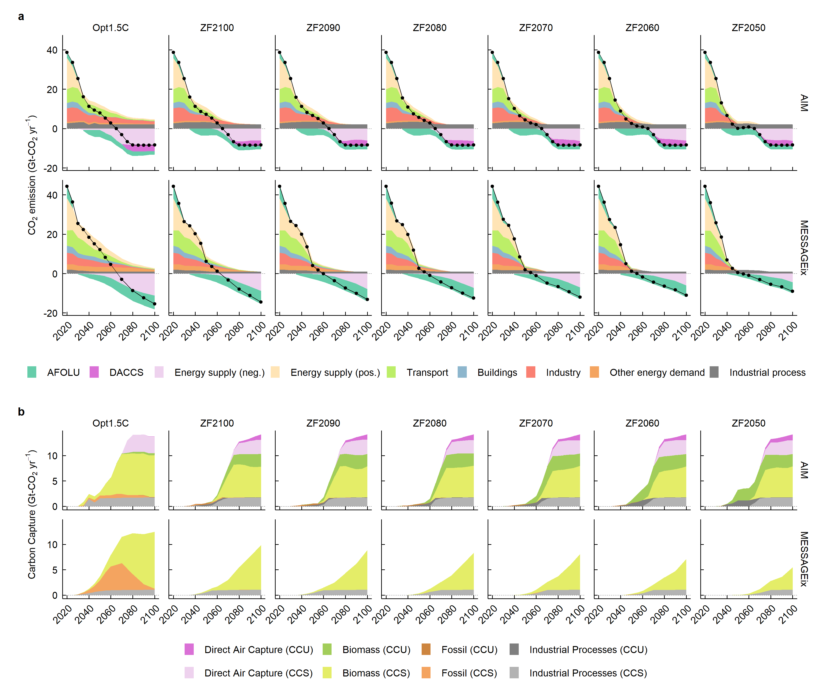
Extended Data Fig. 5 | CO₂ emissions and carbon capture, utilization and storage. a, Sectoral CO₂ emissions during the period 2020–2100. Line and dot plots show net CO₂ emissions from energy and AFOLU sectors during the period 2020–2100. b, Carbon capture and its destination, including CCU and CCS during the period 2020–2100.

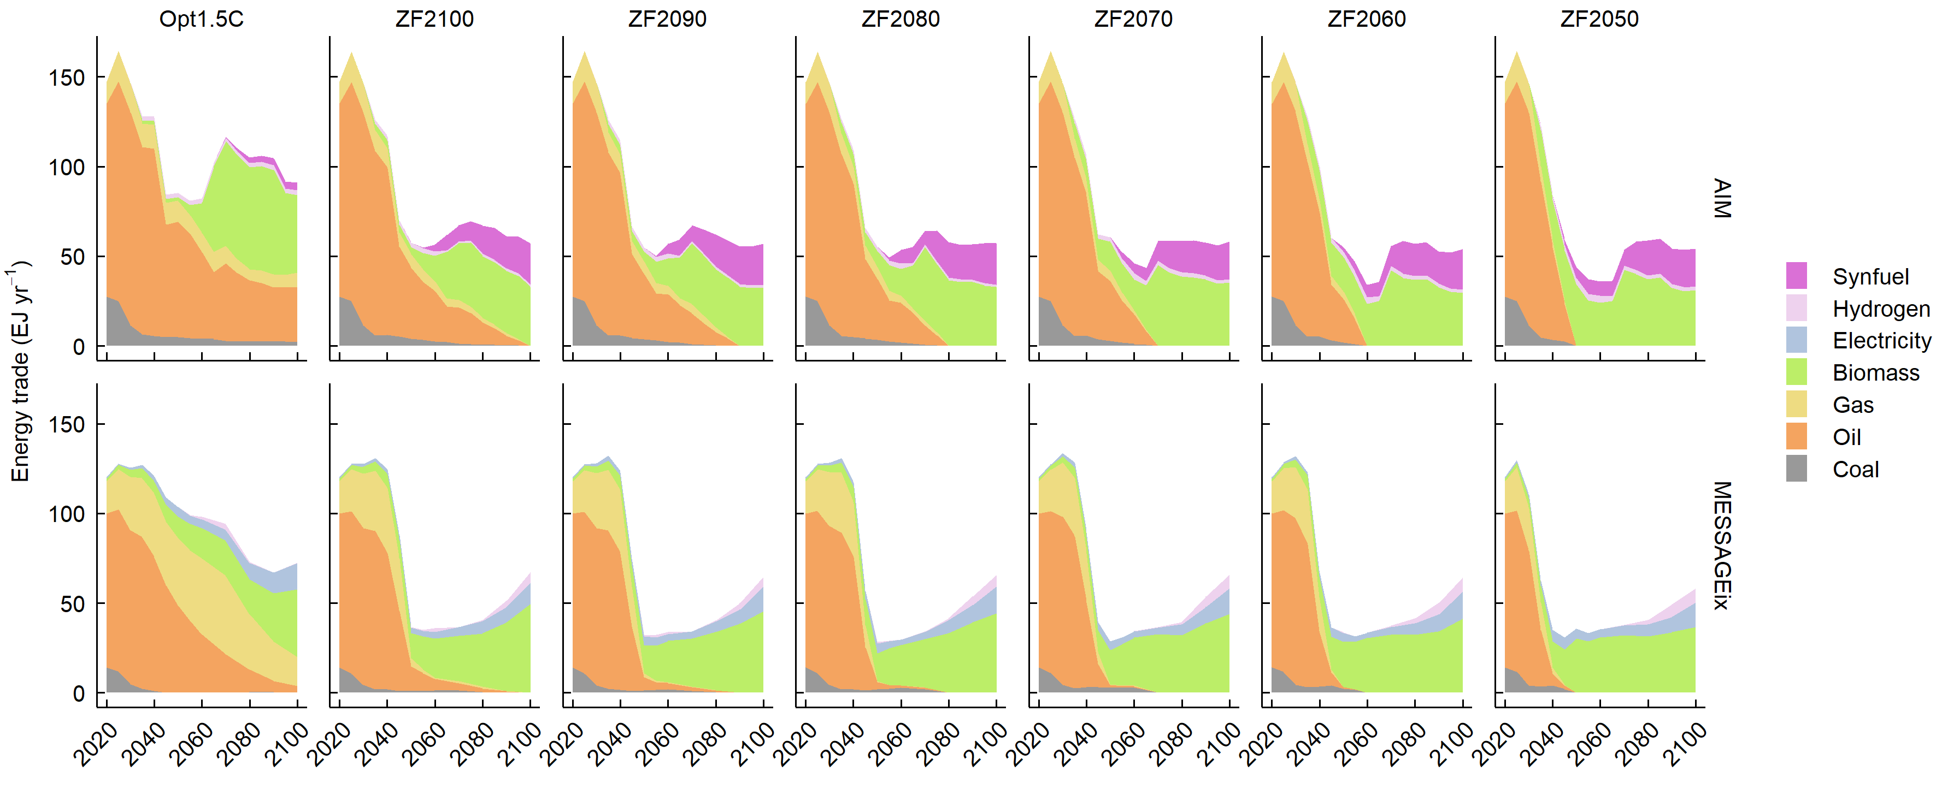
Extended Data Fig. 6 | Energy trade. International energy trade during the period 2020–2100. Hydrogen includes trade via liquefied hydrogen, methylcyclohexane (MCH), and ammonia.

