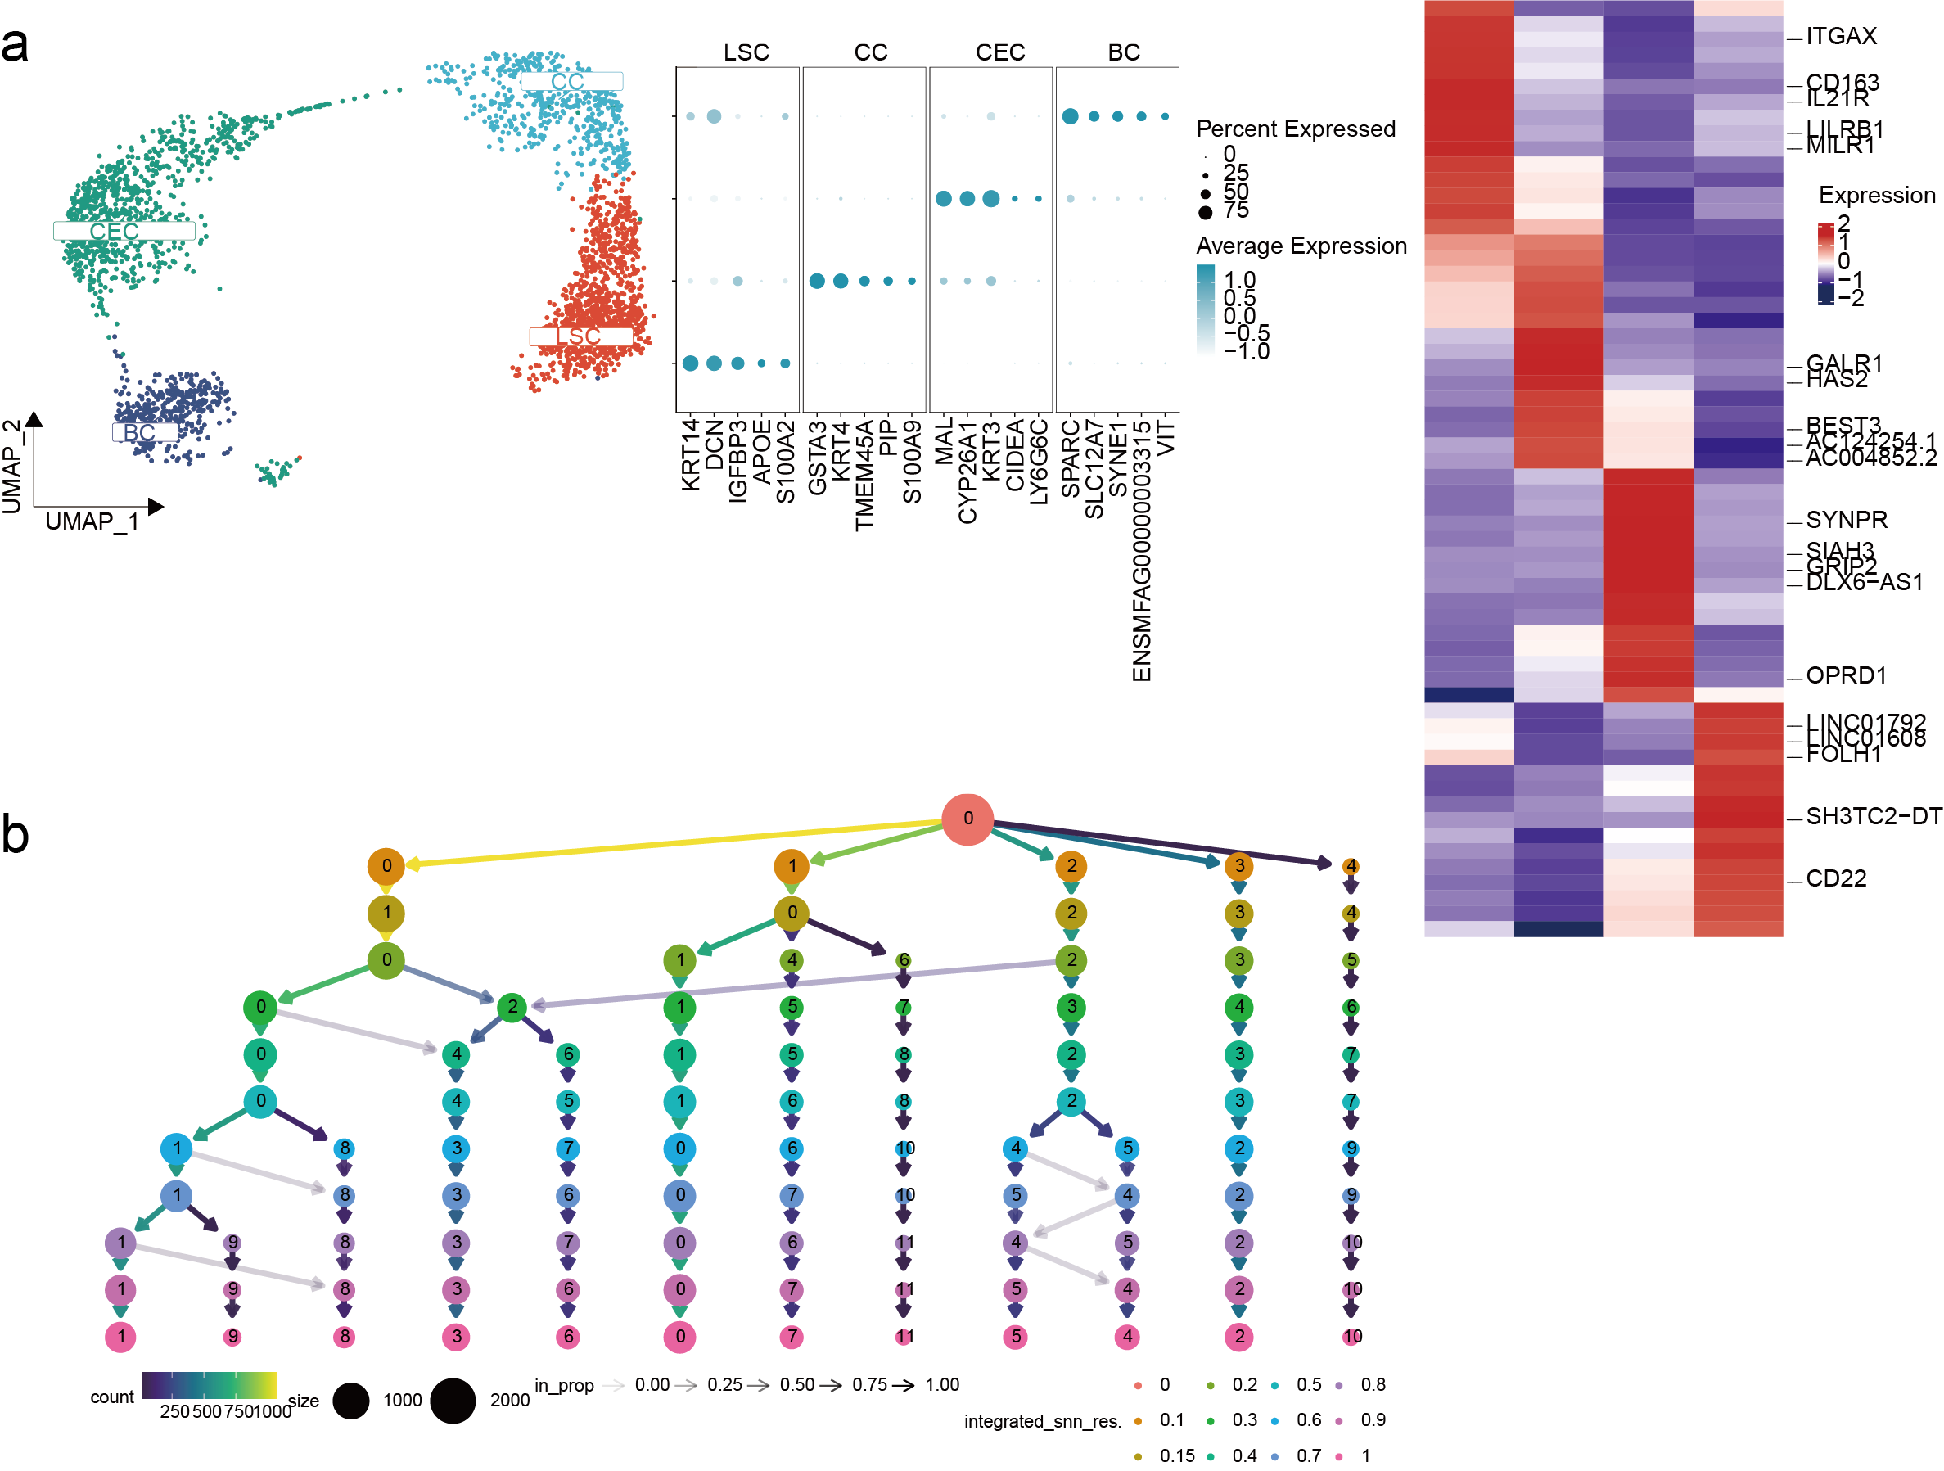
Supplementary Fig. S1: Single-cell atlas of long-read scRNA-seq data from the Macaca fascicularis corneal limbus. (a) Single-cell atlas of Macaca fascicularis corneal limbus long-read scRNA-seq sequencing data at the gene level, including UMAP(left panel), dot plot(middle panel), and heatmap(right panel). (b) Clustree results of cell clustering.
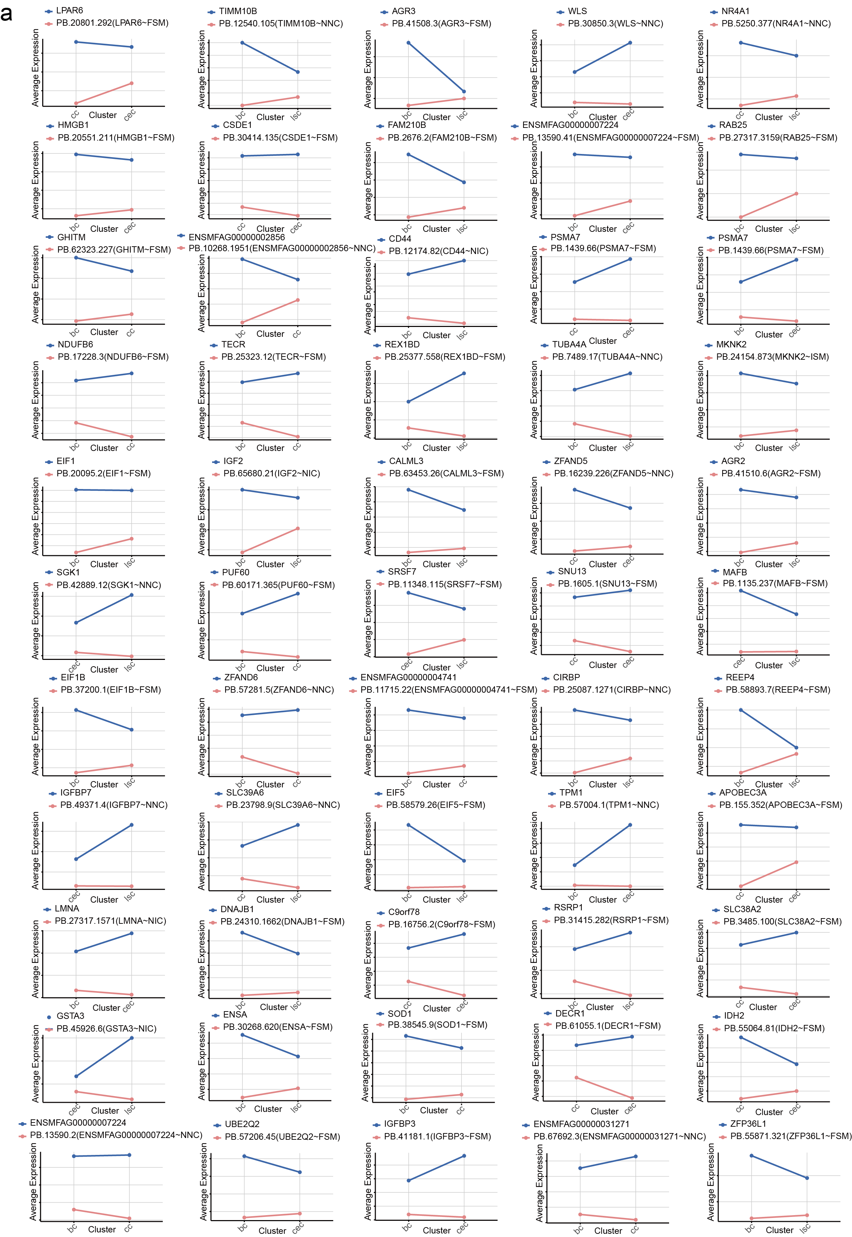
Supplementary Fig. S2: Expression patterns of pair-DEIs compared to genes. (a) Line plots comparing the expression patterns of pair-DEI-specific isoforms with gene-level expression across cell types, relative to the switch isoform.
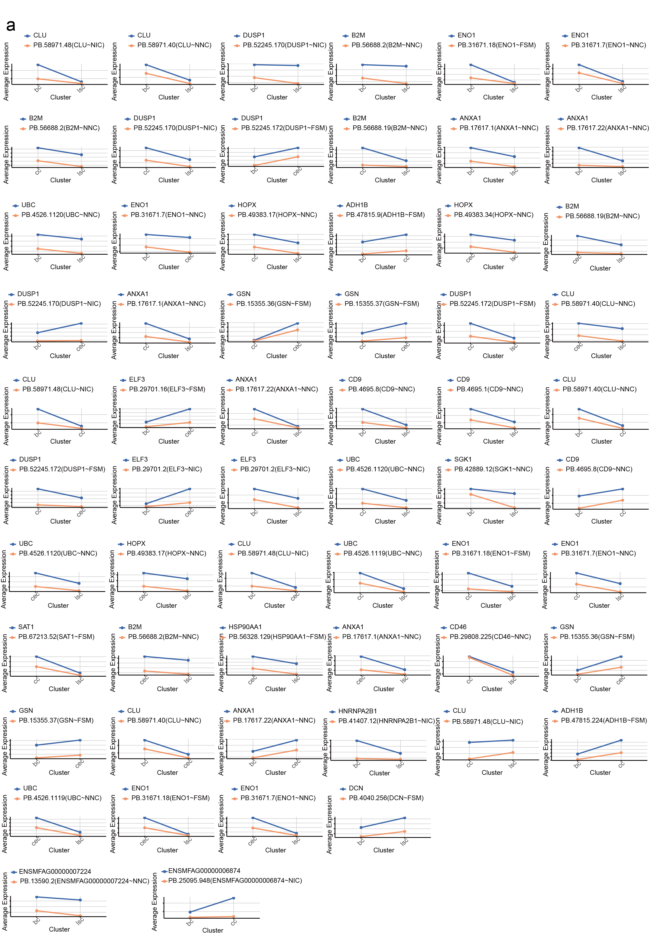
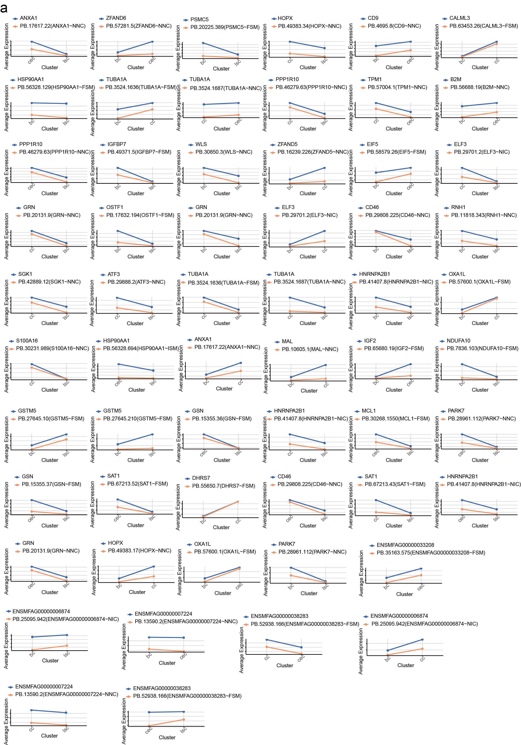
Supplementary Fig. S3-4: Expression patterns of switch isoforms obtained from IsoformSwitchAnalyzeR. (a) Line plots comparing the expression patterns of switch isoform-specific isoforms with gene-level expression across cell types.
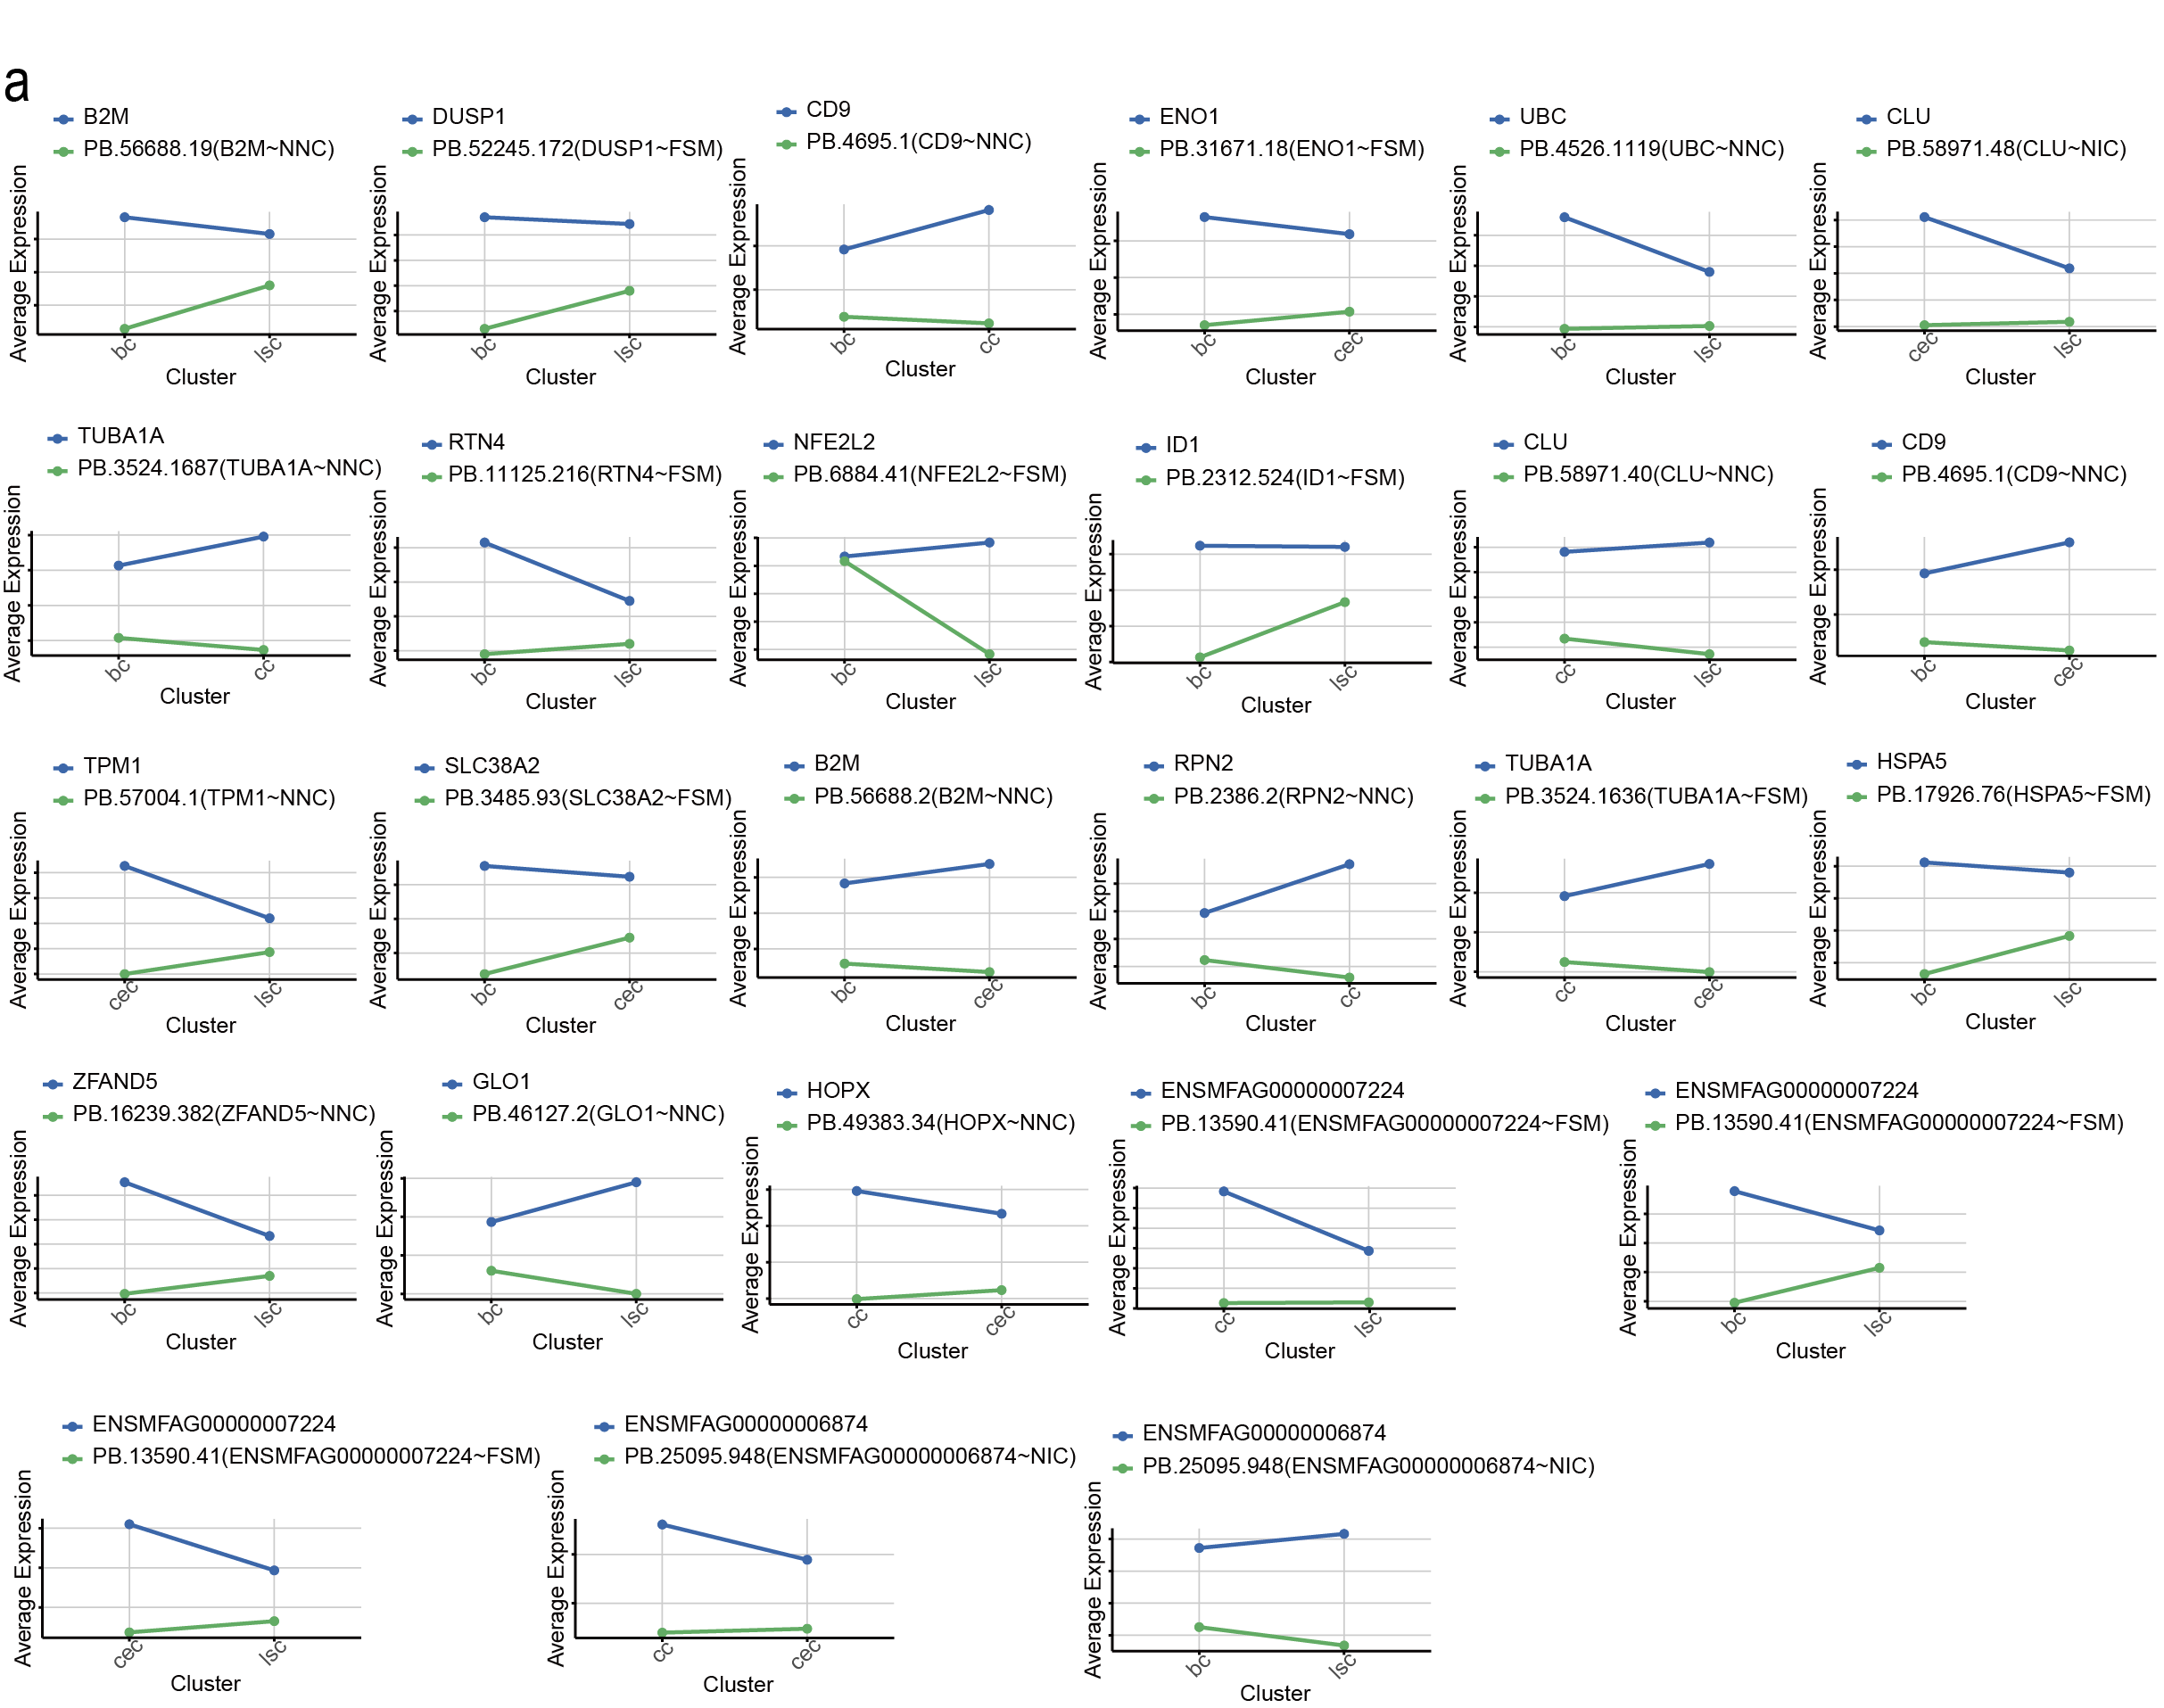
Supplementary Fig. S5: Expression patterns of shared isoforms between pair-DEI and Switch. (a) Line plots comparing the expression patterns of shared isoforms between pair-DEI and Switch with gene-level expression across cell types.
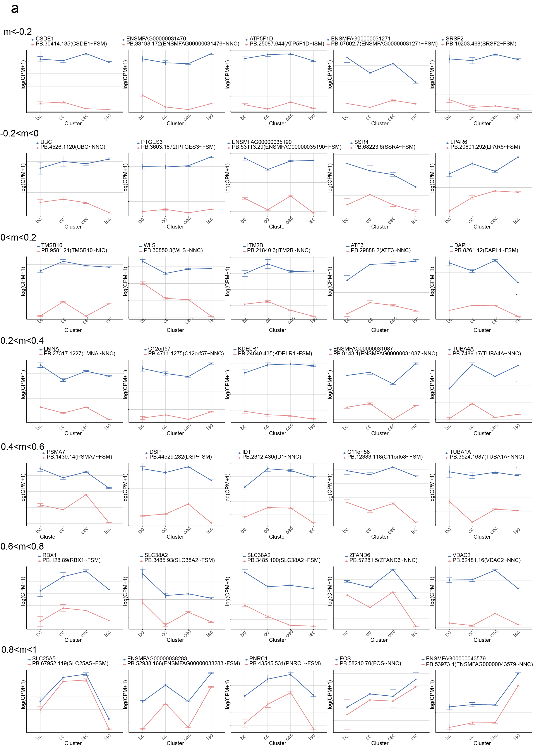
Supplementary Fig. S6: Expression patterns of isoforms in different adj R² value ranges when comparing across multiple cell types in the Macaca fascicularis long-read scRNA-seq dara. (a) Line plots comparing the expression patterns of candidate isoforms from multi-DEI in different adj R² value ranges with gene expression.
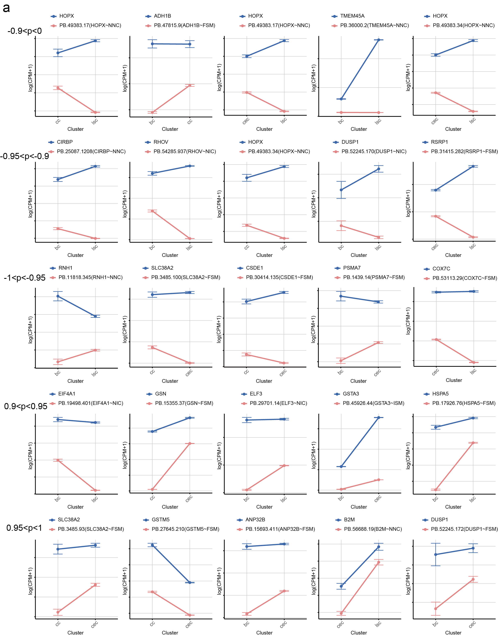
Supplementary Fig. S7: Expression patterns of isoforms in different ranges of the product of pearson correlation coefficient and cosine similarity in the comparison between two cell types in the Macaca fascicularis corneal limbus long-read scRNA-seq data. (a) Line plot comparing the expression patterns of candidate isoforms of pair-DEI with gene expression patterns in various ranges of the product of Pearson Correlation Coefficient and Cosine Similarity.
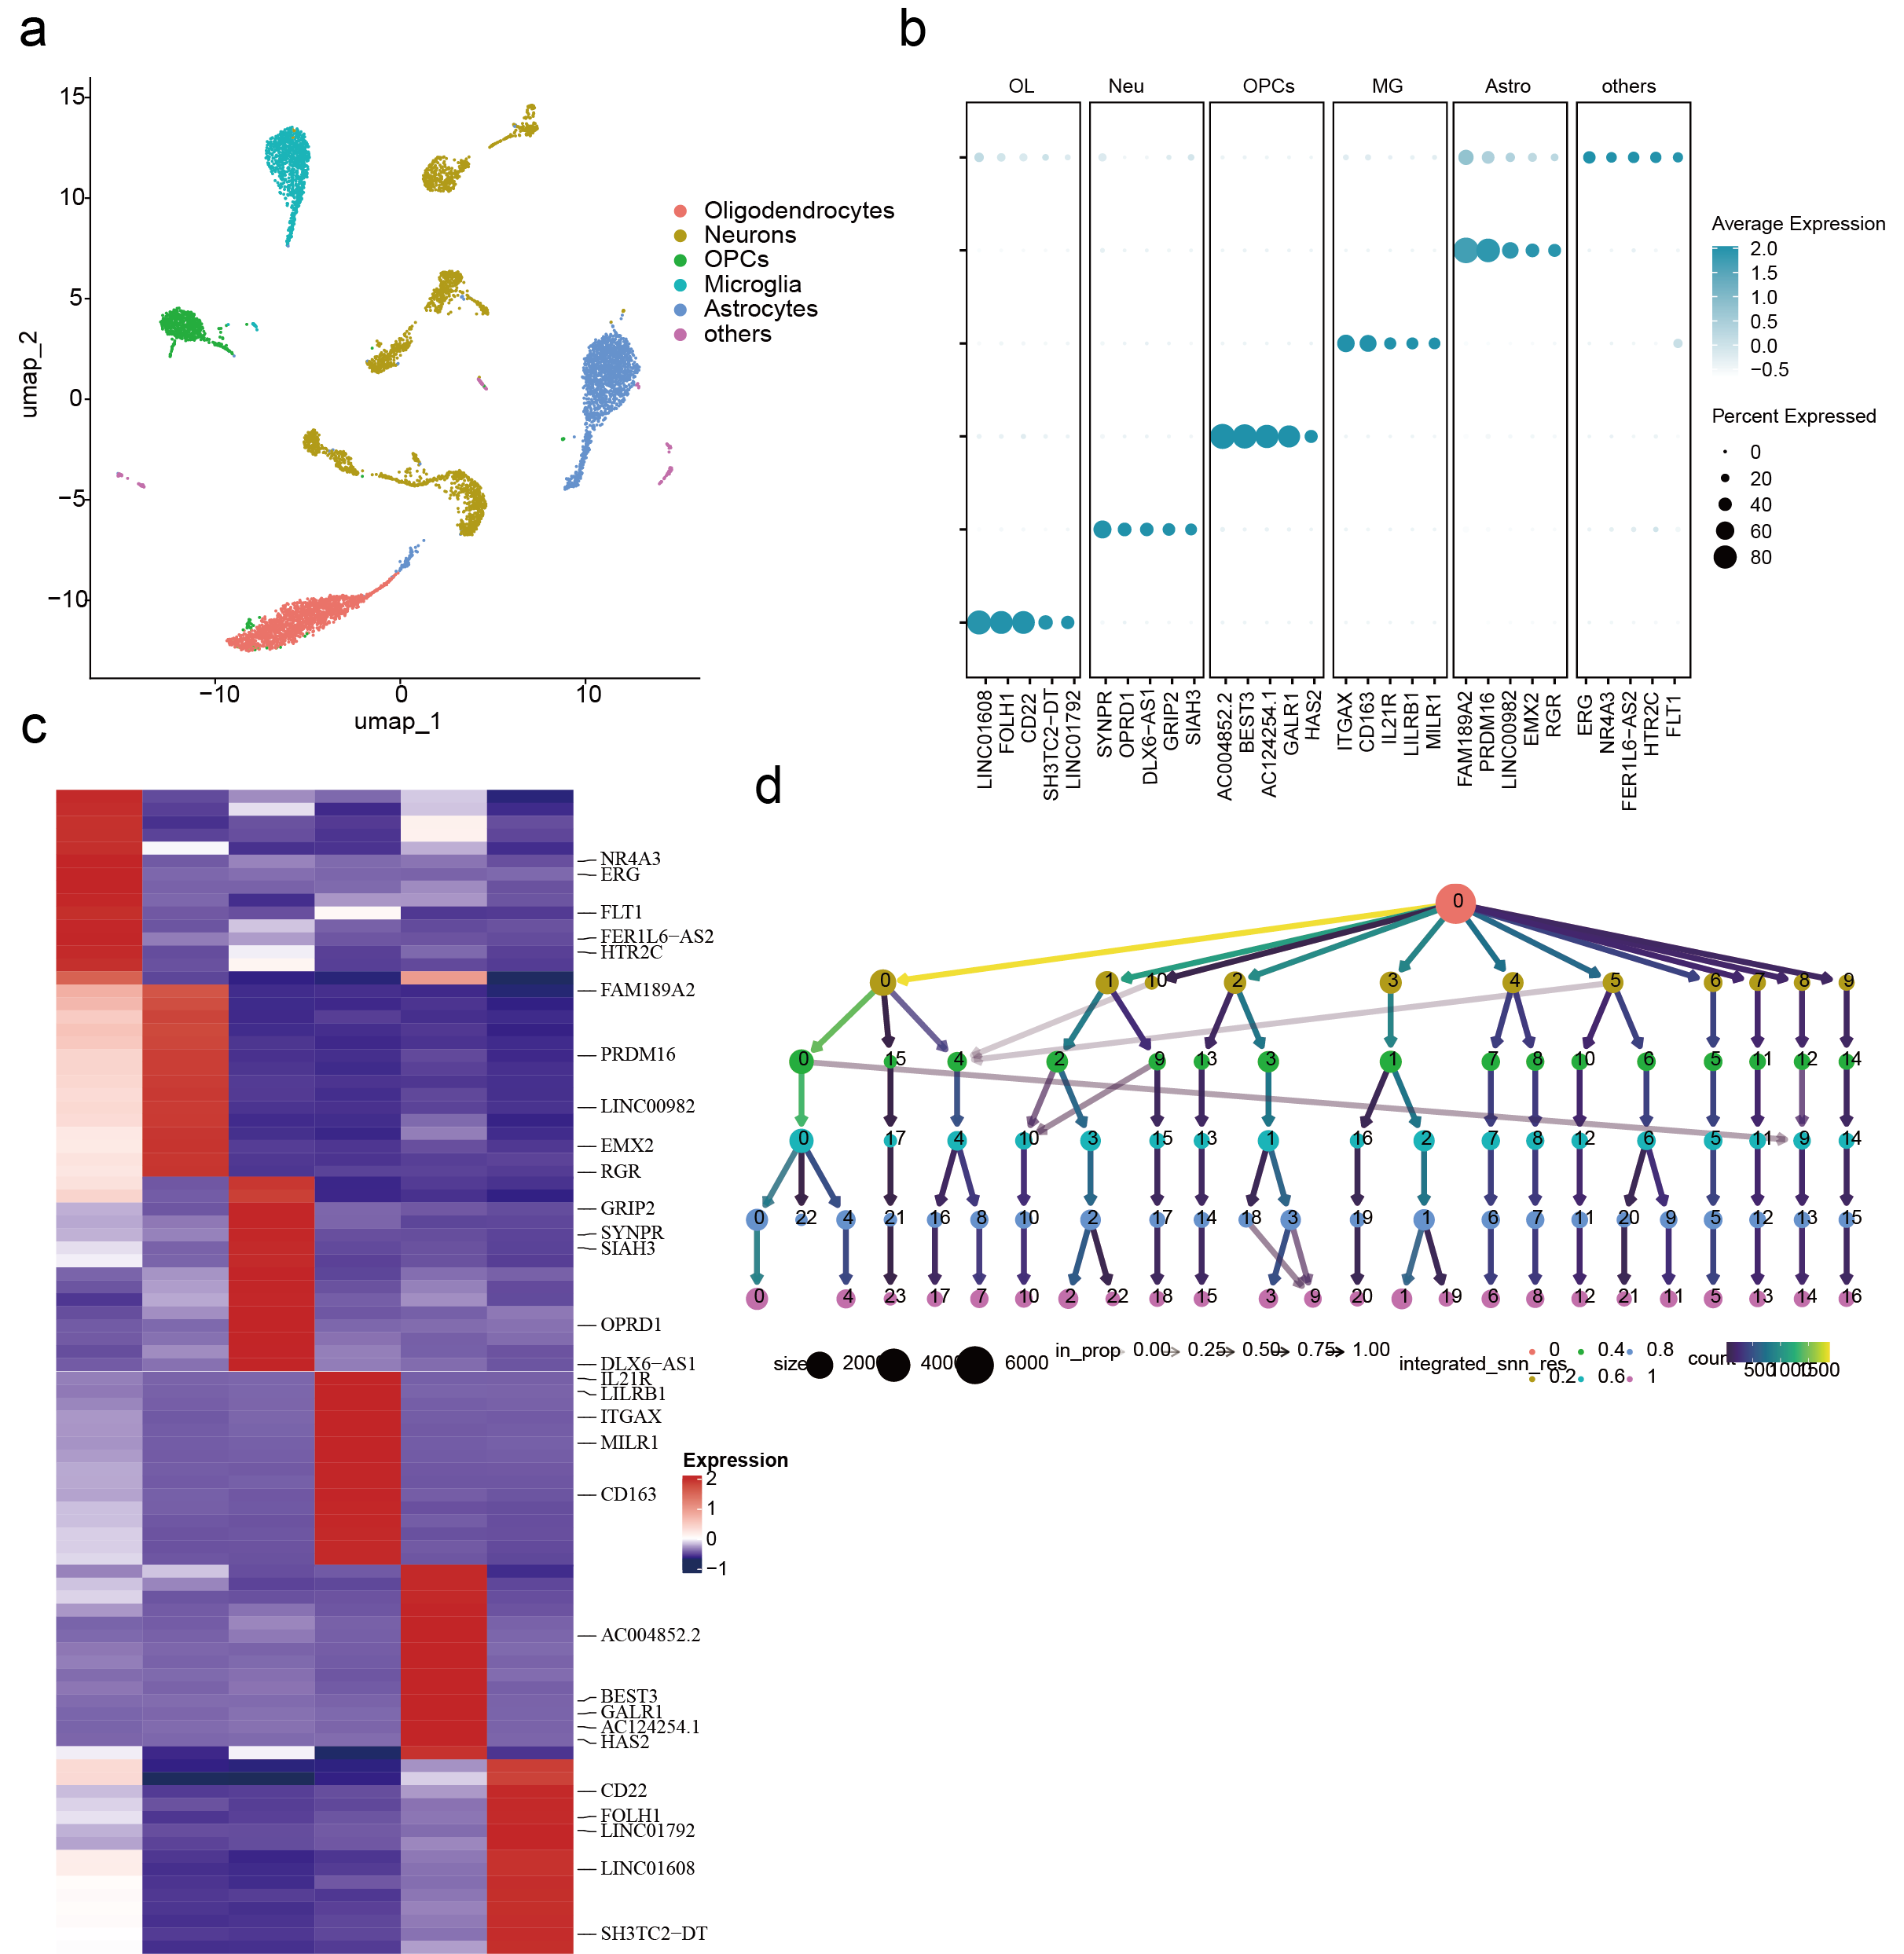
Supplementary Fig. S8: Single-cell atlas of human frontal cortex based on long-read scRNA-seq data. (a-c) Single-cell atlas at the gene level for human frontal cortex, including UMAP, dotplot, and heatmap. (d) Clustree result of cell clustering.
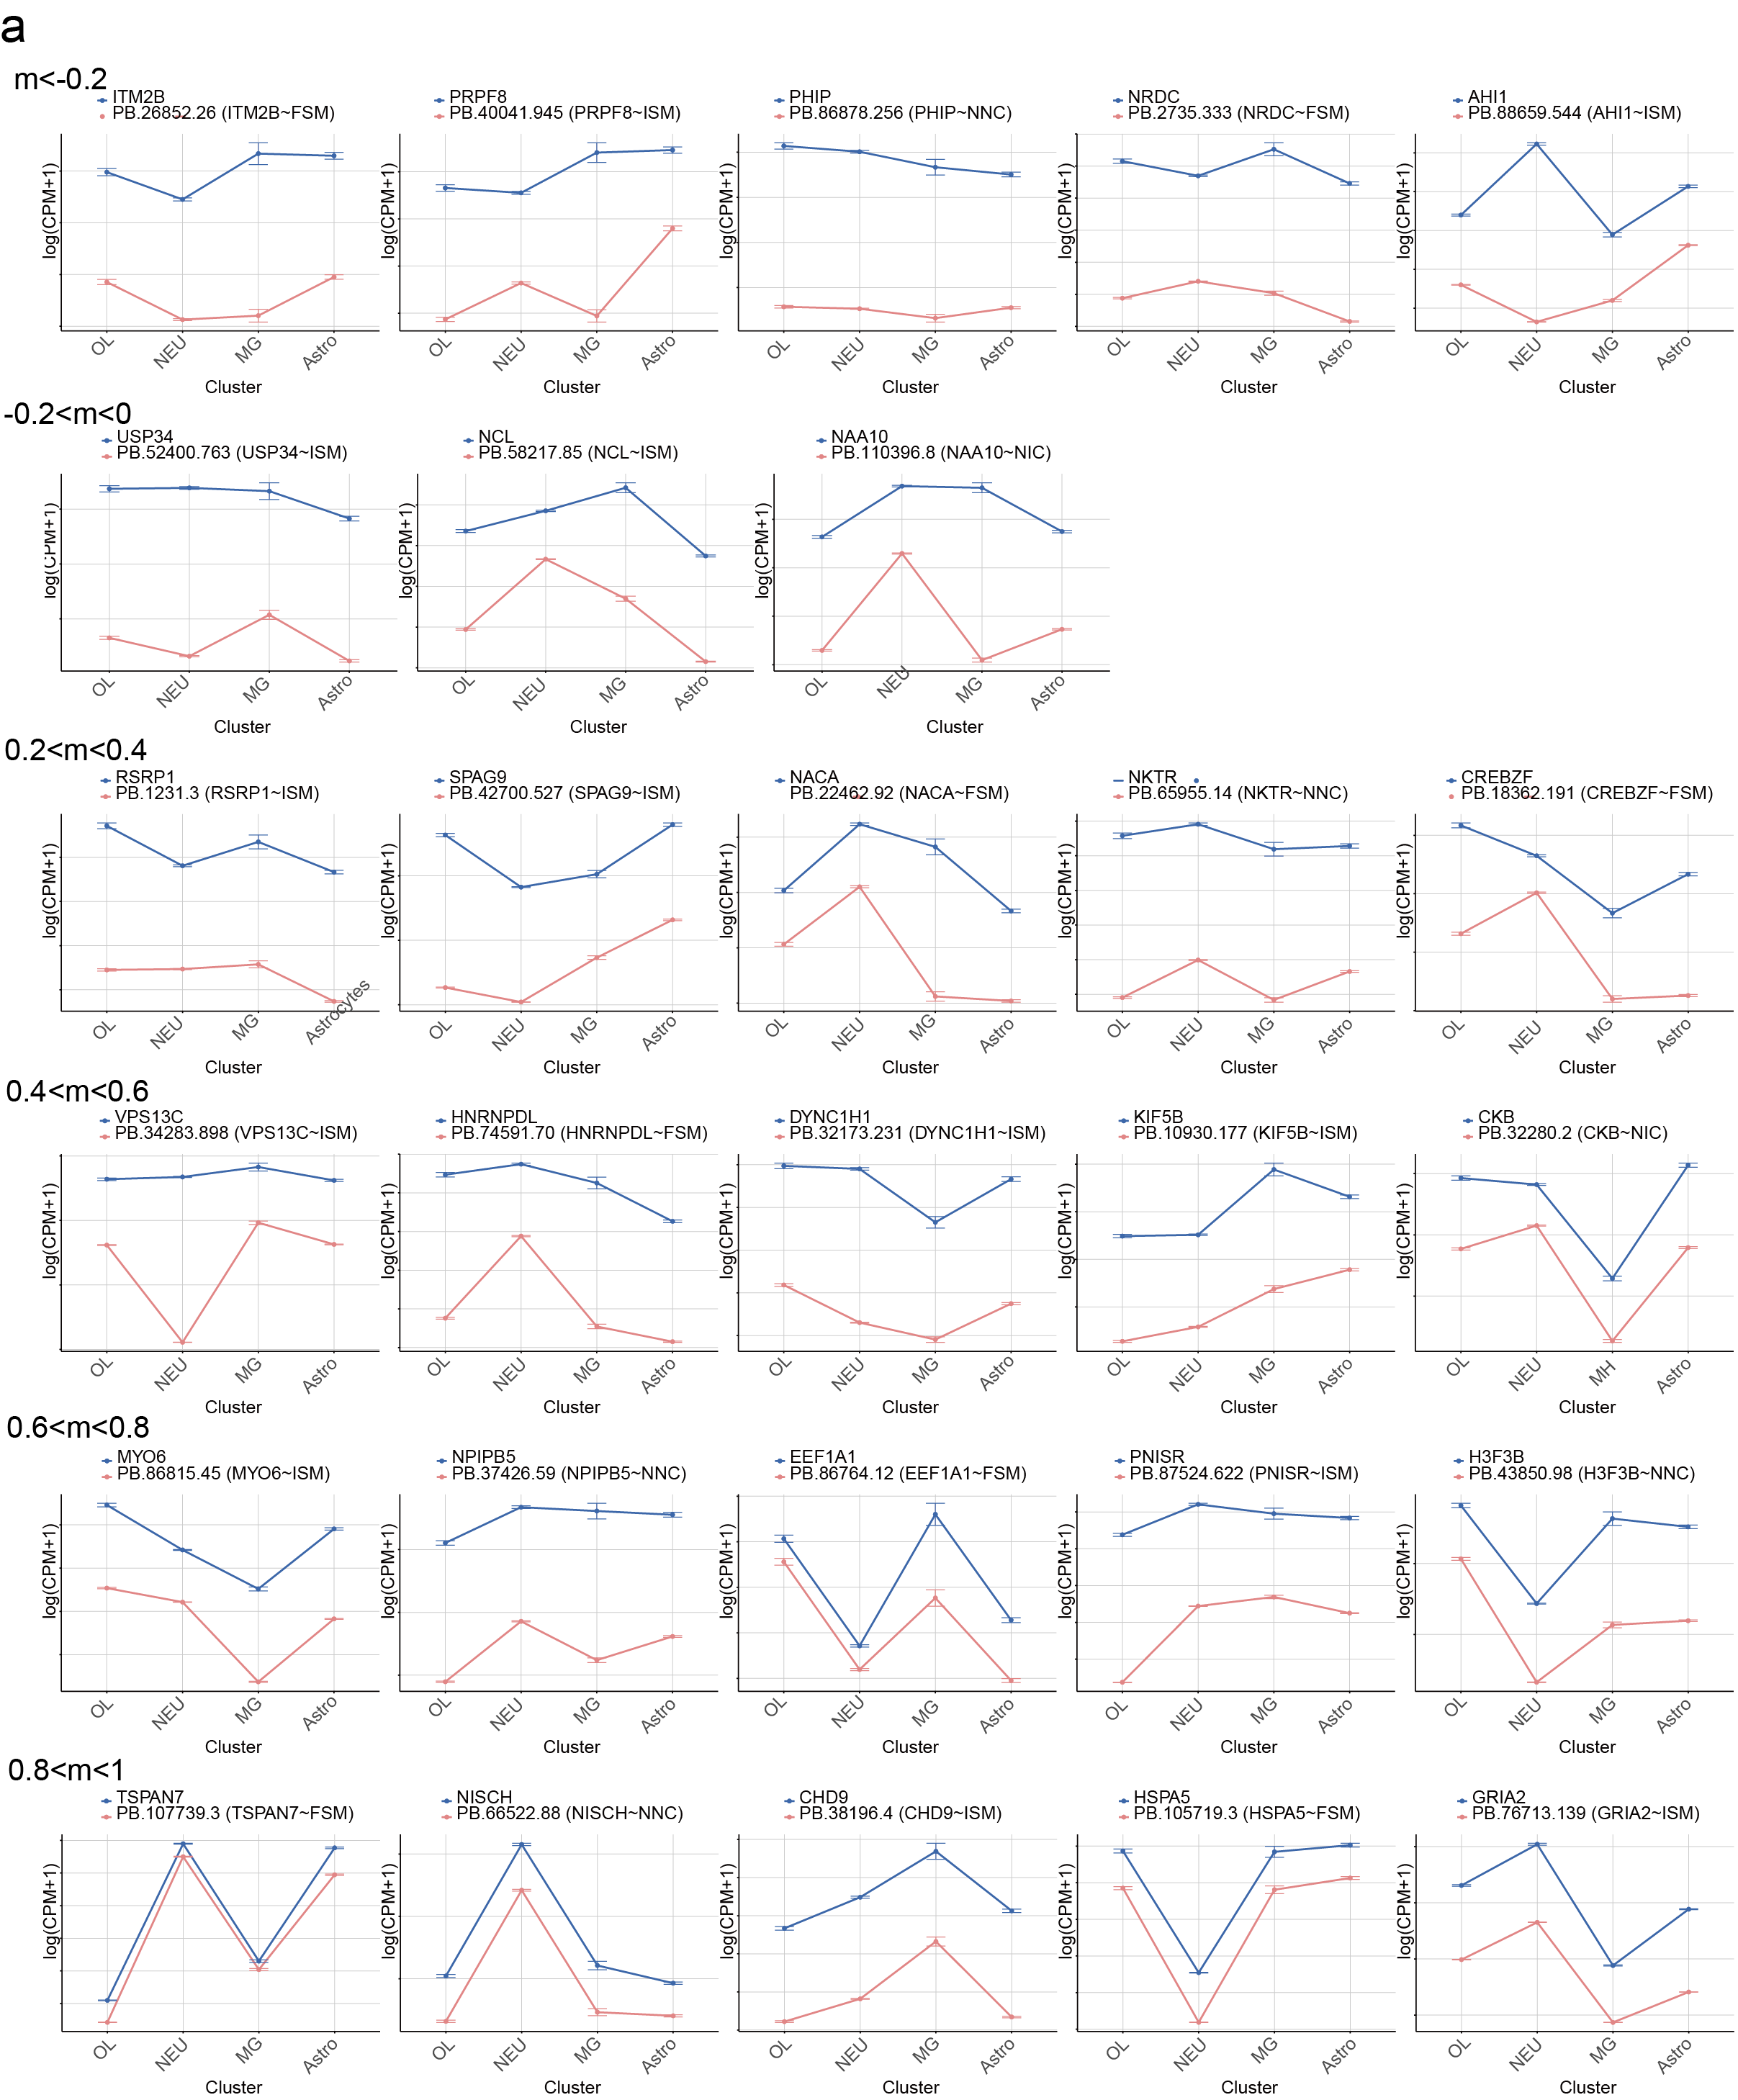
Supplementary Fig. S9: Expression patterns of isoforms in different adj R² value ranges in the long-read scRNA-seq data of human brain tissue slices when comparing more than two cell types. (a) Line plot comparing the expression patterns of candidate isoforms from multi-DEI in different adj R² value ranges with gene expression patterns.
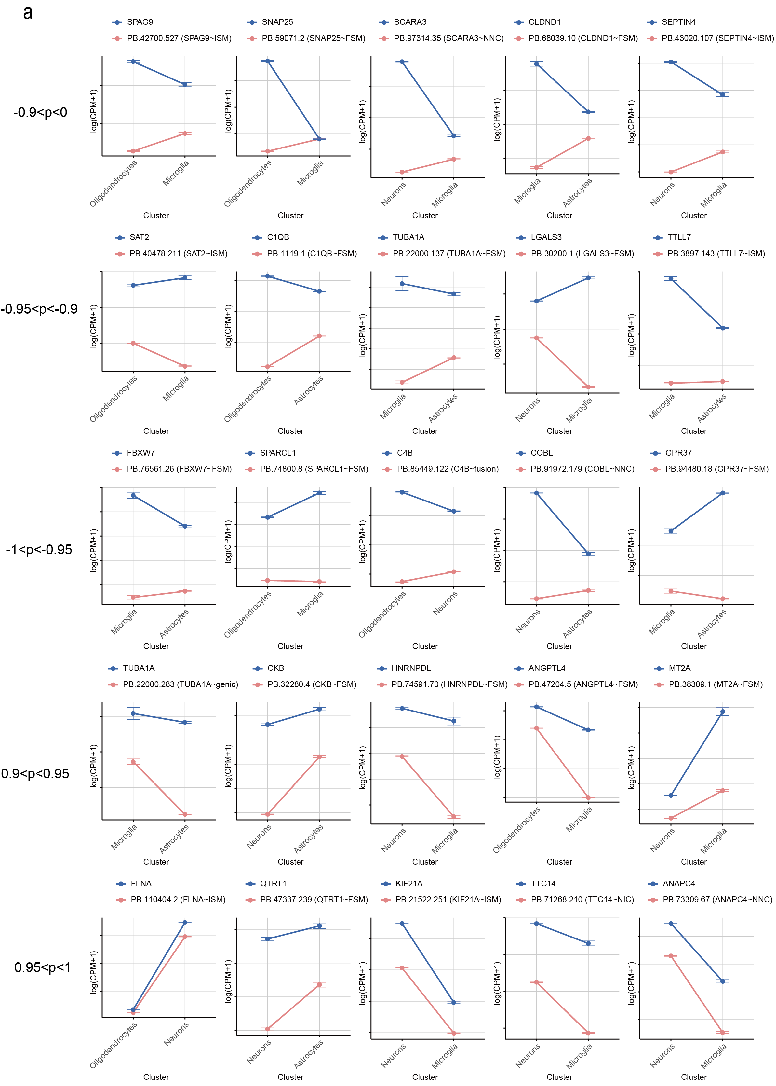

Supplementary Fig. S10: Expression patterns of isoforms in different value ranges of the product of pearson correlation coefficient and cosine similarity in the long-read scRNA-seq data of human frontal cortex when comparing two cell types. (a) Line plot comparing the expression patterns of candidate isoforms from pair-DEI in different value ranges of the product of pearson correlation coefficient and cosine similarity with gene expression patterns.

Table S1. Shared isoforms between switch isoform and DEI. Isoforms defined as both switch isoforms and pair-DEI isoforms, along with their parameters from the two tools.
isoform | condition | absdIF | Correlation × Cosine similarity
PB.56688.19(B2M~NNC) | LSC_BC | 0.224 | -0.986
PB.52245.172(DUSP1~FSM) | LSC_BC | 0.219 | -0.98
PB.13590.41(ENSMFAG00000007224~FSM) | LSC_BC | 0.251 | -0.984
PB.31671.18(ENO1~FSM) | CEC_BC | 0.129 | -0.989
PB.4526.1119(UBC~NNC) | LSC_BC | 0.165 | -0.992
PB.58971.48(CLU~NIC) | LSC_CEC | 0.176 | -0.989
PB.4695.1(CD9~NNC) | CC_BC | 0.15 | -0.982
PB.11125.216(RTN4~FSM) | LSC_BC | 0.272 | -0.923
PB.6884.41(NFE2L2~FSM) | LSC_BC | 0.198 | -0.994
PB.13590.41(ENSMFAG00000007224~FSM) | LSC_CEC | 0.138 | -0.996
PB.58971.40(CLU~NNC) | LSC_CC | 0.124 | -0.983
PB.4695.1(CD9~NNC) | CEC_BC | 0.142 | -0.984
PB.3524.1687(TUBA1A~NNC) | CC_BC | 0.156 | -0.954
PB.2312.524(ID1~FSM) | LSC_BC | 0.211 | -0.988
PB.56688.2(B2M~NNC) | CEC_BC | 0.105 | -0.989
PB.2386.2(RPN2~NNC) | CC_BC | 0.267 | -0.967
PB.3524.1636(TUBA1A~FSM) | CEC_CC | 0.103 | -0.998
PB.13590.41(ENSMFAG00000007224~FSM) | LSC_CC | 0.133 | -0.996
PB.57004.1(TPM1~NNC) | LSC_CEC | 0.369 | -0.932
PB.3485.93(SLC38A2~FSM) | CEC_BC | 0.198 | -0.987
PB.25095.948(ENSMFAG00000006874~NIC) | CEC_CC | 0.102 | -0.969
PB.16239.382(ZFAND5~NNC) | LSC_BC | 0.342 | -0.872
PB.46127.2(GLO1~NNC) | LSC_BC | 0.293 | -0.929
PB.17926.76(HSPA5~FSM) | LSC_BC | 0.309 | -0.885
PB.25095.948(ENSMFAG00000006874~NIC) | LSC_BC | 0.172 | -0.941
PB.49383.34(HOPX~NNC) | CEC_CC | 0.12 | -0.981

