Supplementary 1

[Table 1: Dietary intake information from 11 patients. Each provided information on three occasions pre-operatively and post-operatively via an online recall questionnaire]

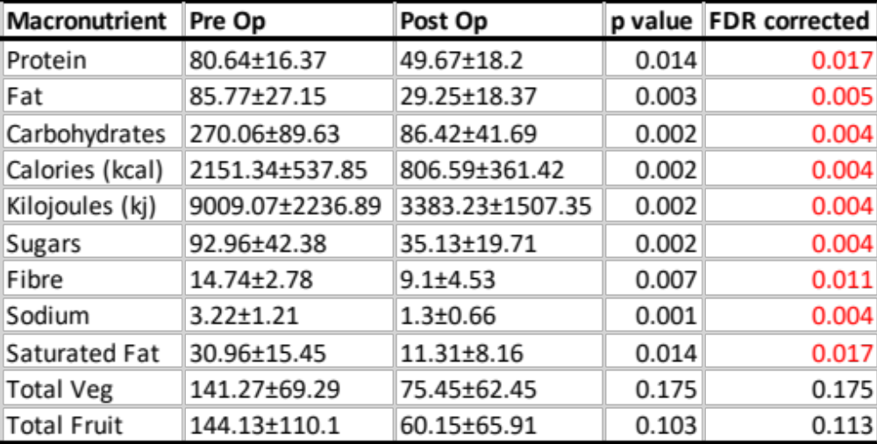

all listed data are means ± standard deviation (g/day) unless stated otherwise

[Figure 1: Boxplots comparing Pre and Post-Operative Dietary intake information]

