Supplementary Materials

Table of contents
Appendix 1. Measures 2
Table S1. Demographic information of the community sample 5
Table S2. Internal consistency reliability, Means, Standard Deviations and Intercorrelations of 23 specific symptoms 6
Table S3. Final Item factor loadings for seven symptom dimensions 8
Table S4. Latent profile analysis fit statistic 9
Table S5. Symptom dimensions and specific individual symptoms in different psychopathological profiles 10
Table S6. Demographic characteristics in different psychopathological profiles 12
Table S7. Global characteristics of symptom networks in different psychopathological profiles. 14
Table S8. Pairwise comparisons of the networks across psychopathological profiles. 15
Table S9. Simple regression analysis of profile membership as a predictor of RDoC negative valence constructs 16
Fig.S1. Scree plots with parallel analysis. 17
Fig.S2. The proportional likelihood single nodes belong to communities determined by the bootstrap EGA. 18
Fig.S3. Bootstrapped confidence intervals of estimated edge-weights for the four estimated networks. 19
Fig.S4. Average correlations between centrality indices of networks sampled with persons dropped and the original sample. 20
Fig.S5. Standardized centrality for the four profiles’ estimated networks. 21
Fig.S6. Associations between the symptom dimensions and RDoC negative valence construct. 22
Reference 23

Appendix 1. Measures
Obsessional-compulsive symptoms The Obsessive-Compulsive Inventory-Revised (OCI-R) measures OCD symptoms across 6 subscales including washing, checking, neutralising, obsessing, ordering and hoarding [1]. Participants rate the extent to which they have been bothered by specific thoughts or behaviors over the past month on a five-point Likert scale, ranging from "Not at all" (0) to "Extremely" (4).

Depressive symptoms The Patient Health Questionnaire-9 assesses the severity of depressive symptoms [2]. This instrument consists of 9 items and the respondent rates the frequency of depressive symptoms over the past two weeks on a four-point Likert scale, ranging from "Not at all" (0) to "Nearly every day" (3).

Anxiety symptoms The Generalized Anxiety Disorder 7-item scale (GAD-7) is a widely utilized self-report measure designed to assess the severity of anxiety symptoms [3]. This scale consists of 7 items and prompts participants to rate the frequency of anxiety symptoms experienced over the past two weeks on a four-point Likert scale, ranging from "Not at all" (0) to "Nearly every day" (3).

Perceived stress The Perceived Stress Scale (PSS) comprises 10 items designed to evaluate the degree to which individuals perceive their lives as unpredictable, uncontrollable, and overloaded [4]. Participants rate each item on a five-point Likert scale, ranging from "Never" (0) to "Very Often" (4).

Eating disorders symptoms The Eating Attitudes Test 26 (EAT-26) comprises 26 items aiming to assess attitudes and behaviors related to eating disorders [5]. The EAT-26 consists of 3 subscales: dieting (13 items), bulimia and food preoccupation (6 items), and oral control (7 items). Participants rate each item on a six-point Likert scale, ranging from "never" (1) to "always" (6).

Alcohol consumption and related problems The Alcohol Use Disorders Identification Test (AUDIT) assess the severity of alcohol consumption and related problems [6]. The AUDIT comprises 10 items and consists of 3 subscales: alcohol consumption (3 items), alcohol-related problems (2 items) and alcohol dependence symptoms (4 items). Participants provide responses on a five-point Likert scale.

Nicotine dependence symptoms The Fagerström Test for Nicotine Dependence (FTND) assess the severity of nicotine dependence [7]. Scoring criteria of the scale varies depending on the item. 2 items are based on a 4-point scale, while the remaining items are rated on a 2-point scale (yes/no).

Psychotic-like experiences The Community Assessment of Psychic Experiences (CAPE) prompts respondents to report on the frequency of specific psychotic-like experiences [8]. The CAPE comprises 8 items and consists of 2 subscales: Delusion (6 items) and Hallucinations (2 items). Participants response on a four-point Likert scale ranging from "Never" (0) to "Almost Always" (3).

Hostility-related symptoms The Hostility subscale of Symptom Checklist (SCL90-HOS) consists of 6 items to assess the severity of hostile tendencies in individuals [9]. The SCL90-HOS is based on a 5-point Likert scale, ranging from "Never" (1) to “Severe” (5).

Outward irritability symptoms The outward Irritability subscale of Irritability, Depression and Anxiety Scale (IDA) assess the outward expressions of irritability [10]. The SCL90-HOS comprises 4 items based on a 4-point Likert scale.

Insomnia symptoms The Insomnia Severity Index (ISI) comprise 7 items to assess the severity of insomnia symptoms and their impact on individuals' daily functioning [11].

Somatic symptom The Somatic Symptom Scale (SSS) is designed to assess the severity of somatic symptoms such as gastrointestinal problems, back pain and headache [12]. The SSS comprises 8 items based on a 5-point Likert scale ranging from "0" (not at all bothered) to "4" (extremely bothered).

Problematic smartphone use The Mobile Phone Addiction Index (MPAI) consists of 17 items to assess the severity of problematic mobile phone use such as excessive use and withdrawal symptoms when unable to use the phone [13]. The MPAI is based on 5-point Likert scale ranging from "Never" (1) to " Always" (5).

Childhood trauma Childhood Trauma Questionnaire-Short Form (CTQ-SF) comprises 28 items to assess maltreatment or adverse experience in childhood [14]. Based on 5-point Likert scale, CTQ-SF consists of five subscales: emotional abuse, physical abuse, sexual abuse, emotional neglect, and physical neglect.

Behavioral inhibition system The Behavioral Inhibition System (BIS) subscale of the Behavioral Activation and Behavioral Inhibition Scales (BAS-BIS) comprises five items aimed at evaluating individuals' responses to punishment, non-reward, and novel stimuli [15]. Behavioral inhibition system diminishes behavioral responses aimed at avoiding negative consequences.

Intolerance of uncertainty The Intolerance of Uncertainty Scale (IUS) comprises a 12-item self-report questionnaire designed to evaluate individuals' propensity to perceive uncertainty as distressing, utilizing a 5-point Likert scale [16]. IUS consists of 2 subscales: anticipatory anxiety (7 items) and inhibitory anxiety (5 items).

Table S1. Demographic information of the community sample.
Variable | Responses | N(%) / Mean(SD)
Gender | Male | 2152 (52.46%)
 | Female | 1950 (47.54%)
Age | / | 27.08 (7.78)
Educational level | Year≤9 | 76 (1.85%)
 | 9＜Year≤12 | 282 (6.87%)
 | 12＜Year≤16 | 3003 (73.21%)
 | Year＞16 | 741(24.67%)
Marital status | Unmarried | 2974 (72.50%)
 | Married | 1012 (24.67%)
 | divorced | 94 (2.29%)
 | Remarried | 20 (0.49%)
 | Widowed | 2 (0.05%)
Psychiatric diagnosis status | Yes | 820 (19.99%)
(Self-report) | No | 3282 (80.01%)
Whether an only child | Yes | 1891 (46.10%)
 | No | 2211 (53.90%)
BMI | Lean: BMI <18.5 | 563 (13.73%)
 | Normal: 18.5≤BMI<24 | 2418 (58.95%)
 | Overweight: 24≤BMI<28 | 756 (18.43%)
 | Obesity: BMI≥28 | 353 (8.61%)
 | Missing Value | 12 (0.29%)

Table S2. Internal consistency reliability, Means, Standard Deviations and Intercorrelations of 23 specific symptoms.
 | a | M | SD | 1 | 2 | 3 | 4 | 5 | 6 | 7 | 8 | 9 | 10 | 11 | 12 | 13 | 14 | 15 | 16 | 17 | 18 | 19 | 20 | 21 | 22 | 23
1.wash | .793 | 3.073 | 2.886 | 1.000
2.check | .834 | 3.452 | 2.989 | 0.657 | 1.000
3.neu | .745 | 2.996 | 2.755 | 0.664 | 0.717 | 1.000
4.obs | .865 | 3.698 | 3.069 | 0.612 | 0.644 | 0.641 | 1.000
5.hoa | .755 | 3.832 | 2.764 | 0.540 | 0.605 | 0.569 | 0.573 | 1.000
6.ord | .824 | 3.827 | 2.979 | 0.675 | 0.683 | 0.735 | 0.595 | 0.562 | 1.000
7.PHQ | .898 | 8.144 | 6.022 | 0.413 | 0.426 | 0.410 | 0.670 | 0.408 | 0.391 | 1.000
8.GAD | .920 | 6.527 | 5.170 | 0.409 | 0.444 | 0.424 | 0.678 | 0.405 | 0.397 | 0.825 | 1.000
9.diet | .869 | 5.282 | 6.692 | 0.276 | 0.280 | 0.311 | 0.290 | 0.241 | 0.300 | 0.246 | 0.252 | 1.000
10.buli | .755 | 1.683 | 2.820 | 0.395 | 0.370 | 0.403 | 0.438 | 0.348 | 0.365 | 0.373 | 0.341 | 0.607 | 1.000
11.oral | .638 | 2.833 | 3.244 | 0.352 | 0.355 | 0.379 | 0.371 | 0.321 | 0.361 | 0.307 | 0.283 | 0.447 | 0.457 | 1.000
12.PSS | .874 | 18.172 | 6.918 | 0.392 | 0.415 | 0.381 | 0.668 | 0.387 | 0.354 | 0.714 | 0.709 | 0.206 | 0.338 | 0.253 | 1.000
13.consu | .866 | 1.472 | 2.468 | 0.177 | 0.213 | 0.229 | 0.204 | 0.166 | 0.186 | 0.184 | 0.175 | 0.125 | 0.169 | 0.137 | 0.136 | 1.000
14.depe | .863 | 0.608 | 1.661 | 0.306 | 0.325 | 0.350 | 0.318 | 0.272 | 0.300 | 0.289 | 0.285 | 0.221 | 0.299 | 0.269 | 0.238 | 0.684 | 1.000
15.prob | .802 | 1.000 | 2.499 | 0.274 | 0.301 | 0.310 | 0.287 | 0.248 | 0.271 | 0.270 | 0.269 | 0.228 | 0.283 | 0.250 | 0.231 | 0.701 | 0.804 | 1.000
16.HOS | .791 | 11.954 | 5.280 | 0.444 | 0.460 | 0.463 | 0.640 | 0.431 | 0.443 | 0.634 | 0.645 | 0.320 | 0.443 | 0.349 | 0.639 | 0.213 | 0.351 | 0.350 | 1.000
17.OIR | .904 | 7.449 | 2.614 | 0.411 | 0.416 | 0.415 | 0.576 | 0.366 | 0.396 | 0.579 | 0.579 | 0.256 | 0.377 | 0.288 | 0.616 | 0.189 | 0.327 | 0.314 | 0.833 | 1.000
18.delu | .878 | 9.072 | 3.749 | 0.499 | 0.532 | 0.543 | 0.668 | 0.461 | 0.484 | 0.610 | 0.617 | 0.255 | 0.411 | 0.353 | 0.556 | 0.273 | 0.418 | 0.392 | 0.602 | 0.559 | 1.000
19.hal | .740 | 2.473 | 1.095 | 0.419 | 0.418 | 0.442 | 0.436 | 0.352 | 0.390 | 0.399 | 0.399 | 0.229 | 0.374 | 0.309 | 0.315 | 0.270 | 0.427 | 0.389 | 0.444 | 0.405 | 0.653 | 1.000
20.SSS | .848 | 8.225 | 5.636 | 0.393 | 0.391 | 0.387 | 0.569 | 0.387 | 0.368 | 0.709 | 0.646 | 0.249 | 0.370 | 0.313 | 0.551 | 0.202 | 0.310 | 0.311 | 0.569 | 0.516 | 0.556 | 0.411 | 1.000
21.FTND | .962 | 2.286 | 4.639 | 0.158 | 0.207 | 0.223 | 0.226 | 0.130 | 0.174 | 0.232 | 0.213 | 0.069 | 0.151 | 0.157 | 0.173 | 0.440 | 0.432 | 0.433 | 0.260 | 0.234 | 0.296 | 0.290 | 0.206 | 1.000
22.ISI | .924 | 15.810 | 6.495 | 0.390 | 0.417 | 0.402 | 0.560 | 0.355 | 0.388 | 0.696 | 0.596 | 0.223 | 0.312 | 0.323 | 0.517 | 0.241 | 0.335 | 0.337 | 0.501 | 0.464 | 0.538 | 0.378 | 0.716 | 0.257 | 1.000
23.PSU | .875 | 9.661 | 4.631 | 0.424 | 0.452 | 0.450 | 0.522 | 0.444 | 0.413 | 0.460 | 0.448 | 0.229 | 0.339 | 0.291 | 0.488 | 0.170 | 0.266 | 0.264 | 0.455 | 0.419 | 0.463 | 0.339 | 0.394 | 0.172 | 0.396 | 1.000
Note. a= Cronbach’s alpha coefficient; WASH=compulsive washing; CHECK= compulsive checking; NEU= compulsive neutralizing; OBS= obsessive beliefs; HOA= hoarding; ORD= compulsive ordering; PHQ= depressive symptoms; GAD= anxiety symptoms ; DIET= dieting; BULI= bulimia and food preoccupation; ORAL= oral control; PSS= perceived stress; CONSU= alcohol consumption; DEPE= alcohol dependence symptoms; PROB =alcohol-related problems; HOS= hostility; OIR= outward irritability; DELU= delusion; HAL= hallucinations; SSS= somatic symptom; FTND= nicotine dependence; ISI= insomnia; PSU= problematic smartphone use.

Table S3. Final Item factor loadings for seven symptom dimensions.
 | Obsessive-Compulsive | Emotional Distress | Substance -Related | Eating-Related | Aggressive | Psychotic | Somatoform
WASH | 0.784*
CHECK | 0.827*
NEU | 0.839*
OBS | 0.805*
HOA | 0.703*
ORD | 0.806*
PSU | 0.580*
PHQ |  | 0.922*
GAD |  | 0.890*
PSS |  | 0.789*
CONSU |  |  | 0.770*
DEPE |  |  | 0.893*
PROB |  |  | 0.901*
FTND |  |  | 0.500*
DIET |  |  |  | 0.711*
BULI |  |  |  | 0.823*
ORAL |  |  |  | 0.606*
HOS |  |  |  |  | 0.958*
OIR |  |  |  |  | 0.869*
DEL |  |  |  |  |  | 0.928*
HAL |  |  |  |  |  | 0.703*
SSS |  |  |  |  |  |  | 0.863*
ISI |  |  |  |  |  |  | 0.830*
Note. *P<0.05. Specific symptoms were loaded on only one dimension and there was no cross-loading. The factor analysis results indicated good model fit (CFI=0.938, TLI=0.925, SRMR= 0.051, RMSEA=0.068, 90% confidence interval of RMSEA = [0.066, 0.070].
Abbreviations: WASH=compulsive washing; CHECK= compulsive checking; NEU= compulsive neutralizing; OBS= obsessive beliefs; HOA= hoarding; ORD= compulsive ordering; PHQ= depressive symptoms; GAD= anxiety symptoms ; DIET= dieting; BULI= bulimia and food preoccupation; ORAL= oral control; PSS= perceived stress; CONSU= alcohol consumption; DEPE= alcohol dependence symptoms; PROB =alcohol-related problems; HOS= hostility; OIR= outward irritability; DEL= delusion; HAL= hallucinations; SSS= somatic symptom; FTND= nicotine dependence; ISI= insomnia; PSU= problematic smartphone use.

Table S4. Latent profile analysis fit statistics.
Model | Log  likelihood | AIC | BIC | SABIC | Entropy | Smallest  class % | aLMR  p-value | aLMR  meaning | BLRT  p-value | BLRT  meaning
1 | -40743.401 | 81514.802 | 81603.271 | 81558.785
2 | -29540.490 | 59138.979 | 59322.237 | 59230.087 | 0.935 | 0.48635 | 0.0000 | 2>1 | 0.0000 | 2>1
3 | -25943.281 | 51974.562 | 52252.608 | 52112.795 | 0.913 | 0.25963 | 0.0000 | 3>2 | 0.0000 | 3>2
4 | -23541.230 | 47200.460 | 47573.295 | 47385.819 | 0.899 | 0.18698 | 0.0000 | 4>3 | 0.0000 | 4>3
5 | -22166.457 | 44480.914 | 44948.537 | 44713.397 | 0.895 | 0.15553 | 0.0002 | 5>4 | 0.0000 | 5>4
6 | -20991.878 | 42161.757 | 42724.168 | 42441.365 | 0.898 | 0.11263 | 0.0003 | 6>5 | 0.0000 | 6>5
7 | -20358.061 | 40924.123 | 41581.323 | 41250.856 | 0.894 | 0.09873 | 0.4103 | 6>7 | 0.0000 | 7>6
Abbreviations: AIC= Akaïke information criterion; BIC= Bayesian information criterion; SABIC= Sample-size adjusted BIC; aLMR= the adjusted Lo, Mendell, and Rubin’s Likelihood Ratio Test; BLRT= Bootstrap likelihood ratio test.

Table S5. Symptom dimensions and specific individual symptoms in different psychopathological profiles.
 | SUG (G1)  (n=767) | MSG (G2)  (n=1216) | DSG (G3)  (n=1156) | SSG (G4)  (n=963) | F-value | P-value | Difference between profiles
OC | -0.53 (0.57) | 0.10 (0.65) | -0.76 (0.48) | 1.20(0.91) | 1429.622 | .000 | G4>G2>G1>G3
WASH | 1.80 (1.93) | 3.34 (2.66) | 1.57 (1.75) | 5.55 (3.11) | 491.894 | .000 | G4>G2>G1>G3
CHECK | 2.42 (2.11) | 3.59 (2.56) | 1.65(1.78) | 6.27(3.11) | 607.597 | .000 | G4>G2>G1>G3
NEU | 1.97 (1.90) | 3.05 (2.32) | 1.40 (1.58) | 5.65 (2.95) | 587.566 | .000 | G4>G2>G1>G3
OBS | 1.98 (1.78) | 4.27 (2.31) | 1.40 (1.51) | 7.10 (2.73) | 1340.592 | .000 | G4>G2>G1>G3
HOA | 2.77 (2.11) | 4.11 (2.51) | 2.37 (1.92) | 6.08 (2.83) | 454.541 | .000 | G4>G2>G1>G3
ORD | 2.76 (2.32) | 3.96 (2.57) | 2.20 (2.05) | 6.47 (3.00) | 505.305 | .000 | G4>G2>G1>G3
PSU | 7.89 (4.37) | 10.44 (3.82) | 6.97 (4.21) | 13.31 (3.35) | 575.241 | .000 | G4>G2>G1>G3
Distress | -0.71 (0.45) | 0.32 (0.61) | -0.84 (0.42) | 1.17 (0.82) | 2282.515 | .000 | G4>G2>G1>G3
PHQ | 4.22 (3.15) | 10.01 (4.49) | 3.51 (2.93) | 14.46 (5.34) | 1482.895 | .000 | G4>G2>G1>G3
GAD | 3.20 (2.56) | 8.05 (4.15) | 2.69 (2.51) | 11.86 (4.64) | 1359.373 | .000 | G4>G2>G1>G3
PSS | 13.82 (4.91) | 20.60 (5.35) | 13.28 (5.06) | 24.44 (5.21) | 1092.324 | .000 | G4>G2>G1, G4>G2>G3
Substance | 0.11 (0.60) | -0.43 (0.06) | -0.51 (0.02) | 1.07 (1.51) | 1105.746 | .000 | G4>G1>G2>G3
CONSU | 3.17 (2.39) | 0.15 (0.55) | 0.01 (0.11) | 3.53 (3.12) | 880.223 | .000 | G4>G1>G2>G3
DEPE | 0.51 (1.03) | 0.00 (0.00) | 0.00 (0.00) | 2.18 (2.74) | / | / | /
PROB | 1.13 (1.87) | 0.00 (0.00) | 0.00 (0.00) | 3.36 (3.97) | / | / | /
FTND | 3.82 (5.10) | 1.07 (3.24) | 0.01 (0.21) | 5.34 (6.19) | 422.660 | .000 | G4>G1>G2>G3
Eating | -0.46 (0.45) | 0.01 (0.69) | -0.59 (0.35) | 1.06 (1.28) | 683.584 | .000 | G4>G2>G1>G3
DIET | 3.38 (4.69) | 5.62 (6.41) | 2.86 (4.24) | 9.28 (8.60) | 178.100 | .000 | G4>G2>G1, G4>G2>G3
BULI | 0.60 (1.23) | 1.64 (2.33) | 0.43 (0.94) | 4.10 (4.02) | 330.180 | .000 | G4>G2>G1>G3
ORAL | 1.93 (2.31) | 2.80 (2.88) | 1.61 (2.16) | 5.06 (4.14) | 200.183 | .000 | G4>G2>G1>G3
Somatoform | -0.61 (0.51) | 0.23 (0.60) | -0.83 (0.43) | 1.19 (0.88) | 1920.379 | .000 | G4>G2>G1>G3
SSS | 5.26 (3.41) | 9.45 (4.37) | 4.35 (2.99) | 13.70 (5.86) | 900.857 | .000 | G4>G2>G1>G3
ISI | 12.74 (4.29) | 17.06 (5.29) | 11.33 (3.78) | 22.06 (6.33) | 865.381 | .000 | G4>G2>G1>G3
Aggressive | -0.63 (0.43) | 0.17 (0.69) | -0.74 (0.36) | 1.18 (0.98) | 1513.557 | .000 | G4>G2>G1>G3
HOS | 8.78 (2.33) | 12.74 (4.02) | 8.33 (1.99) | 17.84 (5.48) | 1160.511 | .000 | G4>G2>G1>G3
OIR | 5.95 (1.53) | 7.92 (2.18) | 5.77 (1.33) | 10.06 (2.62) | 906.908 | .000 | G4>G2>G1>G3
Psychotic | -0.52 (0.38) | 0.00 (0.53) | -0.77 (0.17) | 1.33 (1.03) | 1987.708 | .000 | G4>G2>G1>G3
DELU | 7.31 (1.67) | 9.07 (2.52) | 6.44 (0.74) | 13.64 (4.16) | 1310.476 | .000 | G4>G2>G1>G3
HAL | 2.12 (0.43) | 2.30 (0.74) | 2.03 (0.18) | 3.50 (1.68) | 298.165 | .000 | G4>G2>G1>G3
Abbreviations: OC= obsessive-compulsive dimension; WASH=compulsive washing; CHECK= compulsive checking; NEU= compulsive neutralizing; OBS= obsessive beliefs; HOA= hoarding; ORD= compulsive ordering; PHQ= depressive symptoms; GAD= anxiety symptoms ; DIET= dieting; BULI= bulimia and food preoccupation; ORAL= oral control; PSS= perceived stress; CONSU= alcohol consumption; DEPE= alcohol dependence symptoms; PROB =alcohol-related problems; HOS= hostility; OIR= outward irritability; DEL= delusion; HAL= hallucinations; SSS= somatic symptom; FTND= nicotine dependence; ISI= insomnia; PSU= problematic smartphone use. SUG (G1) = Substance use group; MSG (G2) = Moderate symptomatology unrelated to substance abuse group; DSG (G3) = Disengaged from symptomatology group; SSG (G4) = Severe symptomatology group.

Table S6. Demographic characteristics in different psychopathological profiles.
Demographic characteristics | Total  (N=4102) | SUG (G1)  (n=767) | MSG (G2)  (n=1216) | DSG (G3)  (n=1156) | SSG (G4)  (n=963) | Difference between profiles
Age (years) | 27.08(7.78) | 28.04(8.22) | 26.07(6.87) | 28.27(9.10) | 26.20(6.47) | F=20.543  P= .000 | 1>2,1>4, 3>2,3>4
Gender  Male  Female | 2152  1950 | 558(72.8%)  209(27.2%) | 516(42.4%)  700(57.6%) | 450(38.9%)  706(61.1%) | 628(65.2%)  335(34.8%) | χ²=323.320  P= .000 | 1>4>2, 1>4>3  2>4>1, 3>4>1
BMI  BMI <18.5  18.5≤BMI<24  24≤BMI<28  BMI≥28  Missing values | 563  2418  756  353  12 | 89(11.6%)  435(56.7%)  178(23.2%)  59(7.7%)  6(0.8%) | 191(15.7%)  695(57.2%)  228(18.8%)  102(8.4%)  0(0.0%) | 145(12.5%)  750(64.9%)  193(16.7%)  66(5.7%)  2(0.2%) | 138(14.3%)  538(55.9%)  157(16.3%)  126(13.1%)  4(0.4%) | χ²=76.437  P= .000 | /  3>1, 3>2, 3>4  1>3, 1>4  4>1, 4>2, 4>3  1>2
Marriage  Unmarried  Married  Divorced  Remarried  Widowed | 2974  1012  94  20  2 | 523(68.2%)  222(28.9%)  17(2.2%)  5(0.7%)  0(0.0%) | 975(80.2%)  215(17.7%)  24(2.0%)  1(0.1%)  1(0.1%) | 794(68.7%)  314(27.2%)  35(3.0%)  12(1.0%)  1(0.1%) | 682(70.8%)  261(27.1%)  18(1.9%)  2(0.2%)  0(0.0%) | χ²=68.288  P= .000 | 2>1, 2>3, 2>4  1>2, 3>2, 4>2  /  3>2  /
Education  Year≤9  9＜Year≤12  12＜Year≤16  Year＞16 | 76  282  3003  741 | 12(1.6%)  40(5.2%)  580(75.6%)  135(17.6%) | 22(1.8%)  96(7.9%)  851(70.0%)  247(20.3%) | 11(1.0%)  45(3.9%)  819(70.8%)  281(24.3%) | 31(3.2%)  101(10.5%)  753(78.2%)  78(8.1%) | χ²=141.140  P= .000 | 4>3  4>1, 4>3, 2>3  4>2, 4>3,1>2  3>1>4, 3>2>4
Only Child  Yes  No | 1891  2211 | 376(49.0%)  391(51.0%) | 551(45.3%)  665(54.7%) | 518(44.8%)  638(55.2%) | 446(46.3%)  517(53.70%) | χ²=3.732  P= .292 | /  /
Diagnosis  Yes  No | 820  3282 | 85(11.1%)  682(88.9%) | 237(19.5%)  979(80.5%) | 92(8.0%)  1064(92.0%) | 406(42.2%)  557(57.8%) | χ²=438.801  P= .000 | 4>2>1, 4>2>3  1>2>4, 3>2>4
Note. The age row presents the mean and standard deviation for each profile, while other categorical variables display the frequency and proportion within each profile. The final column presents the results of variance tests and post hoc comparisons among the profiles.
Abbreviations: SUG (G1) = Substance Use Group; MSG (G2) = Moderate Symptomatology Group; DSG (G3) = Disengaged from Symptomatology Group; SSG (G4) = Severe Symptomatology Group

Table S7. Global characteristics of symptom networks in different psychopathological profiles.
Network Characteristics | SUG | MSG | DSG | SSG
Global Network Strength | 6.92 | 6.54 | 5.92 | 9.18
Number of non-zero edges (% possible) | 77 (36.7%) | 70 (33.3%) | 61 (29%) | 105 (50%)
Number of zero edges (% possible) | 133 (63.3%) | 140 (66.7%) | 149 (71%) | 105 (50%)
Number of positive edges (% total) | 76 (98.7%) | 50 (71.4%) | 59 (96.7%) | 94 (89.5%)
Number of negative edges (% total) | 1 (1.3%) | 20 (28.6%) | 2 (3.3%) | 11 (10.5%)
Top two nodes by strength centrality | OBS、PHQ | PSS、NEU | OBS、PHQ | PHQ、HOS
Top two nodes by expected influence centrality | OBS、PHQ | PHQ、OBS | OBS、PHQ | HOS、CHECK
Top two nodes by bridge strength centrality | PHQ、PSS | PSS、OBS | PHQ、PSS | OBS、DEL
Top two nodes by bridge expected influence centrality | PHQ、PSS | OBS、PSS | PHQ、PSS | OBS、DEL
Abbreviations: CHECK= compulsive checking; NEU= compulsive neutralizing; OBS= obsessive beliefs; PHQ= depressive symptoms; PSS= perceived stress; HOS= hostility; DEL= delusion. SUG = Substance Use Group; MSG = Moderate Symptomatology Group; DSG = Disengaged from Symptomatology Group; SSG = Severe Symptomatology Group.

Table S8. Pairwise comparisons of the networks across the four psychopathological profiles.
Symptom network characteristic | G1vs.G2 | G1vs.G3 | G1vs.G4 | G2vs.G3 | G2vs.G4 | G3vs.G4
NCT result
omnibus tests of network structure invariance (p value) | 0.331 | 0.005 | 0 | 0 | 0 | 0
global strength invariance test (p value) | 0.468 | 0.358 | 0 | 0.385 | 0 | 0
number of significantly different edges with Holm-Bonferroni correction | 3 | 0 | 8 | 4 | 10 | 11
Edge comparisons across networks
spearman correlations among all edges | 0.71 | 0.71 | 0.56 | 0.75 | 0.7 | 0.6
Jaccard Index | 0.47 | 0.53 | 0.48 | 0.52 | 0.42 | 0.42
Centrality comparisons across networks
number (%) of nodes matching rank-order (strength centrality) | 4 (19%) | 6(28.6%) | 2 (9.5%) | 4 (19%) | 3(14.3%) | 4 (19%)
number (%) of nodes matching rank-order (expected influence centrality) | 4 (19%) | 8(38.1%) | 3(14.3%) | 4 (19%) | 5(23.8%) | 3(14.3%)
number (%) of nodes matching rank-order (bridged strength centrality) | 6(28.6%) | 8(38.1%) | 3(14.3%) | 2 (9.5%) | 0 (0%) | 4 (19%)
number (%) of nodes matching rank-order (bridged expected influence centrality) | 3(14.3%) | 5(23.8%) | 1 (4.8%) | 5(23.8%) | 4 (19%) | 2 (9.5%)
Note. Jaccard Index calculates the ratio of shared edges to the total number of edges in both networks.
Abbreviations: G1 = Substance Use Group; G2 = Moderate Symptomatology Group; G3 = Disengaged from Symptomatology Group; G4 = Severe Symptomatology Group.

Table S9. Simple regression analysis of profile membership as a predictor of RDoC negative valence constructs.
Predictor variable | CTQS |  | IUS |  | BIS
Memberships (relative to DSG) | β | SD | β | SD | β | SD
SUG | -0.016 | 0.562 | 0.032* | 0.352 | -0.036* | 0.132
MSG | 0.236** | 0.496 | 0.375** | 0.311 | 0.324** | 0.116
SSG | 0.485** | 0.527 | 0.560** | 0.330 | 0.356** | 0.123
R² | 0.216 |  | 0.287 |  | 0.164
Note. *P<0.05, **P<0.001.
Abbreviations: CTQS=Childhood trauma; IUS=Intolerance of uncertainty; BIS=Behavioral inhibition. SUG = Substance Use Group; MSG = Moderate Symptomatology Group; DSG = Disengaged from Symptomatology Group; SSG = Severe Symptomatology Group.

Fig.S1. Scree plots with parallel analysis.
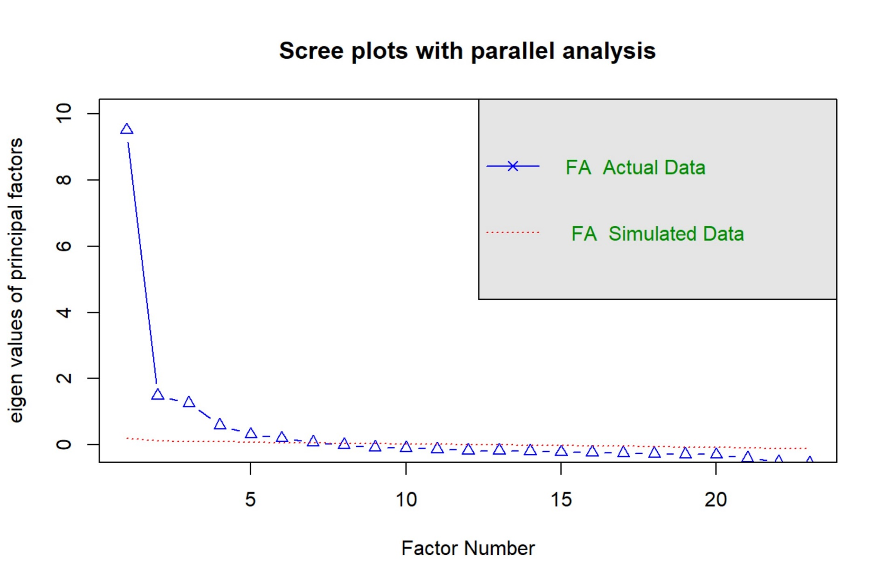
Note. The blue line represents the eigenvalues of the factor model for the real data and the red line represents the eigenvalues of the factor model for the simulated data.

Fig.S2. The proportional likelihood single nodes belong to communities determined by the bootstrap EGA.
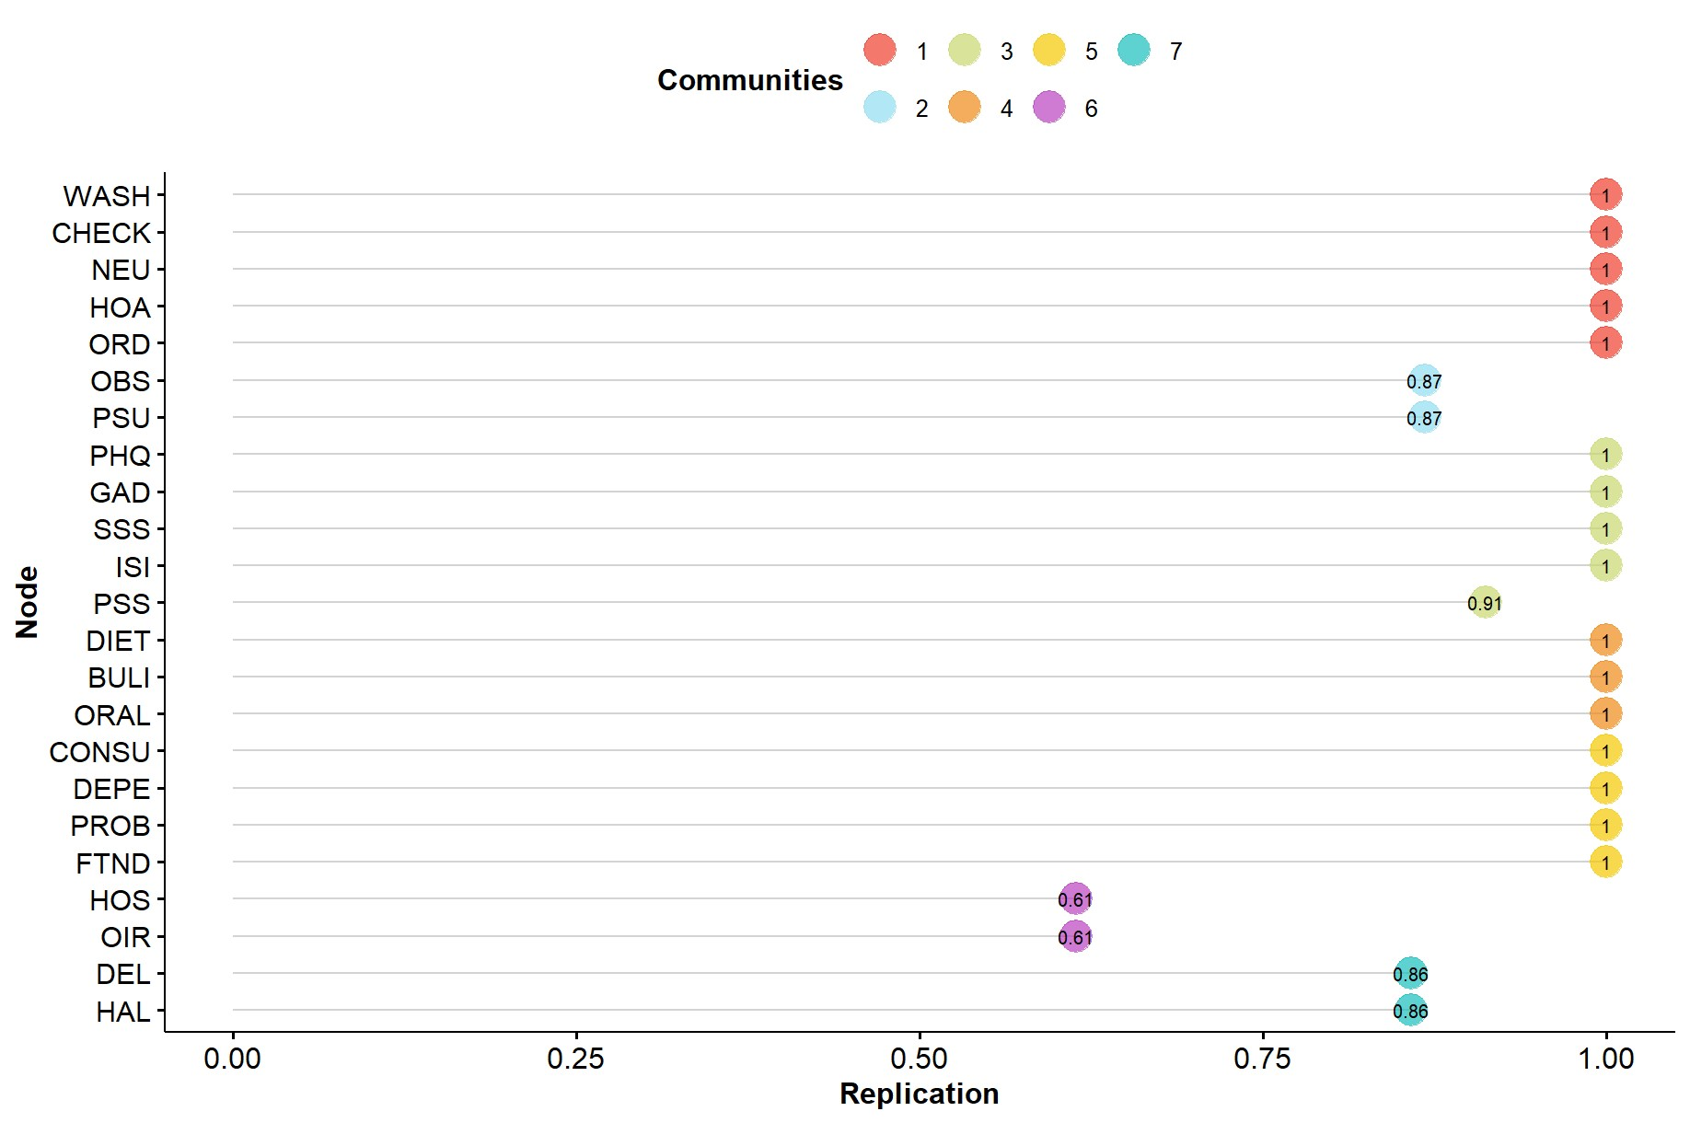
Abbreviations: WASH=wash subscale of OCI-R; CHECK= check subscale of OCI-R; NEU= neutralising subscale of OCI-R; OBS=obsessing subscale of OCI-R; HOA= hoarding subscale of OCI-R; ORD= ordering subscale of OCI-R; PHQ= patient health questionnaire-9; GAD= generalized anxiety disorder 7-item scale; DIET= dieting subscale of EAT-26; BULI= bulimia and food preoccupation subscale of EAT-26; ORAL= oral control subscale of EAT-26; PSS= perceived stress scale; CONSU= alcohol consumption subscale of AUDIT; DEPE= alcohol dependence symptoms subscale of AUDIT; PROB =alcohol-related problems subscale of AUDIT; HOS= hostility subscale of SCL90; OIR= outward irritability subscale of IDA; DEL= delusion subscale of CAPE; HAL= hallucinations subscale of CAPE; SSS= somatic symptom scale; FTND= fagerström test for nicotine dependence; ISI= insomnia severity index; PSU= problematic smartphone use.

Fig.S3. Bootstrapped confidence intervals of estimated edge-weights for the four estimated networks.
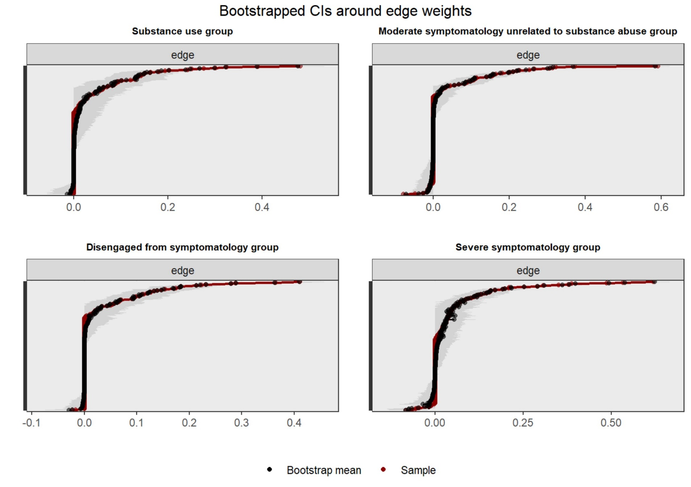
Note. Sample values are depicted by red lines, and bootstrapped mean values are depicted by black lines. The gray area represents the bootstrapped CIs. Each horizontal line represents one edge of the network.

Fig.S4. Average correlations between centrality indices of networks sampled with persons dropped and the original sample.
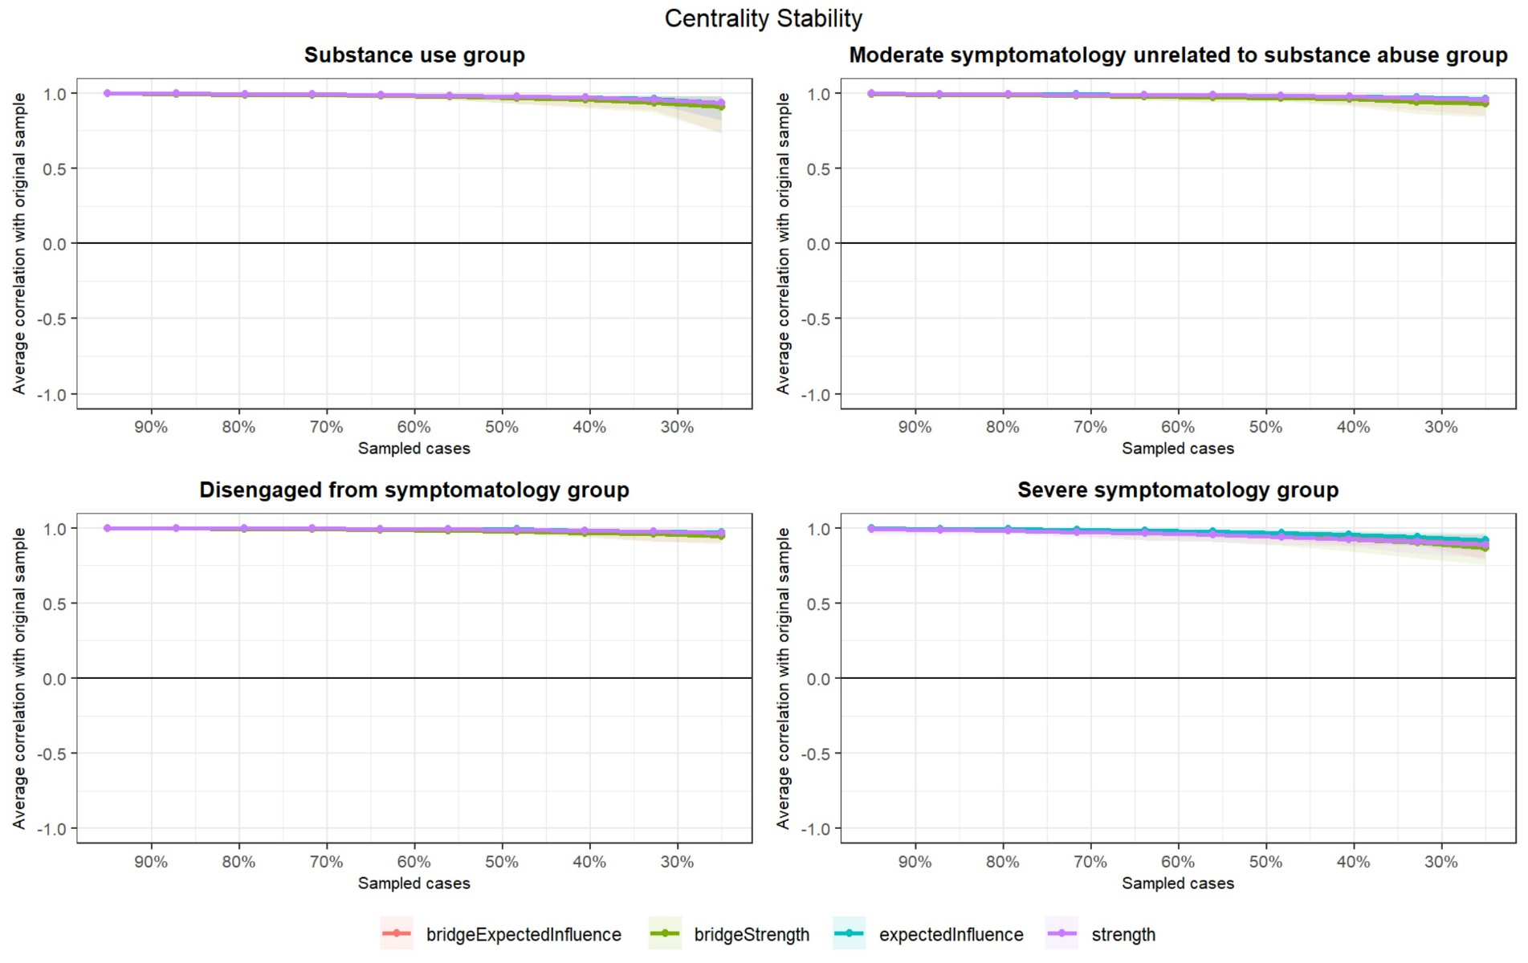
Note. The lines represent the means, while the shaded areas indicate the range spanning from the 2.5th quantile to the 97.5th quantile.

Fig.S5. Standardized centrality for the four profiles’ estimated networks.
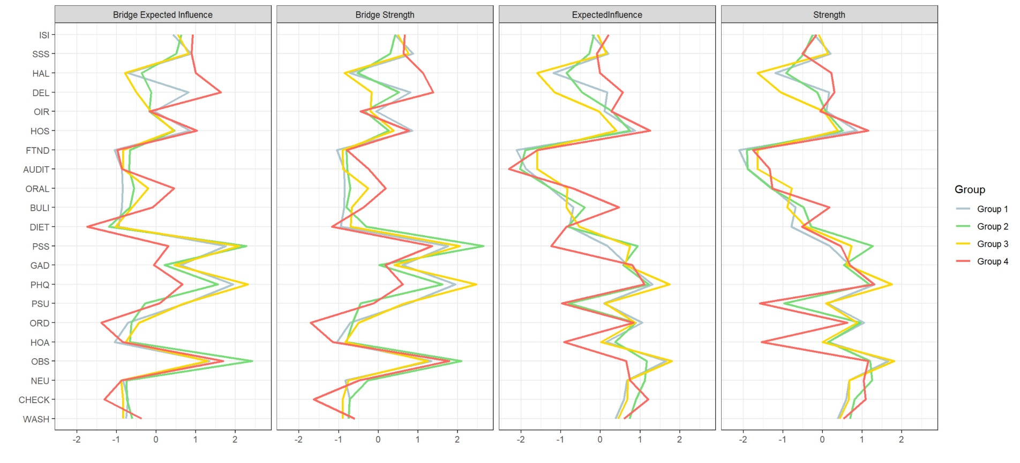
Abbreviations: ISI= insomnia; SSS= somatic symptom; HAL= hallucinations; DEL= delusion; OIR= outward irritability; HOS= hostility; FTND= nicotine dependence; AUDIT= alcohol use disorder symptom; ORAL= oral control; BULI= bulimia and food preoccupation; DIET= dieting; PSS= perceived stress; GAD= anxiety symptoms; PHQ= depressive symptoms; PSU= problematic smartphone use; ORD= compulsive ordering; HOA= hoarding; OBS= obsessive beliefs; NEU= compulsive neutralizing; CHECK= compulsive checking; WASH=compulsive washing. Group 1 = Substance Use Group; Group 2 = Moderate Symptomatology Group; Group 3 = Disengaged from Symptomatology Group; Group 4 = Severe Symptomatology Group.

Fig.S6. Associations between the symptom dimensions and RDoC negative valence construct.
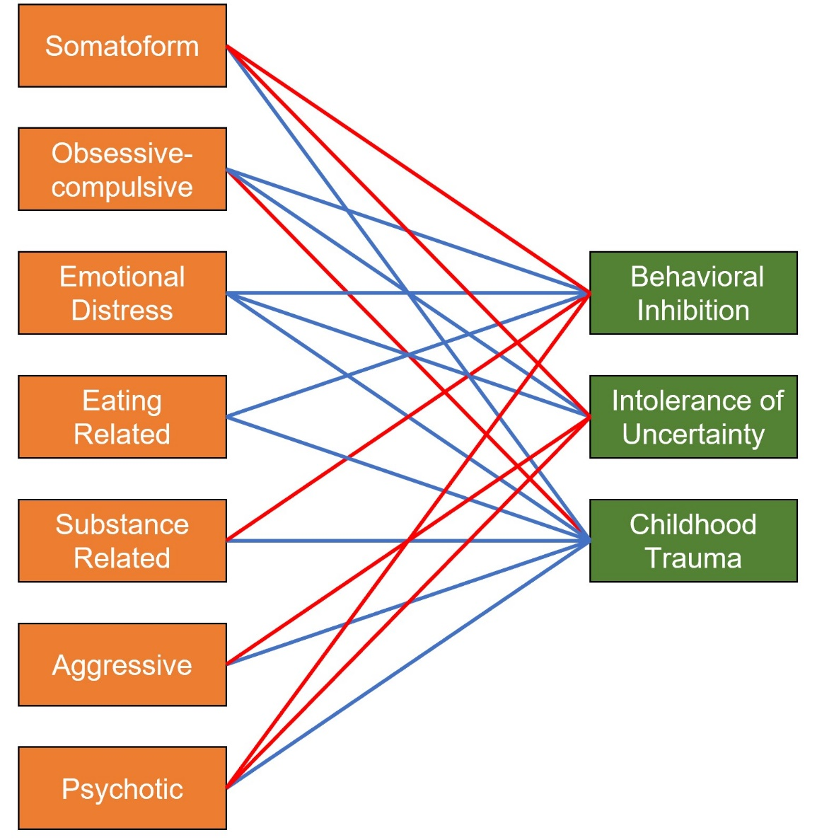
Note. The red line represents a negative relationship and the blue line represents a positive relationship.

It is worth noting the specificity of the relationships between different symptom dimensions and RDoC negative valence constructs. Regarding childhood trauma, the obsessive-compulsive dimension displayed a negative relationship, while the other dimensions showed positive relationships. Concerning intolerance of uncertainty, positive relationships were observed for the obsessive-compulsive and emotional distress dimensions, with negative relationships found for the somatoform, aggressive, and psychotic dimensions. In terms of the behavioral inhibition system, positive relationships were noted for the obsessive-compulsive, emotional distress, and eating-related dimensions, while negative relationships were observed for the substance-related, somatoform, and psychotic dimensions.

Reference
[1] Foa EB, Huppert JD, Leiberg S, Langner R, Kichic R, Hajcak G, et al. The Obsessive-Compulsive Inventory: development and validation of a short version. Psychol Assess 2002;14:485. https://doi.org/10.1037/1040-3590.14.4.485.
[2] Löwe B, Unützer J, Callahan CM, Perkins AJ, Kroenke K. Monitoring depression treatment outcomes with the patient health questionnaire-9. Med Care 2004;42:1194–201. https://doi.org/10.1097/00005650-200412000-00006.
[3] Spitzer RL, Kroenke K, Williams JB, Löwe B. A brief measure for assessing generalized anxiety disorder: the GAD-7. Arch Intern Med 2006;166:1092–7. https://doi.org/10.1001/archinte.166.10.1092.
[4] Cohen S, Kamarck T, Mermelstein R. A global measure of perceived stress. J Health Soc Behav 1983:385–96. https://doi.org/10.2307/2136404.
[5] Garner DM, Olmsted MP, Bohr Y, Garfinkel PE. The eating attitudes test: psychometric features and clinical correlates. Psychol Med 1982;12:871–8. https://doi.org/10.1017/s0033291700049163.
[6] Saunders JB, Aasland OG, Babor TF, De la Fuente JR, Grant M. Development of the alcohol use disorders identification test (AUDIT): WHO collaborative project on early detection of persons with harmful alcohol consumption‐II. Addiction 1993;88:791–804. https://doi.org/10.1111/j.1360-0443.1993.tb02093.x.
[7] Heatherton TF, Kozlowski LT, Frecker RC, FAGERSTROM K-O. The Fagerström test for nicotine dependence: a revision of the Fagerstrom Tolerance Questionnaire. Br J Addict 1991;86:1119–27. https://doi.org/10.1111/j.1360-0443.1991.tb01879.x.
[8] Wang D, Sun M, Ouyang X, Fang F. Validity and reliability of the simplified version of Community Assessment of Psychic experiences in college students. Chin Ment Health J 2022;36:172–8. https://doi.org/10.3969/j.issn.1000-6729.2022.02.014.
[9] Derogatis LR, Unger R. Symptom checklist‐90‐revised. Corsini Encycl Psychol 2010:1–2. https://doi.org/10.1002/9780470479216.corpsy0970.
[10] Snaith RP, Taylor CM. Irritability: definition, assessment and associated factors. Br J Psychiatry 1985;147:127–36. https://doi.org/10.1192/bjp.147.2.127.
[11] Bastien CH, Vallières A, Morin CM. Validation of the Insomnia Severity Index as an outcome measure for insomnia research. Sleep Med 2001;2:297–307. https://doi.org/10.1016/s1389-9457(00)00065-4.
[12] Gierk B, Kohlmann S, Kroenke K, Spangenberg L, Zenger M, Brähler E, et al. The somatic symptom scale–8 (SSS-8): a brief measure of somatic symptom burden. JAMA Intern Med 2014;174:399–407. https://doi.org/10.1001/jamainternmed.2013.12179.
[13] Leung L. Linking psychological attributes to addiction and improper use of the mobile phone among adolescents in Hong Kong. J Child Media 2008;2:93–113. https://doi.org/10.1080/17482790802078565.
[14] Bernstein DP, Stein JA, Newcomb MD, Walker E, Pogge D, Ahluvalia T, et al. Development and validation of a brief screening version of the Childhood Trauma Questionnaire. Child Abuse Negl 2003;27:169–90. https://doi.org/10.1016/s0145-2134(02)00541-0.
[15] Carver CS, White TL. Behavioral inhibition, behavioral activation, and affective responses to impending reward and punishment: the BIS/BAS scales. J Pers Soc Psychol 1994;67:319. https://doi.org/10.1037/0022-3514.67.2.319.
[16] Carleton RN, Norton MPJ, Asmundson GJ. Fearing the unknown: A short version of the Intolerance of Uncertainty Scale. J Anxiety Disord 2007;21:105–17. https://doi.org/10.1016/j.janxdis.2006.03.014.

