Examining the interplay between air pollution, surface vegetation cover, and stroke prevalence in East Africa: An ecological perspective

Supplemental materials
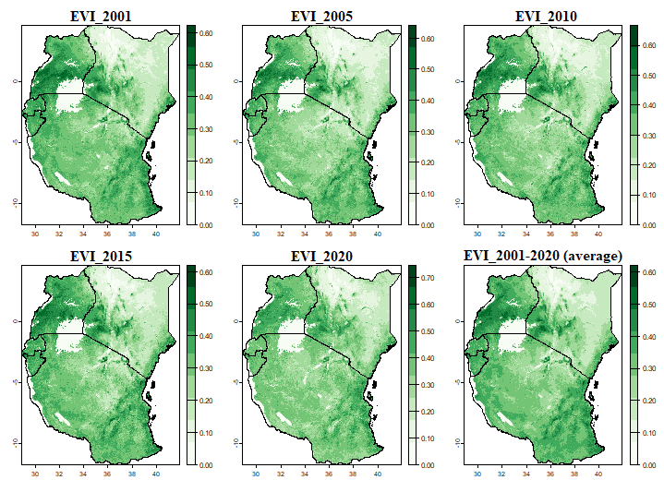
Fig. A.1 – Spatial and temporal distribution of the enhanced vegetation index
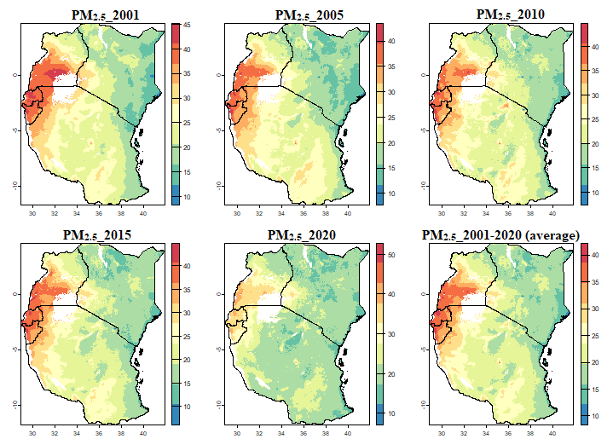
Fig. A.2 – Spatial and temporal distribution of PM_{2.5}
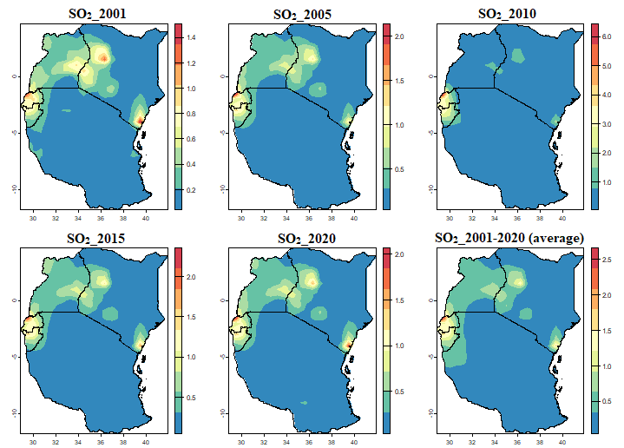
Fig. A.3 – Spatial and temporal distribution of SO₂
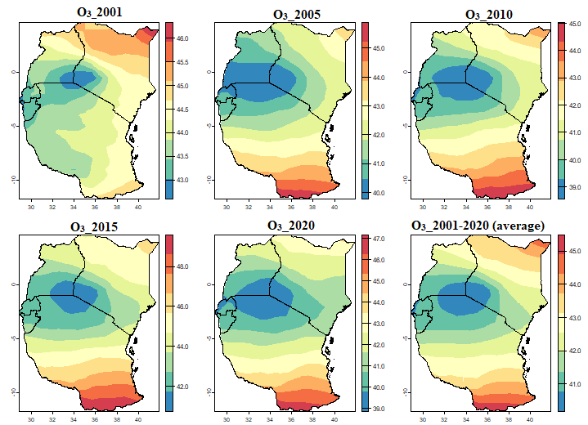
Fig. A.4 – Spatial and temporal distribution of O₃
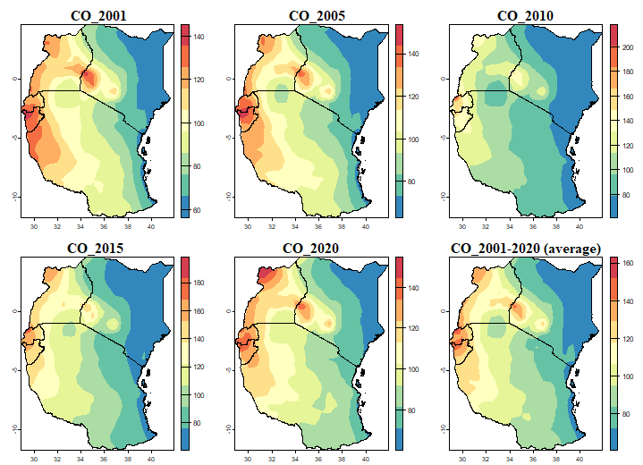
Fig. A.5 – Spatial and temporal distribution of the CO

