Risk Assessment of Heavy Metals in Typical Karst Soils and Analysis of Potential Influencing Factors

Sijing Sun^{2,3}, Junlei Wang^{1,2}, Liyuan Mu^{1,2}, Naiming Zhang^{1,2}, Li Bao^{1,2,*}
¹College of Resources and Environment, Yunnan Agricultural University, Kunming 650000, China
²Yunnan Engineering Research Center for Soil Fertilization and Pollution Remediation, Kunming 650000, China
³College of Water Resources, Yunnan Agricultural University, Kunming 650000, China

Abstract: The southwestern region of Yunnan Province, China, is characterized by typical karst landforms, where the elevated concentration of soil heavy metals has had significant impacts on the local environment. The objective of this study was to investigate the spatial distribution of soil heavy metals (Cu, Zn, Pb, Cd, and Cr) and identify the influencing factors in the target area using geo-detector and spatial interpolation techniques. The average concentration of chromium (Cr) in the study area exceeded the background level of soil elements in Yunnan Province, being 1.35 times higher than the background value. The concentrations of the other heavy metals did not exceed the background levels, although individual sampling points showed values above the standard. In terms of spatial distribution, the high-concentration areas for all five heavy metals were primarily located in the central part of the study area. GeoDetector analysis revealed that soil pH, soil organic matter, GDP, evapotranspiration, rainfall, and land-use type were the main factors influencing soil heavy metal. Interaction detector analysis showed that the results of factor interactions led to either non-linear or two-factor enhancement. Among Cu, Zn, and Cd, the strongest interacting combination was found between pH and organic carbon (OC). This study clarifies the factors affecting soil heavy metal concentrations in karst regions and provides a scientific evaluation method and decision-making support for similar areas with high background values. The findings hold significant scientific value and practical implications.
Keywords: heavy metals; GeoDetector; spatial distribution; influencing factors; pollution evaluation
1 Introduction
The spatial differentiation of soil heavy metals strongly correlates with the spatial location of heavy metal pollution sources(Y. Zhang et al. 2017). Complex natural and anthropogenic activities result in high spatial heterogeneity of pollution sources and differences in the spatial distributions of different heavy metals. While geostatistical methods have been widely employed to investigate the spatial variation characteristics and distribution patterns of soil heavy metals, they are insufficient for elucidating the influence mechanisms from the perspective of environmental factor differentiation. Notably, in ecologically fragile karst regions, there remains a paucity of comprehensive studies that systematically combine geodetector analysis with spatial visualization techniques to investigate the interactions between multiple environmental factors and their compound effects on heavy metal distribution patterns.
GeoDetector is a statistical method developed based on the principle of spatial hierarchical heterogeneity, and it can determine spatial heterogeneity and reveal the driving factors behind this heterogeneity(J. Wang and Xu 2017). This method can be used to evaluate the factors influencing heavy metal distribution in soils and the interaction factors on heavy metals. The advantage of GeoDetector is that it can not only analyze the type of quantities, but it can also detect numerical and qualitative data.
In recent years, the Geodetector has demonstrated robust capabilities in deciphering spatial heterogeneity within environmental science, particularly excelling in identifying pollution-driving factors and analyzing interaction effects. In soil pollution research, its applications have expanded from single-source pollution analysis to multi-factor synergistic effect evaluation (Wu et al. 2024; Yang et al. 2024). For instance, Wu et al. (2024) quantified the impacts of parent materials, altitude, and soil type on the spatial distribution of molybdenum in topsoil using the Geodetector, revealing nonlinear enhancement effects among natural factors. Similarly, Yang et al. (2024) integrated machine learning with the Geodetector and found that atmospheric diffusion significantly increased the driving contribution (q-value rose from 0.057 to 0.235) to arsenic pollution in mining areas, highlighting the complex interplay between anthropogenic activities and natural processes. Such studies underscore that the Geodetector not only identifies dominant driving factors but also elucidates multi-scale mechanisms of pollution formation through interaction detection, offering methodological support for precise source identification.
However, current research predominantly focuses on independent analyses of driving factors, while the integration of the Geodetector with pollution assessment frameworks remains insufficient. On one hand, existing pollution evaluation methods—such as the geo-accumulation index and potential ecological risk index—can characterize pollution levels but struggle to incorporate the spatial heterogeneity of driving factors (Li et al. 2022). On the other hand, quantitative results from the Geodetector have yet to be systematically applied to optimize assessment models. For example, Zhang et al. (2021) identified precipitation and topography as dominant factors influencing heavy metal distributions via GIS and the Geodetector but failed to further develop dynamic response models linking pollution risks to driving factors(J. Zhang et al. 2021). Likewise, Xiang et al. (2021) revealed synergistic/antagonistic effects of heavy metals in soil-crop systems but did not utilize the Geodetector to analyze their spatial dependencies. Such disconnects limit mechanistic explanations in pollution assessments and hinder the formulation of targeted risk management strategies(Xiang et al. 2021).
Therefore, in this study, the single-factor pollution index method, the Nemero composite pollution index method, the geo‑accumulation index method, and the potential ecological risk index method were selected to evaluate soil pollution across 20 counties and districts in southwestern Yunnan Province. The spatial distributions of the heavy metals in the soils in the study area were obtained via empirical Bayesian kriging interpolation, and the factors affecting the heavy metals were further analyzed using a combination of correlation analysis and a GeoDetector. This study combines several assessment methods and spatial analysis techniques to assess the pollution status, ecological risk, and spatial distribution characteristics of heavy metals in soil in southwestern Yunnan Province and discusses the multifactorial mechanisms affecting the distribution of heavy metals. Furthermore, our findings address soil heavy metal pollution in this area and provide evidence to support decision-making in similar areas with high background values.
The value of this study is that it provides baseline data for environmental management and monitoring in this region. By understanding the factors influencing heavy metal pollution, the government and environmental protection agencies can formulate corresponding environmental protection policies and implement measures to prevent and control heavy metal pollution in a targeted manner to protect environmental health. In addition, in-depth analyses of the influencing factors of heavy metal pollution benefit scientific research, promote the innovation and application of environmental protection and ecological restoration technologies and provide a scientific basis for environmental management.
2 Methods and materials
2.1 Overview of the study area
The study area is located in southwestern Yunnan Province, China (21°8′–25°48′N, 98°5′–101°49′E), including 20 counties and districts in Baoshan City, Pu'er City, Lincang City, Xishuangbanna Dai Autonomous Prefecture, and Dali Bai Autonomous Prefecture (Fig. 1). The study area is characterized by high mountainous valleys, and the Nujiang and Lancang rivers run through the area. This area has a subtropical monsoon climate and tropical monsoon climate, with an average annual rainfall of 1269.11 mm. The range of the mean annual rainfall in the study area was 668.91 to 2057.82 mm. The high-value rainfall areas were concentrated in the west and southeast, and the low-value areas were mainly located in the northeast and southwest. The average annual temperature ranges from 15.4 to 18.3°C, and the soil types mainly include Ultisols (Soil Taxonomy). The region is rich in mineral resources, including iron, lead-zinc, and copper ores.
Fig. 1 Study area and locations of the sampling points
2.2 Sampling and analysis
In this study, soils with relatively flat and stable topography were selected for collection in 2022, and five surface (0–20 cm) soil samples were collected using the plum point method. Debris and weeds were removed and put into sealed bags, and the sample number, sampling location, and locating coordinates were recorded. A total of 455 soil samples were collected. The study area and the location of the sampling points are shown in Fig. 1. The soil was dried naturally and passed through a 1 mm sieve. The pH value and the organic matter, copper (Cu), zinc (Zn), lead (Pb), cadmium (Cd), and chromium (Cr) contents of the collected soil samples were determined. The pH was determined using a pH meter, soil solutions were prepared using soil samples weighing 10.00 ± 0.03 g and 30 mL distilled water. The soil organic matter content was determined using the potassium dichromate-external heating method. First, 0.5 g of Cu, Zn, Pb, Cd, and Cr were put in an ablution jar, and then, 5 mL of HNO₃ and 2 mL of H₂O₂ were added. Then, the jar was sealed with a lid and placed in a microwave ablator. Microwave digestion was carried out using a microwave digestion instrument, and then the sample was analyzed using a graphite furnace atomic absorption spectrometer (Shimadzu-AA6880). The limits of detection of Cu, Zn, Pb, Cd, and Cr were 0.27, 0.5, 0.1, 0.002, and 0.09 mg·kg⁻¹, respectively.
To ensure the accuracy and reliability of the experimental results, stringent quality assurance and control measures were implemented throughout the sampling and analysis stages. During sampling, polyethylene gloves and tools (e.g., brushes and scoops) were used to avoid contamination from external sources. All tools were acid-washed and rinsed with deionized water before use to prevent contamination. Digesting vessels and glassware were soaked in 20% nitric acid for over 24 hours prior to each use, followed by three rinses with deionized water to eliminate any residual heavy metal ions. Procedural blanks and certified reference materials were incorporated into the experimental design to verify the accuracy of the analytical methods. Each sample batch included at least two procedural blanks, two standard reference materials (GBW-07405, soil, National Research Center for Certified Reference Materials of China), and at least 10% parallel samples to ensure data reliability. Each sample was analyzed in triplicate, with one or two reagent blanks, all of which returned results below the detection limit. The recovery rates for metal ions ranged from 92.05% to 102.58%, confirming the credibility of the measurement results.
2.3 Data collection
Based on existing studies and taking into account the actual situation(Gong et al. 2023), 15 influencing factors were selected, including the average annual evapotranspiration (EVP), average annual rainfall (PRE), soil organic matter (OC), soil pH, soil texture (CLAY, SAND, and SLIT), soil type (ST), geomorphologic type (GT), gross domestic product (GDP), land-use type (LUT), farmland production potential (SPT), vegetation type (VT), distance from a river (WD), and distance from a road (RD). Among them, the EVP(X. Xu 2022), PRE(X. Xu 2022), CLAY, SAND, SLIT, ST, GT, GDP(X. Xu 2017), LUT(X. Xu et al. 2020), SPT(X. Xu and Liu 2017), VT(Hou et al. 2001), and WD(X. Xu 2018) data were obtained from the Resource and Environmental Science Data Registration and Publishing System (https://www.resdc.cn), and the spatial distribution data of China's soil texture were compiled based on 1:1,000,000 soil type maps and the soil profile data obtained from the second soil census. Data on the spatial distribution of soil types in China (ST) were digitized from the 1:1,000,000 soil type maps of the People's Republic of China compiled and published by the National Soil Census Office in 1995. Data on the spatial distribution of landform types (GT) were derived from the Geomorphological Atlas of the People's Republic of China (1:1,000,000). The RD data were obtained from 91 Guardian Map Assistants. The soil pH, organic matter (OC), and heavy metal data were obtained from measured data. A total of 15 factors were selected in this study (Fig. 2).
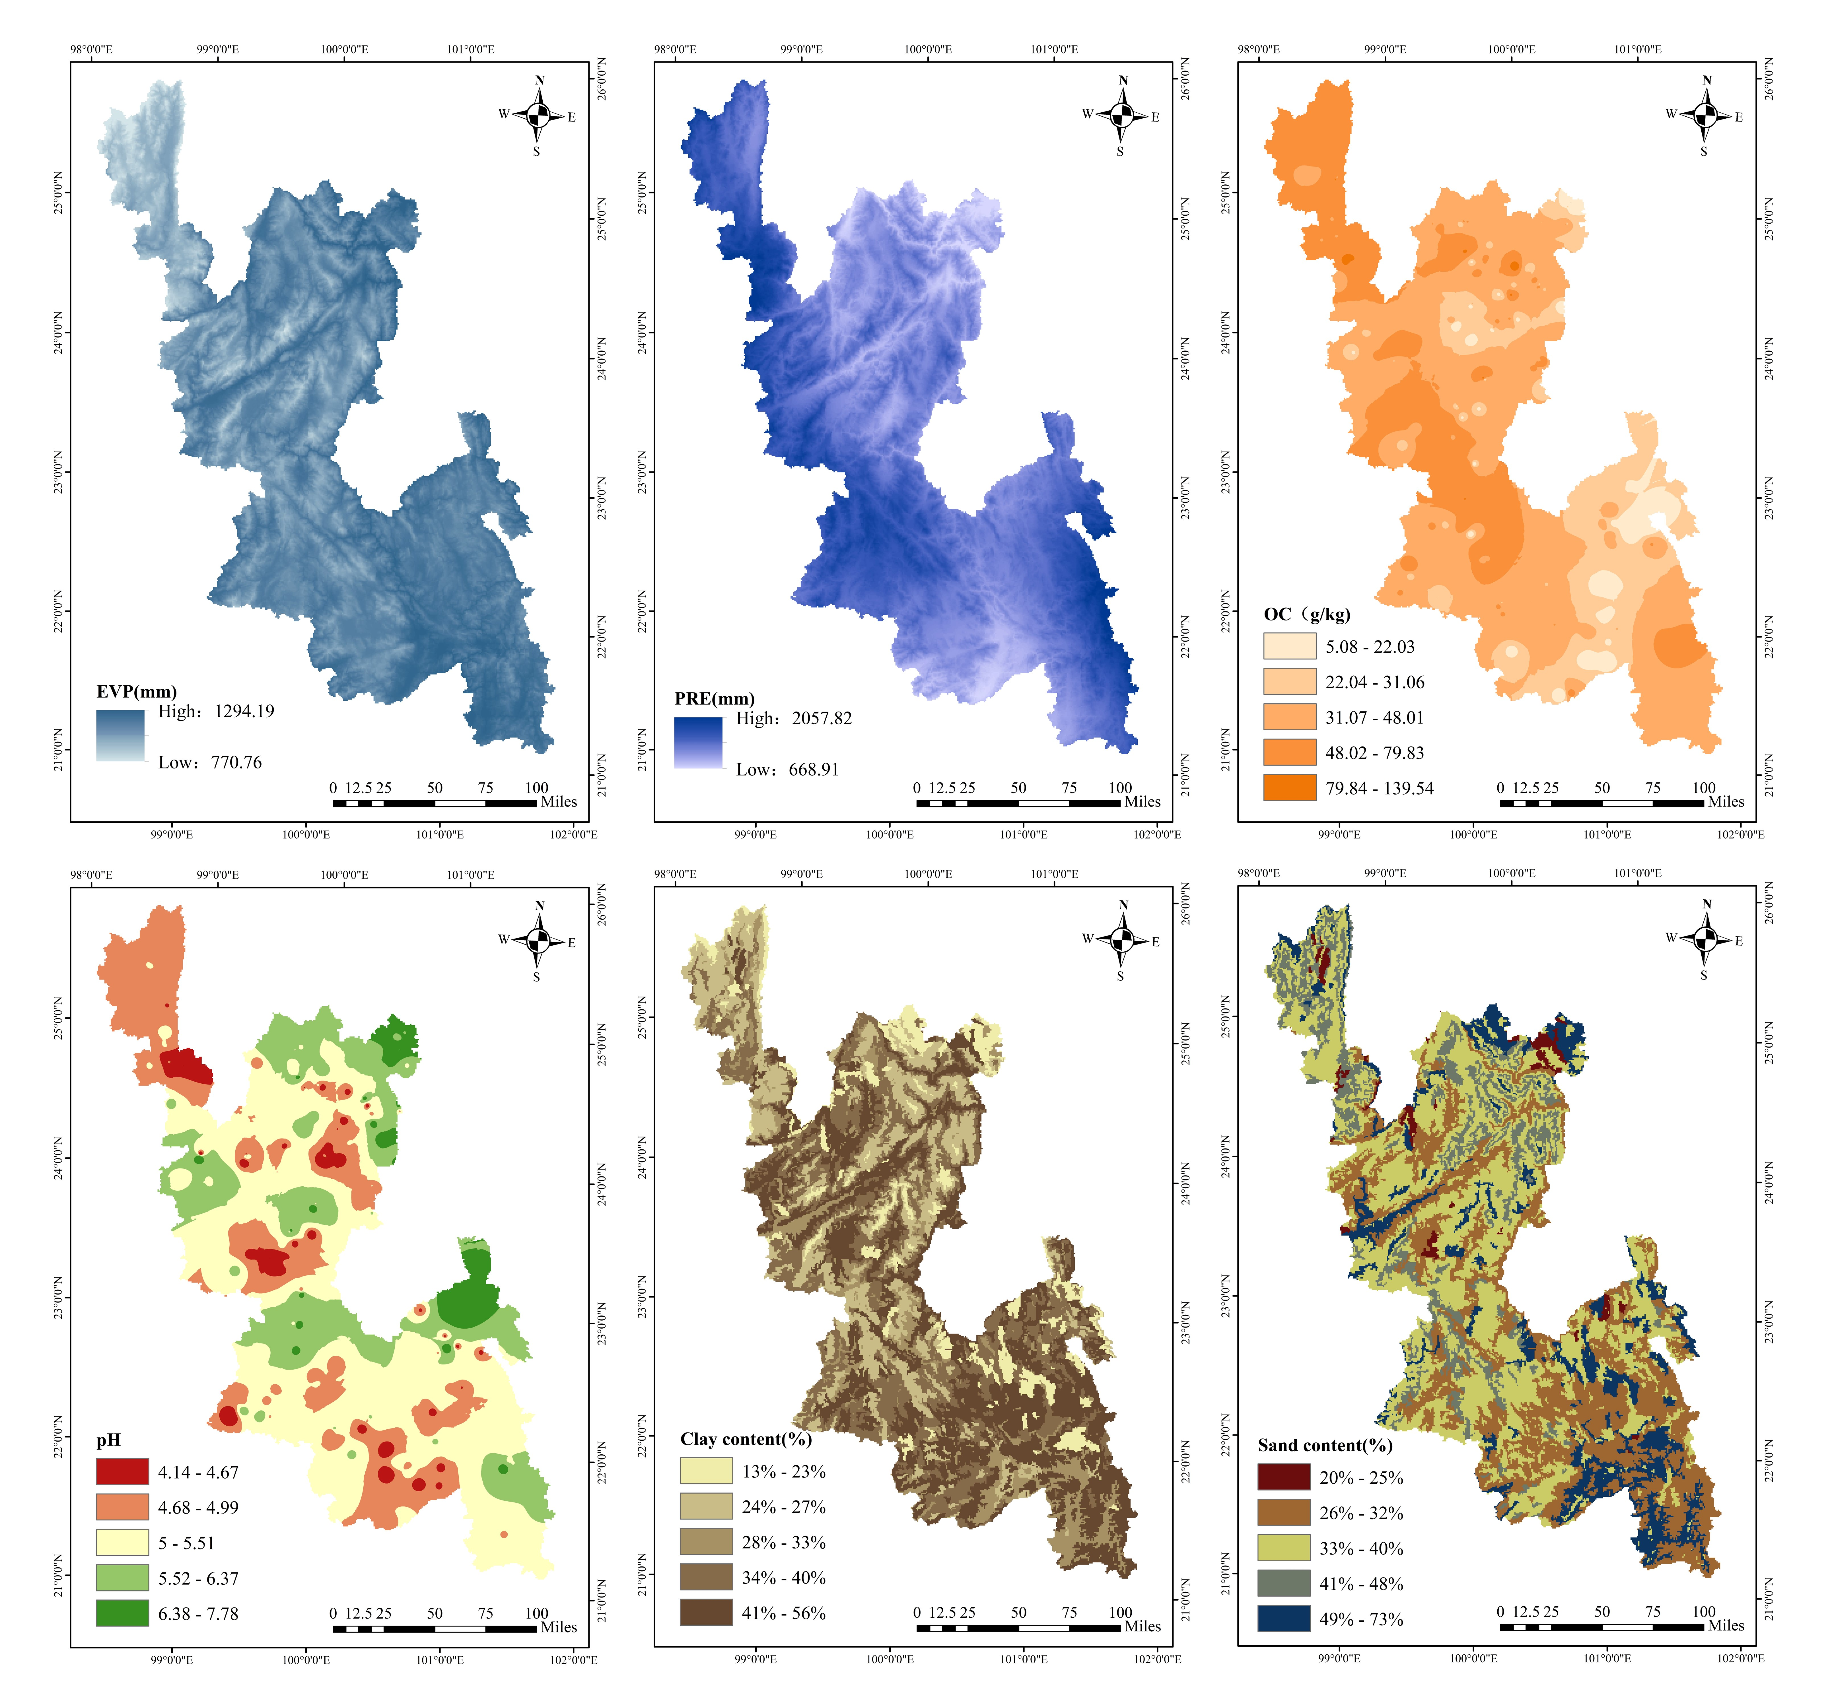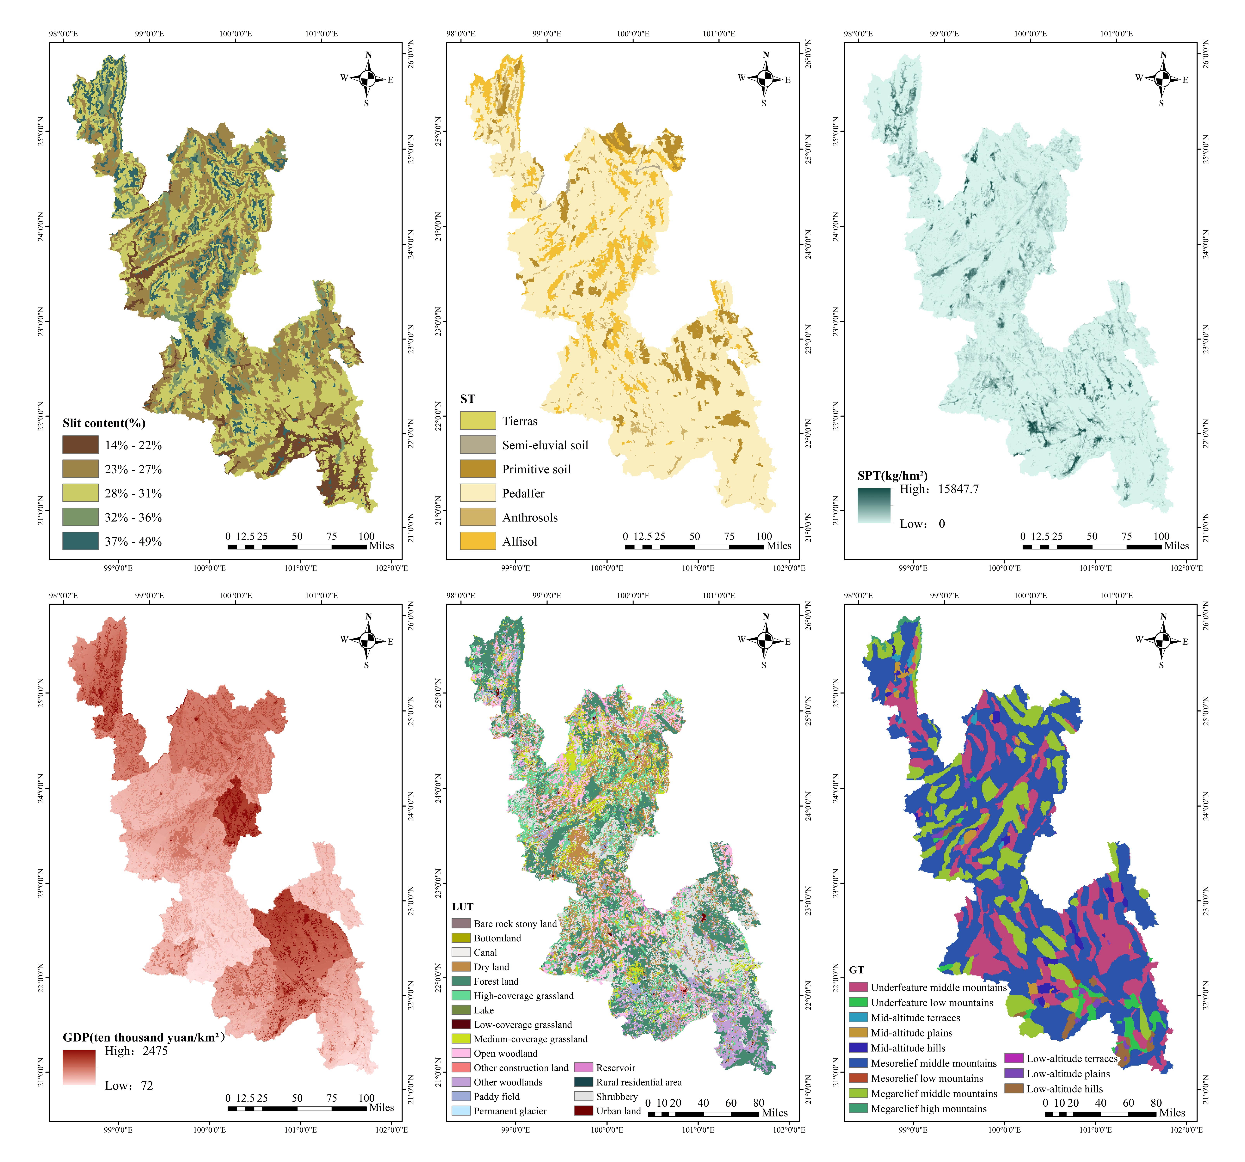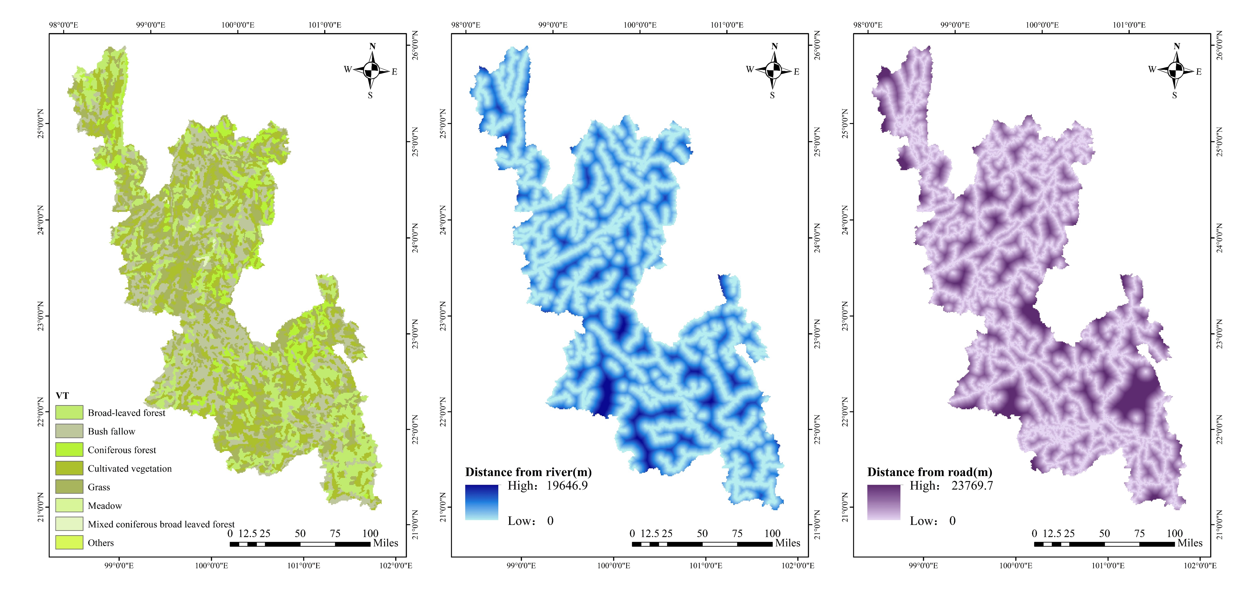
Fig. 2 Distribution of each factor X
2.4 Evaluation methods for soil heavy metal pollution
2.4.1 Single-factor pollution index method
The single factor pollution index (P_{i}) reflects the degree of pollution of individual heavy metals by calculating the concentration of each heavy metal. The calculation formula is as follows:
$P_{i}=\frac{C_{i}}{S_{i}}$,
Where C_{i} is the measured concentration value of heavy metal i in soil and Si is the standard evaluation value of heavy metal i in soil. In this study, the background value of soil heavy metal elements in Yunnan Province(F. Wei et al. 1990) was referred to as the analytical standard. The grading criteria of the single factor pollution index method (P_{i}) are presented in Table 1.
Table 1 Evaluation grading criteria of the single factor pollution index method (P_{i})
Class | P_{i} | Contamination level
1 | P_{i}≤1 | Uncontaminated
2 | 1<P_{i}≤2 | Lightly contaminated
3 | 2<P_{i}≤3 | Lightly contaminated to moderately contaminated
4 | 3<P_{i}≤5 | Moderately contaminated
5 | P_{i}>5 | Heavily contaminated
2.4.2 Nemerow Composite Pollution Index Method
The Nemerow Composite Pollution Index ($P_{n}$) is a composite pollution index calculated by combining single-factor pollution indices, which can express the impact of high concentrations of heavy metal elements on the environment. The calculation formula is as follows:
$$P_{n}=\sqrt{\frac{{\overline{P}}_{i}^{2}+P_{imax}^{2}}{2}},$$
where ${\overline{P}}_{i}$ is the mean value of the single-factor pollution index, and $P_{imax}$ is the maximum value of the single-factor pollution index. The grading criteria of the Nemerow composite pollution index method (P_{n}) are presented in Table 2.
Table 2 Evaluation grading criteria of the Nemerow composite pollution index method (P_{n})
Class | P_{n} | Contamination level
1 | P_{n}≤0.7 | Uncontaminated
2 | 0.7<P_{n}≤1.0 | Lightly contaminated
3 | 1.0<P_{n}≤2.0 | Lightly contaminated to moderately contaminated
4 | 2.0<P_{n}≤3.0 | Moderately contaminated
5 | P_{n}≥3.0 | Heavily contaminated
2.4.3 Geo‑Accumulation Index
The geo‑accumulation index (I_{geo}) reflects the pollution accumulation status of heavy metals in soil, and can also reflect the impacts of human activities. The calculation formula is as follows:
$$I_{geo}=\log_{2}{\frac{C_{n}}{1.5B_{n}}},$$
where $C_{n}$ is the measured value of heavy metal n, and $B_{n}$ is the measured geochemical background value of heavy metal n. In this study, the background values of the soil heavy metal elements in Yunnan Province were used(F. Wei et al. 1990), and 1.5 was the correction coefficient that considers that the process of diagenesis may cause changes in the background value. The grading criteria of the geo‑accumulation index method (I_{geo}) are presented in Table 3.
Table 3 Evaluation grading criteria of the geo‑accumulation index method (I_{geo})
Class | I_{geo} | Contamination level
1 | I_{geo}≤0 | Uncontaminated
2 | 0<I_{geo}≤1 | Lightly contaminated
3 | 1<I_{geo}≤2 | Moderately contaminated
4 | 2<I_{geo}≤3 | Moderately contaminated to heavily contaminated
5 | 3<I_{geo}≤4 | Heavily contaminated
6 | 4<I_{geo}≤5 | Heavily contaminated to extremely contaminated
7 | I_{geo}>5 | Extremely contaminated
2.4.4 Potential Ecological Risk (Hakanson) Index Method
Potential ecological risk evaluation is a method proposed by Hakanson for estimating the potential ecological risks of pollutants in sediments and soils. It is also an important method for assessing the risk posed by heavy metal pollution of soils and the quality of the soil environment(Hakanson 1980). The specific calculation formula is as follows:
$E_{r}^{i}=T_{r}^{i}×C_{j}^{r}=T_{r}^{i}×（\frac{C_{j}^{i}}{C_{r}^{i}}）$,
$$RI=\sum_{i=1}^{n}{E_{r}^{i}},$$
where $E_{r}^{i}$ is the single potential ecological risk index for soil heavy metal i, RI is the potential ecological risk index of the sample site, and $T_{r}^{i}$ is the toxicity response coefficient of heavy metal i, $C_{j}^{i}$ is the measured value of heavy metal i, and $C_{r}^{i}$ is the background value. The background value of soil heavy metals in Yunnan Province was used in this study. Since the classification criteria in this evaluation method were mainly based on the toxicity coefficients of eight pollutants (PCB, Cd, Hg, Pb, As, Cr, Zn, and Cu), In this study, the toxicity coefficients of Cu, Zn, Pb, Cd, and Cr were 5, 1, 5, 30, and 2, respectively(Hakanson 1980). Therefore, this study improved the classification criteria for potential ecological risk assessment(Mingyi et al. 2019; Huang et al. 2022). First, the upper limit of the lowest level of $E_{r}^{i}$ is determined by the maximum value of 30 (Cd) in the toxicity coefficient, and the remaining levels are obtained by multiplying the upper level by 2 in turn. Therefore, the classification criteria for $E_{r}^{i}$ used in this study were $E_{r}^{i}$≤30 (low risk), 30 < $E_{r}^{i}$ ≤60 (moderate risk), 60 < $E_{r}^{i}$ ≤120 (considerable risk), 120 < $E_{r}^{i}$ ≤240 (high risk), and $E_{r}^{i}$ ≥240 (extremely high risk). The primary threshold (Level 1) was calculated by dividing the original $RI$ threshold (150) by the sum of toxicity coefficients for eight heavy metals (133), yielding a unit toxicity coefficient of 1.13. This coefficient was then multiplied by the sum of toxicity coefficients for the five heavy metals studied here (43), resulting in an initial Level 1 threshold of 1.13×43=48.59, which was rounded to 50. Subsequent classification thresholds (Levels 2–4) were derived by doubling the preceding level’s value. Therefore, the classification criteria for RI used in this study were: RI < 50 (low risk), 50 ≤ RI ≤ 100 (moderate risk), 100 ≤ RI ≤ 200 (considerable risk), and RI ≥ 200 (high risk).
2.5 GeoDetector
GeoDetector is a tool for detecting and utilizing spatial dissimilarity, and the model includes four detectors: the dissimilarity and factor detector, the interaction detector, the risk detector, and the ecological detector(J. Wang and Xu 2017). In this study, we focused on selecting the factor and interaction detectors. The factor detector is mainly used to determine the spatial dissimilarity of heavy metal Y and the explanatory powers of the degrees of influence of different factors X on variable heavy metal Y, represented by the q-value.
$$q=1-\frac{\sum_{h=1}^{L}{N_{h}σ_{h}^{2}}}{Nσ^{2}},$$
where h=1,..., L is the stratification, i.e., categorization or partitioning, of variable Y or factor X; $N_{h}$ is the number of cells in layer h; $N$is the number of units in the district as a whole; $σ_{h}^{2}$is the variance of the Y-value of layer h; and $σ^{2}$is the variance of the Y-value of the whole district.
The value domain of q is [0,1], and a larger q-value means that the factor has a stronger explanatory power for Y and that the spatial differentiation of Y is more obvious.
The interaction detector detects whether the effect of the two factors X on the variable Y is enhanced or weakened by the simultaneous action of the two factors or if their effects are independent. The types of interactions of the two factors are described in Table 4.
Table 4 Types of the interactions between two factors X on variable Y¹⁾
Basis of judgment | Interaction type
q (X₁∩X₂) <Min[q (X₁), q (X₂)] | Nonlinear weakening
Min[q (X₁), q (X₂)]<q (X₁∩X₂) <Max[q (X₁), q (X₂)] | Uni-variable weakening
q (X₁∩X₂) >Max[q (X₁), q (X₂)] | Bi-variable enhancement
q (X₁∩X₂) =q (X₁) +q (X₂) | Independent
q (X₁∩X₂) >q (X₁) +q (X₂) | Nonlinear enhancement
1) Nonlinear weakening: the interaction of the two factors nonlinearly attenuates the effect of the variable; Uni-variable weakening: the effect of the variable is attenuated by the interaction; Bi-variable enhancement: the effect of the variable is augmented by the interaction of the two factors; Independent: the effect of the variable is independent; and Nonlinear enhancement: the effect of the variable is nonlinearly augmented
2.6 Data processing
Excel was used to conduct the basic data preprocessing, empirical Bayesian kriging interpolation of the measured soil pH, organic matter, and heavy metal data in ArcMap 10.6 was used to obtain the spatial distributions, and Euclidean distance analysis was used to obtain the distances from rivers and roads. The optimal parameter based geographical detector (OPGD) model was chosen to analyze the geographical detector using the GD package(Song et al. 2020) in R to study the factors affecting the soil heavy metals. The mapping was conducted in Origin 2022 and ArcMap 10.6 with R 4.3.1.
3 Results and analysis
3.1 Characterization of soil heavy metal contents
As can be seen from Table 5, the mean contents of the five soil heavy metals (Cu, Zn, Pb, Cd, and Cr) in the study area were 40.23, 84.69, 37.19, 0.18, and 87.92 mg/kg, respectively, which were near the background values of the soil in Yunnan Province(F. Wei et al. 1990). It was found that, except for Cr, the other heavy metals did not exceed the background values, indicating that the high concentrations of the heavy metals in the study area may have been affected by human activities(Luo et al. 2022). The average soil pH in the study area was 5.33. Based on the soil pollution risk screening value (pH ≤ 5.5) in the Soil Environmental Quality Soil Pollution Risk Control Standard for Agricultural Land (GB 15618-2018), the maximum values of the five heavy metals exceeded the soil pollution risk screening value. The coefficient of variation (CV) is defined as the ratio of the standard deviation to the mean, and it has been shown that for soil heavy metals, the coefficient of variation can be categorized as follows: low variation (CV < 0.1), medium variation (0.1 < CV < 1), and strong variation (CV > 1). A higher coefficient of variation indicates that the distribution of the heavy metal is not uniform and is greatly influenced by various sources(Mamat et al. 2014). The CVs of the soils in the study area were 1.38, 1.66, and 2.53 for Cu, Pb, and Cd, respectively, indicating substantial variability; while the CVs were 0.84 and 0.70 for Zn and Cr, indicating moderate variability.
Table 5 Descriptive analysis of soil heavy metals
Norm |  | Cu | Zn | Pb | Cd | Cr
Mean (mg/kg) |  | 40.23 | 84.69 | 37.19 | 0.18 | 87.92
Maximum (mg/kg) |  | 529.00 | 695.20 | 1042.00 | 7.94 | 600.00
Minimum (mg/kg) |  | 2.10 | 15.10 | 0.40 | 0.004 | 2.90
Median (mg/kg) |  | 26.50 | 69.70 | 27.50 | 0.09 | 78.20
Standard Deviation (mg/kg) |  | 55.34 | 71.54 | 61.74 | 0.45 | 61.22
Coefficient of Variation |  | 1.38 | 0.84 | 1.66 | 2.53 | 0.70
Soil Background Value in Yunnan Province (mg/kg) |  | 46.30 | 89.70 | 40.60 | 0.22 | 65.20
Risk Screening Value (mg/kg) | pH≤5.5 | 50 | 200 | 70 | 0.3 | 150
Risk Screening Value (mg/kg) | 5.5<pH≤6.5 | 50 | 200 | 90 | 0.3 | 150
Risk Screening Value (mg/kg) | 6.5<pH≤7.5 | 100 | 250 | 120 | 0.3 | 200
Risk Screening Value (mg/kg) | pH>7.5 | 100 | 300 | 170 | 0.6 | 250
3.2 Spatial distribution of heavy metals in soils
The empirical Bayesian kriging interpolation (EBK) method was used to interpolate the five soil heavy metals in the study area. The interpolation results are shown in Fig. 3, from which it can be seen that the spatial distribution patterns of Zn and Cd in the study area are similar. The high-value areas are predominantly located in the central part of the study area, the low-value areas are predominantly located in the southwestern part of the study area, and the overall trend is decreasing from the northwest to the southeast. The high-value areas for Cu are mainly distributed in the eastern-central part of the study area, and the low-value areas are distributed in the northwest and southwest corners. The high-value areas for Pb are concentrated in the northeast and central parts of the study area but decrease toward the peripheral zones. The high-value areas for Cr are primarily located in the northern-central and southeastern parts of the study area, while the low-value areas are mainly located in the northwest and southeast.
Fig. 3 Spatial distributions of soil heavy metals in the study area
3.3 Evaluation of soil heavy metal pollution
As shown in Fig. 4(A), the heavy metal pollution in the study area was evaluated using Pi and the background values of the soil elements in Yunnan Province as the standard. The Pi variations of each heavy metal were as follows: 0.05–11.43 (Cu), 0.17–7.75 (Zn), 0.0099–25.67 (Pb), 0.018–36.09 (Cd), and 0.044–9.20 (Cr). The ${\overline{P}}_{i}$ values of Cu, Zn, Pb, Cd, and Cr were 0.87, 0.94, 0.92, 0.81, and 1.35, respectively. According to the evaluation grading criteria described in Table 1, the average contamination level of Cr reached light contamination (1 < P_{i} ≤ 2), and the rest of the heavy metals did not reach the contamination level. As can be seen from Fig. 4(B), among all of the sampling points, the percentage of points where Cr reached more than the light contamination level (P_{i}>2) was 9.23%. The five heavy metals had different degrees of soil contamination. The percentage of the points where Cu and Cd reached the heavily contaminated level was 1.76%, the percentage of points where Pb and Cr reached the heavily contaminated level was 1.54%, and the percentage of points where Zn reached the heavily contaminated level was 0.88%.
The pollution accumulation status of the soil heavy metals is reflected by I_{geo} (Fig. 4(C)). The average I_{geo} values of Cu, Zn, Pb, Cd, and Cr in the study area were −1.36, −0.94, −1.14, −1.90, and −0.39, respectively. According to the grading criteria described in Table 2, the average geo‑accumulation index of the five heavy metals in the study area was less than zero, and the pollution accumulation status was uncontaminated. As can be seen from Fig. 4(D), the proportion of polluted samples at each sampling point and the pollution degrees of the five soil heavy metals in the study area were predominantly uncontaminated and lightly contaminated, but Pb and Cd together exhibited one heavily contaminated point and one heavily contaminated to extremely contaminated point.
The $P_{n}$ values of the heavy metals in the soil at the sampling sites in the study area ranged from 0.139–26.25, with a mean value of 1.59. The pollution status was lightly contaminated to moderately contaminated, and the percentages of the polluted samples at each sampling site were as follows: uncontaminated (13.19%), lightly contaminated (23.74%), lightly contaminated to moderately contaminated (48.35%), moderately contaminated (5.49%), and heavily contaminated (9.23%), respectively. As can be seen from Fig. 4(E), the heavily polluted areas in the study area were mainly located in the eastern-central and northwestern parts of the study area, similar to the spatial distributions of the Cd and Cr pollution.
Fig. 4 Evaluation of soil contamination status in the study area
As can be seen from Figures 5(A) and 5(B), the mean values of the individual potential ecological risk index $E_{r}^{i}$ for the soil heavy metals in the study area were Cd (24.53) > Pb (4.57) > Cu (4.34) > Cr (2.69) > Zn (0.94), and the five heavy metals were at the low-risk level. However, there was Cd contamination at individual sites. The percentages of the points where Cd posed low, medium, considerable, high, and severe risks were 83.08%, 10.33%, 4.18%, 1.32%, and 1.10%, respectively. The average RI value of the soil heavy metal composite ecological risk index was 37.09, ranging from 2.59 to 1107.43, and the low, medium, considerable, and high risk sites accounted for 85.27%, 9.45%, 3.30%, and 1.98% of the total sites, respectively. Overall, the heavy metals in the study area posed low risks, but this level was exceeded at some individual points.
Fig. 5 Evaluation results for potential ecological risks of soils in the study area
3.4 Classification categories and number of each impact factor X
The best discretization methods for continuous variables derived from the OPGD model(Song et al. 2020) (Table 6) included five methods: the equal interval method (equal), natural breakpoint method (natural), quantile classification method (quantile), geometric interval method (geometric), and standard deviation method (sd). The results revealed that the classification methods and the number of classifications of the different factors X for different variables Y were different.
Table 6 Optimal discretization method and number of categories for each continuous variable
TYPE | Cu | Zn | Pb | Cd | Cr | P_{n}
EVP | sd (5) | natural (6) | natural (6) | natural (4) | natural (6) | equal (6)
PRE | quantile (6) | equal (6) | sd (6) | natural (6) | natural (6) | sd (5)
OC | geometric (6) | quantile (6) | natural (6) | natural (6) | quantile (6) | geometric (6)
pH | natural (5) | quantile (6) | natural (6) | natural (6) | equal (5) | natural (6)
CLAY | geometric (6) | sd (5) | natural (6) | equal (5) | natural (6) | equal (5)
SAND | sd (6) | quantile (6) | quantile (6) | quantile (6) | sd (6) | equal (5)
SLIT | quantile (6) | natural (6) | geometric (6) | natural (6) | sd (6) | natural (6)
GDP | sd (6) | sd (6) | quantile (6) | quantile (6) | sd (6) | sd (6)
SPT | sd (6) | sd (6) | geometric (6) | sd (6) | sd (6) | sd (6)
RD | natural (6) | natural (4) | natural (6) | equal (6) | equal (5) | equal (6)
WD | natural (6) | equal (5) | natural (6) | equal (6) | equal (5) | equal (6)
3.5 Factor Detectors
The explanatory powers of the 15 influencing factors for the five heavy metals and P_{n} were analyzed using the factor detector (Fig. 6) and were expressed as q-values. For Cu, the most dominant influencing factor was OC (0.254), followed by pH (0.185) and GDP (0.0869). The major factors influencing Zn were pH (0.195), followed by OC (0.117) and GDP (0.0521). The factors with the most significant effects on Pb were OC (0.0758), PRE (0.0201), and LUT (0.02). The most significant factors affecting Cd were pH (0.199), GDP (0.12), and OC (0.0959). The most significant factors affecting Cr were OC (0.131), followed by pH (0.122) and EVP (0.114). The most significant factors affecting P_{n} were OC (0.1759), pH (0.09397), and GDP (0.06441). In summary, pH and OC were the most significant factors affecting the soil heavy metal content.
Fig. 6 q-values of the different factors influencing the heavy metals and P_{n}
3.6 Interactive detectors
The results of the interaction detector (Fig. 7) revealed that for Cu, the two-by-two factorial interactions exhibited bi-variable enhancement for pH∩OC, VT∩GT, CLAY∩SLIT, CLAY∩OC, SAND∩CLAY, SPT∩GT, SPT∩pH, SPT∩OC, LUT∩SPT, LUT∩GT, GDP∩pH, EVP∩pH, and EVP∩OC, and the rest of the interactions exhibited nonlinear enhancement, with pH∩OC being the strongest interaction with an influence of 0.4049. For Zn, the bi-variable enhancement after the interaction was OC∩SLIT/CLAY/SADN/ST, GT∩SLIT, SLIT∩CLAY/SAND/ST/EVP, CLAY∩SAND/ST, SAND∩ST, ST∩EVP, and the strongest interaction was nonlinear enhancement OC∩pH, with an influence of 0.3456. For Pb, nonlinear enhancement OC∩PRE was the strongest interaction (0.1518). For Cd, EVP∩SAND/GT, PRE∩GDP/OC, LUT∩SPT/VT/pH, SAND∩CLAY/SLIT, and CLAY∩pH exhibited bi-variable enhancement, and the strongest interaction was nonlinear enhancement OC∩pH (0.4808). For Cr, only LUT∩SLIT/GT and pH∩ST exhibited bi-variable enhancement, the rest exhibited nonlinear enhancement, and the strongest interaction was nonlinear enhancement EVP∩OC (0.2763). For P_{n}, the interaction combinations with bi-variable enhancement were LUT∩SPT, EVP∩SAND, and GDP∩pH, while the remaining exhibited nonlinear enhancement, and the strongest interaction was pH∩OC (0.4189). In summary, the results of the 15 factor interactions were categorized into nonlinear enhancement and bi-variable enhancement, and among the five heavy metals, except for Pb and Cr, the strongest interactions of the other three heavy metals were pH ∩ OC.
Fig. 7 Effects on heavy metals and P_{n} after the interactions of different influencing factors
3.7 Correlations of soil heavy metals with impact factors
Spearman correlation analysis of the five heavy metals and 15 influencing factors was conducted (Fig. 8), and the results revealed that the five heavy metals were positively correlated with each other and the correlation coefficients of the heavy metals, except for Cu-Pb, were highly significant (P<0.01). The correlation coefficients of the pairs of heavy metals were as follows: Cu-Zn (0.54), Cu-Pb (0.21), Cu-Cd (0.53), Cu-Cr (0.55), Zn-Pb (0.61), Zn-Cd (0.71), Zn-Cr (0.51), Pb-Cd (0.42), Pb-Cr (0.53), and Cd-Cr (0.49). There were highly significant correlations (P < 0.01) between Cu and pH and GDP, with correlation coefficients of 0.55 and −0.28, respectively. The correlation coefficients between Zn and OC, pH, and GT were 0.28, 0.47, and 0.20, respectively, indicating highly significant positive correlations (P < 0.01). The correlation coefficients between Zn and EVP, PRE, CLAY, SLIT, ST, GDP, and LUT (P < 0.05) were −0.21, 0.08, −0.16, 0.10, −0.18, −0.11, and −0.04. There were highly significant correlations (P < 0.01) between Pb and OC, CLAY, and SLIT, with correlation coefficients of 0.49, −0.21, and 0.20, respectively, as well as significant correlations between Pb and PRE, SAND, ST, GT, and LUT, with correlation coefficients of 0.15, 0.10, −0.15, 0.13, and −0.05 (P < 0.05), respectively. Cd exhibited highly significant correlations (P < 0.01) with OC, pH, GT, and GDP, with correlation coefficients of 0.11, 0.55, 0.09, and −0.24, as well as significant correlations with PRE and LUT, with correlation coefficients of 0.16 and −0.07 (P < 0.05). Cr had correlation coefficients of 0.17, 0.11, and −0.19 with PRE, GT, and GDP, indicating highly significant correlations (P < 0.01), as well as correlation coefficients of 0.19, 0.23 and 0.04 with OC, pH, and SLIT, indicating significant correlations (P < 0.05). In summary, the strong correlations between the five heavy metals and pH, OC, GDP, and GT suggest that these factors may have affected the concentrations of the heavy metals.
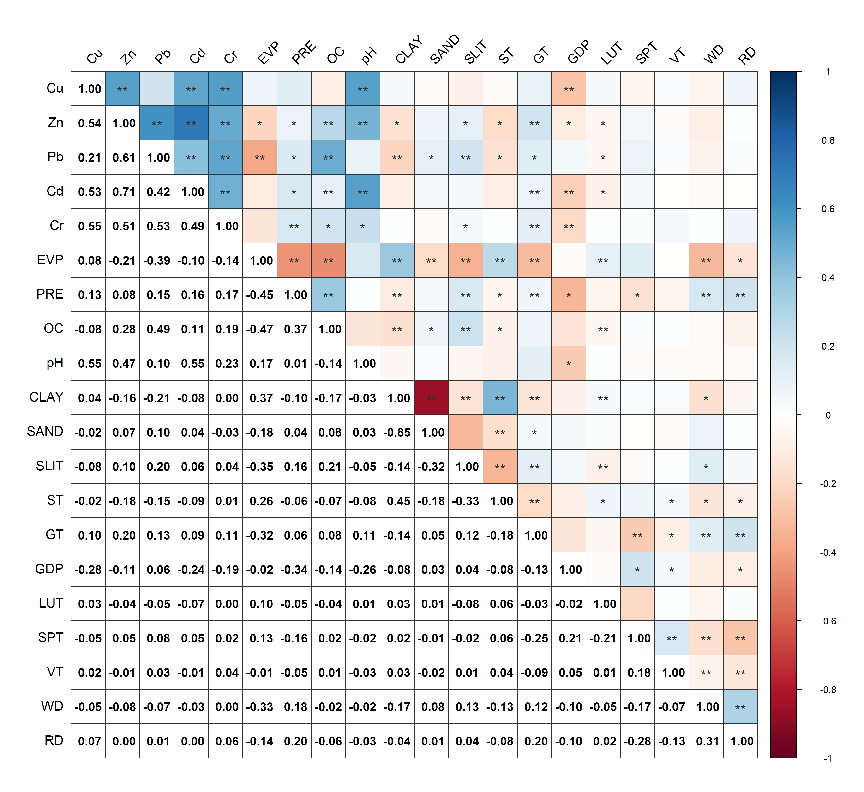
The colors indicate the strength of the correlation between the heavy metals and influencing factors. ** indicates a highly significant correlation (P < 0.01), and * indicates a significant correlation (P < 0.05)
Fig. 8 Correlations between heavy metals and influencing factors
4 Discussion
4.1 Evaluation of soil heavy metal pollution
Our findings reveal that the Cr concentrations in the study area are 1.35 times higher than the background value of Yunnan Province soils, indicating the presence of mild pollution. This is consistent with previous studies linking Cr concentration to similar geological formations and environmental conditions (Gan et al. 2019). However, when we used the national background values, the single-factor index for Cr reached 1.59, demonstrating that the choice of reference standard influenced pollution assessments. This observation emphasizes the need to consider regional background values in pollution studies to avoid overestimating or underestimating risks. Our results also indicate that there was localized Pb and Cd contamination, as shown by the ground accumulation index, with individual sites displaying moderate pollution levels. These findings correlate with studies reporting similar localized metal hotspots in regions with heavy mining and industrial activities (Y. Xu et al. 2021). The potential ecological risk analysis revealed several high-risk points for Cd, which can be attributed to its elevated toxicity coefficient; this result is also supported by research that found Cd to be a major pollutant due to its mobility and toxicity in acidic soils (Fan et al. 2023).
4.2 Influencing Factors of Heavy Metals in Soil
Climatic factors, including rainfall, evapotranspiration, and temperature, play a role in the distribution of heavy metals in soils, particularly Cr and Pb. Our results demonstrate a clear relationship between high rainfall areas and increased heavy metal leaching, especially for Pb. This observation is consistent with previous findings that heavy rainfall promotes the transport of heavy metals in soil (Meite 2018; Qiao et al. 2023). In karst regions, the unique hydrogeological conditions, such as rapid infiltration through fissures and conduits, may exacerbate metal leaching into groundwater, as observed in studies of abandoned mining sites in Southwest China (Deng et al. 2024; Qin et al. 2021). In addition, areas with high evapotranspiration (concentrated in the southeastern part of the study area) exhibited higher Cr concentrations, which supports the idea that evapotranspiration acts as a driving force for the accumulation of this metal in topsoil (Lima 2014). The spatial variation in rainfall and evapotranspiration observed in our study provides new insights into the complex interactions between climate and soil heavy metal dynamics, highlighting the need to consider both climatic factors and soil geochemistry in future pollution studies.
Soil factors, particularly pH, organic matter content, and texture, influence heavy metal accumulation in the study area. Our results show that soil pH and organic matter are the most critical factors affecting metal concentrations, which aligns with other research that has observed strong correlations between these properties and heavy metal bioavailability (Y. Wang et al. 2024). In karst soils, the natural weathering of carbonate rocks contributes to elevated geochemical backgrounds of heavy metals like Cd and Pb, as these metals are often enriched in residual phases during pedogenesis (N. Wei et al. 2025; Wen et al. 2020). Specifically, Pb accumulates to a greater extent in soils with a low pH value and a high content of organic matter, which is in line with similar research results (Defo 2016). Moreover, the strong interaction between pH and organic matter, as revealed by the GeoDetector results, indicates that these factors work synergistically to influence metal mobility. This observation mirrors findings from studies conducted in karst soils, where Cd enrichment was significantly impacted by the combined effects of pH and organic matter (Q. Zhang et al. 2019). For instance, iron oxyhydroxides, common in karst bauxites, act as scavengers for heavy metals like HREEs through adsorption mechanisms (Buccione et al. 2024), further emphasizing the role of soil mineralogy in metal retention.
In our study, the effect of the interaction between soil texture (especially clay content) and pH on heavy metal adsorption further confirmed the higher adsorption capacity of clays for heavy metals (Adhikari et al. 2024; Y. Wang et al. 2024). In karst regions, discontinuous clay layers may create vertical heterogeneity in metal distribution, as reported in contaminated industrial sites where Cd and Pb concentrations fluctuate with depth due to clay barriers (Deng et al. 2024). In addition to natural factors, anthropogenic activities such as GDP, land use, and proximity to roads can affect soil heavy metal concentrations. Our GeoDetector results show that GDP is a predictor of metal contamination, especially Cd. This finding is consistent with research showing that Cd contamination of agricultural soils near industrial areas is mainly caused by wastewater irrigation (Chen et al. 2024). Similarly, our study found that soils near agricultural areas with high production potential had higher levels of Cd and Zn, likely due to the long-term use of fertilizers, aligning with studies that linked heavy metal contamination in agricultural soils to intensive farming practices (Rostami et al. 2021). However, our observation that roads have a minimal impact on heavy metal content in the agricultural soils of this study area contrasts with other findings, where road proximity is identified as a major factor. This discrepancy suggests that local traffic intensity and road types may play a role in determining the extent of metal pollution from vehicular sources (De Silva et al. 2016).
4.3 Comparison of Correlation Analysis and GeoDetector Results
By comparing the results of the Spearman correlation analysis and GeoDetector, we identified both similarities and differences in the factors influencing heavy metals. Both methods highlighted pH and organic matter as the most significant factors, which is consistent with previous studies (Y. Wang et al. 2024). However, Zn and Cd showed certain correlations with topography in the correlation analysis, while GeoDetector did not identify topography as a significant factor. This discrepancy may arise from differences in the spatial resolution and factor stratification used in GeoDetector, emphasizing the need for careful interpretation when using GeoDetector in heterogeneous landscapes (Qiao et al. 2019).
4.4 Limitations
This study analyzed soil heavy metal pollution and its influencing factors in southwestern Yunnan, but several limitations need to be addressed in future research. It focused on the effects of climatic, social, soil, and distance-related factors, but owing to the constraints in acquiring spatial data, other significant factors—such as pesticide and fertilizer use, and industrial pollution—were not fully incorporated. These factors may affect heavy metal distribution but were not adequately considered in the analysis. While GeoDetector effectively identifies the impact of various factors, it faces challenges in multi-scale analysis. Future research should evaluate these factors at different spatial scales.
5 Conclusions
The five soil heavy metals and the factors affecting them were studied, and the main conclusions are as follows.
(1) The Cr content in the study area was 1.35 times the background value of the soil, the average contents of Cu, Zn, Pb, and Cd did not exceed the background values of soil elements in Yunnan Province, but their maximum values exceeded the screening values of soil pollution risk, and the coefficients of variation of the five heavy metals were greater than 0.1. Zn and Cd exhibited decreasing trends from northwest to southeast. The high-value areas for Cu were mainly distributed in the eastern-central part of the study area, the high-value areas for Pb were located in the northeastern and central parts of the study area, and the high-value areas for Cr were mainly located in the central-northwestern part of the study area and part of the southeastern part of the study area.
(2) The single-factor pollution index${\overline{P}}_{i}$ indicated that Cr pollution reached the light pollution level, with 9.23% of the points exceeding or reaching this level. For the other four elements, individual points reached the heavy pollution level. The overall pollution accumulation status in the study area was non-polluted based on the $\overline{I}$_{geo}, but there were strongly polluted spots. Based on the $\overline{P}$_{n}, it was concluded that the study area was lightly polluted, and the heavily polluted areas were located in the eastern-central part and some parts of the northwestern part of the study area. The results of the potential ecological risk evaluation showed that the overall pollution situation in the study area is of low ecological risk, but there are individual sites at high risk for Cd element.
(3) The correlation analysis and GeoDetector revealed that all 15 influencing factors had some influence on the soil heavy metals, among which the soil organic matter, soil pH, GDP, evapotranspiration, rainfall, and land use type were the main factors affecting the soil heavy metals in the study area. The results of the interaction detector revealed that pH∩OC was the combination with the strongest interaction effect (excluding Pb and Cr), and the results of the correlation analysis showed that the correlations between the soil heavy metals and pH, organic matter, GDP, and landform type were significant in the study area.
In summary, there is widespread Cr contamination in the study area, and the remaining four elements exceed safe concentrations in specific areas. The comparison of multiple pollution indices avoids the bias caused by individual indices making the results more accurate. GeoDetector and correlation analyses revealed that soil pH, soil organic matter, GDP, evapotranspiration, rainfall, and land-use type were the main factors affecting the soil heavy metals in the study area. This study provides a reference for the soil environment in the study area and the that can inform future research on sources of pollution.

Data availability
The data on heavy metals used in the study were collected by the research team itself, and the data on the remaining influencing factors have been cited as the source in the References and are available upon reasonable request to facilitate scientific sharing.

Author contribution
Sijing Sun: Writing–original draft, Methodology, Visualization. Junlei Wang: Investigation, Formal analysis. Liyuan Mu: Investigation, Validation. Naiming Zhang: Conceptualization, Supervision. Li Bao: Conceptualization, Funding acquisition, Writing–original draft, Writing–Review & Editing.

Declaration conflict of interest
The authors declare that they have no known competing financial interests or personal relationships that could have appeared to influence the work reported in this manuscript.

Funding
This study was funded by the National Natural Science Foundation of China-Yunnan Joint Fund (CN) (U2002210) and the Yunnan Science and Technology Talent and Platform Programme (202405AM340004).

References
Adhikari, K., Mancini, M., Libohova, Z., Blackstock, J., Winzeler, E., Smith, D. R., et al. (2024). Heavy metals concentration in soils across the conterminous USA: Spatial prediction, model uncertainty, and influencing factors. Science of The Total Environment, 919, 170972. https://doi.org/10.1016/j.scitotenv.2024.170972
Buccione, R., Ameur-Zaimeche, O., Ouladmansour, A., Kechiched, R., & Mongelli, G. (2024). Data-centric approach for predicting critical metals distribution: Heavy rare earth elements in cretaceous Mediterranean-type karst bauxite deposits, southern Italy. Geochemistry, 84(2), 126026. https://doi.org/10.1016/j.chemer.2023.126026
Chen, S., Gao, Y., Wang, C., Gu, H., Sun, M., Dang, Y., & Ai, S. (2024). Heavy metal pollution status, children health risk assessment and source apportionment in farmland soils in a typical polluted area, Northwest China. Stochastic Environmental Research and Risk Assessment, 38(6), 2383–2395.
De Silva, S., Ball, A. S., Huynh, T., & Reichman, S. M. (2016). Metal accumulation in roadside soil in Melbourne, Australia: Effect of road age, traffic density and vehicular speed. Environmental Pollution, 208, 102–109. https://doi.org/10.1016/j.envpol.2015.09.032
Defo, C. (2016). Investigating soils retention ratios and modelling geochemical factors affecting heavy metals retention in soils in a tropical urban watershed. Environment, Development and Sustainability, 19, 1649–1671. https://doi.org/10.1007/s10668-016-9819-2
Deng, J., Yu, J., Wang, X., Yu, D., Ma, H., Wu, Y., et al. (2024). Spatial distribution and migration characteristics of heavy metals at an abandoned industrial site in the Southwest of China. Journal of Hazardous Materials, 480, 136447. https://doi.org/10.1016/j.jhazmat.2024.136447
Fan, Q., Jiu, Y., Zou, D., Feng, J., Zhao, M., Zhang, Q., et al. (2023). Alkaline humic acid fertilizer alters the distribution, availability, and translocation of cadmium and zinc in the acidic soil–Sauropus androgynus system. Ecotoxicology and Environmental Safety, 268, 115698.
Gan, Y., Huang, X., Li, S., Liu, N., Li, Y. C., Freidenreich, A., et al. (2019). Source quantification and potential risk of mercury, cadmium, arsenic, lead, and chromium in farmland soils of Yellow River Delta. Journal of Cleaner Production, 221, 98–107. https://doi.org/10.1016/j.jclepro.2019.02.157
Gong, C., Wang, S., Lu, H., Chen, Y., & Liu, J. (2023). Research Progress on Spatial Differentiation and Influencing Factors of Soil Heavy Metals Based on Geographical Detector. Environmental Science, 44(5), 2799–2816. https://doi.org/10.13227/j.hjkx.202205206
Hakanson, L. (1980). An ecological risk index for aquatic pollution control.a sedimentological approach. Water Research, 14(8), 975–1001.
Hou, X., Zhang, X., & Editorial Committee of Chinese Vegetation Atlas, Chinese Academy of Sciences. (2001). 1:1,000,000 Vegetation Atlas of China. Beijing: Science Press.
Huang, C., Cai, L., Xu, Y., Wen, H., Jie, L., Hu, G., et al. (2022). Quantitative analysis of ecological risk and human health risk of potentially toxic elements in farmland soil using the PMF model. Land Degradation & Development, 33(11), 1954–1967. https://doi.org/10.1002/ldr.4277
Li, Y., Cheng, X., Liu, K., Yu, Y., & Zhou, Y. (2022). A new method for identifying potential hazardous areas of heavy metal pollution in sediments. Water Research, 224, 119065. https://doi.org/10.1016/j.watres.2022.119065
Lima, A. T. (2014). Evaporation as the transport mechanism of metals in arid regions. Chemosphere, 111, 639–647. http://dx.doi.org/10.1016/j.chemosphere.2014.05.027
Luo, H., Wang, Q., Guan, Q., Ma, Y., Ni, F., Yang, E., & Zhang, J. (2022). Heavy metal pollution levels, source apportionment and risk assessment in dust storms in key cities in Northwest China. Journal of Hazardous Materials, 422, 126878. https://doi.org/10.1016/j.jhazmat.2021.126878
Mamat, Z., Yimit, H., Ji, R. Z. A., & Eziz, M. (2014). Source identification and hazardous risk delineation of heavy metal contamination in Yanqi basin, northwest China. Science of The Total Environment, 493, 1098–1111.
Meite, F. (2018). Impact of rainfall patterns and frequency on the export of pesticides and heavy-metals from agricultural soils. Science of The Total Environment, 616–617, 500–509. https://doi.org/10.1016/j.scitotenv.2017.10.297
Mingyi S., Zuwei W., & Jiabao W. (2019). Assessment for ecological risk of soil heavy metals with hakanson index method: A review. Chinese Journal of Soil Science, 50(4), 1002–1008. https://doi.org/10.19336/j.cnki.trtb.2019.04.33
Qiao, P., Wang, S., Li, J., Zhao, Q., Wei, Y., Lei, M., et al. (2023). Process, influencing factors, and simulation of the lateral transport of heavy metals in surface runoff in a mining area driven by rainfall: A review. Science of The Total Environment, 857, 159119. https://doi.org/10.1016/j.scitotenv.2022.159119
Qiao, P., Yang, S., Lei, M., Chen, T., & Dong, N. (2019). Quantitative analysis of the factors influencing spatial distribution of soil heavy metals based on geographical detector. Science of the Total Environment, 664, 392–413. https://doi.org/10.1016/j.scitotenv.2019.01.310
Qin, W., Han, D., Song, X., & Liu, S. (2021). Sources and migration of heavy metals in a karst water system under the threats of an abandoned Pb–Zn mine, Southwest China. Environmental Pollution, 277, 116774. https://doi.org/10.1016/j.envpol.2021.116774
Rostami, S., Kamani, H., Shahsavani, S., & Hoseini, M. (2021). Environmental monitoring and ecological risk assessment of heavy metals in farmland soils. Human and Ecological Risk Assessment, 27(2), 392–404. https://doi.org/10.1080/10807039.2020.1719030
Song, Y., Wang, J., Ge, Y., & Xu, C. (2020). An optimal parameters-based geographical detector model enhances geographic characteristics of explanatory variables for spatial heterogeneity analysis: cases with different types of spatial data. GIScience & Remote Sensing, 57(5), 593–610.
Wang, J., & Xu, C. (2017). Geodetector: Principle and prospective. Acta Geographica Sinica, 72(1), 116–134. https://doi.org/10.11821/dlxb201701010
Wang, Y., Zhang, Z., Li, Y., Liang, C., Huang, H., & Wang, S. (2024). Available heavy metals concentrations in agricultural soils: Relationship with soil properties and total heavy metals concentrations in different industries. Journal of Hazardous Materials, 471, 134410. https://doi.org/10.1016/j.jhazmat.2024.134410
Wei, F., Chen, J., & Wu, Y. (1990). Background values of soil elements in China. Beijing: China Environmental Science Press.
Wei, N., Gu, X., Wen, Y., Guo, C., & Ji, J. (2025). Geochemical speciation and activation risks of Cd, Ni, and Zn in soils with naturally high background in karst regions of southwestern China. Journal of Hazardous Materials, 486, 137100. https://doi.org/10.1016/j.jhazmat.2025.137100
Wen, Y., Li, W., Yang, Z., Zhang, Q., & Ji, J. (2020). Enrichment and source identification of Cd and other heavy metals in soils with high geochemical background in the karst region, Southwestern China. Chemosphere, 245, 125620. https://doi.org/10.1016/j.chemosphere.2019.125620
Wu, Z., Hou, Q., Yang, Z., Yu, T., Li, D., Lin, K., & Ma, X. (2024). Identification of factors driving the spatial distribution of molybdenum (Mo) in topsoil in the Longitudinal Range-Gorge Region of Southwestern China using the Geodetector model. Ecotoxicology and Environmental Safety, 271, 115846. https://doi.org/10.1016/j.ecoenv.2023.115846
Xiang, M., Li, Y., Yang, J., Lei, K., Li, Y., Li, F., et al. (2021). Heavy metal contamination risk assessment and correlation analysis of heavy metal contents in soil and crops. Environmental Pollution, 278, 116911. https://doi.org/10.1016/j.envpol.2021.116911
Xu, X. (2017). Spatial Distribution of China’s GDP in Kilometer Grid Dataset. https://doi.org/10.12078/2017121102
Xu, X. (2018). Chinese watershed and river network dataset based on DEM extraction. https://doi.org/10.12078/2018060101
Xu, X. (2022). Annual spatially interpolated dataset of meteorological elements in China. https://doi.org/10.12078/2022082501
Xu, X., Liu, J., Zhang, S., Li, R., Yan, C., & Wu, S. (2020). China Multi-period Land Use Remote Sensing Monitoring Data Set（CNLUCC）. https://doi.org/10.12078/2018070201
Xu, X., & Liu, L. (2017). China Farmland Production Potential Dataset. https://doi.org/10.12078/2017122301
Xu, Y., Shi, H., Fei, Y., Wang, C., Mo, L., & Shu, M. (2021). Identification of Soil Heavy Metal Sources in a Large-Scale Area Affected by Industry. Sustainability, 13(2), 511. https://doi.org/10.3390/su13020511
Yang, J., Wang, J., Zhao, C., Wang, L., Wan, X., Shi, H., et al. (2024). Identifying driving factors of soil heavy metal at the mining area scale: Methods and practice. Chemosphere, 350, 140936. https://doi.org/10.1016/j.chemosphere.2023.140936
Zhang, J., GAO, Y., Wang, G., Jin, Z., & Yang, M. (2021). Spatial Differentiation and Influencing Factors of Heavy Metal Content in Soils of Typical River Valley City. Ecology and Environmental Sciences, 30(6), 1276–1285. https://doi.org/10.16258/j.cnki.1674-5906.2021.06.019
Zhang, Q., Han, G., Liu, M., & Liang, T. (2019). Spatial distribution and controlling factors of heavy metals in soils from Puding Karst Critical Zone Observatory, southwest China. Environmental Earth Sciences, 78(9), 279. https://doi.org/10.1007/s12665-019-8280-6
Zhang, Y., Wu, F., Zhang, X., & Cao, N. (2017). Pollution characteristics and ecological risk assessment of heavy metals in three land-use types on the southern Loess Plateau, China. Environmental Monitoring and Assessment, 189(9), 470. https://doi.org/10.1007/s10661-017-6140-y

