Appendix
Appendix 1: Variables’ description
Financial group | Variable | Description
Liquidity | X1 | Current Ratio
Liquidity | X2 | Quick Ratio
Liquidity | X3 | Interest Expense to Total Revenue
Liquidity | X4 | Total Liability to Total Assests
Liquidity | X5 | Working Capital to Total Assets
Liquidity | X6 | Current Assets to Total Assets
Liquidity | X7 | Cash to Total Assests
Liquidity | X8 | Quick Assets to Total Assets
Liquidity | X9 | Quick Assets to Current Liability
Liquidity | X10 | Cash to Current Liability
Liquidity | X11 | Current Liability to Total Assests
Liquidity | X12 | Inventory to Working Capital
Liquidity | X13 | Inventory to Current Liability
Liquidity | X14 | Inventory to Total Assets
Liquidity | X15 | Working Capital to Equity
Liquidity | X16 | Long-Term Liability to Current Assets
Liquidity | X17 | Current Liability to Current Assets
Capital Structure | X18 | Equity to Total Assets
Capital Structure | X19 | Total Liability to Total Assets
Capital Structure | X20 | (Long-term Liability + Equity) to Fixed Assets
Capital Structure | X21 | Current Liability to Total Liability
Capital Structure | X22 | Current Liability to Equity
Capital Structure | X23 | Equity to Long-term Liability
Capital Structure | X24 | Total Liability to Equity
Capital Structure | X25 | Degree Of Financial Leverage
Capital Structure | X26 | Interest Coverage Ratio
 |  | Profitability
Profitability | X27 | Return On Assets (ROA)
Profitability | X28 | Return On Equity (ROE)
Profitability | X29 | Gross Profit to Net Sales
Profitability | X30 | Operating Income to Net Sales
Profitability | X31 | Pre-tax Income to Net Sales
Profitability | X32 | Net Income to Net Sales
Profitability | X33 | EPS to Net Income
Profitability | X34 | Retained Earnings to Total Assets
Profitability | X35 | Total Income to Total Expenses
Profitability | X36 | Net Income to Total Assets
Profitability | X37 | Gross Profit to Sales
Profitability | X38 | Net Income to Stockholders' Equity
 |  | Turnover Ratio
Turnover Ratios | X39 | (Inventory + Account Receivables) to Equity
Turnover Ratios | X40 | Total Assets Turnover
Turnover Ratios | X41 | Account Receivables Turnover
Turnover Ratios | X42 | Account Payables Turnover
Turnover Ratios | X43 | Inventory Turnover
Turnover Ratios | X44 | Fixed Assets Turnover
Turnover Ratios | X45 | Equity Turnover
Turnover Ratios | X46 | Current Assets to Sales
Turnover Ratios | X47 | Quick Assets to Sales
Turnover Ratios | X48 | Working Capital to Sales
Turnover Ratios | X49 | Cash to Sales
Turnover Ratios | X50 | Cash Flow to Sales
Cash Flow Ratios | X51 | Cash Flow From Operating Activity to Current Liabilities
Cash Flow Ratios | X52 | Cash Flow From Operating Activity to Interest Expenses
Cash Flow Ratios | X53 | Cash Flow to Total Assets
Cash Flow Ratios | X54 | Cash Flow to Total Liability
Cash Flow Ratios | X55 | Cash Flow to Equity
Growth | X56 | Gross Profit Growth Rate
Growth | X57 | Operating Income Growth
Growth | X58 | Net Income Growth
Growth | X59 | Total Assets Growth
Growth | X60 | Total Equity Growth
Growth | X61 | ROA Growth
Growth | X62 | ROE Growth

Appendix 2: Descriptive statistics for liquidity group
 | Obs. | Mean | Std. | Min | Max
X1 | 6975 | 2.990 | 28.562 | 0.050 | 2121.488
X2 | 6975 | 2.037 | 26.903 | 0.000 | 2120.310
X3 | 6975 | 0.039 | 0.219 | -1.596 | 8.979
X4 | 6975 | 0.492 | 0.223 | 0.000 | 1.294
X5 | 6975 | 0.220 | 0.223 | -0.675 | 1.000
X6 | 6975 | 0.609 | 0.234 | 0.005 | 1.000
X7 | 6975 | 0.096 | 0.110 | 0.000 | 1.000
X8 | 6975 | 0.400 | 0.202 | -0.144 | 1.000
X9 | 6975 | 1.920 | 26.912 | -0.154 | 2120.310
X10 | 6975 | 0.170 | 0.177 | 0.000 | 1.000
X11 | 6975 | 0.388 | 0.215 | 0.000 | 1.247
X12 | 6975 | 2.157 | 46.689 | -2021.945 | 2076.083
X13 | 6975 | 0.695 | 4.558 | 0.000 | 369.798
X14 | 6975 | 0.209 | 0.182 | 0.000 | 0.954
X15 | 6975 | 0.406 | 0.532 | -9.321 | 8.712
X16 | 6975 | 0.421 | 1.615 | 0.000 | 75.840
X17 | 6975 | 0.717 | 0.564 | 0.000 | 19.988

Appendix 3: Descriptive statistics for capital structure group
 | Obs. | Mean | Std. | Min | Max
X18 | 6975 | 0.5032 | 0.2231 | -0.2945 | 0.9996
X19 | 6975 | 0.4925 | 0.2228 | 0.0005 | 1.2945
X20 | 6975 | 75.701 | 2220.983 | -1.4496 | 155461.1
X21 | 6975 | 0.807 | 0.239 | 0.008 | 1
X22 | 6975 | 1.3044 | 2.409 | -12.549 | 102.9
X23 | 6975 | 201751.4 | 16825572 | -18.4336 | 1.41E+09
X24 | 6975 | 1.6516 | 2.8276 | -19.37 | 140.033
X25 | 6975 | 7.3357 | 428.82 | -5535.68 | 33808.9
X26 | 6975 | 464.465 | 23200.05 | -21445 | 1922187

Appendix 4: Descriptive statistics for profitability group
 | Obs. | Mean | Std. | Min | Max
X27 | 6975 | 0.0646 | 0.0793 | -0.6246 | 0.8391
X28 | 6975 | 0.1287 | 0.1688 | -6.0811 | 2.9309
X29 | 6975 | 0.1949 | 0.2865 | -11.2742 | 9.3848
X30 | 6975 | 0.0333 | 2.2660 | -135.1348 | 35.1079
X31 | 6975 | 0.0456 | 2.2092 | -133.7451 | 35.4683
X32 | 6975 | 0.0286 | 2.0455 | -114.1053 | 37.4590
X33 | 6975 | 0.0000 | 0.0000 | 0.0000 | 0.0000
X34 | 6975 | 0.0662 | 0.1185 | -1.6317 | 0.6105
X35 | 6975 | 13.1731 | 33.3029 | -42.9948 | 2458.6786
X36 | 6975 | 0.0618 | 0.0779 | -0.9960 | 0.7837
X37 | 6975 | 0.1890 | 0.4108 | -27.7999 | 4.0429
X38 | 6975 | 0.2548 | 0.3646 | -1.7245 | 14.4936

Appendix 5: Descriptive statistics for turnover ratio group
 | Obs. | Mean | Std. | Min | Max
X39 | 6975 | 1.686 | 2.503 | -4.559 | 130.850
X40 | 6975 | 1.151 | 1.347 | -0.003 | 20.071
X41 | 6975 | 53.241 | 1996.595 | -0.040 | 164953.757
X42 | 6975 | 46.388 | 942.617 | -1.739 | 62995.501
X43 | 6975 | 2735.333 | 114108.117 | -2.000 | 8799546.871
X44 | 6975 | 34.719 | 467.549 | -0.379 | 32540.828
X45 | 6975 | 3.084 | 6.133 | -8.593 | 280.805
X46 | 6975 | 2.632 | 38.857 | -290.216 | 2242.019
X47 | 6975 | 1.889 | 36.519 | -290.216 | 2241.890
X48 | 6975 | 1.140 | 31.453 | -862.023 | 2115.984
X49 | 6975 | 0.207 | 1.477 | -9.590 | 75.478
X50 | 6975 | -0.019 | 2.322 | -151.078 | 47.510

Appendix 6: Descriptive statistics for cash flows ratios group
 | Obs. | Mean | Std. | Min | Max
X51 | 6975 | 0.230957 | 5.129807 | -389.575 | 46.9385
X52 | 6975 | -867.721 | 49736.29 | -3986268 | 107979.4
X53 | 6975 | 0.004895 | 0.091277 | -2.13169 | 0.99993
X54 | 6975 | 0.04188 | 3.401343 | -73.6868 | 218.3348
X55 | 6975 | 0.016035 | 0.230323 | -2.90829 | 6.694322

Appendix 7: Descriptive statistics for growth group
 | Obs. | Mean | Std. | Min | Max
X56 | 6975 | 0.435777 | 14.91954 | -348.245 | 1073.964
X57 | 6975 | 1.288135 | 78.60207 | -875.523 | 6161.698
X58 | 6975 | -2.05294 | 148.4937 | -11783 | 2182.516
X59 | 6975 | 0.696499 | 36.87091 | -0.84164 | 2975.898
X60 | 6975 | 0.418074 | 17.59267 | -33.0513 | 1442.047
X61 | 6975 | -0.66777 | 37.66458 | -1715.34 | 1033.853
X62 | 6975 | -0.90652 | 41.63029 | -1941.41 | 910.681

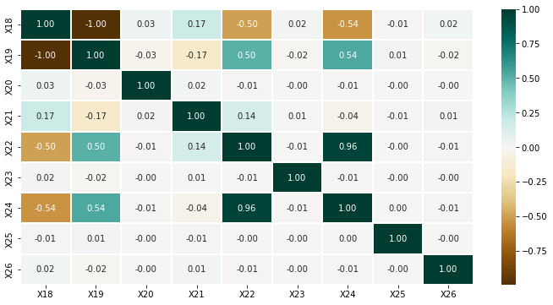
Appendix 8: Correlation coefficient between capital structure variables

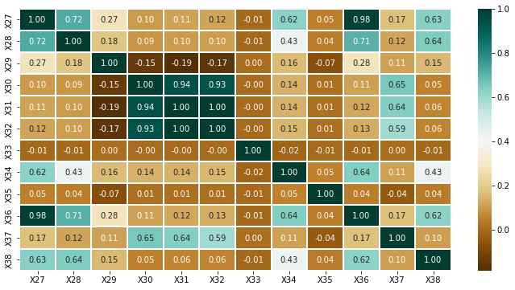
Appendix 9: Correlation coefficient between profitability variables
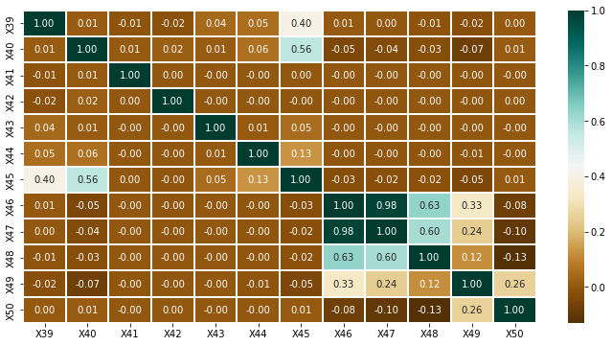
Appendix 10: Correlation coefficient between capital turnover ratio variables

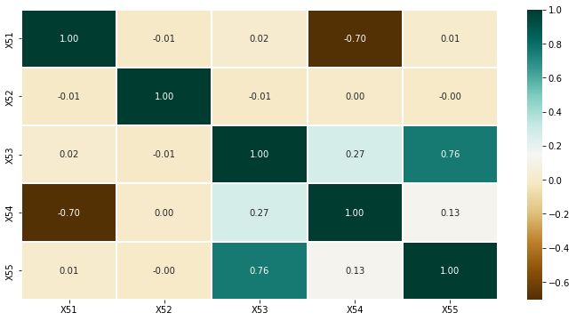
Appendix 11: Correlation coefficient between cash flows ratios variables
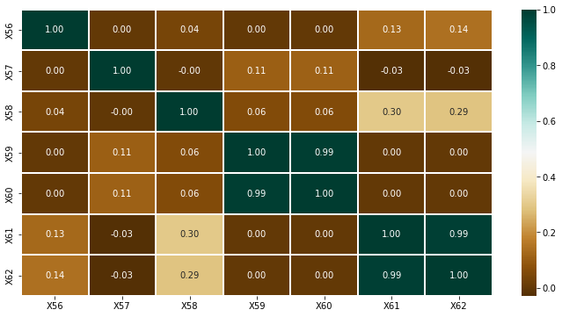
Appendix 12: Correlation coefficient between growth variables

Appendix 13. The features important
Features | Fscore | Features | Fscore | Features | Fscore
X40 | 115 | X59 | 47 | X53 | 34
X46 | 94 | X3 | 46 | X11 | 32
X33 | 89 | X7 | 46 | X58 | 32
X6 | 84 | X21 | 44 | X9 | 31
X41 | 77 | X14 | 43 | X16 | 31
X42 | 72 | X57 | 43 | X30 | 31
X60 | 68 | X26 | 43 | X15 | 31
X43 | 66 | X12 | 42 | X27 | 28
X35 | 65 | X13 | 41 | X37 | 28
X25 | 59 | X36 | 40 | X20 | 28
X44 | 58 | X56 | 40 | X4 | 25
X51 | 58 | X49 | 39 | X48 | 24
X34 | 57 | X55 | 38 | X62 | 23
X47 | 56 | X39 | 37 | X5 | 21
X52 | 53 | X10 | 37 | X2 | 20
X8 | 52 | X61 | 36 | X31 | 20
X38 | 52 | X28 | 35 | X22 | 19
X29 | 48 | X54 | 35 | X1 | 16
X45 | 47 | X32 | 35 | X18 | 10
X50 | 47 | X23 | 35 | X24 | 10
X59 | 47

