SUPPLEMENTARY MATERIAL

Decoding KGK VI Population Movements: Strontium Isotope and Proteomic Insights from the Gumelnița Site (Romania)

Aurélien Tafani, Enrico Greco, Robert H. Tykot, Pierluigi Barbieri, Marco Gaspari, Caterina Gabriele, Andreea Toma, Mihaela Culea, Bogdan Manea, Adelina Darie, Vasile Opriș, Theodor Ignat, Gabriel Vasile, Adrian Bălășescu, Valentin Radu, Gabriel Popescu, Cristina Covătaru, Elia Marin, Kévin Salesse, Hannah F. James, Christophe Snoeck, Cătălin Lazăr

Table of contents

Supplementary Figure S1……………………………………………………………………………2
Supplementary Figure S2……………………………………………………………………………2
Supplementary Figure S3……………………………………………………………………………3
Supplementary Figure S4……………………………………………………………………………4
Supplementary Figure S5……………………………………………………………………………5
Supplementary Figure S6……………………………………………………………………………7
Supplementary Figure S7……………………………………………………………………………8
Supplementary Figure S8……………………………………………………………………………9
References……………………………………………….………………….11

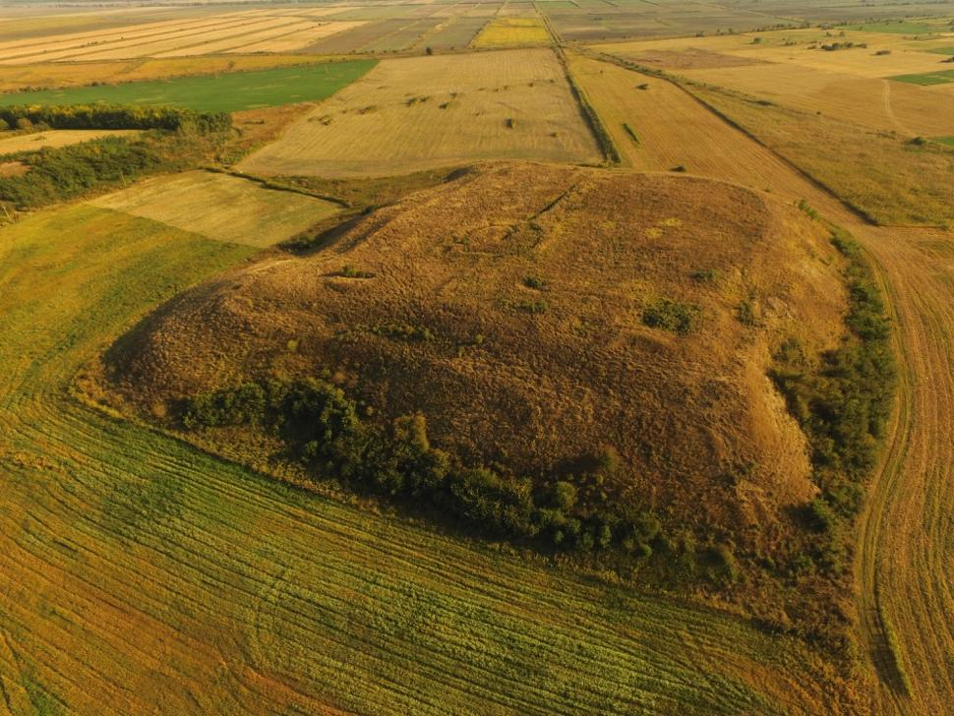
Figure S1. Gumelnița tell settlement (Romania).
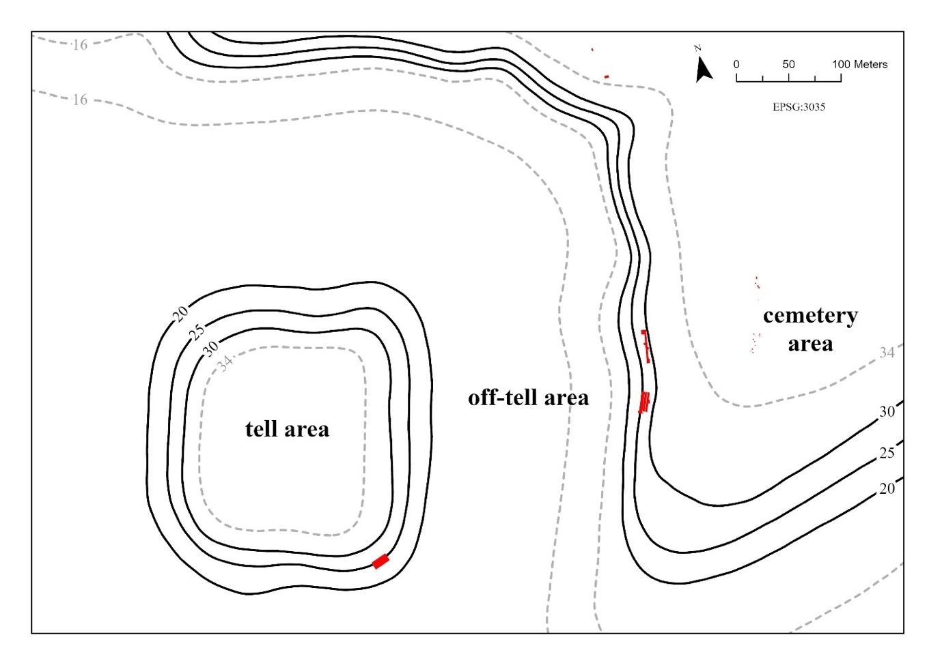
Figure S2. Investigated zones on the Gumelnița site and location of the excavation areas (marked with red) made between 2017 and 2022 by our team.
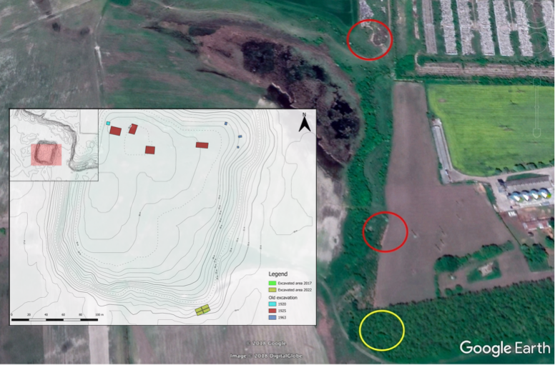
Figure S3. The tell and cemetery at Gumelnița and the location of the investigated areas. In the cemetery (right side of image), the red circles mark the zones explored by our team between 2017 and 2023. The yellow circle marks the approximate area where the first graves in this cemetery were excavated in the 1960s.

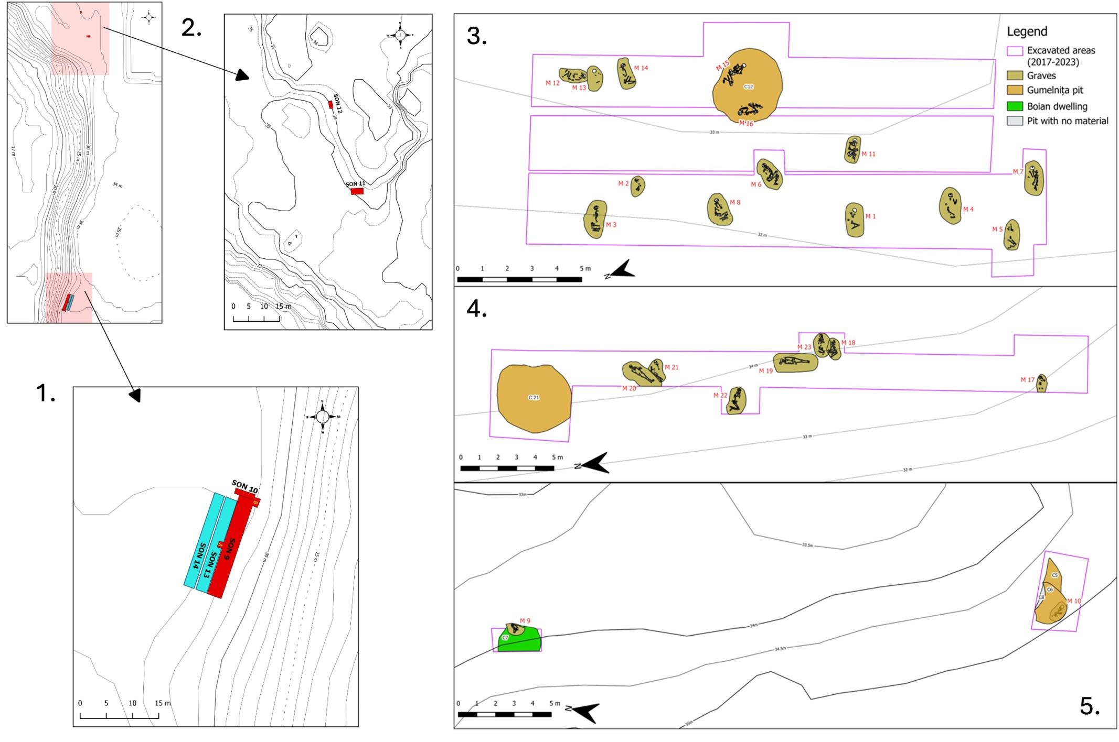
Figure S4. The cemetery at Gumelnița and the location of the investigated areas between 2017-2022. 1 and 2 designate the areas investigated by our team. On the right (3, 4 and 5) is the plan of the excavated trenches, graves and other features (after Lazăr et al. 2021, modified).
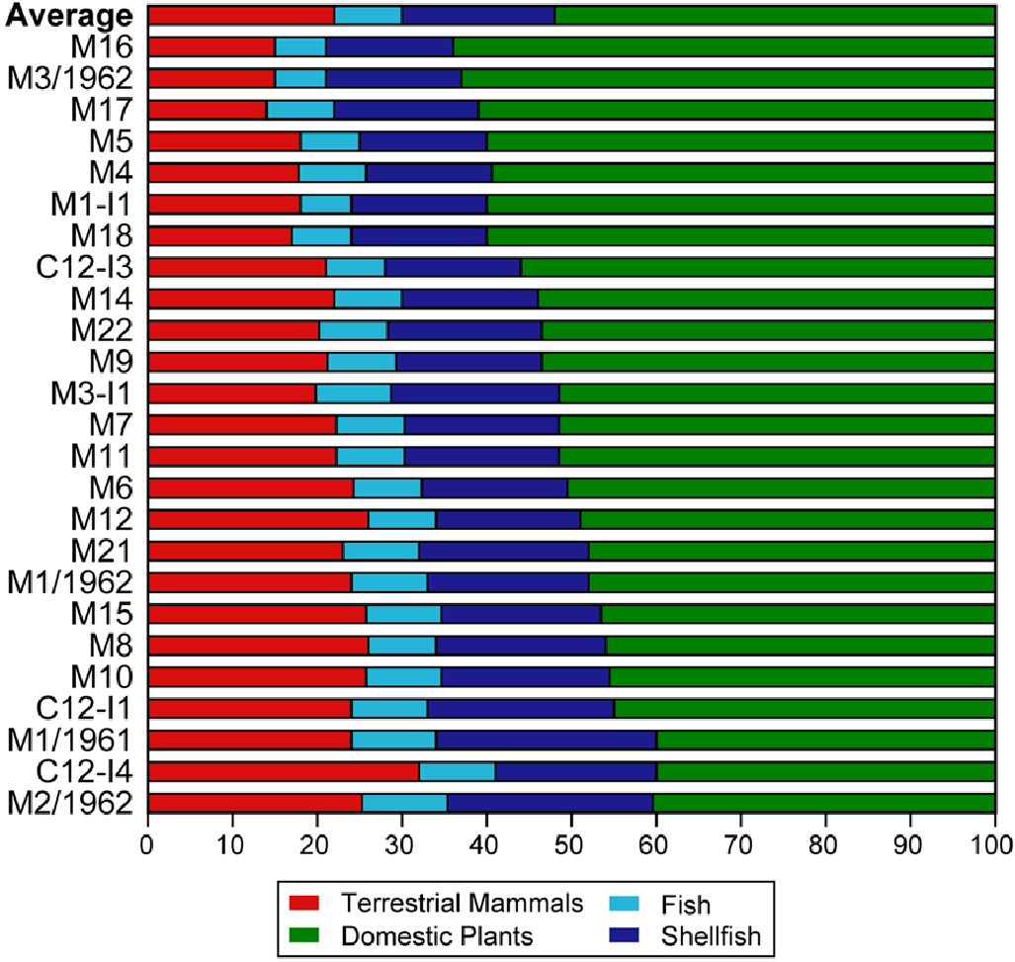
Figure S5. Dietary profiles of human population investigated at the Gumelnița site estimated by FRUITS (after García-Vázquez et al. 2023).

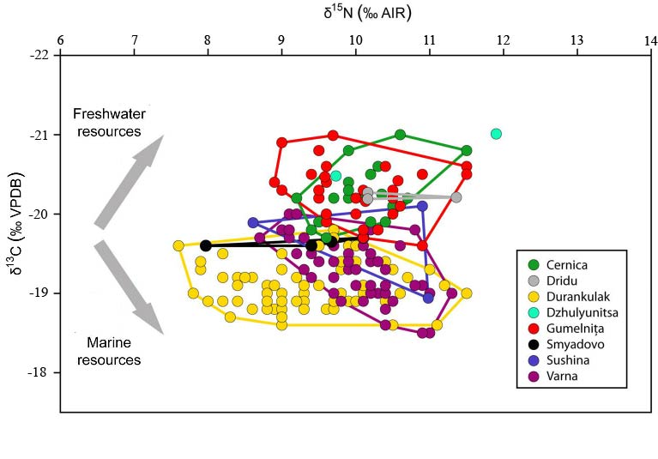
Figure S6. Dietary profiles of human population from various Neolithic/Eneolithic sites in the Northern Balkans (Romania and Bulgaria), excluding lactating children and neonates (after García-Vázquez et al. 2023, modified).

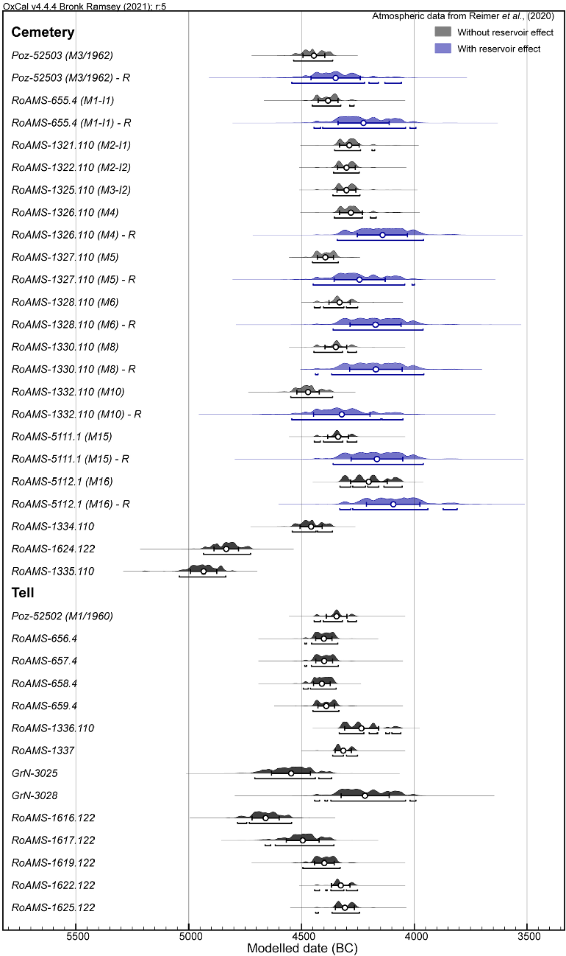
Figure S7. Available radiocarbon data for Gumelnița site (tell settlement and cemetery) lcalibrated with Oxcal. R indicates that the radiocarbon was calibrated with the FRE (in blue). Mean (empty circle), σ and 2σ are represented in each of the radiocarbon dates (after García-Vázquez et al. 2023).
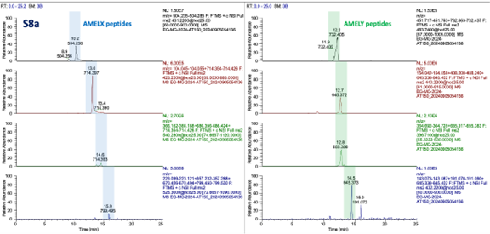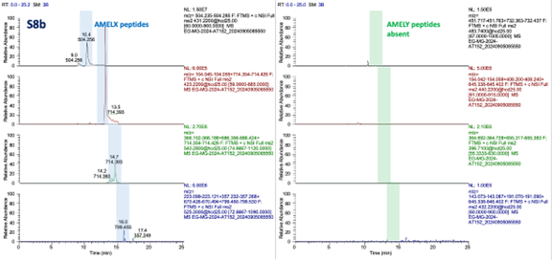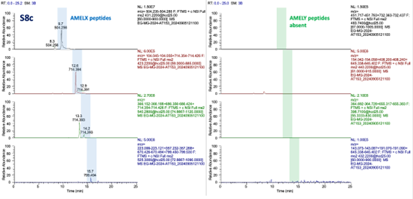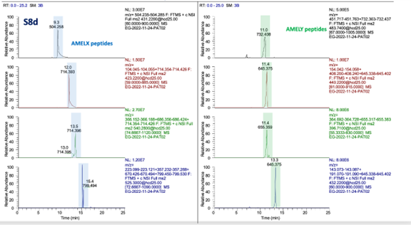

Figure S8. LC-MS/MS proteomic analysis of amelogenins. 8a) Sample AT150, 8b) Sample AT152; 8c) Sample AT153; 8d) Sample AT002/AT007. The right column shows that samples 8a and 8d belong to male individuals, whereas samples 8b and 8c belong to female individuals.
References

García-Vázquez, A., A. Bălășescu, G. Vasile, M. Golea, V. Radu, V. Opriș, T. Ignat, M. Culea, C. Covataru, G. Sava, and C. Lazăr, 2023, Entanglements of the terrestrial-aquatic mixed diet: a stable isotopes perspective on the Chalcolithic human population from Gumelnița site (Romania), Scientific Reports, 13, 8499.
Lazăr, C., 2001, Date noi privind unele morminte Gumelnitene, Cultura si Civilizatie la Dunarea de Jos, 16-17, 173-183.
Lazăr, C., A. Bălăşescu, I. Crăciunescu, C. Covătaru, M. Danu, A. Darie, M. Dimache, O. Frujina, M. Golea, C. Haită, T. Ignat, B. Manea, M. Mărgărit, V. Opriş, V. Radu, T. Sava, G. Sava, D. Ștefan, and G. Vasile, 2017, Gumelnița: Then and Now. The research results of the 2017 fieldwork, Studii de Preistorie, 14, 119‐174.
Lazăr, C., V. Opriș, T. Ignat, B. Manea, O. Frujină, C. Covătaru, A. Darie, A. Bălășescu, V. Radu, G. Vasile, M. Golea, M. Mărgărit, G. Popescu, M. Dimache, D. Pîrvulescu, M. Streinu, B. Șandric, M. Tufaru, A. Iancu, G. Dinu, V. Parnic, C. Căpiță, T. Zavalaș, A. Dima, and T. Sava, 2020, Gumelnița: research results of the 2018 and 2019 fieldwork seasons, Revista de Cercetări Arheologice și Numismatice, 6, 13-100.
Lazăr, C., V. Opriș, T. Ignat, C. Covătaru, B. Manea, G. Popescu, A. Darie, A. Bălășescu, V. Radu, G. Vasile, M. Mărgărit, M. Dimache, M. Golea, A. Toma, V. I. Bîndea, C. Roth, D. Pîrvulescu, T. Zavalaș, V. Parnic, and L. Carozza, 2021, Gumelnița: research results of the 2021 fieldwork season, Revista de Cercetări Arheologice și Numismatice, 7, 13-54.
Lazăr, C., 2021, Rituri şi Ritualuri Funerare în Neoliticul şi Eneoliticul din România: Târgovişte, Cetatea de Scaun.
Reimer, P.J., Austin, W. E. N., Bard, E., Bayliss, A., Blackwell, P. G., Bronk Ramsey, C.,Talamo, S. et al., 2020, The IntCal20 northern hemisphere radiocarbon age calibration curve (0–55 cal kBP). Radiocarbon 62, 725–757, doi:10.1017/RDC.2020.41.

