Supplementary Material
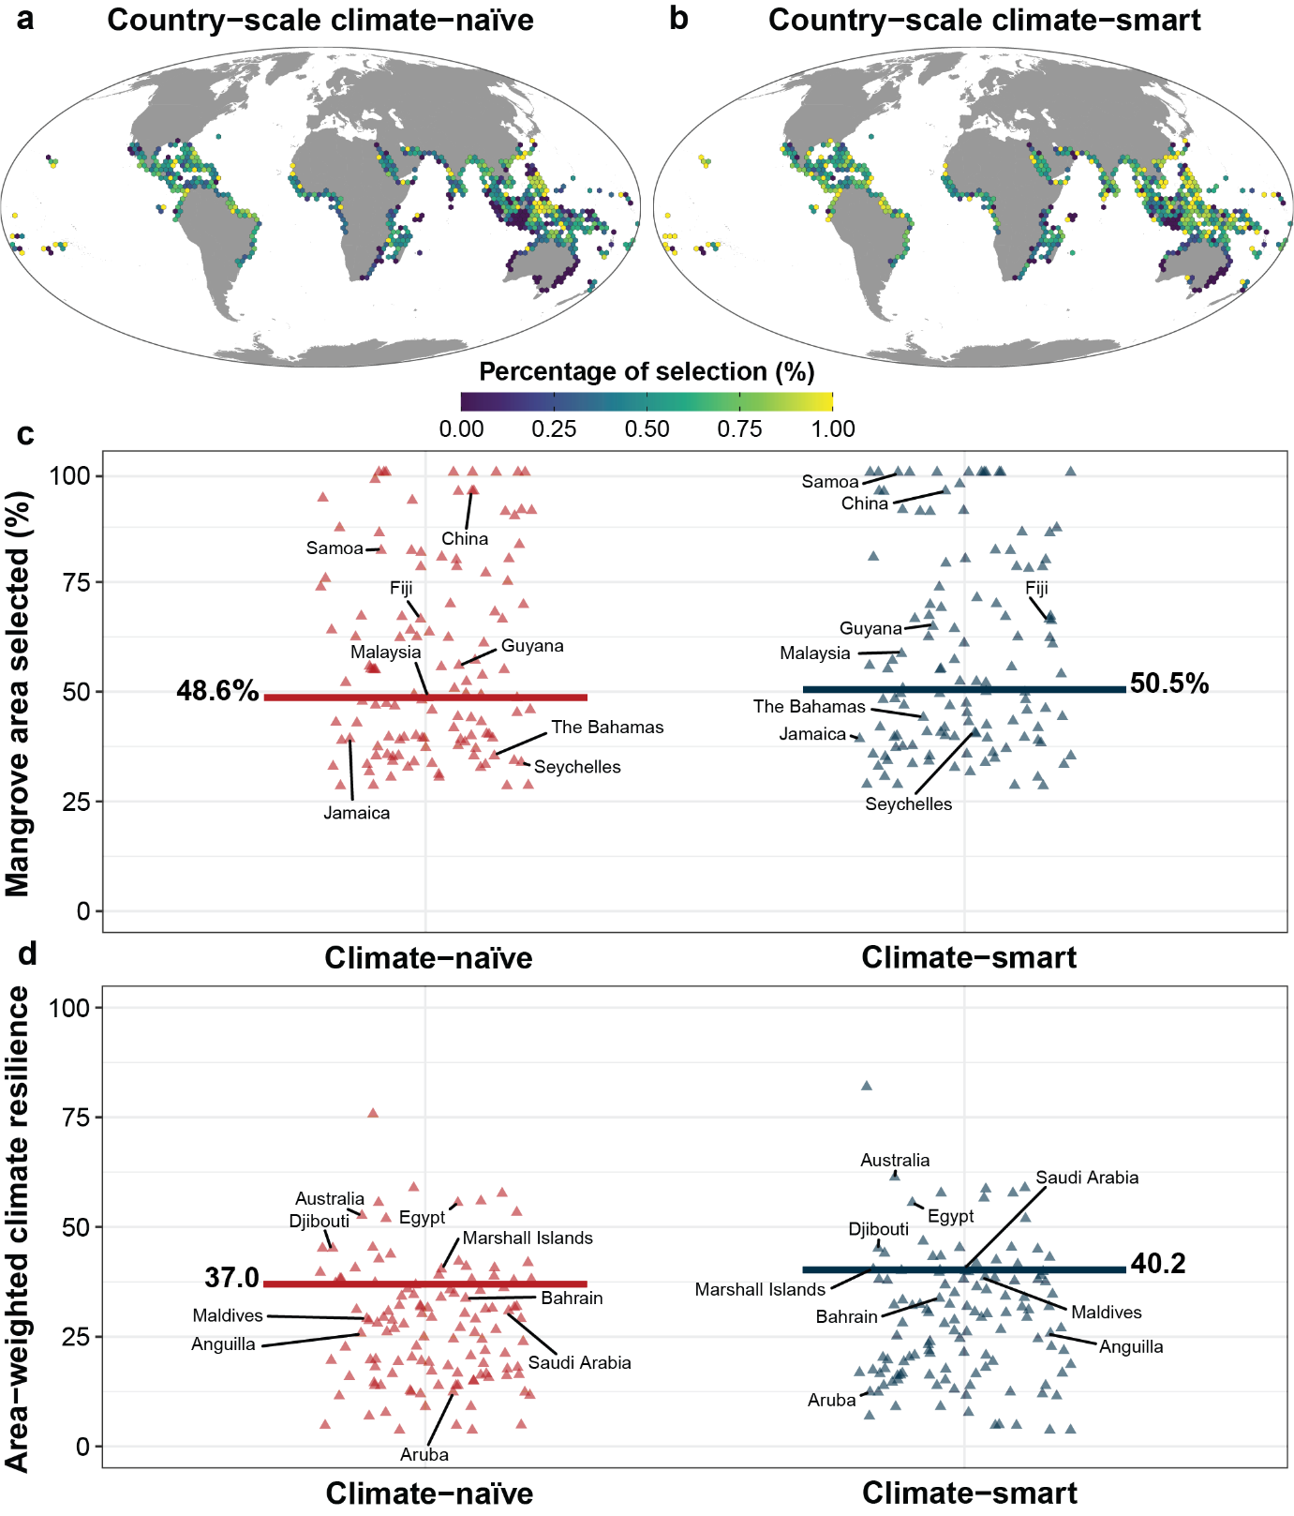
Supp. Fig. 1 | Country-scale results of the climate-naïve and climate-smart prioritisations. Results of the a-b, country-scale a, climate-naïve and b, climate-smart spatial prioritisation. Note that the % selection is shown because the original 631 km² for each planning unit in the analysis was aggregated at a resolution of ~63,000 km² for visualisation. c, % mangrove area selected and d, area-weighted climate resilience of the mangrove areas selected in the prioritisations by country (each country is a triangle). Both prioritisations used a climate-smart threshold of 0.3. The horizontal lines show c, the total % of mangrove area selected and d, the global average climate resilience.

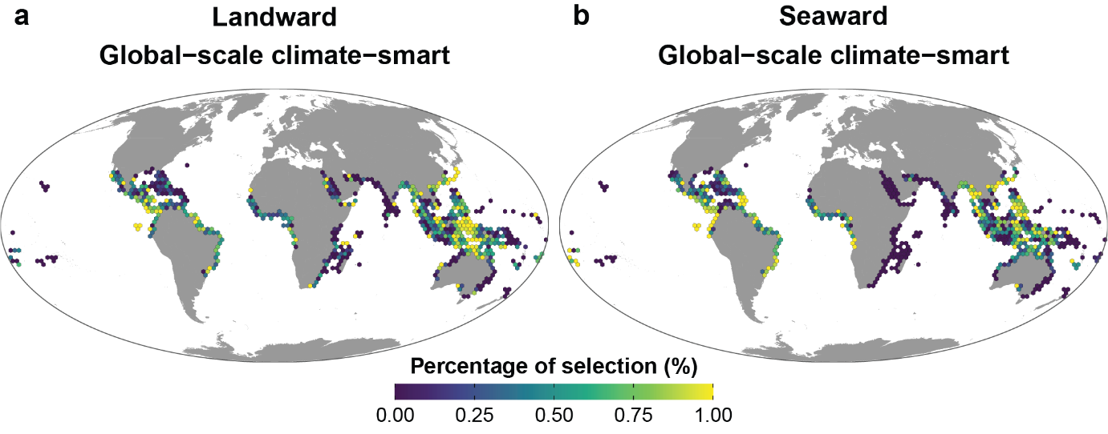
Supp. Fig. 2 | Global-scale climate-smart results of the landward and seaward prioritisations. Results of the a-b, global-scale climate smart a, landward and b, seaward spatial prioritisation. Note that the % selection is shown because the original 631 km² for each planning unit in the analysis was aggregated at a resolution of ~63,000 km² for visualisation.

