Vehicle-specific power-based emission modeling using unsupervised machine learning techniques

Chandrashekar Chowdappa¹, Pritha Chatterjee², Digvijay S. Pawar^{3*}
¹Research Scholar, Department of Civil Engineering, Indian Institute of Technology Hyderabad, Kandi, Sangareddy - 502285, India, E-Mail: ce18resch11009@iith.ac.in
²Assistant Professor, Department of Civil Engineering, Adjunct Faculty of Department of Climate Change, Indian Institute of Technology Hyderabad, Kandi, Sangareddy - 502285, India, E-Mail: pritha@ce.iith.ac.in
^{3*}Associate Professor, Department of Civil Engineering, Indian Institute of Technology Hyderabad, Kandi, - 502285, India, E-Mail: dspawar@ce.iith.ac.in

Supplementary Information
K-means algorithm
The K-means clustering method is an unsupervised approach used to get intuition into the data structure. The aim of k-means clustering is to divide n objects into k groups, where each object is assigned to the cluster with the closest average. This technique creates k distinct clusters with the greatest possible differentiation. The optimal number of clusters k that results in the maximum separation (distance) is not known beforehand and must be determined from the data. K-means clustering seeks to minimize the objective function, which is also known as the sum of squared error (sse) function as depicted in Eq. (S1)
$j= \sum_{j=1}^{k}{\sum_{i=1}^{n}{{\left\|{x_{i}}^{\left(j\right) }-c_{j}\right\|}^{2}}}$ (S1)
Where,
j- objective function, k – represents the number of clusters, n- number of cases, $x_{i}$ – case i, $c_{j}$ - centroid for cluster j, ${x_{i}}^{\left(j\right) }-c_{j}$ - distance function. The k-means clustering algorithm involves the following steps.
a) Randomly select k data points from the data sets (without replacement) to serve as the initial centroids for the k-cluster, where k is the specified number of clusters.
b) Assign each data point to the nearest centroid, forming a k-cluster
c) Compute the new centroids by averaging the data points within each cluster
d) Repeat steps b and c until there is no change in the centroids
K-medoids
In contrast to k-means, k-medoid uses the actual data points as cluster representatives (medoids) instead of using the mean to represent each cluster. (Mohammadnazar et al., 2024). This study used partition around medoids (PAM) for clustering with K-medoids, which is a commonly used algorithm proposed by Mohammadnazar et al., 2024. The steps for a PAM-based-K-medoids clustering algorithm are as follows:
(a) Choose k initial medoids randomly from the data sets
(b) Assigning each data point to the nearest medoid based on the Euclidean distance and the assignment of clusters can be expressed mathematically, as shown in Eq. (S2).
$Cluster \left(x_{i}\right)={}_{mj}^{argmin d}{(x_{i}}-m_{j})$ (S2)
For each data point $x_{i},$calculate the distance to each of the medoid $m_{j}$, and assign $x_{i}$ to the cluster represented by the nearest medoid.
(c) For each cluster $c_{j}$, Identify the point that minimizes the total dissimilarity of all points in that cluster. The new medoid for cluster $j$ can be determined as indicated in Eq. (S3).
$$m_{j={}_{xєc_{j}}^{\arg{min}}{ \sum_{xєc_{j}}{d\left(x,x^{'}\right)}}} (S3)$$
(d) Repeat (b) and (c) until convergence, which is reached when the medoids no longer change
Hierarchical clustering
The hierarchical clustering approach is an unsupervised method that arranges data in a hierarchical structure, which can be visualized as a dendrogram (Sofwan et al., 2021). In this study, the agglomerative (bottom-up) hierarchical clustering was chosen. This method begins with each object in its own cluster, and the algorithm iteratively combines two clusters until all objects are grouped into a single cluster or a predetermined stopping criterion is reached. The following are the steps of the agglomerative hierarchical clustering:
(a) Start with each data point as a single cluster
(b) Compute the pairwise distance between all the data points
(c) Merge the closest cluster
(c) Repaeat the (b) and (c) until all the data points are in one cluster
(d) Determine the optimal number of cluster
(e) Assign data points to the cluster based on the cut
Selecting the optimum number of clusters
We have employed the elbow, silhouette, and gap statistics methods to choose the optimum number of clusters. The ASW plot is an indicator of how close each point in one cluster is to the point of the adjacent cluster and is used to determine the optimal number of clusters. The calculation of silhouette value, ASW and overall ASW value are shown in the form of Eq. (S4)-(S6)
Silhouette value = $S(i)=\frac{b\left(i\right)-a (i)}{max⁡((a\left(i\right), b\left(i\right))}$ (S4)
ASW for the cluster = $C_{i}=\frac{1}{c_{i}}\sum_{jc}{s(j)}$ (S5)
Overall ASW= $\frac{1}{N}=\sum_{i=1 }^{N}{s(i)}$ (S6)
Where,
$S(i)$ = silhouette value for a data pint$i$
$a(i)$ = average distance from the data point $i$ to all points within the same cluster
$b (i)$ = average distance from point $i$ to all the points in any other clusters
$N$ = total number of data points
The gap statistics is the technique to determine the optimum number of clusters k in a data set by comparing the within-cluster dispersion/sum of the squared error (SSE) of the observed data with reference data sets (randomly generated with no clustering structures). The formula for the calculation of gap statistics is depicted in Eq. (S7).
$Gap \left(k\right)=\frac{1}{B}\sum_{n=1}^{B}{\log{({SSE}_{ref}}}(b,k))-log⁡{SSE}_{obs} (k))⁡$ (S7)
Where,
${SSE}_{ref}\left(b,k\right)=$ The SSE for a reference (random) datasets b partitioned into k clusters
${SSE}_{obs}\left(k\right)$ = The sum of the squared error for the observed data when it is portioned into k clusters
$B$ = The number of reference datasets generated
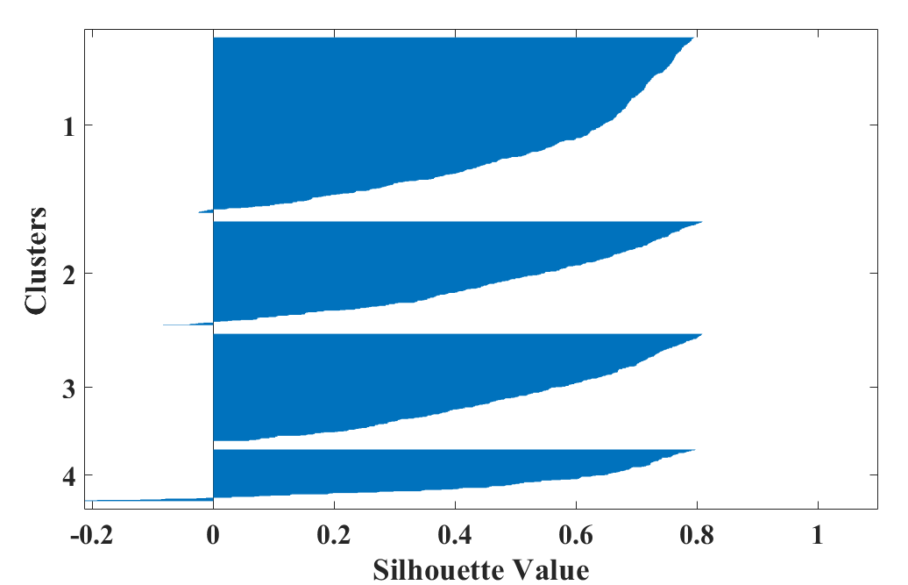
Cluster 1= 0.55
Cluster 2= 0.50
Cluster 3= 0.52
Cluster 4 = 0.53
Average Silhouette value = 0.53
Fig. S.1. Silhouette plot of k-means clustering for BS-VI petrol car
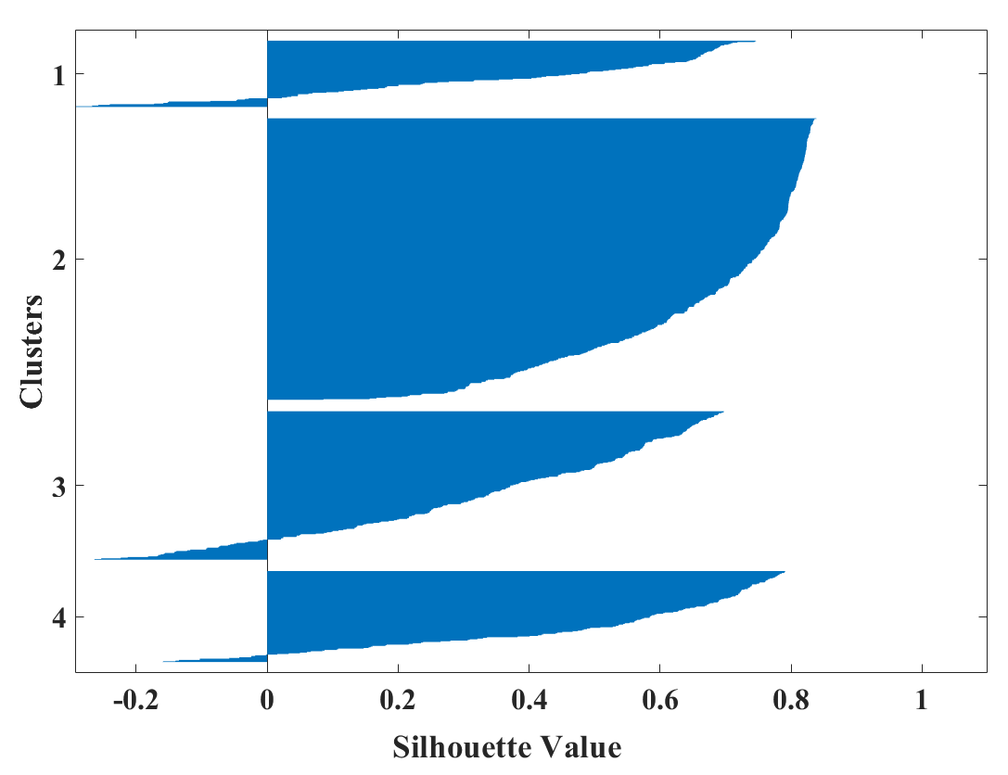
Average Silhouette value = 0.46
Cluster 3 = 0.49
Cluster 1= 0.37
Cluster 2 = 0.67
Cluster 3 = 0.34
Cluster 4 = 0.49
Fig S.2. Silhouette plot of k-means clustering for BS-IV petrol car
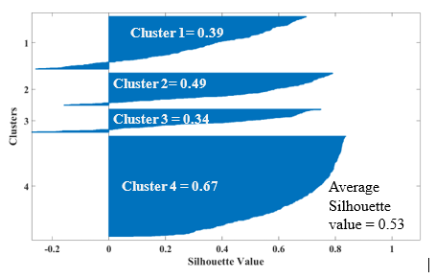
Fig S.3. Silhouette plot of k-means clustering for BS-IV petrol car

${Ef}_{avg}=exp (μ+ \frac{{σ }^{2}}{2}$ ) (S8)
Where,
${Ef}_{avg}$ = average emissions factor
$μ=$mean of the lognormal distribution
$σ$ = standard deviation of the lognormal distribution parameter estimate.
$E (x) = µ$ (S9)
Where,
$µ$ = mean of the normal distribution
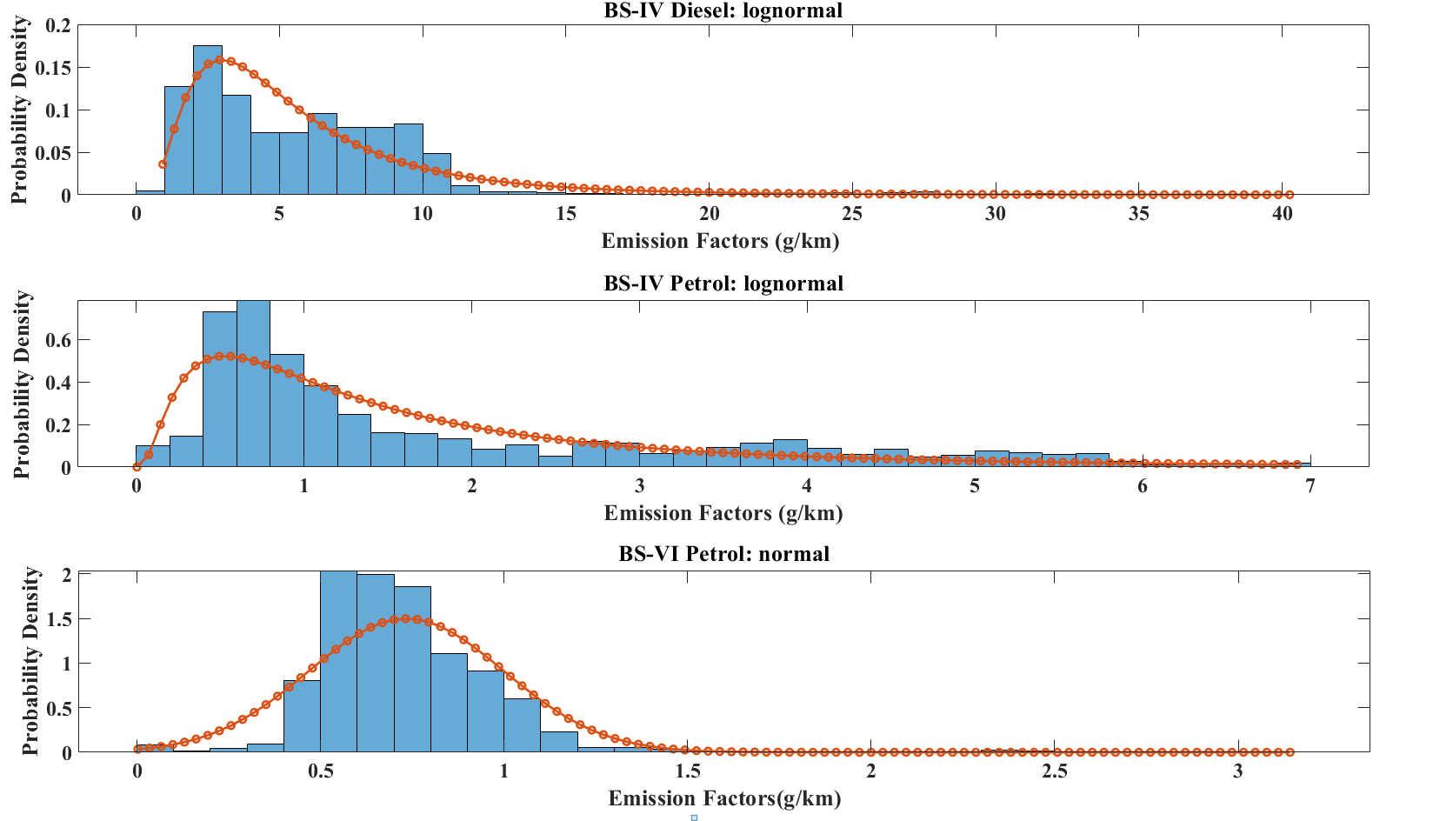
(b)
(a)
(c)
Fig S4. Distribution fit of NO_{x} emissions factors for (a) BS-IV petrol, (b)BS-IV diesel, and (c) BS-VI petrol car
Table S1. AIC and BIC values for different fit
AIC values |  |  |  |  | BIC values
Car types | lognormal | normal | Weibull | exponential | lognormal | normal | Weibull | exponential
BS IV diesel | 6183.3 | 7008.2 | 6373.7 | 6669.9 | 619.35 | 7018.4 | 6383.9 | 6675
BS IV  petrol | 3819.2 | 4568.0 | 3835.9 | 3899.5 | 3892.4 | 4578.2 | 3846.1 | 3904.6
BSVI  petrol | 648.96 | 235.23 | 308.04 | 1663.9 | 659.14 | 245.41 | 318.23 | 1669

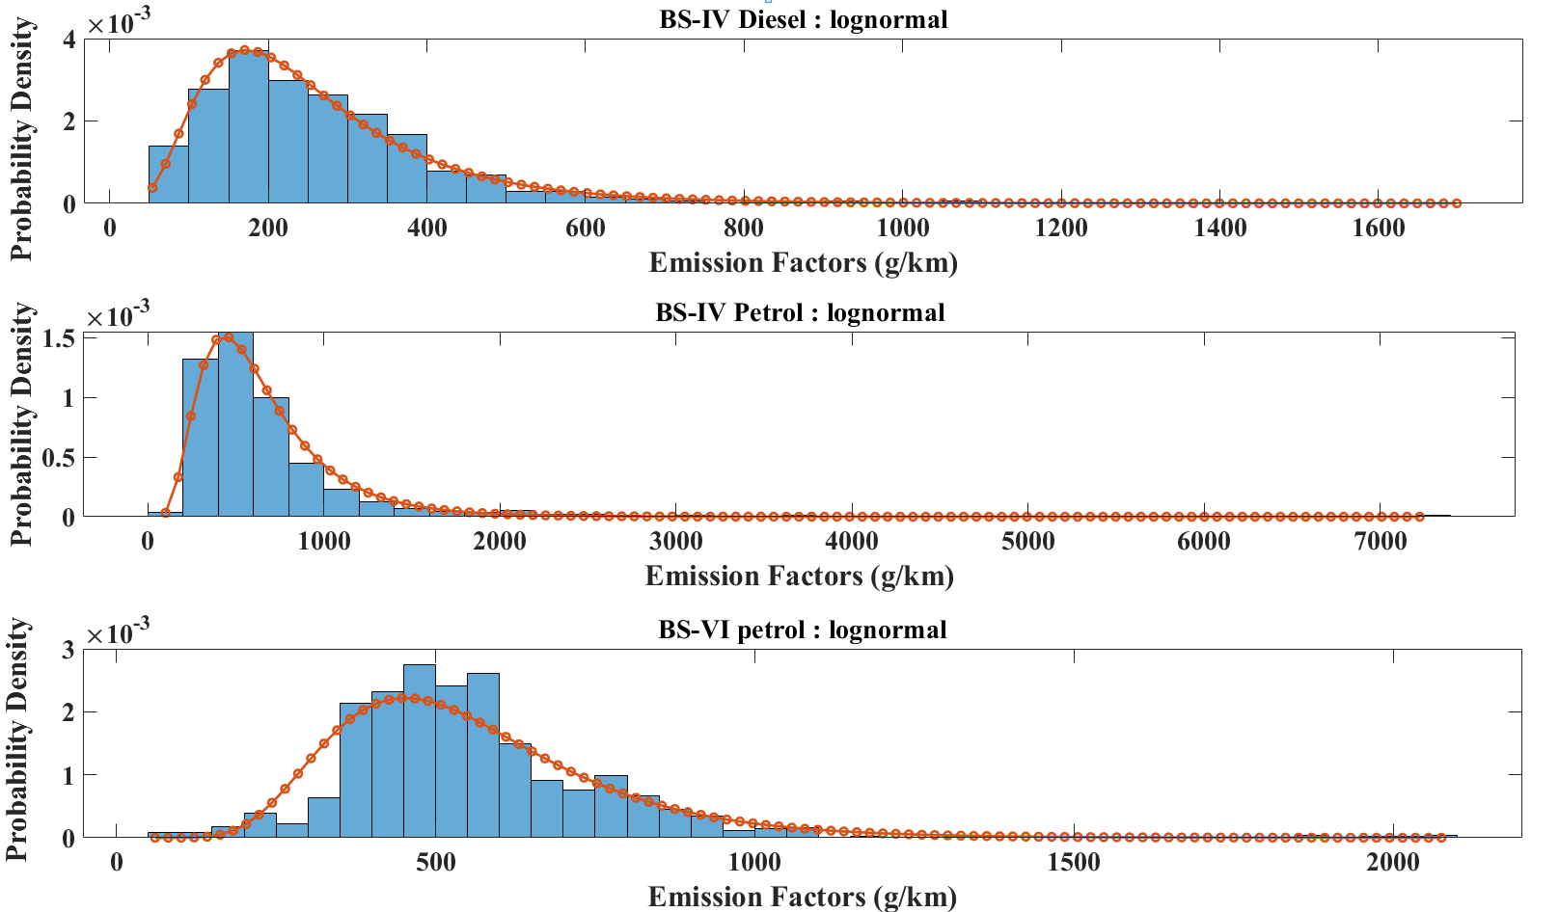
(c)
(b)
(a)

Fig S5 . Distribution fit of CO₂ emissions factors for (a) BS-IV petrol, (b) BS-IV diesel, and (c) BS-VI petrol cars

Table S2 AIC and BIC values for different fit
AIC values |  |  |  |  | BIC values
Car type | lognormal | normal | Weibull | exponential | lognormal | normal | Weibull | exponential
BS IV diesel | 15077 | 15672 | 15294 | 15905 | 15088 | 15682 | 15304 | 15911
BS IV  petrol | 17236 | 18586 | 17765 | 18153 | 17246 | 18596 | 17775 | 18158
BSVI  petrol | 16142 | 16286 | 16287 | 17678 | 16152 | 16296 | 16297 | 17683

References
Sofwan, N. M., & Latif, M. T. (2021). Characteristics of the real-driving emissions from gasoline passenger vehicles in the Kuala Lumpur urban environment. Atmospheric Pollution Research, 12(1), 306-315.
Mohammadnazar, A., Khattak, Z. H., & Khattak, A. J. (2024). Assessing driving behavior influence on fuel efficiency using machine-learning and drive-cycle simulations. Transportation Research Part D: Transport and Environment, 126, 104025.

