Supplementary document
Advanced airborne eDNA sampling allows robust spatiotemporal characterisation of vertebrate communities

Kasun H. Bodawatta¹, Agnete le Maire Madsen¹, Luke E. Holman¹, Jacob Agerbo Rasmussen², Matthew S. Johnson³, Tobias Guldberg Frøslev^{1,4}, Christina Lynggaard^{1,5}, Kristine Bohmann¹

Running title: Optimised air eDNA sampling for vertebrate surveys

¹Section for Molecular Ecology and Evolution, Globe Institute, University of Copenhagen, Copenhagen, Denmark

²Section for Hologenomics, Globe Institute, University of Copenhagen, Copenhagen, Denmark

³Department of Chemistry, University of Copenhagen, Copenhagen, Denmark

⁴Global Biodiversity Information Facility, Copenhagen, Denmark

⁵Helmholtz Institute for One Health, Greifswald, Germany

Supplementary methods
Calculation of air back trajectories
We calculated the air back trajectories for each sampling day at each sampling site using the HYSPLIT model, United States National Oceanic and Atmospheric Administration (https://www.ready.noaa.gov/hypub-bin/trajtype.pl?runtype=archive) ^{1,2}.

Recipe for Longmire’s buffer
One litre of Longmore’s buffer consisted of 100 ml of 1M Tris (8.0 pH), 200 ml of 0.5M Ethylenedinitrilo tetraacetic acid (EDTA, 0.8 pH), 50 ml of 10% SDS (Sodium Dodecyl Sulfate), 20 ml of 10% sodium azide and 2 ml of 5M NaCl ³.

Detailed DNA extraction protocols
During the initial digestion step, for the large filters (Experiment 1 and 3) we used 2700 μl of ATL buffer and 300 μl of Proteinase K, for small filters (Experiment 3) and dry stored filter halves (Experiment 2) we used 1350 μl of ATL and 150 μl of Proteinase K. For filter halves stored in Longmire’s buffer (Experiment 2) we added 720 μl of ATL and 150 μl of Proteinase K to the filter and 1000 μl were taken from the leftover buffer, and was mixed with 720 μl of ATL and 80 μl of Proteinase K. All samples were then shaken in a Tissuelyser II (Qiagen) for 1 min at 20Hz after which samples were incubated at 56°C overnight on a shaker with a rotor head. From the ATL-Proteinase K digest mix we used 2000 μl from the large filters, 1500 μl from the small filters and dry stored filter halves, 3000 μl from the Longmire’s buffer-stored filter halves and the total volume (1800 μl) from the buffer itself. We added an AL buffer and ice-cold 99% ethanol at 1:1 ratio to the digest. This mixture was run through spin columns using a Qiagen vacuum manifold (Hilden, Germany). Subsequent steps were the same as in Lynggaard et al. 2024. We included an extraction negative control for each 21 samples, a room negative control for each 42 samples consisting of 200 ul water in a 2 ml Eeppendorf tube left open in the lab outside the flow hood, and a vacuum manifold negative control for each 21 samples consisting of a spin column introduced to the extraction process from the vacuum manifold step onwards.

Detailed amplicon pooling and library building protocol
Specifically, 4 µl of PCR products were added from PCR replicates with bright bands, 6 µl from medium strength bands and 8 µl from PCR replicates with weak or no bands. From positive control samples we added 2 µl of PCR products and from all the negative controls (extraction, filter, buffer and room controls) we added 8 µl of PCR products. The six PCR replicates from each DNA extract were placed in different pools and only unique tags were used in each amplicon pool. The amplicon pools were purified using Magbio HighPrepTM PCR magnetic beads (amplicon pool to bead ratio for BirT was 1:1, while 1:6 for 16Smam). Purified pools were then quantified using dsDNA high sensitivity qubit assays (Thermo Fisher). Equimolar amounts of the purified amplicon pools were converted into dual-indexed Illumina libraries using the PCR-free TagSteady protocol ⁴. Amplicon libraries were quantified using NEBNext® Library Quant Kit for Illumina® (New England BioLabs). Based on these results, the libraries were pooled equimolarly and submitted for sequencing with an estimated 30,000 paired-reads per PCR replicate. The pooled libraries were sequenced with 300 bp paired-end and approx. 10 % PhiX on an Illumina MiSeq v3 platform, using a total of eight flowcells at the GeoGenetics Sequencing Core, University of Copenhagen, Denmark.

Supplementary results
Air back trajectories
In Kalvebod Fælled (55.58809 N, 12.5381233 E) on 1st through 4th November, 2022 (Experiment 1), air trajectories show that air is arriving from the WSW having crossed the Jutland peninsula and before that, the Northern coast of Europe and the British Isles. Air has been in the boundary layer with some subsidence from higher altitudes (Fig S2). GDAS wind fields and parameters &SETUP, KMSL=0, khmax=48, nstr=8, mhrs=192. On Æbelø (55.6389333 N, 10.16815 E) during 30th to 31st August 2023 (Experiment 2), air is arriving from a range of directions from WNW to S. Air has been in the boundary layer with some subsidence from higher altitudes (Fig S3). GDAS wind fields and parameters &SETUP, KMSL=0, khmax=48, nstr=8, mhrs=192. Finally, in Tofte skov (56.8339617 N, 10.24971 E) from 6th to 9th September 2023 (Experiment 3), air is arriving from all directions in the beginning of the study, to a range of directions from NW through W and S to SE, in the later part of the period. In contrast to the other two sample periods, these filters were exposed to air arriving from the continent (e.g. Poland) and from the Scandinavian peninsula (e.g. Norway) to a much larger extent. Air has been in the boundary layer with some subsidence from higher altitudes (Fig S4). GDAS wind fields and parameters &SETUP, KMSL=0, khmax=48, nstr=8, mhrs=192.

OTU curation and domestic animal sequences
In Experiment 1, without the positive control there were 49 bird OTUs in the BirT dataset. Curation with the LULU algorithm led to retention of 40 OTUs. After merging the OTUs with the same taxonomic identification there were 39 bird taxa, of which 7 were domestic bird species (Table S15). The most prevalent domestic bird species was domestic chicken (Gallus gallus), which was found in 71 samples and accounted for on average 58.6% (SD ± 18.2%) of sequences per sample. In the 16Smam dataset there were 71 OTUs (excluding the positive), which were trimmed to 43 OTUs after LULU. After merging the taxonomically identical OTUs, there were 27 taxa, of which 6 taxa were birds. Of the 21 mammalian taxa, 7 taxa were domestic animals or humans (Table S15). These domestic sequences accounted for the majority of the sampling depth, where pig (Sus scrofa - 73 samples), dog (Canis lupus - 56 samples) and cattle (Bos taurus - 53 samples) were the most prevalent domestic taxa. Among these, pig sequences accounted for in average 62.7% (SD ± 30.9%) of sequences per sample.

In Experiment 2, BirT dataset produced 63 OTUs (excluding the positive) and curation with LULU led to the retention of 43 OTUs. Merging of taxonomically identical OTUs led to a taxa table with 42 bird taxa. Of these taxa, three were domestic bird species, where chicken was the most common domestic bird species (found in 48 samples and accounted for on average 38.3% (SD± 30.1%) of sequences per sample). The uncurated 16Smam OTU table contained 71 OTUs (excluding the positive). Curation with LULU led to an OTU table with 38 OTUs. After merging the taxonomically identical OTUs, there were 24 taxa, of which two taxa were birds. The rest of the 22 taxa included 21 mammals and 1 amphibian. There were 8 domestic taxa in this dataset (Table S15). The most prevalent taxa was pig, which was detected in 60 samples and accounted for on average 71.9% (SD ± 18.7%) of the sequences per sample.

BirT dataset of the Experiment 3 yielded 117 OTUs and after curation with LULU we retained 63 OTUs (excluding the positive). Merging of OTUs with the same identity led to 43 bird taxa. Of these only two were domestic birds (Table S15). Chicken was the most prevalent domestic bird and it was detected in 73 samples, accounting for on average 19.7% (SD ± 27.6%) of the sequences per sample. The 16Smam dataset detected 141 OTUs (excluding the positive). Curation with LULU led to 110 OTUs. Merging of OTUs with the same taxonomic identity led to 32 taxa. Of these three taxa were birds. Rest of the taxa represented 29 mammals and 1 amphibian. Of the 29 mammalian taxa 13 were domestic mammals (Table S15). Pig (in 131 samples) and dog (in 138 samples) were the most common domestic mammal taxa and these accounted for on average 55.1% (SD ± 38.4%) and 32.7% (SD ± 38.4%)of sequences per sample respectively.

Sequence and read abundant information
Experiment 1:
After removal of domestic bird sequences the bird dataset (see Supplementary Table S15) contained 70 samples with wild bird detections (total sequences: 1,808,734, average ± SD: 25,839 ± 17,076). Of the 18 samples from filter class ISO ePM1 65% from Company 1, 17 samples had wild bird detections (total: 286,696 wild bird sequences (average ± SD: 16,864 ± 13,744 sequences per sample), while all samples (n=18) of similar filters from Company 2 yielded wild bird sequences (total: 504,683, average ± SD: 28,037 ± 13,775). Seventeen of the 18 samples of the class ISO ePM 2.5 70% filters had wild bird detections (total sequences: 277,011, average ± SD: 16,294 ± 6,536), while all samples from ISO ePM10 65% filter class yielded wild bird sequences (total: 740,344, average ± SD: 41,130 ± 18,746). In the mammal dataset, only 31 out of the 72 samples contained wild mammal sequences (total: 465,985, average ± SD: 29,124 ± 14,354). Filter class ISO ePM1 65% from the Company 1 yielded seven samples with wild mammal sequences (total: 47,762, average ± SD: 6,823 ± 3,280), while same filter class from the Company 2 yielded only three samples with wild mammal detections (total: 101,387, average ± SD: 33,795 ± 17,389). There were seven samples from class ISO ePM 2.5 70% with wild mammal sequences (total: 51,239, average ± SD: 7,319 ± 4,552) and 14 of the 18 samples of filter class ISO ePM10 65% contained wild mammal sequences (total: 265,597, average ± SD: 18,971 ± 15,753).

Experiment 2:
For the curated BirT taxa table this resulted in 1,852,699 wild bird sequences. These were spread across 20 air filter samples dry-stored with silica beads (average ± SD: 33,951 ± 19,792 per sample), 19 air filter samples stored in Longmire’s buffer (48,280 ± 57,722) and eight Longmire’s buffer samples (32,041 ± 24,616). The curated 16Smam taxa table yielded 813,335 wild mammal sequences across 18 dry-stored samples (average ± SD: 8,556 ± 4,788), 20 air filter samples stored in Longmire’s buffer (29,143 ± 17,693) and 11 Longmire’s buffer samples (6,950 ± 4,252) (Table S3).

Experiment 3:
After removing domestic birds in the bird dataset, the 12V fans with large filters (n = 30) yielded 1,562,159 wild bird sequences (average ± SD: 52,072 ± 23,248 per sample), 12V fans with small filters (n = 29) yielded 777,663 sequences (26,816 ± 15,702), 5V fans with small filters (n = 11) yielded 568,419 sequences (24,714 ± 16,015) and 5V fans with large filters (n = 29) yielded 840,253 sequences (28 974 ± 20,500). Only two of the 30 passive samples with large filters retained wild bird sequences (490,838 ± 3,487), while there were no detections with the passive samplers with small filters (originally 30 samples). For the mammal taxa table, the 12v fans with large filters (n = 22) accounted for 550,421 wild mammal sequences (average ± SD: 25,019 ± 19,346), 12v fans with small filters (n = 13) contained 149,898 sequences (11,530 ± 9,084), 5v fans with small filters (n = 12) yielded 325,171 sequences (27,097 ± 31,187) and 5v fans with large filters (n = 18) accounted for 426,275 sequences (23,681 ± 18,631). Only three passive samplers with large filters contained wild mammal taxa (total: 155,008; average ± SD: 51,669 ± 61,821) and there was no wild taxa detected with the passive samplers with small filters.

Supplementary tables
Table S1. Airflow rate for each sampler setup with and without filters. The average and the Standard deviation (SD) of the airflow rates were calculated after three measurements.
Fan setup | Filter type | Average airflow rate m³h⁻¹ ± SD
12v auxiliary fan with large filter housing | No filter | 0.9965 ± 0.0034
 | ISO ePM1 65% (company 1) | 0.4607 ± 0.0147
 | ISO ePM1 65% (company 2) | 0.4869 ± 0.0178
 | ISO ePM 2.5 70% | 0.5129 ± 0.0026
 | ISO ePM10 65% | 0.5505 ± 0.0043
12v auxiliary fan with small filter housing | No filter | 0.8999 ± 0.0185
 | ISO ePM10 65% | 0.4827 ± 0.0223
5v auxiliary fan with small filter housing | No filter | 0.1869 ± 0.0012
 | ISO ePM10 65% | 0.0552 ± 0.0013
5v auxiliary fan with large filter housing | No filter | 0.2288 ± 0.0016
 | ISO ePM10 65% | 0.0844 ± 0.0039

Table S2. Metadata on sampling sites and samples of air samplers at Kalvebod Fælled (Air filter type experiment: Experiment 1). Table is in a separate excel file.

Table S3. Curated taxa table of the Experiment 1. Tab 1 and 3 shows the OTU tables after curation with Lulu for BirT and 16Smam primers respectively. Tab 2 and 4 include the taxa table after merging taxonomically identical OTUs (without the positive control). Domestic taxa and non-targeted taxa are highlighted in yellow. Table is in a separate excel file.

Table S4. Domestic and exotic pet taxa found in each dataset. Number of samples where each taxa detected are given in the table. Taxa that are not expected to find in the sampling area is highlighted in red. Average ± SD of proportion of sequences represented by each domestic or exotic pet species are given parenthesis.

Class | Species (Taxa #) | Experiment 1 (Kalvebod Fælled) | Experiment 2 (Æbelø) | Experiment 3 (Tofte forest)
Aves | Gallus gallus | 71 (58.6%± 18.2%) | 48 (38.3%± 30.1%) | 73 (19.7%± 27.6%)
 | Meleagris gallopavo | 30 (2.7%± 5.5%) | 2 (0.6%± 3.7%)
 | Psittacula sp. | 1 (0.04%± 0.3%)
 | Pavo cristatus | 1 (0.07%± 0.6%)
 | Cairina moschata | 1 (0.01%± 0.09%)
 | Lophura nycthemera | 1 (0.007%± 0.06%)
 | Melopsittacus undulatus | 1 (0.004%± 0.04%) |  | 1 (0.06%± 0.7%)
 | Psittacula krameri |  | 1 (0.02%± 0.2%)
Mammals | Sus scrofa | 73 (62.7%± 30.9%) | 60 (71.9%± 18.7%) | 131 (55.1%± 38.4%)
 | Sus spp. |  |  | 8 (0.001%± 0.006%)
 | Canis lupus | 56 (13.1%± 19.2%) | 36 (7.7%± 10.7%) | 138 (32.7%± 38.4%)
 | Canis spp. |  |  | 1 (0.00005%± 0.0007%)
 | Bos taurus | 53 (6.6%± 10.3%) |  | 23 (1.7%± 7.8%)
 | Bos indicus |  | 31 (3.3%± 4.6%)
 | Capra hircus |  | 1 (0.08%± 0.58%)
 | Capra_spp. |  |  | 1 (0.2%± 2.5%)
 | Ovis_spp. |  |  | 2 (0.08%± 0.8%)
 | Homo sapiens | 64 (12.2%± 28.4%) | 8 (6.9%± 33.8%) | 35 (4.7%± 17.9%)
 | Homo spp. |  |  | 1 (0.0005%± 0.006%)
 | Pan troglodytes |  | 4 (0.59%± 2.9%) | 11 (0.5%± 2.7%)
 | Equus caballus | 5 (0.3%± 1.5%) | 5 (0.18%± 0.7%) | 2 (0.03%± 0.3%)
 | Felis silvestris |  | 1 (0.05%± 0.38%)
 | Felis spp. | 2 (0.3%± 2.4%)
 | Loxodonta africana | 1 (0.04%± 0.4%)

Table S5. Pairwise differences between bird and mammalian taxa richness detected by four different filter types. Significant differences are indicated with bold font.

Primer set | Comparison | Estimate | t.ratio | p
BirT | ISO ePM1 65% (company 1) vs. ISO ePM1 65% (company 2) | -2.61 | -4.346 | 0.0003
 | ISO ePM1 65% (company 1) vs. ISO ePM 2.5 70% | -1.04 | -1.703 | 0.3302
 | ISO ePM1 65% (company 1) vs. ISO ePM10 65% | -5.83 | -9.710 | <0.0001
 | ISO ePM1 65% (company 2) vs. ISO ePM 2.5 70% | 1.57 | 2.577 | 0.0578
 | ISO ePM1 65% (company 2) vs. ISO ePM10 65% | -3.22 | -5.363 | <0.0001
 | ISO ePM 2.5 70% vs. ISO ePM10 65% | -4.79 | -7.858 | <0.0001
16S_mam | ISO ePM1 65% (company 1) vs. ISO ePM1 65% (company 2) | 0.0556 | 0.214 | 0.9965
 | ISO ePM1 65% (company 1) vs. ISO ePM 2.5 70% | -0.023 | -0.087 | 0.9998
 | ISO ePM1 65% (company 1) vs. ISO ePM10 65% | -1.000 | -3.850 | 0.0015
 | ISO ePM1 65% (company 2) vs. ISO ePM 2.5 70% | -0.078 | -0.297 | 0.9908
 | ISO ePM1 65% (company 2) vs. ISO ePM10 65% | -1.056 | -4.064 | 0.0007
 | ISO ePM 2.5 70% vs. ISO ePM10 65% | -0.977 | -3.705 | 0.0024

Table S6. Results of Pairwise PERMANOVA tests investigating the differnces in bird community composition among filter types. The full model of 16S_mam dataset did not show any significant differences between filter types. Significant differences are indicated with bold font.

Primer set | Comparison | F Model | R² | Adjusted p value
BirT | ISO ePM1 65% (company 1) vs. ISO ePM1 65% (company 2) | 1.454 | 0.0422 | 0.5825
 | ISO ePM1 65% (company 1) vs. ISO ePM 2.5 70% | 0.7868 | 0.0239 | 1.000
 | ISO ePM1 65% (company 1) vs. ISO ePM10 65% | 3.024 | 0.0839 | 0.0018
 | ISO ePM1 65% (company 2) vs. ISO ePM 2.5 70% | 1.656 | 0.0478 | 0.3912
 | ISO ePM1 65% (company 2) vs. ISO ePM10 65% | 1.174 | 0.0334 | 1.000
 | ISO ePM 2.5 70% vs. ISO ePM10 65% | 2.871 | 0.0801 | 0.0102

Table S7. Pairwise differences between beta dispersion (distance to group centroids) of bird and mammalian communities between the four different filter types. Significant differences are indicated with bold font and there were no significant pairwise differences in 16S_mam dataset.
Primer set | Comparison | estimate | t.ratio | p
BirT | ISO ePM1 65% (company 1) vs. ISO ePM1 65% (company 2) | 0.0855 | 3.728 | 0.0023
 | ISO ePM1 65% (company 1) vs. ISO ePM 2.5 70% | 0.0417 | 1.792 | 0.2867
 | ISO ePM1 65% (company 1) vs. ISO ePM10 65% | 0.1335 | 5.819 | <0.0001
 | ISO ePM1 65% (company 2) vs. ISO ePM 2.5 70% | -0.0438 | -1.909 | 0.2345
 | ISO ePM1 65% (company 2) vs. ISO ePM10 65% | 0.0481 | 2.123 | 0.1569
 | ISO ePM 2.5 70% vs. ISO ePM10 65% | 0.0918 | 4.000 | 0.0009

Table S8. Results on Critical threshold (ct) values based on qPCRs with BirT primers on different filter types of experiment 1. Log transformed DNA concentrations were calculated using the known concentrations of the DNA used in the standard curve. Table is in a separate excel file.

Table S9. Metadata on sample sites and samplers of air samplers at Æbelø (Sample storage experiment: Experiment 2). Table is in a separate excel file.

Table S10. Curated taxa table of the Experiment 2. Tab 1 and 3 shows the OTU tables after curation with Lulu for BirT and 16Smam primers respectively. Tab 2 and 4 include the taxa table after merging taxonomically identical OTUs (without the positive control). Domestic taxa and non-targeted taxa are highlighted in yellow. Table is in a separate excel file.

Table S11. Pairwise differences between bird and mammalian taxa richness detected by different storage methods.

Primer set | Comparison | estimate | t.ratio | p
BirT | Dry stored vs. Longmire’s buffer stored | 6.30 | 8.765 | < 0.0001
 | Dry stored vs. Buffer | 10.05 | 13.98 | < 0.0001
 | Longmire’s buffer stored vs. Buffer | 3.75 | 5.218 | < 0.0001
16Smam | Dry stored vs. Longmire’s buffer stored | 0.1 | 0.399 | 0.9162
 | Dry stored vs. Buffer | 1.1 | 4.389 | 0.0003
 | Longmire’s buffer stored vs. Buffer | 1.0 | 3.990 | 0.0008

Table S12. Pairwise PERMANOVA test investigating the community compositional differences between sample storage methods.

Primer set | Comparison | F Model | R² | Adjusted p value
BirT | Dry stored vs. Longmire’s buffer stored | 2.138 | 0.0546 | 0.0003
 | Dry stored vs. Buffer | 2.634 | 0.0921 | 0.0003
 | Longmire’s buffer stored vs. Buffer | 0.9327 | 0.0359 | 1.000
16Smam | Dry stored vs. Longmire’s buffer stored | 14.35 | 0.2849 | 0.0003
 | Dry stored vs. Buffer | 6.705 | 0.1989 | 0.0006
 | Longmire’s buffer stored vs. Buffer | 6.709 | 0.1878 | 0.0003

Table S13. Metadata on sample sites and samples of air samplers at Lille Vildmose (Airflow rate experiment: Experiment 3).

Table S14. Curated taxa table of the Experiment 3. Tab 1 and 3 shows the OTU tables after curation with Lulu for BirT and 16Smam primers respectively. Tab 2 and 4 include the taxa table after merging taxonomically identical OTUs (without the positive control). Domestic taxa and non-targeted taxa are highlighted in yellow. Table is in a separate excel file.

Table S15. Pairwise differences between bird and mammalian taxa richness detected by different air sampler types.

Primer set | Comparison | estimate | t.ratio | p
BirT | 12V large filter vs. 12V small filter | 2.085 | 3.851 | 0.0023
 | 12V large filter vs. 5V small filter | 3.918 | 7.238 | < 0.0001
 | 12V large filter vs. 5V large filter | 1.951 | 3.605 | 0.0055
 | 12V large filter vs. large passive filter | 5.818 | 10.75 | < 0.0001
 | 12V large filter vs. small passive filter | 6.251 | 11.55 | < 0.0001
 | 12V small filter vs. 5V small filter | 1.833 | 3.388 | 0.0112
 | 12V small filter vs. 5V large filter | -0.133 | -0.246 | 0.9999
 | 12V small filter vs. large passive filter | 3.733 | 6.898 | < 0.0001
 | 12V small filter vs. small passive filter | 4.167 | 7.700 | < 0.0001
 | 5V small filter vs. 5V large filter | -1.967 | -3.634 | 0.0049
 | 5V small filter vs. large passive filter | 1.900 | 3.511 | 0.0075
 | 5V small filter vs. small passive filter | 2.333 | 4.312 | 0.0004
 | 5V large filter vs. large passive filter | 3.867 | 7.144 | < 0.0001
 | 5V large filter vs. small passive filter | 4.300 | 7.947 | < 0.0001
 | Large passive filter vs. small passive filter | 0.433 | 0.801 | 0.9670
16Smam | 12V large filter vs. 12V small filter | 0.600 | 3.270 | 0.0163
 | 12V large filter vs. 5V small filter | 0.733 | 3.997 | 0.0013
 | 12V large filter vs. 5V large filter | 0.233 | 1.272 | 0.7999
 | 12V large filter vs. large passive filter | 0.965 | 5.256 | < 0.0001
 | 12V large filter vs. small passive filter | 1.133 | 6.177 | < 0.0001
 | 12V small filter vs. 5V small filter | 0.133 | 0.727 | 0.9783
 | 12V small filter vs. 5V large filter | -0.367 | -2.000 | 0.3470
 | 12V small filter vs. large passive filter | 0.365 | 1.988 | 0.3537
 | 12V small filter vs. small passive filter | 0.533 | 2.909 | 0.0467
 | 5V small filter vs. 5V large filter | -0.500 | -2.727 | 0.0755
 | 5V small filter vs. large passive filter | 0.231 | 1.261 | 0.8056
 | 5V small filter vs. small passive filter | 0.400 | 2.182 | 0.2521
 | 5V large filter vs. large passive filter | 0.731 | 3.987 | 0.0014
 | 5V large filter vs. small passive filter | 0.900 | 4.908 | < 0.0001
 | Large passive filter vs. small passive filter | 0.169 | 0.920 | 0.9410

Table S16. Pairwise PERMANOVA test investigating the community compositional differences between air sampler types (Pairwise comparisons were only conducted for BirT communities as there were no overall significance effects of sampler types on 16Smam communities).

Primer set | Comparison | F Model | R² | Adjusted p value
BirT | 12V large filter vs. 12V small filter | 2.068 | 0.0351 | 0.0569
 | 12V large filter vs. 5V small filter | 2.239 | 0.0421 | 0.0279
 | 12V large filter vs. 5V large filter | 1.518 | 0.0259 | 0.5709
 | 12V large filter vs. large passive filter | 2.051 | 0.0639 | 0.0629
 | 12V small filter vs. 5V small filter | 1.193 | 0.0233 | 1.000
 | 12V small filter vs. 5V large filter | 0.7746 | 0.0136 | 1.000
 | 12V small filter vs. large passive filter | 2.194 | 0.071 | 0.0439
 | 5V small filter vs. 5V large filter | 1.0643 | 0.0208 | 1.000
 | 5V small filter vs. large passive filter | 2.324 | 0.0918 | 0.0419
 | 5V large filter vs. large passive filter | 2.061 | 0.0664 | 0.1069

Tables S17. Curated taxa table (presence/absence) of all three experiments. First tab of the table provides all detected taxa across the three study areas and the subsequent tabs belong to each of the study areas (i.e., experiment). Table is in a separate excel file. Data from this table was used to generate Figs 6 and 7.

Table S18. Amount of template DNA and PCR cycles used for metabarcoding PCRs.

Project | Primer set | Sampler type | Amount of template DNA | Number of PCR cycles
Experiment 1: Air filter type experiment | BirT | 12v fan with 6x6cm filters | 3 µl | 35
 | 16Smam | 12v fan with 6x6cm filters | 3 µl | 35
Experiment 2: Sample storage experiment | BirT | Dry stored filter half | 3 µl | 33
 |  | Longmire’s buffer stored filter half | 3 µl | 35
 |  | Buffer extract | 3 µl | 37
 | 16Smam | Dry stored filter half | 3 µl | 35
 |  | Longmire’s buffer stored filter half | 3 µl | 37
 |  | Buffer extract | 3 µl | 37
Experiment 3: Airflow rate experiment | BirT | 12v fan with 6x6cm filters | 2 µl | 36
 |  | 12v fan with 4x4cm filters | 2 µl | 36
 |  | 5v fan with 4x4cm filters | 2 µl | 36
 |  | 5v fan with 6x6cm filters | 2 µl | 36
 |  | 4x4cm passive filters | 3 µl | 41
 |  | 6x6cm passive filters | 3 µl | 41
 | 16Smam | 12v fan with 6x6cm filters | 2 µl | 37
 |  | 12v fan with 4x4cm filters | 2 µl | 37
 |  | 5v fan with 4x4cm filters | 3 µl | 37
 |  | 5v fan with 6x6cm filters | 3 µl | 37
 |  | 4x4cm passive filters | 3 µl | 39
 |  | 6x6cm passive filters | 3 µl | 39

Supplementary figures
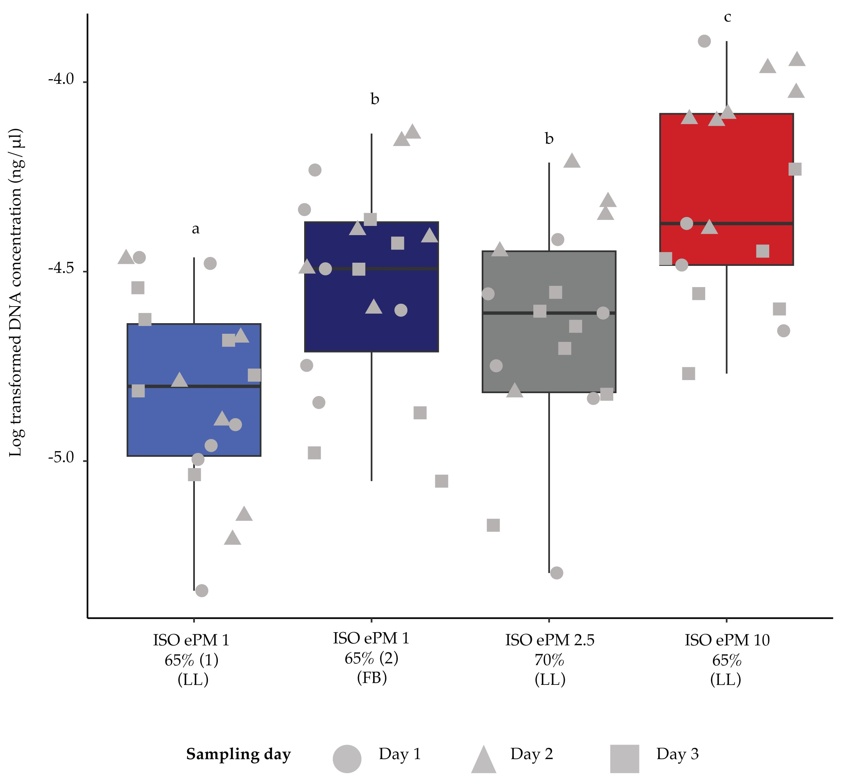

Fig S1. Box plot shows the differences in log-tranformed bird DNA concentrations accumulated by different filter types based on qPCR results from BirT primers. Letters above box plots indicate the outcome of the post hoc tests.

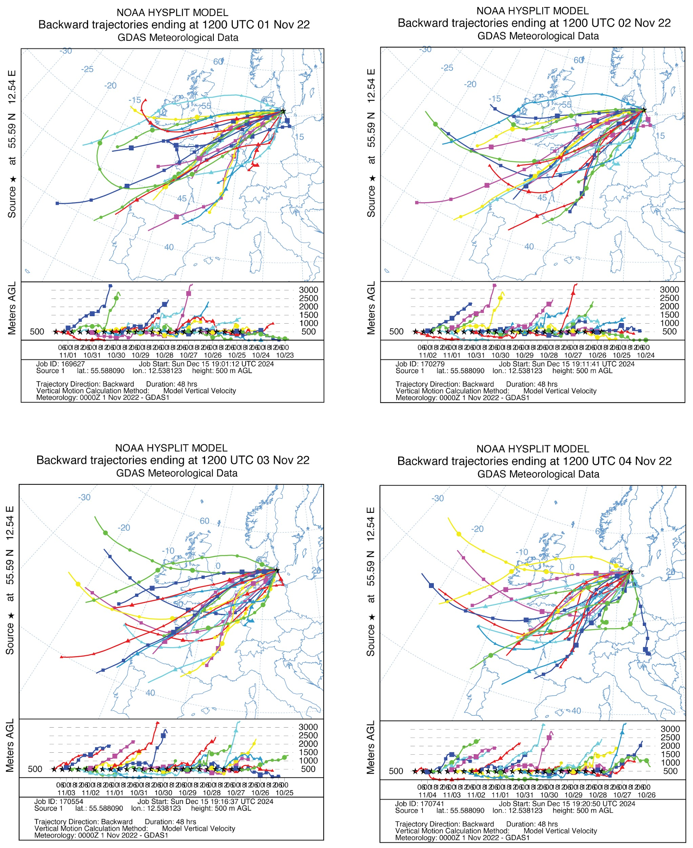
Fig S2. Air flow back trajectories at Kalvebod Fælled (55.58809 N, 12.5381233 E) from 1st to 4th November 2022 (Experiment 1).

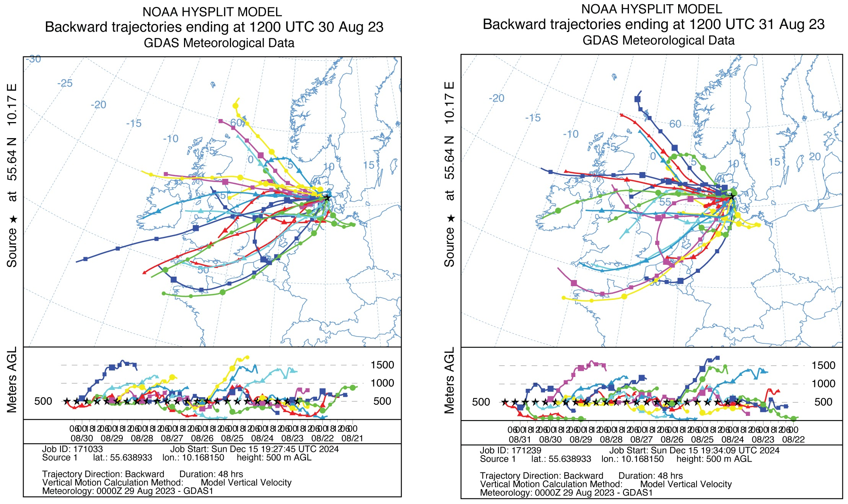
Fig S3. Air flow back trajectories on Æbelø (55.6389333 N, 10.16815 E) from 30th to 31st August 2023 (Experiment 2).

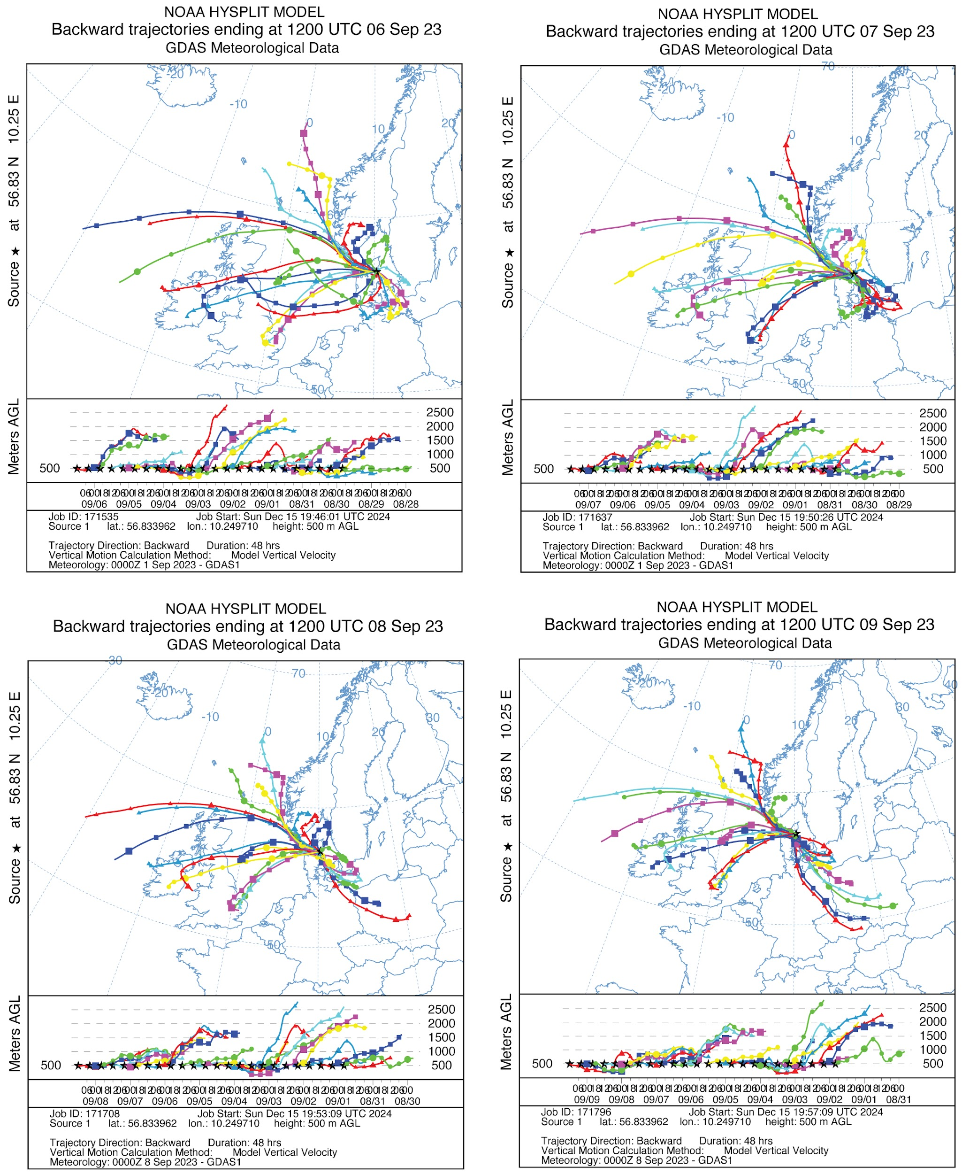
Fig S3. Air flow back trajectories at Tofte skov (56.8339617 N, 10.24971 E) from 6th to 9th September 2023 (Experiment 3).

References
1. Stein, A. F. et al. NOAA’s HYSPLIT atmospheric transport and dispersion modeling system. Bull. Am. Meteorol. Soc. 96, 2059–2077 (2015).
2. Rolph, G., Stein, A. & Stunder, B. Real-time environmental applications and display sYstem: READY. Environ. Model. Softw. 95, 210–228 (2017).
3. Nolan, K. & Schrock, S. Recipe for Longmire’s Solution. https://hdl.handle.net/2022/15408 (2013).
4. Carøe, C. & Bohmann, K. Tagsteady: A metabarcoding library preparation protocol to avoid false assignment of sequences to samples. Mol. Ecol. Resour. 20, 1620–1631 (2020).

